# Disturbance and recovery of mouse gut microbiota in response to antibiotics.

John Guittar1,*, Aspen Reese2, Lawrence David3, Timothy Brennhofer1,4, Ashley Shade5,6, Elena Litchman1,6,7

1 Kellogg Biological Station, Michigan State University, 3700 E Gull Lake Dr, Hickory Corners, MI 49060, USA

2 Harvard University, Cambridge, MA 02138, USA

3 Department of Molecular Genetics and Microbiology, Duke University, Box 3382, Durham, 11 NC 27708, USA

4 Grinnell College, 1115 8th Ave, Grinnell, IA 50112, USA

5 Department of Microbiology and Molecular Genetics, Department of Plant, Soil and Microbial Sciences, and The Plant Resilience Institute, Michigan State University, East Lansing MI 48840, USA

6 Program in Ecology, Evolutionary Biology and Behavior, Michigan State University East Lansing MI 48840, USA

7 Department of Integrative Biology, Michigan State University, East Lansing, MI 48824, USA

* Correspondence author: E-mail: [guittarj@msu.edu](mailto:guittarj@msu.edu)

# Abstract

# Introduction

* We want to improve our understanding of antibiotic disturbance and recovery in the mammalian gut.
* Most work in this area has focused on shifts in abundance at coarse taxonomic scales. We want to look at disturbance and recovery at the OTU scale, in order to more explicitly examine ecological dynamics.
* One way to better understand ecological mechanisms is to focus on traits. For example, in plant systems, traits related to dispersal ability and rapid growth are often associated with early colonists to distubed areas. Indeed, these traits often form a syndrome characteristic of pioneer species.
* Colonization of the gut after disturbance my be particularly difficult, because it is an abiotic community with strong impediments to dispersal. Spores have been hypothesized to be a life history trait that enhances the probability of dispersal among hosts.

## *Questions:*

1. Which traits (other than antibiotic resistance) predict OTU tolerance/susceptibility to antibiotics?
2. Which traits predict recovery after antibiotic disturbances?
3. Which traits predict successful immigration from the regional pool during the recovery process?

              - Are these traits related to dispersal ability and rapid growth, as expected?

To answer these questions, we will use data from Reese et al. (2018).

Another way to frame many of these questions is: can OTU traits help to predict the boxes into which OTUs fall in the following diagram:

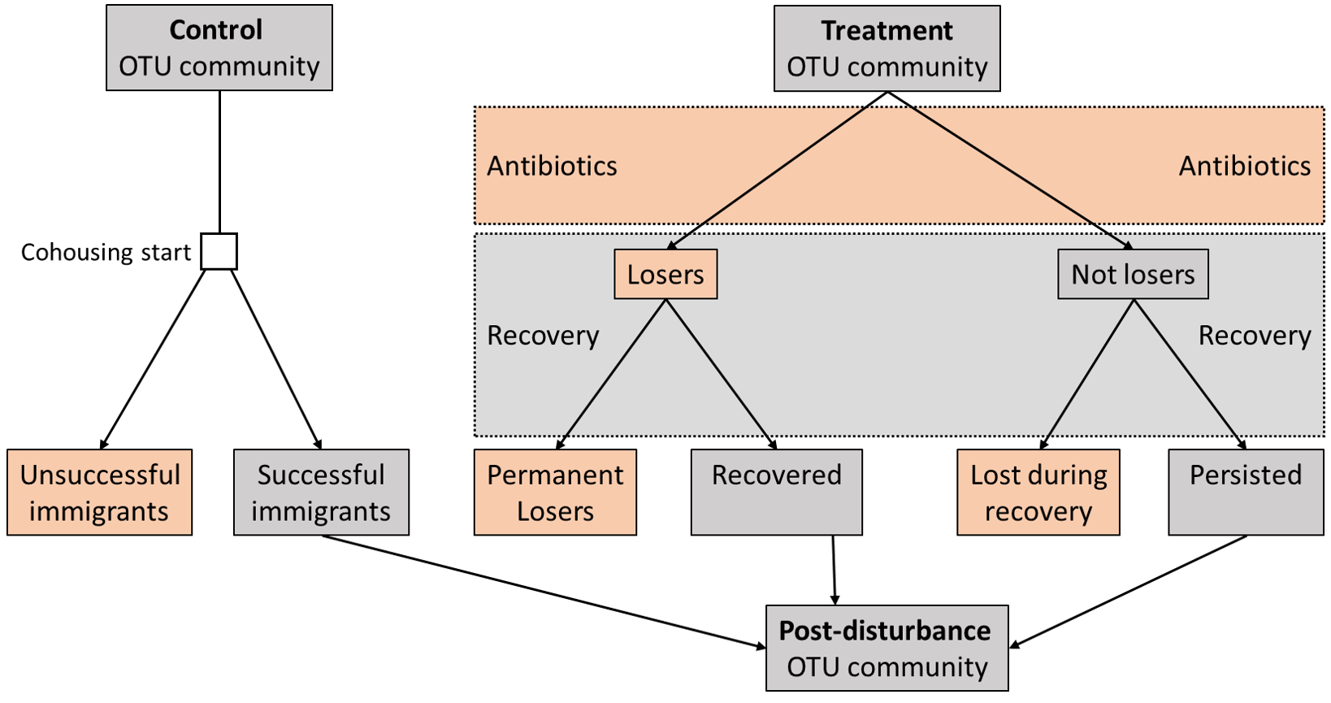

**Figure 1:** The potential fates and fortunes of OTUs in mice treated with antibiotics. Positive outcomes are shaded light green, whereas negative outcomes are shaded light red.

###### 

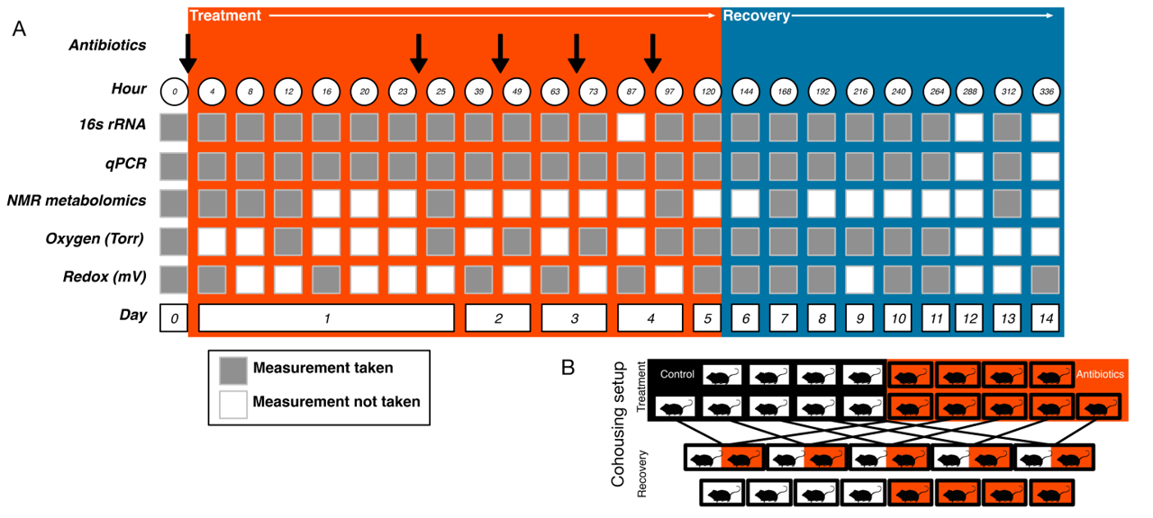

**Figure 2:** A figure drawn from Reese et al. (2018) showing the experimental setup and data collection schedule.

###### 

# Methods

# Results

###### 

**Figure 3:** PCoA of mouse microbiomes over time, during and after 120 hours of antibiotic treatment. Control mice (left) and treated mice (right) were cohoused after treatment (hour 120) for the duration of the experiment.

###### 

**Figure 4:** PCoA of mouse microbiomes over time, during and after 120 hours of antibiotic treatment. Control mice (left) and treated mice (right) were not cohoused at any point during the experiment.

###### 

**Figure 5:** Percent of phyla observed across all mice present within single mice, assessed at increasingly specific taxonomic levels.

###### 

**Figure 6:** Shannon diversity over time within mice.

###### 

**Figure 7:** OTU richness over time within mice.

###### 

**Figure 8:** OTU community evenness (i.e., equitability, i.e., Shannon diversity H / log(OTU richness))

###### 

**Figure 9:** A test of the potential role of mass effects. The hypothesis is that, all else being equal, the abundance of a taxon in the regional pool (i.e., the cohoused mouse) is going to correlate positively with time to arrival (i.e., successful colonization) in the treated mouse. This hypothesis is supported. However, we can’t be sure if the pattern is because the taxa that are more abundant taxa in the control mouse are simply better suited for the gut environment, and thus are faster to colonize the antibiotic-treated mouse. So, the analysis has it’s limitations, but I still think it’s worth noting.

###### 

**Figure 10:** Rarefied OTU abundances, colored by OTU status. This figure is to compare mice treated by antibiotics to untreated mice.

###### 

**Figure 11:** Rarefied OTU abundances, colored by OTU status. This figure is to compare mice in cohousing environments during the recovery process, with mice caged alone during the recovery process.

###### 

**Figure 12:** OTU richness from communities rarefied to 5000 seqeunces, colored by OTU status. This figure is to compare mice treated by antibiotics to untreated mice.

###### 

**Figure 13:** OTU richness from communities rarefied to 5000 seqeunces, colored by OTU status. This figure is to compare mice in cohousing environments during the recovery process, with mice caged alone during the recovery process.

###### 

**Figure 14:** Trends in abundances of 12 taxa that differ significantly between antibiotic treated mice and control mice. The translucent red square shows the window of antibiotic treatment.

###### Works Cited

Reese, A. T., E. H. Cho, B. Klitzman, S. P. Nichols, N. A. Wisniewski, M. M. Villa, H. K. Durand, S. Jiang, F. S. Midani, S. N. Nimmagadda, T. M. O’Connell, J. P. Wright, M. A. Deshusses, and L. A. David. 2018. Antibiotic-induced changes in the microbiota disrupt redox dynamics in the gut. eLife 7:e35987.