(s) Tyler Bryant

Abstract

This coursework report will detail the functionality of my project as well as include images that show the building process / wireframes of how I wanted the project to look at the beginning and then what it looks like now.

SOFT355 cOURSEWORK

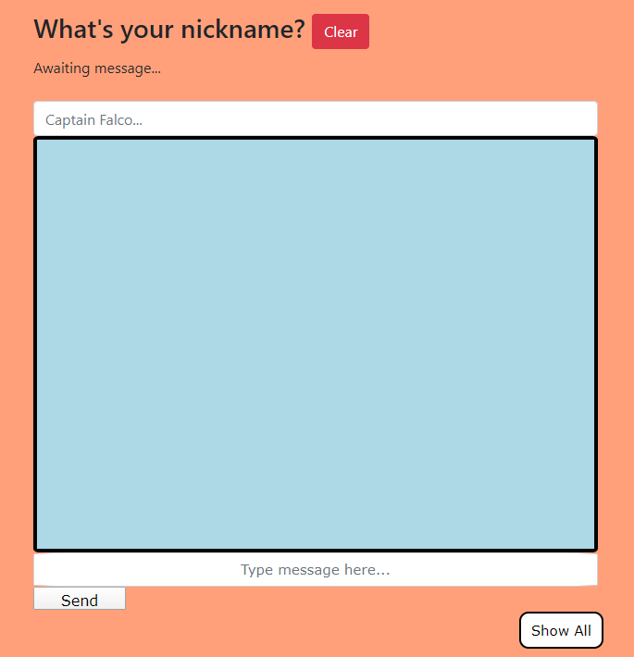

Contents

Functionality 1

What the application does: 1

How the user interacts with the program: 1

What technologies were used: 1

Requirements 1

Who is the application aimed at? 1

What features were included and why? 2

Design 2

What is the system architecture (clients/servers/peers) 2

How do the processes interact? 2

How are the data and code structured? 2

Why are these structures appropriate? 2

Testing 2

What automated testing have you performed (unit tests etc) 2

What usability testing have you performed? 2

Why is your chosen test strategy appropriate? 2

DevOps Pipeline 2

Describe your development environment 2

Describe your continuous integration pipeline and how you used it 2

Personal Reflection 2

What worked well/didn’t work well in terms of your work and the technologies you used? 2

What lessons would you take from this project into your next project? 2

# Functionality

## What the application does:

My application is a game review website that has a chatroom integrated into it. The ability to browse images from different games and different platforms means that the application is useful to multiple types of gamers and non-gamers. The chat room is run as a webpage but connected via a server using socket.io.

## How the user interacts with the program:

The user is able to browse the website just like any other website but they can also opt to join the website’s chat room through a link at the bottom of their screen, via a browser mounted navigation bar, which will open the chat room webpage and there is a notification within the chat box saying a new member has joined the chat. Simply message where it says to and then the messages appear in chat box.

## What technologies were used:

The application was developed through Visual Studio 2019 using HTML and CSS for the core website whilst using JavaScript for the server and client side of the chat room webpage. To help aid me in this, I also used the software Brackets which enabled me to see a live preview of my web app and see how the webpages were looking whilst being able to get the JavaScript scripts constructed within Visual Studio.

# Requirements

## Who is the application aimed at?

My web application is aimed mainly towards users who play video games as this is the core theme of the website but that doesn’t mean that non-gamer users shouldn’t have access to the application. As the content of the website is about different games and genres then it could benefit to them by either gaining knowledge from the website itself or the community using the chat room.

## What features were included and why?

The website has the capability to allow the user to create an account which is then saved onto an external database. The chat room is a feature which allows the user to connect to other users and communicate across systems. I included the chat room into a website as this would be a scenario which can and is already implemented into some web services already. I wanted to show how the project would look as if it was a finalised and publish web app

# Design

## What is the system architecture (clients/servers/peers)

The web app uses Socket.io as its means to connect to other users. The website is able to connect to the local host which acts as a server by using the sockets that have been created and then can host this to the clients that also access the web app. The web application communicates with the localhost server to them share messages sent locally, seen here: 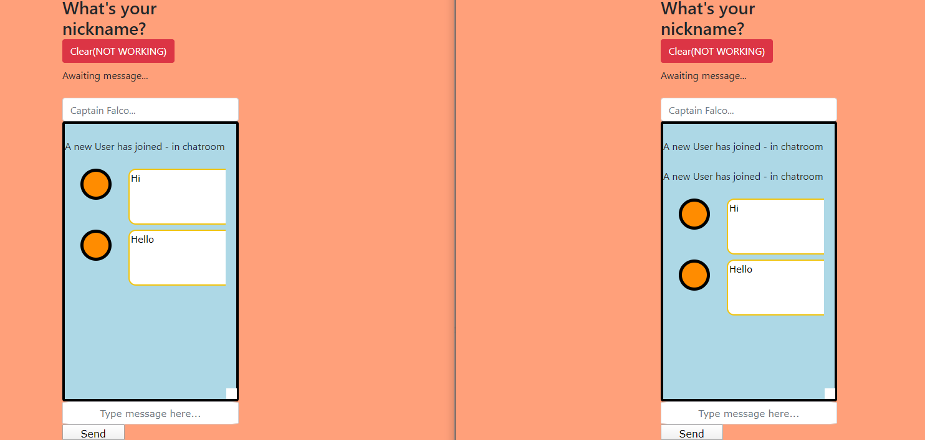

## How do the processes interact?

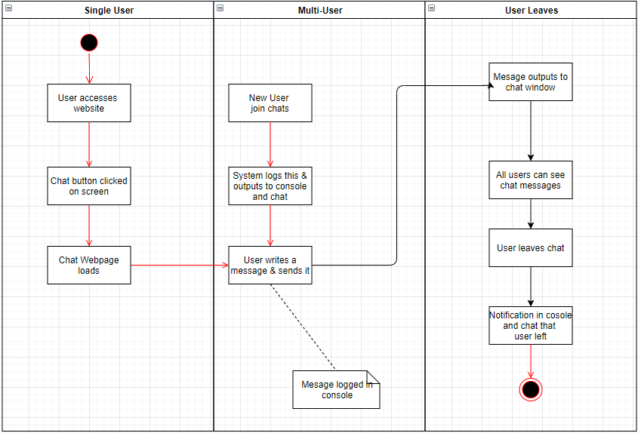There are a few processes within this project that all work as one unit. There is a function which listens for when a new user joins the chat but there is also a function which listens for when a user leaves, all of which are output to both the chat room and to the system log. This UML diagram shows this.

## 

## How are the data and code structured?

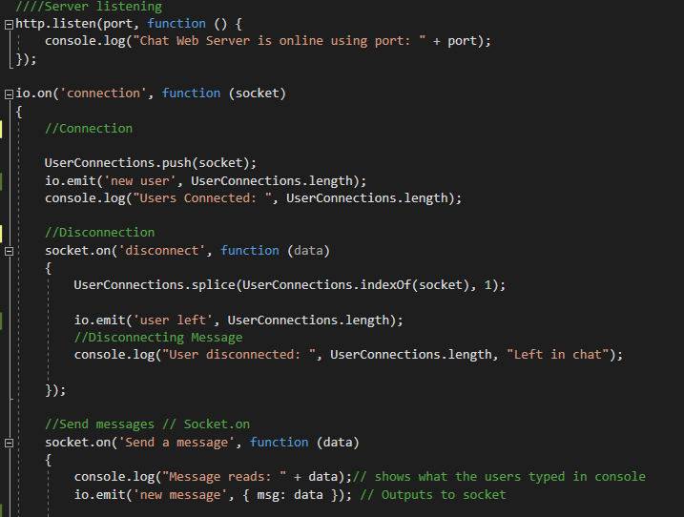The code is structed in order of relevance as this means that all functions that affect each other are grouped together. As a developer I can see what elements are used together and in what context through comments I have left myself. Here is an example of what I mean:

As all these functions are related to how the application handles the connections and disconnections of the chat room, they are grouped together to make things easier for myself when I am looking to amend or alter the information that they handle. I also have the messages of the application output to the console as this means, from an administrative point of view, I am able to see the entire conversation that all clients have and how many are in the chat: 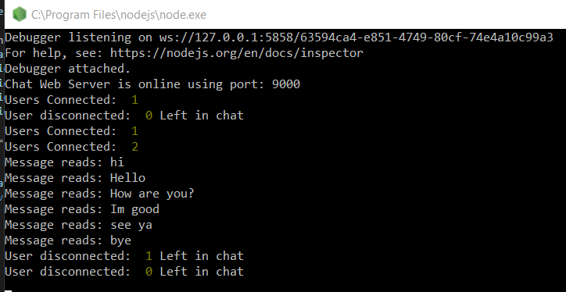

## Why are these structures appropriate?

This structure is appropriate as it means that I can look back and reference certain parts of the code and if there is an issue or error. The use of the system log as well means that if one element is outputting more than it should, I am able to see this and then deconstruct it and find out why this is happening rather than having to search the entire applications worth of code.

# Testing

## What automated testing have you performed (unit tests etc)

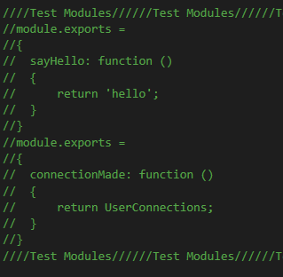In my project I had attempted to use Mocha and Chai to test my project, but these tests wouldn’t work as I had hoped. Therefore, the project does not include any tests, but I have included some screenshots of how my application affects memory within the Visual Studio environment. This was where I had started to build tests:

# DevOps Pipeline

## Describe your development environment

The development environment I used was that of Visual Studio and a mix of my own system / laptop and the computers within the University. I have not been able to set up any automated methods or functions expect the ones that run when the application is started. As this was a single person project, I didn’t need to concern myself with other developers working on my project and so by using a GitHub repository I was able to keep a track on my project and its version control.

## Describe your continuous integration pipeline and how you used it

My website’s chatroom updates the connection to the server upon each message sent. If a new user joins the chat, then this is output to all users currently connected to the chat room and from here the user will now be able to view messages that are sent / they send themselves. As stated before, as the application doesn’t use any automated tests upon loading, I have to manually check elements if they cause issues and this can lead to a lot of time being put into code analysis of my own.

# 

# Personal Reflection

## What worked well/didn’t work well in terms of your work and the technologies you used?

Firstly, the chat application can communicate with another user and so being able to use socket.io and see the chat conversation on two separate tabs made me feel a sense of achievement. This also led me to style the chat message area so it looks more user friendly and I added an icon which would have included the users avatar icon, had I had the time to ad this feature and a full user login system.

I also included a way for the system to view the entire conversation within the chat room by having the messages output to the system console. This isn’t a major feature, but it did help when I was testing to see if messages were being sent or not.

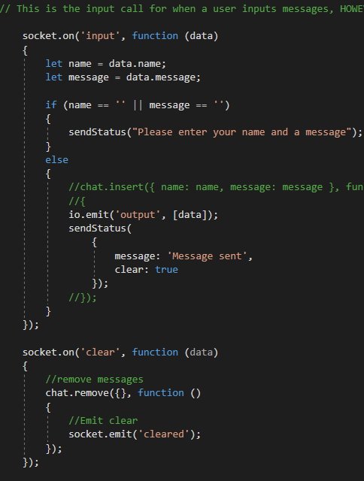As for what didn’t work well, the chat room isn’t able to take in the username of its users and there is a clear button which was designed to clear all messages from the chat message-box, but this doesn’t work either. I also wasn’t able to attach a database to store the chat messages as this feature was clashing with the connection between clients. Another issue would be that as I was ill for a portion of the project I was slow to amend the project and be able to add as much functionality I would have liked but I have included the code that I was trying to work on inside the project code to then show what I was trying to achieve:

This code was supposed to be an alternative to the connection socket call I have already got implemented as this would have been able to take the username of the client as well as their message which in turn would output at the same time.

## What lessons would you take from this project into your next project?

From this project I have learnt that there can be conflicting variables and functions that need to be double-checked before moving onto another section and this was shown whilst I was trying to fix my message outputs but had forgotten to close a function that was for the socket.

I would take the process of using sockets into my next project and I would attempt to find a work around to how I could manipulate certain aspects of the process that makes up how certain functions go together so that I would be able to produce the code a little faster and more efficiently as this project to a lot longer than I had expected given the quality of it.