Thibault Chatel

Paper Project

Parallel System 2020/2021

Work Stealing for Interactive Services to Meet Target Latency
https://www.cse.wustl.edu/~angelee/home_page/papers/steal.pdf

Introduction

This paper arises from the observation that in specific context, full parallelism can be more harmful than helpful, and presents a strategy of what we could call “controlled” parallelism.
Actually, in the case of a web service such as web search or finance, based on distributed server systems, companies want to guarantee, to as many users as possible, a response time shorter than a specified value. This promise could be compromised if we imagine that a large request monopolizes all the resources, due to full parallelism strategy, delaying all the following requests, large or not.
In front of this observation, the authors of this paper proposed a solution to sometimes deny parallelism to large request, leaving so resources available for the following ones, inspired by work-stealing.

What is classical work-stealing ?

Work-stealing refers to a scheduling policy, which aims at minimizing the makespan of a single parallel job.
To do so, we consider workers, generally one for each core, and we consider a job which can be decomposed into multiple tasks that may execute in parallel.
We introduce also the notion of deque.
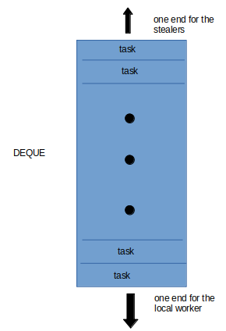
A deque is a data structure designed for storing the tasks waiting to be completed, with both ends reachable, as we see on the drawing.
Working on the job, a worker will create tasks which will be stored in its deque in a LIFO fashion considering the worker end (equivalently a FIFO fashion considering the stealers end).
If the worker has its deque not empty, it picks a task from it, from the bottom as described. If its deque is empty, it steals a task from the top of the deque of another worker, selected randomly. If the selected worker had an empty deque, the worker performs a new random steal attempt.

The advantage of this policy is that, the “excess work” of feeding an empty worker is done by the empty worker itself, without interrupting an occupied one.

The context

The context given here is the one of interactive cloud services such as web search, online gaming or finance. We consider multicore server with multiple parallelizable requests. The workload is highly parallelizable with both inter-request and intra-request parallelism. Applications expressing its logical parallelism with fork/join or parallel loops, leaving then the runtime schedule the parallel computation, mapping it to the available processing resources dynamically, are perfect candidates for this topic of research.
The focus of this paper is to optimize for target latency, meaning given a target latency, the system minimizes the number of requests whose latency (the time elapsed between the arrival of the request and its completion) exceeds this target.

Two work-stealing policies

- Steal-First
Steal-First would be the most natural policy if we were looking to exploit all the parallelism. The idea is that a worker only admit a new request if there is no more stealable work waiting in the deques of the other workers.
The weakness is that when the system is heavily loaded, a large request can delay the following ones and so we miss target latency for many requests.
- Admit-First
Opposing to the previous policy, Admit-First only steal from the other workers’ deque if the global queue is empty.
Doing so we avoid the problem of a large request delaying others but we do not fully exploit all the available fine-grain parallelism

Tail-control algorithm

Given the strengths and weaknesses of the two previous policies, the one presented in this paper is based on the idea that under heavy instantaneous load, the system must explicitly sacrifice a small number of large requests, executing them serially so they leave resources available for waiting requests which could meet the target latency. The default mode would be the Steal-First policy, to exploit the available parallelism.
The problem, for implementing such a behavior, is that request’s work in unknown at arrival and we don’t want to unnecessarily serialize large requests as doing so, these requests will certainly miss the target latency. Requests will be classified as large or not depending on a threshold, adapted by the runtime, depending on the instantaneous system load.
The tail-control work-stealing scheduling strategy is so designed to aggressively parallelize requests when the system is lightly loaded, inspired by the Steal-First policy, and when the system is momentarily overloaded, it identifies and serializes large requests.

Extending work-stealing with Tail Control

To present the scheduler we will illustrate with the help of the following drawing.
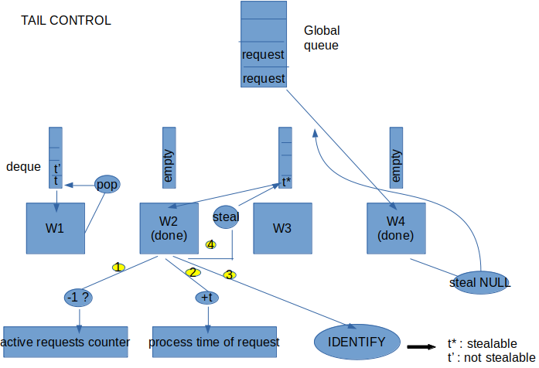
- While a worker has tasks in its deque, as it is the case for W1, it feeds itself taking the task at the bottom of its deque and processes it.
- When a worker is done with its last task and is deque is so empty, as it is the case for W2 :
- It finds out if the request at the origin of this last task, is now completed since this last task is completed. It is not necessarily the case as other tasks of this request could still be waiting in the deque of another worker. If this request is completed, then the worker decrements by 1 the global active requests counter.
- Because each worker takes care of measuring the time it took to complete the tasks belonging to a request, it increases by this amount the global process time of the request
- After that, it identifies meaning it look at the processing time of each request and with that sets them as stealable or not. In our example we see that the task t* belongs to a request stealable but not the task t’. We will detail this operation just after.
- Finally, because t* is stealable, W2 steals this task and processes it.
- It can occur that the steal attempt fails to find a stealable task like it is the case for W4. In that case, W4 feeds itself directly from the global queue, where the requests are stored waiting to be completed.

To have a better idea of the IDENTIFY operation, consider the following drawing.
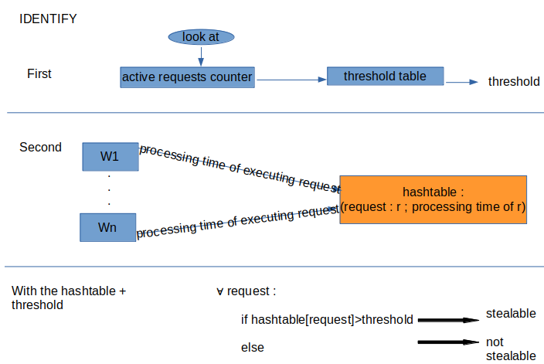

- First, what the worker responsible for the call to this operation does is to look at the global active requests counter we mentioned earlier. The worker then searches at index = the value it got from the counter, inside the threshold table (details on it in a following section) which returns the threshold quantifying if a request is considered large or not.
- Secondly, the worker builds a hashtable consisting of keys : the requests and of values : the processing time of the request. To do so, the worker asks each workers what is the processing time of their current requests and adds this with the global process time of the request we mentioned earlier.
- Now, the worker is able, for all the requests, by comparing their processing time inside the hashtable with the threshold, to declare them as stealable or not.

Experimental evaluation
We will consider these results to explain their evaluations.
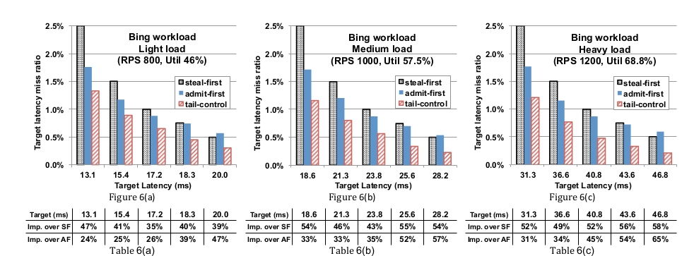
The experimental setup used to obtain these figures, consisted of a server with dual eight-core Intel Xeon 2.4Ghz processors with 64GB memory and Linux version 3.13.0. They disabled processor throttling, processor sleeping and hyper-threading.
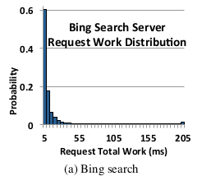
In these figures, they compared the Tail-control policy with the Steal-First and Admit-First ones. The metric is the number of requests that missed the latency target.
The work distribution for these figures is inspired by the demand that encounters a Bing search server, presented in this figure.
Within each figure, we have different target latencies, increasing as we go to the right, so that’s why the result gets better in general as we go in this direction.
What differs between the 3 figures is the rps, meaning the number of request per seconds. In fact the inter-arrival time distributions is distributed according to a Poisson distribution of mean 1/rps. The figure on the left has a light load setting whereas the one on the right has a heavy load setting.
Under each figure we can find a table precising how much better Tail-control is compared to Steal-First and Admit-First for each target latency values.

What we first see is that Tail-control out-perform both Steal-First and Admit-First in every cases. The difference is the most impressing in the context of heavy load, looking at the table 6(c). What we can also highlight is the fact that with low target latency (the left-most part of the figures) Admit-First always out-performs Steal-First. This is due to the distribution of the Bing workload, which presents a majority of very small requests but very heavy ones in comparison can occur as we see on the right of the figure for this distribution. In that case, in general even though the resources are not fully used, the Admit-First will be able to perform the small requests in the given time and will serialize the large requests, which will fail to hit target latency BUT won’t delay the others, whereas with the Steal-First policy, these very large requests will cause the problem we expected them to do and so that’s why we Admit-First is better than Steal-First for the Bing workload.

Details on the threshold table

The threshold table is a set of tuples (qt, lqt) where qt refers to a number of active requests and lqt the threshold we should consider for this number of active requests. As we saw, this threshold table is a crucial part of the IDENTIFY operation we detailed just above.
We will need the following definitions to explain how this table is computed. An instantaneous pileup refers to a short period of time when the system experiences a high load. The work distribution is represented as a set of non-overlapping bins, each bin i being associated to a probability of a request to fall in this bin : pi, and a maximum work of the requests in this bin : wi.
The main idea of the algorithm computing this table is, considering several values of threshold l, we can with a given l, get the time of a pileup phase which itself helps us knowing how much requests won’t respect the target latency. Doing so for all the qt, we can then add to the table the tuple (qt, the l that minimizes the number of misses).

First, we can easily define pl, the probability that a request will be considered large given the threshold l, pl = ∑ pi for i s.t. wi>l . We also derive from this the probability that a request will be considered small, ps = 1- pl.
The pileup start time corresponds to the time when a large request is first detected while being in the Steal-First behavior. This pileup ends when this request ends and when all the work accumulated due to this overload finished.
- The request being detected as large ran in parallel for l (the threshold) amount of work. Considering our server is made of m cores, it so first ran in parallel during l/m units of time. After that the request is serialized. Given the information of the bins, we can estimate the expected amount of work/time that is serialized per large request, being wf=∑ pi(wi-l)/pl for i s.t. wi>l . Combining both terms we have that this request executes for l/m+wf .
- For the work accumulated, let’s first consider the amount accumulated at start of the pileup. We have two terms : one for the large request, which has work l+wf. The other qt-1 requests represent an average work of (qt-1)*mean(wi). We are now left with the work due to requests that arrived during the pileup. These new requests have a utilization of U=mean(wi)*rps and will so need U cores to process. Tail-control has so m-U remaining cores to execute the already accumulated requests and it will so take
(l+wf + (qt-1)*mean(wi))/(m-U) units of time.
Finally, we get that the expected time of the pileup phase T is equal to
max{ l/m+wf , (l+wf + (qt-1)*mean(wi))/(m-U) }

Knowing the length of the pileup phase, we have rps*T requests arriving during this time, in expectation. We can also compute the expected number of large requests, being pl*(rps*T + qt-1) + 1. Pessimistically assuming that large requests always exceed the target latency we get that the number of large requests exceeding the target latency is missl= pl*(rps*T + qt-1) + 1.
We could also compute misss, the number of miss for small requests and with that we have the number of misses=missl+misss which helps us select the best value l for the threshold given we have qt active requests.

