Texas Commission on Environmental Quality

Implementation Guide

|  |  |
| --- | --- |
| VERSION: 1.0 | REVISION DATE: 10/12/2020 |

Contents

Section 1. Revision History 1

Section 2. Overview 1

2.1 Purpose 1

Section 3. How to deploy readily available WAR file? 2

Section 4. How to compile source code? 5

4.1.1 Using “Eclipse” 5

4.1.2 Using Maven 6

Section 5. How to modify property file? 7

# Revision History

| **Version** | **Date** | **Name** | **Description** |
| --- | --- | --- | --- |
| 1.0 | 10/12/2020 | Gopinadh Goduguchinta | Initial version |
|  |  |  |  |

# Overview

## Purpose

This document is the implementation guide. This describes below,

1. How to deploy readily available WAR file?
2. How to create WAR file from the source code?
3. How to modify the property file?

# How to deploy readily available WAR file?

**Steps:**

1. Get “air-dataflow-warfile.7z” file
2. Extract the “air-dataflow-warfile.7z” file

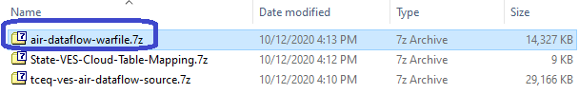

Right click on “air-dataflow-warfile.7z” file and choose “Extract Here”

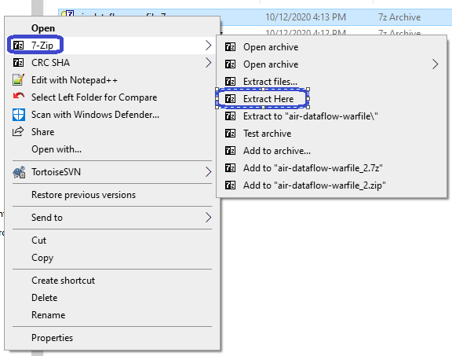

Now you have “air-dataflow.war” file.

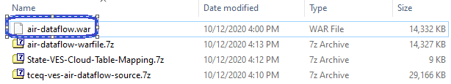

Right click on “air-dataflow.war” file and choose “Open archive”

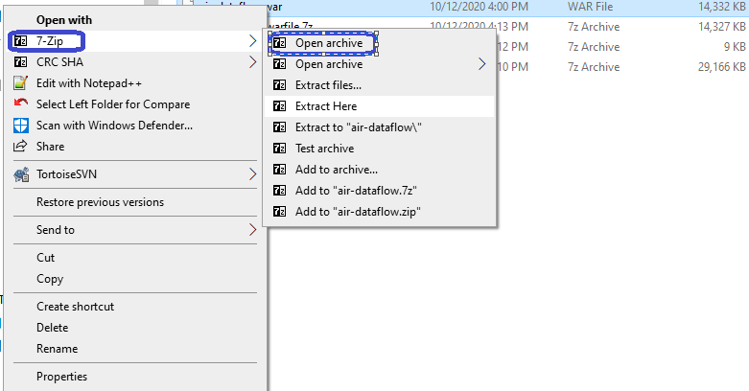

Now you see “WEB-INF” folder.



Double click on the “WEB-INF” folder then you see “classes” folder.

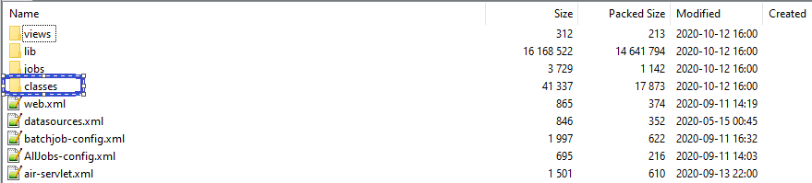

Double click on “classes” folder then you see “vesAir.properties” file.



Right click on vesAir.properties file

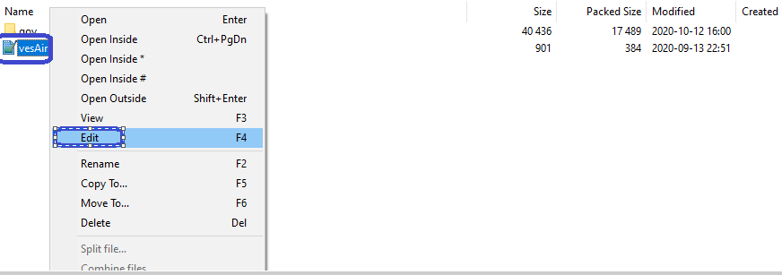

Replace your State’s/Tribe’s database details, nass account details and VES details

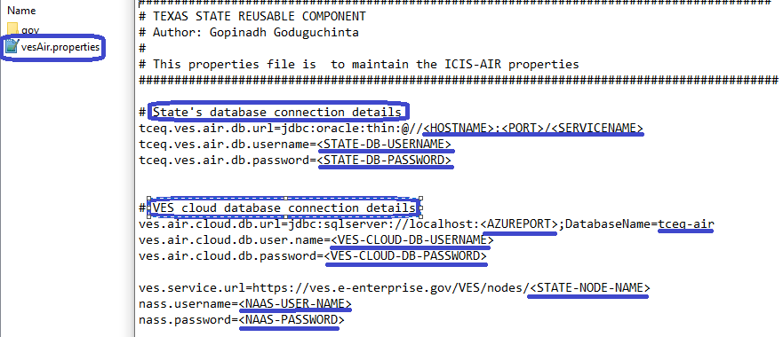

1. Deploy the updated war file into any server like Tomcat, JBOSS, WebSphere, Weblogic etc.
2. That’s it. Now you can use below URL to run the dataflow.

https://<YOUR_HOST_NAME>/<WEB-CONTEXT>/runAirDataflow

http://<YOUR_HOST_NAME>:<PORT_NUMBER>/<WEB-CONTEXT>/runAirDataflow

# How to compile source code?

# ****Using “Eclipse”****

1. Get the “tceq-ves-air-dataflow-source.7z” file.
2. Unzip/Extract the Zip file “tceq-ves-air-dataflow-source.7z” which will create a “tceq-ves-air-dataflow” folder
3. Import extracted/unzipped “tceq-ves-air-dataflow” into “Eclipse”
4. Goto “tceq-ves-air-dataflow” -> “pom.xml” like below.

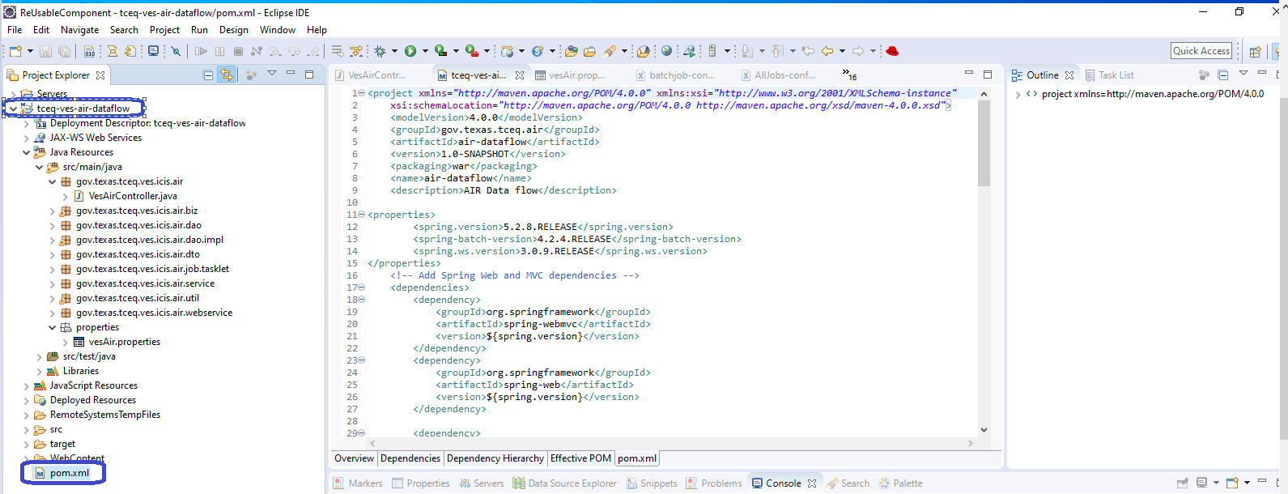

1. Right click on the “pom.xml” then goto “Run As” choose “Maven install” to create “air-dataflow.war” file.

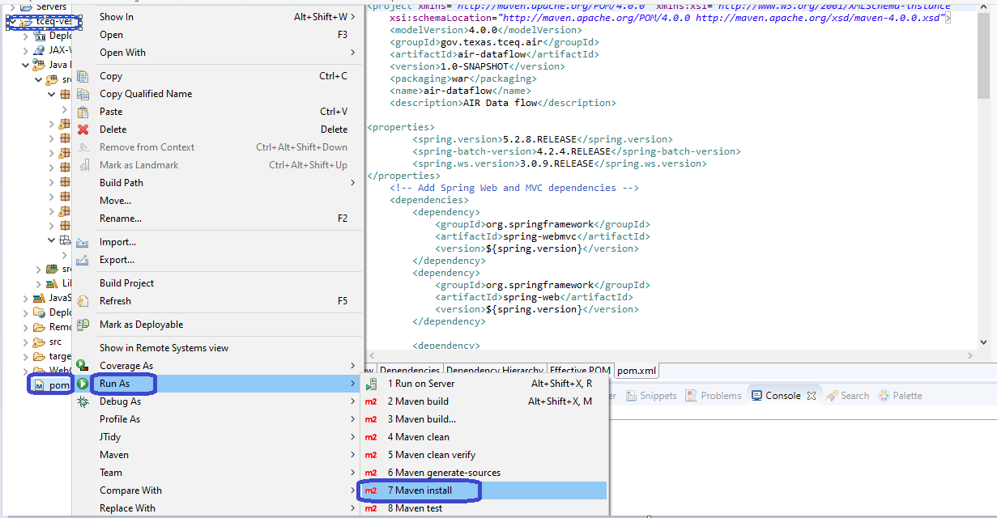

1. Now “air-dataflow.war” file is generated & ready to use. it is available in “target” folder.

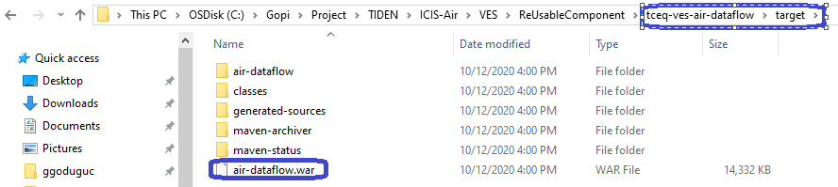

# ****Using Maven****

1. Install “Maven” if you don’t have in your system.

Example: Google “Download Maven” or go to below URL download maven <http://maven.apache.org/download.cgi>

1. Once maven installed, check if correctly installed.

Open “Command Prompt”, type “mvn -version”

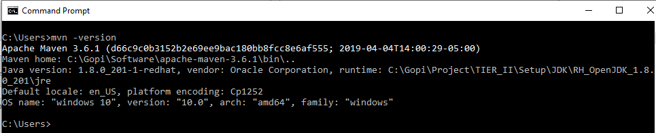

1. Get the “tceq-ves-air-dataflow-source.7z” file.
2. Unzip/Extract the Zip file “tceq-ves-air-dataflow-source.7z” which will create a “tceq-ves-air-dataflow” folder
3. Open command prompt and goto the folder where you extracted the “tceq-ves-air-dataflow” folder

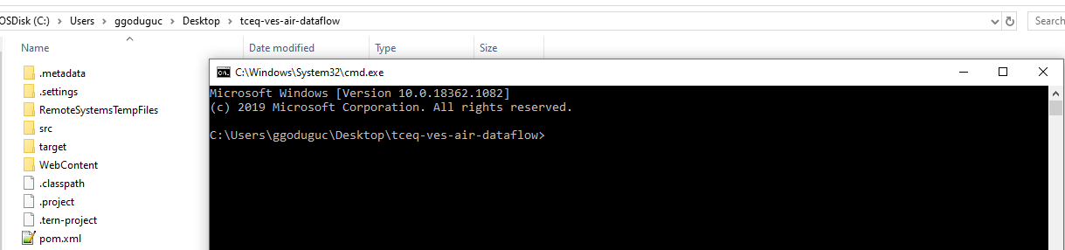

1. Type “mvn clean install” and enter on command prompt.

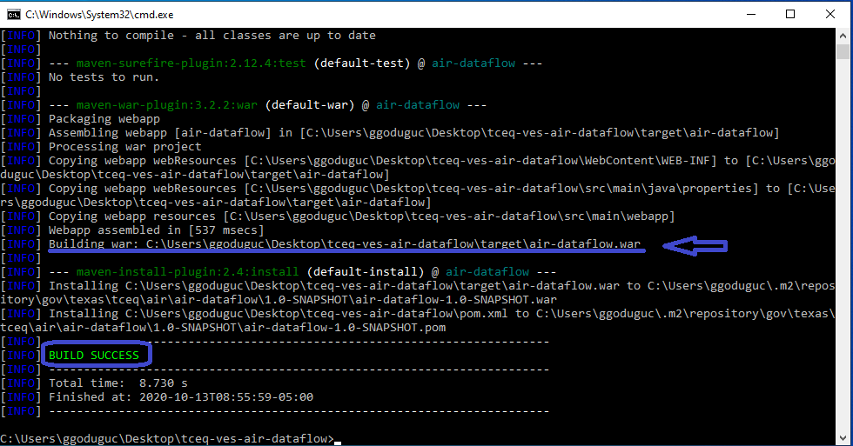

1. Now “air-dataflow.war” file is available in “tceq-ves-air-dataflow\target” folder.

# How to modify property file?

**We can modify the property file according to State’s/Tribe’s databases and VES cloud database.**

Get the “air-dataflow.war” file.



Right click on “air-dataflow.war” file and choose “Open archive”



Now you see “WEB-INF” folder.



Double click on the “WEB-INF” folder then you see “classes” folder.



Double click on “classes” folder then you see “vesAir.properties” file.



Right click on vesAir.properties file



Replace your State’s/Tribe’s database details, nass account details and VES details



1. Deploy the updated war file into any server like Tomcat, JBOSS, WebSphere, Weblogic etc.