TEXAS PROJECT DELIVERY FRAMEWORK

**FUNCTIONAL SOFTWARE  
DESIGN DESCRIPTION**



Texas Commission on Environmental Quality

**ICIS-NPDES  
Wastewater Permitting  
Dataflow**

|  |  |  |  |  |
| --- | --- | --- | --- | --- |
| VERSION: 2.3 | | REVISION DATE: 05/16/2023 | | |
| **Approver Name** | **Title** | | **Approval link** | **Date** |
| Robert Sadlier | Deputy Director,  OW, WQD | | <https://svnprd.tceq.texas.gov/svn/pmo/icis_npdes_ww_permit/Design/approval-archive/FSDD-v2.3-approvals/RS-approval-FSDD-v2.3-ICIS-NPDES-WW-dataflow.pdf> | 06/08/2023 |
| Greg Rogers | Deputy Director,  OAS, IRD | | <https://svnprd.tceq.texas.gov/svn/pmo/icis_npdes_ww_permit/Design/approval-archive/FSDD-v2.3-approvals/GR-approval-FSDD-v2.3-ICIS-NPDES-WW-dataflow.pdf> | 06/14/2023 |
| Jennifer Bowers | Section Manager,  OW, WQD, WQDSS | | <https://svnprd.tceq.texas.gov/svn/pmo/icis_npdes_ww_permit/Design/approval-archive/FSDD-v2.3-approvals/JB-approval-FSDD-v2.3-ICIS-NPDES-WW-dataflow.pdf> | 06/05/2023 |
| Kim Nguyen | Lead Subject Matter Expert,  OW, WQD, WQDSS, ITST | | <https://svnprd.tceq.texas.gov/svn/pmo/icis_npdes_ww_permit/Design/approval-archive/FSDD-v2.3-approvals/KN-approval-FSDD-v2.3-ICIS-NPDES-WW-dataflow.pdf> | 06/05/2023 |
| Patrick McSorley | Section Manager,  OAS, IRD, ESS | | <https://svnprd.tceq.texas.gov/svn/pmo/icis_npdes_ww_permit/Design/approval-archive/FSDD-v2.3-approvals/PM-approval-FSDD-v2.3-ICIS-NPDES-WW-dataflow.pdf> | 06/02/2023 |
| Mary McKelvy | Team Lead,  OAS, IRD, ESS, ADAS | | <https://svnprd.tceq.texas.gov/svn/pmo/icis_npdes_ww_permit/Design/approval-archive/FSDD-v2.3-approvals/MM-approval-FSDD-v2.3-ICIS-NPDES-WW-dataflow.pdf> | 06/01/2023 |
| Nicholas Smith | Project Manager,  OAS, IRD, ESS, ADAS | | <https://svnprd.tceq.texas.gov/svn/pmo/icis_npdes_ww_permit/Design/approval-archive/FSDD-v2.3-approvals/NS-approval-FSDD-v2.3-ICIS-NPDES-WW-dataflow.pdf> | 05/26/2023 |

Contents

Section 1. Overview 1

1.1 Purpose 1

1.2 Scope 1

Section 2. System Architecture 2

2.1 Process Overview 2

2.2 Data Processing Overview 4

Section 3. Data Dictionary 10

3.1 TCEQ Source Tables 10

3.2 TCEQ ICIS-NPDES WW Permit Tables 10

3.3 Database Modifications 10

Section 4. User Interface Design 11

4.1 User Interface Design Overview 11

4.2 User Interface 11

4.3 User Interface Navigation Hierarchy 40

4.4 User Function Categories (or Use Cases) 40

Section 5. Other Interfaces 41

Section 6. Other Design Features 42

6.1 Updates for Work Order #02 under Contract 582-22-30094 42

Section 7. Requirements Traceability Matrix 45

Section 8. References 46

Section 9. Glossary 47

Section 10. Revision History 50

Section 11. Appendices 52

# 

# Overview

## Purpose

*Describe the purpose of the Functional Software Design Description (SDD) and its intended audience.*

This Functional System Design Document (FSDD) describes the system design for the ICIS-NPDES Wastewater Permitting Data Flow implementation for the Texas Commission on Environment Quality (TCEQ) under the TIDEN Support contract (Work Order 09). The FSDD has been updated to include the system design specification details outlined in Work Order #02 under the NEIEN Support Contract 582-22-30094.

## Scope

*Describe the scope of the software to be produced.*

The goal of this system is to:

* Provide the ability to electronically submit ICIS-NPDES Facility and Permitting data to the EPA. Only “Replace” transaction types will be supported by this plug-in, except for Permit Reissuance and Permit Termination payloads which support “Change” transaction types only.
* Pre-validate data prior to submission to EPA by checking against a set of data quality guidelines identified in the FSDD.
* Construct ICIS-NPDES XML submission file(s) by pulling appropriate data from Central Registry and ARTS databases.
* Submit the ICIS-NPDES WW Permitting XML submission file(s) to EPA, retrieve the processing/error report from the CDX Node (EPA’s Node for receiving ICIS-NPDES data submission), and parse the contents of the EPA report to the TIDEN Node ICIS-NPDES WW Permit tables that track data history. This will enable TCEQ to determine if any record within a payload for a given permit number was rejected by EPA’s ICIS-NPDES system.
* Provide the ability to download EPA’s processing/error report from the TIDEN User Interface and export the status of each submitted record to CSV format for offline viewing.
* Provide the ability to re-submit an EPA Accepted or Rejected submission as a new submission if the submission has not been re-submitted already and for only the permits that had a rejected transaction.
* Provide the ability to initiate manual submissions by allowing user to enter Permit Numbers and Payloads.

This document includes the design details for the entire TIDEN ICIS-NPDES Wastewater Permitting data flow process, which includes the following:

* Design of a new TIDEN ICIS-NPDES Wastewater Permitting dataflow Management User Interface module and associated logic to allow TCEQ staff to review submissions.
* Configuration details for configuring TIDEN to include the ICIS-NPDES Wastewater Permitting data flow plug-in.
* Database objects needed to support ICIS-NPDES Wastewater Permitting Plug-in.
* TIDEN User Interface design to allow re-submission of failed data.
* TIDEN User Interface design to allow manual submission process.

# System Architecture

*Provide and describe a figure that depicts the overall system architecture.*

## Process Overview

The TIDEN ICIS-NPDES Wastewater Permitting data flow includes the components outlined in the diagram below:

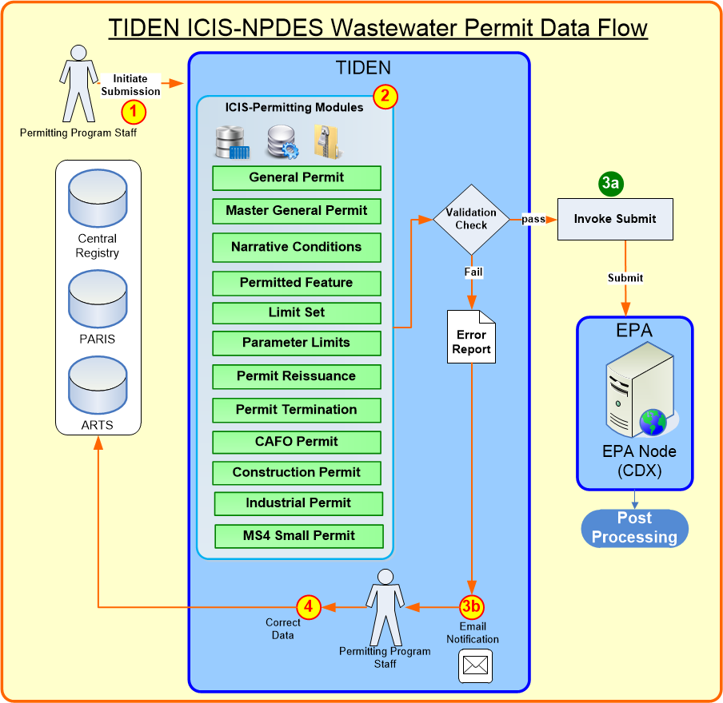

The process consists of the following steps:

1. The TCEQ ICIS-NPDES WW Permit Reporting staff logs into the TIDEN.
2. The ICIS-NPDES WW Permit plug-in consists of the following components:
   1. ICIS-NPDES WW Permit Operations: generates the ICIS-NPDES WW Permit Replace XML files. Solicit operations are configured in the TIDEN UI to support manual submissions, TIDEN UI is configured to support re-submissions, and scheduled tasks operations are configured to support automated submissions.
   2. ICIS-NPDES WW Permit UI module: allows the TCEQ staff to review the status of previous submissions, download the EPA processing/error report, select submissions for re-submission, review historical permit submission status, and manually generate a Replace XML files for submission to ICIS-NPDES.
3. Prior to the generation of the XML file, data is validated in the TIDEN database table to ensure that it passes preliminary checks.
   1. If the submission file passes the validation checks, the XML file is generated and TIDEN begins communication with EPA-CDX to submit the file. The ICIS-NPDES WW Permit plug-in proceeds to send any records that pass TIDEN data validation checks to EPA. Only the invalid records that fail TIDEN validation are excluded.

Note: After the EPA CDX Node processes the transaction and returns an EPA report, TCEQ can open the EPA report in the TIDEN ICIS-NPDES Wastewater Permitting dataflow management or in the email notification to view records that were accepted or rejected by the EPA.

* 1. TIDEN sends email notifications to WQ-TIDEN@TCEQ.TEXAS.GOV with necessary attachments as defined in Requirement 4.2.9.

1. Permitting Staff identifies the data changes needed to correct TIDEN and/or EPA errors and makes corrections to the data in the respective TCEQ databases and initiates a re-submission to resubmit the data to EPA.

A diagram illustrating Step 2 in detail is provided below.

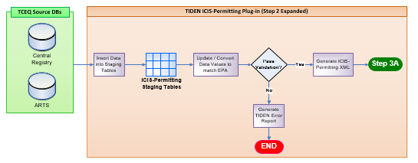

A diagram illustrating the post processing steps in detail is shown below.

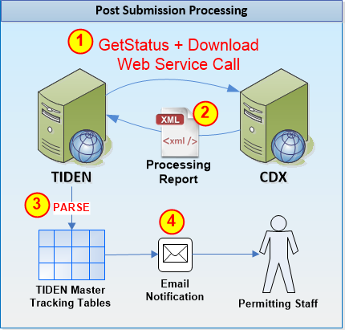

## Data Processing Overview

### Payloads

TCEQ needs to be able to initiate submissions based on the following Operations and Payloads that can be submitted under each task. NOTE: Permit Reissuance must be submitted to ICIS on or after the permit effective date. So, each General Permit type has one operation for NOI-New and NOTs and a second operation for NOI-Renewal authorizations. This allows renewal applications to be submitted to EPA on a separate schedule than the new authorizations.

|  |  | **Payload Types** | | | | | | | | | | | |
| --- | --- | --- | --- | --- | --- | --- | --- | --- | --- | --- | --- | --- | --- |
| **#** | **Operations** | General Permit | CAFO Permit | Master General Permit | SW Construction Permit | SW Industrial Permit | Limit Set | Parameter Limits | Narrative Condition Schedule | Permitted Feature | Permit Reissuance | Permit Termination | SW MS4 Small Permit |
| 1 | Master General Data |  |  | X |  |  |  |  |  |  | X | X |  |
| 2 | TXG11 Data | X |  |  |  |  | X | X | X | X |  | X |  |
| 3 | TXG11 Data_Renewal | X |  |  |  |  | X | X | X | X | X | X |  |
| 4 | TXG13 Data | X |  |  |  |  | X | X | X | X |  | X |  |
| 5 | TXG13 Data_Renewal | X |  |  |  |  | X | X | X | X | X | X |  |
| 6 | TXG31 Data | X |  |  |  |  | X | X | X | X |  | X |  |
| 7 | TXG31 Data_Renewal | X |  |  |  |  | X | X | X | X | X | X |  |
| 8 | TXG34 Data | X |  |  |  |  | X | X | X | X |  | X |  |
| 9 | TXG34 Data_Renewal | X |  |  |  |  | X | X | X | X | X | X |  |
| 10 | TXG50 Data | X |  |  |  |  | X | X | X | X |  | X |  |
| 11 | TXG50 Data_Renewal | X |  |  |  |  | X | X | X | X | X | X |  |
| 12 | TXG64 Data | X |  |  |  |  | X | X | X | X |  | X |  |
| 13 | TXG64 Data_Renewal | X |  |  |  |  | X | X | X | X | X | X |  |
| 14 | TXG67 Data | X |  |  |  |  | X | X | X | X |  | X |  |
| 15 | TXG67 Data_Renewal | X |  |  |  |  | X | X | X | X | X | X |  |
| 16 | TXG83 Data | X |  |  |  |  | X | X | X | X |  | X |  |
| 17 | TXG83 Data_Renewal | X |  |  |  |  | X | X | X | X | X | X |  |
| 18 | TXG87 Data | X |  |  |  |  |  |  | X |  |  | X |  |
| 19 | TXG87 Data_Renewal | X |  |  |  |  |  |  | X |  | X | X |  |
| 20 | TXG92 Data | X | X |  |  |  |  |  | X |  |  | X |  |
| 21 | TXG92 Data_Renewal | X | X |  |  |  |  |  | X |  | X | X |  |
| 22 | TXR04 Data | X |  |  |  |  | X | X | X | X |  | X | X |
| 23 | TXR04 Data_Renewal | X |  |  |  |  | X | X | X | X | X | X | X |
| 24 | TXR05 Data | X |  |  |  | X | X | X | X | X |  | X |  |
| 25 | TXR05 Data_Renewal | X |  |  |  | X | X | X | X | X | X | X |  |
| 26 | Submit_TXR05_FirstBatch | X |  |  |  | X | X | X | X | X |  |  |  |
| 27 | TXR15 Data | X |  |  | X |  | X | X | X | X |  | X |  |
| 28 | TXR15 Data_Renewal | X |  |  | X |  | X | X | X | X | X | X |  |
| 29 | Submit_TXR15_FirstBatch | X |  |  | X |  |  |  | X |  |  |  |  |

For each of the Payloads listed in the table above, TIDEN will submit data with “Replace” transaction type only, except for Permit Reissuance and Permit Termination payloads that can be submitted with “Change” transaction type only.

### Data Processing Logic for Automatic Submissions

TCEQ will submit a replacement data for all payloads to ICIS-NPDES WW Permit on a pre-defined basis, typically weekly.

The data processing logics for all data families is illustrated in the diagram below.

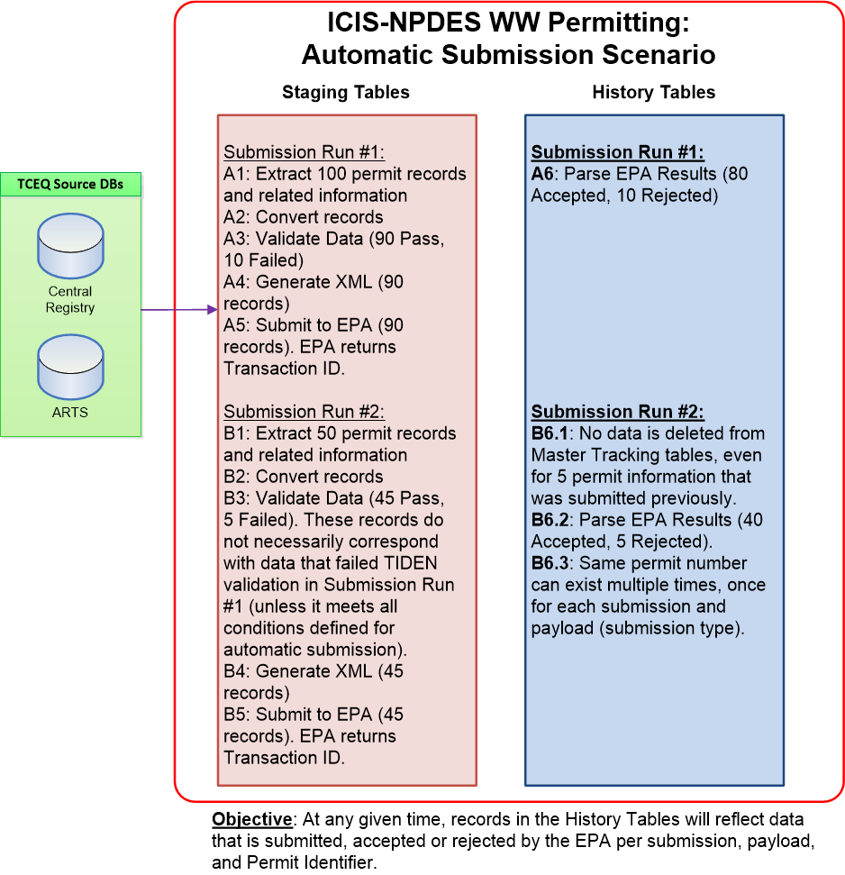

### Data Processing Logic for Re- Submissions

TCEQ will submit a replacement data for payloads to ICIS-NPDES for permits that had at least one (1) TIDEN error and/or EPA rejected transaction in the parent submission. If a re-submission contains TIDEN and/or EPA errors, the system will allow users to select the re-submission run and generate a secondary resubmission. This process is repeated until all records are successfully submitted to and accepted by EPA. The original submission, the initial re-submission, and each subsequent re-submission will be shown as separate submissions.

The data processing logics for all payloads is illustrated in the diagram below.

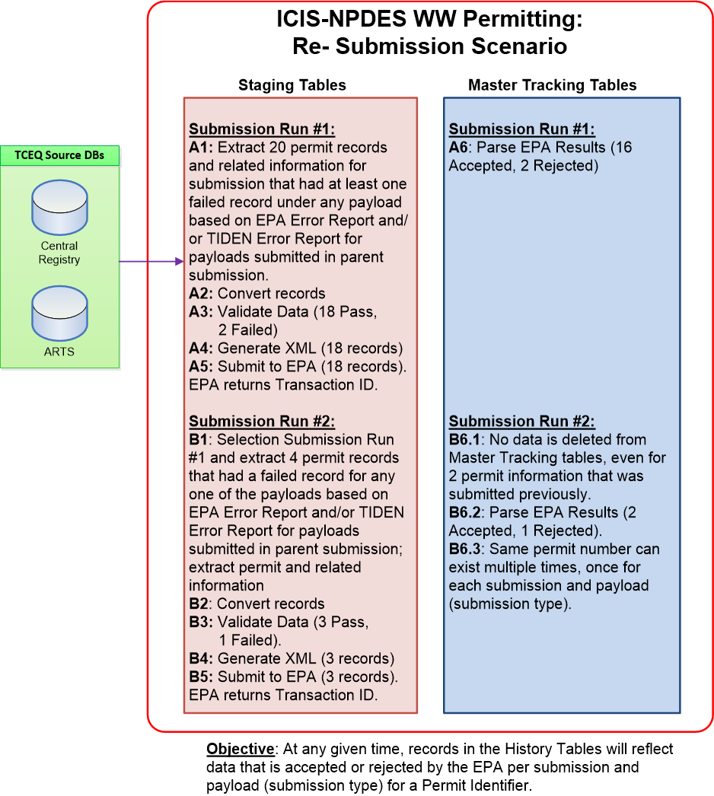

### Data Processing Logic for Manual Submissions

TCEQ will submit a replacement data for payloads designated for a permit number for a given operation only.

The data processing logics for all data families is illustrated in the diagram below.

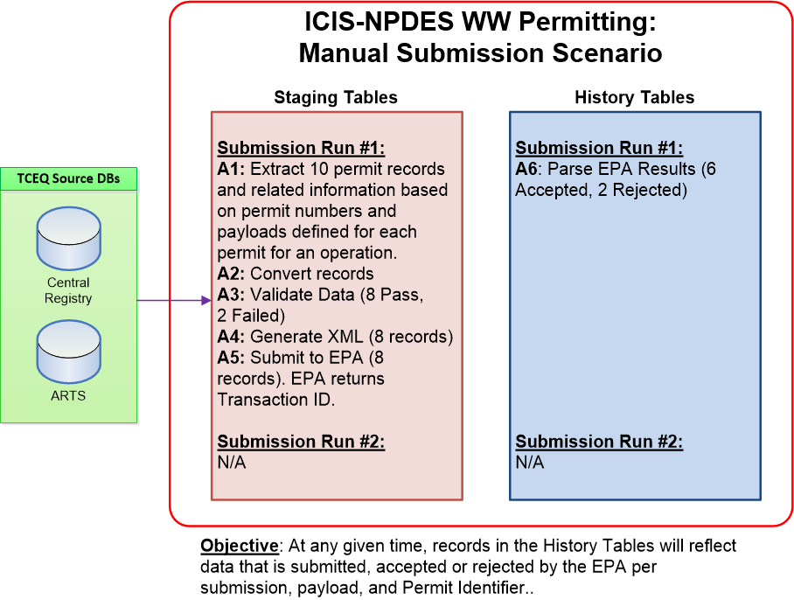

### Data Extraction Transaction Log

The following instances of transaction logs will be used to track the processing stage of the records in data extraction process from source tables for the ICIS-NPDES WW Permit data flow.

| **ID** | **Transaction Log** | **Description** |
| --- | --- | --- |
| 1 | Data Extracted and Converted | The ICIS-NPDES Wastewater Permitting data has been extracted from TCEQ’s source databases, successfully converted to EPA Codes where applicable, and inserted into the ICIS-NPDES WW Permit staging tables.  Note 1: Only certain data elements will require conversion to an EPA reference value. The data elements that will require conversion and conversion mappings for these elements are documented in the data mapping spreadsheets.  Note 2: Any record that cannot be converted to EPA Code will be captured in TIDEN Error Report. |
| 2 | Data Validation Completed | Data set passed the TIDEN ICIS-NPDES WW Permit plug-in data validation check. The database stored procedure will only validate records that are extracted and successfully converted to EPA Code as listed in #1 above.  Note: Any record that does not pass TIDEN validation will be captured in TIDEN Error Report. |
| 3 | XML Generation Completed | The XML file has been successfully generated for records that were extracted and converted to EPA Code (#1) as well as passed TIDEN validations (#2). Upon completion of the process (XML File generation), TIDEN will remove all data from Staging tables that was extracted from source database for the submission. |
| 4 | XML Generation Failed | The database stored procedure encountered an error while generating the XML file. The stored procedure will record error in Transaction Log and remove all data from Staging tables that has been extracted from source database for the submission.  Note 1: An example of this is size of a field not large enough to hold all data or some other Oracle exceptions that have not been logged before. User will view the Transaction log to review the GenXML error message. |

# Data Dictionary

*Provide a reference to the location of or provide the actual Data Dictionary Table that contains a description of each element in the software application.*

## TCEQ Source Tables

Details for the TCEQ Source Tables are included in the data mapping files.

### Central Registry (CR) database

ER-Diagram for CR database is attached below.



### ARTS database

ER-Diagram for ARTS database is attached below.



## TCEQ ICIS-NPDES WW Permit Tables

Data Dictionary will be provided after implementation.

## Database Modifications

As confirmed with TCEQ previously, database design will be confirmed in Admin or User Guide instead; or within the SDD (this document) upon delivery of complete package to TCEQ’s UTE environment.

The following new database objects will be created to support the ICIS-NPDES Wastewater Permitting dataflow:

* **ICIS-NPDES WW Permit Staging tables:** temporary storage of Central Registry and ARTS data for generating the ICIS-NPDES WW Permit XML submission file.
* **ICIS-NPDES WW Permit Submission History table:** Used to keep track of data that is accepted or rejected by EPA. These tables will store information displayed to user in History tab, specifically permit identifier, payload, and accepted or rejected status.
* **ICIS-NPDES WW Permit Submission Procedures:** Stored procedures used to pull data from ICIS-NPDES WW Permit staging tables and generate the ICIS-NPDES WW Permit XML submission files

1. **ICIS-NPDES WW Permit Staging Table Structure for Permitting data:**

The latest set of ER-Diagrams for ICIS-NPDES Wastewater Permitting data Staging table Structure can be downloaded from https://svnprd.tceq.texas.gov/svn/pmo/icis_npdes_ww_permit/DataMapping/ER-Diagrams/

1. **ICIS-NPDES WW Permit History Table Structure:**

Table structure for History table will be defined during project implementation.

# User Interface Design

## User Interface Design Overview

*Provide a high-level description of the user interface for this software application. Describe any systems requirements (e.g., performance or usability) associated with all of the user interfaces.*

In order to support this new data flow, several items within TIDEN will need to be initially configured. This section identifies those configuration steps:

## User Interface

*Provide and describe a diagram of the navigation hierarchy that illustrates how a user moves through the user interface.*

### ICIS-NPDES WW Permit Module

The ICIS-NPDES WW Permit module will provide a comprehensive interface to track the status and results of the TIDEN ICIS-NPDES WW Permit submissions. In addition, WQD staff may manually generate, download, and submit the ICIS-NPDES WW Permit XML Replace submission file from this module.

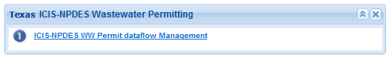

The ICIS-NPDES WW Permit module will consist of 2 tabs:

1. **Summary Tab:** Provides an overview of all ICIS-NPDES WW Permit submission. The TIDEN user can download the submission file (in XML or Excel format), TIDEN error report (if available), and download the EPA processing report from this screen. User can also initiate Manual and Re-submission processes from this screen.

The records shown in the summary table will be colored as follows:

* Pending – Yellow (may appear green depending on your screen settings)
* Completed – White
* Error – Orange
* Failed – Red
* Transfer Failed – Red

Descriptions of the possible status values are provided below:

* Pending: The ICIS-NPDES WW Permit XML submission file was submitted to the EPA-CDX Node, and CDX returned a Transaction ID to indicate that it received the file.
* Transfer Failed: The TIDEN attempted to submit the ICIS-NPDES WW Permit XML submission file to the EPA-CDX Node but did not receive a Transaction ID value from CDX.
* Failed: CDX received the XML submission file from the TIDEN, but failed to process the file due to significant errors (i.e., the submission file is not compliant with the ICIS-NPDES WW Permit schema structure, submission file contains viruses, user is not authorized to submit the schema, et cetera).*
* Completed: EPA finished processing the ICIS-NPDES WW Permit submission file and all records were accepted and there are no TIDEN errors.*
* Errors: EPA finished processing the ICIS-NPDES WW Permit submission file at least one record was rejected and/or there are TIDEN errors.*

* Permitting Staff may download the EPA Report to view the records that were accepted or rejected from ICIS-NPDES; and/or reasons for rejecting the submission file. For details on EPA Report format, please refer to section 4.2.8 of the document.

Columns that are displayed in this tab are as follows:

* View: allows user to download submission file data in Excel format. Each tab within the excel represents different payloads submitted under the operation. All tabs are listed in excel regardless of payloads submitted under the operation.
* Submission: lists file name for the submission file. This name is generated as concatenation of operation name, followed by an underscore, and finally Node Transaction ID.
* Method: lists method of generating submission file, which can be “MANUAL”, “AUTOMATIC”, “RENEWAL”, or “RESUBMIT” for manual, automatic, renewals, and re-submissions, respectively.
* Status: lists current submission status.
* TIDEN Error Report: icon to download TIDEN Error Report in Excel format. The icon is displayed and available only when one or more error(s) is(are) captured in TIDEN data validation. For details on format of the file, please refer to section 4.2.7.
* EPA Errors?: lists “Y” (Yes) if there are any transactions rejected in submission to EPA. Otherwise, column value is set to “N” (No). Column value is populated when report is received from CDX (i.e., submission status is not Pending or Transfer Failed).
* EPA Report: icon to download EPA Report. The icon is displayed when report is received from CDX (i.e., submission status is not Pending or Transfer Failed). For details on EPA Report, please refer to section 4.2.8.
* Creation Date: date when submission is generated.
* Submit Date: date when submission is submitted to CDX. This date is populated for all submission statuses except Transfer Failed.
* Original Transaction ID: ID corresponding to Node Transaction ID that the submission originated from.
* Node Transaction ID: ID to uniquely identify a submission generated in TIDEN. This is neither equivalent nor represents EPA Transaction ID.
* EPA Transaction ID: EPA ID used to uniquely identify a successfully submission to EPA. This ID is populated upon receipt from (i.e., submission status is not Pending or Transfer Failed).
* Size: lists submission file size (zipped XML).

Columns are displayed in the order listed above where a checkbox option (to select the submission for re-submit) will be available to the left of each row.

Additionally, user needs to be able to search for historical submissions based on following set of parameters:

* Creation Date Range: search for submissions based on when submission is created in the system. If only the End Date is defined, then system will return all submissions that were created on or before the End Date. Alternatively, if only the Start Date is defined, then system will return all submissions that were created on or after the Start Date. If neither are defined, then TIDEN will not use Creation Date Range as criteria to filter submissions.
* Submit Date Range: search for submissions based on when submission is submitted to EPA. Therefore, submissions in Transfer Failed status are automatically filtered with definition of this search criterion. If only the End Date is defined, then system will return all submissions that were submitted on or before the End Date. Alternatively, if only the Start Date is defined, then system will return all submissions that were submitted on or after the Start Date. If neither are defined, then TIDEN will not use Submission Date Range as criteria to filter submissions.
* EPA Transaction ID: filter submissions based on EPA Transaction ID returned when a submission is successfully made to CDX. Therefore, submissions in Transfer Failed status are automatically filtered with definition of this search criterion.
* Node Transaction ID: filter submissions based on Node Transaction ID generated in TIDEN to uniquely identify each submission.
* Status: filter submissions based on current status of the submission.

Note: Status of “Action Pending” will filter all submissions in Error, Failed, or Transfer Failed

* Document Name: filter submissions based on name of the submission file. This will be a wildcard search at the beginning and end. In other words, if submission file name is IP_CAFO_20160817, then system will return this submission record when user searches for “CAFO” using this search parameter.
* Original Transaction ID: filter submissions based on the Transaction ID that are displayed in the Original Transaction ID.

Upon opening this tab, TIDEN will automatically filter transactions to show the following status in this order: Errors, Transfer Failed, Failed, then by Submit Date descending. User defined filter results will be displayed in chronological order by Submit Date descending (from recent to oldest).

A screenshot of the Summary Tab is shown below:

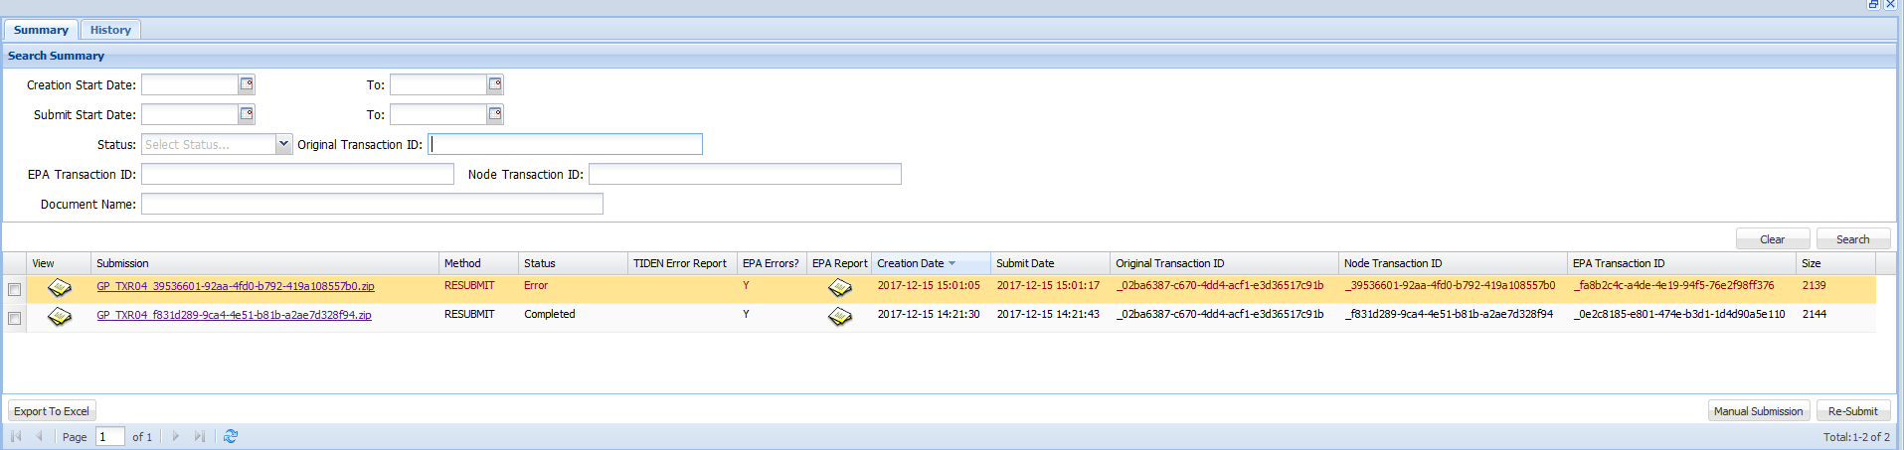

1. **History Tab:** Displays list of permits that were submitted to EPA in a submission and whether all submitted records for a payload for the permit are accepted or rejected by EPA.

Below is a screenshot of the History Tab:

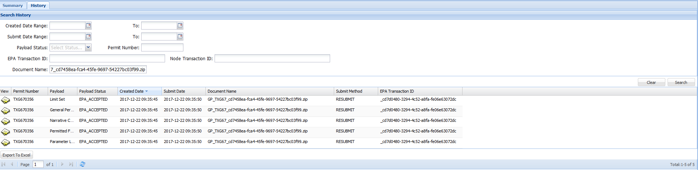

The tab will have the following columns in this order: View, Permit Number, Payload, Payload Status, Create Date, Submit Date, Document Name, Submit Method, and EPA Transaction ID. TIDEN will initially display transactions in chronological order by Submit Date descending (from recent to oldest). Filter results will be displayed in the same manner.

Additionally, user can search for historical submissions based on following set of parameters:

* Creation Date Range: search for submissions based on when submission is created in the system. If only the End Date is defined, then system will return all submissions that were created on or before the End Date. Alternatively, if only the Start Date is defined, then system will return all submissions that were created on or after the Start Date. If neither are defined, then TIDEN will not use Creation Date Range as criteria to filter submissions.
* Submit Date Range: search for submissions based on when submission is submitted to EPA. If only the End Date is defined, then system will return all submissions that were submitted on or before the End Date. Alternatively, if only the Start Date is defined, then system will return all submissions that were submitted on or after the Start Date. If neither are defined, then TIDEN will not use Submission Date Range as criteria to filter submissions.
* Payload Status: filter data based on Payload Status column. Options available are “GENERATED”, “EPA_ACCEPTED”, and “EPA_REJECTED”.
* Permit Number: filter submissions based on Permit Identifier submitted to EPA.
* EPA Transaction ID: filter submissions based on EPA Transaction ID returned when a submission is successfully made to CDX.
* Node Transaction ID: filter submissions based on Node Transaction ID generated in TIDEN to uniquely identify each submission.
* Document Name: filter submissions based on Operations applicable to the submission file that permit is submitted in. This will be a wildcard search at beginning and end. In other words, if submission file name is IP_CAFO_20160817, then system will return this submission record when user searches for “CAFO” using this search parameter.

### ICIS-NPDES WW Permit Domains and Operations

The ICIS-NPDES WW Permit plug-in will use solicit or submit operations to submit data to ICIS-NPDES. The solicit operations will support manual submissions, and the submit operations will support automatic submissions. In general, Solicit, Submit, and Re-Submit operations will perform the following actions:

1. Solicit information from source databases that meet the data mapping criteria.
2. Validate the data. Any TIDEN errors encountered will be captured in TIDEN Error Report.
3. Generate submission file for all records that pass TIDEN validation.
4. Submit generated submission file to EPA.
5. Send email notification with necessary attachments as defined in Requirement 4.2.9.

Descriptions of the Domains and Operations that will be configured for the ICIS-NPDES WW Permit plug-in are identified below:

1. **Create an ICIS-NPDES WW Permit Domain:** A Domain is a logical grouping of operations. A new domain called ICIS-NPDES WW Permit will be defined in the Node Domain module to manage the ICIS-NPDES Wastewater Permitting dataflow operations. NOTE: TCEQ has an existing TIDEN ICIS-NPDES domain for compliance and enforcement data transfer. This project will create a separate domain and user interface. Access to each domain should be exclusive. In other words, TIDEN should have a separate module / web part that will allow TIDEN Admin to configure access to ICIS-NPDES WW Permit data and submissions apart from other modules / web parts.

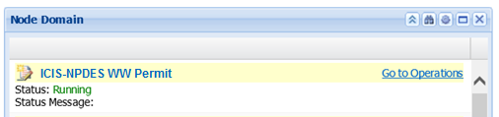

1. **Create the following Solicit Operations:**

| **#** | **Solicit Task Name** | **Processes Executed** |
| --- | --- | --- |
| 1 | Solicit_MasterGeneralData | Master General |
| 2 | Solicit_TXG11Data | TXG11 Concrete Batch GP Authorization |
| 3 | Solicit_TXG13Data | TXG13 Aquaculture GP Authorization |
| 4 | Solicit_TXG31Data | TXG31 TPDES Oil and Gas Extraction GP Authorization |
| 5 | Solicit_TXG34Data | TXG34 Petroleum Bulk Stations and Terminal Authorization |
| 6 | Solicit_TXG50Data | TXG50 John Graves Scenic Riverway GP Authorization |
| 7 | Solicit_TXG64Data | TXG64 Water Treatment Plant GP Authorization |
| 8 | Solicit_TXG67Data | TXG67 Hydrostatic Test Water GP Authorization |
| 9 | Solicit_TXG83Data | TXG83 Petroleum Contaminated Waters GP Authorization |
| 10 | Solicit_TXG87Data | TXG87 Pesticide GP Authorization |
| 11 | Solicit_TXG92Data | TXG92 CAFO GP Authorization (TPDES only) |
| 12 | Solicit_TXR04Data | TXR04 MS4 GP Authorization |
| 13 | Solicit_TXR05Data | TXR05 Multi-Sector GP Authorization |
| 14 | Solicit_TXR15Data | TXR15 Construction GP Authorization |

1. **Create the following Submit Operations:**

| **#** | **Submit Task Name** | **Processes Executed** |
| --- | --- | --- |
| 1 | Submit_MasterGeneralData | Master General |
| 2 | Submit_TXG11Data | TXG11 Concrete Batch GP Authorization (NOI-New and NOT) |
| 3 | Submit_TXG11Data_Renewal | TXG11 Concrete Batch GP Authorization (NOI-Renewal) |
| 4 | Submit_TXG13Data | TXG13 Aquaculture GP Authorization (NOI-New and NOT) |
| 5 | Submit_TXG13Data_Renewal | TXG13 Aquaculture GP Authorization (NOI-Renewal) |
| 6 | Submit_TXG31Data | TXG31 TPDES Oil and Gas Extraction GP Authorization (NOI-New and NOT) |
| 7 | Submit_TXG31Data_Renewal | TXG31 TPDES Oil and Gas Extraction GP Authorization (NOI-Renewal) |
| 8 | Submit_TXG34Data | TXG34 Petroleum Bulk GP Authorizations (NOI-New and NOT) |
| 9 | Submit_TXG34Data_Renewal | TXG34 Petroleum Bulk GP Authorizations (NOI-Renewal) |
| 10 | Submit_TXG50Data | TXG50 John Graves Scenic Riverway GP Authorization (NOI-New and NOT) |
| 11 | Submit_TXG50Data_Renewal | TXG50 John Graves Scenic Riverway GP Authorization (NOI-Renewal) |
| 12 | Submit_TXG64Data | TXG64 Water Treatment Plant GP (NOI-New and NOT) |
| 13 | Submit_TXG64Data_Renewal | TXG64 Water Treatment Plant GP (NOI-Renewal) |
| 14 | Submit_TXG67Data | TXG67 Hydrostatic Test Water GP Authorization (NOI-New and NOT) |
| 15 | Submit_TXG67Data_Renewal | TXG67 Hydrostatic Test Water GP Authorization (NOI-Renewal) |
| 16 | Submit_TXG83Data | TXG83 Petroleum Contaminated Waters GP Authorization (NOI-New and NOT) |
| 17 | Submit_TXG83Data_Renewal | TXG83 Petroleum Contaminated Waters GP Authorization (NOI-Renewal) |
| 18 | Submit_TXG87Data | TXG87 Pesticide GP Authorization (NOI-New and NOT) |
| 19 | Submit_TXG87Data_Renewal | TXG87 Pesticide GP Authorization (NOI-Renewal) |
| 20 | Submit_TXG92Data | TXG92 CAFO GP Authorization (TPDES only) (NOI-New and NOT) |
| 21 | Submit_TXG92Data_Renewal | TXG92 CAFO GP Authorization (TPDES only) (NOI-Renewal) |
| 22 | Submit_TXR04Data | TXR04 MS4 GP Authorization (NOI-New and NOT) |
| 23 | Submit_TXR04Data_Renewal | TXR04 MS4 GP Authorization (NOI-Renewal) |
| 24 | Submit_TXR05Data | TXR05 Multi-Sector GP Authorization (NOI-New and NOT) |
| 25 | Submit_TXR05Data_Renewal | TXR05 Multi-Sector GP Authorization (NOI-Renewal) |
| 26 | Submit_TXR05_FirstBatch | TXR05 Multi-Sector GP Authorizations (NOI-New) for First Batch submission |
| 27 | Submit_TXR15Data | TXR15 Construction GP Authorization (NOI-New and NOT) |
| 28 | Submit_TXR15Data_Renewal | TXR15 Construction GP Authorization (NOI-Renewal) |
| 29 | Submit_TXR15_FirstBatch | TXR15 Construction GP Authorization (NOI-New) for First Batch submission |

1. **Create ReSubmitICISNPDESWWData Scheduled Task Operation:** A scheduled task operation called “ReSubmitICISNPDESWWData” will be configured in the TIDEN to re-submit permit data that had at least one (1) rejected transaction in parent submission to the EPA or one (1) TIDEN error.
2. **Create GetICISNPDESWWProcessingReport Scheduled Task Operation:** A scheduled task operation called “GetICISNPDESWWProcessingReport” will be configured in the TIDEN to retrieve the submission processing report from the EPA. The GetICISNPDESWWProcessingReport operation will perform the following actions:
3. Invoke a GetStatus call to the CDX Node
4. If CDX returns a status of “Completed” or “Failed”, the task will invoke a Download web service call to retrieve the processing/error report from EPA.
5. Email the EPA processing report to the email addresses specified in the EmailTo parameter.
6. Call the SP_ICISNPDESWW_PARSE_EPA_RPT stored procedure to parse EPA’s processing results into the Master Tracking tables in the TIDEN database.

### Manual Submission

The manual submission process will be used to send user defined data for a specific permit or authorization on demand (ie. whenever the user needs to send data for a specific permit or list of permits). The manual submission will be used to send permit information from Notices of Change and when an ePermits failure occurs. However, it can also be used to send permit information from Notices of Intent (new and renewal) and Notices of Terminations. The steps to run a manual submission are described below:

* 1. Login to the TIDEN application and navigate to the Node 2.0 tab.

Screenshot of Tiden links

* 1. Click on the “ICIS-NPDES WW Permit dataflow Management” link under the Favorite Links web part.



* 1. Click on the “Manual Submission” button.
  2. Upon clicking on the “Manual Submission” button, TIDEN will display a pop-up window to enable the user to select the solicit operation. The user selects the appropriate solicit operation from the dropdown. The list of manual submission operations are defined in Section 4.2.2.2.

Below is a screenshot of the Manual Submission screen.

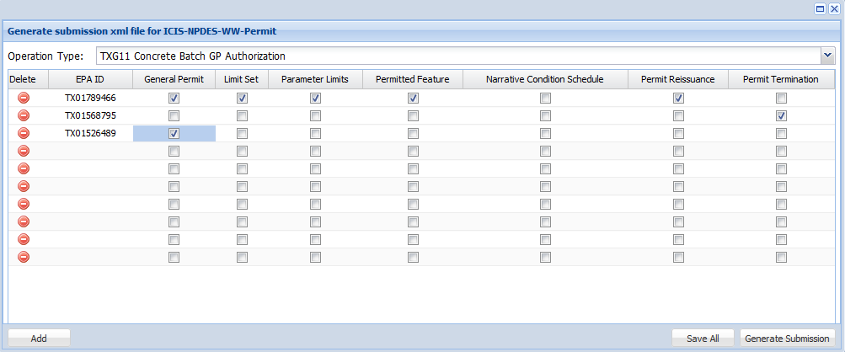

* 1. TIDEN will initially create 10 blank rows. The user can click on “Add” button to add 10 additional rows as needed. Unused rows do not need to be deleted prior to saving or generating submission. The user enters Permit Identifier on the EPA ID column and selects the applicable payloads that need to be submitted for the Permit Identifier. List of Payloads is filtered based on Operation as identified in section 2.2.1. The system will allow the user to enter multiple permit identifiers, each with its selected payloads. TIDEN will allow the user to save all entries for that operation and exit the system. The user can navigate to the operation and add additional entries to the entries previously saved. Multiple operations at a time can have saved lists, but there can only be one saved list per operation (i.e., Operation type of “TXR04 MS4 GP Authorization” and “TXG11 Concrete Batch GP Authorization” can both have saved lists at the same time, but there can only be one saved list for operation type of “TXG11 Concrete Batch GP Authorization” at a time).
  2. When ready, user can click on “Generate Submission” button for TIDEN to generate a submission file and submit it to the EPA.
  3. TIDEN will get data from source databases into Staging tables for Permit Numbers and Payloads defined for the operation in manual submission process. When TIDEN initiates solicit from source databases, the system will remove WQD User-defined permit numbers and payloads from operation’s manual submission page to prevent re-submission of same data set.
  4. TIDEN will execute TIDEN Validation Checks and capture errors in TIDEN Error Report.
  5. All records that pass TIDEN validation are used to generate the submission file to EPA.
  6. The submission file will be submitted to EPA even if one or more records within the submission fail TIDEN validation.
  7. Email notification will be sent to necessary individuals with applicable attachments as defined in Requirement 4.2.9.
  8. The transaction will be populated in the Summary tab with a status of Pending.
  9. The TIDEN GetICISNPDESWWProcessingReport task downloads the processing report from EPA and parses report results into master tracking tables. Upon parsing the results, submission statistics (accepted and rejected transactions) will be displayed in History tab, and the EPA report will be available for download in the Summary Tab.
  10. The submission status on the Summary Tab will be updated to Error, Completed, or Failed.
  11. Email notification will be sent to necessary individuals with applicable attachments as defined in Requirement 4.2.9.

Please note that:

* + 1. If an error is encountered in submission file generation process, then permit numbers and payload relation defined for the operation will not be available for the user to re-initiate a manual submission for the same data set.
    2. WQD User will not have ability to copy and paste Permit Number and Payload relation from a historical submission record.

### Automatic Submissions

The automatic submission process will be used to send permit data when an NOI or NOT are approved in IDA-ARTS. The automatic submission process initiates the dataflow process at a recurring frequency set by the WQD user. For each general permit, there will be two automatic submission operations: one for new NOIs and NOTs and a second one for NOI Renewals. The automatic submission process extracts permit records when an NOI, NOI-Renewal, or NOT was approved since the last run date for that operation. The list of automatic submission operations is defined in Section 4.2.2.3.

Note: Due to EPA business rule for batch submissions, Renewal operations must be scheduled on or after the 1st day of the next month to avoid EPA rejections.

Steps to configure the automatic submission frequency for each operation are provided below:

1. Login to the TIDEN application and navigate to the Node 2.0 tab.

Screenshot of Node Domain window and links

1. Under the Node Domain window, find the “ICIS-NPDES WW Permit” domain and click on the “Go to Operations” link.



1. Click the Edit icon for the “Submit_TXG11Data” operation.

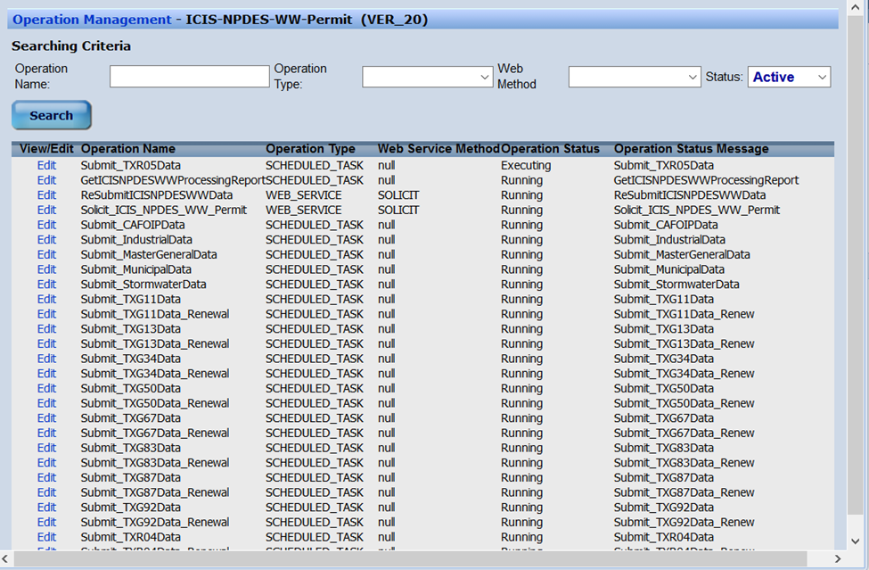

1. Scroll down to the Scheduling section, and select the “Weeks” option from the “Type” dropdown list.

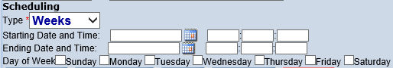

1. Define the task’s active date range by populating the “Starting Date and Time” and “Ending Date and Time” parameters. As depicted below, the scheduled task will remain active from 8/1/2016 to 7/31/2018

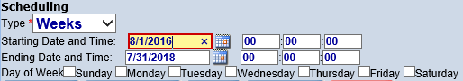

1. Identify the day that the task will be run by specifying values for the “Day of Week” parameter. As shown below, the task will run every Saturday starting 8/1/2016 until 7/31/2018.

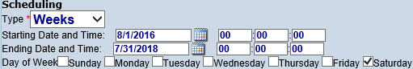

Please note that steps defined above are demonstrated for “Submit_TXG11Data” only but are applicable to all Submit operations generated for ICIS-NPDES Wastewater Permitting data submission process. Scheduling Type options available in TIDEN by default are as follows:

| **Type** | **Parameter** | **Comments** |
| --- | --- | --- |
| Inactive |  | Indicates that operation is not current defined to run automatically |
| Once | Start Date and Time | Operation is executed at date and time defined If date and time is in the past, then operation is executed immediately |
| Seconds | Start Date and Time | Operation is executed after date and time defined |
| Ending Date and Time | Operation is stopped from execution after date and time defined |
| Interval | Time period (in seconds) to execute each subsequent run |
| Days | Start Date and Time | Operation is executed after date and time defined |
| Ending Date and Time | Operation is stopped from execution after date and time defined |
| Interval | Time period (in days) to execute each subsequent run |
| Weeks | Start Date and Time | Operation is executed after date and time defined |
| Ending Date and Time | Operation is stopped from execution after date and time defined |
| Day of Week | Days of week (M-S) when operation should be executed |
| Months | Start Date and Time | Operation is executed after date and time defined |
| Ending Date and Time | Operation is stopped from execution after date and time defined |
| Day of Month | Day of month (1-31 as applicable) when operation should be executed |
| Years | Start Date and Time | Operation is executed after date and time defined |
| Ending Date and Time | Operation is stopped from execution after date and time defined |
| Day of Month | Day of month (1-31 as applicable) when operation should be executed |
| Month of Year | Month in annual calendar (1-12) when operation should be executed |

Finally, note that automatic submission process is designed as follows:

1. Get data from source databases into Staging tables based on conditions defined in the Data Mapping document. If no permits were approved or terminated since the last automatic operation run date/time, then no submission file will be generated and process will terminate.
2. Execute TIDEN Validation Checks and capture errors in TIDEN Error Report.
3. All records that pass TIDEN validation are used to generate the submission file to EPA.
4. The submission file will be submitted to EPA even if one or more records within the submission fail TIDEN validation.
5. Email notification will be sent to necessary individuals with applicable attachments as defined in Requirement 4.2.9.
6. The transaction will be populated in the Summary tab with a status of Pending.
7. The TIDEN GetICISNPDESWWProcessingReport task downloads the processing report from EPA and parses report results into master tracking tables. Upon parsing the results, submission statistics (accepted and rejected transactions for each permit identifier and payload) will be displayed in History tab, and the EPA report will be available for download in the Summary tab.
8. The Submission status on the Summary tab will be updated to Errors, Completed, or Failed.
9. Email will be sent to necessary individuals with applicable attachments as defined in Requirement 4.2.9.

Authorizations for MSGP (SWD) and CGP (SWC) have never been entered into ICIS. Active authorizations must be initially submitted to and accepted by ICIS-NPDES so that future permit actions on these permits are accepted by EPA (i.e., renewal, changes to existing authorizations, and termination).

1. First batch submissions entail the following requirements:

a. For “Submit_TXR05_FirstBatch” and “Submit_TXR15_FirstBatch”, the TIDEN will generate and submit all active authorizations as a first batch submission.

b. Do not include any PermitReissuance or PermitTermination payloads (any permit with last RT_LGLS.LGL_TYP_CD = "NOI-RENEWAL", "WAIVER-RENEWAL" should be treated as "NOTICE OF INTENT" or "WAIVER").

c. Using current authorization details (physical attribute doesn't have end date - RT_PHYS_ATTRS.PHYS_ATTR_END_DT is null).

d. For “Submit_TXR05_FirstBatch”, use System Date instead of the permit effective date to calculate the following dates:

i. LimitSetStatusStartDate

ii. InitialMonitoringDate

iii. InitialDMRDueDate

iv. LimitStartDate

e. The system will allow a large volume of data to be generated, extracted, and submitted to ICIS-NPDES. First batch submissions for these two (2) permit types may take a significant amount of time to extract and submit data to ICIS-NPDES. While these processes are running, albeit one-at-a-time (not simultaneously), no other database processes should be executed to prevent database resource issues. If the system is unable to generate, extract and submit the data, even when running these processes one-at-a-time, the first batch submission may consist of multiple smaller batch submissions or another equivalent solution.

f. The system will allow re-submission of records that failed TIDEN and/or EPA validation during the first batch submissions. Data extraction logic for Re-Submissions of the First Batch Submissions will function as defined in a-d above. Data processing logic for Re-Submissions will function as defined in Section 4.2.5 Re-Submissions.

g. Note: because First batch submission process is handled under two (2) new operations, there is no reverting back to the original logic. When ready, TCEQ can inactivate the “Submit_TXR05_FirstBatch” and “Submit_TXR15_FirstBatch” operations and activate the “Submit_TXR05Data,” “Submit_TXR05_Data_Renewal,” “Submit_TXR15Data,” and “Submit_TXR15Data_Renewal” operations.

### Re-Submissions

The re-submission process will be used to re-submit a submission that contained TIDEN and/or EPA errors. The re-submission file will only retrieve records within the submission that had TIDEN and/or EPA errors. It will not resubmit records that did not have errors. Data extraction logic (ie. which records and payloads to extract and data manipulation requirements) for re-submissions will be the same as the parent submission, except as noted above. The WQD user must correct all TIDEN and EPA errors in source databases before re-submitting a submission file.

1. Login to the TIDEN application and navigate to the Node 2.0 tab.

Screenshot of node and links

1. Click on the “ICIS-NPDES WW Permit dataflow Management” link under the Favorite Links web part.



1. Navigate to Summary tab, check the box in the first column to select the desired submission to re-submit, and click on “Re-Submit” button available at the bottom-left side of the page. Upon clicking the “Re-Submit” button, TIDEN will display a pop-up message to confirm the user’s request for re-submission. Click “Yes” to confirm the update.

Pop-up message: “Are you sure you want to re-submit data from **XXXXX** submission file?”

The system will populate “**XXXXX**” with file name selected for re-submission.

Note that re-submission file is to be generated if user-selected submission meets all of following conditions:

1. Submission status is Failed, Transfer Failed, or Error. If not, the following pop up message will be displayed: “Only submissions in Error, Transfer Failed, and Failed status can be selected for re-submission.”
2. Submission does not have a child re-submission record already generated. If it has a child re-submission, then the following pop up will be displayed: “Only submissions that have not been re-submitted already can be selected for re-submission.”
3. When user confirms that they want to re-submit, TIDEN will solicit information for records that either were rejected by EPA or had TIDEN errors in the original submission. The only exception to the rule is when submission status is Transfer Failed when system will attempt to re-submit the same file instead of attempting to generate and submit a new submission file. Therefore, steps 5-8 below will be skipped in such scenario.
4. Execute TIDEN validation checks and capture TIDEN errors in TIDEN Error Report.
5. All records that pass TIDEN validation are used to generate the submission file.
6. Once a re-submission file is generated, the original transaction will be changed to white background with a status of Completed to signify that a re-submit has already occurred for that transaction.
7. The re-submission file will be submitted to EPA even if one or more records within the transaction fail TIDEN validation.
8. The transaction will be populated in the Summary tab with a status of Pending. If a submission in Transfer Failed status was selected for re-submission, then the same submission file will be updated to Pending status *if* file can be submitted to EPA without errors.
9. TIDEN sends email notification to appropriate individuals with necessary attachments as defined in Requirement 4.2.9.
10. The TIDEN GetICISNPDESWWProcessingReport task downloads the processing report from EPA and parses the report results into the master tracking tables. Upon parsing the results, submission statistics (accepted and rejected transactions) will be displayed in History tab, and the EPA report will be available for download in Summary tab.
11. The submission status on the Summary tab is updated to Errors, Completed, or Failed.
12. TIDEN sends email notification to appropriate individuals with necessary attachments as defined in Requirement 4.2.9.
13. The re-submission process is repeated until a Completed (without errors) status is achieved.

### Data Validation Checks

The table below summarizes data validation checks that will be performed in the TIDEN before the data is submitted to EPA.

Please note all data conversion validations specified in table below are defined as per Data Mapping Document. Any data element that is hard-coded in record generation, such as AgencyTypeCode – which is defaulted to State, is not listed in data conversion validation list.

| **ID** | **Validation Check** |
| --- | --- |
| **General Permit Payload** | |
| 1 | The following General Permit data elements are required:   * PermitIdentifier * PermitTypeCode * AgencyTypeCode * AssociatedPermitIdentifier if AssociatedPermit block is included * AssociatedPermitReasonCode if AssociatedPermit block is included * SICCode if SICCodeDetails block is included * SICPrimaryIndicatorCode if SICCodeDetails block is included * StateRegionCode * NAICSCode * NAICSPrimaryIndicatorCode |
| 2 | Perform the following character count checks:   * PermitIdentifier must be exactly 9 characters * PermitTypeCode must be between 1 and 3 characters * AssociatedMasterGeneralPermitIdentifier must be exactly 9 characters * AgencyTypeCode must be between 1 and 3 characters * PermitStatusCode must be between 1 and 3 characters * EffluentGuidelineCode must be between 1 and 3 characters * AssociatedPermitIdentifier must be exactly 9 characters * AssociatedPermitReasonCode must be between 1 and 3 characters * SICPrimaryIndicatorCode must be exactly 1 character * FacilitySiteName must be between 1 and 80 characters * LocationAddressText must be between 1 and 50 characters * LocationAddressCityCode must be between 1 and 12 characters * LocationStateCode must be exactly 2 characters * LocationZipCode must be between 1 and 14 characters * FacilityTypeOfOwnershipCode must be between 1 and 3 characters * TribalLandCode must be between 1 and 4 characters * AffiliationTypeText must be between 1 and 3 characters * FirstName must be between 1 and 30 characters * LastName must be between 1 and 30 characters * IndividualTitleText must be between 1 and 40 characters * OrganizationFormalName must be between 1 and 80 characters * ElectronicAddressText must be between 1 and 100 characters * StatusCode must be exactly 1 character * MailingAddressText must be between 1 and 50 characters * MailingAddressCityName must be between 1 and 30 characters * MailingAddressStateCode must be exactly 2 characters * MailingAddressZipCode must be between 1 and 14 characters * StateRegionCode must be between 1 and 5 characters * NAICSPrimaryIndicatorCode must be exactly 1 character * MiddleName must be between 1 and 10 characters * CountryName must be between 1 and 35 characters * MailingAddressCountryCode must be between 1 and 3 characters * LocationProvince must be between 1 and 35 characters |
| 3 | Perform data conversion validations on following fields as defined in the Data Mapping Document:   * FacilityTypeofOwnershipCode * AffiliationTypeText |
| **CAFO Permit Payload** | |
| 4 | The following CAFO Permit data elements are required:   * PermitIdentifier * AnimalTypeCode is required if AnimalType block is included * ManuerLitterProcessedWastewaterStorageType is required if ManureLitterProcessedWastewaterStorage block is included * StorageTotalCapacityMeasure is required if ManureLitterProcessedWastewaterStorage block is included |
| 5 | Perform the following character count checks:   * PermitIdentifier must be exactly 9 characters * CAFODesignationReasonText must be between 1 and 500 characters * AnimalTypeCode must be between 1 and 3 characters * OtherAnimalTypeName must be between 1 and 50 characters * ManuerLitterProcessedWastewaterStorageType must be between 1 and 3 characters * OtherStorageTypeName must be between 1 and 50 characters |
| 6 | Perform data conversion validations on following fields as defined in the Data Mapping Document:   * AnimalTypeCode * ManureLitterProcessedWastewaterStorageType |
| **Master General Permit Payload** | |
| 7 | The following Master General Permit data elements are required:   * PermitIdentifier * PermitTypeCode * AgencyTypeCode * GeneralPermitIndustrialCategory * AssociatedPermitIdentifier if AssociatedPermit block is included * AssociatedPermitReasonCode if AssociatedPermit block is included |
| 8 | Perform the following character count checks:   * PermitIdentifier must be exactly 9 characters * PermitTypeCode must be between 1 and 3 characters * AgencyTypeCode must be between 1 and 3 characters * PermitCommentsText must be between 1 and 4000 characters * GeneralPermitIndustrialCategory must be between 1 and 3 characters * PermitComponentTypeCode must be between 1 and 3 characters * AssociatedPermitIdentifier must be 9 character(s) * AssociatedPermitReasonCode must be between 1 and 3 characters |
| 9 | Perform data conversion validations on following fields as defined in the Data Mapping Document:   * GeneralPermitIndustrialCategory * PermitComponentTypeCode |
| **SW Construction Permit Component Payload** | |
| 10 | The following SW Construction Permit Component data elements are required:   * PermitIdentifier |
| 11 | Perform the following character count checks:   * PermitIdentifier must be exactly 9 characters |
| 12 | Perform data conversion validations on following fields as defined in the Data Mapping Document:   * None |
| **SW Industrial Permit Component Payload** | |
| 13 | The following SW Industrial Permit Component data elements are required:   * PermitIdentifier |
| 14 | Perform the following character count checks:   * PermitIdentifier must be exactly 9 characters |
| 15 | Perform data conversion validations on following fields as defined in the Data Mapping Document:   * None |
| **Limit Set Payload** | |
| 16 | The following Limit Set data elements are required:   * PermitIdentifier * PermittedFeatureIdentifier * LimitSetDesignator * LimitSetType * LimitSetStatusIndicator * LimitSetStatusStartDate * NumberUnitsReportPeriodInteger * LimitSetName |
| 17 | Perform the following character count checks:   * PermitIdentifier must be exactly 9 characters * PermittedFeatureIdentifier must be between 3 and 4 characters * LimitSetDesignator must be between 1 and 2 characters * LimitSetType must be 1 character(s) * LimitSetNameText must be between 1 and 100 characters * LimitSetStatusIndicator must be 1 character(s) * LimitSetStatusReasonText must be between 1 and 100 characters * LimitSetModificationTypeCode must be between 1 and 3 characters |
| 18 | Perform data conversion validations on following fields as defined in the Data Mapping Document:   * None |
| **Parameter Limits Payload** | |
| 19 | The following Compliance data elements are required:   * PermitIdentifier * PermittedFeatureIdentifier * LimitSetDesignator * ParameterCode * MonitoringSiteDescriptionCode * LimitSeasonNumber * LimitStartDate * LimitEndDate * ConcentrationNumericConditionUnitMeasureCode * QuantityNumericConditionUnitMeasureCode * NumericConditionText * NumericConditionStatisticalBaseCode * FrequencyOfAnalysisCode * SampleTypeText |
| 20 | Perform the following character count checks:   * PermitIdentifier must be exactly 9 characters * PermittedFeatureIdentifier must be between 3 and 4 characters * LimitSetDesignator must be between 1 and 2 characters * ParameterCode must be between 1 and 5 characters * MonitoringSiteDescriptionCode must be between 1 and 3 characters * LimitTypeCode must be between 1 and 3 characters * LimitModificationTypeCode must be between 1 and 3 characters * ConcentrationNumericConditionUnitMeasureCode must be between 1 and 2 characters * QuantityNumericConditionUnitMeasureCode must be between 1 and 2 characters * NumericConditionText must be between 1 and max characters * NumericConditionStatisticalBaseCode must be between 1 and 3 characters * NumericConditionQualifier must be between 1 and 3 characters * NumericConditionOptionalMonitoringIndicator must be 1 character(s) * FrequencyOfAnalysisCode must be between 1 and 5 characters * SampleTypeText must be between 1 and 3 characters |
| 21 | Perform data conversion validations on following fields as defined in the Data Mapping Document:   * LimitTypeCode * MonthLimitApplies * ConcentrationNumericConditionUnitMeasureCode * QuantityNumericConditionUnitMeasureCode * NumericConditionText * NumericConditionQualifier |
| **Narrative Condition Schedule Payload** | |
| 22 | The following Narrative Conditions data elements are required:   * PermitIdentifier * NarrativeConditionNumber * ScheduleEventCode if PermitScheduleEvent block is included * ScheduleDate if PermitScheduleEvent block is included |
| 23 | Perform the following character count checks:   * PermitIdentifier must be exactly 9 characters * NarrativeConditionCode must be 3 character(s) * Comments must be between 1 and 4000 characters * ScheduleEventCode must be between 1 and 5 characters * ScheduleEventComments must be between 1 and 4000 characters |
| 24 | Perform data conversion validations on following fields as defined in the Data Mapping Document:   * NarrativeConditionCode * ScheduleEventCode |
| **Permitted Feature Payload** | |
| 25 | The following Permitted Feature data elements are required:   * PermitIdentifier * PermittedFeatureIdentifier * PermittedFeatureTypeCode * LatitudeMeasure is required if GeographicCoordinates is included * LongitudeMeasure is required if GeographicCoordinates is included |
| 26 | Perform the following character count checks:   * PermitIdentifier must be exactly 9 characters * PermittedFeatureIdentifier must be between 3 and 4 characters * PermittedFeatureTypeCode must be between 1 and 3 characters |
| 27 | Perform data conversion validations on following fields as defined in the Data Mapping Document:   * None |
| **Permit Reissuance Payload** | |
| 28 | The following Permit Reissuance data elements are required:   * PermitIdentifier * PermitIssueDate * PermitEffectiveDate * PermitExpirationDate |
| 29 | Perform the following character count checks:   * PermitIdentifier must be exactly 9 characters |
| 30 | Perform data conversion validations on following fields as defined in the Data Mapping Document:   * None |
| **Permit Termination Payload** | |
| 31 | The following Permit Termination data elements are required:   * PermitIdentifier * PermitIssueDate * PermitTerminationDate |
| 32 | Perform the following character count checks:   * PermitIdentifier must be exactly 9 characters |
| 33 | Perform data conversion validations on following fields as defined in the Data Mapping Document:   * None |
| **SW MS4 Small Permit Payload** | |
| 34 | The following SW MS4 Small Permit data elements are required:   * PermitIdentifier |
| 35 | Perform the following character count checks:   * PermitIdentifier must be exactly 9 characters * MS4PermitClassCode must be exactly 1 character |
| 36 | Perform data conversion validations on following fields as defined in the Data Mapping Document:   * None |

The table below summarizes additional data validation checks that will be performed to ensure that data conforms to EPAs schema v_5.3.

| **ID** | **Validation Check** |
| --- | --- |
| **General Permit Payload** | |
| 1 | The following General Permit data validations are required:   * If Permit Type is General Permit Covered Facility (GPCF), an Associated Master General Permit (MGP) ID must exist.   + Note: This business rule is not checked for Replace transactions where the Permit exists in ICIS. * If any one of the Permit Dates (PermitIssuedDate, PermitEffectiveDate, or PermitExpirationDate) exists, then all 3 dates must exist. * Permit Issue Date must be less than or equal to Permit Effective Date. * Permit Effective Date must be less than or equal to Permit Expiration Date. * Permit Expiration Date cannot be greater than 5 years after the Permit Effective Date. * The combination of Associated NPDES ID and Association Reason must be unique within the permit. * Only one permit SIC Code can be designated as the Primary SIC Code. * The same permit SIC Code cannot be included multiple times with different SIC Primary Indicator Codes. * For each unique Contact, only one of each Telephone Number Type Code can be entered (i.e., only 1 OFF, only 1 CEL, only 1 FAX, and only 1 PGE). * If LatitudeMeasure is not blank, LongitudeMeasure must not be blank and vice versa. * If NAISC CODE has a value, use it; otherwise, pull the data from Central registry for the permit. * If only 1 NAICS, default NAICSPrimaryIndicatorCode to ‘Y’; otherwise, set to ‘N’. |
| **CAFO Permit Payload** | |
| 2 | The following CAFO Permit data validations are required:   * The AnimalTypeCode entered must be unique for Animal Type. * For each Animal Type entered, TotalNumberEachLivestock must exist and be greater than zero. * OpenConfinementCount is required if AnimalTypeCode is defined. * ManuerLitterProcessedWastewaterStorageType is required to be "OTH" if OtherStorageTypeName is defined and vice-versa. * The ManureLitterandProcessedWastewaterStorageType entered must be unique in the ManureLitterProcessedWastewaterStorage block. |
| **Master General Permit Payload** | |
| 3 | The following Master General Permit data validations are required:   * If any one of the Permit Dates (PermitIssueDate, PermitEffectiveDate, or PermitExpirationDate) exists, then all 3 dates must exist. * Permit Issue Date must be less than or equal to Permit Effective Date. * Permit Effective Date must be less than or equal to Permit Expiration Date. * Permit Expiration Date cannot be greater than 5 years after the Permit Effective Date.   + Note: This rule is only checked if Permit Effective Date and Permit Expiration Date have not already been saved. * The combination of Associated NPDES ID and Association Reason must be unique within the permit. |
| **SW Construction Permit Component Payload** | |
| 4 | The following SW Construction Permit Component data validations are required:   * NA |
| **SW Industrial Permit Component Payload** | |
| 5 | The following SW Industrial Permit Component data validations are required:   * NA |
| **Limit Set Payload** | |
| 6 | The following Limit Set data validations are required:   * LimitSetStatusIndicator must be specified if LimitSetStatusStartDate or LimitSetStatusReasonText have a value. * NumberSubmissionUnitsInteger must be greater than or equal to NumberUnitsReportPeriodInteger. * NumberSubmissionUnitsInteger must be evenly divisible by NumberUnitsReportPeriodInteger. * The NumberofSubmissionUnitsInteger must be greater than or equal to the NumberofReportPeriodInteger. Note:   + This rule only applies to Scheduled Limit Sets.   + This business rule is not checked if one or more of the fields being compared is blank. * LimitSetModificationEffectiveDate Must be:   + on or after the permit’s issuance date   + on or before the permit’s expiration date. * LimitSetModificationEffectiveDate must be specified if LimitSetModificationTypeCode has a value and vice-versa. |
| **Parameter Limits Payload** | |
| 7 | The following Parameter Limits data validations are required:   * The system will generate a warning message if seasonal Limit records have duplicate months. * Other limits of the same kind as the added limit share the following key data and have one or more of the same month(s) selected:   + NPDES ID   + Permitted Feature Identifier   + Limit Set Designator   + Parameter Code   + Monitoring Location   + Limit Start Date   + Limit End Date * If ALL is entered for Month Applies, no other month can be added. * LimitStartDate must be earlier than LimitEndDate. * LimitModificationTypeCode is required if LimitModificationEffectiveDate has a value and vice-versa. * For a Permit Modification Limit (Change of Limit Status = PAC) the following data cannot be blanked out:   + LimitModificationEffectiveDate   + LimitModificationTypeCode * LimitModificationEffectiveDate must be:   + On or after the PermitIssueDate   + On or earlier than PermitExpirationDate * QuantityNumericConditionUnitMeasureCode must be entered if any Limit values have a NumericConditionStatisticalBaseCode entered and ConcentrationNumericConditionUnitMeasureCode does not have a value. * QuantityNumericConditionUnitMeasureCode is required if NumericConditionStatisticalBaseCode has a value and ConcentrationNumericConditionUnitMeasureCode does not have a value. * ConcentrationNumericConditionUnitMeasureCode must be entered if any Concentration Limit NumericConditionQuantity values have a NumericConditionStatisticalBaseCode entered. * ConcentrationNumericConditionUnitMeasureCode is required if NumericConditionStatisticalBaseCode has a value and QuantityNumericConditionUnitMeasureCode does not have a value. * NumericConditionStatisticalBaseCode is required if ConcentrationNumericConditionUnitMeasureCode or QuantityNumericConditionUnitMeasureCode have a value. * If QuantityNumericConditionUnitMeasureCode is entered, at least one NumericConditionStatisticalBaseCode must exist for Q1 or Q2. * If ConcentrationNumericConditionUnitMeasureCode is entered, at least one NumericConditionStatisticalBaseCode must exist for C1, C2 or C3. * For each Limit, only one of each Value Type can be entered (i.e., only one Q1, one Q2, one C1, one C2, and one C3). * For a Quantity or Concentration Limit Value, if NumericConditionStatisticalBaseCode is blank the following must be true:   + NumericConditionQuantity is blank   + NumericConditionQualifier is blank   + NumericConditionOptionalMonitoringIndicator is No * NumericConditionQuantity cannot have a value if ConcentrationNumericConditionUnitMeasureCode and QuantityNumericConditionUnitMeasureCode do not have a value. * NumericConditionQualifier cannot have a value if ConcentrationNumericConditionUnitMeasureCode and QuantityNumericConditionUnitMeasureCode do not have a value. * For a Quantity or Concentration Limit Value, if NumericConditionOptionalMonitoringIndicator is Yes, NumericConditionQuantity must be blank. * For a Quantity or Concentration Limit Value, if a NumericConditionQualifier exists, the following must be true:   + NumericConditionQuantity is not blank   + NumericConditionOptionalMonitoringIndicator is No * NumericConditionQuantity must be numeric and cannot have an equal, greater than, less than, greater than or equal to, less than or equal to signs with it. * The NumericConditionStatisticalBaseCode entered must be unique for NumericConditionText (i.e., Q1 and Q2 must have a unique statistical base code). * The NumericConditionStatisticalBaseCode entered must be unique for NumericConditionText (i.e., C1, C2, C3 must have a unique statistical base code). * Only one NumericConditionStatisticalBaseCode with Statistical base Code Monthly Average Indicator - A (i.e., monthly average) can be entered for NumericConditionText (i.e., Q1 and Q2). * Only one NumericConditionStatisticalBaseCode with Statistical base Code Monthly Average Indicator - A (i.e., monthly average) can be entered for NumericConditionText (i.e.C1, C2, C3). * NumericConditionQualifier value can be = (equals), &lt; (less than), &lt;= (less than or equal to), &gt; (greater than), or &gt;= (greater than or equal to). * If the Limit Value’s Statistical Base NumericConditionStatisticalBaseCode is a Minimum (i.e., MIN) the Limit Value Qualifier NumericConditionQualifier must be greater than or equal to (>=) or greater than (>). |
| **Narrative Condition Schedule Payload** | |
| 8 | The following Narrative Conditions data validations are required:   * For each Permit Schedule, the combination of Schedule Event and Schedule Date must be unique. |
| **Permitted Feature Payload** | |
| 9 | The following Permitted Feature data validations are required:   * If LatitudeMeasure is not blank, LongitudeMeasure must not be blank and vice versa. |
| **Permit Reissuance Payload** | |
| 10 | The following Permit Reissuance data validations are required:   * PermitIssueDate must be less than or equal to the PermitEffectiveDate. * The PermitEffectiveDate submitted must be less than or equal to the current date and PermitExpirationDate. * PermitExpirationDate must be less than 5 years after PermitEffectiveDate specified above (not original permit's effective date). |
| **Permit Termination Payload** | |
| 11 | The following Permit Termination data validations are required:   * PermitTerminationDate must be:   + On or after PermitEffectiveDate   + On or before submission date. |
| **SW MS4 Small Permit Payload** | |
| 12 | The following SW MS4 Small Permit data validations are required:   * NA |

### ICIS-NPDES WW Permit TIDEN Error Report

When the submission file fails validation checks, an error report will be generated. The Error Report, which should contain Submission file name in the title, will contain the following fields:

* 1. **Node Transaction ID:** Node Transaction ID corresponding to the submission
  2. **Operation Name:** TIDEN operation corresponding to the submission
  3. **EPA Permit ID:** 9-digit EPA Permit Number (i.e., PermitIdentifier value)
  4. **Payload and Element:** payload and EPA XML element
  5. **Data Value:** value corresponding to the Element Name for the record
  6. **Error Message:** message providing a description of the validation rule that was broken
* Note: message will list EPA XML data element values, other than *PermitIdentifier*, used to uniquely identify a record.  For list of Element Names used to uniquely identify a record per payload, please refer to table in section 4.2.8.2.  Note that *SubmissionTransactionTypeCode* will not be listed in Error Message.

1. **Additional Error Message Details:** additional details about the error message; column will typically contain data for errors in Limit Set payload.

### ICIS-NPDES WW Permit EPA Report

#### Format of EPA Report

CDX returns EPA Report in PDF and XML formats only when Payload Header Block contains Property section. Therefore, for each submission to CDX, Payload Header Section must contain Property section as identified in the Data Mapping Document (v1.3 onwards).

EPA Report for Full-Batch submissions contains up to six (6) files as follows:

1. **Batch Audit Report:** PDF providing details on submission summary (number of accepted and rejected transactions), Accepted Transaction List, and Rejected Transaction List. File name returned by EPA will be [TransactionID]_[SubmittingParty]_[SubmissionDate]_Response.pdf. File is available to download for Completed and Error status only.
2. **Batch Transactions Summary XML Report:** XML providing details on submission summary (number of accepted and rejected transactions). File name returned by EPA will be [TransactionID]_[SubmittingParty]_[SubmissionDate]_Summary_Response.pdf. File is available to download for Completed and Error status only.
3. **Accepted Transactions XML Report:** XML listing transactions accepted by EPA. File name returned by EPA will be [TransactionID]_[SubmittingParty]_[SubmissionDate]_ Accepted _Response.pdf. File is available to download for Completed and Error status only.
4. **Rejected Transactions XML Report:** XML listing transactions rejected by EPA. File name returned by EPA will be [TransactionID]_[SubmittingParty]_[SubmissionDate]_Rejected_Response.pdf. File is available to download for Completed and Error status only.
5. **Batch File-Level Error Report:** PDF providing details on error with submission file at file-level (instead of individual records). File name returned by EPA will be [TransactionID]_[SubmissionDate]_File_Error_Response.pdf. File is generated the EPA only when there exist file-level errors in the submission that prevents EPA from processing any transaction within the file. File is available to download for Failed status only.
6. **Batch File-Level Error XML Report:** XML providing details on error with submission file at file-level (instead of individual records). File name returned by EPA will be [TransactionID]_[SubmissionDate]_File_Error_Response.pdf. File is generated the EPA only when there exist file-level errors in the submission that prevents EPA from processing any transaction within the file. File is available to download for Failed status only.
7. **Metadata file:** XML providing details on errors encountered when processing the submission file, such as file contains virus, no XML submitted, user is not authorized, et cetera. File name returned by EPA will be submission-metadata.xml. File is available to download for Failed status only.

All of the files above are received from CDX in a single .ZIP file format. ZIP file name is titled as [TransactionID]_[SubmittingParty]_[SubmissionDate]_Response.zip. Additionally, the **Batch Transactions Summary XML Report**, **Accepted Transactions XML Report**, and **Rejected Transactions XML Report** are further packaged into a Result ZIP file within the Response ZIP file above. File name for Result ZIP file is defined in [TransactionID]_[SubmittingParty]_[SubmissionDate]_Response.zip format.

In file names listed above, data elements are defined as follows:

* **[TransactionID]:** EPA Transaction ID corresponding to the submission.
* **[SubmittingParty]:** For TCEQ, this value will default to TX.
* **[SubmissionDate]:** Date the batch was submitted by TCEQ.

#### Data Parsing from EPA Report

This section is used to highlight format of **Accepted Transactions XML Report** and **Rejected Transactions XML Report** so data can be parsed to correctly identify Accepted and Rejected payloads for a given permit number.

Note: For details on **Batch Audit Report**, **Batch Transactions Summary XML Report,** **Batch File-Level Error Report**, or **Batch File-Level Error XML Report,** please refer to ICIS Flow Configuration Document and/or ICIS-NPDES Batch User Guide v_5.3.

For both the Accepted and Rejected Transactions XML Report, EPA returns accepted or rejected data element using Key Identifiers for each payload. These key identifiers, i.e., data elements, per payload are defined in the table below.

|  |  | **Data Elements (XML Submission Fields)** | | | | | | | | | |
| --- | --- | --- | --- | --- | --- | --- | --- | --- | --- | --- | --- |
| **#** | **Payload** | SubmissionTransactionTypeCode | PermitIdentifier | PermittedFeatureIdentifier | LimitSetDesignator | NarrativeConditionNumber | ParameterCode | MonitoringSiteDescriptionCode | LimitSeasonNumber | PermitTrackingEventCode | PermitTrackingEventDate |
| 1 | CAFO Permit | X | X |  |  |  |  |  |  |  |  |
| 2 | General Permit | X | X |  |  |  |  |  |  |  |  |
| 3 | Master General Permit | X | X |  |  |  |  |  |  |  |  |
| 4 | SW Construction Permit | X | X |  |  |  |  |  |  |  |  |
| 5 | SW Industrial Permit | X | X |  |  |  |  |  |  |  |  |
| 6 | SW MS4 Small Permit | X | X |  |  |  |  |  |  |  |  |
| 7 | Limit Set | X | X | X | X |  |  |  |  |  |  |
| 8 | Parameter Limits | X | X | X | X |  | X | X | X |  |  |
| 9 | Narrative Condition Schedule | X | X |  |  | X |  |  |  |  |  |
| 10 | Permitted Feature | X | X | X |  |  |  |  |  |  |  |
| 11 | Permit Reissuance | X | X |  |  |  |  |  |  |  |  |
| 12 | Permit Termination | X | X |  |  |  |  |  |  |  |  |

The difference between Accepted and Rejected Transactions XML Reports are additional data elements reported to indicate information, warning, or error in processing the transaction.

For Accepted Transactions XML Report, EPA reports the following data elements in addition to Key Data Elements for the payload when there is a warning corresponding to data submission:

* **InformationCode:** EPA code corresponding to the warning
* **InformationTypeCode:** lists “Information” or “Warning”
* **InformationDescription:** lists warning message.

Similarly, for Rejected Transactions XML Report, EPA reports the following data elements in addition to Key Data Elements for the payload in all instances:

* **ErrorCode:** EPA code corresponding to the error
* **ErrorTypeCode:** always lists “Error”
* **ErrorDescription:** lists error message corresponding to the error code

### Email Notifications

The system is responsible for sending email notifications when a TIDEN error report is generated, the EPA report contains a “Rejected Transactions XML Report” or a “Batch File-Level Error Report”, or the submission status is Transfer Failed. Each email notification is defined in the table below.

|  |  |
| --- | --- |
| **Email #1: Upon TIDEN validation** | |
| Email Template Name | TIDEN Error Email |
| Trigger for when email is sent | TIDEN generates the XML Submission file if the number of records that failed the TIDEN validation checks is greater than zero. |
| Email To | WQ-TIDEN@tceq.texas.gov |
| Email CC | N/A |
| Email BCC | N/A |
| Email Subject | TIDEN Error Report for [Submission Name] |
| Email Body | Dear WQD,  This is to notify you that the above referenced ICIS-NPDES WW Permit submission file includes TIDEN validation errors. These records were not submitted to EPA.  The TIDEN Error Report is attached to this email for your reference.  Thank you. |
| Input Parameters | * Submission Name |
| Attachments | * TIDEN Error Report |
| **Email #2: Upon status of Transfer Failed** | |
| Email Template Name | Transfer Failed Email |
| Trigger for when email is sent | TIDEN is unable to submit the XML Submission file to the EPA-CDX Node, and the submission status is updated from Pending to Transfer Failed. |
| Email To | WQ-TIDEN@tceq.texas.gov |
| Email CC | N/A |
| Email BCC | N/A |
| Email Subject | TIDEN Transfer Failed for [Submission Name] |
| Email Body | Dear WQD,  This is to notify you that the above referenced ICIS-NPDES WW Permit submission file has a status of Transfer Failed. None of the records were submitted to EPA.  Thank you. |
| Input Parameters | * Submission Name |
| Attachments | * None |
| **Email #3: EPA Error Report is received** | |
| Email Template Name | EPA Error Report Email |
| Trigger for when email is sent | TIDEN receives an EPA Report that contains either a “Rejected Transactions XML Report” or a “Batch File-Level Error Report”. |
| Email To | WQ-TIDEN@tceq.texas.gov |
| Email CC | N/A |
| Email BCC | N/A |
| Email Subject | EPA Error Report for [Submission Name] |
| Email Body | Dear WQD,  This is to notify you that EPA has identified errors in the above referenced ICIS-NPDES WW Permit submission file. These records were not accepted by EPA.  The EPA Error Report is attached to this email for your reference.  Thank you. |
| Input Parameters | * Submission Name |
| Attachments | * EPA Rejected (PDF) Report |

### Other System Design Considerations

1. A separate set of domain and operations are generated as part of this Work Order. Therefore, security can be established to restrict access to the domain, and therefore its data flows.
2. Security access in TIDEN will be defined and configured at the domain level only, not for individual operations.
3. A separate Oracle schema (in Oracle 11g database version) will be generated for purposes of managing ICIS-NPDES WW Permit data flow processes. Specifically, all database objects, views, procedures, tables, et cetera, for ICIS-NPDES WW Permit data flow will be managed in a separate schema than core TIDEN schema. Additionally, this single schema will have ability to access all source databases (CR and ARTS).
4. If a submission is submitted to EPA and is pending response, then WQD user should wait for TIDEN to get response back from EPA before starting another submission for the same permit.
5. If submission to EPA returns with rejected transactions, then WQD User should correct these errors before starting a re-submission, new automatic submission, or manual submission for the same permit.
6. Multiple users can start a manual submission at the same time. Therefore, caution and internal communication is advised when initiating a manual submission.
7. If multiple submissions are started by multiple WQD Users simultaneously, or by system automated process, then this can impact system performance for data solicitation and submission.
8. If multiple submissions are started by multiple WQD Users simultaneously, or by system automated process, then it may result in database lock as multiple processes may attempt to generate data in Staging tables at once.
9. If an error is encountered in submission file generation process, it will be flagged in Node Transaction Log only. WQD User must manually navigate to Node Transaction Log to view error encountered and correct it as needed. Refer to section 2.2.5 Data Extraction Transaction Log for more details.
10. The following lists Data Flow Name and Endpoint URL (Node 2.1) for TEST and PRODUCTION environments that will be configured and used for submissions.

**TEST:**

**Note: ICIS-NPDES WW Permit will send test data to ICIS Stage instead of ICIS Test**

Data Flow Name: ICIS-NPDES WW Permit

Endpoint URL (Node 2.1): <https://testngn.epacdxnode.net/ngn-enws20/services/NetworkNode2ServiceConditionalMTOM>

**PRODUCTION:**

Data Flow Name: ICIS-NPDES WW Permit

Endpoint URL (Node 2.1): <https://cdxnodengn.epa.gov/ngn-enws20/services/NetworkNode2ServiceConditionalMTOM>

1. The following characters must be converted to acceptable values as listed when submitting data for an alpha-numeric field. For details on data type, refer to section 3.4 of the ICIS-NPDES Batch User Guide v_5.3.

| **Invalid Character** | **Valid Substitution** |
| --- | --- |
| > | &gt; |
| < | &lt; |
| & | &amp; |
| ‘ | &apos; |
| “ | &quot; |

## User Interface Navigation Hierarchy

*Provide and describe a diagram of the navigation hierarchy that illustrates how a user moves through the user interface.*

N/A

## User Function Categories (or Use Cases)

*Customize the following subsections to accurately and comprehensively document each category of user function or use case that requires an interface. Document each category of user function or use case individually in a corresponding subsection. Label each subsection appropriately and title each subsection descriptively to indicate the function or use case being documented.*

N/A

### Function (or Use Case) *X*

*Provide a description of the function supporting this category of user interfaces.*

N/A

# Other Interfaces

*Customize the following subsections to accurately and comprehensively document the design of any additional interfaces not described in the previous sections. Identify the technology that will be used to enable the interaction. Label each subsection appropriately and title each subsection descriptively to indicate the interface being documented.*

N/A

# Other Design Features

*Describe any design features that are not captured in the previous sections.*

## Updates for Work Order #02 under Contract 582-22-30094

6.1.1 Update to Parameter Limits Payload.

6.1.1.1 Enhance the parameter limits logics by allowing 2 limit blocks on the same parameter code to resolve business rule PLT050.

1. 1) Add a FROM DUAL on line 102 of the ICIS_WW_PMT_PARAM_LMT procedure at the end of the Limit XMLELEMENT block starting on line 87. This will make it so that the NumericCondition block is repeated within the Limit block instead of the Limit block being repeated for each NumericCondition and have both ConcentrationNumericConditionUnitMeasureCode and QuantityNumericConditionUnitMeasureCode in the same Limit block, satisfying the requirement.

6.1.2 General Permit Payload must include the following components.

6.1.2.1 Middle name field in Facility Contact: This adds the capability to send a middle name for facility contacts to EPAs ICIS database/system.

1. Add line to pass middle name value on line 311 of procedure ICIS_WW_PMT_PARSE_SUBMIT_XML using the same logic first and last name are using in that location.
2. Add lines to the ICIS_WW_PMT_XML_BSC_GEN_PERMIT procedure at lines 183,197,104, and 206 so middle name is inserted into the XML using the same logic being used for first and last names.

6.1.2.2 Contact Foreign Addresses: This adds the capability to send contacts’ foreign addresses to EPA’s ICIS database/system to ensure compliance with EPA’s Electronic Reporting Rules.

1. Change XML create statements at lines 73 and 180 in the ICIS_WW_PMT_XML_BSC_GEN_PERMIT procedure to include the new foreign contact values.

6.1.3 Share Semi-Annually and Quarterly DMRs.

6.1.3.1 Semi-Annually and Quarterly Discharge Monitoring Reports (DMR) frequency values must be included for all Limits/Parameter Limits operations. The existing dataflow logic for all Limits/Parameter Limits operations in TIDEN is capable of sending the monitoring frequency values for the Semi-annual and Quarterly DMR datasets to EPA’s ICIS database/system whenever the “Report Due Date” field in the master general permit has a value (not blank).

1. Add logic defined [here](https://tceq.sharepoint.com/:w:/r/sites/ow/permits/_layouts/15/Doc.aspx?sourcedoc=%7b5B6FFAAB-491F-477C-9555-E0FFE309CDCA%7d&file=DMR%20Due%20date%20for%20Semi-Annually%20and%20Quarterly..docx&wdLOR=c1477EB19-1BE7-4D3B-B6FE-EB95431BAD0D&action=default&mobileredirect=true&cid=6d47381c-66b5-4203-8d18-0a0b64276c20) (DMR Due date for Semi-Annually and Quarterly..docx) to the statement starting on line 46 in the ICIS_WW_PMT_XML_LMT_SET procedure.
2. Change logic in THEN blocks starting at lines 350, 401, 508, 538, 595, and 667 to use logic in above link to set dates on permits.

6.1.4 Update to the TXG92-CAFO application type.

6.1.4.1 The automatic process operation logic for existing authorizations of TXG92-CAFO permits include the application type “NOI-Significant Expansion” to not send this application type as a NOI (Notice of Intent).

1. Remove NOI-SIGNIFICANT EXPANSION from the options on line 321 of the ICIS_WW_PMT_RT procedure.
2. Remove NOI-SIGNIFICANT EXPANSION from lines 261, 451, 616, and 622 of the ICIS_WW_PMT_RT_FIRST procedure.

6.1.4.2 The manual process will continue to send this application type.

6.1.5 Add TXG13 to flow TPDES Level V.

6.1.5.1 The new authorization type “TPDES Level V” is included in the existing reference list (e.g., TPDES Levels II, III, and IV) for the TXG13 General Permit operation in TIDEN to send to EPA’s ICIS database/system.

1. Update line 767 in ICIS_WW_PMT_RT procedure to allow for TPDES level 5 data instead of filtering by only levels 1-4.
2. Add Level 5 data to RT_PHYS table in DEVEXA ICIS database, and to the ARTS database.

6.1.6 Add additional XML data fields into the existing dataflow logic.

6.1.6.1 Add the LimitSetName, FrequencyOfAnalysisCode, Sample Type, StateRegionCode, NAICSCode, NAICSPrimaryIndicatorCod, AssociatedPermitIdentifier, AssociatedPermitReasonCode data fields to the existing dataflow logic.

1. LimitSetName: Add the name in the SELECT block starting on line 27 using the logic from the data mapping and add the name to the XMLFOREST block on line 69 in the ICIS_WW_PMT_XML_LMT_SET procedure.
2. Sample Type and FrequencyOfAnalysisCode: Add lines in the SELECT statement starting on line 23 using the logic from the data mapping, the XMLForest statement starting on line 72, and the INSERT statement on line 180, all in the ICIS_WW_PMT_XML_PARAM_LMT procedure.
3. StateRegionCode: Add a line in the XML creation block that handles facility starting on line 73 of the ICIS_WW_PMT_XML_BSC_GEN_PMT procedure.
4. NAICSCode, NAICSPrimaryIndicatorCode, AssociatedPermitIdentifier and AssociatedPermitReasonCode: Add a line in the XML creation block that handles facility starting on line 52 of the ICIS_WW_PMT_XML_BSC_GEN_PMT procedure using the logic in the data mapping to retrieve the values through SQL.

6.1.7 Add TXG64 program to TIDEN.

6.1.7.1 Modify the existing logic for the MonthLimitApplies, UnitMeasureCode, and NumericConditionText fields on the Parameter limit payload to flow the limits according to the TXG64 master general permit.

6.1.8 Add TXG31 program to TIDEN.

6.1.8.1 Modify the existing logic for the UnitMeasureCode and NumericConditionText fields on the Parameter limit payload to flow the limits according to the TXG31 master general permit.

6.1.8.2The logic for the parameter code needs to be modified to evaluate Criteria's A, B, C, D, and E. (The current parameter code logic evaluates Criteria’s A, B, and C.)

# Requirements Traceability Matrix

*Provide reference to the location of the Requirements Traceability Matrix that indicates traceability from the system requirements documented in the System Requirements Specification to the design elements documented in the System Design Description (SyDD), the design elements documented in the SyDD to the software requirements documented in the Software Requirements Specification (SRS), and the software requirements documented in the SRS to the design elements documented in the Software Design Description.*

| FSDD Design Requirement Reference | SRS Business Requirements Reference |
| --- | --- |
| 4.2.1: ICIS-NPDES WW Permit Module | 3.1.1.13, 3.1.1.14  3.2.1  3.4.1, 3.4.4 |
| 4.2.2: ICIS-NPDES WW Permit Domains and Operations | 3.2.2. |
| 4.2.3: Manual Submission | 3.1.1.1, 3.1.1.2,  3.1.1.4, 3.1.1.5, 3.1.1.6,  3.1.1.8, 3.1.1.9,  3.2.3, 3.2.4,  3.4.2, 3.4.3,  3.7 |
| 4.2.4: Automated Task submissions |
| 4.2.5: Re-Submissions |
| 4.2.6: Data Validation Checks | 3.1.1.7 |
| 4.2.7: ICIS-NPDES WW Permit TIDEN Error Report | 3.1.1.10 |
| 4.2.8: ICIS-NPDES WW Permit EPA Report | 3.1.1.11 |
| 4.2.9: Email Notifications | 3.1.1.12 |
| 4.2.10: Other System Design Considerations | 3.1.1.3,  3.8.1, 3.8.2 |
| Section 6: Other Design Features | 3.8.3, 3.8.4, 3.8.5, 3.8.6, 3.8.7, 3.8.8, 3.8.9, 3.8.10 |

Please note that System Requirements (Performance and Quality Requirements) defined in Section 3.6 of the *Software Requirements Specifications (SRS)* document are inherent to ICIS-NPDES WW Permit implementation and do not concretely map to any specific data requirement defined in this FSDD.

# References

*Provide a list of all documents and other sources of information referenced in the Software Design Description (SDD) and utilized in developing the Software Design Description. Include for each the document number, title, date, and author.*

| **Document No.** | **Document Title** | **Date** | **Author** |
| --- | --- | --- | --- |
| 1 | ICIS-NPDES WW Requirements v1.4 (Post Prod Final)v.docx | 01/18/2018 | TCEQ |
| 2 | ICIS_Data_Exchange_Template_v5.3.xlsx  ICIS-NPDES_Batch_User_Guide_v5.3.pdf  ICIS-NPDES_Example_XML_Instance _Document_v5.3.pdf  ICIS_Flow_Configuration_Document_v5.0.pdf  ICIS_v5.3.zip (schema file) |  | EPA |
| 3 | Data Mapping Document: ARTS_Data_Mapping_by Payload_v1.4_Post_Prod_Final.xlsx | 01/10/2018 | TCEQ |
| 4 | ICIS_NPDES_Data_Mapping_by Payload_schema5.3_v1.7_ARTS_11-03-2021.xlsx | 11/03/2021 | TCEQ |
| 5 | DMR due date for Semi-Annually and Quarterly.docx | 10/19/2017 | TCEQ |
| 6 | [*Executed-WorkOrder#02-582-22-30094.pdf*](https://svnprd.tceq.texas.gov/svn/pmo/icis_npdes_ww_permit/Contracting/Work-Order-Document(s)/WorkOrder%2302-Dataflow-Enhancements/WorkOrder/Executed-WorkOrder%2302-582-22-30094.pdf) *(SVN hyperlink)* | 02/10/2023 | TCEQ |
| 7 | [ITR7669&ITR7557-Ticket-Details.docx](https://svnprd.tceq.texas.gov/svn/pmo/icis_npdes_ww_permit/Analysis/ITR7557-7669-Enhancements/ITR7669&ITR7557-Ticket-Details.docx) *(SVN hyperlink)* | 03/10/2023 | TCEQ |

# Glossary

*Define all terms and acronyms required to interpret the Software Design Description properly.* In this document, the following terms and acronyms are used:

| **General Terms** | |
| --- | --- |
| **Term** | **Definition** |
| **ARTS** | Application and Registration Tracking System. One of TCEQ’s source databases used to extract permitting data. |
| **CDX** | Central Data Exchange. EPA’s central Node on the Exchange Network for supporting environmental data submissions and queries. |
| **CR** | Central Registry. One of TCEQ’s source databases used to extract permitting data. |
| **CSV Format** | Comma Separated Value format |
| **Domain** | A logical grouping of related operations on which to base data flow management/administration (e.g., ICIS-NPDES, FRS, RCRA, etc). Every operation is tied to one and only one domain. |
| **EN-Node** | Exchange Network Node |
| **EPA** | Environmental Protection Agency |
| **FSDD** | Functional Software Design Description |
| **ICIS-NPDES** | ICIS refers to EPA’s Integrated Compliance Information System (ICIS). ICIS-NPDES is a specific module under “ICIS” for tracking NPDES permitting data. |
| **ICIS-NPDES WW Permit plug-in** | The ICIS-NPDES WW Permit plug-in is a new component that will be developed in TIDEN to enable TCEQ to electronically submit, track and manage the data they submit to EPA’s ICIS-NPDES system. |
| **ID** | Short for Identifier |
| **NAAS** | Network Authentication and Authorization Server. Centralized server hosted by EPA for performing authentication and authorization of Node users. |
| **NPDES** | National Pollutant Discharge Elimination System |
| **Operation** | A specific implementation of a Web Method, usually defined by the set of parameters passed into a particular Web Method that differentiates the type of request. *(For example, the Submit Web Method has the signature (<token>, <transID>, <dataflow>, <documents>). Each allowable setting for the dataflow parameter (e.g., NEICritHap, FRSMonthly, etc) defines a unique operation.)* As such, each Handler can have many Operations. |
| **OW** | Office of Water |
| **Payload** | A group of data elements. The Data Mapping Document identifies the data elements contained in each payload. |
| **SDD** | System Design Document. The terms SDD and FSDD are synonymous. |
| **SRS** | Software Requirements Specifications |
| **Submission** | A file that is generated by TIDEN and submitted to EPA. The file many contain one or more permits and each permit may contain one or more payloads. The file adheres to XML schema structure. The terms Submission and Transaction are synonymous. |
| **Task** | A service that has an associated schedule which determines the interval of its execution. Tasks can be executed on demand by a Node or Domain Admin using the Node Admin Console. |
| **TCEQ** | Texas Commission on Environmental Quality |
| **TIDEN** | Texas Integrated Data Exchange Node. TIDEN serves as TCEQ’s Node for submitting data to the EPA and received data requests from other state agencies and organizations. |
| **UI** | User Interface |
| **URL** | Uniform Resource Locator |
| **Web Method** | The processing that a Web Service performs when invoked. In this document, it refers to one of the nine Web Methods that are implemented within TIDEN: Ping, Authenticate, Submit, Solicit, Query, GetStatus, GetServices, Download, and Notify. |
| **WQD** | Water Quality Division |
| **XML** | eXtensible Markup Language. For more information see: http://en.wikipedia.org/wiki/XML |

| **User Account Types** | |
| --- | --- |
| **Term** | **Definition** |
| **Admin Console Users** | User who can log in to the Admin console tool; could be either Node Admin or Domain Admin. |
| **Node Users** | User who can have privileges to call one or more Web Services on the Node, according to the security policies assigned by the Node and Domain Admins. Node users can be classified as either NAAS managed Node Users or Locally managed Node Users. |
| **Node Admin** | Administers the overall operations of the Node, including Node maintenance, configuration, User management (Node users and Domain Admins), and Domain management. |
| **Domain Admin** | Administers the entire domain(s) assigned by the Node Admin. The privileges include adding/updating/deleting of operations, and adding/updating/removing of Node users within the assigned domain  *Note: The domain admin does not have privileges for creating a new domain.* |

# Revision History

*Identify changes to the Software Design Description.*

| **Version** | **Date** | **Name** | **Description** |
| --- | --- | --- | --- |
| 0.1 | 8/23/2016 | Karan Arora | Initial Version drafted for JAD session preparation. |
| 0.2 | 8/24/2016 | Karan Arora | Updated based on JAD Session #1 with TCEQ. |
| 0.3 | 8/28/2016 | Karan Arora | Updated based on JAD Session #2 with TCEQ. |
| 1.0 | 8/30/2016 | Karan Arora | Updated based on JAD Session #3 with TCEQ. Also, updated for EPA Report details (Section 6.2.8). |
| 1.0R | 11/9/2016 | TCEQ | Review of 1.0 version, clarification of items, comments. |
| 1.1 | 11/15/2016 | Karan Arora | Updated based on TCEQ comments |
| 1.1.1 | 11/16/2016 | Karan Arora | Changes accepted that are approved by TCEQ during 11/16/2016 meeting |
| 1.1.2 | 11/28/2016 | Karan Arora | Updated for data validations and meeting with TCEQ on 11/28/2016 |
| 1.1.2R | 12/2/2016 | TCEQ | Review of 1.1.2 version and updates based on internal discussion at TCEQ |
| 1.2 | 12/5/2016 | Karan Arora | Updated in response to TCEQ comments and data validations |
| 1.2R | 12/15/2016 | TCEQ | Updated for data validation review |
| 1.3 | 12/21/2016 | Karan Arora | Updated based on TCEQ comments on data validations; confirmed some updates that were pending on enfoTech for confirmation. |
| 1.4 | 1/26/2018 | TCEQ | Updated to remove PARIS and Individual Permit requirements and added revisions made during Coding, UAT, and Deployment for ARTS and General Permits. |
| 1.5 | 1/26/2018 | TCEQ | Added SWC and SWD (TXR15 and TXR05) first batch requirements which are highlighted in yellow. |
| 1.5R | 06/01/2018 | Karan Arora; Nicki Chang | Reviewed TCEQ comments on First Batch submission. |
| 1.6 | 06/26/18 | Tracy Edwards (TCEQ) | TCEQ reviewed and agreed to all changes for version 1.5R. Version 1.6 represents the new version. |
| 1.6 | 06/27/18 | Tracy Edwards and Laurie Fleet | Revision clean-up |
| 1.7 | 04/12/23 | Mark Thompson | Updated based on WO #2 requirements |
| 1.8 | 04/19/2023 | Nick Smith and Kim Nguyen | TCEQ provided feedback/comments on v1.7 and updated document to v1.8 |
| 1.9 | 04/20/2023 | Nick Smith and Kim Nguyen | Added additional verbiage for TXG31. Updated document version to v1.9 |
| 2.0 | 04/21/2023 | Mark Thompson | Updated and finalized |
| 2.1 | 04/25/2023 | Mark Thompson | Updated based on TCEQ comments |
| 2.2 | 04/27/2023 | Kimberly Sladek | Updated document format to make document accessible |
| 2.3 | 05/16/2023 | Nick Smith and Patrick McSorley | Updated content based on ESS comments provided on v2.2 |
| 2.3 | 06/14/2023 | Nick Smith | Signature/approval block with SVN approval URLs. Version 2.3 received formal approval on 06/14/2023. |

# Appendices

*Include any relevant appendices.*

Tables Linkages for CR and ARTS database tables:

**Data Mapping Documents**: The latest ICIS-NPDES Wastewater Permitting data mapping files can be downloaded from https://svnprd.tceq.texas.gov/svn/pmo/icis_npdes_ww_permit/DataMapping/.