1. **Create Database**

**CREATE** **DATABASE** **IF** **NOT** **EXISTS** Library;

**USE** Library;

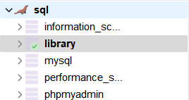

1. **Table Structures:**
   1. Create a books table with these essential fields:
      1. book_id (Primary Key)
      2. title
      3. author
      4. borrowed_date (YYYY-MM-DD)

**CREATE** **TABLE** library (

book_id **INT** **NOT** **NULL**,

title **VARCHAR**(100),

author **VARCHAR**(100),

borrowed_date **DATE** **NOT** **NULL**

);

1. **Required Operations:**
   1. Data Entry:
      1. Add at least 5 books
      2. Include title, author, and borrowed_date
      3. Use proper date format (YYYY-MM-DD)

**INSERT** **INTO** library (book_id, title, author, borrowed_date)

**VALUES**

('111111', 'To Kill a Mockingbird', 'Harper Lee', '2024-12-09'),

('222222', '1984', 'George Orwell', '2024-12-10'),

('333333', 'The Great Gatsby', 'F. Scott Fitzgerald', '2024-12-11'),

('444444', 'Pride and Prejudice', 'Jane Austen', '2024-12-12'),

('555555', 'The Catcher in the Rye', 'J.D. Salinger', '2024-12-13');

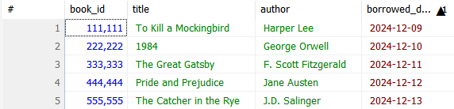

* 1. Basic Queries:
     1. List all books

**SELECT** * **FROM** library;

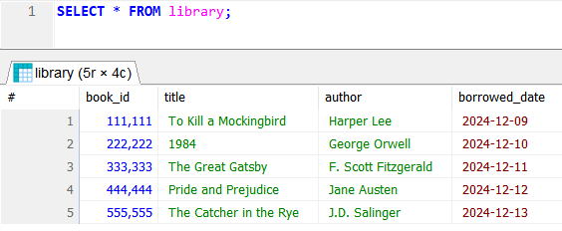

* + 1. Find books by author

**SELECT** * **FROM** library

**WHERE** author = ‘AUTHOR_NAME';

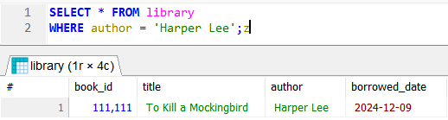

* + 1. Find books borrowed on a specific date

**SELECT** * **FROM** library

**WHERE** borrowed_date = '2024-12-10';

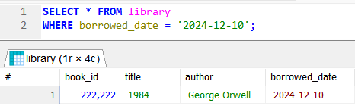

* + 1. Find books borrowed after a certain date

**SELECT** * **FROM** library

**WHERE** borrowed_date > '2024-12-10';

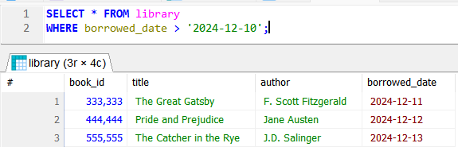

* 1. Data Manipulation:
     1. Update borrowed_date

**UPDATE** library

**SET** borrowed_date = '2024-12-15'

**WHERE** book_id = '111111';

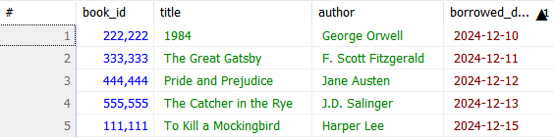

* + 1. Delete a book

**DELETE** **FROM** library

**WHERE** book_id = '111111';

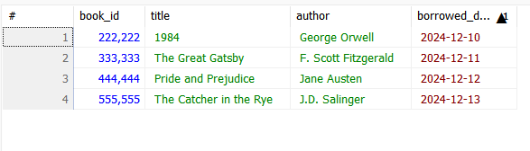

* + 1. Re-add a deleted book

**INSERT** **INTO** library (book_id, title, author, borrowed_date)

**VALUES** ('111111', 'To Kill a Mockingbird', 'Harper Lee', '2024-12-09');

