针灸平台的表结构：
1、整体结构

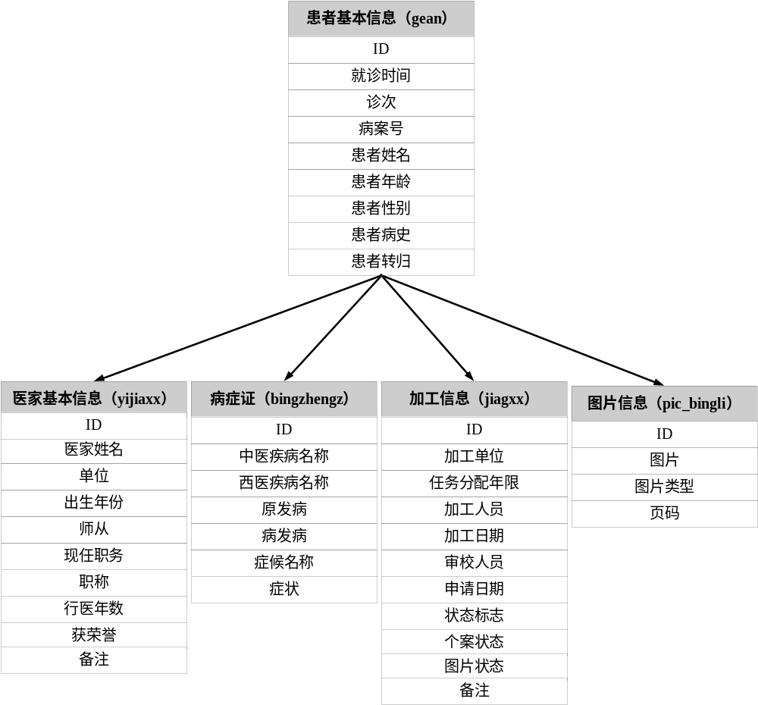

2、病症证表的结构子表

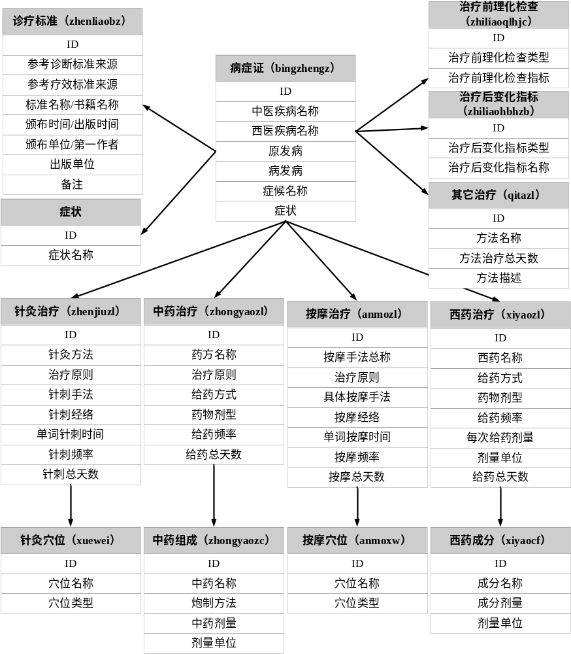

3、帐户管理表

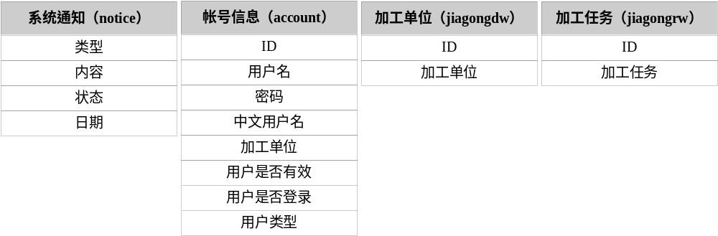

其中，每个关联又产生出一个关联表，例如患者基本信息表和医家基本信息表有一个关联，那么就会对应的产生一张代表这个关联的表gean2yijiaxx，该表的结构为：命名方式是主表2子表。
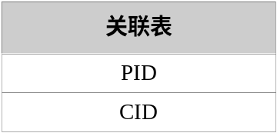

数据库执行脚本为：
数据表建立成功,以下是数据表的清单:
患者基本信息表：
drop table gean
create table gean( jiuzhensj date , zhenci varchar(2000) , binganh varchar(2000) , huanzhexm varchar(2000) , huanzhenl varchar(2000) , huanzhexb varchar(2000) , huanzhebs varchar(2000) , huanzhezg varchar(2000) , ID integer not null primary key )
患者基本信息的关联表：
drop table gean2yijiaxx
create table gean2yijiaxx( PID integer not null , CID integer not null)
drop table gean2huanzhezzxx
create table gean2huanzhezzxx( PID integer not null , CID integer not null)
drop table gean2jiagxx
create table gean2jiagxx( PID integer not null , CID integer not null)
医家信息表：
drop table yijiaxx
create table yijiaxx( xingming varchar(2000) , danwei varchar(2000) , chushengnf varchar(2000) , shicong varchar(2000) , xianrenzw varchar(2000) , zhicheng varchar(2000) , congyisj varchar(2000) , huorongy varchar(2000) , beizhu varchar(2000) , ID integer not null primary key )
病症证表（其中有一个诊治表，是由于程序需要而生成的一个中介表）：
drop table huanzhezzxx
create table huanzhezzxx( zhenzhixx varchar(2000) , ID integer not null primary key )
drop table huanzhezzxx2bingzhengz
create table huanzhezzxx2bingzhengz( PID integer not null , CID integer not null)
drop table bingzhengz
create table bingzhengz( zhongyijbmc varchar(2000) , xiyijbmc varchar(2000) , yuanfab varchar(2000) , bingfab varchar(2000) , zhenghoumc varchar(2000) , zhengzhuang varchar(2000) , ID integer not null primary key )
病症证关联表：
drop table bingzhengz2zhiliaoqlhjc
create table bingzhengz2zhiliaoqlhjc( PID integer not null , CID integer not null)
drop table bingzhengz2zhiliaohbhzb
create table bingzhengz2zhiliaohbhzb( PID integer not null , CID integer not null)
drop table bingzhengz2zhiliao
create table bingzhengz2zhiliao( PID integer not null , CID integer not null)
drop table bingzhengz2zhengzhuang
create table bingzhengz2zhengzhuang( PID integer not null , CID integer not null)
drop table bingzhengz2zhenliaobz
create table bingzhengz2zhenliaobz( PID integer not null , CID integer not null)
治疗前理化检查表：
drop table zhiliaoqlhjc
create table zhiliaoqlhjc( zhiliaoqlhjclx varchar(2000) , zhiliaoqlhjczb varchar(2000) , ID integer not null primary key )
治疗后变化指标表：
drop table zhiliaohbhzb
create table zhiliaohbhzb( zhiliaohbhzblx varchar(2000) , zhiliaohbhzbmc varchar(2000) , ID integer not null primary key )
治疗表：（该表也是由于程序需要，而生成的中介表）
drop table zhiliao
create table zhiliao( zhiliaolx varchar(2000) , ID integer not null primary key )
drop table zhiliao2zhenjiuzl
create table zhiliao2zhenjiuzl( PID integer not null , CID integer not null)
drop table zhiliao2zhongyaozl
create table zhiliao2zhongyaozl( PID integer not null , CID integer not null)
drop table zhiliao2xiyaozl
create table zhiliao2xiyaozl( PID integer not null , CID integer not null)
drop table zhiliao2anmozl
create table zhiliao2anmozl( PID integer not null , CID integer not null)
drop table zhiliao2qitazl
create table zhiliao2qitazl( PID integer not null , CID integer not null)
针灸治疗表：
drop table zhenjiuzl
create table zhenjiuzl( zhenjiuff varchar(2000) , zhiliaoyz varchar(2000) , zhencisf varchar(2000) , zhencijl varchar(2000) , dancizcsj varchar(2000) , meirizcpl varchar(2000) , zhencizts varchar(2000) , ID integer not null primary key )
drop table zhenjiuzl2xuewei
create table zhenjiuzl2xuewei( PID integer not null , CID integer not null)
针灸穴位表：
drop table xuewei
create table xuewei( xueweimc varchar(2000) , xueweilx varchar(2000) , ID integer not null primary key )
中药治疗表：
drop table zhongyaozl
create table zhongyaozl( yaofangmc varchar(2000) , zhiliaoyz varchar(2000) , geiyaofs varchar(2000) , yaowujx varchar(2000) , geiyaopl varchar(2000) , geiyaozts varchar(2000) , ID integer not null primary key )
drop table zhongyaozl2zhongyaozc
create table zhongyaozl2zhongyaozc( PID integer not null , CID integer not null)
中药组成表：
drop table zhongyaozc
create table zhongyaozc( zhongyaomc varchar(2000) , paozhiff varchar(2000) , zhongyaojl varchar(2000) , jiliangdw varchar(2000) , ID integer not null primary key )
西药治疗表：
drop table xiyaozl
create table xiyaozl( xiyaomc varchar(2000) , geiyaofs varchar(2000) , yaowujx varchar(2000) , meirigypl varchar(2000) , meicigyjl varchar(2000) , geiyaozts varchar(2000) , jiliangdw varchar(2000) , ID integer not null primary key )
drop table xiyaozl2xiyaocf
create table xiyaozl2xiyaocf( PID integer not null , CID integer not null)
西药成分表：
drop table xiyaocf
create table xiyaocf( chengfenmc varchar(2000) , chengfenjl varchar(2000) , jiliangdw varchar(2000) , ID integer not null primary key )
按摩治疗表：
drop table anmozl
create table anmozl( anmosfzc varchar(2000) , zhiliaoyz varchar(2000) , jutiamsf varchar(2000) , anmojl varchar(2000) , danciamsj varchar(2000) , meiriampl varchar(2000) , anmozts varchar(2000) , ID integer not null primary key )
drop table anmozl2xueweiAnmo
create table anmozl2xueweiAnmo( PID integer not null , CID integer not null)
按摩穴位表：
drop table xueweiAnmo
create table xueweiAnmo( xueweimc varchar(2000) , xueweilx varchar(2000) , ID integer not null primary key )
其它治疗表：
drop table qitazl
create table qitazl( fangfamc varchar(2000) , fangfams varchar(2000) , fangfazlzts varchar(2000) , ID integer not null primary key )
drop table zhengzhuang
create table zhengzhuang( zhengzhuangmc varchar(2000) , ID integer not null primary key )
诊疗标准表：
drop table zhenliaobz
create table zhenliaobz( cankaozdbzly varchar(2000) , cankaolxbzly varchar(2000) , biaozhunmc varchar(2000) , banbusj varchar(2000) , banbudw varchar(2000) , chubandw varchar(2000) , beizhu varchar(2000) , ID integer not null primary key )
加工信息表：
drop table jiagxx
create table jiagxx( jiagongdw varchar(2000) , renwufpnx varchar(2000) , jiagongry varchar(2000) , jiagongrq date , shengjiaory varchar(2000) , shengjiaorq date , zhuangtaibz integer , geanzt integer , tupianzt integer , beizhu varchar(2000) , ID integer not null primary key )

创建序列对象
drop sequence merci_sequence_gean;
create sequence merci_sequence_gean minvalue 1 maxvalue 999999999999 start with 100000 increment by 1 cache 20;
drop sequence merci_sequence_yijiaxx;
create sequence merci_sequence_yijiaxx minvalue 1 maxvalue 999999999999 start with 100000 increment by 1 cache 20;
drop sequence merci_sequence_huanzhezzxx;
create sequence merci_sequence_huanzhezzxx minvalue 1 maxvalue 999999999999 start with 100000 increment by 1 cache 20;
drop sequence merci_sequence_bingzhengz;
create sequence merci_sequence_bingzhengz minvalue 1 maxvalue 999999999999 start with 100000 increment by 1 cache 20;
drop sequence merci_sequence_zhiliaoqlhjc;
create sequence merci_sequence_zhiliaoqlhjc minvalue 1 maxvalue 999999999999 start with 100000 increment by 1 cache 20;
drop sequence merci_sequence_zhiliaohbhzb;
create sequence merci_sequence_zhiliaohbhzb minvalue 1 maxvalue 999999999999 start with 100000 increment by 1 cache 20;
drop sequence merci_sequence_zhiliao;
create sequence merci_sequence_zhiliao minvalue 1 maxvalue 999999999999 start with 100000 increment by 1 cache 20;
drop sequence merci_sequence_zhenjiuzl;
create sequence merci_sequence_zhenjiuzl minvalue 1 maxvalue 999999999999 start with 100000 increment by 1 cache 20;
drop sequence merci_sequence_xuewei;
create sequence merci_sequence_xuewei minvalue 1 maxvalue 999999999999 start with 100000 increment by 1 cache 20;
drop sequence merci_sequence_zhongyaozl;
create sequence merci_sequence_zhongyaozl minvalue 1 maxvalue 999999999999 start with 100000 increment by 1 cache 20;
drop sequence merci_sequence_zhongyaozc;
create sequence merci_sequence_zhongyaozc minvalue 1 maxvalue 999999999999 start with 100000 increment by 1 cache 20;
drop sequence merci_sequence_xiyaozl;
create sequence merci_sequence_xiyaozl minvalue 1 maxvalue 999999999999 start with 100000 increment by 1 cache 20;
drop sequence merci_sequence_xiyaocf;
create sequence merci_sequence_xiyaocf minvalue 1 maxvalue 999999999999 start with 100000 increment by 1 cache 20;
drop sequence merci_sequence_anmozl;
create sequence merci_sequence_anmozl minvalue 1 maxvalue 999999999999 start with 100000 increment by 1 cache 20;
drop sequence merci_sequence_xueweiAnmo;
create sequence merci_sequence_xueweiAnmo minvalue 1 maxvalue 999999999999 start with 100000 increment by 1 cache 20;
drop sequence merci_sequence_qitazl;
create sequence merci_sequence_qitazl minvalue 1 maxvalue 999999999999 start with 100000 increment by 1 cache 20;
drop sequence merci_sequence_zhengzhuang;
create sequence merci_sequence_zhengzhuang minvalue 1 maxvalue 999999999999 start with 100000 increment by 1 cache 20;
drop sequence merci_sequence_zhenliaobz;
create sequence merci_sequence_zhenliaobz minvalue 1 maxvalue 999999999999 start with 100000 increment by 1 cache 20;
drop sequence merci_sequence_jiagxx;
create sequence merci_sequence_jiagxx minvalue 1 maxvalue 999999999999 start with 100000 increment by 1 cache 20;

创建触发器
create or replace trigger merci_triggle_gean before insert on gean for each row begin select merci_sequence_gean.nextval into :new.ID from dual; end ;
create or replace trigger merci_triggle_yijiaxx before insert on yijiaxx for each row begin select merci_sequence_yijiaxx.nextval into :new.ID from dual; end ;
create or replace trigger merci_triggle_huanzhezzxx before insert on huanzhezzxx for each row begin select merci_sequence_huanzhezzxx.nextval into :new.ID from dual; end ;
create or replace trigger merci_triggle_bingzhengz before insert on bingzhengz for each row begin select merci_sequence_bingzhengz.nextval into :new.ID from dual; end ;
create or replace trigger merci_triggle_zhiliaoqlhjc before insert on zhiliaoqlhjc for each row begin select merci_sequence_zhiliaoqlhjc.nextval into :new.ID from dual; end ;
create or replace trigger merci_triggle_zhiliaohbhzb before insert on zhiliaohbhzb for each row begin select merci_sequence_zhiliaohbhzb.nextval into :new.ID from dual; end ;
create or replace trigger merci_triggle_zhiliao before insert on zhiliao for each row begin select merci_sequence_zhiliao.nextval into :new.ID from dual; end ;
create or replace trigger merci_triggle_zhenjiuzl before insert on zhenjiuzl for each row begin select merci_sequence_zhenjiuzl.nextval into :new.ID from dual; end ;
create or replace trigger merci_triggle_xuewei before insert on xuewei for each row begin select merci_sequence_xuewei.nextval into :new.ID from dual; end ;
create or replace trigger merci_triggle_zhongyaozl before insert on zhongyaozl for each row begin select merci_sequence_zhongyaozl.nextval into :new.ID from dual; end ;
create or replace trigger merci_triggle_zhongyaozc before insert on zhongyaozc for each row begin select merci_sequence_zhongyaozc.nextval into :new.ID from dual; end ;
create or replace trigger merci_triggle_xiyaozl before insert on xiyaozl for each row begin select merci_sequence_xiyaozl.nextval into :new.ID from dual; end ;
create or replace trigger merci_triggle_xiyaocf before insert on xiyaocf for each row begin select merci_sequence_xiyaocf.nextval into :new.ID from dual; end ;
create or replace trigger merci_triggle_anmozl before insert on anmozl for each row begin select merci_sequence_anmozl.nextval into :new.ID from dual; end ;
create or replace trigger merci_triggle_xueweiAnmo before insert on xueweiAnmo for each row begin select merci_sequence_xueweiAnmo.nextval into :new.ID from dual; end ;
create or replace trigger merci_triggle_qitazl before insert on qitazl for each row begin select merci_sequence_qitazl.nextval into :new.ID from dual; end ;
create or replace trigger merci_triggle_zhengzhuang before insert on zhengzhuang for each row begin select merci_sequence_zhengzhuang.nextval into :new.ID from dual; end ;
create or replace trigger merci_triggle_zhenliaobz before insert on zhenliaobz for each row begin select merci_sequence_zhenliaobz.nextval into :new.ID from dual; end ;
create or replace trigger merci_triggle_jiagxx before insert on jiagxx for each row begin select merci_sequence_jiagxx.nextval into :new.ID from dual; end ;

帐户管理信息表：
create table account(id integer,token varchar(2000),pass varchar(2000),type integer,cname varchar(2000),branch varchar(2000),valid integer,login integer);
create sequence seq_account_id，minvalue 1，maxvalue 999999999999start with 100increment by 1cache 20;
create table JiaGongDW(branch varchar(2000),id integer);
create sequence seq_JiaGongDW_idminvalue 1maxvalue 999999999999start with 100increment by 1cache 20;
create table JiaGongRW(task varchar(2000),id integer);
create sequence seq_JiaGongRW_idminvalue 1maxvalue 999999999999start with 100increment by 1cache 20;
create or replace trigger seq_JiaGongDW_idbefore inserton JiaGongDWfor each rowbegin
select seq_JiaGongDW_id.nextval into :new.id from dual;end
create or replace trigger tri_account_idbefore inserton accountfor each rowbeginselect seq_account_id.nextval into :new.id from dual;end
create or replace trigger seq_JiaGongRW_idbefore inserton JiaGongRWfor each rowbegin
select seq_JiaGongRW_id.nextval into :new.id from dual;end
create table notice(type integer,message varchar(2000),status integer, noticedate date);

