**DataSheet.xlsx**: Edit this file to configure the scripts to run using the project details.  
**Config** Sheet: Details needed to set the scripts to run in your desired Project  
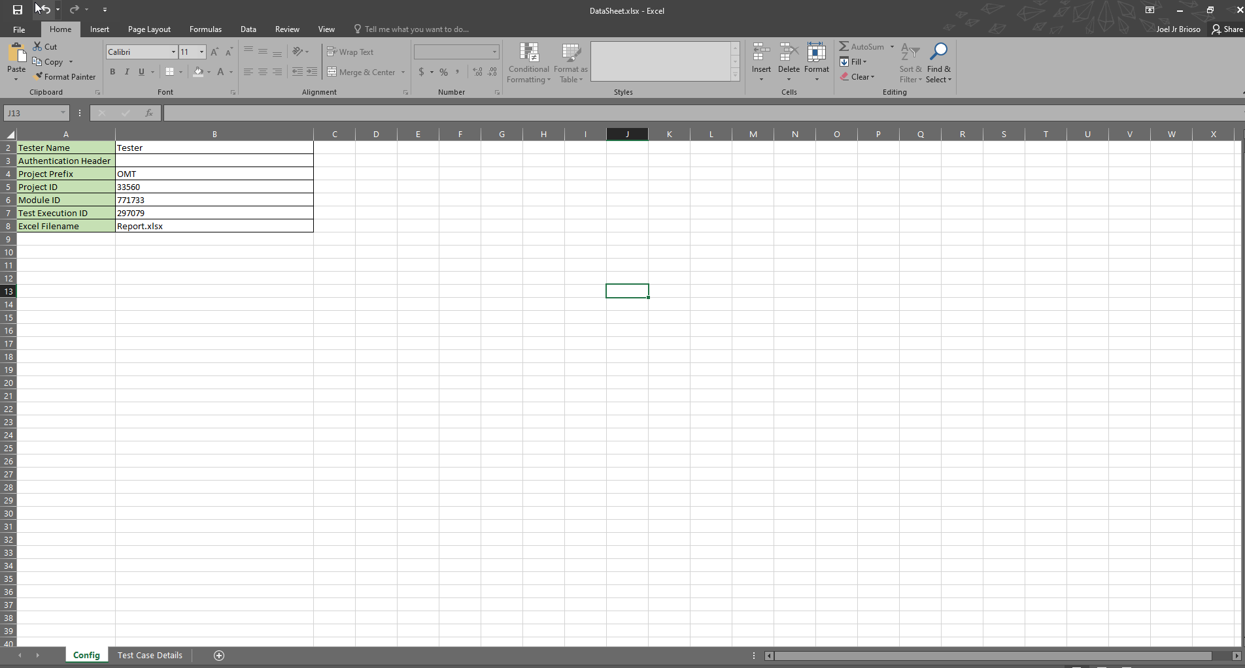

**Test Case Details** Sheet:Details needed to assign the values for the qtest fields of the test cases **Tester Name:** Name of Rollout tester

**Authentication Header  
Note:** When sharing the Datasheet, remove your authentication header  
**How to Get**  
**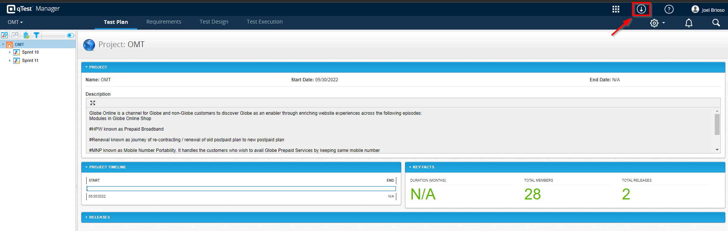  
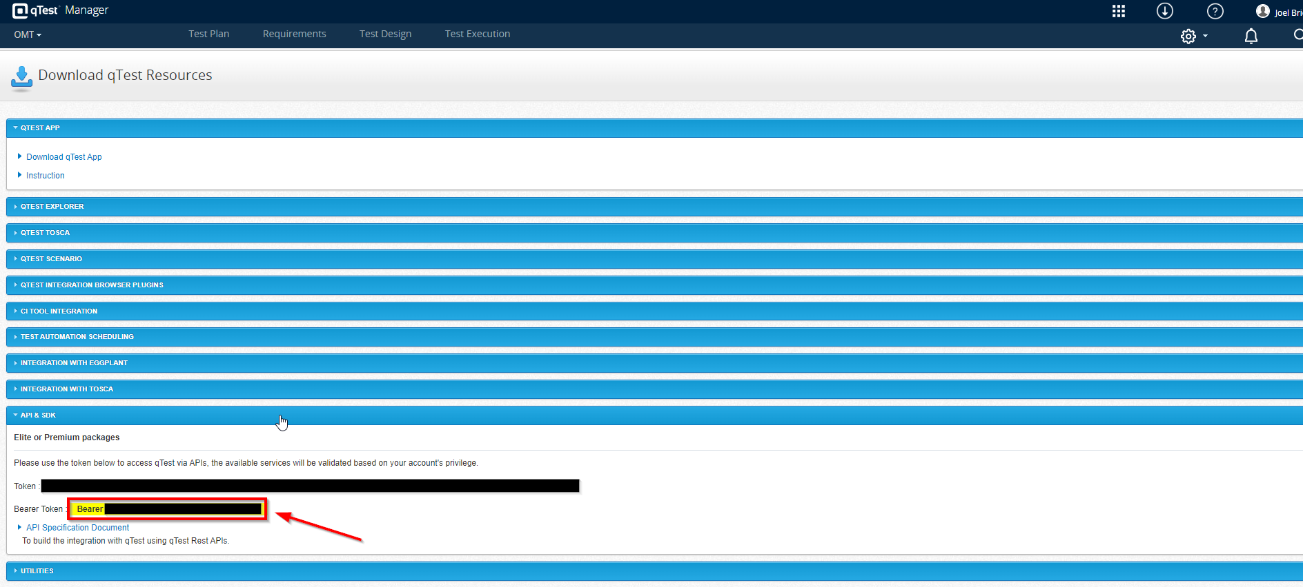**

**Project Prefix:** A text to append in the folder name of the Modules and Text Execution  
**Output:** ProjectPrefix_TesterName_TimeOfExecution i.e. OMT_Tester_Jul_25_2022_09_41_16  
**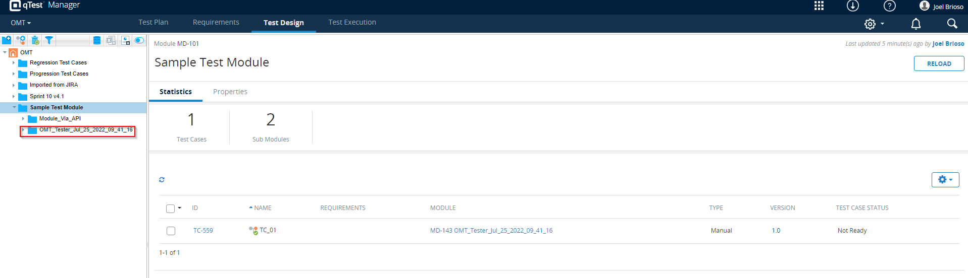  
Project ID:   
How to Get:** Navigate to **Test plan** of the project **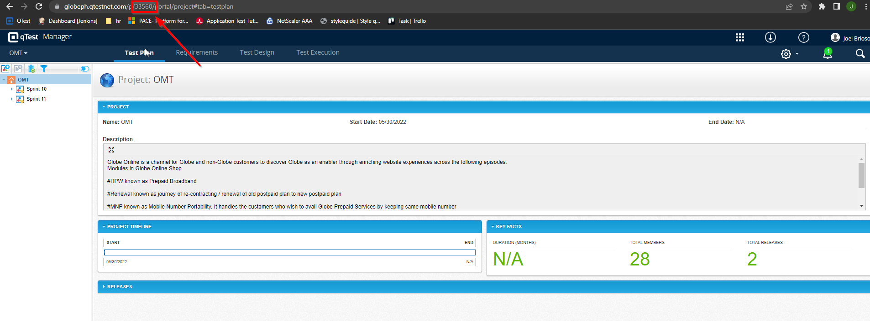  
Module ID  
How to Get:** Navigate to **Test Design** and select a folder to store the test cases 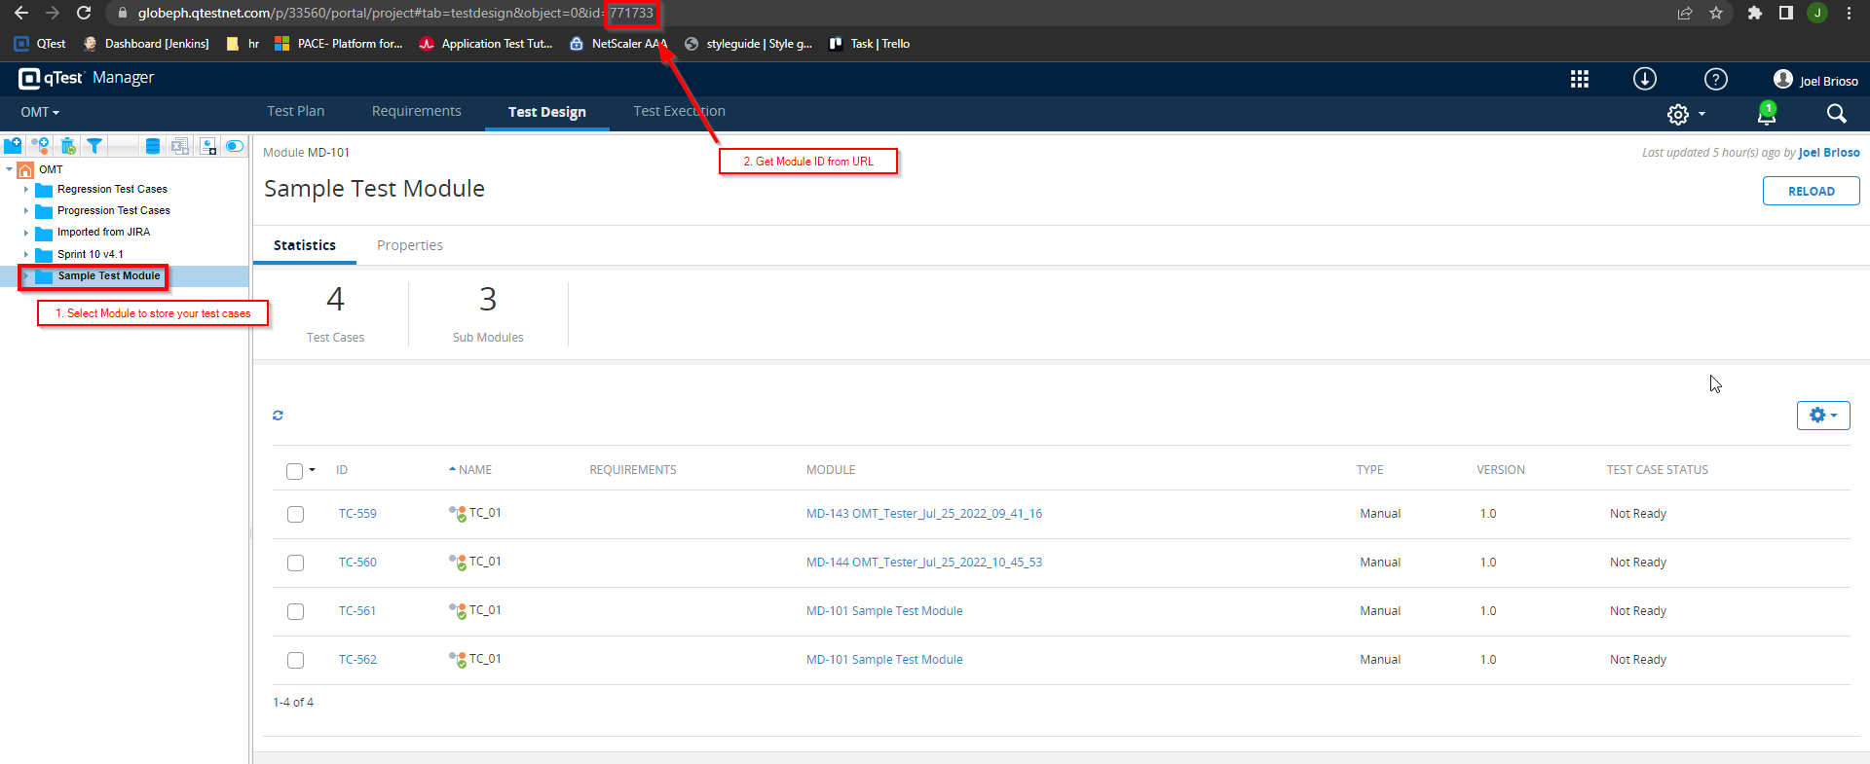

**Test Execution ID  
How to Get:** Navigate to **Test Execution** and select a folder to store the test runs **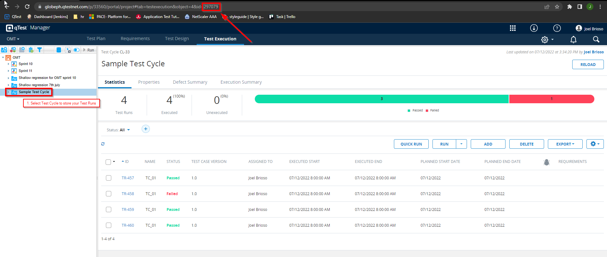  
  
Excel Filename:** Filename of the Excel Report of Execution