KENDRIYA VIDYALAYA NO. 1, NAVAL BASE KOCHI

PHYSICS INVESTIGATORY PROJECT

TO DETERMINE THE DEPENDENCE OF RESISTANCE ON LENGTH AND AREA OF CROSS SECTION OF A WIRE WITH THE HELP Of OHM’S LAW



NAME OF GROUP MEMBERS : AKARSH MURALI B

NAME AND ADDRESS OF GUIDE : MRS. SINDHU R MENON

PGT (PHY) KENDRIYA VIDYALAYA NO.1,

NAVAL BASE KOCHI

CERTIFICATE

To Whom It May Concern

Name of the institution:

Kendriya Vidyalaya No: 1, Katari Bagh, Naval Base, Kochi-682004

This is to certify that the project entitled “To Determine The Dependence Of Resistance On Length And Area Of Cross Section Of A Wire With The Help Of Ohm's Law” Was carried out by AKARSH MURALI B of Class XII C roll no .………………

This project was carried out in accordance with the requirement of the Physics investigatory project for the session 2024-25.

INTERNAL EXAMINER PRINCIPAL

EXTERNAL EXAMINER TEACHER IN CHARGE

ACKNOWLEDGEMENT

I have taken efforts in this project. However, it would not have been possible without the kind support and help of many individuals. I would like to thank my principal Mr.SASI EK Sir and school for providing me with facilities required to do my project.

I am highly indebted to my Physics teacher Mrs. SINDHU R MENON Madam for invaluable guidance which has sustained my efforts in all the stages of this project work. I would also like to thank my parents for their continuous support and encouragement.

My thanks and appreciations also go to my fellow classmates in developing the project and to the people who have willingly helped me out with their abilities.

|  |  |  |  |  |
| --- | --- | --- | --- | --- |
| CONTENTS | | |  | |
| SINO | TITLE | PAGE NO | |
| 1 | ACKNOWLEDGEMENT | 3 | |
| 2 | AIM | 5 | |
| 3 | APPARATUS | 5 | |
| 4 | THEORY | 5 | |
| 5 | CIRCUIT DIAGRAM | 6 | |
| 6 | PROCEDURE | 7 | |
| 7 | OBSERVATIONS | 7 | |
| 8 | CALCULATIONS | 9 | |
| 9 | GRAPHS | 12 | |
| 10 | RESULT | 13 | |
| 11 | PRECAUTIONS | 13 | |
| 12 | SOURCES OF ERROR | 13 | |
| 13 | REFERENCE | 14 | |

TO DETERMINE THE DEPENDENCE OF RESISTANCE

0N LENGTH AND AREA OF CROSS SECTION OF A

WIRE WITH THE HELP OF OHM’S LAW

AIM:

TO DETERMINE THE DEPENDENCE OF RESISTANCE0N LENGTH AND AREA OF CROSS SECTION OF A WIRE WITH THE HELP OF OHM’S LAW

APPARATUS:

Three wires of uniform area with different length and three wires of uniform length with different areas, a voltmeter, an ammeter, a battery eliminator, a rheostat, a meter scale, one way key, connecting wires and a piece of sand paper.

THEORY:

Ohm's law states that the current flowing through the conductor is directly is

Proportional to the potential difference across its ends, provided other physical Conditions remain constant. That is,

V 

Thus, the ratio V/I is a constant. This constant is called as the resistance [R] of the conductor.

R I/A



p = RA/I

If A= 1m2 L= 1m

Resistivity- It is the resistance offered by a conductor of unit length and unit are of cross- section. SI UNIT : $ρ=Ωm$

CIRCUIT DIAGRAM: 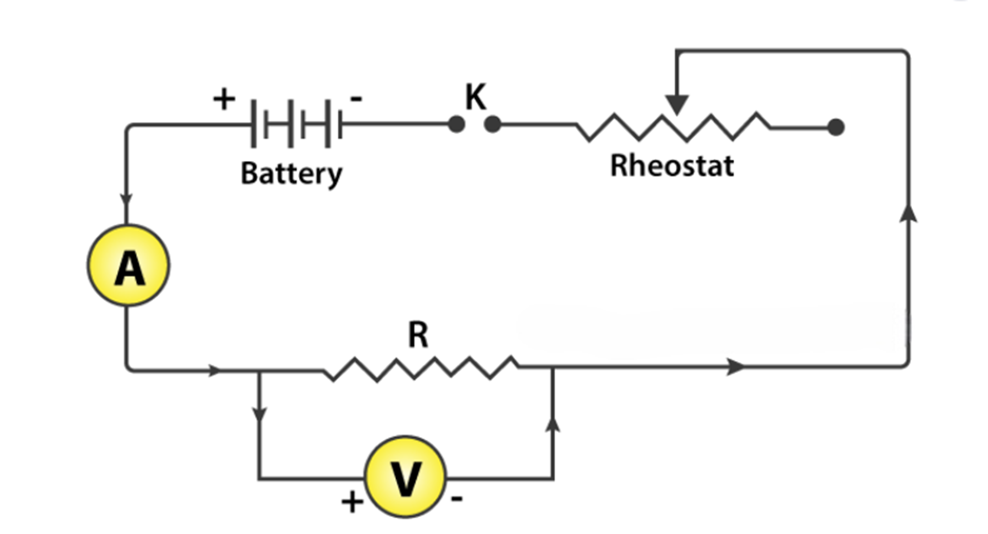

PROCEDURE:

* Connect the positive terminal of the battery to the positive terminal of the ammeter.
* Connect the negative terminal of the ammeter to the positive terminal of the voltmeter.
* Connect the negative terminal of the voltmeter to the Rheostat.
* Connect the Rheostat to one terminal of the key.
* Connect the other terminal to the battery eliminator.
* Now connect the wires of different lengths and different areas one after the other parallel to the voltmeter.
* Arrange the apparatus as described above
* Clean the ends of the connecting wires with sand paper to remove the insulations if any.
* Make neat, clean and tight connections according to the above descriptions. While making connections ensure that positive marked terminals of voltmeter and ammeter are joined towards the positive terminal of the battery eliminator.
* Determine the least count of the voltmeter and also note the zero error if any.
* Insert the key K, slide the rheostat contact and see that ammeter and voltmeter are working properly.

FOR WIRES OF UNIFORM LENGTH AND CHANGING AREAS OF CROSS Section:

* + Using a screw gauge, measure the radii of the three wires of uniform length.
  + Take at least three readings of radii for each wire.
  + Connect these wires in parallel with the voltmeter one by one.
  + Adjust the sliding contact of the rheostat such that a measurable current passes through the resistance wire.
  + Note down the values of the potential difference V from voltmeter and current I from ammeter.
  + Take at least 3 sets of independent observations (Separately for three wires).

FOR WIRES OF UNIFORM AREA OF CROSS SECTION AND CHANGING LENGTHS:

* + - * Measure the length of the three wires using a meter scale.
      * Using a screw gauge measure the radius of one wire (Since three wires have same radius).
      * Take at least three readings.
      * Connect these wires parallel to the voltmeter one by one.
      * Take the readings of the voltmeter and ammeter adjusting the sliding contacts of the rheostat slightly.
      * Take at least 3 sets of the independent observations (Separately for three wires.

OBSERVATIONS:

* Least count of ammeter:10 mA
* Least count of voltmeter: 0.05V
* Least count of screw gauge: 0.01 mm
* Zero error: NIL
* Zero correction: NIL

TABLES FOR CHANGING LENGTH:

FOR AREA OF CROSS SECTION

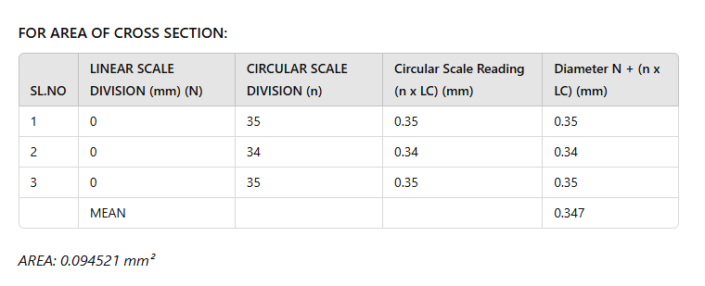

FOR RESISTANCE KEEPING ‘A’ CONSTANT AND VARYING ‘L’

1. 20 CM WIRE

|  |  |  |
| --- | --- | --- |
| AMMETER READING (A) | VOLTMETER READING (V) | RESISTANCE (Ω) |
| 0.1 | 0.2 | 2 |
| 0.15 | 0.3 | 2 |
| 0.2 | 0.4 | 2 |

R mean= 2 Ω

1. 30 CM WIRE

|  |  |  |
| --- | --- | --- |
| AMMETER READING (A) | VOLTMETER READING (V) | RESISTANCE (Ω) |
| 0.1 | 0.3 | 3 |
| 0.15 | 0.4 | 2.67 |
| 0.2 | 0.6 | 3 |

R mean= 2.89 Ω

1. 40 CM WIRE

|  |  |  |
| --- | --- | --- |
| AMMETER READING (A) | VOLTMETER READING (V) | RESISTANCE (Ω) |
| 0.1 | 0.5 | 5 |
| 0.15 | 0.7 | 4.55 |
| 0.2 | 0.9 | 4.5 |

R mean= 4.683 Ω

TABLES FOR CHANGING AREA:

FOR AREA OF CROSS SECTION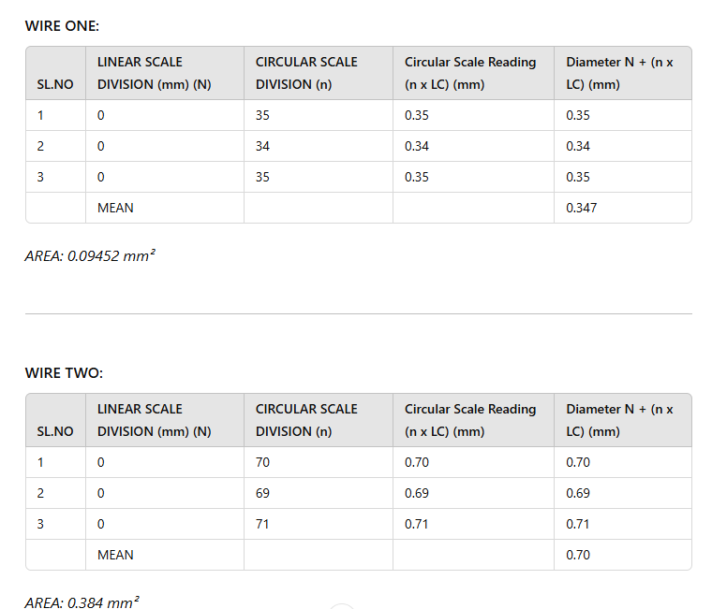

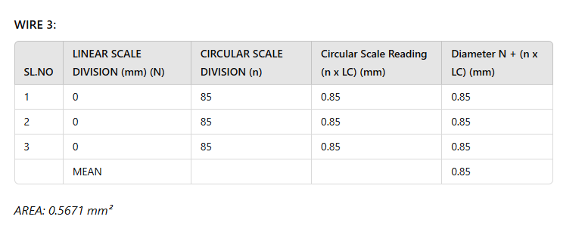

TABLE FOR RESISTANCE KEEPING ‘L’ CONSTANT AND CHANGING ‘A’

1) 0.09452 $mm^{2}$ WIRE

|  |  |  |
| --- | --- | --- |
| AMMETER READING (A) | VOLTMETER READING (V) | RESISTANCE (Ω) |
| 0.1 | 0.3 | 3 |
| 0.15 | 0.4 | 2.67 |
| 0.2 | 0.6 | 3 |

R mean = 2.89 Ω

2) 0.384 WIRE

|  |  |  |
| --- | --- | --- |
| AMMETER READING (A) | VOLTMETER READING (V) | RESISTANCE (Ω) |
| 0.45 | 0.7 | 1.55 |
| 0.55 | 0.8 | 1.45 |
| 0.65 | 0.9 | 1.38 |

R mean= 1.46 Ω

3)0.5671 $mm^{2}$ WIRE

|  |  |  |
| --- | --- | --- |
| AMMETER READING (A) | VOLTMETER READING (V) | RESISTANCE (Ω) |
| 0.2 | 0.2 | 1 |
| 0.5 | 0.5 | 1 |
| 0.6 | 0.6 | 1 |

R mean= 1 Ω

CALCULATION:

FOR RESISTANCE KEEPING ‘A’ CONSTANT AND CHANGING ‘L’

MEAN DIAMETER OF THE WIRES = 0.347mm

RADIUS = 0.1735mm

AREA = 0.09452mm2

WIRE 1 MEAN RESISTANCE (L= 20CM)

= (2 +2 +2)/3

= 2 Ω

WIRE 2 MEAN RESISTANCE (L=30 CM)

= (3+ 2.67+ 3)/3

= 2.89Ω

WIRE 3 MEAN RESISTANCE (L=40CM)

= (5+ 4.55+ 4.5)/3

= 4.683Ω

FOR RESISTANCE KEEPING ‘L’ CONSTANT AND CHANGING ‘A’

* MEAN DIAMTER OF WIRES, RADIUS,
* WIRE 1, = 0.347 mm R1 = 0.1735 mm
* WIRE 2 = 0.70 mm R2 = 0.35 mm
* WIRE 3 = 0.85 mm R3 = 0.425 mm
* AREAS,
* WIRE 1 = 0.09452 $mm^{2}$
* WIRE 2 = 0.384 $mm^{2}$
* WIRE 3 = 0.5671 $mm^{2}$
* WIRE 1 DIAMETER = 0.35mm
* WIRE 1 RADIUS= 0.175mm
* WIRE 1 AREA= 0.096 $mm^{2}$
* WIRE 2 DIAMETER = 0.70mm
* WIRE 2 RADIUS = 0.35mm
* WIRE 2 AREA = 0.384 $mm^{2}$
* WIRE 3 DIAMETER =0.85 mm
* WIRE 3 RADIUS = 0.425 mm
* WIRE 3 AREA = 0.567 $mm^{2}$

1. WIRE 1 MEAN RESISTANCE ( 30 (1)) = (3+ 2.67 + 3)/3

= 2.89Ω

1. WIRE 2 MEAN RESISTANCE ( 30 (2))= (1.55 + 1.45+ 1.38)/3

= 1.46Ω

1. WIRE 3 MEAN RESISTANCE ( 30 (3))= (1+ 1+ 1)/3

= 1Ω

GRAPHS: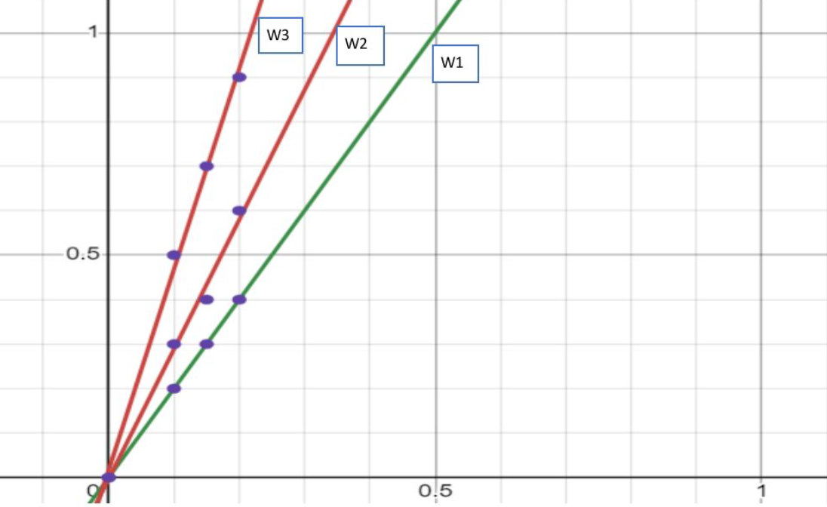

VARIATION WITH LENGTH

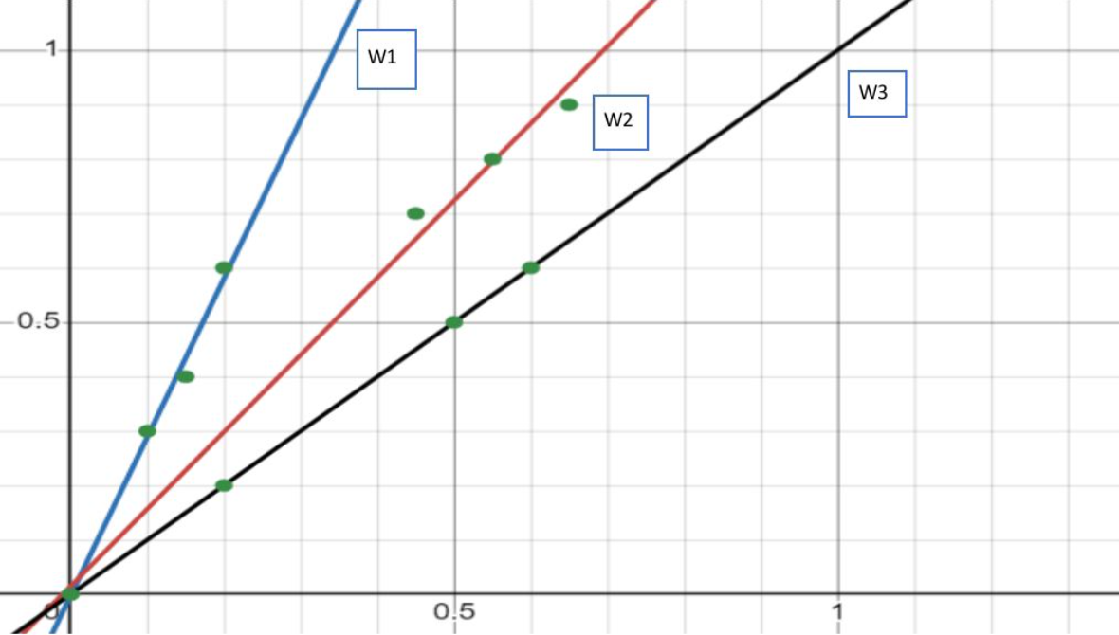

VARIATION WITH AREA OF CROSS SECTION

RESULT:

As the value of resistance (R) increases with length and decreases with increase in area of cross section and is also near to the theoretical values expected, the relation,

$$R=\frac{ρL}{A}$$

The dependence of R on L and A is thus verified.

Sources of error:

* The instruments screws maybe loose.
* Thick connecting wires may not be available.
* Rheostat may have high resistance.

PRECAUTIONS:

* The connections should be neat, clean and tight.
* Voltmeter and ammeter should be of proper range.
* Thick copper wires should be used for connections after removing the insulations near their ends by rubbing with sand paper.

Reference:

BOOKS:

Ncert Textbook Physics Part I ---- Current Electricity

Comprehensive Physics Lab Manual

WEBSITE:

https://en.wikipedia.org/wiki/Electrical_resistance

https://en.wikipedia.org/wiki/Ohm%27s_law