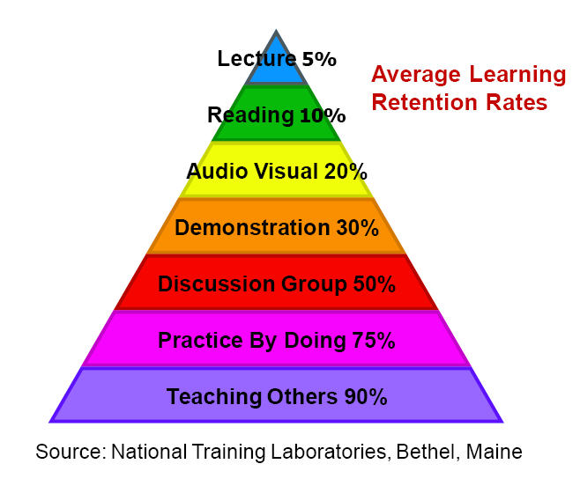**The Learning Pyramid was developed in the 1960s by the NTL Institute in Bethel, Maine.**

5% from lecture.

10% from reading.  
20% from audio-visual.  
30% from a demonstration.  
50% from engaging in a group discussion.   
**75% from when you practice what you learned.**  
90% from when you teach someone else/use immediately.

