Risk Averse, LLC Project 4:
  - Project Four Written Report

Team: Ryder Anderson, Tyler Thedie, Ayub Abdi
Department of Civil & Environmental Engineering, University of Nebraska-Lincoln
CIVE 202: Civil Engineering Analysis II
Client: Risk Averse, LLC
Professor: Dr. Kaycie Lane
April 17, 2026

Contents
Table of Figures 3
Executive Summary 4
Methods 5
Data Import and Review 5
Dataset Cleaning and Merging 5
Risk Definition and Scaling 5
Geopandas 6
Analysis 7
Florida Risk Analysis 7
Wyoming Risk Analysis 11
Comparison of NRI Risk and Proposed Risk 13
Ethics and Bias 14
AI Usage 14
References 15

Table of Figures
Figure 1 Florida Strong Winds Risk Score 8
Figure 2 Florida Strong Wind Highest Risk Counties 9
Figure 3 Florida Landslide Risk Score 10
Figure 4 Florida Landslide Highest Risk Counties 11
Figure 5 Wyoming Strong Winds Risk Score 12
Figure 6 Wyoming Strong Winds Risk Counties 13

Executive Summary
The findings in this report are based on the National Risk Index (NRI) and Social Vulnerability Index datasets. As the client requested, this report focuses on comparing the current scoring system of risks by the Federal Emergency Management Agency (FEMA) with our proposed method for measuring risk. The primary aim of the project was to see if there would be any differences in the communities identified as being at risk due to any differences in scoring methods. The prompts included downloading and cleaning two states' NRI datasets at the census tract level, using metadata, incorporating the SVI dataset, handling missing values, creating tables or charts, and at least one map using GeoPandas.
Two states chosen for the written report are Florida and Wyoming. It was necessary to compare states that differ in hazards and community factors. Florida has a relatively higher number of hazards related to strong winds from hurricanes, whereas Wyoming provides a stark contrast. In code, all NRI, SVI, shape file, and NRI data dictionary files were first loaded to begin the process of cleaning to be used later.
Our risk assessment formula was dependent on the hazard, vulnerability, and resilience of a community. The first part of our formula consisted of exposure, annual frequency, and loss ratio per year for the hazards present in a region. We used vulnerability and resilience scores present in the database, standardized them, and weighed them. In our equation, vulnerability was given more weight than resilience; thus, areas with high vulnerability and low resilience were scored as having a higher risk score. In the code, the modified score was calculated by multiplying 0.40 by the hazard, 0.45 by the vulnerability, and subtracting 0.15 of resilience, all adjusted between (0-100), allowing for comparison with FEMA's scores.
In general, modification of the risk definition produced different results. In the case of Florida, there were areas where the score obtained in the new definition was higher than the previous one. Wyoming also differed in terms of the results, but not as drastically as in Florida. The above information implies that if risk definitions change the areas under threat, this will reflect the results.

Methods

Data Import and Review
The importing of this project was done in Python and included pandas, NumPy, matplotlib, GeoPandas, and MinMaxScaler from sklearn.preprocessing packages. Firstly, there were importations of the previously mentioned packages and reading of state NRI CSV files, SVI CSV files, Census tract shapefile, and the NRI data dictionary. The shapefile was imported using the GeoPandas library, which allows us to work with both spatial data and regular tables in a GeoDataFrame.
Next stage of the code was changing -9999 values of the tract shapefile to NaN values since they could influence the process of visualization and subsequent analysis. Furthermore, the NRI data dictionary was added to provide a more detailed description of the utilized variables, including their names and field aliases. It was crucially important since, in accordance with the client's prompt, we had to use metadata in order to explain NRI variables utilized within the project. The FEMA’s Understanding Scores and Ratings website was utilized to provide a more thorough explanation about the concept of risk as defined by the National Risk Index (Federal Emergency Management Agency, 2025; Agency for Toxic Substances and Disease Registry, n.d.).

Dataset Cleaning and Merging
To link the two datasets, the code first added a new column called STCNTY to the NRI dataset based on the information in the STCOFIPS variable, so that the datasets had a common column to link. Then the NRI and SVI datasets were linked together per state into comprehensive datasets based on that common column.
Finally, the code identified the numeric variables and replaced missing numeric data with the median value for those variables. This was done using the median rather than the average since the median is more robust against outliers, and replacing missing data with zero would be unrealistic. The code removed duplicate values of TRACTFIPS and also duplicated the cleaned datasets to prevent future issues.

Risk Definition and Scaling
The National Risk Index, created by FEMA, considers factors such as annual expected loss, social vulnerability, and community resilience and provides percentile ranks and ratings of communities relative to other communities at similar levels. These factors evenly contribute to the risk score. Our project considered all the factors mentioned above but varied the weightings to construct a new definition of risk that considered vulnerability and resilience more.
First, in our approach, SOVI_SCORE and RESL_SCORE were normalized to have values between zero and one. This assured the data would not be largely affected by outliers. Then, the hazard score was determined with the hazard exposure, annual frequency, and historic loss ratio considered. Specifically, in the case of the strong wind risk in Florida, the calculation of the hazard score was the product of SWND_EXPT, SWND_AFREQ, and SWND_HLRP variables from the code.
Once the initial hazard score was developed, normalization was done on it as well. After that, the new risk score formula was used to generate the final risk score:
New Risk = 0.40(Hazard) + 0.45(Social Vulnerability) – 0.15(Resilience)
Our equation was designed to decrease the hazard weight, accurately weight high resilience in low-frequency areas, and the issue of vulnerability weighting.
First, the NRI equation favored exposure and frequency, meaning two identical communities get the same score regardless of their ability to prepare and recover from a hazard. Huge disaster relief, new building code implementations, and huge investments can dramatically increase an area’s ability to recover and prepare for hazards. The original NRI equation wasn’t properly weighing this idea, but ours does by putting a higher weight on social vulnerability.
Second, the NRI equation barely changed the score for high resilience in low frequency areas. In our model, resilience subtracts from risk meaning real world infrastructure and disaster improvements have a greater impact on ton score.
Lastly, the huge increase in vulnerability weighting suggests that whether or not a hazard occurs is not the only determinate factor in risk. It is also whether the infrastructure, the human ability to cope, and the relief programs put in place can help lower the risk and overall damage.
In case the result turns out to be negative, a value of zero was assigned to it. The resulting new score was then normalized from 0 to 100 for easy comparison with the FEMA risk scores.

Geopandas
The creation of the maps involved the use of GeoPandas. From the GeoPandas introduction, it states that the GeoDataFrame combines geometries with data and can be visualized through the use of GeoDataFrame.plot(). In the code provided, the tract shapefile was transformed using to_crs("ESRI:102003"), and then the TRACTFIPS attributes were converted to strings, after which the tract data was combined with the risk data for visualization.
This process was necessary because it satisfied the client's requirement that at least one GeoPandas map be included in the project. The creation of the maps involved the visualization of the original NRI risk and the proposed risk side-by-side. This helps us easily identify any similarities or differences between the two methods.

Analysis

Florida Risk Analysis
Florida was chosen because of its wide range of hazardous conditions, and it would give us a strong comparison against Wyoming. The Florida NRI and Florida SVI datasets were joined based on the STCNTY column that we created from STCOFIPS in the NRI dataset. We then filled all the missing numeric columns with the median to ensure no missing data could affect the analysis.
To calculate Florida's strong winds, the code took the SOVI and RESL values and calculated a hazard value using SWND_EXPT, SWND_AFREQ, and SWND_HLRP. This represented how exposed an area is and how often the hazard happens, as well as how much historic loss has occurred from that hazard. The value is then normalized before we add it to our risk assessment equation. Finally, we then scale the output value between 0 and 100 s so that our final result can be easily comparable to the original FEMA risk score.
Figure 1 compares Florida’s strong wind risk under the original NRI method and our proposed risk method at the Census tract level. This figure’s purpose is to show where the two methods give similar results and where they do not. Some tracts appear as the same level of risk, but others shift up or down depending on which equation was used. This shows how changing the way risk is defined can change which area appears to be most at risk. 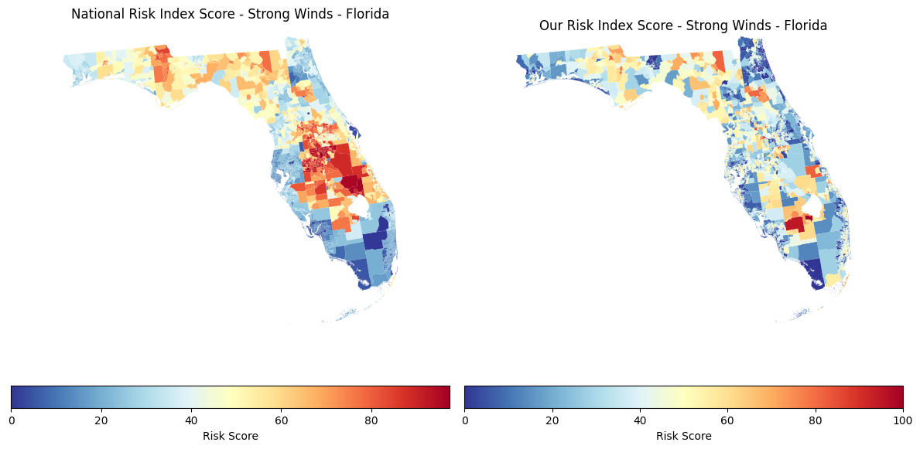
Figure 1 Florida Strong Winds Risk Score

Figure 2 compares the county-level average strong wind risk scores in Florida using both the NRI method and our proposed method. This graph makes it possible to observe differences in ranking better than the tract map. There are some counties where both methods are quite consistent with each other, but then there are also some where our method differs from the other one between the top 10 highest and top 10 lowest risk counties. As a result of our formula placing more importance on social vulnerability and decreasing risk accordingly, some countries rise in the ranking relative to NRI.
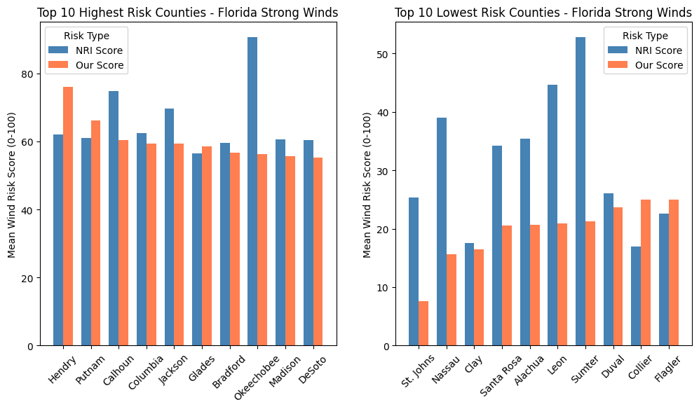
Figure 2 Florida Strong Wind Highest Risk Counties

The same comparisons were made for the landslide risk score in Florida using both methods. The only difference in the calculations was that the equation was built from the landslide variables instead of from the strong wind variables. Figure 3 compares the Florida landslide risk maps using the original NRI compared to our proposed maps. Just like the strong wind, the figures show that some of the tracts stay similar from method to method, while others shift.
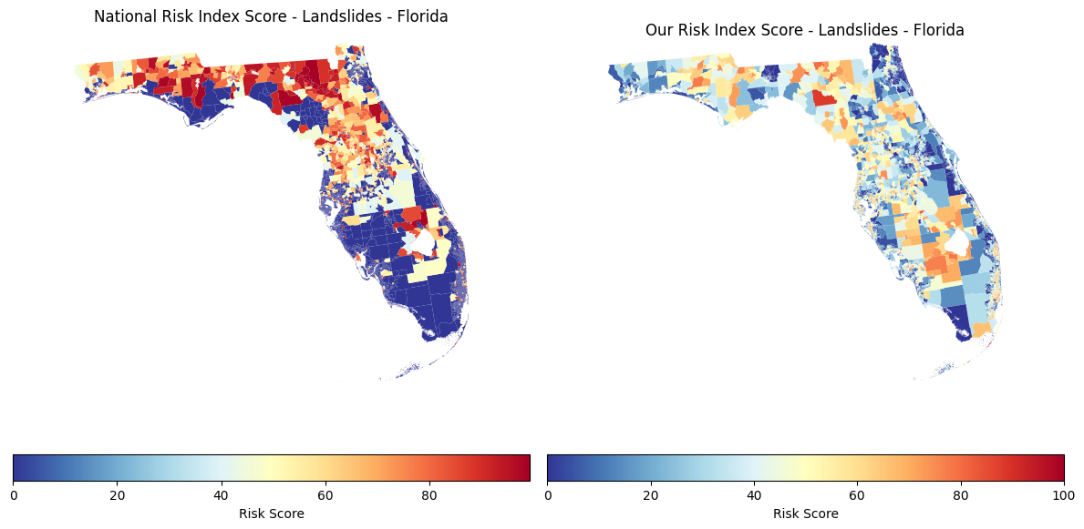
Figure 3 Florida Landslide Risk Score

Figure 4 below represents the comparison of the average landslide hazard score by counties in Florida with respect to the two methodologies. This graph is helpful because it can help us visualize how the rankings differ with respect to any changes in the equation between the top 10 highest and top 10 lowest risk counties. The important finding from the Florida analysis is that the graphs present a comparison of FEMA methodology versus the proposed methodology.
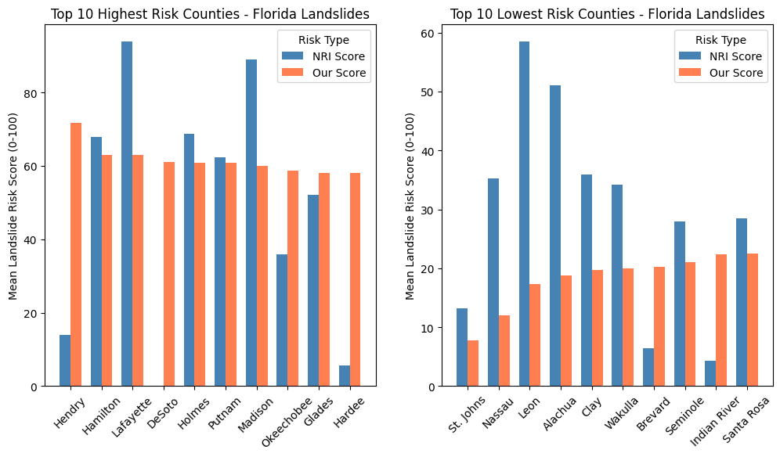
Figure 4 Florida Landslide Highest Risk Counties

Wyoming Risk Analysis
Wyoming is the second selected study state and was chosen as it offers a very distinct contrast to Florida in terms of hazards, communities, and overall landscapes. It was very helpful to show the risk formula and whether the changes would also have the same effect on another state. For Wyoming, the same overall process was used as we did for Florida. The code normalized the social vulnerability and resilience scores, calculated the hazard portion for strong winds, and then used those values in the proposed risk equation. Again, this score was scaled into a range from 0 to 100 to compare it with the initial NRI risk score.
Figure 5 demonstrates the strong wind risk in Wyoming using the NRI risk model compared to the risk model we developed using the census tract as the analysis unit. Like the Florida maps, this figure is meant to compare the two methods directly rather than just show one result by itself. Some tracts appear as the same level of risk, but others shift up or down depending on which equation was used.
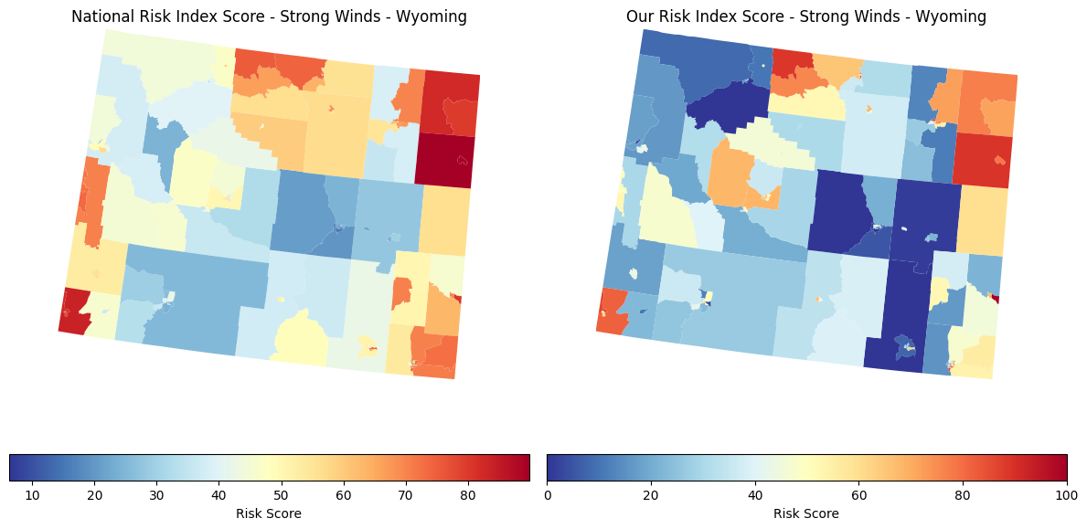
Figure 5 Wyoming Strong Winds Risk Score

Figure 6 provides the ranking comparison between the NRI method and the proposed method of strong wind risk assessment in Wyoming based on their county-level average scores. The figure allows us to find which counties remain similar in ranking and where ranking becomes different by either moving the county up or down compared to the FEMA scoring system. The result again confirms the impact of modifying the equation in determining the outcome of the comparison between the top 10 highest and top 10 lowest risk counties.
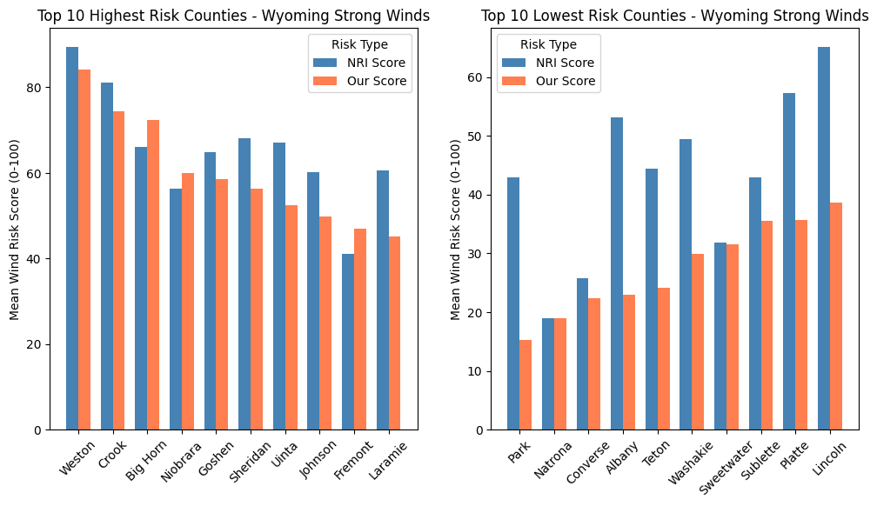
Figure 6 Wyoming Strong Winds Risk Counties

Comparison of NRI Risk and Proposed Risk
The client prompt explains that the NRI is a way of measuring risk based on expected annual loss, social vulnerability, and community resilience, along with percentile rankings and ratings that compare communities to others at the same level. In this project, we were required to analyze the comparison between FEMA's definition of risk assessment and the one proposed in our definition, as well as possible categorical biases in this assessment.
In contrast to the FEMA definition of risk assessment, the method used in this paper alters the formula used in the analysis by placing additional weights on social vulnerability and subtracting the effects of resilience. Hazard accounted for 40%, vulnerability for 45%, and resilience was subtracted from the total by 15% in our formula.
This is important because the effects on different communities are not identical following a disaster Two communities can experience an equal level of hazard exposure, but the effect will vary depending on which of the two is more vulnerable and less resilient. The proposed approach acknowledges that difference. On the other hand, it highlights the influence of the adopted risk definition on the outcomes, and the differences in the outcomes may make the data analysis biased towards one community over another.

Ethics and Bias
One of the key elements in this project is that the concept of risk is highly dependent on the definition of the phenomenon and the selection of variables within the data. Risk, expected annual loss, social vulnerability, and community resilience definitions in the existing NRI were evaluated based on FEMA's National Risk Index information (Federal Emergency Management Agency, 2025; Agency for Toxic Substances and Disease Registry, n.d.).
The significance of this variable is obvious in the context of differentiating communities based on their perceived risk. If another equation selects other communities than those selected by the first, this will certainly influence perceptions and decision-making related to the use of data further. In this regard, an equation that prioritizes physical hazard may be too simplistic to reflect the real situation in vulnerable communities. Conversely, the latter would be reflected better in a vulnerability-based equation.
The other request from the client was to consider the implications that varying definitions of risk might have for future financing, data gathering, and the interpretation of the findings by state and local communities. The primary conclusion drawn from our findings is that while risk involves hazard, it also involves the nature of its victim community and how capable they are of responding to it. This means that the equation can be modified, and that will change the rankings, which may impact their standing in the future.

AI Usage
AI was used in the making of this project. The AI tools used were Grammarly to correct grammatical errors and typos, and ChatGPT to give more information on what should be included in the report, such as giving subheadings and headings names to make the report flow. Claude has also helped with explaining some parts of the code annotation and mentions where Claude has helped with explaining or building certain lines for scaling, clipping negative values, and some of the GeoPandas setup. (OpenAI, 2026; Anthropic, 2026; Grammarly, 2026).

References
OpenAI. (2026). ChatGPT [Large language model]. https://chat.openai.com/
Anthropic. (2026). Claude [Large language model]. https://claude.ai/
Grammarly. (2026). Grammarly [Writing assistance software]. https://www.grammarly.com/
Federal Emergency Management Agency. (2025). Understanding scores and ratings. National Risk Index. https://hazards.fema.gov/nri/understanding-scores-ratings
Agency for Toxic Substances and Disease Registry. (n.d.). Social Vulnerability Index (SVI): Data and documentation download. Centers for Disease Control and Prevention. https://www.atsdr.cdc.gov/place-health/php/svi/svi-data-documentation-download.html

