CIVE 202 Report
Project 3 – Transportation Data Visualization

3/28/26

Contributors:
Tyler Thiede
Table of Contents
Table of Figures 3
Introduction 4
Methods 4
Results 7
Bibliography 11

Table of Figures
Figure 1 IDM parameters, symbols, descriptions, and typical values 5
Figure 2 IDM acceleration and desired minimum gap equations 6
Figure 3 Stacked bar chart of vehicles per household by census division 6
Figure 4 Histogram of vehicles per household distribution 7
Figure 5 Boxplot of vehicles per household by home type 8
Figure 6 follower and leader vehicle position over time 9
Figure 7 Follower and leader vehicle speed over time 9
Figure 8 Follower leader and simulated follower position over time 10

Introduction
The Federal Highway Administration (FHWA) has tasked our firm with organizing and visualizing transportation data from the National Household Travel Survey (NHTS) and the Next Generation Simulation (NGSIM) prior to a meeting of the transportation planning group in our firm meeting. We have been provided two different CSV files and two Metadata files that explain the content of the data sets.
Specifically, the PE has asked to complete the following tasks:
- A bar chart comparing categories within a specific variable
- A histogram showing the distribution of a specific variable
- A boxplot showing the distribution of a variable in each category
- At least two different time-series plots showing and analyzing driving behavior

A simulation study using the Intelligent Driver Model (IDM) was performed to visualize and simulate vehicle behavior and trajectories. The acceleration of the follower was calculated using the IDM equations and the results were visualized on a plot.

A timetable documentation of how long the data analysis takes in Python was also created to compare to similar Excel methods.

Methods
Two datasets have been made available to analyze and provide important features and trends. These two datasets include the National Travel Survey (NHTS) and the Next Generation Simulation (NGSIM). To analyze these datasets, the data was imported into Python.
To import the data into Python, the pandas import was used to read and store the csv. To make the data more interpretable, various graphs were created using the matplotlib and seaborn imports.
The first graph created is a bar graph displaying the count and distribution of the vehicles per household within each census division in the NHTS data. To create this bar graph, the matplotlib function “figure()” was used to create a display area for the bar chart. The NHTS data was then grouped to count how many of each home type exists in each census division. This was done through using “groupby()” and applying the “size()” and “unstack()” functions to the grouped data. The “plot()” function was then applied to our grouped data to create the bar chart. The arguments included in the function included the type of plot (bar) and the color properties. Various other matplotlib functions were called to adjust the axis labels, title, and layout. This bar chart was created to help transportation engineers obtain a better understanding of the census divisions. It helps to answer the question, “Where are people most car-dependent?”
The second graph utilized is a histogram that plots the frequency of the number of vehicles per household. The histogram was created by using matplotlib to create a figure by calling “figure()” function on the matplotlib import. Once the figure space was created the “hist()” function was called to create the plot. The arguments passed through the function included the vehicles per household column in the NHTS data, the number of bins, and the color properties. Like the bar graph, several matplotlib functions were called to adjust the axis labels, title, and various format intricacies. This histogram was designed to help visualize the distribution of vehicles per household to answer the question of what how many vehicles are in most households.
The third graph is a boxplot that shows the relationship between vehicles per house by home type. The figure space was created once again by the “figure()” function called using the matplotlib import. This time however the plot was created by calling the “boxplot()” function on our NHTS dataset. The arguments passed through this function include the column (vehicles per household) and what we were sorting by (home type). More matplotlib functions were called to adjust labels and titles. This graph ties in will to help understand the data in pair with both the bar graph and histogram. It answers the question of how housing influences the vehicles per household. Understanding the number of vehicles per household, the distribution of number of vehicles per household, and how the number of vehicles per household is distributed between census divisions can give transportation engineers a well-informed summary of the survey’s results.
For the NGSIM dataset, a position time graph and a speed vs time graph of the leader and follower in a trajectory was created to help interpret traffic trends in the region. A subset of the data was first created to view one trajectory of the data. This was performed by retrieving the rows where the trajectory number was equal to our selected trajectory number to filter the data to one trajectory. To create the x-axis length the time was retrieved from our subset that collected all values from the time column.
For the position time graph, the matplotlib “figure()” function created the graph space, and the seaborn “lineplot()” function created the visual. Two line plot functions were called. One was for the leader while the other was for the follower. The arguments passed through these functions included our filtered data subset, the x-axis (time), and the y-axis (follower or leader position). With both lines plotted, we can see the distance each vehicle traveled over the data interval. This is useful when tied along with the speed of the road to see how congested the road is.
For the speed time graph, the exact same process was sued as the position time graph besides changing the y-axis on both line plots to the leader and follower speed columns. This graph is extremely useful to understand the efficiency of traffic. The more constant the speed is over the interval the less stop and go traffic is which often results in less crashes and more efficient road systems.
For the simulation study, the NGSIM data set was used. A follower vehicle will be simulated using a specified trajectory’s leader’s position, speed, and acceleration. The time data and leader position and speed data values will be gathered from the specified trajectory. The time step, and all IDM parameters will then be set. These variables and values can be seen in Figure 1. The simulation will then run and will iterate through the time data points. The loop will calculate the gap, difference in velocity between the simulation and leader, and then call the IDM acceleration function which performs the acceleration calculation found in Figure 2 to update and determine the simulation acceleration. The simulation speed and position will then be updated based on the new changes and the loop will repeat until the end of the time data (end of the simulation).

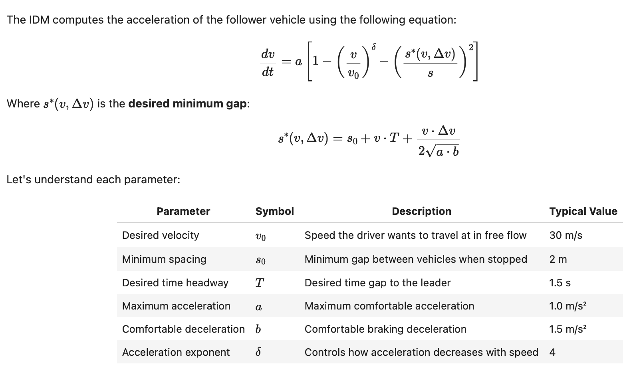
Figure 1 IDM parameters, symbols, descriptions, and typical values

Figure 2 IDM acceleration and desired minimum gap equations

Results
Figure 3 displays the stacked bar chart of vehicles per household by census division. First, the bar chart shows the distribution of vehicles per census division. South Atlantic, East North Central, and Pacific census divisions have the highest vehicle count. This suggests the divisions are either bigger or that they have a higher vehicle count in a more condensed area. Meanwhile, New England, and East South Central have a much lower vehicle count meaning they are either smaller areas or there is a lower density of vehicles.
Second, the stacked bar chart also displays the distribution of vehicles per household within each census division. Regardless of the census division, the most common number of vehicles per household is 2 followed by either 3 or 1. Most census divisions reflect a similar distribution, so it is hard to derive any deeper conclusions from this aspect of the bar chart.
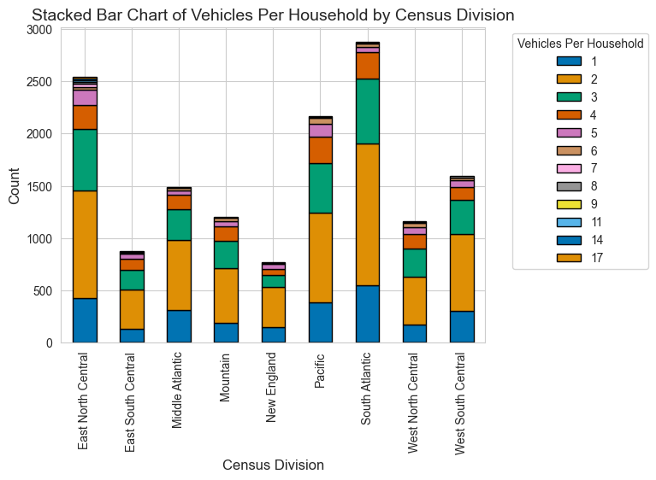
Figure 3 Stacked bar chart of vehicles per household by census division
Figure 4 is a histogram of vehicles per household. It shows a clear skewed right distribution. The mean and median appear to be around 2.5-3 vehicles per household. It is very clear in this graph most homes have 2 vehicles. It is also important to note there are clearly several extreme outliers at around 14 and 17. These outliers are most likely the result of an apartment being counted as a “household” and all the vehicles belonging to the residents are together.
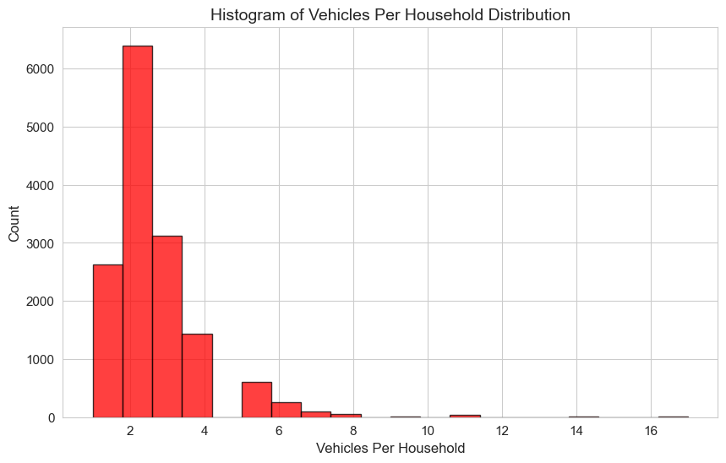
Figure 4 Histogram of vehicles per household distribution
Figure 5 is a boxplot showing the vehicles per household grouped by the home type. There are 5 home types in the data and the vehicles per household distributions between each home type is different. However, all home types do have a skewed right distribution like the vehicles per household histogram distribution. The median is around 2 for all home types besides the Boat, RV, van, etc. which is around 5. The distribution of all the home types besides the miscellanous category vary from 1 to around 4-5.
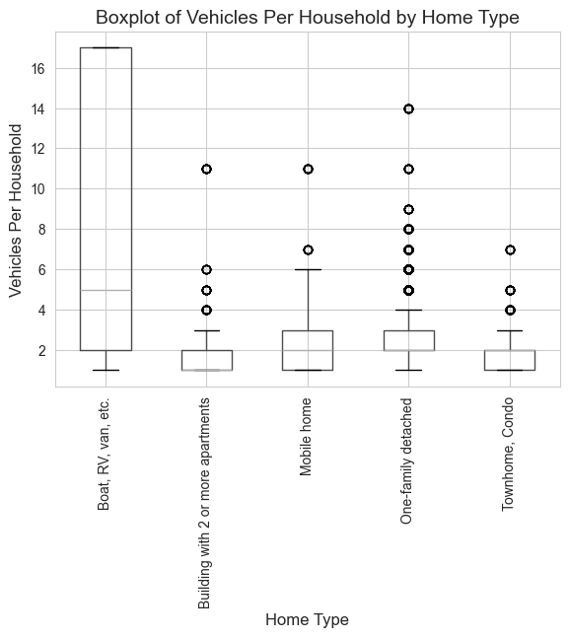
Figure 5 Boxplot of vehicles per household by home type
The three visualizations of the NHTS dataset together reveal clear patterns in vehicle ownership and how it varies across geography and housing type. The stacked bar chart shows that vehicle availability differs notably by census division, but the distribution of number of vehicles per household remains relatively the same with each census division. The suggests regional differences of transportation and infrastructure need. Areas with higher vehicle ownership will need more transportation needs while areas with less will need less. The histogram also supports this by showing the distribution of vehicles per household, which is skewed right with a center around 1-3 vehicles.
The box plots provide more information by displaying how vehicle ownership varies by home type. Detached one-family households will have a slightly higher median but a wider spread while other types of homes have a slightly lower median ang generally less varied distributions. This suggests that the environment plays a significant role in transportation behavior. It shows that denser housing is associated with lower vehicle dependence. Together, all these results show how both regional and infrastructure type patterns influence vehicle ownership which offers helpful information for transportation planning.
Figure 6 displays trajectory 4 follower and leader positions from the NGSIM data set. This graph is useful to view much ground the vehicles cover over the time where fluctuations occur while also viewing the gap at these fluctuations. Transportation engineers can use this graph to not only view the gap between the leader and follower but also view where the graph has a slope close to 0 to view where traffic slows. The graph shows a relatively constant gap except for when traffic slows around 55 seconds into the data. The gap decreases significantly which suggests traffic was slowed.

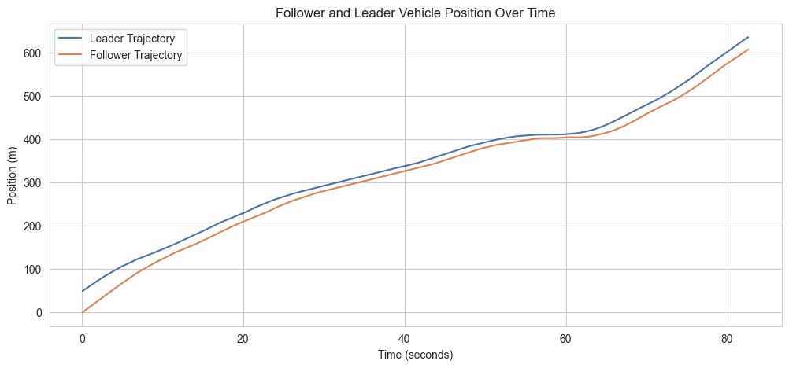
Figure 6 follower and leader vehicle position over time
Figure 7 displays trajectory 4 follower and leader speeds. from the NGSIM data set. The graph confirms our conclusion from the previous graph that traffic slows around 55-60 seconds. If traffic engineers compare many trajectories over the same stretch of road and find this is a common occurrence, it can suggest that more lanes or other changes may need to be added to this stretch of road to increase efficiency so slowing is kept to a minimal amount ensuring traffic keeps around a constant speed.

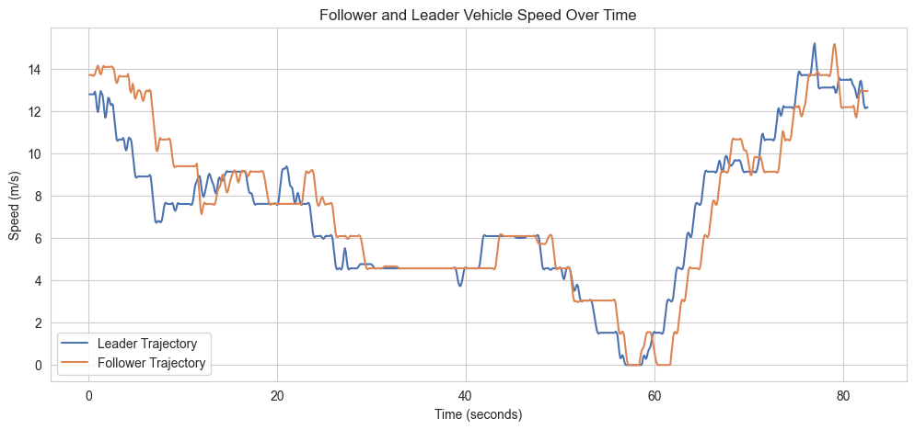
Figure 7 Follower and leader vehicle speed over time
Figure 8 displays the results of the IDM simulation modeling. The leader, follower, and the simulated follower are all displayed on the line chart. The simulation provides a relatively accurate simulation of a real follower vehicle as it matches the follower’s movement trends. However, it is also important to note where the differences are found and patterns that correlate with them. For instance, the simulated follower appears to veer off its actual course when the real follower makes a sudden change in speed. These points can be found at time 55 and time 65. At time 55 the follower flows down and the simulated follower delays momentarily and its gap becomes incredibly small to the leader. The inverse happens at time 65 when the follower speeds up. The simulated follower delays momentarily in this acceleration. The results suggest the simulation provides a pretty accurate depiction of a real follower vehicle but lack in accuracy during big change is speed.
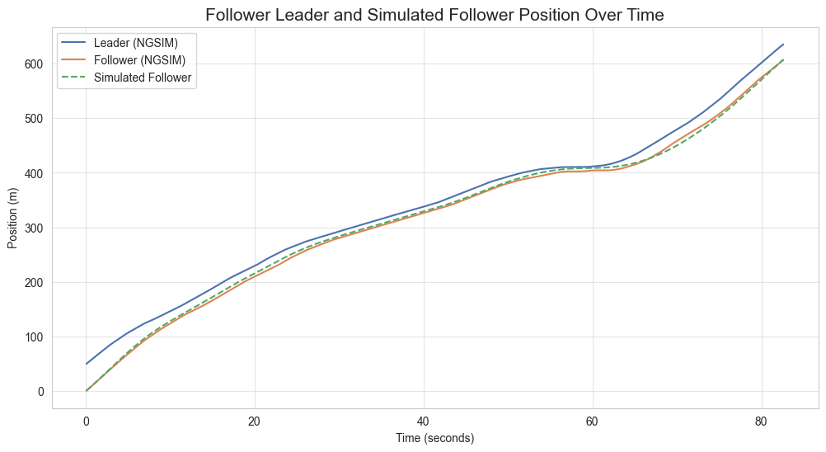
Figure 8 Follower leader and simulated follower position over time

Bibliography
NGSIM. (n.d.). NGSIM Excel Data.
NHTS. (n.d.). NHTS Excel Data.

