Scope of Work
Project #3: Visualizing Data
Client: Federal Highway Administration (FHWA)
Course: CIVE 202 Civil Engineering Analysis II
Team Members: Tyler Thiede
Submitted to: Dr. Lane

Project Goals
The Federal Highway Administration (FHWA) has tasked our firm with organizing and visualizing transportation data from the National Household Travel Survey (NHTS) and the Next Generation Simulation (NGSIM) prior to a meeting of the transportation planning group in our firm meeting. We have been provided two different CSV files and two Metadata files that explain the content of the data sets.
Specifically, the PE has asked to complete the following tasks:
- A bar chart comparing categories within a specific variable
- A histogram showing the distribution of a specific variable
- A boxplot showing the distribution of a variable in each category
- At least two different time-series plots showing and analyzing driving behavior

The variables selected to plot are open ended but need to be important and representative to the transportation planning group. The plots must be descriptively labeled, easy to interpret, and show clear evidence they were created using matplotlib or seaborn.

A simulation study using the Intelligent Driver Model (IDM) must also be performed to visualize and simulate vehicle behavior and trajectories. The acceleration of the follower but be calculated using the IDM equations and the results must be visualized on a plot.

The PE also expects time documentation of how long the data analysis takes in Python so they can compare it to how long a similar Excel analysis tool performs the same function.

Project Tasks
- A bar chart comparing categories within a specific variable
The bar chart will use the NHTS dataset. It will use the vehicles per household and census division variables. The stacked bar chart will group the data by census division and plot the count of the vehicles per household. The bars will be split into the proportion of different number of vehicles per household. This bar chart will help the engineers obtain a better understanding of the census divisions and helps to answer the question of where people are most car dependent.

- A histogram showing the distribution of a specific variable
The histogram will use the NHTS dataset. It will use the variable storing the vehicles per household. Once plotted, the histogram will visualize the distribution of the vehicles per household so transportation engineers can understand the normal number of vehicles per household and how the data might be skewed, a good idea of the mean and median, and potential outliers. The histogram will help answer the question of how many vehicles are in most households.

- A boxplot showing the distribution of a variable in each category
The boxplot will use the NHTS dataset. It will map the distribution of the variables home types to the vehicles per household. The boxplots will be grouped by home types and the number of vehicles per household will be used to display the distribution. The boxplots will help answer the question of how these key variables are related to help the transportation engineers better connect the previous plots as well.

- At least two different time-series plots showing and analyzing driving behavior
Both time-series plots will use the NGSIM data set. The first plot will be a line graph that plots the trajectory of the position over time of the follower and leader vehicles. The follower and leader trajectories will come from a selected trajectory from the dataset and will be plotted on the same plot to view how close the follower and leader’s positions match the same trajectory.
The second plot will graph the follower and leader vehicle speeds over time. The trajectories will use the same trajectory ID to help compare position and speed of the same set of vehicles. This plot will help transportation engineers view how frequent the vehicles are speeding up and slowing down to help better analyze the efficiency of traffic and possible needs for changes.

- Simulation study using the Intelligent Driver Model
The simulation study will use the NGSIM data set. A follower vehicle will be simulated using a specified trajectory’s leader’s position, speed, and acceleration. The time data and leader position and speed data values will be gathered from the specified trajectory. The time step, and all IDM parameters will then be set. These variables and values can be seen in Figure 1. The simulation will then run and will iterate through the time data points. The loop will calculate the gap, difference in velocity between the simulation and leader, and then call the IDM acceleration function which performs the acceleration calculation found in Figure 1 to update and determine the simulation acceleration. The simulation speed and position will then be updated based on the new changes and the loop will repeat until the end of the time data (end of the simulation).
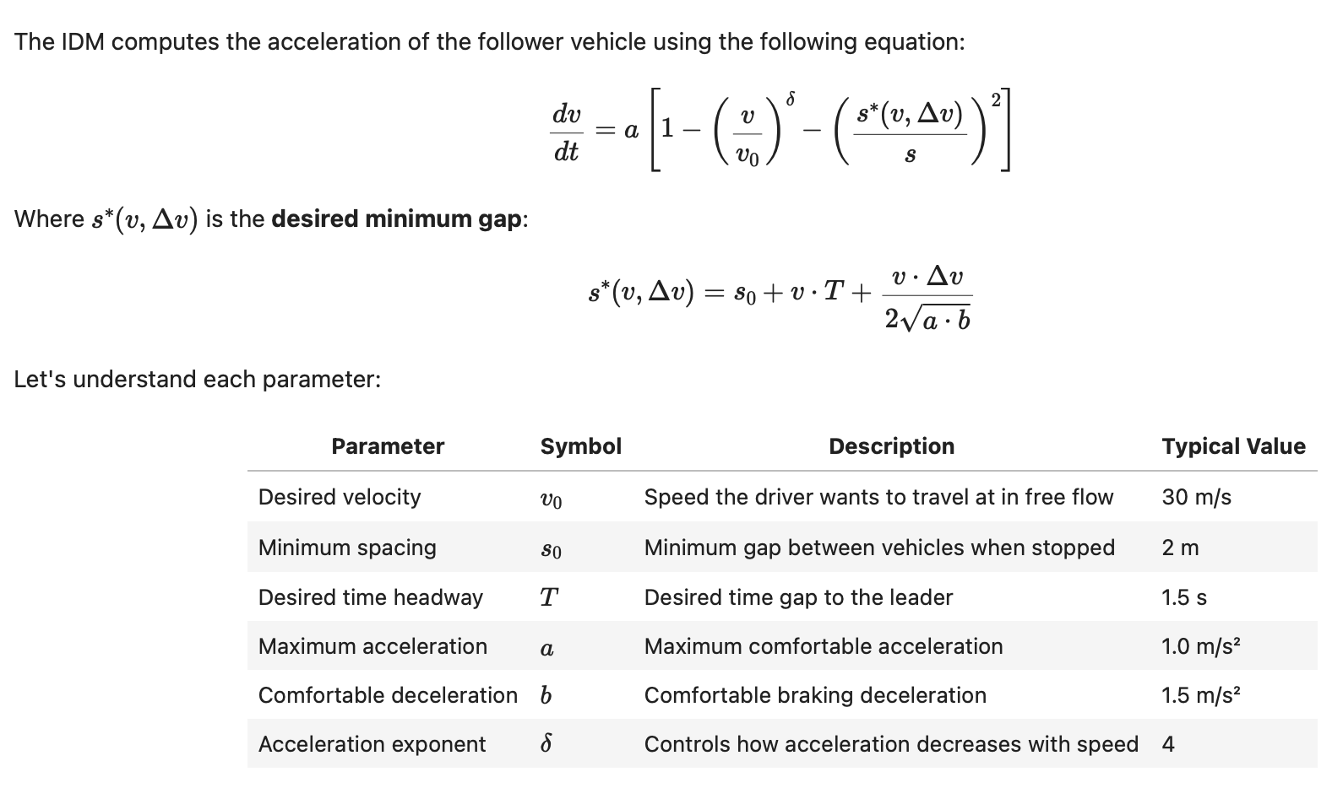
Figure 1 Screenshot of IDM equations and parameters

- Documented timetable to perform data analysis
An Excel spreadsheet will be created that maps the activity, member who completed the task, amount of time spent, and date of time spent on activity. This timetable will also sum the amount of time spent on the project. This timetable can be easily compared to documentation on how long the Excel data analysis took for the same project to compare which solution is more efficient.

Project Deliverables
Component | Description
Jupyter notebook containing Python code (.ipynb) | A Jupyter Notebook that documents the code used to automate the "Mix Design" tab. It must include sequential user prompts, calculations and must be tested for four mix designs.
Github Link | A link to a repository containing the code, data, and a READMe file that summarizes the project and identifies each file
GANTT chart | The Gantt chart is used to visualize task sequencing and dependencies
Annotated Code Document | A line-by-line explanation of the entirety of the code
Engineering Timesheet | Timesheet is well organized and contains all the required components. Timesheet includes relevant tasks, a clear distribution of work and describes each task completed.
Scope of Work | Outlines the project goals, tasks, and deliverable that you will complete for a client
Technical report | Report must include the following elements:  Introduction: Background on the FHWA project and your objectives  Methods:  A description of the variables you selected and why these were selected by your team  A description of how each plot was constructed  A description of any method you have used  Results and Discussion:  A discussion of the key findings in each of your plots  A discussion of how each of these key findings could be relevant to the transportation industry  References: proper intext citations and a reference list

Conclusion
A program will be written in Python to help visualize and interpret the NHTS and NGSIM data sets through a bar graph, histogram, boxplot, and line graphs. An IDM simulation will be performed to predict and map a follower’s acceleration in a real survey trajectory. The source code, a GANTT chart, ACD, timesheet, and technical report will be submitted and will fully document and explain the processes used in the analysis.

