CIVE202- Civil Engineering Analysis II – Project 5 Written Technical Report
Spring 2026
Jacob Oetken, Michael McCarthy, Tyler Thiede, Bryce Ripley
May 8, 2026

Table of Contents
Introduction 3
Methods 3
Data Sources and Initial Processing 4
Implementation and Function Descriptions 4
Governing Equations 5
Inputs/Outputs 5
Sequence of Implementation 7
Results 8
Summary Table of Tensile Yielding Results for all Scenarios 9
LRFD Percent Utilization by Scenario 10
ASD percent utilization by Scenario 11
Conclusion 11

Introduction
This report is intended to document a proof-of-concept Python development that was created for Kiewit Corporation with the goal of automating the AISC steel design calculations for W-shaped tension members. The work completed follows the Structural PE Program Managers requests to standardize the frequently used in-house spreadsheets, and create a single, reproducible set of functions that implement the AISC Example D.1 tensile member procedure, carry out three design scenarios, and visualize the results on a plot. Deliverables are to include the Python notebook, ASTM and AISC tables used as inputs, the numerical outputs for the three comparison scenarios, and the two comparative plots showing Load and Resistance Factor Design (LRFD) and Allowable Strength Design (ASD) utilization.
The LRFD is the strength-based design method utilized by the AISC Steel Design Manual to determine the available design strength of the W-shaped steel member. For the LRFD, the design strength must be equal to or greater than the required strength of the member (AISC, 2011). This design method ensures the safety of the design by applying a load factor to increase the intended load and a resistance factor to reduce the value of the nominal strength of the member. When these factors are applied, it is considered safe if the factored strength still exceeds the factored load.
The ASD is another method used by the AISC Steel Design Manual to determine the required strength of a W-shaped member, but it uses working stress under service loads. These service loads are the Dead Load, defined as the weight of the structure itself, and the Live Load, which includes any change in the load that the structure must also support. The available strength is referred to as the allowable strength, and it must be equal to or exceed the required strength of the member (AISC, 2011).

The automation focuses on the tensile yielding limit state, which is shown in the AISC Steel Construction Manual and the provided worked examples. The notebook also reads two primary data sources being the AISC W shape section table, as well as the ASTM material yield strength table. Using these two data sources, the notebook calculated the nominal tensile capacity. Following that, the code then applies the implemented strength factors, (.9 for LRFD and 1.67 for ASD) and outputs both the LRFD and ASD utilization ratios and whether each scenario passes or fails. All calculations assume consistent U.S. Customary Units.
The notebook is organized not only for clarity but also for reproducibility and transparency in mind. A simple design input data class collects scenario inputs such as the load_shape_table and load_astm_table, takes in the according csv data, implements the LRFD and ASD checks, and finally runs a user input case along with three predefined scenarios with bar chart utilization plots. The methods section below lists the equations, data sources, and any assumptions made in calculations. Following that are the results, where all computed tables and plots produced by the notebook will be interpreted and analyzed. The report finally concludes with implementation notes, limitations, and engineering recommendations.

Methods
This project translated the AISC tensile-yielding procedure for W-shaped tension members into a single reproducible, transparent Python notebook. The implementation follows the exact steps listed in the ASIC Example D.1. providing examples on how to read section and material properties, calculate the nominal tensile capacity using the specified beams gross section, apply the LRFD and ASD strength factors, and report the members utilization and pass-fail status for each scenario created. The notebook is organized to load data sources, a tensile-yielding check, and then a final function that takes in the user’s inputs and plots the utilization percentage across different scenarios.

Data Sources and Initial Processing
- W Shape Section Table: This data source holds the AISC section properties such as designation, gross area, moments, section modulus, etc. This data is then read form the W_Shape_Table.csv.
- Material Table: ASTM yield strengths are read from the ASTM_Material_Fy_Table.csv.
- Initial Processing Steps: The raw AISC shape file was trimmed to contain only W shape members, missing/non missing entries are read as NaN. The notebook is created so that an error is displayed if a requested shape or material is not found.

Implementation and Function Descriptions
- DesignInput: Captures a scenario with shape, material, dead_load_kips, and live_load_kips.
- load_shape_table(csv_path)/ Load_astm_table(csv_path): read and normalize the W-Shape and ASTM tables and return pandas DataFrames designations.
- get_ag(shape, shapes_df)/get_fy(material, astm_df): lookup helpers that return Ag and Fy; get-fy will default the material to A992 is a blank input is received
- Tensile_yielding_check(D, L, Fy, Ag): serves as the core calculation for this notebook, carrying out all calculations that implement LRFD and ASD checks regarding the equations displayed below. This will also return pass/fail checks.
- Main function and evaluation: run_case and evaluate_case wrap the lookup and check that the functions create a result table for the inputted scenarios. The notebook also includes a prompt for the user to follow for inputs, as well as the three predefined comparisons.
- Plotting: Two bar charts are produced with this notebook, one being the LRFD utilization % and ASD utilization % with a reference line at 100% utilization to clearly denote the designs max limit.

Governing Equations
All variables that are used within the notebook contain the same units that are down: D, L (kips), Fy (ksi), and Ag in in² . With these units, P_{n} = F_{y} A_{g} yields the result in kips.

- Factored Tensile load (LRFD):
$$P_{u}=1.2\left(D\right)+1.6\left(L\right)$$

- Service tensile load (ASD):
$$P_{a }= D + L$$
- Nominal tensile yielding strength (gross section):
$$P_{n} = F_{y}A_{g}$$
- LRFD design strength (yielding):
$$∅P_{n} = .90P_{n}$$
- ASD allowable strength (yielding):

- Capacity Checks:
LRFD passes if $∅P_{n}≥ P_{u}$
ASD passes if $P_{allow}≥ P_{a}$

- Percent utilizations:

$U_{LRFD }= \frac{∅P_{u}}{P_{n}}\left(100\right)$ $U_{ASD }= \frac{P_{a}}{\frac{P_{n}}{Ω}}\left(100\right)$

Inputs/Outputs
Several inputs gather data about the user’s scenario. These include the W-shape designation which is inputted in the form “W12X50.” Inputs in incorrect form or not in the database will yield the message, “Shape not found. Try again.” and will also prompt the user to input the designation again. The second input required is the ASTM material. Once again, invalid inputs will prompt the user to enter a valid entry. A blank input will default to the most common material being A992.
Once the designation and material are selected by the user, the dead and live loads are prompted for input. After our program ensures the entries are valid numbers, the calculations for the scenario are run and a summary table is printed.
The summary table output includes 4 different scenarios. These include the user inputted scenario first, but also 3 predefined scenarios we created for reference and to add context to the user inputted scenario. This table has many fields with their values and meanings defined below:
- Scenario: The scenario the respective row’s data correlates to.
- Shape: This is the inputted designation for the specific scenario (User input).
- Material: This is the inputted material for the specific scenario. (User input).
- Fy (ksi): The minimum yield stress of the selected material (ASTM Material Table).
- Ag (in^2): The cross-sectional area of the W-shape designation (ASTM W Shape Table).
- D (kips): The dead load applied to the member (User input).
- L (kips): The live load applied to the member (User input).
- Pu (kips): The required tensile strength using LRFD load calculations.
- Pa (kips): The required tensile strength using ASD load calculations.
- Pn (kips): The tensile yielding strength of the member.
- Phi*Pn (kips); The design tensile strength for LRFD.
- Pn/Omega (kips): The allowable tensile strength for ASD.
- LRFD Utilization (%): The ratio of required strength to design strength.
- ASD Utilization (%): The ratio of required strength to allowable strength.
- LRFD Pass: Determination if Pu is less than or equal to Phi*Pn.
- ASD Pass: Determination if Pa is less than or equal to Pn/Omega.
The table includes not only the LRFD and ASD pass/fail determination, but also includes segway calculation values to help users see where designation/material combos failed along the way. The table aims to include all required specific values for users, but we also created a bar plot of the results to help users visualize percent utilization for each scenario.
Our program prints two separate bar plots. The first one displays the LRFD utilization percent for each scenario, while the second displays the ASD utilization percent for each scenario. The bar plots help visualize the amount of room each member has before meeting its maximum load capacity. It can also help visualize how much a member exceeds its capacity. As seen in the figure below, a dotted line at 100% is used to display the maximum utilization of each scenario. In the given case, the user input exceeds the maximum capacity in its scenario, while the other 3 scenarios are under their maximum utilization.
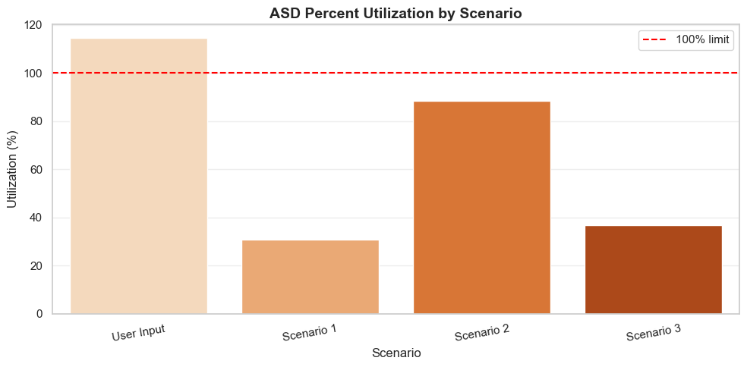

Sequence of Implementation
The sequence of user input to result is as follows:
- The DesignInput data class stores the following fields:
  - Scenario name: Defaults to User Input.
  - Shape: Calls prompt_shape function which standardizes the input and then calls the get_ag function which checks if the input is in W_Shape_Table.csv. If the shape is found in the csv, the shape argument is set to the input. If it is not, it prompts the user for a valid shape.
  - Material: Calls prompt_material function which standardizes the input and then calls the get_fy function which checks if the input is in ASTM_Material_Fy_Table.csv. If the material is found in the csv, the material argument is set to the input. If it is not, it prompts the user for a valid material.
  - Dead Load: Calls the prompt_nonnegative_float function which standardizes the input and checks if the value is a nonnegative number. If it is, the dead load argument is set to the input; otherwise, it prompts the user for a valid input.
  - Live Load: Calls the prompt_nonnegative_float function which standardizes the input and checks if the value is a nonnegative number. If it is, the live load argument is set to the input; otherwise, it prompts the user for a valid input.
- The results are calculated by calling the evaluate_cases function using the following arguments:
  - Cases: This is a list of the 4 cases specified earlier in the program. These include the user case which contains all the values stored in the DesignInput data class and the 3 other scenarios with predefined DesignInput data class field values.
  - Shapes Data Frame: This is the W_Shape_Table.csv turned into a data frame using pandas.
  - ASTM Data Frame: This is the ASTM_Material_Fly_Table.csv turned into a data frame using pandas.
- The evaluate_cases function returns the selected rows by calling the function run_case 1 time for each scenario. For each scenario, the following operations are performed:
  - Material_used and Fy are set to their respective values using the get_fy function which returns the correctly formatted material and the minimum yield stress of the material chosen.
  - Ag is found by calling the get_ag function which finds the cross-sectional area of the specified designation.
  - The result is then calculated by calling the tensile_yielding_check function which performs all the governing equations using the data we’ve collected from the scenario. These equations can be found under the “Governing Equations” section of the report. The results of these equations are then returned and stored in the variable named result.
  - Finally, all selected rows are returned with the respective scenario’s values.
- The results returned by the evaluate_cases function are then formatted to reduce excessive decimals and are printed into a summary table.

Results
The notebook evaluated both the user input scenarios and three predefined comparison scenarios created by the team. The outputs consist of a results table and two utilization plots, one for the LRFD and the other for ASD. By doing so, the results allow the user to make direct comparisons on how each W-shape member performs under the specified loading conditions.

Summary Table of Tensile Yielding Results for all Scenarios
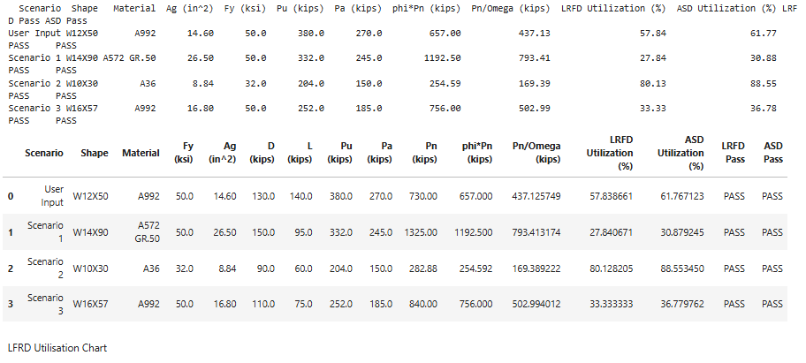
Figure 1 shows the LRFD percent utilizations for the user scenario along with the three predefined comparison scenarios. The results show a visible difference in member performance which varies depending on the gross area and the materials' overall strength. Scenario 2, which uses the smallest W10X30 member made from A36 steel, gives the highest LRFD utilization percent right around 80%, making it the closest of the 4 scenarios to the max design limit. The user input falls right in the middle with a LRFD utilization percentage around 58% proving that the W12X50 member provides more than enough capacity to support the load with a good margin of safety included. Scenarios 1 and 3 show to have the lowest LRFD utilization percents hovering around ~30%, which is a direct reflection of a larger cross-sectional area given the beam selection. Though all four scenarios do pass both LRFD and ASD requirements, scenario 2 is the outlier as it nears its maximum design limit as is, therefore any additional or unexpected increase in member loading may cause a failure.

LRFD Percent Utilization by Scenario
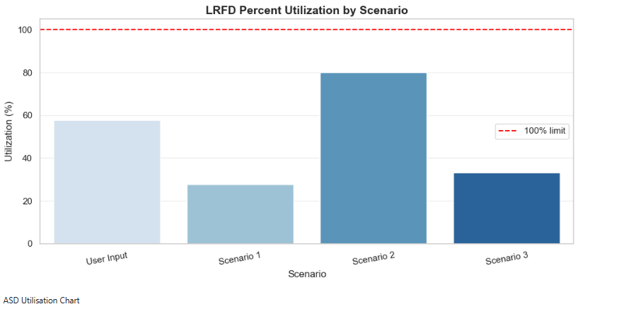

The LRFD percent utilization plot was created to compare the factored load performance of the user defines scenario as well as the three predefined W shape tension member scenarios. The results show a clear difference in how efficient each member is at holding the applied load. Scenario 2, the W10X30, A36 steel, shows the highest LRFD utilization right around 80%, meaning it is the closest to reaching the 100% maximum design limit and the most important case as any additional loads could cause the member to fail. The User input falls right in the middle ground, and is much easier to visualize with this plot, with a LRFD utilization percent at 58% showing that the users' W12X50 member provides enough capacity with a margin of safety attached. Scenarios 1 and 3 exhibit the lowest LRFD utilization percents right around 30% as these members have a much larger cross-sectional area thus provide a much larger tensile strength. Overall, the LRFD plot visualizes the passing of the four scenarios but gives helpful insight on which member is nearing its maximum load design or could be reworked to become more efficient in the building design.

ASD percent utilization by Scenario
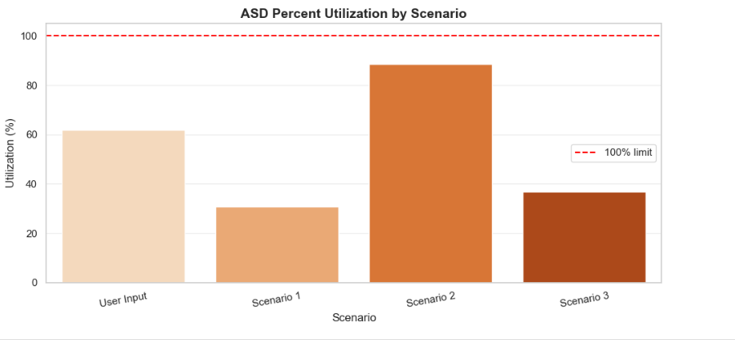

The ASD percent utilization plot provides a service level comparison of the four scenarios that were evaluated and demonstrates how each selected W shape member performs under the tensile load. Very similar to the LRFD, result 2 with the W10X30, A36 steel is the most utilized material reaching roughly 88% of its allowable tensile strength. This makes scenario 2 the closest to its ASD design limit, as well as the least conservative of the four scenarios carried out. The user input scenario again falls in the middle ground with an ASD utilization percent of roughly 62%, proving that the W12X50, A992 steel provides more than enough tensile load capacity with a good margin of error to deal with. Scenarios 1 and 3 remain the lowest with ASD utilization rates hovering right around 33%, due to their much larger cross-sectional area. Overall, the ASD and LRFD plots demonstrate very similar trends in that they both display the passing of all four scenarios but visually show which members are close to their maximum limit and need potential reworking, as well as which members are the most efficient for the given load.

Conclusion
Our Python program successfully and efficiently automates the tensile yielding design process for structural steel members by combining user inputs, ASTM material properties, and W-Shape Designation data, and AISC governing equations into a single simple design process. Using the use of pandas data frames and many modular functions, we developed a program that retrieves material properties and designation properties from csv data based on inputted user valuers that calculate LRFD and ASD stress and percent utilization values that are then plotted against existent scenarios.
Our design creates a very modular and structured approach to the computations by storing external csv files, validating user inputs, calculating values, and then outputting the results into both a formatted table and 2 bar charts that help users visualizes the capacity of their inputted scenario under both LRFD and ASD specifications. Our code reduces the likelihood of user calculation error by performing standardized calculations that are readable, and much quicker than human calculations.
Overall, the program provides a quick, reliable, and repeatable method for evaluating design scenarios for W-Shaped beams that produces a clear summary table and excellent documentation to help users understand our computation process. The project shows how programming can be implemented into structural engineering design to improve computational efficiency.

References
American Institute of Steel Construction. (2011). Steel Construction Manual (14th edition). American Institute of Steel Construction.
American Institute of Steel Construction. (2011). Design examples for the 14th-edition Steel Construction Manual. American Institute of Steel Construction.

