Chris Bero

PH114-08

January 31st, 2013

Daniel M., Eric M., Elizabeth S.

An Exploration Of The Simple Pendulum

Statement of Purpose:

Our group will observe a pendulum under several different conditions and view firsthand the mechanical operation of simple pendulums.

Introduction:

This experiment taught us several basic principles of the mechanical nature of pendulums. By varying the length, amplitude, and mass of the pendulum we observed how its period was affected. We accomplished this by hanging different masses of wood on string from a ring stand and manually adjusting the amplitude of release.

Equipment:

Datastudio, block, string, ruler, rangefinder, calculator, pencil, ringstand.

Procedure:

1. Set up the ring stand with >100cm of room underneath the pendulum clamp.
2. Hang up a pendulum ~100cm long from the ring stand.
3. Pull the block back 10cm from its resting position, record ten full swings.
4. Take three sets of this data at 10cm.
5. Calculate the average of the three.
6. Repeat the process but only pull the block 5cm to the side.
7. Calculate the average of the next three sets of swings
8. Change to a block of different mass.
9. Record 10 more swings from a 10cm amplitude.
10. Determine from the two 10cm sets whether the mass affects the period.
11. Repeat three sets of ten swings for 100cm, 75cm, and 50cm lengths of string
12. Graph the results of the length-varied data

Data:

On data sheet.

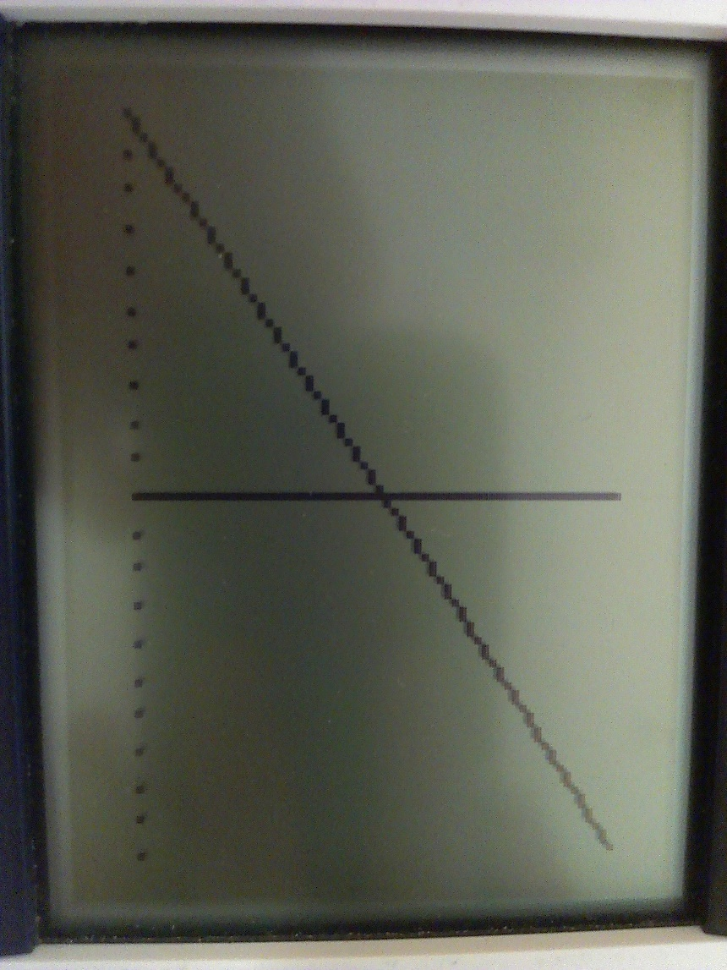

Analysis:

There were several possible errors apparent in the experiment. Neither the method available to measure the length of the pendulums nor the system for measuring the amplitude and releasing the bob were precise devices. We found that the mass and amplitude did not significantly affect the pendulum’s period. We saw less than .01s variance in period with respect to amplitude, and received the same averages for varied weight. The length did affect the period, and our graph showed a linear relationship.

Conclusion:

In our experiment we discovered the relation between various aspects of pendulum behavior. By controlling different aspects of the pendulum we found that the period is not affected by amplitude or weight, but is affected by length.