**CPE 435 Operating System Labs**

**Lab 8: POSIX Threads**

**Introduction:**

A thread is a semi-process, which has its own stack, and executes a given piece of code. Unlike a real process, the thread normally shares its memory with other threads (where as for processes we usually have a different memory area for each one of them). A Thread Group is a set of threads all executing inside the same process. They all share the same memory, and thus can access the same global variables, same heap memory, same set of file descriptors, etc. All these threads execute in parallel (i.e. using time slices, or if the system has several processors, then really in parallel).

Pthreads are defined as a set of C language programming types and procedure calls. Vendors usually provide a Pthreads implementation in the form of a header/include file and a library, which you link with your program.

**Sample code:**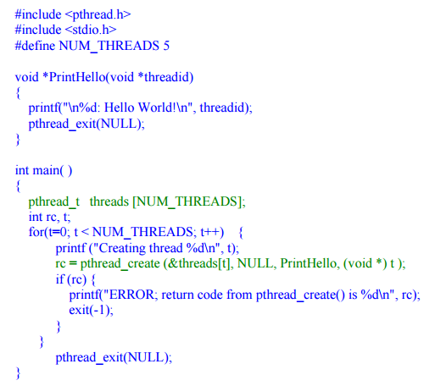

**Task:**

*Write a parallel program to compute the definite integral using Rectangular decomposition:*

$4*\int_{0}^{1}{\sqrt{1-x^{2} }}$.dx

*Write a program in a general pthreads manner, so that they can utilize an arbitrary number of processes/threads so the computation is divided among these computational entities as evenly as possible. Design program so that the number of intervals can be entered as a run time parameter by the user under the constraint that it must be greater than or equal to the number of processes/ threads that are used. Empirically evaluate a decomposition in terms of execution time for large number of intervals for an eight process/thread case and general accuracy (the integral’s value is* ***pi ,****you will get**best approximation of* ***pi*** *as the number of intervals increases**) .*

*You are expected to do the following tasks:*

* *Write a serial code version to compute integral, using timing function evaluate it is execution time .*
* *Write a parallel version of code using pthreads model, compare the result and execution time.*
* *Compare the performance of two models (serial and pthreads ).try different number of intervals by increasing the number. Show graph to summary the execution time of the two models versus different number of intervals.*

*Hint:*

*You need to study the integral using rectangular decomposition, or trapezoidal method.How to measure the execution time in serial programs. Also timing function could be used to measure the execution time in pthread model.*