FlyByWire feature user manuals
One manual per pull request (pr/01 to pr/26): what the feature does, how to use it, what to expect in each situation, and its current limitations with the reason.
A32NX and A380X · written 2026-09-28 against the builds installed in the sim (develop plus the pr/* features).

How to read these manuals
- What it is for: the problem the change solves, in one paragraph.
- Using it / numbered steps: where the controls are and what to press.
- What you should see tables: the expected behaviour in each situation; if the sim does something else, it is a bug worth reporting with the PR number.
- Limitations and why: what does not work yet, the reason (sim limit, missing data, not in the FCOM, out of scope) and what to do about it.
- Stacked PRs need the PRs below them installed: the branch line of each manual names them.
- Instrument pictures come from a local browser harness running the installed instrument bundles. Pictures that do not come from the harness (drawn diagrams, in-sim screenshots taken during development) carry an amber line under their caption: they are not representative of the in-game UI and serve as a reference for the explanation only.

Contents
If the list below is empty, right-click it and choose Update Field.

PR 1 - A32NX weather radar on the ND
A native weather radar picture on both A32NX NDs, from MSFS's own radar data
Aircraft | A32NX
Where to find it | ND in ARC or ROSE NAV; the weather radar panel on the pedestal (WX SYS and MODE knobs)
PR branch | pr/01-a32nx-nd-weather-radar (base of PRs 2, 4, 3, 9)
Status | Tested in the sim over several sessions and weather presets (September 2026).
Pictures | In-sim screenshots taken during development (the radar is drawn by a native WASM gauge, which the browser harness cannot run).

1. What it is for
The A32NX ND had no working weather radar. A native gauge (ndwxr) now draws the MSFS weather radar on the CPT and F/O NDs, aligned with the range rings, in the colours of an airborne radar.
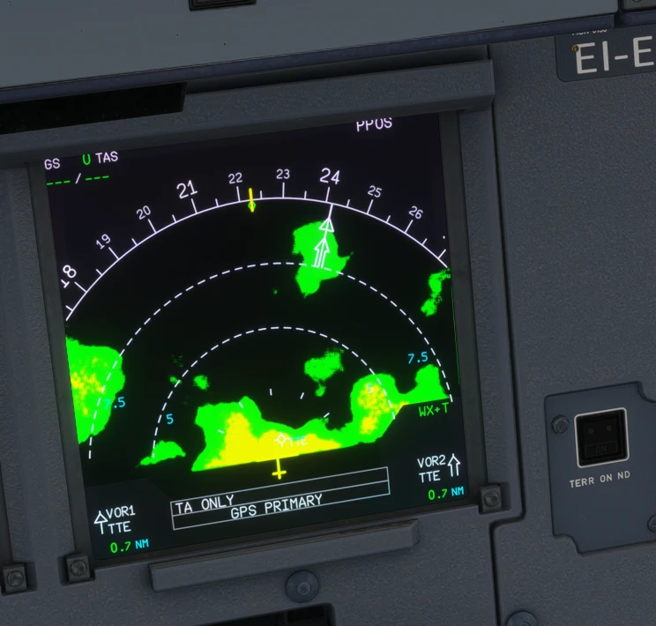  Figure 1. A32NX ND in ARC with weather ahead: green, yellow and red cells.  In-sim screenshot taken during development: not representative of the final in-game UI, reference for the explanation only. | 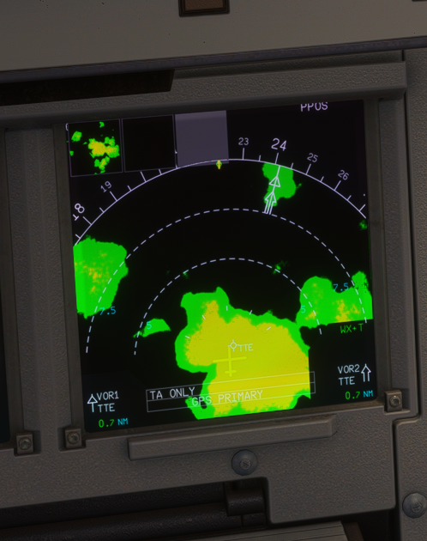  Figure 2. Another cell field, ROSE-like forward view.  In-sim screenshot taken during development: not representative of the final in-game UI, reference for the explanation only.

2. Using it
Control | Position | ND
WX SYS knob | SYS 1 / SYS 2 | Radar on (system 1 or 2)
 | OFF | No radar
MODE knob | WX | Precipitation
 | WX+T | Precipitation and turbulence (magenta)
 | TURB | Turbulence only
 | MAP | Nothing (no ground map)
EFIS | ARC or ROSE NAV | Radar shown (forward half); nothing on ROSE ILS, ROSE VOR, PLAN

The selected mode is written in green on the ND (see the PR 3 manual).

3. Reading the picture
Colour | Rain rate | Meaning
Green | from 0.7 mm/h | Light precipitation
Yellow | from 4 mm/h | Moderate
Red | from 12 mm/h | Heavy: avoid
Magenta | above 20 mm/h, within 40 NM | Turbulence (WX+T, TURB)

The engine's rain rate is noisy pixel by pixel; each level is smoothed, so the picture shows solid areas with crisp edges.

4. What to expect
Situation | What you should see
On the ground | Nothing drawn: like a real radar, it does not transmit with both main gear compressed.
Clear sky | No picture (nothing to return).
WX SYS OFF, or MODE MAP | No picture.
CPT and F/O NDs | Independent: each ND uses its own IR position (IR 1 CPT, IR 2 F/O, IR 3 by the ATT HDG knob) and its own range and mode; the two knobs are shared.

5. Limitations and why
Limitation | Why | What to do
Turbulence is a proxy. | MSFS gives no turbulence data; rain above 20 mm/h within 40 NM is drawn magenta. | -
No tilt, no gain. | The MSFS radar has neither. | -
Drawn only airborne with weather around. | The MSFS radar image needs both. | Test with the MSFS weather presets.

PR 2 - A380X weather radar on the ND and weather on the VD
The native weather radar on both A380X NDs, driven by the SURV panel, and the weather on the vertical display
Aircraft | A380X
Where to find it | ND in ARC or ROSE NAV with the WX overlay selected on the EFIS panel; MFD SURV CONTROLS (WXR block); the VD under the ND
PR branch | pr/02-a380x-nd-weather-radar (stacked on PR 1)
Status | Tested in the sim (September 2026).
Pictures | In-sim screenshots taken during development (native WASM gauge; the browser harness cannot draw it).

1. What it is for
The A380X ND always showed WXR INOP (both WXR systems were hard-coded as failed) and had no radar picture. It now has the native radar of the A32NX, with the A380 rules, and the VD shows the weather on its vertical cut.
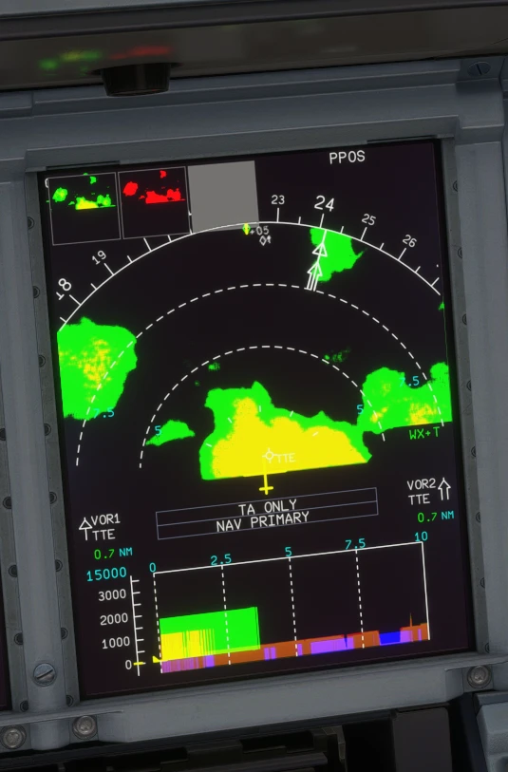
Figure 3. A380X ND with weather cells ahead, and the same cells on the VD below.
In-sim screenshot taken during development: not representative of the final in-game UI, reference for the explanation only.

2. Using it
- EFIS control panel: select the WX overlay.
- MFD SURV CONTROLS (see the PR 5 manual): WXR AUTO, TURB on or off, MODE WX or MAP, WX ON VD.
- The radar is shown when the WXR & TAWS system selected on the SURV panel is not failed. A system is failed only while its AESU is reset or its power is lost (AC ESS for system 1, AC 4 for system 2).
- The ND range table is -1 (ZOOM, the airport map) and 10 to 640 NM; the radar is hidden at ZOOM.
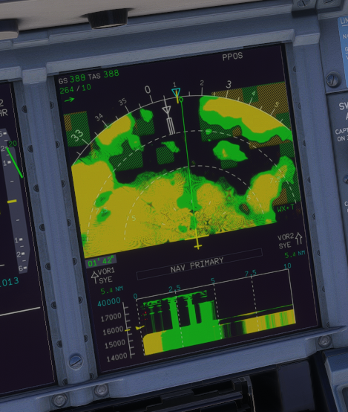  Figure 4. Moderate rain (yellow) over a wide area, with its VD cut.  In-sim screenshot taken during development: not representative of the final in-game UI, reference for the explanation only. | 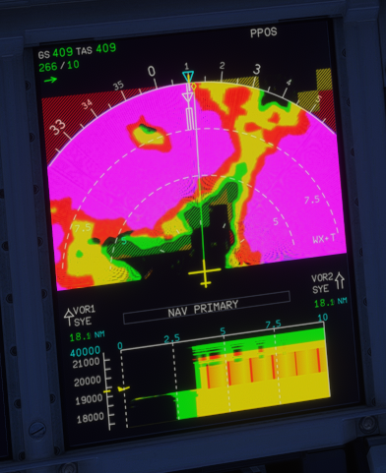  Figure 5. TURB on: heavy rain drawn magenta (turbulence proxy).  In-sim screenshot taken during development: not representative of the final in-game UI, reference for the explanation only.

3. Weather on the VD
- WX ON VD (SURV CONTROLS) shows the weather on the VD, along the same cut as the terrain (see the PR 9 manual).
- Cells are drawn green and yellow with a red core; no magenta: the real VD does not display turbulence (FCOM DSC-31-20-40-10).
- Heights are placed on the ADR baro-corrected altitude, like the VD's aircraft symbol.

4. Limitations and why
Limitation | Why | What to do
The VD weather is stylised. | The vertical MapView of MSFS is a single thin beam (tilting it crashes the gauge); the VD picture is built from the ND radar views. | -
PRED W/S and GAIN are not drawn. | The MSFS radar has no predictive windshear or gain. | -
No TURB-only mode. | The A380 has none: TURB off gives WX, on gives WX+T. | -

PR 3 - Weather radar mode on the ND
The selected weather radar mode (WX, WX+T, TURB, MAP) is shown in green on the ND, on both aircraft
Aircraft | A32NX and A380X
Where to find it | ND, ARC and ROSE NAV pages, right side, above the TERR box
PR branch | pr/03-nd-wxr-mode-label (stacked on PR 4)
Status | Tested in the sim (September 2026).
Pictures | Captain NDs in the local browser harness, running the builds installed in the sim (the radar picture itself is drawn by the native gauge, not by the harness).

1. What it is for
Nothing on the ND told the crew which radar mode was selected. The mode now appears in green on the right of the ARC and ROSE NAV pages while the radar is on, as on the real ND.
Label | A32NX (MODE knob) | A380X (SURV CONTROLS)
WX | WX | WX (TURB off)
WX+T | WX+T | WX with TURB on
TURB | TURB | -- (no TURB-only mode on the A380)
MAP | MAP | MODE MAP
(none) | WX SYS OFF | WXR off, no WX overlay, or the WXR & TAWS system failed

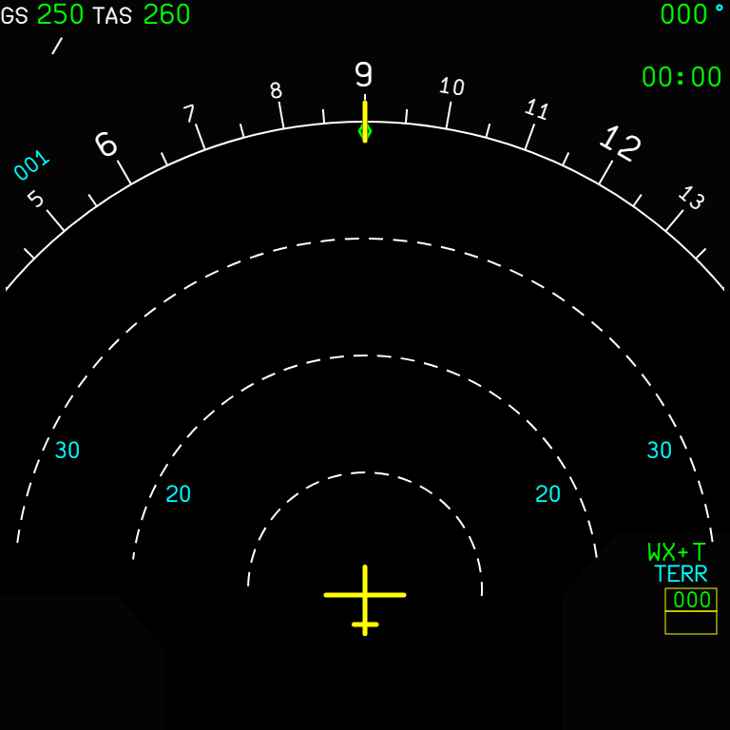  Figure 6. A32NX ARC: WX+T above the TERR box. | 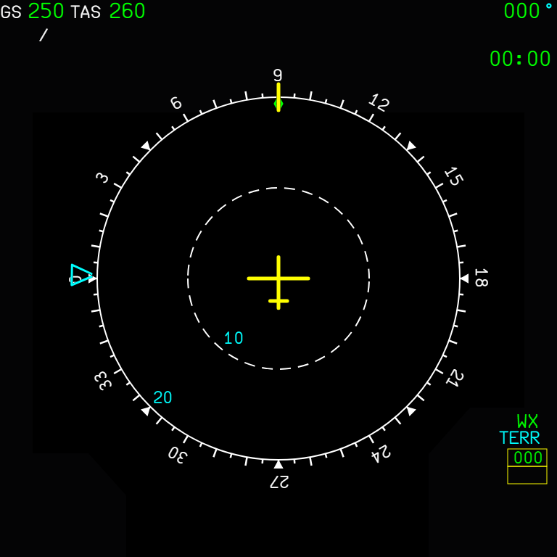  Figure 7. A32NX ROSE NAV: WX.

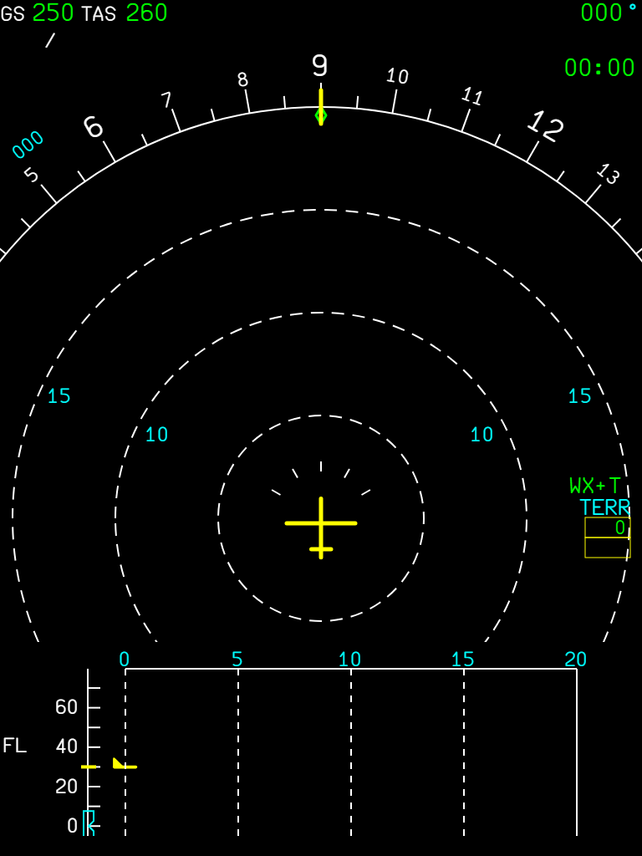
Figure 8. A380X ARC: WX+T.
- Shown only on ARC and ROSE NAV pages, and not while the terrain replaces the weather (TERR ON ND).
- Shown on the ground too, where the radar itself does not transmit (nothing is drawn).
- The native radar gauge decides and publishes the label (`A32NX_WXR_ND_{L,R}_MODE`), so the ND follows exactly what the gauge draws.

2. Limitations and why
Limitation | Why | What to do
No label in PLAN, ROSE ILS, ROSE VOR. | The radar is not shown on those pages. | -

PR 4 - Terrain on the ND (TERR ON ND) and A380X VD terrain
EGPWS terrain display on the ND of both aircraft without SimBridge, from MSFS's own terrain data, and the terrain profile on the A380X vertical display
Aircraft | A32NX and A380X
Where to find it | A32NX: TERR ON ND pushbutton; A380X: the TERR overlay on the EFIS panel (a WXR & TAWS system selected and not failed); the VD under the A380X ND
PR branch | pr/04-nd-terrain (stacked on PR 2)
Status | Tested in the sim by the user: OK (2026-09-29).
Pictures | In-sim screenshots at Aspen (KASE) during development (native WASM gauge).

1. What it is for
TERR ON ND needed SimBridge. The native gauge now draws it from MSFS's own terrain, with the EGPWS colours, on every map page but PLAN, also on the ground.
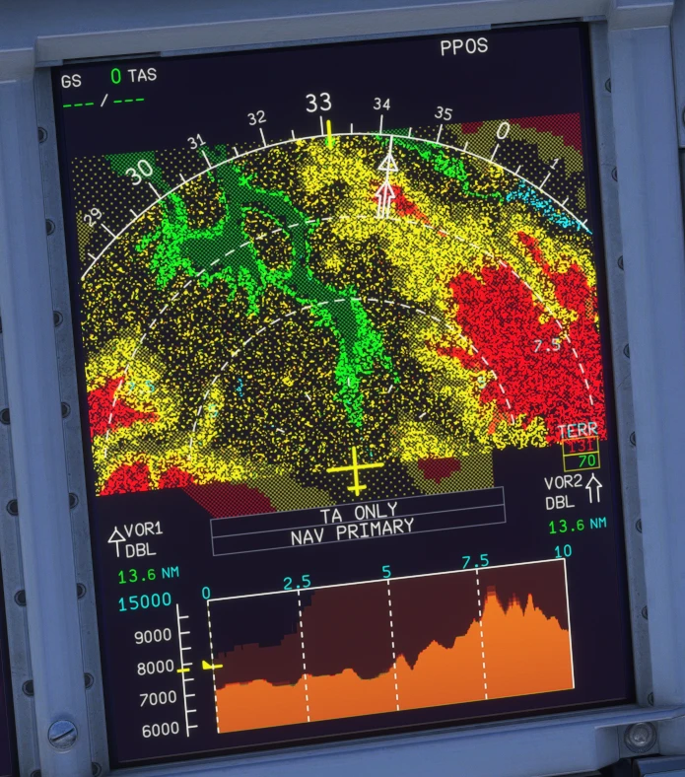  Figure 9. A380X at Aspen, 10 NM: terrain far above the aircraft in red, close in yellow, below in green; the VD terrain profile in brown.  In-sim screenshot taken during development: not representative of the final in-game UI, reference for the explanation only. | 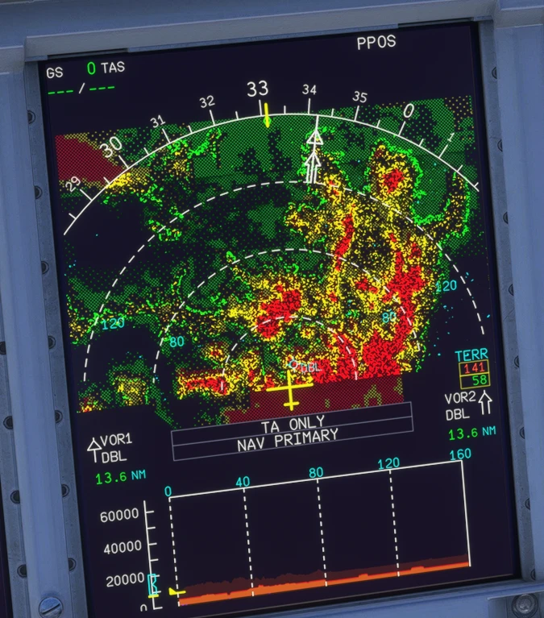  Figure 10. The same place at 160 NM.  In-sim screenshot taken during development: not representative of the final in-game UI, reference for the explanation only.

2. Reading the colours
Terrain relative to the aircraft | Colour
More than 2000 ft above | Dense red
1000 to 2000 ft above | Dense yellow
500 ft below (250 ft gear down) to 1000 ft above | Medium yellow
Down to 1000 ft below (500 ft gear down) | Dense green
1000 to 2000 ft below | Light green
More than 2000 ft below | Nothing
Water | Cyan-blue dots

The dots are a random stipple, as on the real display. The map turns with the ND's heading; ARC shows the forward half, the ROSE modes the whole disk.

3. A380X vertical display
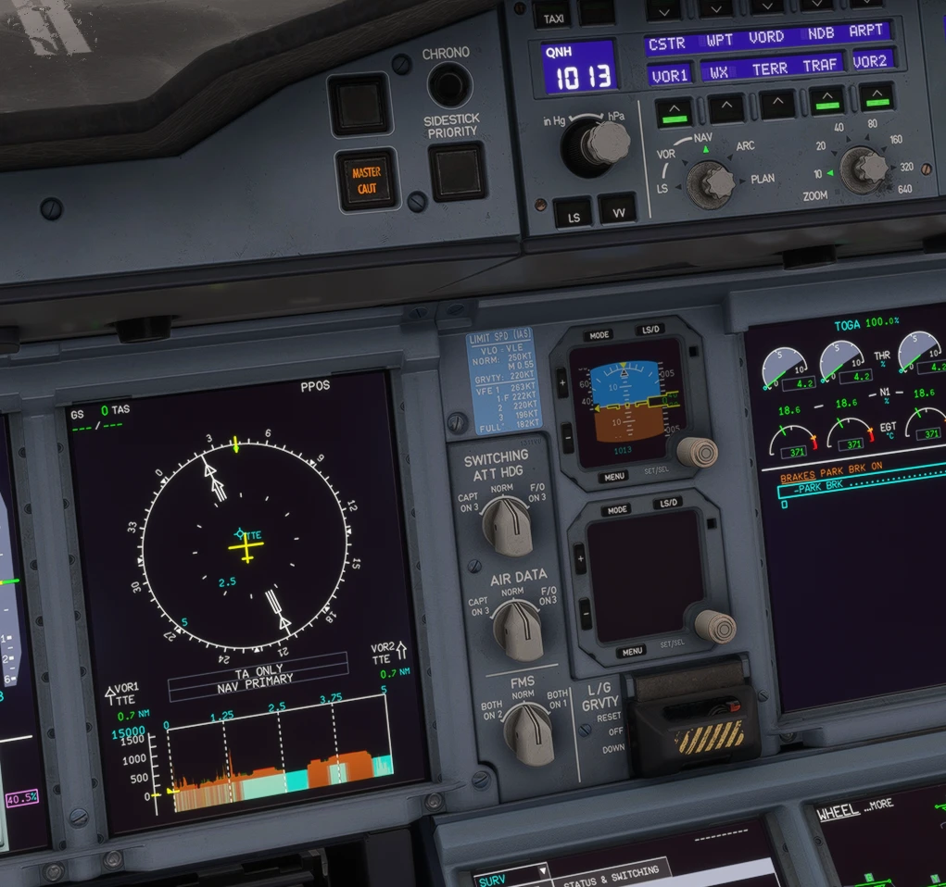
Figure 11. The A380X VD terrain profile (brown), water in cyan from sea level down.
In-sim screenshot taken during development: not representative of the final in-game UI, reference for the explanation only.
- Needs the TERR SYS of the SURV page not OFF (otherwise NO TERR DATA AVAILABLE, see the PR 5 manual).
- The cut follows the flight plan or the track (PR 9 manual).

4. The peaks box
The TERR box with the highest and lowest elevations of the range needs real elevations, which a gauge cannot read from MSFS: its figures come from SimBridge when it runs. Without SimBridge the box stays empty and the terrain is drawn as usual.

5. Limitations and why
Limitation | Why | What to do
At most 8 map views per module. | MSFS crashes a 9th; the A380X switches its views between weather and terrain. | -
Peaks box only with SimBridge. | No elevation readback from MSFS. | Run SimBridge.
Terrain far above the range top is shown red. | MSFS does not clamp to the first colour entry. | -

PR 5 - A380X SURV controls and pedestal SURV panel
The weather radar block of the MFD SURV CONTROLS page, the STATUS & SWITCHING page and the pedestal SURV panel now work and drive the same systems
Aircraft | A380X
Where to find it | MFD system menu SURV (or the KCCU SURV key): CONTROLS and STATUS & SWITCHING; the SURV panel on the pedestal
PR branch | pr/05-a380x-surv-panel (base of PR 6)
Status | Tested in the sim (September 2026).
Pictures | Captain MFD and ND in the local browser harness, running the build installed in the sim; figure 3 is an in-sim screenshot.

1. What it is for
The A380 has no separate radar, TCAS or TAWS control panels: they are on the MFD SURV pages and the pedestal SURV panel (FCOM DSC-34-20-60-50). In FBW the weather radar block of the page was a stub (every button greyed), STATUS & SWITCHING did not reflect failures, and no button of the pedestal panel worked. Now they do, and the page and the panel stay in step.

2. SURV CONTROLS
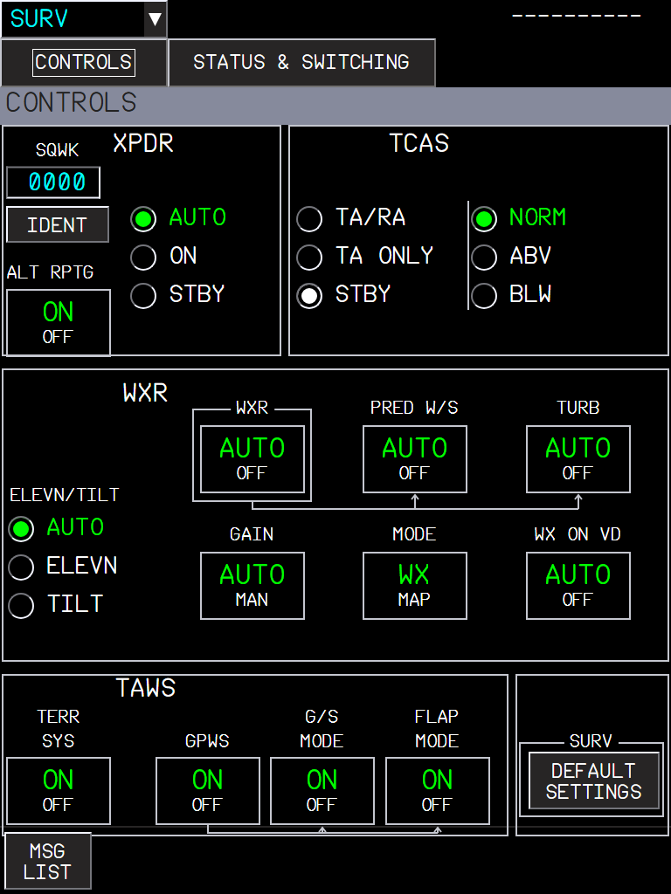
Figure 12. SURV CONTROLS: XPDR (code, IDENT, AUTO / ON / STBY, ALT RPTG), TCAS (TA/RA, TA ONLY, STBY; NORM, ABV, BLW), WXR, TAWS, and DEFAULT SETTINGS.
WXR button | Effect
WXR AUTO / OFF | Weather radar on or off (the ND radar picture).
PRED W/S AUTO / OFF | Predictive windshear (written for the systems; MSFS has no predictive windshear).
TURB AUTO / OFF | Turbulence detection (magenta on the ND, see the radar manuals).
GAIN AUTO / MAN | Radar gain (written; MSFS has no gain).
MODE WX / MAP | Weather or ground mapping.
WX ON VD AUTO / OFF | Weather on the vertical display.
ELEVN / TILT | AUTO, or a manual elevation or tilt.

The WXR buttons are inhibited only when the selected WXR system has really failed.

3. STATUS & SWITCHING
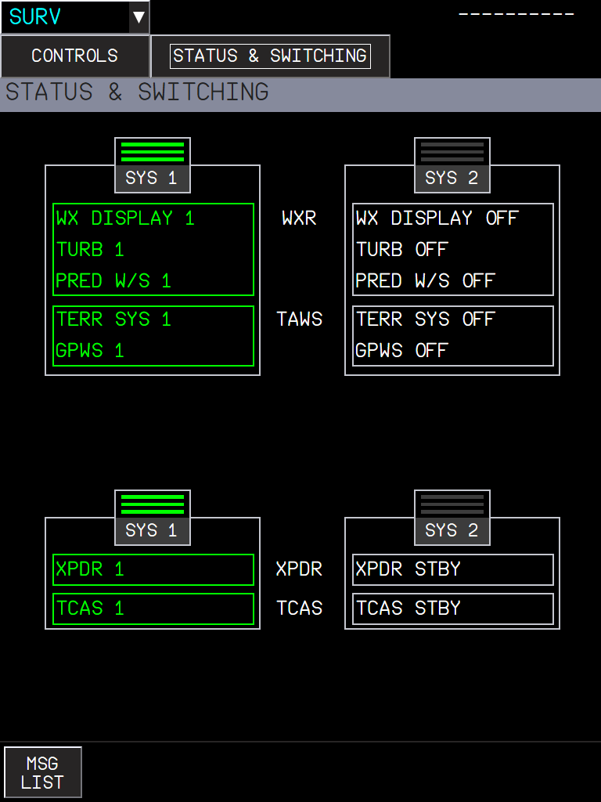
Figure 13. STATUS & SWITCHING: SYS 1 / SYS 2 of the WXR and TAWS (top) and of the XPDR and TCAS (bottom); the selected system is lit, each item shows its real state.
- WXR DISPLAY, TURB, PRED W/S, TERR SYS, GPWS items show the real failure of each system.
- XPDR / TCAS SYS 1 / SYS 2 select the transponder system (the one the TCAS uses) and light from it.
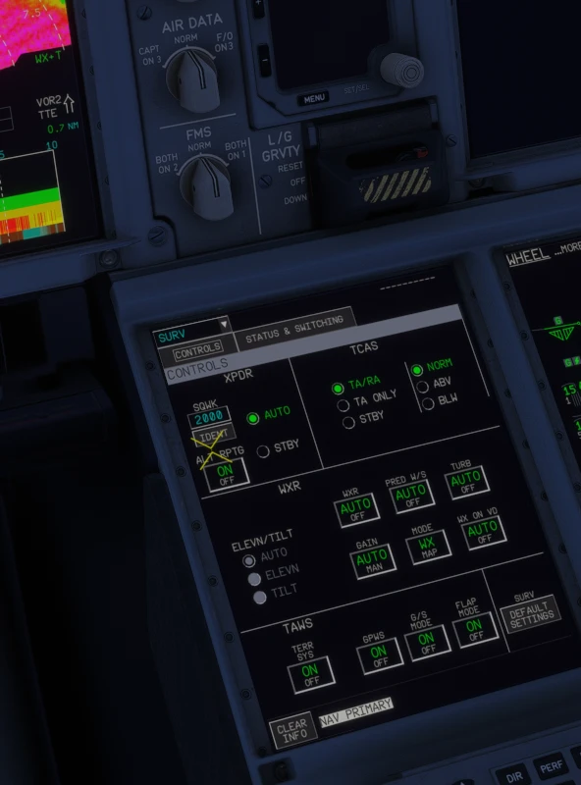
Figure 14. The SURV CONTROLS page in the sim (in-sim screenshot).
In-sim screenshot taken during development: not representative of the final in-game UI, reference for the explanation only.

4. The pedestal SURV panel
The panel buttons never worked: their light template runs the button code only when the panel is powered, and the pedestal never told it so. They are powered from DC 1 now and linked to the MFD pages:
Panel button | Does | Same as
WXR TAWS SYS 1 / SYS 2 | Selects the WXR / TAWS system | STATUS & SWITCHING, top
XPDR TCAS SYS 1 / SYS 2 | Selects the transponder system | STATUS & SWITCHING, bottom
G/S MODE | Glide slope mode of the GPWS on / off | SURV CONTROLS, TAWS
TCAS ABV / BLW / TA ONLY | TCAS display and mode | SURV CONTROLS, TCAS

Each button lights from the same value the page uses, so pressing one on the pedestal changes the page, and the reverse.

5. Messages on the vertical display
The VD message was always "NO TERR AND WX DATA AVAILABLE" when TERR SYS was off. Now:
Situation | VD message
TERR SYS OFF only | NO TERR DATA AVAILABLE
WXR failed or OFF, or WX ON VD OFF | NO WX DATA AVAILABLE
Both | NO TERR AND WX DATA AVAILABLE

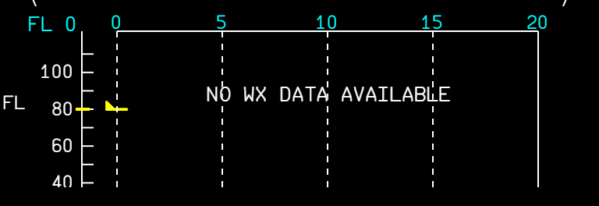  Figure 15. WXR off: NO WX DATA AVAILABLE. | 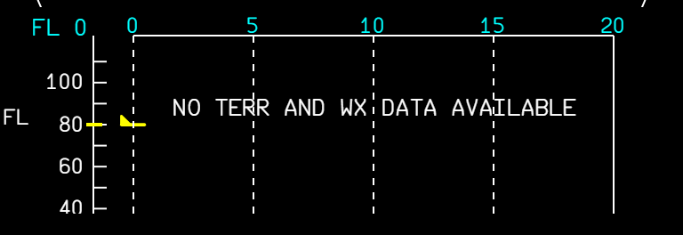  Figure 16. TERR SYS off and WXR off: NO TERR AND WX DATA AVAILABLE.

6. Limitations and why
Limitation | Why | What to do
PRED W/S and GAIN MAN do nothing visible. | The MSFS radar has no predictive windshear and no gain; the values are written for when it does. | -
One MSFS radar for both systems. | SYS 1 / SYS 2 select the failure state and the lights; the picture comes from the same sim radar. | -

PR 6 - ECAM procedure lines for the SURV systems, and CABIN CREW on the LINE-UP checklist
The WXR & TAWS and XPDR & TCAS lines of the ADR / IR / TCAS fault procedures tick from the real system selection
Aircraft | A380X
Where to find it | EWD procedures (ADR x+y FAULT, IR x+y FAULT, TCAS 1 / 2 FAULT); MFD SURV STATUS & SWITCHING page; EWD checklist LINE-UP
PR branch | pr/06-a380x-checklists-surv (stacked on PR 5: needs its system selection)
Status | Tested in the sim (September 2026).
Pictures | EWD and MFD in the local browser harness, running the builds installed in the sim; the EWD states are the ones the FWS sends.

1. What it is for
The dual ADR and IR fault procedures ask the crew to move the WXR & TAWS and the XPDR & TCAS to the system that still has valid data. Those lines were hard-coded as done, so the ECAM ticked them even when the wrong system stayed selected. They now follow the selection made on the MFD SURV STATUS & SWITCHING page (PR 5), and the TCAS 1 / 2 FAULT procedures show their XPDR & TCAS line, which was hidden.

2. Where the systems are selected
Figure 17. MFD SURV STATUS & SWITCHING: the SYS 1 / SYS 2 buttons of WXR & TAWS (top) and XPDR & TCAS (bottom).

3. What you see
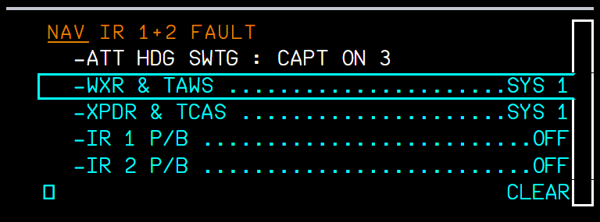  Figure 18. IR 1+2 FAULT with both systems on SYS 2: the two lines wait, in cyan. | 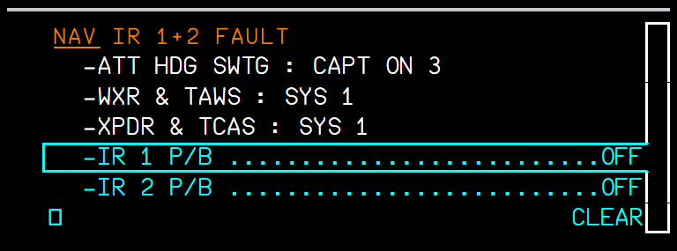  Figure 19. After selecting SYS 1 on the SURV page: the lines are done (white) and the cursor moves on.

Procedure | WXR & TAWS | XPDR & TCAS
ADR 1+2 FAULT, ADR 2+3 FAULT, IR 1+2 FAULT, IR 2+3 FAULT | SYS 1 | SYS 1
ADR 1+3 FAULT, IR 1+3 FAULT | SYS 2 | SYS 2
TCAS 1 FAULT | - | SYS 2
TCAS 2 FAULT | - | SYS 1

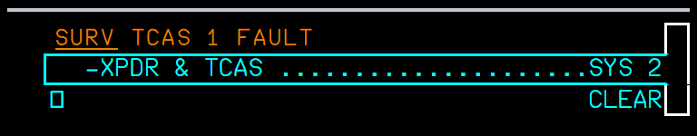
Figure 20. TCAS 1 FAULT: the XPDR & TCAS line is now shown.
Situation | What you should see
The right system is already selected when the fault appears | The line is shown already done.
The crew selects the other system | The line ticks within a second; the cursor moves to the next line.
The crew goes back to the failed side | The line becomes due again (it follows the live selection).

4. LINE-UP checklist
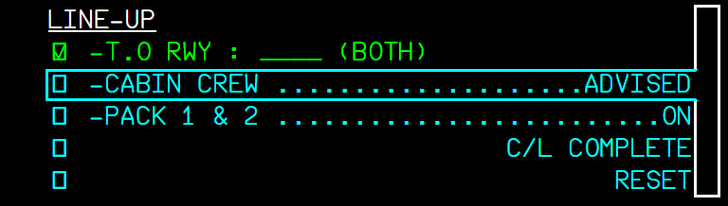
Figure 21. ECAM LINE-UP: the CABIN CREW ... ADVISED line (crew check).
The ECAM LINE-UP checklist gets the CABIN CREW line that the flyPad checklist already had (A380 FCOM BEFORE TAKEOFF checklist: CABIN CREW ... ADVISE). It is ticked by the crew.

5. Limitations and why
Limitation | Why | What to do
No SURV lines in the normal checklists. | The A380 FCOM normal checklists (PRO-NOR-C-L) have none; an earlier version of this change added some and was reverted. | -
Needs PR 5. | The system selection LVars come from the SURV panel of PR 5. | Install both.

PR 7 - TCAS in TA ONLY: intruders shown as TAs
While resolution advisories are inhibited, an intruder that would be an RA is shown and announced as a traffic advisory; the TA ONLY message is centred on the A32NX ND as in the FCOM
Aircraft | A32NX and A380X
Where to find it | ND traffic display; TCAS mode on the A32NX TCAS panel / A380X SURV CONTROLS
PR branch | pr/07-tcas-ta-only-intruder-level (independent)
Status | Tested in the sim by the user: OK (2026-09-29).
Pictures | Captain NDs in the local browser harness, running the builds installed in the sim; the symbol legend is a drawing (the harness has no traffic).

1. What it is for
With every RA inhibited (TA ONLY selected, or below 1000 ft radio altitude), the TCAS kept classifying an intruder that met the RA criteria as an RA. The ND drew it as a red RA square, and since it was not a TA, there was no "TRAFFIC, TRAFFIC" and no TA state. A real TCAS in TA ONLY shows it as an amber TA with the TA aural. The classification is now capped at TA while all RAs are inhibited.
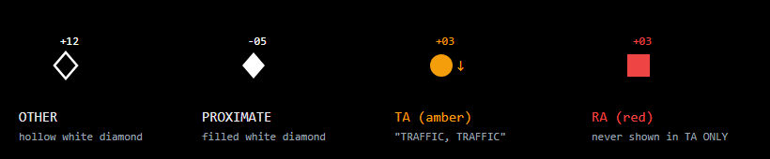
Figure 22. The ND traffic symbols: other, proximate, TA, RA, with the relative altitude in hundreds of feet and the vertical trend arrow.
Diagram drawn for this manual: not representative of the in-game UI, reference for the explanation only.

2. What you see
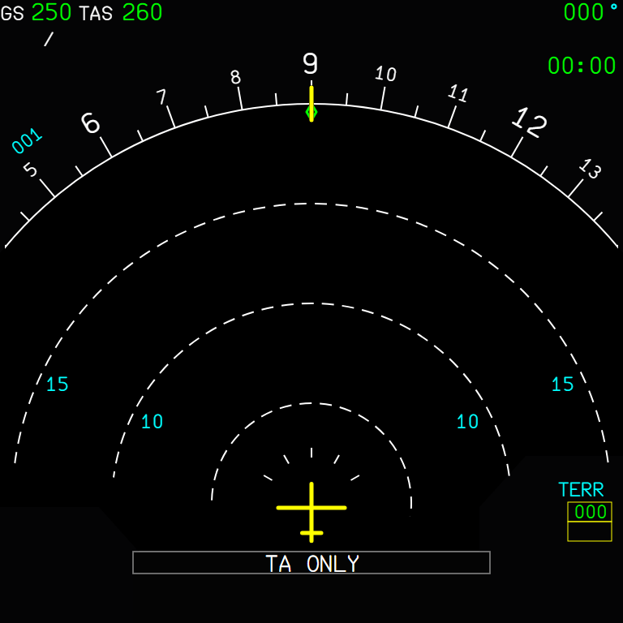  Figure 23. A32NX: TA ONLY, centred at the bottom of the ND (A320 FCOM DSC-34-SURV-60-20 figure). | 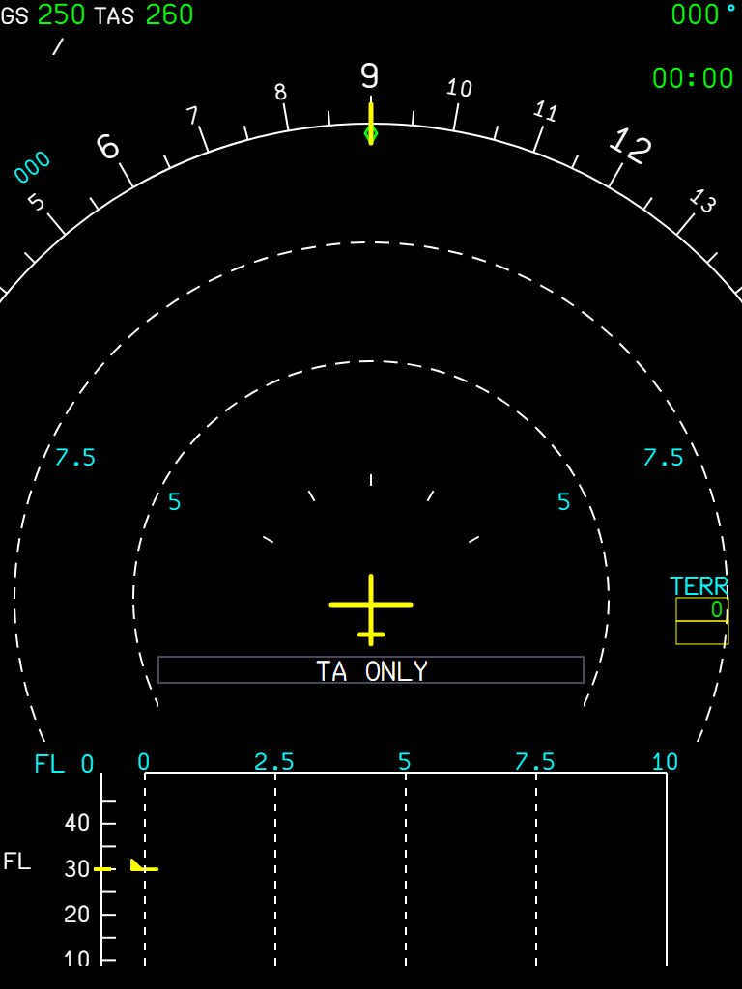  Figure 24. A380X: TA ONLY in the message box.

Situation | What you should see
TA ONLY selected, intruder meeting the RA criteria | Amber TA circle and "TRAFFIC, TRAFFIC" (before: red RA square, no aural).
Below 1000 ft radio altitude (all RAs inhibited) | Same: TAs only, TA ONLY on the ND.
Partial inhibits (no CLIMB / DESCEND / INCREASE DESCENT RA) | Unchanged: RAs are still issued.
An RA already running when the inhibit starts | It runs to its own end.

3. Limitations and why
Limitation | Why | What to do
Same change on both aircraft. | The A32NX TcasComputer and the A380X LegacyTcasComputer share the classification code. | -

PR 8 - Independent CPT and F/O MCDUs
Each MCDU has its own page, scratchpad and messages, on the one shared FMS
Aircraft | A32NX
Where to find it | The two MCDUs on the pedestal
PR branch | pr/08-a32nx-mcdu-independent (independent; the close-up cockpit model needs a companion change in aircraft-large-files)
Status | Tested in the sim (September 2026). Not to merge (2026-09-29): the pull request will not be opened; the feature stays on its branch.
Pictures | The MCDU gauge in the local browser harness, running the build installed in the sim; the gauge draws the CPT screen in its left half and the F/O screen in its right half, shown here side by side.

1. What it is for
The two MCDUs mirrored each other: same page, same scratchpad. On the aircraft each MCDU is its own display, working on the shared FMGC data (A320 FCOM DSC-22_10-10). Now each pilot can work on a different page.
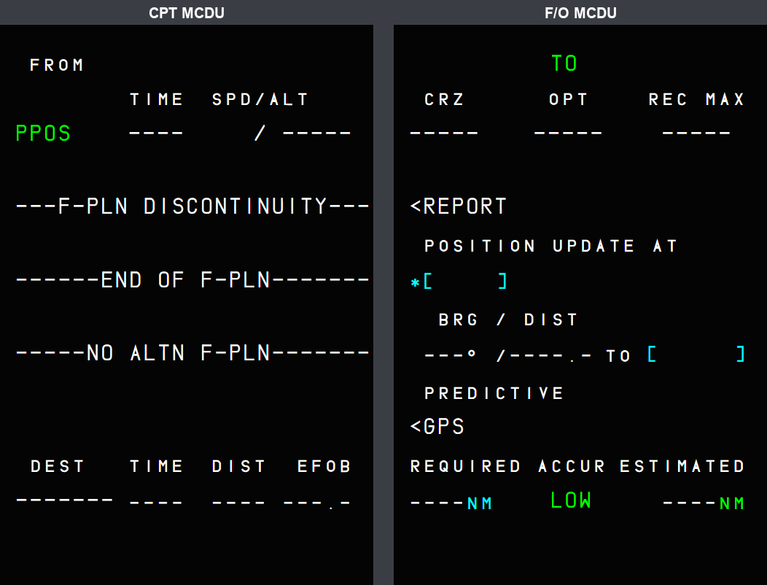
Figure 25. CPT on F-PLN, F/O on PROG at the same time.

2. What is per MCDU and what is shared
Per MCDU | Shared (one FMS)
The page shown, the line keys | The flight plans, performance, fuel, navigation data
The scratchpad and what is typed in it | The data entered from either MCDU
The scratchpad messages (FORMAT ERROR, NOT ALLOWED ...) of an entry | FMGC messages (queued on both)
The keyboard entry (the MCDU that was clicked) | The EFIS symbols, the guidance

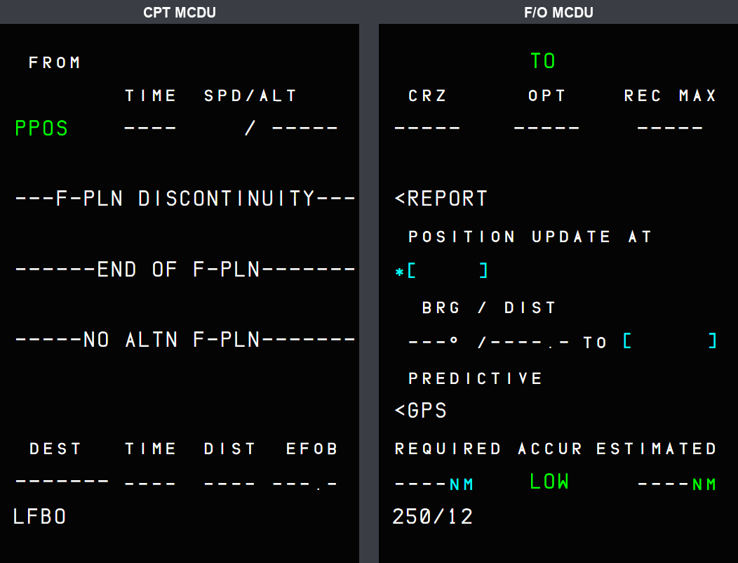
Figure 26. Each scratchpad keeps its own text: LFBO on the CPT, 250/12 on the F/O.

3. Messages
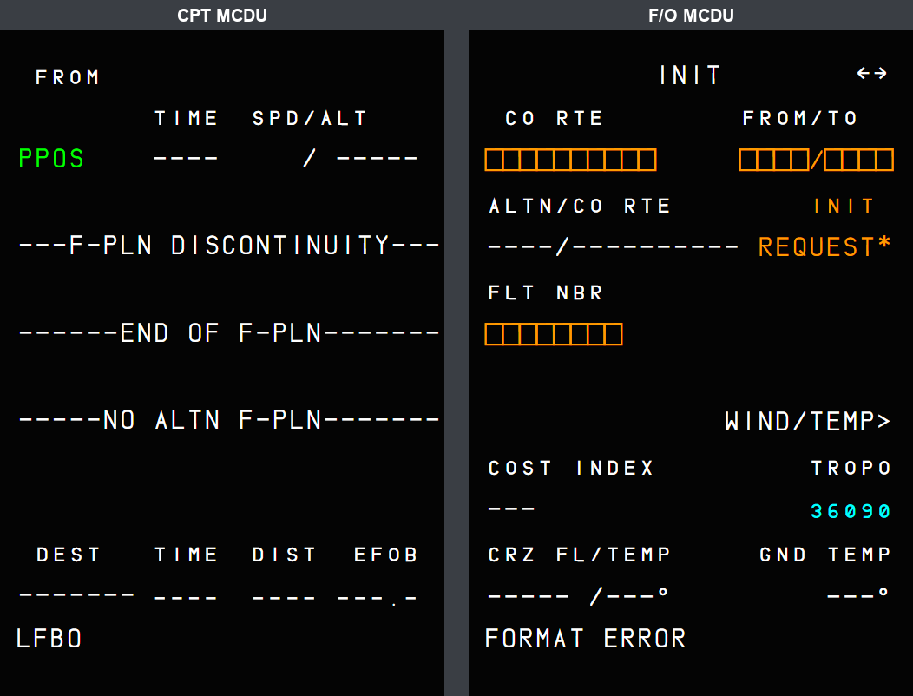  Figure 27. A wrong entry on the F/O MCDU: FORMAT ERROR there only. | 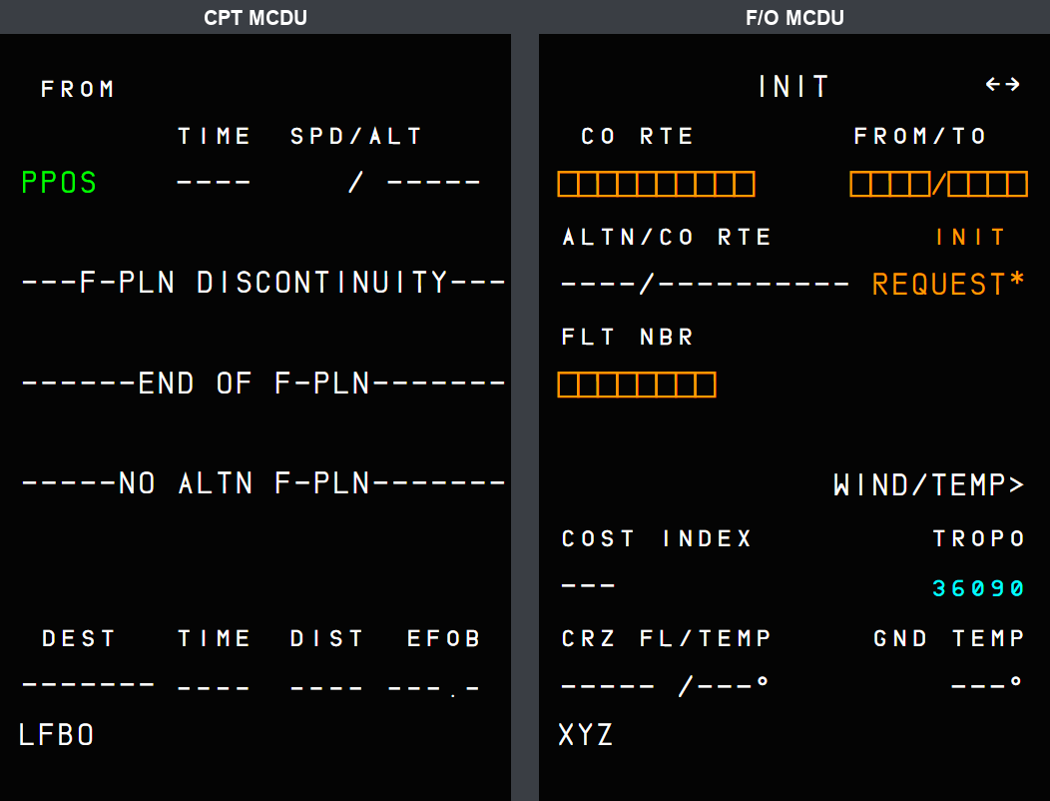  Figure 28. CLR on the F/O MCDU: its message clears and its entry comes back; the CPT scratchpad is untouched.

Situation | What you should see
An entry is rejected | The message shows on the MCDU where the entry was made.
An FMGC message (e.g. CHECK TAKE OFF DATA) | Queued on both MCDUs; CLR on one clears it there only.
The FMS changes pages by itself (flight phase change on PROG / PERF / IDENT, engine-out page, INIT B to FUEL PRED) | Applies to both MCDUs.
ATSU system status (not the answer to an entry) | On the ATSU scratchpad of both MCDUs.
Typing with the PC keyboard | Goes to the MCDU that was clicked last; only that MCDU animates its keys.
SimBridge remote MCDU | CPT screen on its left side, F/O screen on its right side.

4. Power
- CPT MCDU: AC ESS SHED bus. F/O MCDU: AC 2 bus.
- An unpowered MCDU ignores its keys; the other one keeps working.

5. Limitations and why
Limitation | Why | What to do
No return to the MENU page after a power loss. | Same as the CPT MCDU before this change. | -
Close-up cockpit model: both screens show the whole texture until the companion change is merged. | The 4 UV values of the high-detail model (LOD00) live in the aircraft-large-files repository; this PR only changes LOD01. | Merge the aircraft-large-files PR first.

PR 9 - Radar, terrain and VD after the A380 and A320 manuals
The vertical cut, the VD scale and terrain placement, and the weather picture reworked to the FCOM / FCTM
Aircraft | A380X (VD) and both aircraft (weather picture)
Where to find it | A380X VD; both NDs with the radar
PR branch | pr/09-nd-manuals-pass (top of the stack 1, 2, 4, 3)
Status | Tested in the sim (September 2026).
Pictures | In-sim screenshots taken during development (native WASM gauge).

1. The vertical cut (A380X VD)
- In the managed lateral modes the VD shows the terrain and weather along the flight plan (a 200 NM window from just behind the aircraft, with the turns); in the selected modes along the track (FCOM: VIEW ALONG ACFT TRK). More than 5 NM off the plan: the track.
- The terrain is the highest across a width of 2 × RNP (1 NM terminal, 2 NM en route above 18 000 ft).
- The grey area starts at the next track change of more than 3° (the VD no longer matches the ND beyond it).

2. The VD scale and the terrain height
- With a trajectory, the highest of the aircraft and the path sits at three quarters of the window: in cruise the ground stays on the plot, as on the real aircraft at FL400.
- The gap under the aircraft symbol is the true height, whatever the altimeter setting (FCOM / FCTM).
- Water in the ND teal; no magenta on the VD; no VD weather when TERR is not available.
Figure 29. A380X VD with the terrain profile and water (in-sim).
In-sim screenshot taken during development: not representative of the final in-game UI, reference for the explanation only.

3. The weather picture (both aircraft)
- The radar scans on the ground too (A320 FCOM), but draws nothing there.
- MAP mode is a ground map from the terrain.
- The picture builds up over 30 s after the radar starts, sweeping left to right (A380 FCOM).
- The ARC picture keeps the ND bottom corners free, as on the real display.
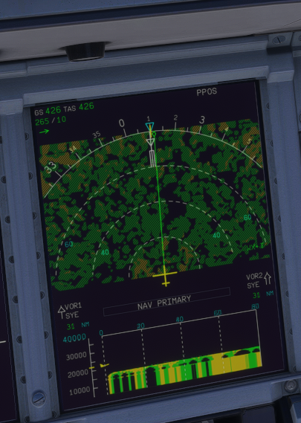  Figure 30. Just after WX is selected: the picture is building up.  In-sim screenshot taken during development: not representative of the final in-game UI, reference for the explanation only. | 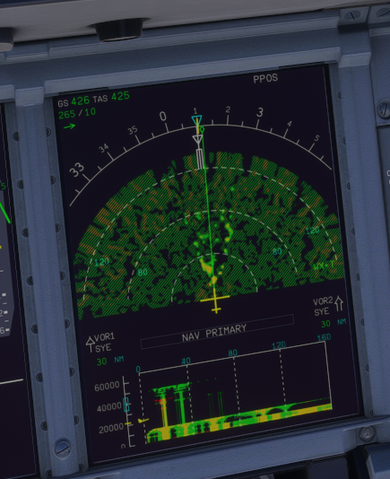  Figure 31. A few seconds later.  In-sim screenshot taken during development: not representative of the final in-game UI, reference for the explanation only.

4. Limitations and why
Limitation | Why | What to do
No A380 AUTO off-path display. | MSFS runs one radar per aircraft; a third view changed what the beam views delivered, so it was removed. | -

PR 10 - A380X MFD FMS pages to the FCOM
Every FMS page of the MFD laid out on its A380 FCOM figure, the FCOM entry formats, and the pages and functions FBW did not have
Aircraft | A380X
Where to find it | MFD (both sides), FMS pages: ACTIVE, POSITION, SEC INDEX, DATA menus; SURV pages (see also the PR 5 manual)
PR branch | pr/10-a380x-mfd-fcom-pages (base of PRs 11-17, 20, 22)
Status | Built in September 2026 and used in the sim since; individual pages were fixed after the in-sim checks (button widths, SEC page return, printer checkboxes).
Pictures | Captain MFD in the local browser harness, running the build installed in the sim. The harness has no navigation database and no flight plan, so most values are dashes or amber boxes: the pictures show the layout and the functions of each page.

1. What changed, in short
- Layout: each page is placed on its figure of the A380 FCOM (DSC-22-FMS-20-30, the 2011 KAL FCOM): field positions, 40 px entry fields, 22.5 px labels, 38 px tab bar, the title bar. Where FBW followed a newer FMS standard than this FCOM, the FCOM figure was followed.
- Entry formats: every field accepts the FCOM entry formats (DSC-22-FMS-20-100) and answers with the FCOM messages (FORMAT ERROR, ENTRY OUT OF RANGE, NOT IN DATABASE...).
- New pages: ALTERNATE, CLOSEST AIRPORTS, OFFSET, EQUI-TIME POINT, LL XING / TIME MKR, WIND, the POSITION pages, DATA / WAYPOINT, NAVAID, ROUTE, PRINTER, company requests (wind, flight plan, report, takeoff data), TRANSFER TO MAILBOX, REJECTED ATC INFO.
- New functions: FUEL PLANNING with CONFIRM BLOCK, LRC and MAX TURB speeds, VERT REV RTA, FMS P/N, pilot-stored elements, automatic airway connection, printing.
The menus at the top of the FMS pages give access to everything: ACTIVE (the active flight plan and its pages), POSITION, SEC INDEX (the secondary flight plans) and DATA.

2. ACTIVE menu

INIT
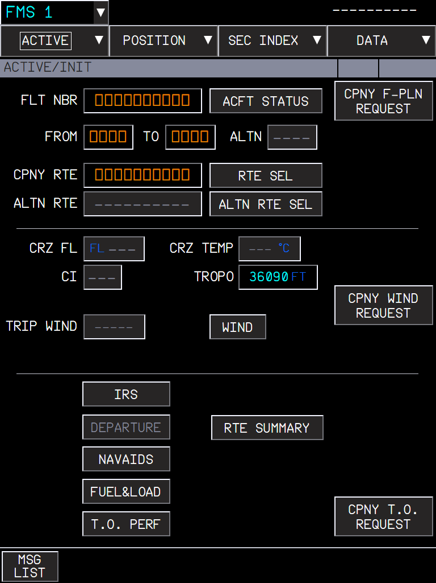
Figure 32. INIT: every button is live. CPNY F-PLN REQUEST (flight plan from the airline, i.e. SimBrief), RTE SEL / ALTN RTE SEL (route selection from the stored and company routes), CPNY WIND REQUEST, CPNY T.O. REQUEST, WIND, and the shortcuts IRS, DEPARTURE, NAVAIDS, FUEL&LOAD, T.O. PERF and RTE SUMMARY.
- Amber boxes are mandatory entries; blue dashes are optional ones.
- CPNY RTE: type a stored or company route of the city pair: it is inserted; otherwise NOT IN DATABASE.
- RTE SUMMARY stores the active route as a pilot-stored route (DATA / ROUTE).

FUEL&LOAD and FUEL PLANNING
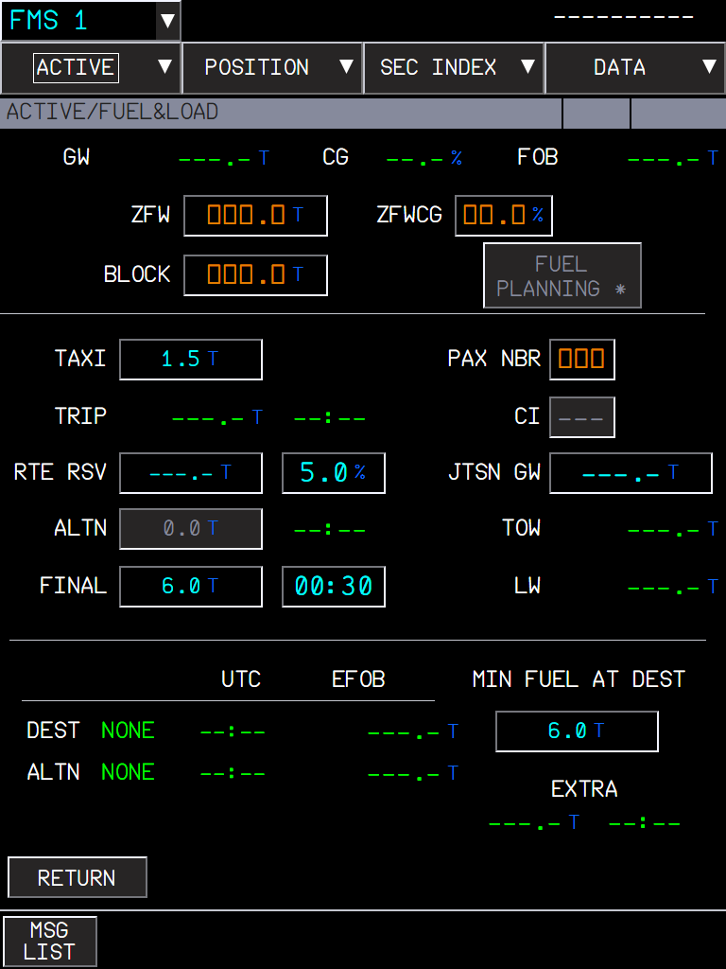
Figure 33. FUEL&LOAD. FUEL PLANNING (next to BLOCK) is available when the flight plan and the weights allow the predictions.
FUEL PLANNING computes the minimum block fuel from the FMS predictions (trip, reserves, alternate, final, taxi) and offers CONFIRM BLOCK, which inserts it (FCOM P 179). The EXTRA line shows what is left above the minimum.

PERF
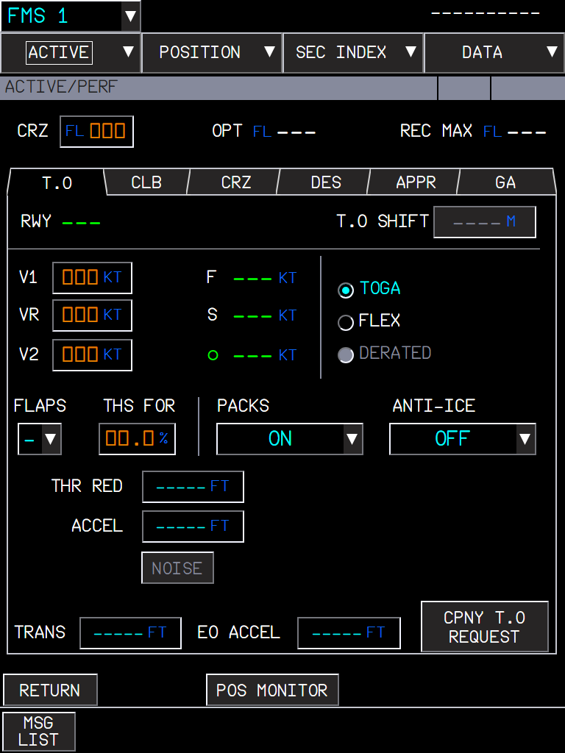  Figure 34. PERF T.O with the company takeoff data button (see the PR 11 manual). | 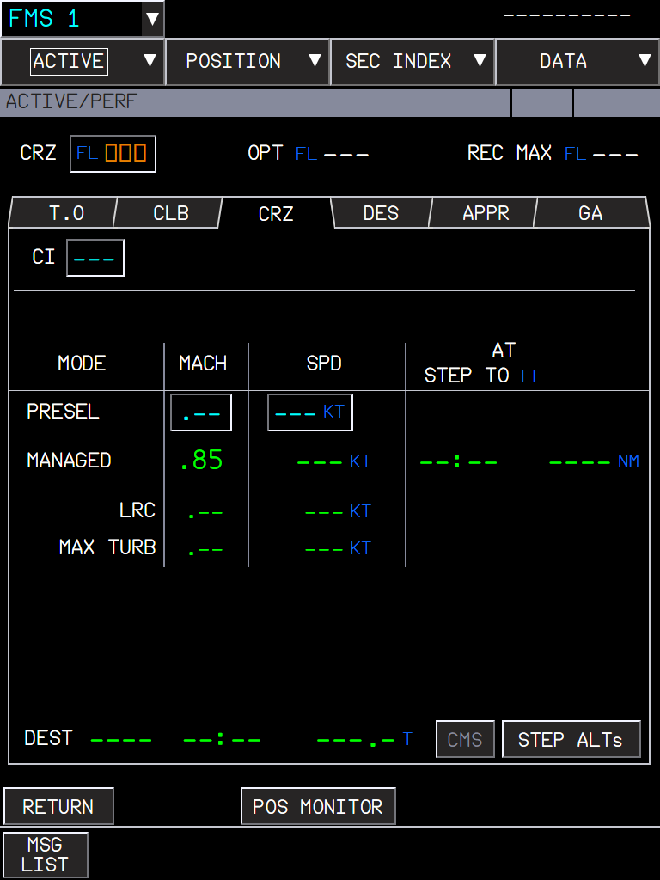  Figure 35. PERF CRZ: MANAGED, PRESEL, and the LRC and MAX TURB speeds.

- LRC (long range cruise): the Mach giving 99 % of the maximum specific range (FCOM PER-IFT).
- MAX TURB: the recommended speed for flying in turbulence.

F-PLN and its revisions
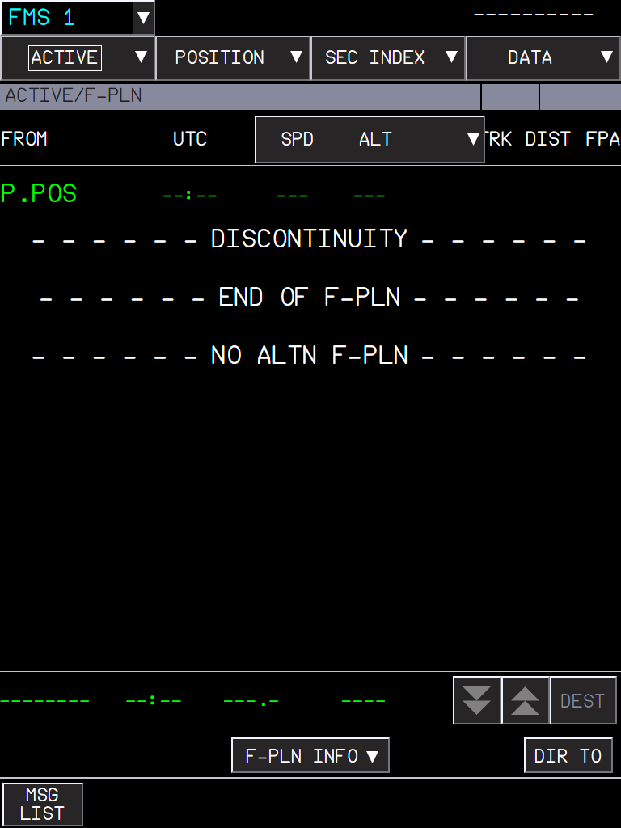
Figure 36. F-PLN without a flight plan: P.POS, DISCONTINUITY, END OF F-PLN, NO ALTN F-PLN.
Click a waypoint name to open the lateral revision menu, a speed/altitude to open the vertical revision. The new pages below open from these menus or from F-PLN INFO.
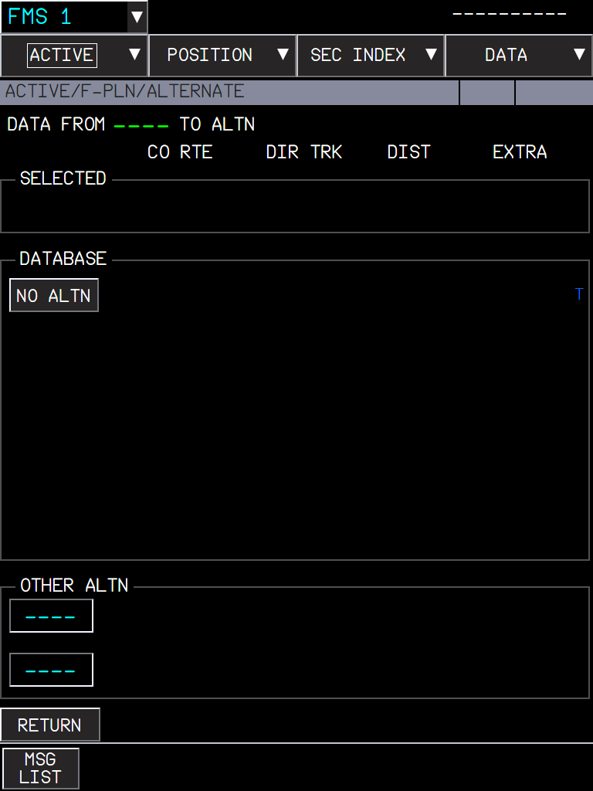  Figure 37. ALTERNATE: the selected alternate, the database alternates with their company route, track, distance and EXTRA fuel, and two OTHER ALTN fields. | 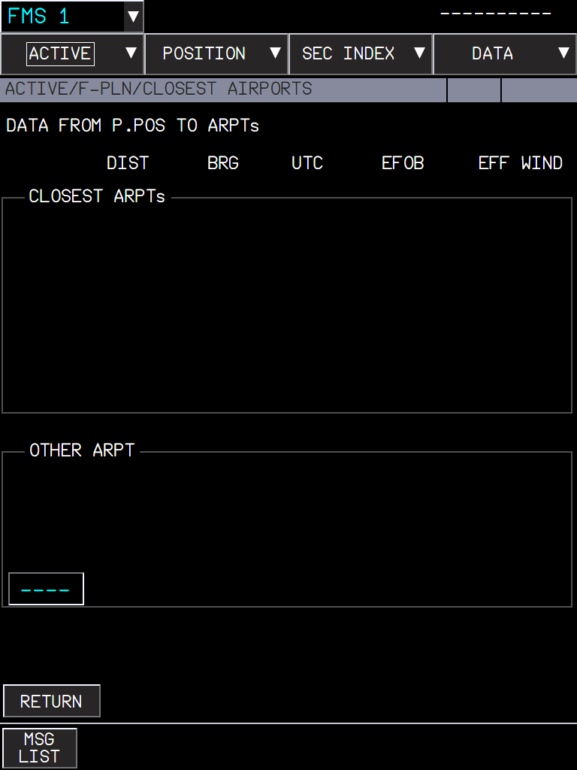  Figure 38. CLOSEST AIRPORTS: the 4 closest airports from P.POS with distance, bearing, UTC, EFOB and effective wind, and up to three OTHER ARPTs.

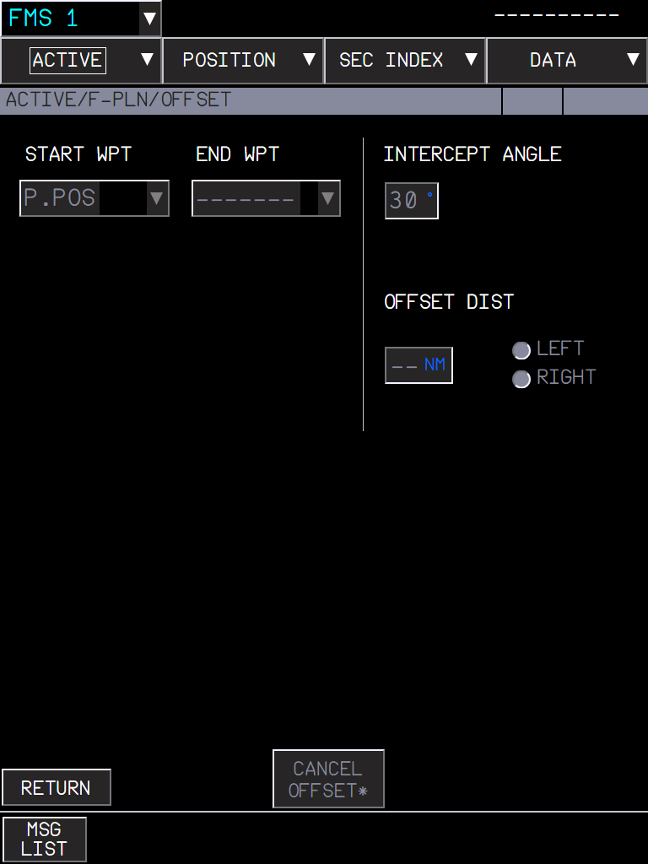  Figure 39. OFFSET: start and end waypoints, distance LEFT / RIGHT, intercept angle (30° by default), CANCEL OFFSET. | 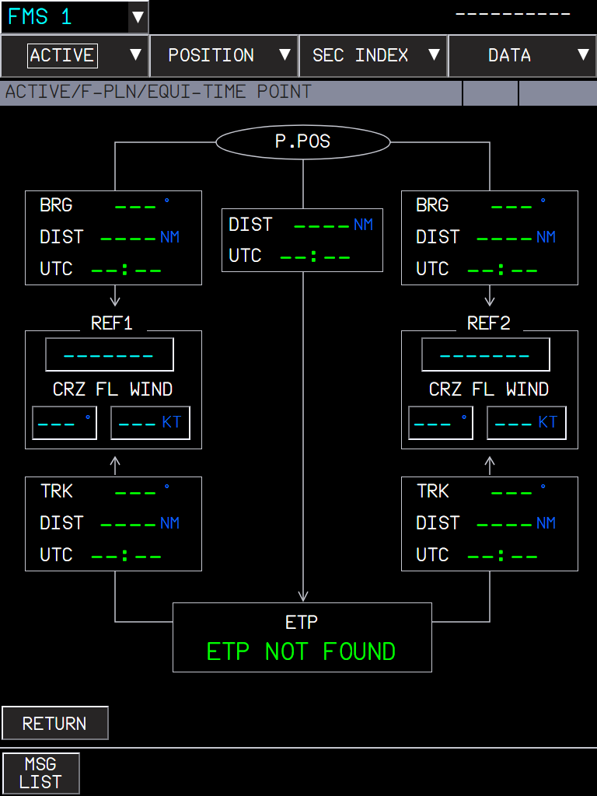  Figure 40. EQUI-TIME POINT: two reference airports, their cruise wind, and the ETP with its bearing, distance and time.

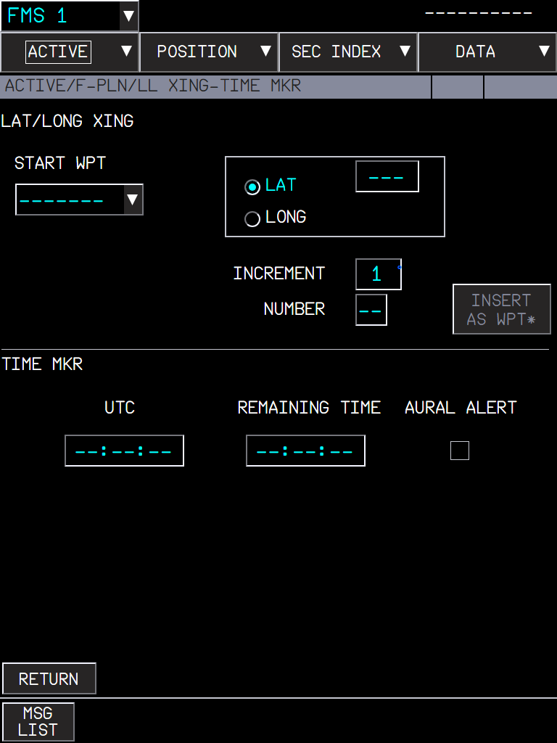  Figure 41. LL XING / TIME MKR: a waypoint at every LAT or LONG crossing (start, increment, number, INSERT AS WPT); a time marker with remaining time and an aural alert. | 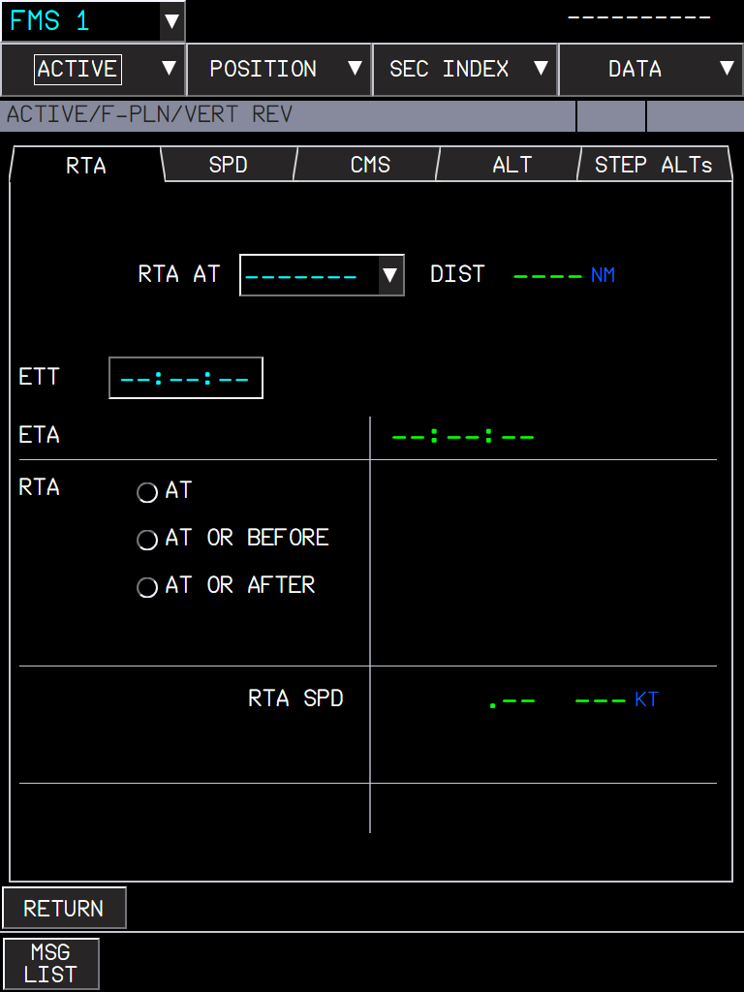  Figure 42. VERT REV, RTA tab: time at a waypoint (AT, AT OR BEFORE, AT OR AFTER), ETA and the speed to meet it; the time error thresholds of the FCOM apply.

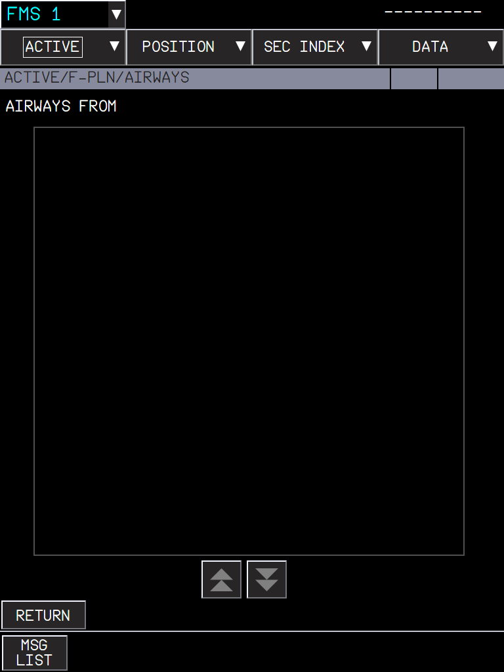
Figure 43. AIRWAYS: up to 31 segments; typing the next airway after a waypoint connects the two airways automatically at their intersection.

WIND and the company requests
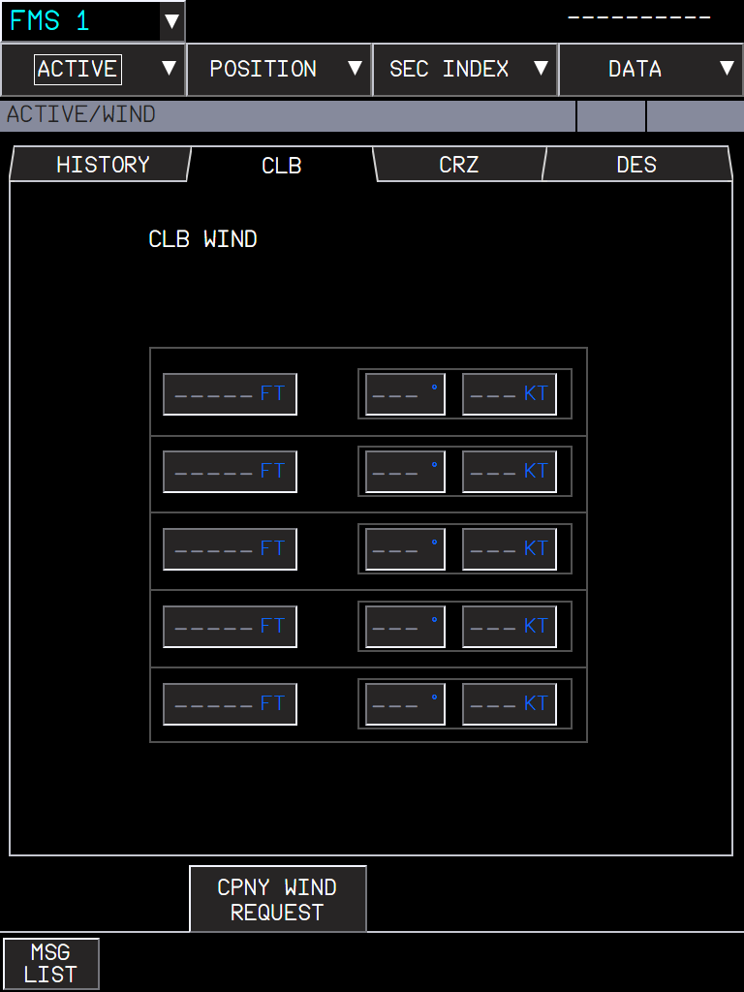  Figure 44. WIND: HISTORY (winds recorded in the last flight), CLB, CRZ (per waypoint, 4 levels and the SAT), DES; CPNY WIND REQUEST at the bottom. | 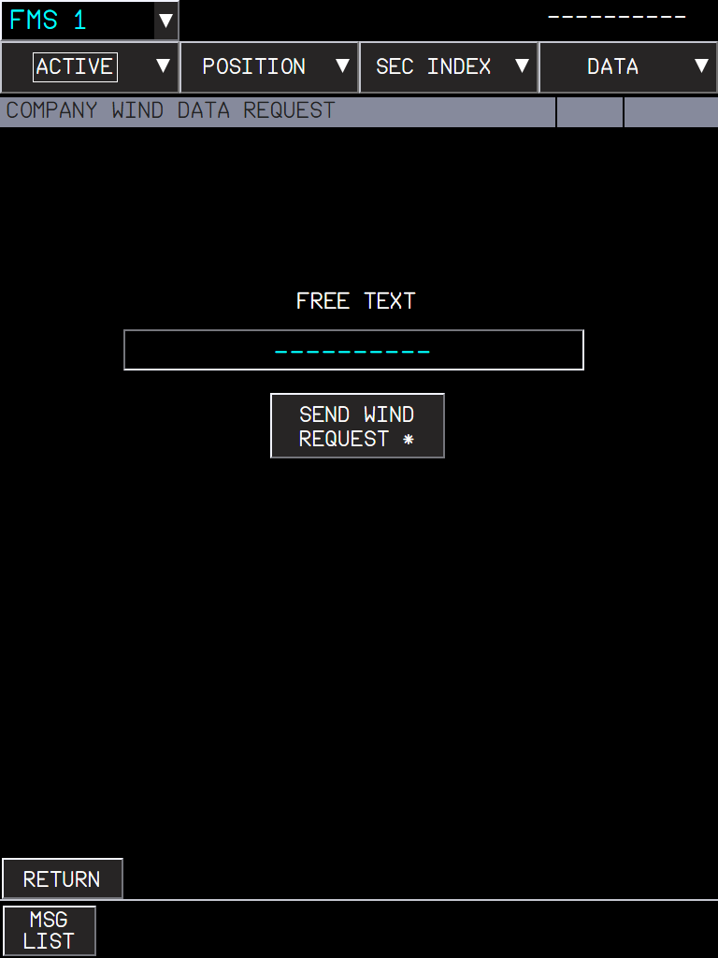  Figure 45. COMPANY WIND DATA REQUEST: free text and SEND WIND REQUEST.

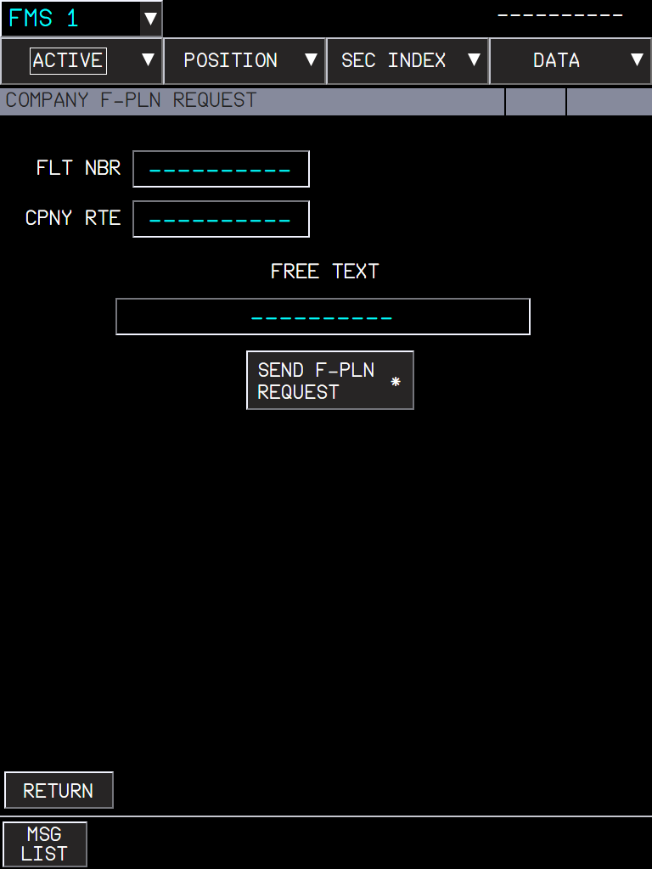  Figure 46. COMPANY F-PLN REQUEST: flight number, company route, free text. | 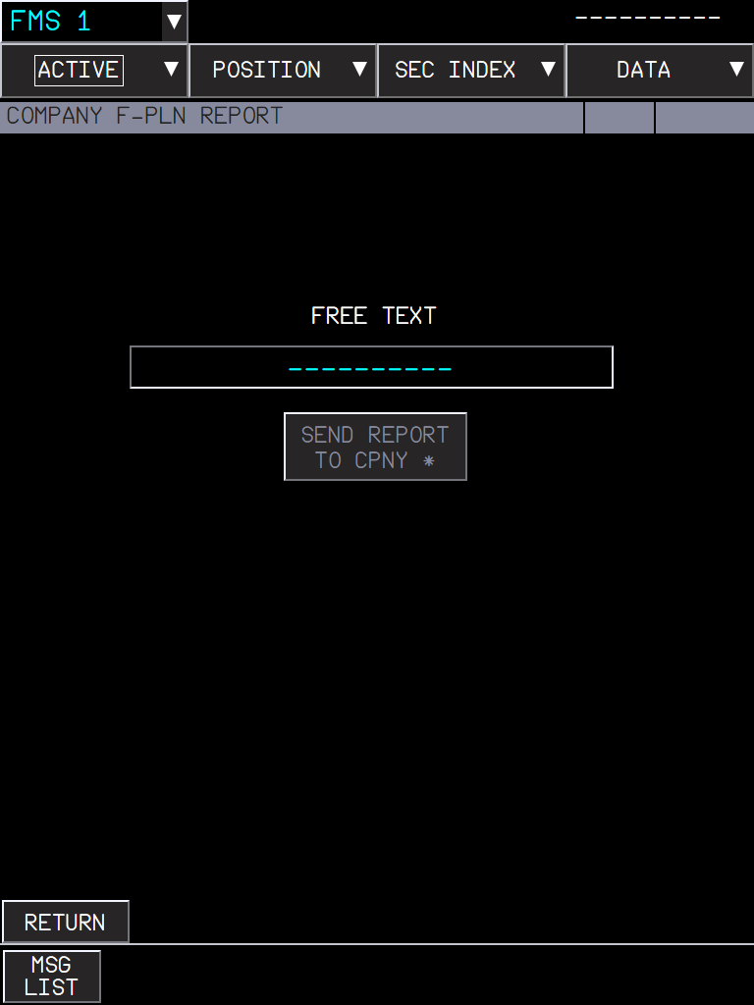  Figure 47. COMPANY F-PLN REPORT: free text, SEND REPORT TO CPNY.

NOTE The company functions use SimBrief (flight plan) and the flyPad (takeoff data). A request without a company able to answer ends after a timeout with the FCOM message.

3. POSITION menu
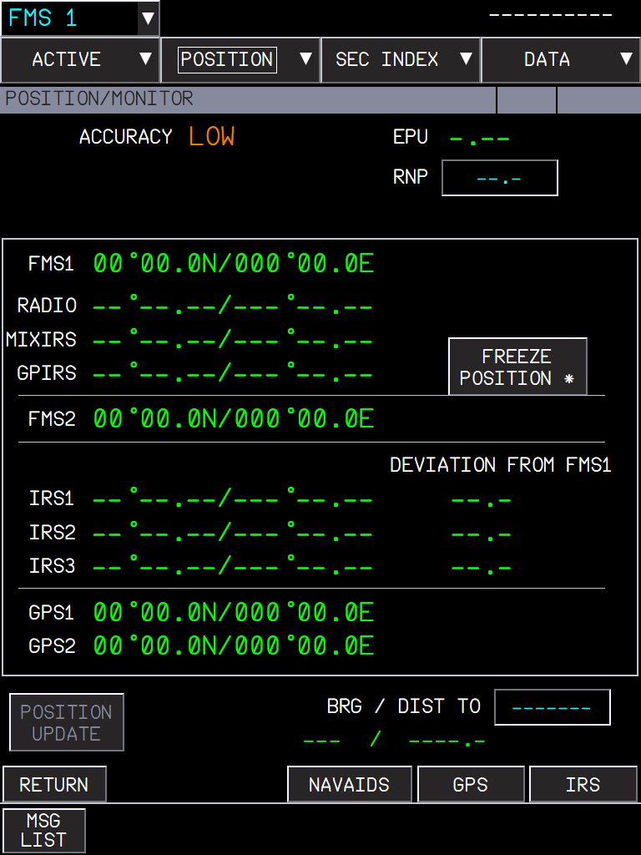  Figure 48. MONITOR: FMS1/2, RADIO, MIXIRS, GPIRS, IRS and GPS positions, accuracy, EPU and RNP, FREEZE POSITION, BRG / DIST TO. | 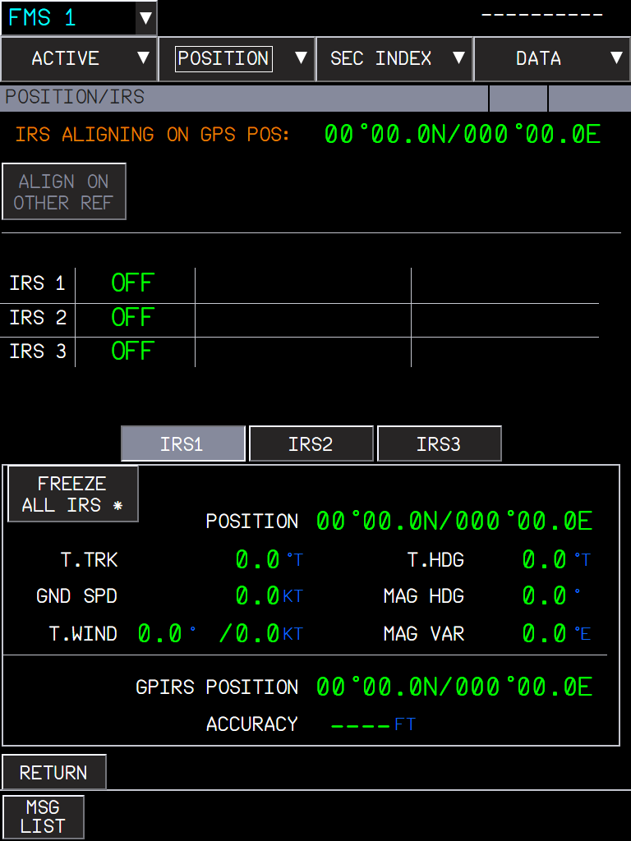  Figure 49. IRS: alignment, the three IRS with their data, FREEZE ALL IRS.

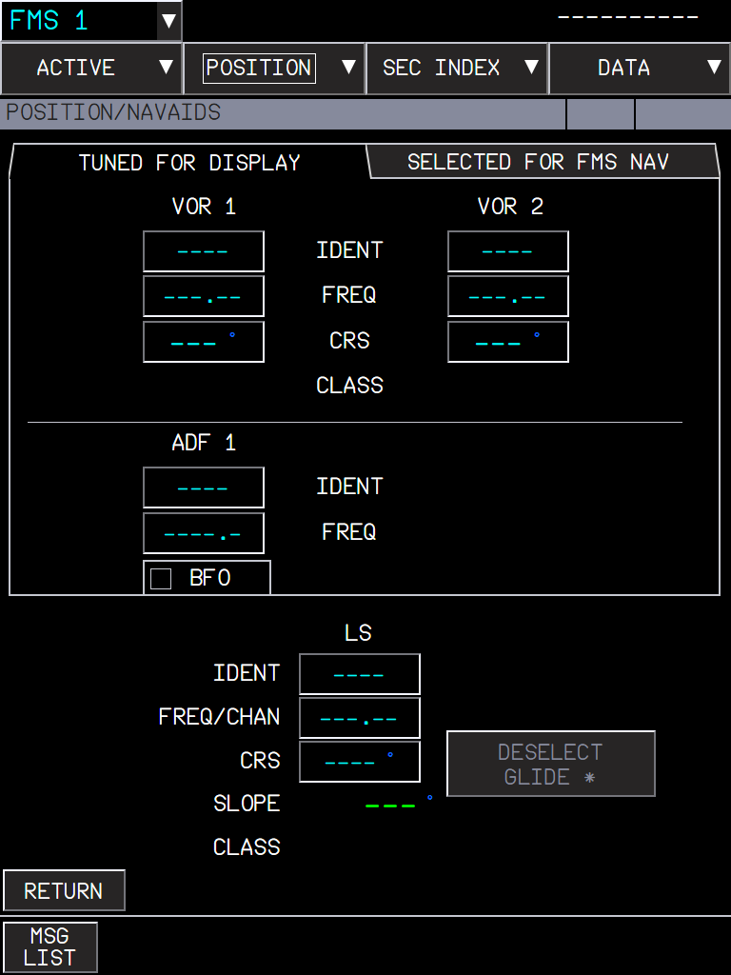  Figure 50. NAVAIDS: tuned for display (VOR, ADF, LS) and selected for FMS NAV, DESELECT GLIDE. | 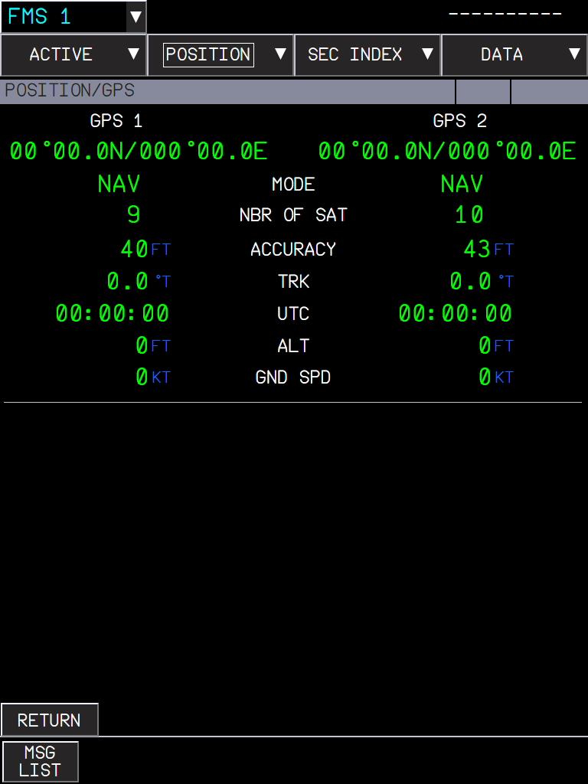  Figure 51. GPS: both receivers: position, mode, satellites, accuracy, track, UTC, altitude, ground speed.

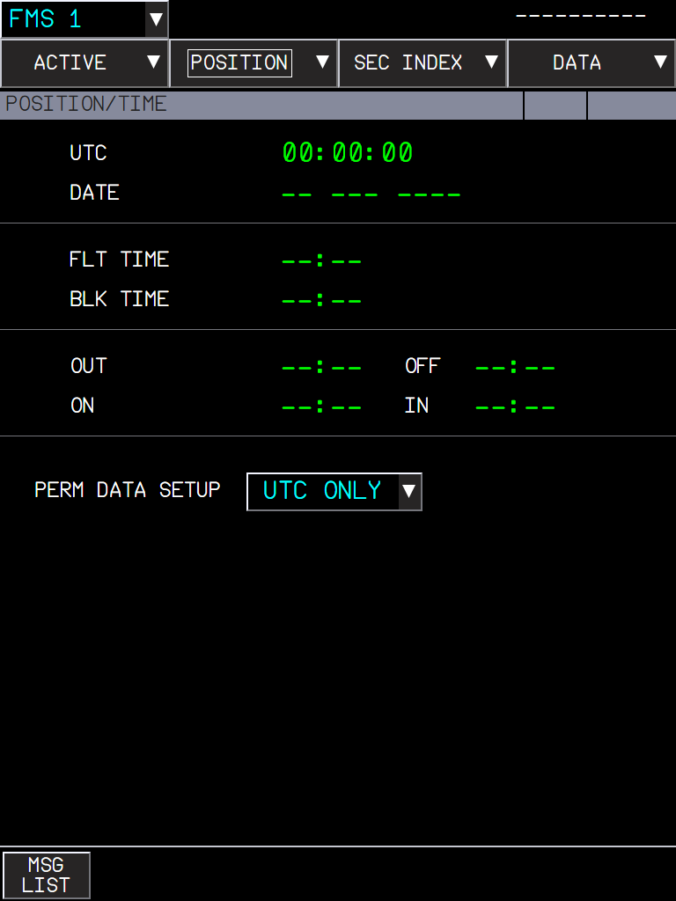  Figure 52. TIME: UTC, date, flight and block time, OUT / OFF / ON / IN, and PERM DATA SETUP (what the permanent data shows). | 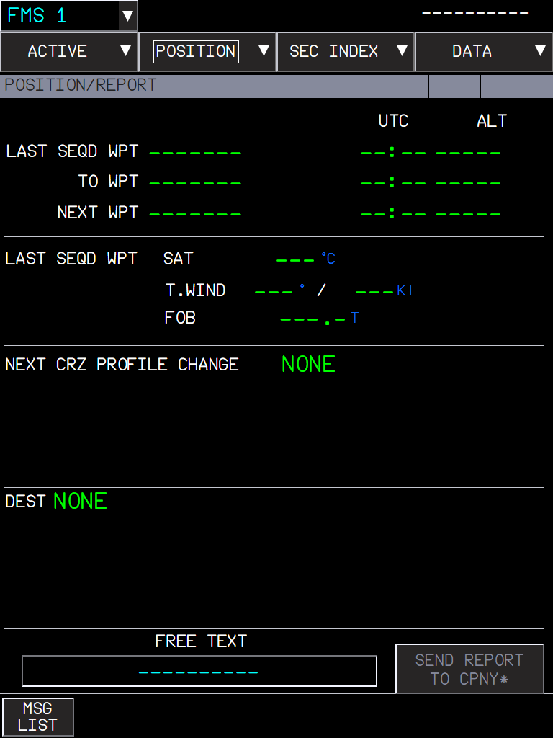  Figure 53. REPORT: last, to and next waypoints with time and altitude, the last sequenced waypoint data, the next cruise profile change, destination.

NOTE The TIME page is not in the 2011 FCOM; it follows a later FMS standard at the user's request.

4. SEC INDEX
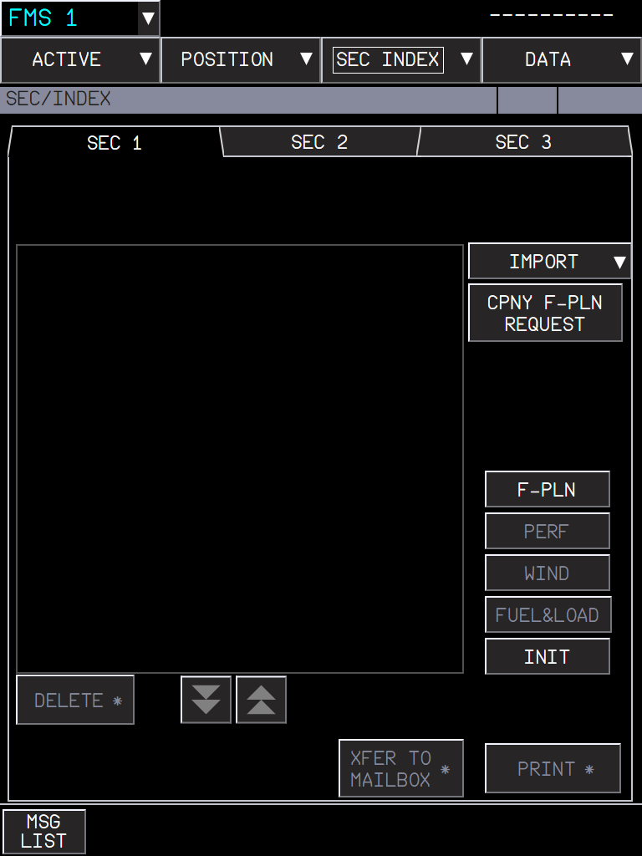  Figure 54. SEC INDEX: SEC 1 / 2 / 3, IMPORT, CPNY F-PLN REQUEST into a SEC, the pages of the SEC, DELETE, XFER TO MAILBOX and PRINT. | 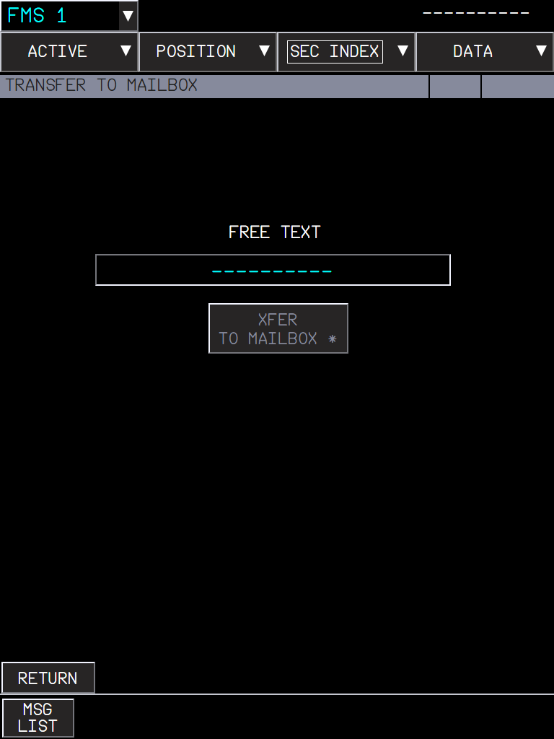  Figure 55. TRANSFER TO MAILBOX: sends the SEC flight plan to the ATC mailbox with a free text.

REJECTED ATC INFO (FCOM P 321-323) lists the elements of an ATC flight plan inserted in SEC 3 that the FMS rejected, 4 per page. MSFS cannot send an ATC flight plan, so the list stays empty.

5. DATA menu
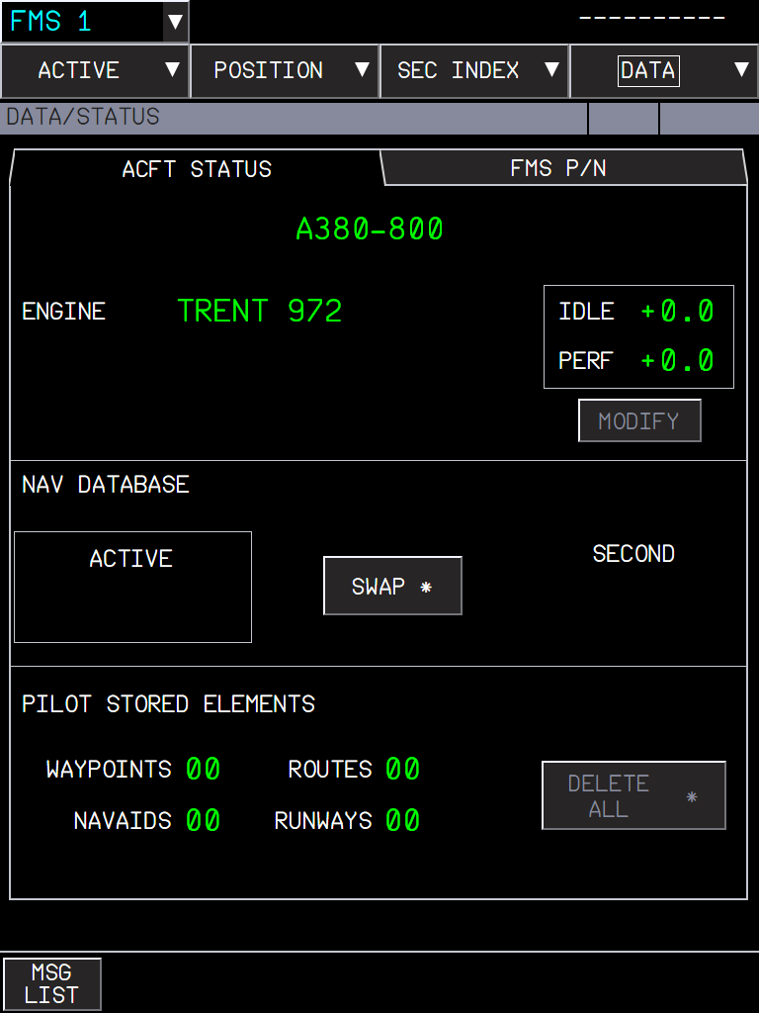  Figure 56. STATUS: aircraft and engine, IDLE / PERF factors (FMS P/N tab), navigation database SWAP, and the count of the pilot-stored elements with DELETE ALL. | 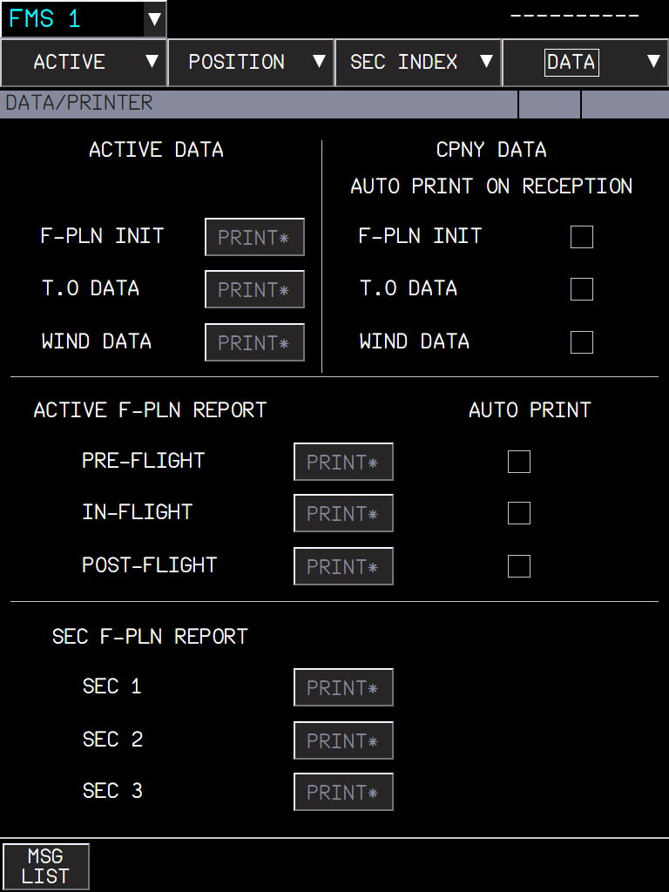  Figure 57. PRINTER: print the F-PLN INIT, T.O and wind data, the active and SEC flight plan reports, and the AUTO PRINT options.

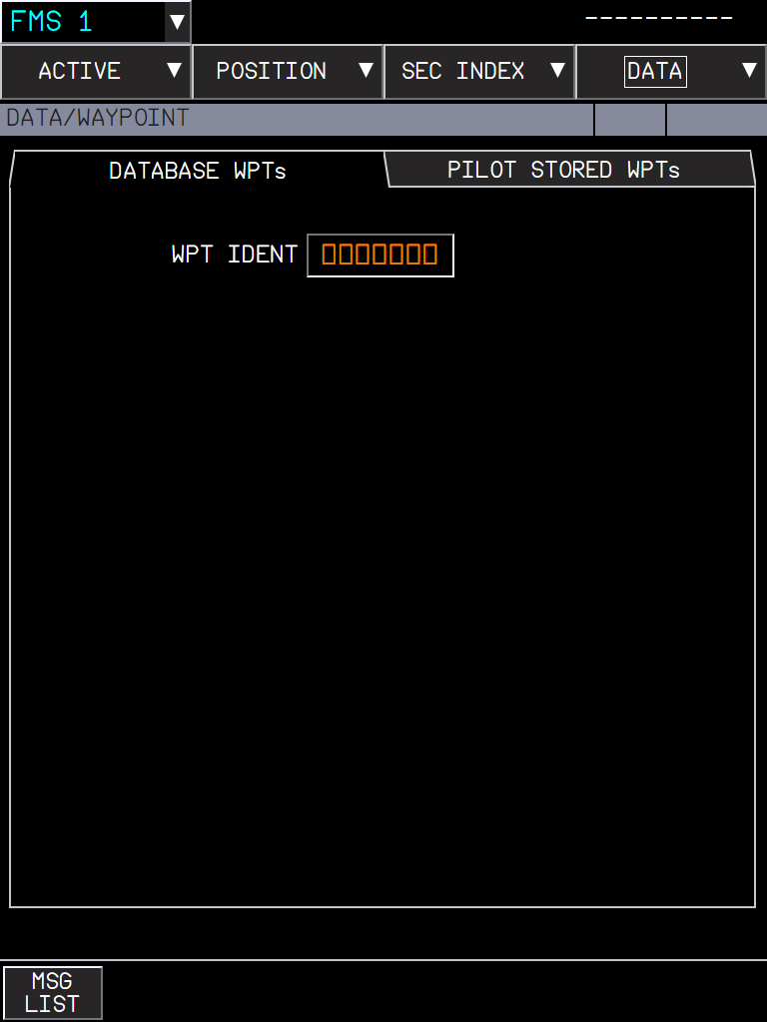  Figure 58. WAYPOINT: database waypoints by ident; pilot-stored waypoints (lat/long, place/bearing/distance, place-bearing/place-bearing), NEW WPT. | 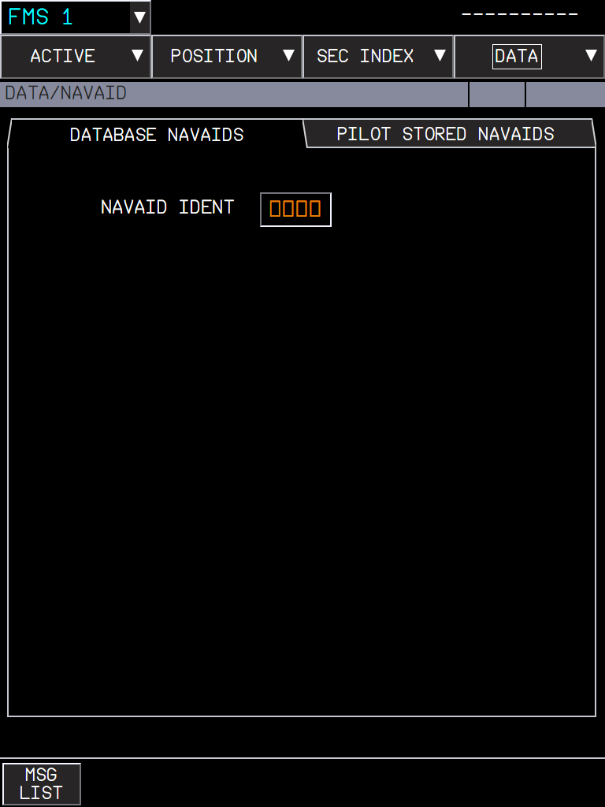  Figure 59. NAVAID: database navaids (class, position, frequency, ILS course and slope...); pilot-stored navaids, NEW NAVAID.

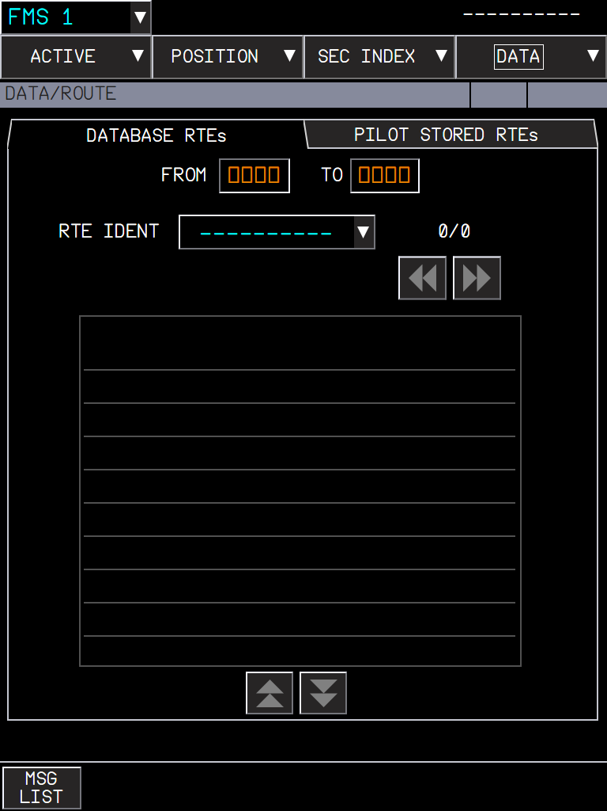  Figure 60. ROUTE: database (company) routes of a city pair, pilot-stored routes with their summary, NEW RTE, DELETE. | 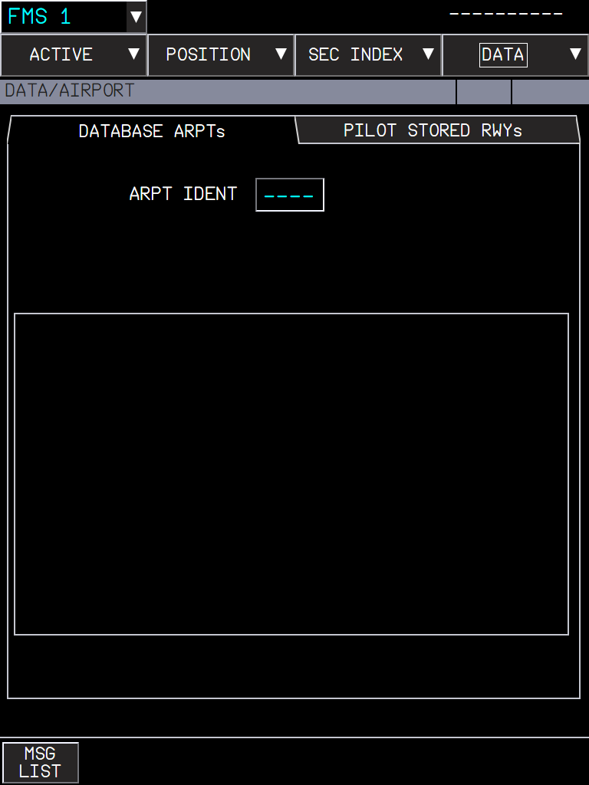  Figure 61. AIRPORT: database airports, and the PILOT STORED RWYs tab.

The printouts appear in the flyPad printouts list.

6. What to expect
Situation | What you should see
An entry in a wrong format | FORMAT ERROR in the message area; the field keeps its value.
A value out of the FCOM range | ENTRY OUT OF RANGE.
A waypoint or navaid not found | NOT IN DATABASE (or the NEW WPT / NEW NAVAID page when the FCOM says so).
A company request with no company answer | The FCOM timeout message after a few minutes.
A page not available in the flight phase | Its button is greyed.

7. Limitations and why
Limitation | Why | What to do
The layout follows the 2011 A380 FCOM. | It is the reference available; later FMS standards differ in places. | Report a difference with its FCOM page.
Some values are FBW model stand-ins. | For example GPS satellites and accuracy, like on the A32NX MCDU GPS page; MSFS does not simulate them. | -
Company functions answer only through SimBrief and the flyPad. | There is no airline datalink in MSFS. | -
Pilot-stored navaids cannot be tuned. | The radio tuning uses the MSFS navaids only. | -

PR 11 - A380 takeoff calculator and company T.O data
Takeoff weight limit, FLEX temperature, V-speeds and takeoff run on the flyPad, sent to the MFD PERF T.O page through the company takeoff data function of the FCOM
Aircraft | A380X (the flyPad screen is shared with the A32NX, see the PR 12 manual)
Where to find it | flyPad > Performance > Takeoff; MFD > ACTIVE > PERF > T.O tab > CPNY T.O REQUEST / RECEIVED CPNY T.O
PR branch | pr/11-a380-takeoff-calculator (stacked on PR 10); completed by PR 12
Status | Used in the sim during development (September 2026); the final version with the PR 12 changes is still to re-test in the sim.
Pictures | flyPad and MFD pages in the local browser harness, running the build installed in the sim. The harness has no navigation database: the runway is entered by hand and the company uplink is simulated on the MFD.

1. What it is for
Before each takeoff the crew needs the takeoff weight limit of the runway, the FLEX temperature (reduced thrust), the speeds V1, VR, V2 and the flaps. On the real A380 they come from the OIS takeoff application or from the airline (company takeoff data, sent to the FMS by datalink). The flyPad calculator does the computation; SEND TO FMS plays the airline: the MFD receives the data as company T.O data, and the crew checks and inserts it, as in FCOM DSC-22-FMS-20-30.

2. The flyPad screen
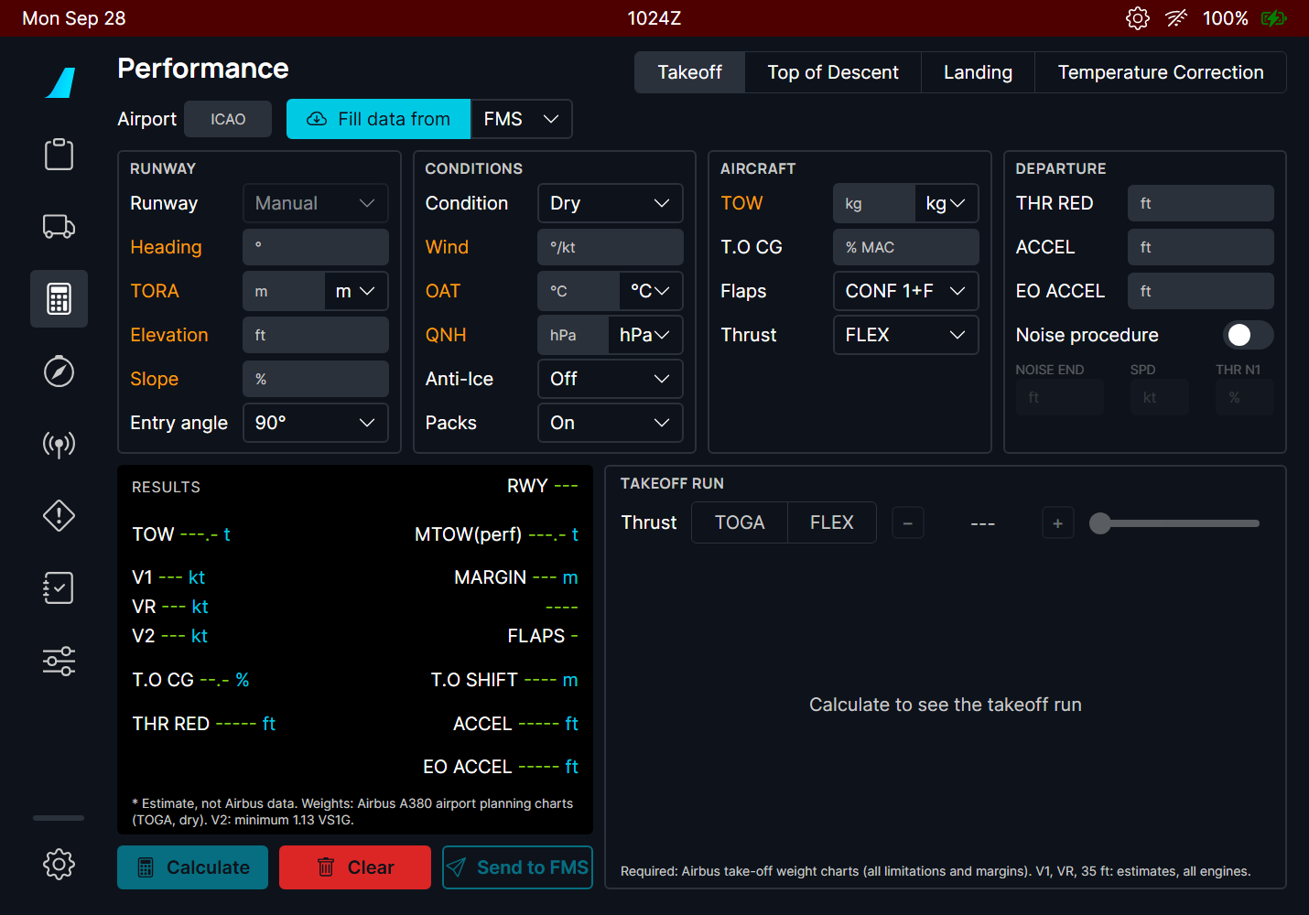
Figure 62. The takeoff screen. Amber labels: inputs still missing (Calculate stays dim).
Part | Contents
Airport, Fill data from | ICAO code; imports from the FMS (departure, runway, TOW, CG, THR RED / ACCEL), the OFP (SimBrief) or the METAR (wind, OAT, QNH).
RUNWAY | Runway from the list (or Manual), heading, TORA, elevation, slope, and the entry angle (90° or 180° turn onto the runway, or 0° when rolling straight on: it sets the line-up distance lost).
CONDITIONS | Runway condition, wind, OAT, QNH, anti-ice, packs.
AIRCRAFT | TOW in t (or klb), one decimal, T.O CG in % MAC, flaps (CONF 1+F, 2, 3 or OPT = the best one), thrust (TOGA or FLEX).
DEPARTURE | THR RED, ACCEL, EO ACCEL altitudes (they default to the elevation + 1500 ft), and the noise abatement procedure (NOISE END altitude, speed, N1).
RESULTS | The results in the layout of the OIS takeoff application (FCOM PER-TOF-TOR-SRS).
TAKEOFF RUN | The runway with the V1, VR and 35 ft points, the required distance and the margin, for TOGA or any FLEX temperature of the allowed range.

3. A FLEX takeoff
- Fill the airport and runway (or Fill data from FMS / OFP), the conditions (METAR), the TOW and the T.O CG.
- Keep Thrust FLEX and press Calculate.
- Read the FLEX temperature and the speeds in RESULTS; check the takeoff run and its margin.
- Send to FMS, then insert the data on the MFD (section 6).
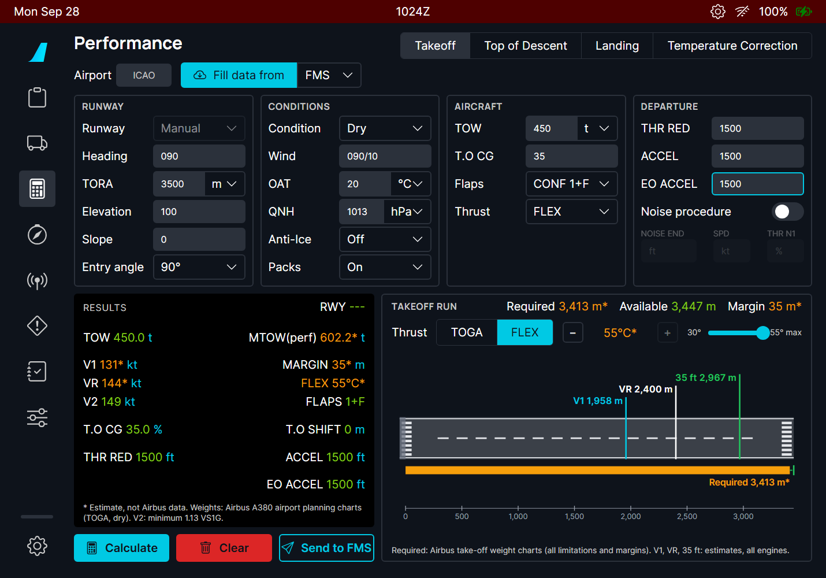
Figure 63. 450 t, 3500 m, 20 °C, CONF 1+F: FLEX 55 °C (the maximum, amber: estimate), V1 131 / VR 144 / V2 149 kt, MTOW(perf) 602 t. The takeoff run needs 3413 m of the 3447 m available after line-up: 35 m margin.

Reading the results
Line | Meaning
TOW / MTOW(perf) | Your takeoff weight, and the maximum the runway and conditions allow at TOGA.
V1, VR, V2 | The takeoff speeds. V2 is at least 1.13 VS1G and 1.10 VMCA, VR at least 1.05 VMCA, V1 at least VMCG (FCOM PER-TOF-TOR-SRS).
MARGIN | Runway left beyond the required distance.
FLEX / TOGA | The FLEX temperature, or TOGA.
FLAPS, T.O CG, T.O SHIFT | The configuration, the CG entered, the takeoff shift (distance lost at line-up or an intersection).
THR RED, ACCEL, EO ACCEL | The altitudes of the DEPARTURE section.

NOTE Green values come from Airbus data (the takeoff weight charts of the A380 Aircraft Characteristics); amber with a star are estimates of the FBW model (see Limitations).

4. TOGA or another FLEX temperature
The TAKEOFF RUN panel lets you look at the run for TOGA, or for any FLEX temperature between the OAT and the maximum (FCOM PER-TOF-THR-FLX). Use - / + or the slider; the speeds and the run follow.
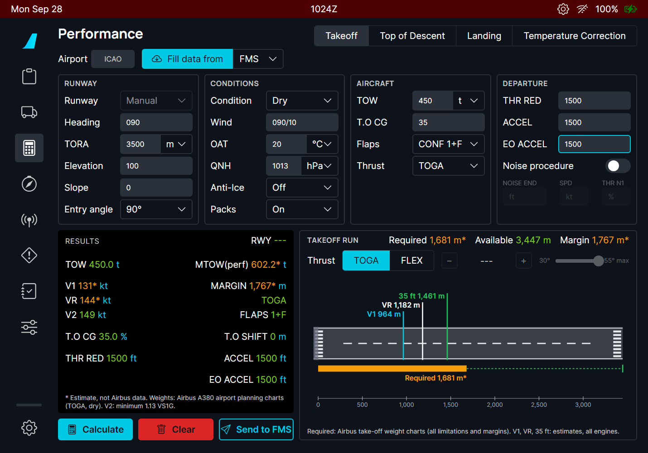  Figure 64. TOGA: the run needs 1681 m, margin 1767 m. | 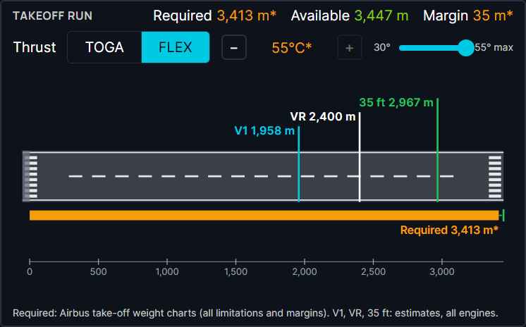  Figure 65. FLEX range 30 °C to 55 °C max: the selected temperature is the one sent to the FMS.

Send to FMS sends the thrust selected for the takeoff run only (TOGA, or FLEX at its temperature), with its own speeds.

5. Options
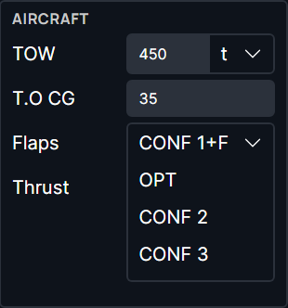  Figure 66. Flaps: CONF 1+F, 2, 3, or OPT (the calculator picks the best). | 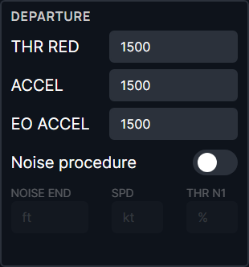  Figure 67. Noise procedure: NOISE END altitude, speed and N1 become available; they are sent with the data.

6. Errors
When the takeoff is not possible, a message says why and there is no result:
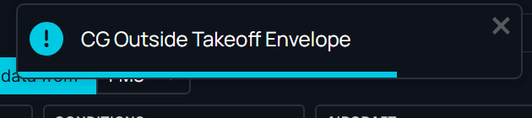  Figure 68. CG outside the takeoff envelope (here 30 % at 450 t: the forward limit moves aft with the weight). | 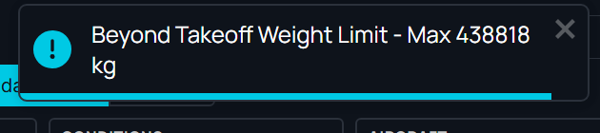  Figure 69. 510 t on 2100 m at 40 °C: the maximum takeoff weight is 438.8 t.

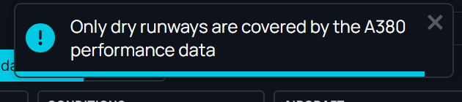
Figure 70. A wet or contaminated runway: the A380 data covers dry runways only.
Message | Meaning
Beyond Takeoff Weight Limit - Max ... | TOW above the runway limit: reduce the weight or use another runway.
CG Outside Takeoff Envelope | The CG is outside the A380 takeoff CG envelope for this weight.
Above Structural MTOW | TOW above 510 t.
Only dry runways are covered... | The A380 data has no wet or contaminated takeoff.
Runway shorter than the A380 performance data (1700 m) | The charts start at 1700 m.
Above Maximum Tailwind / OAT / Pressure Altitude | Outside the A380 limits (FCOM LIM-12).
Flex Not Possible | No FLEX temperature is possible at this weight: take off at TOGA.

7. On the MFD: company T.O data
The MFD PERF T.O page gets two buttons: CPNY T.O REQUEST (ask the airline) and, once data has arrived, RECEIVED CPNY T.O.
Figure 71. PERF T.O before any data: the CPNY T.O REQUEST button (bottom right). | 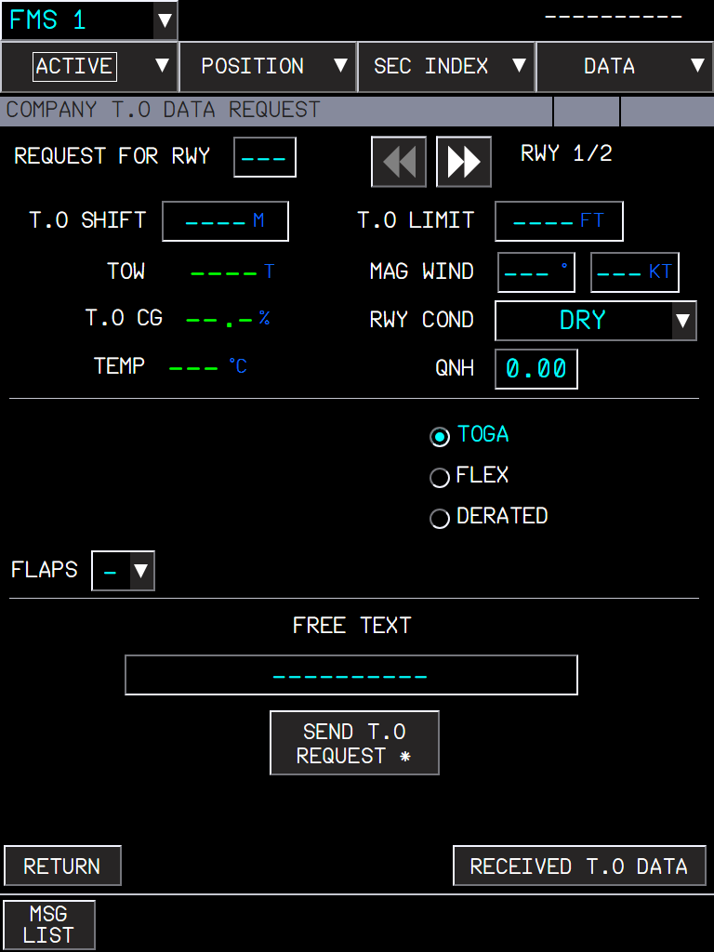  Figure 72. COMPANY T.O DATA REQUEST: up to 2 runways, TOGA / FLEX / DERATED, free text; SEND T.O REQUEST.

- After SEND T.O REQUEST the page shows REQUEST PENDING...; without an answer after 4 minutes, NO COMPANY REPLY. The flyPad Send to FMS is that answer.
- When data arrives: the message COMPANY T.O DATA RECEIVED WAITING FOR INSERTION and the button RECEIVED CPNY T.O on PERF.
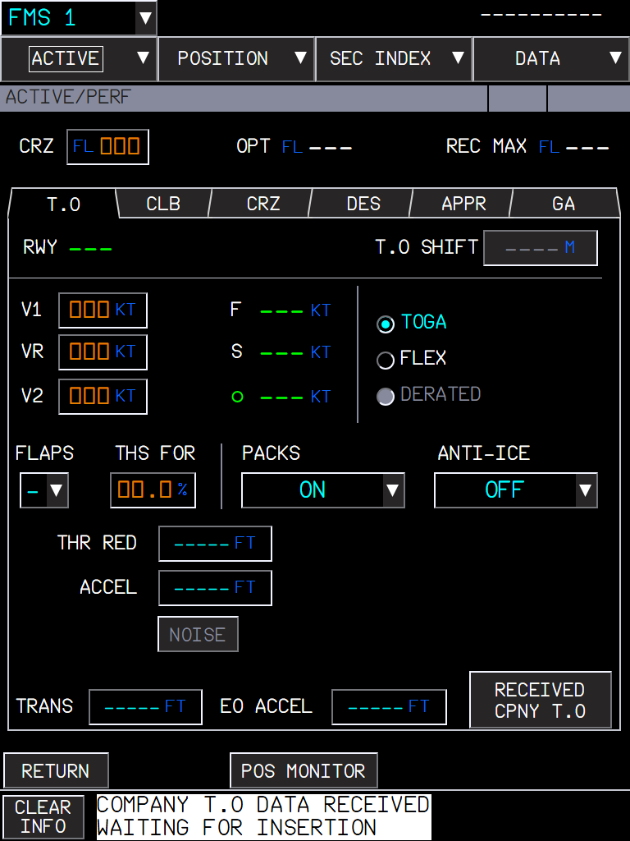  Figure 73. Data received: the message and the RECEIVED CPNY T.O button. | 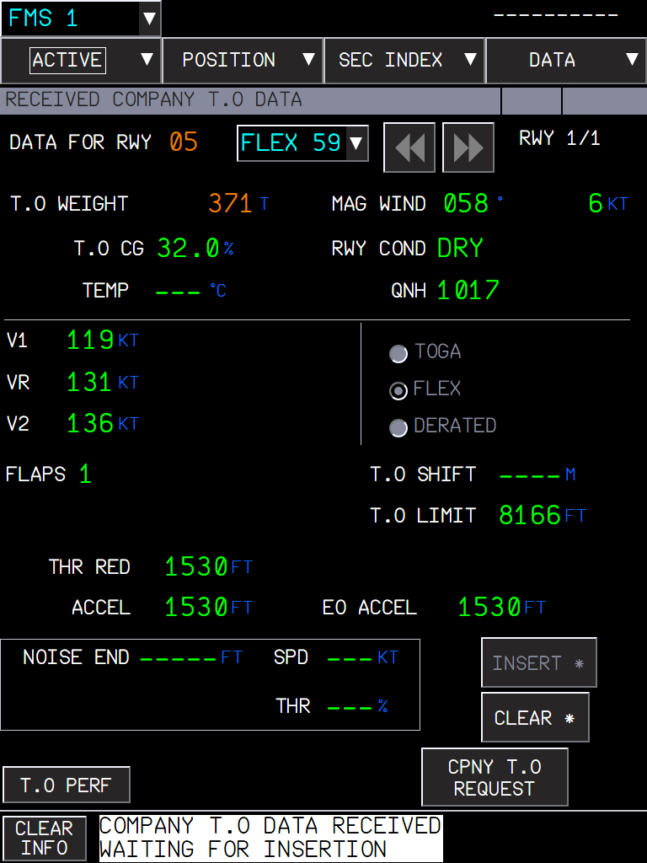  Figure 74. RECEIVED COMPANY T.O DATA: runway 05 in amber (not the flight plan runway), TOW in amber with UPLINK/ACTIVE TOW DISAGREE: INSERT is not available.

The RECEIVED COMPANY T.O DATA page
- Up to 4 runways (arrows, RWY 1/4) × 2 thrust ratings (the TOGA / FLEX list at the top).
- Runway in amber: not the departure runway of the active flight plan.
- TOW in amber with UPLINK/ACTIVE TOW DISAGREE: the uplink TOW is more than 2 t below or 7 t above the FMS TOW (FUEL&LOAD).
- TEMP shows dashes for a FLEX takeoff; T.O LIMIT is the TORA; the noise fields are filled when the procedure was sent.
- INSERT (only when runway and TOW agree) fills PERF T.O: speeds, flaps, thrust, shift, THR RED, ACCEL, EO ACCEL and noise. It does not fill THS FOR: the crew enters the CG there. CLEAR deletes the data.
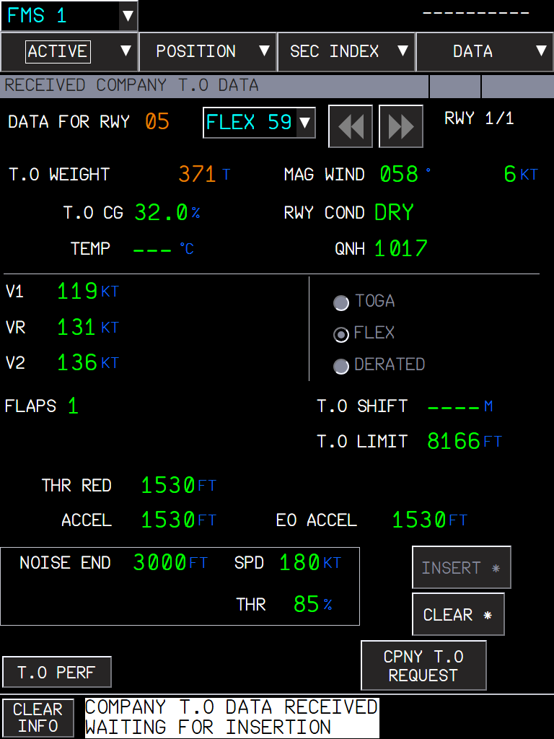
Figure 75. An uplink with the noise procedure: NOISE END 3000 ft, SPD 180 kt, THR 85 %.
TIP The flyPad warns you right after Send to FMS if INSERT will not work: another departure runway in the FMS, no TOW in the FMS, or a TOW outside -2 t / +7 t of the FMS one.

8. What to expect
Situation | What you should see
Inputs missing | Amber labels; Calculate stays dim.
Calculate with valid inputs | RESULTS and the takeoff run; FLEX at its maximum by default.
TOW too high, CG out of envelope, wet runway... | A message with the reason; no result.
Send to FMS with a runway from the list | "Takeoff data sent to the FMS: RECEIVED CPNY T.O on the PERF page"; the MFD shows the data a moment later.
Send to FMS with a manual runway | Nothing is sent: the FMS needs the runway ident.
RECEIVED page, other runway than the flight plan | Runway in amber; INSERT not available.
INSERT | PERF T.O filled; THS FOR still to enter.

9. Limitations and why
Limitation | Why | What to do
Dry runways only. | The only public A380 takeoff data is the takeoff weight charts of the Airbus A380 Aircraft Characteristics (dry, ISA and ISA+15, runway 1700-5100 m, altitude 0-8000 ft). | On a wet runway, use the dry result with extra margin, as a training estimate only.
Speeds, FLEX, wind, slope and temperature effects are estimates (amber *). | The charts give weights only. The rest is a model fitted on them and checked on the FCOM examples (FLEX 38 at 560 t / 614 t). | -
The run distances (V1, VR, 35 ft points) are all-engine estimates. | No A380 distance data is public. | -
Send to FMS needs a runway from the list. | The FMS checks the uplink against its departure runway. | Choose the runway in the list.
Not certified data. | For simulation and training. | -

PR 12 - A320 takeoff calculator and MCDU uplink takeoff data
The flyPad takeoff screen of the A380, with the FBW A320neo performance model, sending its results to the MCDU as uplink takeoff data (FCOM DSC-22_20-50-10-28)
Aircraft | A32NX (the A380 part of the screen is in the PR 11 manual)
Where to find it | flyPad > Performance > Takeoff; MCDU > PERF TAKE OFF > <TO DATA (6L)
PR branch | pr/12-a320-takeoff-calculator (stacked on PR 11)
Status | The flyPad calculation was used in the sim; the MCDU uplink pages are checked in the harness; the full flow is still to re-test in the sim.
Pictures | flyPad and MCDU in the local browser harness, running the build installed in the sim. The harness has no navigation database and no flight plan: the runway is typed and the uplink is sent to the MCDU by the harness (the same message the flyPad sends).

1. What it is for
The A320 takeoff speeds, FLEX temperature and THS come from the airline or the crew's own tool. Here the flyPad computes them with the FlyByWire A320neo performance model (built from Airbus data) and sends them to the FMGC as an uplink takeoff data message, which the crew inserts from the MCDU PERF TAKE OFF page as on the real aircraft.

2. The flyPad screen (A320)
The screen is the one of the A380 (see the PR 11 manual) with these A320 differences:
- No noise procedure fields; T.O CG is optional: below 27 % MAC the forward CG performance applies (A320 FCOM PER-LOD) and the THS is shown in RESULTS.
- All values come from the FBW A320 model: they are shown in green (no estimates).
- Wet and contaminated runways are computed (the A380 page accepts dry only).
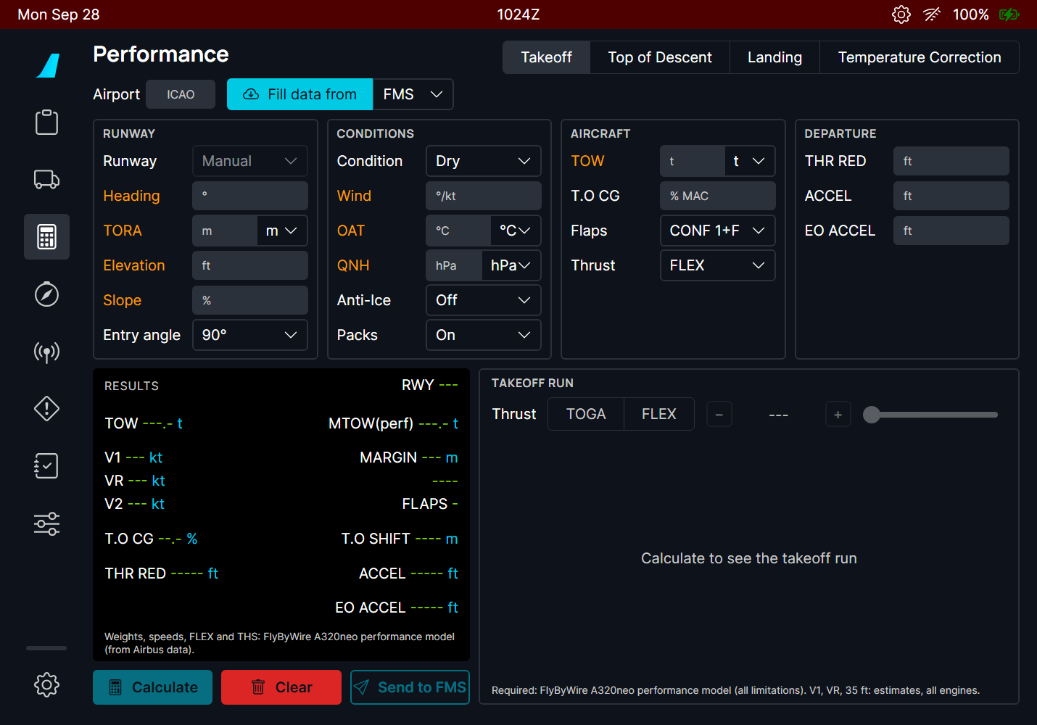
Figure 76. The A320 takeoff screen before any input.
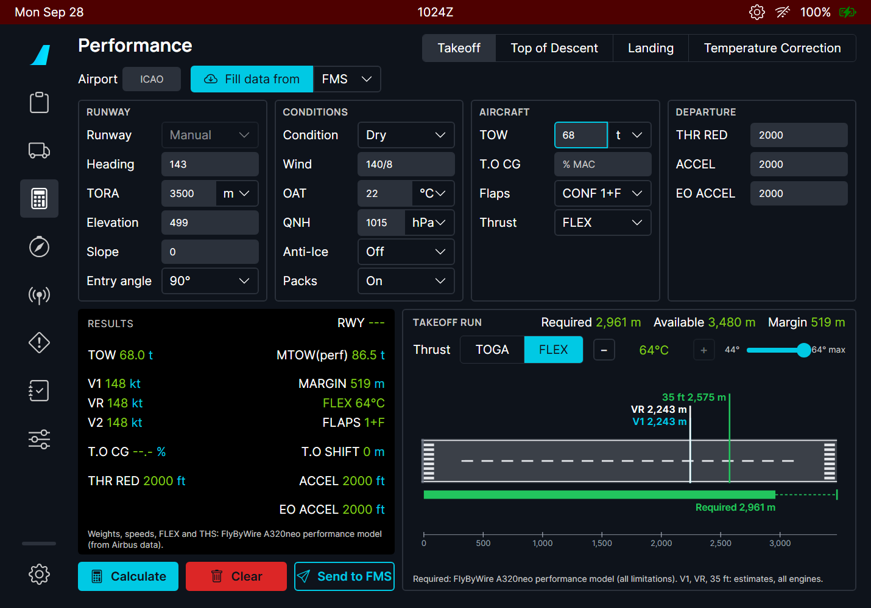
Figure 77. LFBO 14R-like runway (3500 m, 499 ft), 68 t, 22 °C: FLEX 64 °C (maximum), required 2961 m of 3480 m, margin 519 m.
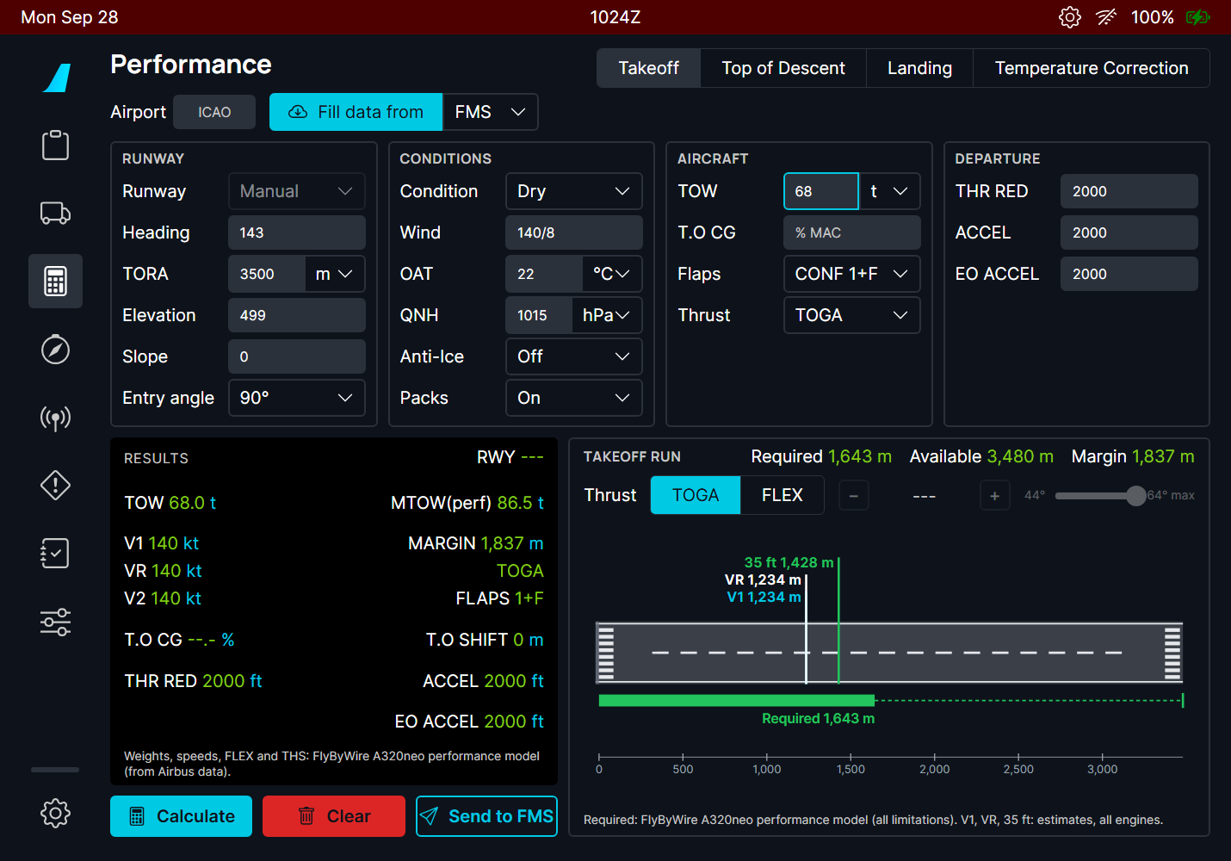  Figure 78. The TOGA run at the same weight: 1643 m. | 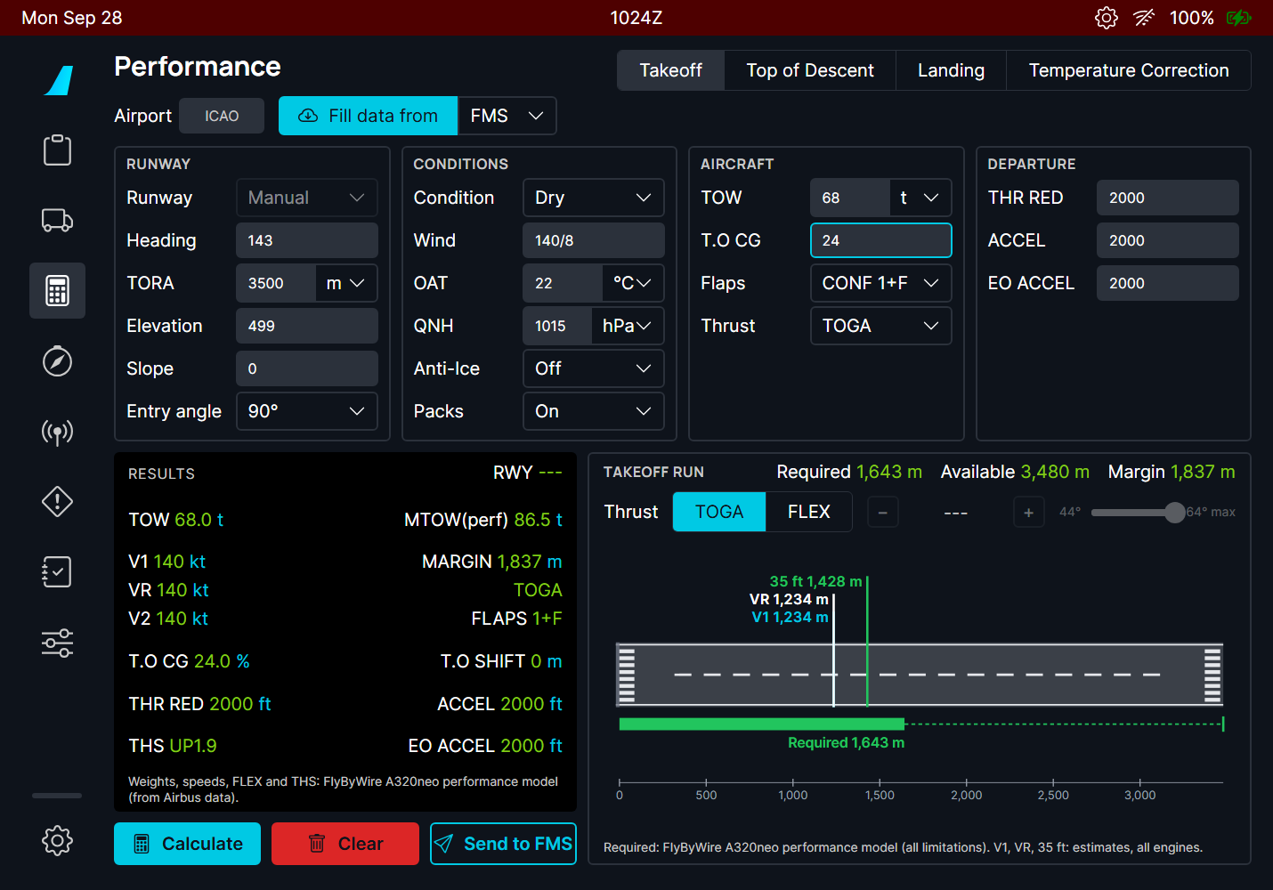  Figure 79. T.O CG 24 % (forward CG) at TOGA: the THS (UP1.9) appears in RESULTS.

NOTE At light weights the FBW A320 model gives V1 = VR = V2 (the pictures show 148/148/148 at FLEX and 140/140/140 at TOGA for 68 t). This comes from the FlyByWire model itself (the same with its version before this PR), not from this feature.

3. Sending to the MCDU
- On the flyPad, choose the runway from the list (the uplink carries the runway ident), calculate, choose TOGA or the FLEX temperature for the takeoff run, and press Send to FMS.
- The flyPad says "Takeoff data sent to the FMS: MCDU PERF TAKE OFF, UPLINK TO DATA, RECEIVED TO DATA", and warns right away if the FMGC departure runway or TOW will prevent the insertion.
- On the MCDU the scratchpad shows TAKEOFF DATA UPLINK.
- PERF TAKE OFF > <TO DATA (6L) > RECEIVED <TO DATA (6L): the UPLINK MAX TO DATA page (or FLX TO DATA with 4R). Check it, then INSERT UPLINK.
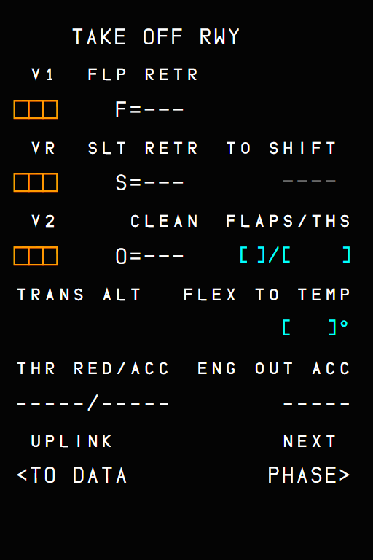  Figure 80. PERF TAKE OFF: the new UPLINK <TO DATA prompt (6L), in PREFLIGHT and DONE. | 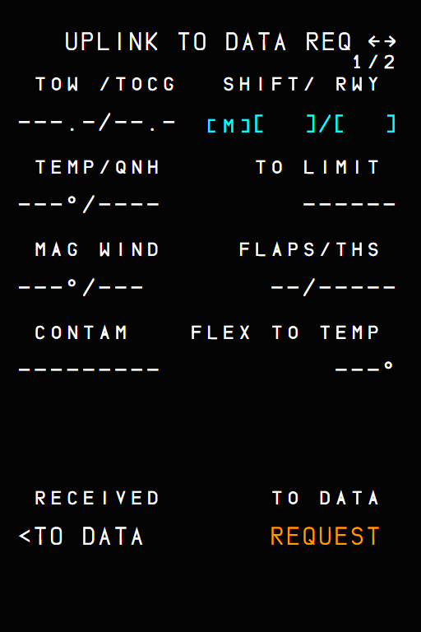  Figure 81. UPLINK TO DATA REQ: the request page (two runways, 1/2). RECEIVED <TO DATA (6L), TO DATA REQUEST (6R).

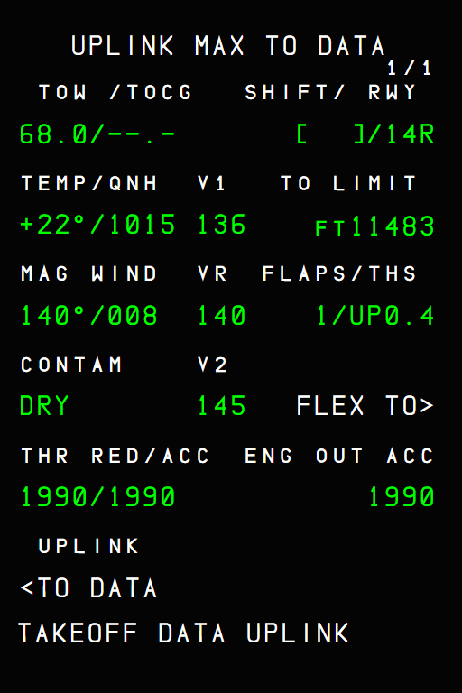  Figure 82. UPLINK MAX TO DATA after TAKEOFF DATA UPLINK: TOW, runway 14R, temperature and QNH, V1 / VR / V2, TO LIMIT, flaps / THS, THR RED / ACC, ENG OUT ACC. FLEX TO> (4R) shows the FLEX data. | 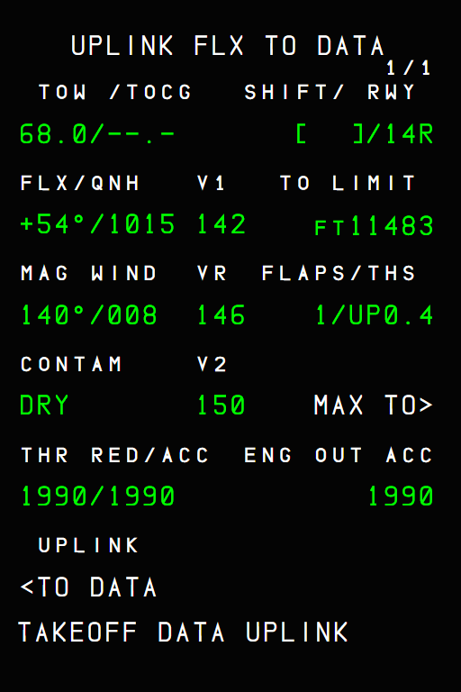  Figure 83. UPLINK FLX TO DATA: FLX +54 °C with its own speeds.

There is no INSERT UPLINK prompt in these pictures because the harness FMGC has no flight plan. The prompt appears only when the uplink is complete (V1 and VR present) and the checks below pass.

The insertion rules (A320 FCOM)
- The uplink runway must be the departure runway of the flight plan.
- The uplink TOW must be not more than 1 t below or 3 t above the FMGC TOW; otherwise there is no insertion.
- INSERT UPLINK fills V1, VR, V2, FLAPS/THS, FLEX TO TEMP (cleared for a MAX takeoff), THR RED/ACC, ENG OUT ACC and the TO SHIFT.
- An incomplete uplink (for example without V1 or VR) gives no INSERT UPLINK prompt (DSC-22_20-70 P 6).
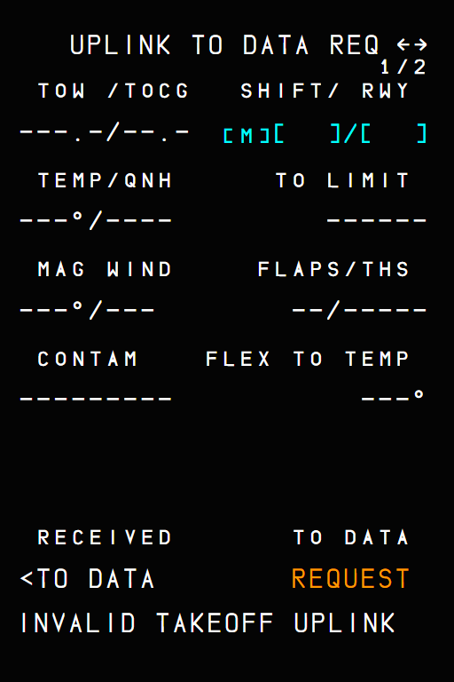
Figure 84. An uplink the FMGC cannot read: INVALID TAKEOFF UPLINK in the scratchpad.
MCDU message | Meaning
TAKEOFF DATA UPLINK | Uplink takeoff data received.
INVALID TAKEOFF UPLINK | The uplink is not valid (missing data).
REQUEST IS PENDING | A request was sent and has no answer yet.
NO ANSWER TO REQUEST | No answer 4 minutes after the request.

PERF TAKE OFF also gets the TO SHIFT field (1 m up to the runway length, CLR to delete): the distance lost when taking off from an intersection.

4. What to expect
Situation | What you should see
Send to FMS with a runway from the list | Success message; TAKEOFF DATA UPLINK on the MCDU.
Send to FMS with a manual runway | Nothing is sent: choose the runway in the list.
FMGC departure runway differs | flyPad warning; no INSERT UPLINK on the MCDU.
FMGC TOW differs by more than -1 t / +3 t | flyPad warning "INSERT UPLINK needs a TOW within -1 t / +3 t"; no INSERT UPLINK.
No TOW in the FMGC | flyPad warning "No TOW in the FMS (INIT B: ZFW and BLOCK)": fill INIT B first.
INSERT UPLINK | PERF TAKE OFF filled with the uplink.

5. Limitations and why
Limitation | Why | What to do
Only the thrust selected for the takeoff run is sent. | The airline sends what the crew asked for; the MCDU holds MAX and FLEX pages, the flyPad fills the one you use. | Select TOGA or FLEX before sending.
V1 = VR = V2 at light weights. | The FlyByWire A320 model (upstream). | Check against your own tools.
No real airline datalink. | The flyPad plays the airline. | -

PR 13 - A380X pilot-stored elements kept across sessions
An optional flyPad setting that keeps the waypoints, navaids, routes and runways you stored in the MFD for the next flight
Aircraft | A380X
Where to find it | flyPad > Settings > Realism > Keep MFD Pilot Stored Waypoints, Navaids, Routes and Runways Between Sessions; MFD > DATA > WAYPOINT / NAVAID / ROUTE / AIRPORT, DATA / STATUS
PR branch | pr/13-pilot-stored-elements-persistence (stacked on PR 10)
Status | Built and tested with 17 unit tests; checked in the sim during development.
Pictures | flyPad and captain MFD in the local browser harness, running the build installed in the sim, with a few stored elements created by the harness.

1. What it is for
On the A380 the crew can store its own waypoints, navaids, routes and runways in the FMS (DATA pages). The FCOM says they are all deleted when all FMCs are shut down (DSC-22-FMS), and that is what happens by default: a new flight starts with an empty list.
In the simulator you may want to keep them from one session to the next (your own departure procedures, a favourite route). The setting below does that. It is marked Unrealistic because the real aircraft does not keep them.

2. The setting
Figure 85. flyPad > Settings > Realism: the last line. Off by default.
- Off (default, as the FCOM): the stored elements are deleted at the end of the session.
- On: they are saved in the simulator storage and restored at the next session, before the FMS loads them.
- A reload of the flight (same session) never restores them twice.
- Turning the setting off drops the kept copy: the next session starts empty.
- The A380 OIT flyPad has the same option.

3. Storing elements in the MFD
The DATA menu pages have a PILOT STORED tab each. The DATA / STATUS page counts them and DELETE ALL clears everything.
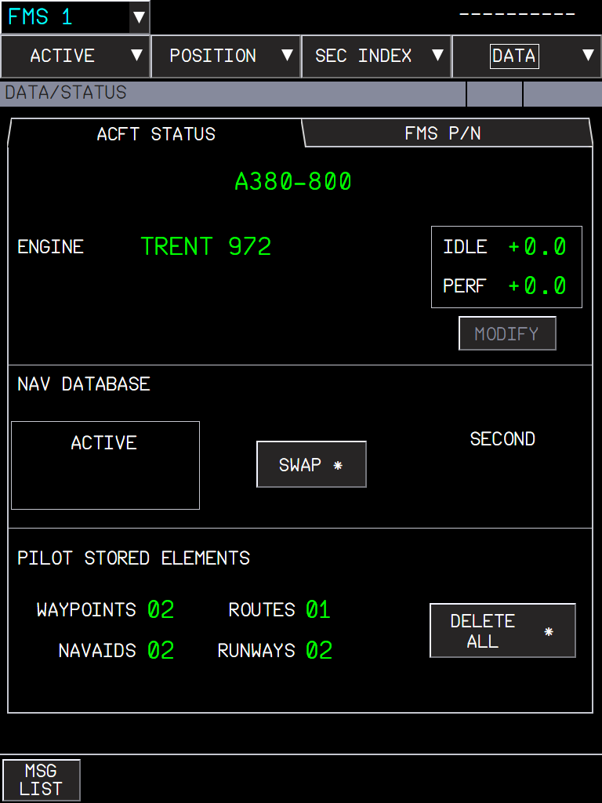  Figure 86. DATA / STATUS: PILOT STORED ELEMENTS: 2 waypoints, 2 navaids, 1 route, 2 runways. | 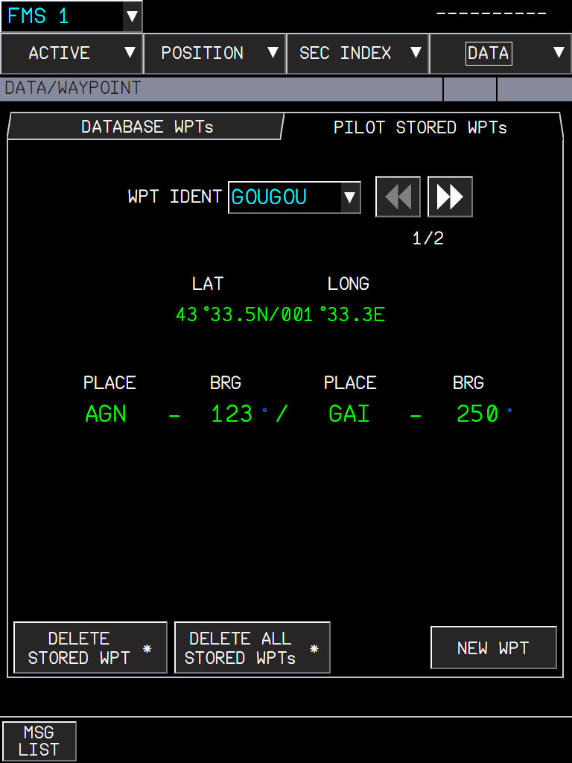  Figure 87. PILOT STORED WPTs: GOUGOU, defined by place/bearing - place/bearing (AGN 123° / GAI 250°), 1/2.

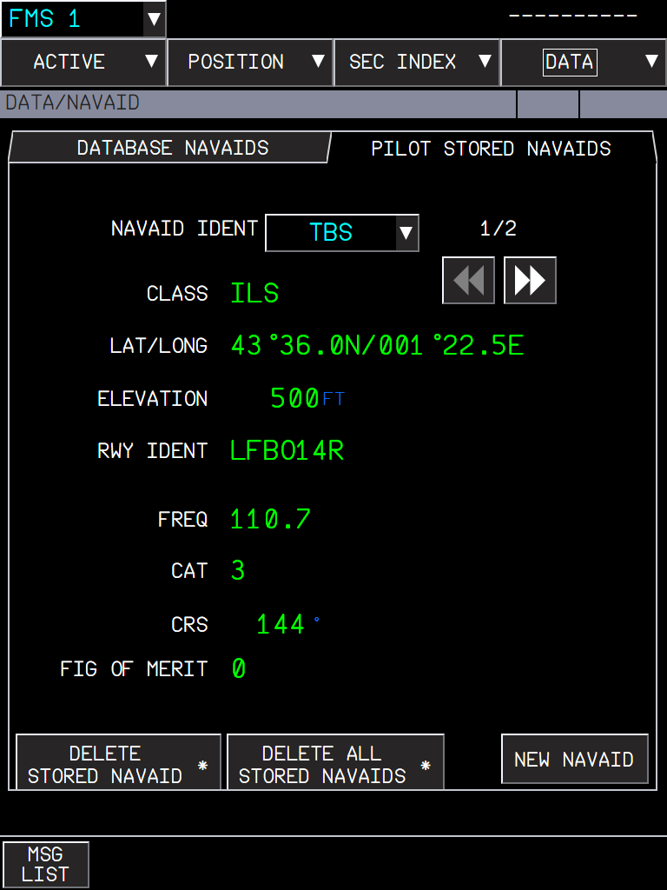  Figure 88. PILOT STORED NAVAIDS: an ILS with its class, position, elevation, runway, frequency, category, course and figure of merit. | 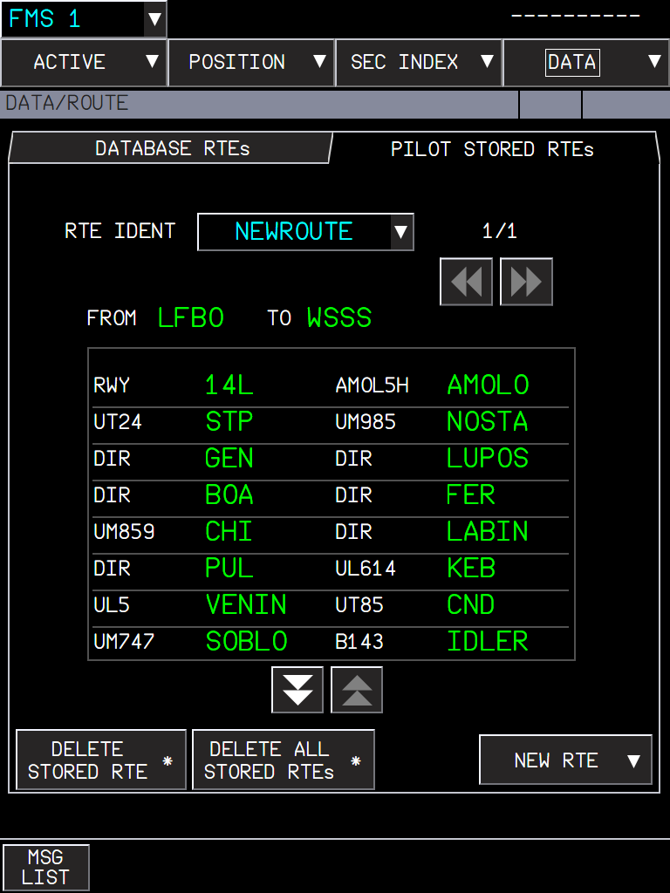  Figure 89. PILOT STORED RTEs: NEWROUTE LFBO to WSSS with its summary (runway, SID, airways and waypoints).

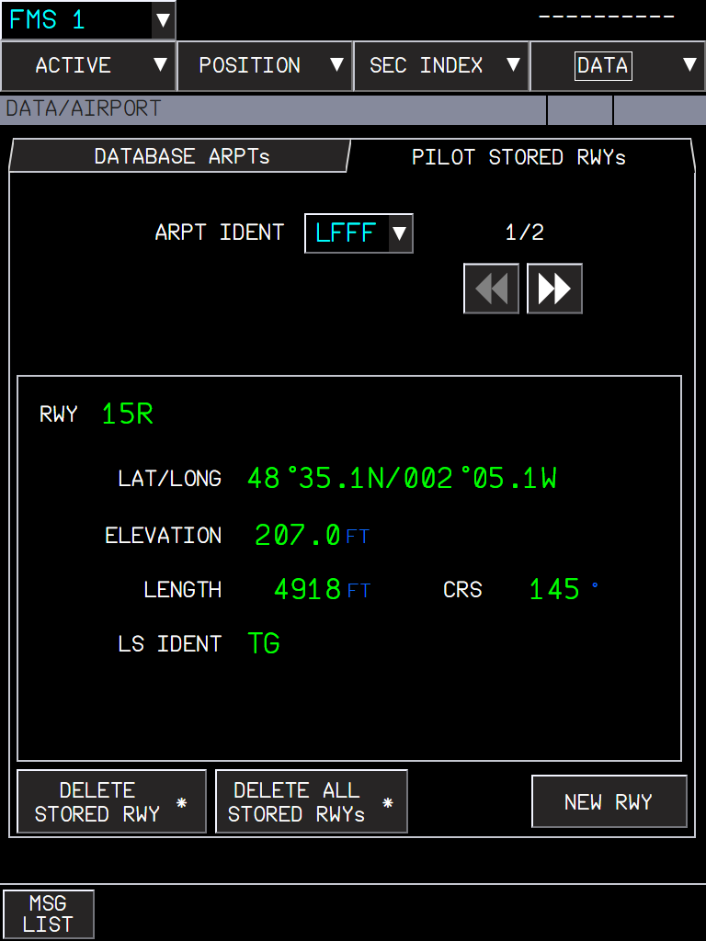
Figure 90. PILOT STORED RWYs (DATA / AIRPORT): runway 15R of LFFF with its position, elevation, length, course and LS ident.

Limits of the database (FCOM)
Element | Limit | When full
Navaids | 20 | The first one created is deleted.
Runways | 10 | The first one created is deleted.
Routes | 5 | PILOT RTEs LIST FULL.
Waypoints | the FMS list of 99 | LIST OF 99 IN USE.

Storing an element with the name of an existing one replaces it (no duplicates).

4. What to expect
Situation | What you should see
Setting off, new session | DATA / STATUS shows 00 everywhere.
Setting on, new session | The elements of the last session are back.
Setting on, flight reloaded | The elements are there once (no duplicates).
Setting turned off | The kept copy is deleted; the current elements stay until the end of the session.
Stored route of another city pair | Not offered in INIT / RTE SEL (routes are per city pair).

5. Limitations and why
Limitation | Why | What to do
Pilot-stored navaids cannot be tuned. | The radio tuning uses the MSFS navaids only. | -
The waypoint limit is 99, not the FCOM 50. | The FMS shares one list of 99 waypoints with its other functions. | -
Keeping the elements is not realistic. | The real FMS deletes them at shutdown. | Leave the setting off for realism.

PR 14 - A380X DIRECT TO options
DIRECT WITH ABEAM, CRS IN and CRS OUT on the MFD DIRECT TO page, as in the A380 FCOM
Aircraft | A380X
Where to find it | MFD > ACTIVE > F-PLN > DIR TO (or the KCCU DIR key)
PR branch | pr/14-direct-to-options (stacked on PR 10)
Status | Built with 10 unit tests on the flight plan geometry; checked in the sim during development.
Pictures | Captain MFD in the local browser harness, running the build installed in the sim. The harness has no navigation database and no flight plan, so the geometry is shown with a diagram (figure 3).

1. What it is for
The DIRECT TO page of the A380 (FCOM DSC-22-FMS-20-30, DIRECT TO) has four options. FBW showed them but only the first one worked. All four work now:
Option | What the FMS builds
DIRECT | A direct leg from the aircraft to the target waypoint (as before).
DIRECT WITH ABEAM | The direct leg, plus an abeam point for each waypoint it bypasses: the point of the direct leg abeam that waypoint, named AB + the first 5 letters of the waypoint (BERGI gives ABBERGI).
CRS IN | An inbound course to the target: the aircraft continues on its current track to the intercept point INTCPT on that course, then flies the course to the target.
CRS OUT | An outbound course from the target: the aircraft continues on its current track to the intercept point INTCPT on the outbound course, then follows it (without overflying the target).

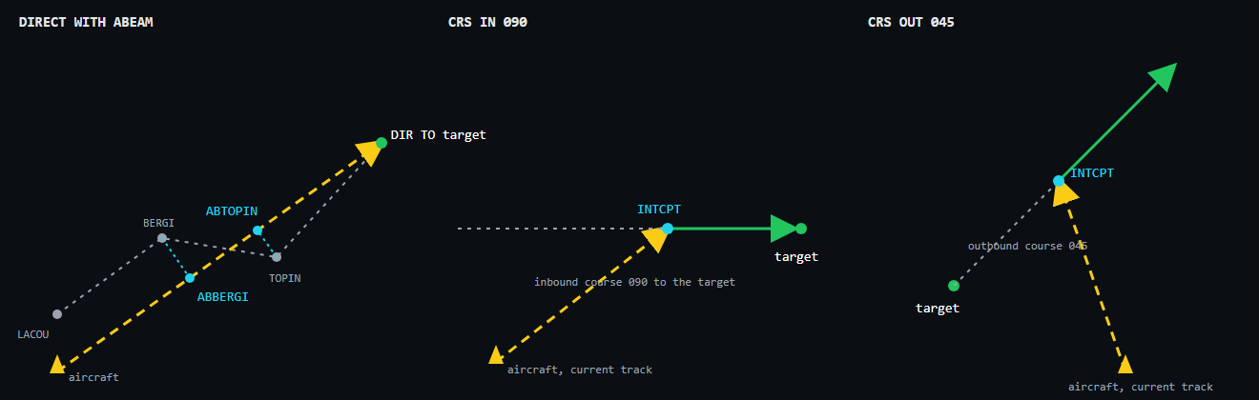
Figure 91. The three new options. Yellow: the aircraft and its path to the first point; green: the course flown after it; blue: the points the FMS creates.
Diagram drawn for this manual: not representative of the in-game UI, reference for the explanation only.

2. Using the page
- Choose the target in DIRECT TO (a flight plan waypoint from the list, or type any fix).
- Choose the option. For CRS IN / CRS OUT a course field appears next to the option.
- For a flight plan waypoint the course is already filled: CRS IN = the course from the previous waypoint to the target, CRS OUT = the course from the target to the next waypoint (FCOM P 131). Type another one if ATC asks (NNN magnetic, NNNT true).
- Check the temporary flight plan (TMPY, yellow) and press INSERT DIR TO.
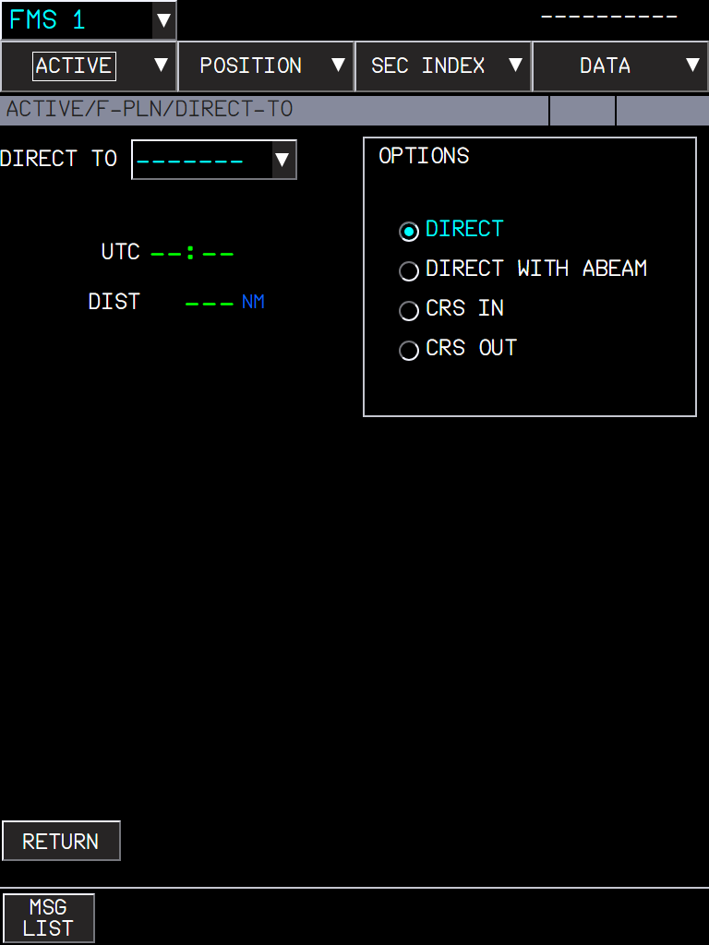  Figure 92. The DIRECT TO page: target, UTC and distance, and the four OPTIONS. | 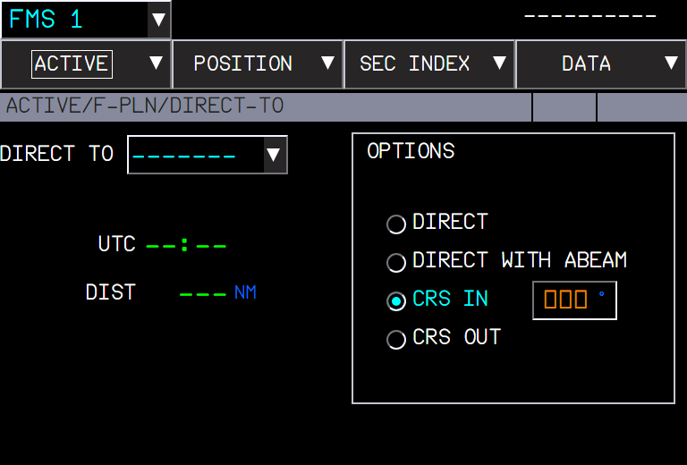  Figure 93. CRS IN selected: the course field (amber boxes until a course is known).

With DIRECT WITH ABEAM, the temporary F-PLN shows (ABEAM PTS) in place of the abeam points until the direct is inserted (FCOM P 162).

3. What to expect
Situation | What you should see
DIRECT WITH ABEAM, waypoints bypassed | One ABxxxxx point per bypassed waypoint, on the direct leg.
DIRECT WITH ABEAM, a waypoint whose abeam is not between the aircraft and the target | No abeam point for it.
CRS IN / OUT with a course that can be intercepted ahead | INTCPT on the course, then the course.
CRS IN more than 160° from the current track, parallel, or behind | No intercept point: a course to the target.
CRS OUT parallel to the track | No intercept point: a course from the target.
CRS IN / OUT without a course | No DIR TO until a course is entered.

4. Limitations and why
Limitation | Why | What to do
Abeam point names can repeat letters of the waypoint. | The FCOM rule is AB + 5 characters; two waypoints starting with the same 5 letters give the same name. | -
No intercept point when the geometry does not allow one. | Following the FCOM limits (160°, parallel, behind). | Use DIRECT, or another course.

PR 15 - A380X fuel jettison
Jettison down to a gross weight set on the MFD, with the ECAM memo, the ABN PROC procedure and the COMPLETED alert (FCOM DSC-28-40)
Aircraft | A380X
Where to find it | Overhead FUEL panel: JETTISON ARM and ACTIVE pushbuttons; MFD FMS ACTIVE/FUEL&LOAD: JTSN GW; ECP ABN PROC > FUEL > JETTISON
PR branch | pr/15-fuel-jettison (independent)
Status | Tested in the sim (September 2026).
Pictures | MFD and EWD in the local browser harness, running the builds installed in the sim; the EWD states are the ones the FWS sends in flight.

1. What it is for
FBW had the overhead JETTISON ARM and ACTIVE pushbuttons, but they did nothing. The fuel management (FQMS) now jettisons the fuel of the transfer tanks down to the gross weight entered on the MFD, and the ECAM shows the memo and the procedures of the FCOM.

2. 1. Set the jettison gross weight
- MFD FMS ACTIVE/FUEL&LOAD page. JTSN GW is shown when the active flight plan has its mandatory data.
- Enter the gross weight at which the jettison must stop, in tonnes (or 1000 lb with the LBS unit).
- Allowed range: from ZFW + 11 000 lb (5.0 t) to the maximum gross weight (FCOM DSC-22-FMS-20-100). Outside it: ENTRY OUT OF RANGE with the range.
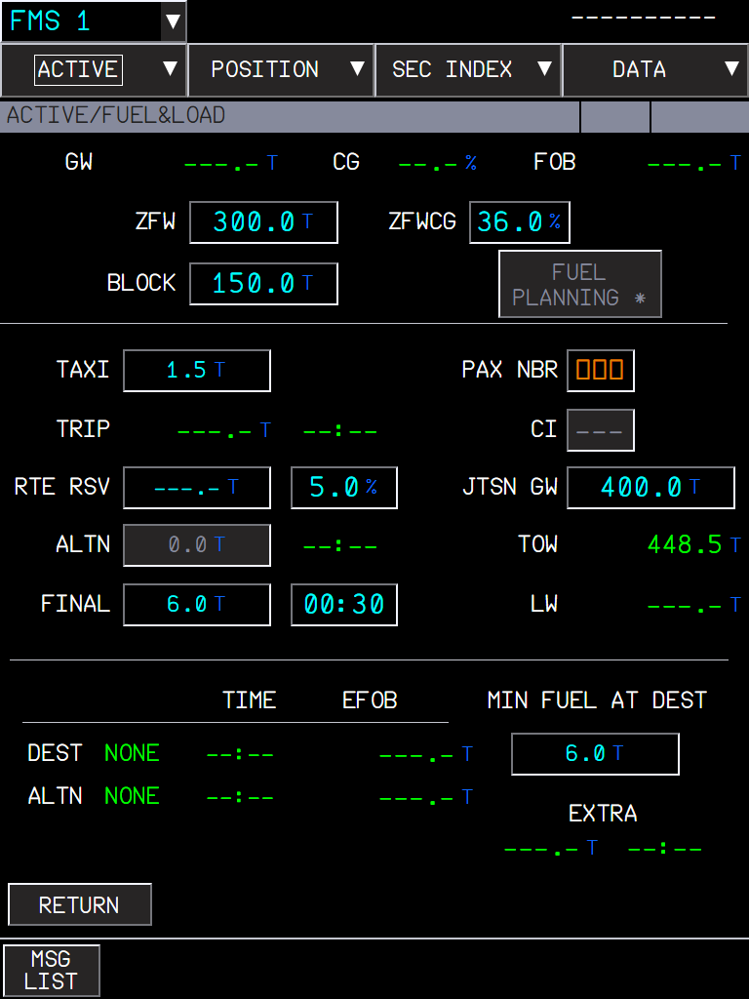  Figure 94. JTSN GW 400.0 t entered (ZFW 300.0 t). | 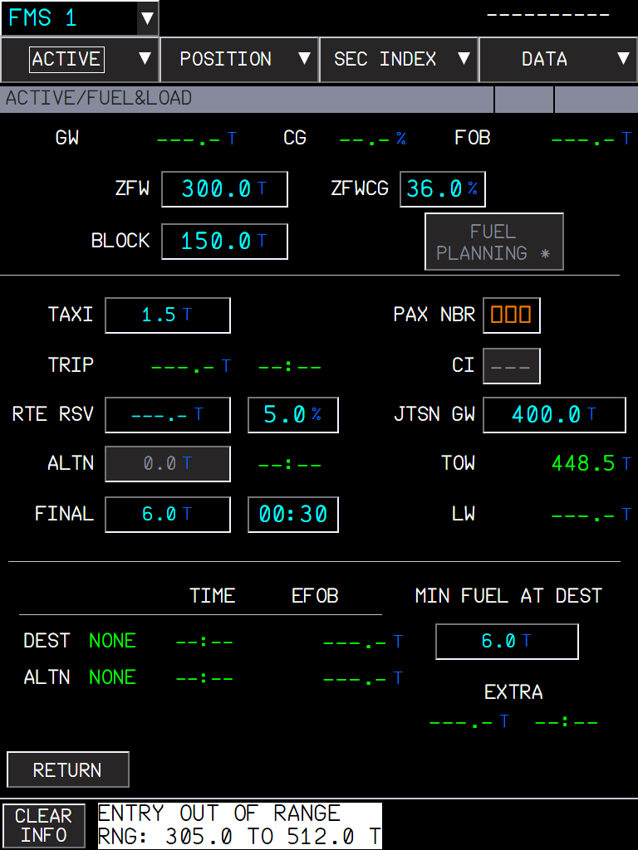  Figure 95. 290 t is below ZFW + 5.0 t: the range is shown in the message area.

CAUTION Without a JTSN GW the FQMS has no target weight: the jettison then runs until the transfer tanks are empty (or a pushbutton is set OFF).

3. 2. Run the procedure
The ABN PROC procedure takes the crew through the steps. ECP ABN PROC, then FUEL, then JETTISON:
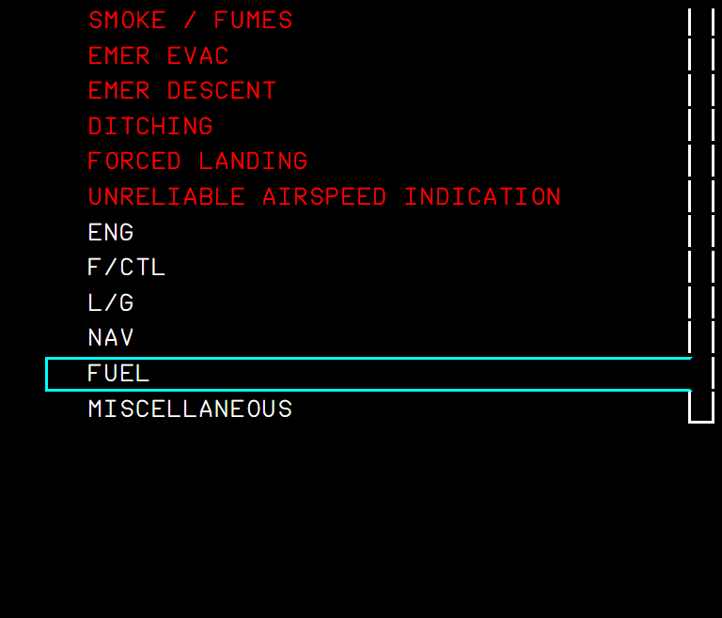  Figure 96. ABN PROC menu: FUEL selected. | 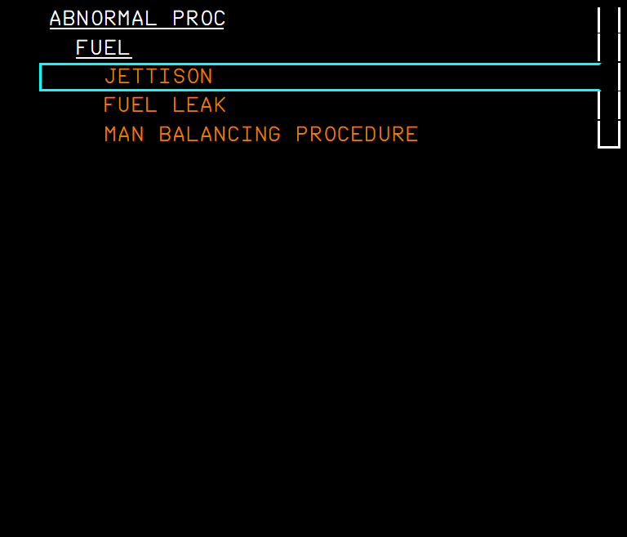  Figure 97. FUEL sub-menu: JETTISON.

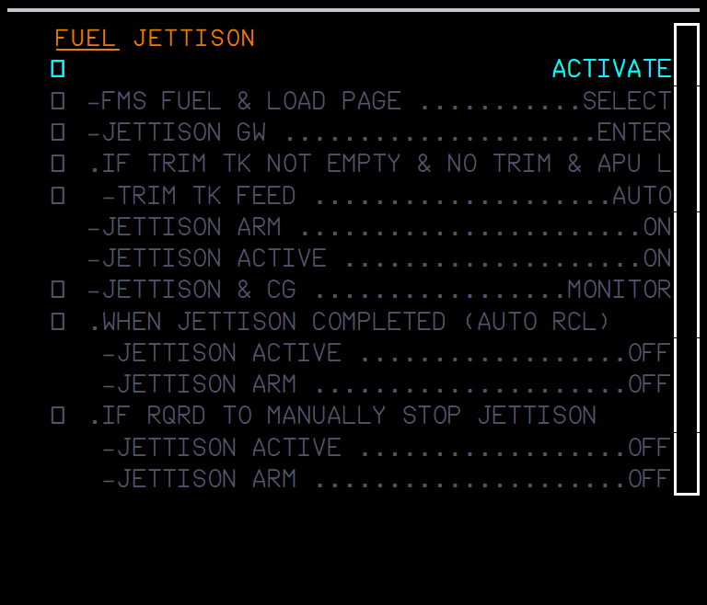  Figure 98. The procedure before ACTIVATE: all lines in grey. | 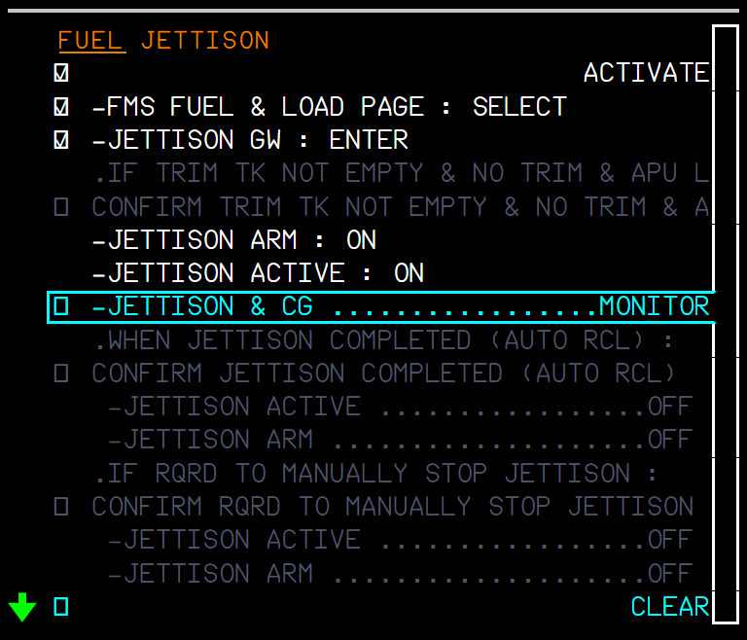  Figure 99. Activated: the FMS lines checked by the crew, JETTISON ARM and ACTIVE ticked by the FWS as the pushbuttons are set (sensed lines).

- FMS FUEL & LOAD PAGE ... SELECT, JETTISON GW ... ENTER: crew check lines.
- IF TRIM TK NOT EMPTY & NO TRIM & APU LINE FAULT: TRIM TK FEED AUTO (condition line, confirmed by the crew).
- JETTISON ARM ON, JETTISON ACTIVE ON: sensed, they tick themselves.
- JETTISON & CG ... MONITOR: watch the SD FUEL page and the CG.
- WHEN JETTISON COMPLETED (AUTO RCL) / IF RQRD TO MANUALLY STOP JETTISON: ACTIVE OFF then ARM OFF, sensed.

4. 3. During the jettison
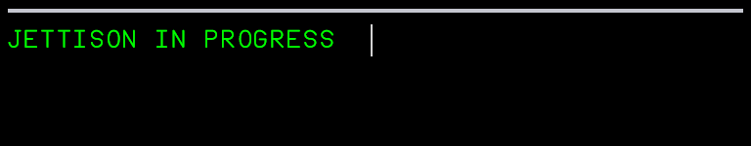
Figure 100. The EWD memo while the fuel is jettisoned.
- Memo JETTISON IN PROGRESS (green).
- Fuel leaves the transfer tanks (outer, mid, inner and trim) at the FCOM rate of 330 693 lb/h (about 2.5 t per minute), in proportion to their content, so they empty together. The feed tanks are never jettisoned.
- The trim tank is held when the CG reaches the forward T.O/LDG limit, and resumes when the CG is 0.5 % aft of it.
- The other automatic transfers pause during the jettison.
- The SD FUEL page shows the two jettison valves open and the quantities decreasing.

5. 4. When it stops
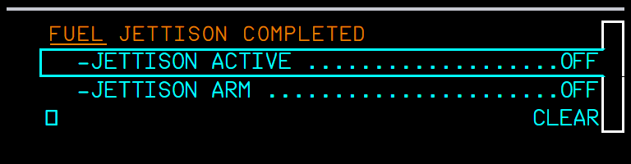
Figure 101. FUEL JETTISON COMPLETED: set ACTIVE then ARM OFF; the lines tick as the pushbuttons are released.
Situation | What you should see
Gross weight reaches the JTSN GW | The jettison stops, FUEL JETTISON COMPLETED shows, the ACTIVE ON light goes off.
All transfer tanks empty (or no JTSN GW entered) | Same: stops and COMPLETED.
ACTIVE or ARM set OFF by the crew | Stops at once (manual stop). No COMPLETED alert.
Both pushbuttons OFF after COMPLETED | The alert and the COMPLETED state clear; a new jettison can be started.
ACTIVE ON without ARM | Nothing: ARM is needed.
AC 1 bus not powered | No jettison (FQMS channel unpowered).

6. Limitations and why
Limitation | Why | What to do
JETTISON FAULT, VLV NOT CLOSED and the INOP SYS are not shown. | FBW has no jettison valve failures to trigger them. | -
The fuel does not leave through an outlet. | The MSFS fuel system has no overboard dump: the FQMS sets the tank quantities directly and opens valves 57 / 58 for the SD picture. | -
After an update, the first flight needs a full MSFS restart. | The change touches the behaviour XML of the overhead, which MSFS loads at start. | Restart MSFS once after installing.

PR 16 - A380X KCCU keyboard entries
Values typed on the KCCU keyboard are entered with ENT, and ESC cancels the edition, as the FCOM describes the KCCU
Aircraft | A380X (MFD, OIT, ND OANS panel: every entry field of the displays)
Where to find it | KCCU (keyboard and cursor control unit) on the pedestal, KBD switch ON; any MFD entry field
PR branch | pr/16-kccu-keyboard-entry (stacked on PR 10)
Status | Built and used in the sim (September 2026).
Pictures | Captain MFD in the local browser harness, running the build installed in the sim; the KCCU keys are sent to the MFD as the sim sends them.

1. What it is for
On the A380 the crew types on the KCCU keyboard. Before this change a value typed on the 3D KCCU keys was often lost: the field was validated only when the display lost the focus, and clicking a 3D key ends the focus before the key reaches the field. Now the field follows the FCOM (DSC-31-30-20, KCCU):
- ENT validates the entry directly.
- ESC "cancels the current field edition. The field returns to the last valid value".
- With the KBD switch ON, the edition continues whatever happens to the display focus: only ENT, ESC or the selection of another field end it (the previous field is then validated). One field is in edition per side.
- A click on a field selects it even when it already had the focus.
- KBD switch OFF: the PC keyboard works as before.

2. Entering a value
- Set the KBD switch of your KCCU ON.
- Click the field with the cursor (trackball or mouse).
- Type the value on the KCCU keys (or the PC keyboard).
- Press ENT. The value is checked with the FCOM entry format of the field.
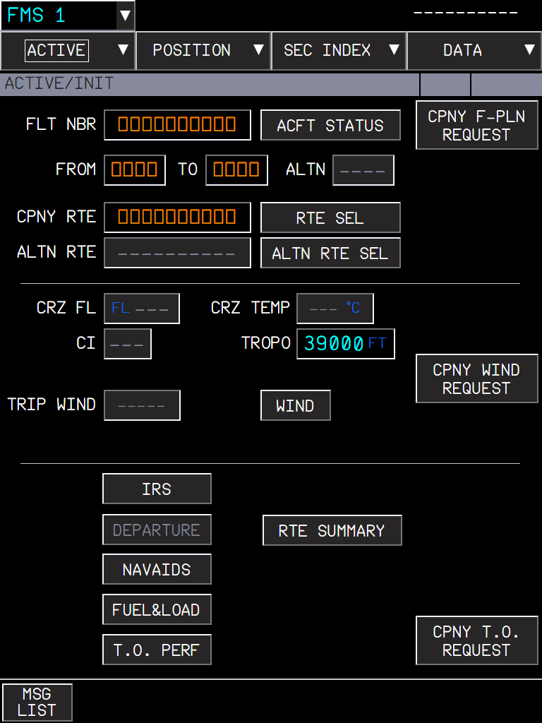  Figure 102. TROPO selected, 39000 typed on the KCCU keys. | 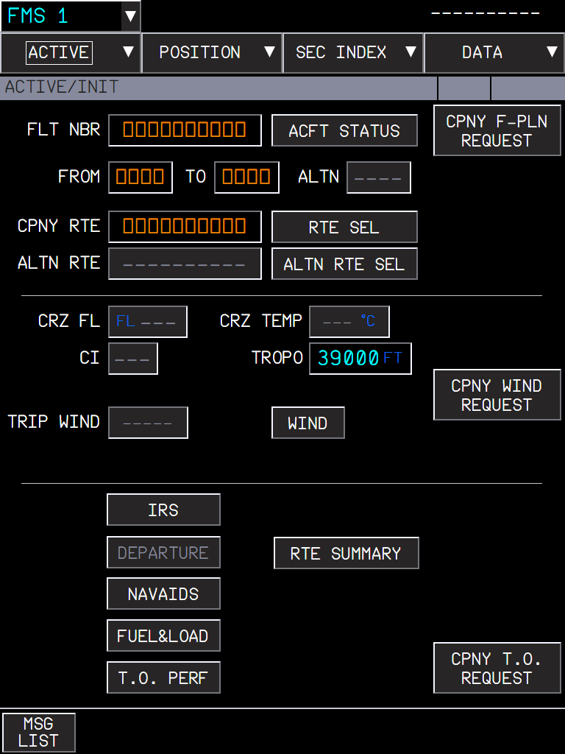  Figure 103. After ENT: TROPO 39000 FT entered (big cyan: a pilot entry).

3. Wrong entries
ENT on a wrong value leaves the field unchanged and shows the FCOM message in the message area; the message gives the expected format. CLR INFO (KCCU key) clears it.
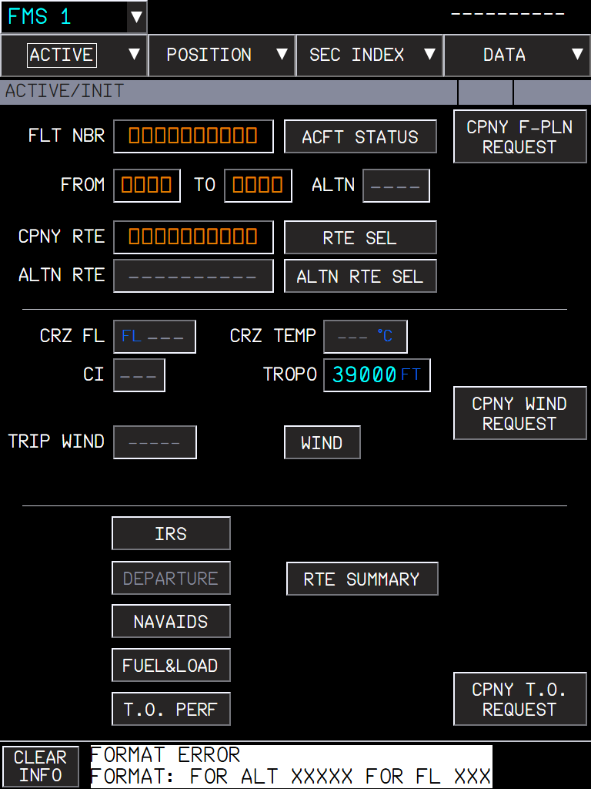  Figure 104. "ABC" in TROPO: FORMAT ERROR, FORMAT: FOR ALT XXXXX FOR FL XXX. | 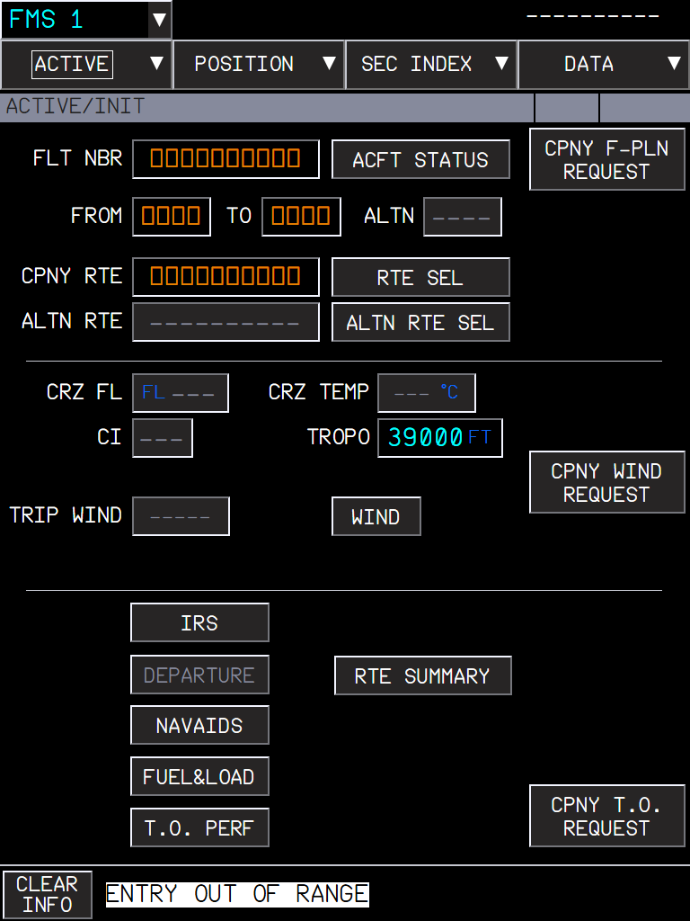  Figure 105. 99999 in TROPO: ENTRY OUT OF RANGE.

4. Cancelling with ESC
  Figure 106. 41000 typed in TROPO, not validated... |   Figure 107. ... ESC: the field returns to its last valid value, 39000.

5. What to expect
Situation | What you should see
Value typed, ENT | The value is entered (or an FCOM error message).
Value typed, ESC | The field returns to its last valid value.
Value typed, another field clicked | The first value is validated, the new field is in edition.
Value typed, click on a 3D KCCU key or elsewhere in the cockpit | KBD ON: the field stays in edition, the value is not lost.
KBD switch OFF | The PC keyboard types in the field; the field is validated when it loses the focus, as before.

6. Limitations and why
Limitation | Why | What to do
One field in edition per side. | As on the aircraft: each KCCU drives its own side. | -

PR 17 - A380X ECAM procedures from the FCOM
The ABN PROC procedures that showed nothing, and the lines of the ENG FAIL, ALL ENGINES FAILURE and COND alerts, written from the A380 FCOM
Aircraft | A380X
Where to find it | ECP ABN PROC (not-sensed procedures, EWD); the sensed alerts appear by themselves on the EWD
PR branch | pr/17-ecam-procedures (independent)
Status | Tested in the sim (September 2026).
Pictures | EWD in the local browser harness, running the build installed in the sim; the EWD states are the ones the FWS sends.

1. What it is for
Many ABN PROC procedures were marked WIP: they had no lines and no FWS entry, so selecting one showed nothing. They now carry the FCOM text (PRO-ABN-ECAM-10 and -20). Some sensed alerts also got their FCOM lines, with the lines the FWS can check ticking by themselves.

2. Opening a not-sensed procedure
- Press ABN PROC on the ECP. The EWD lists the red emergency procedures, then the categories (ENG, F/CTL, L/G, NAV, FUEL, MISCELLANEOUS).
- Move the cursor with the ECP UP / DOWN keys and press CHECK: the category opens, then the procedure.
- The procedure shows in grey with ACTIVATE: a preview. CHECK on ACTIVATE runs it: the lines turn cyan and the cursor walks through them.
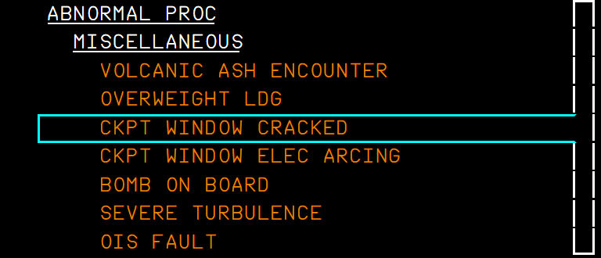  Figure 108. ABN PROC > MISCELLANEOUS. | 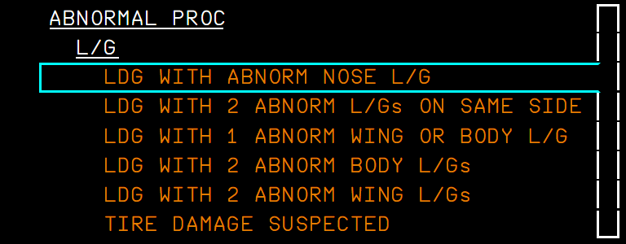  Figure 109. ABN PROC > L/G: the landing gear procedures.

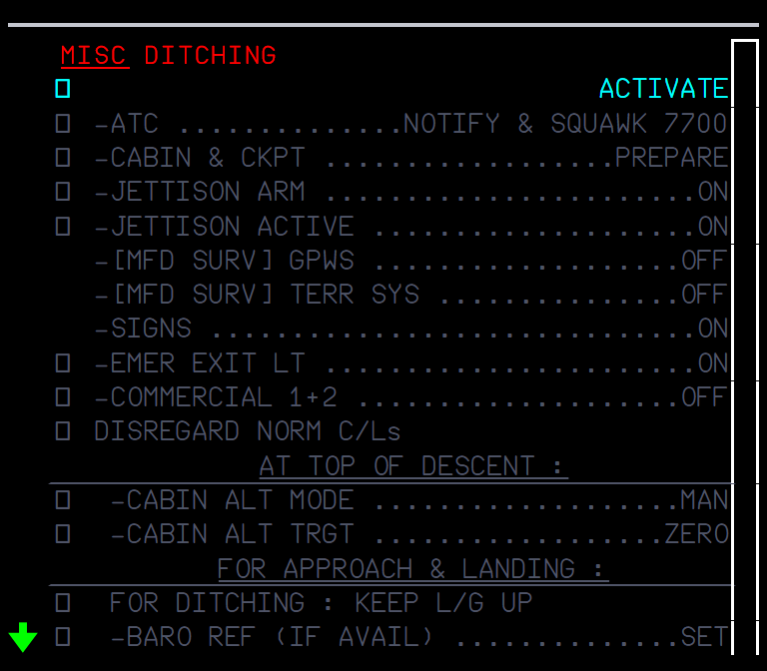  Figure 110. DITCHING before ACTIVATE (grey preview). | 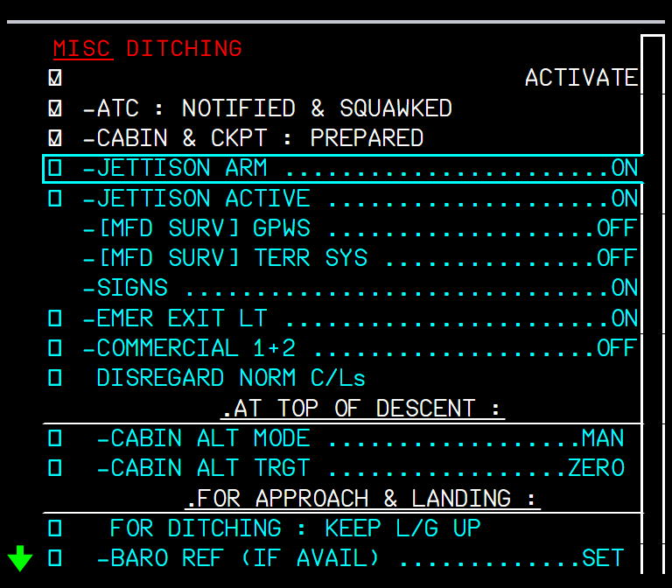  Figure 111. DITCHING activated: ATC and CABIN & CKPT checked by the crew; the cursor on JETTISON ARM.

3. The procedures added
Menu | Procedures
Emergency list (red) | DITCHING, FORCED LANDING
MISCELLANEOUS | CKPT WINDOW CRACKED, CKPT WINDOW ELEC ARCING, OIS FAULT
FUEL | FUEL LEAK (the FUEL LEAK DETECTED procedure, with LAND ANSA), MAN BALANCING PROCEDURE
L/G | LDG WITH ABNORM NOSE L/G, WITH 2 ABNORM L/Gs ON SAME SIDE, WITH 1 ABNORM WING OR BODY L/G, WITH 2 ABNORM BODY L/Gs, WITH 2 ABNORM WING L/Gs (they call the WHEEL page)
NAV | IR ALIGNMENT IN ATT MODE
ENG | HI VIBRATIONS (was missing from the list)

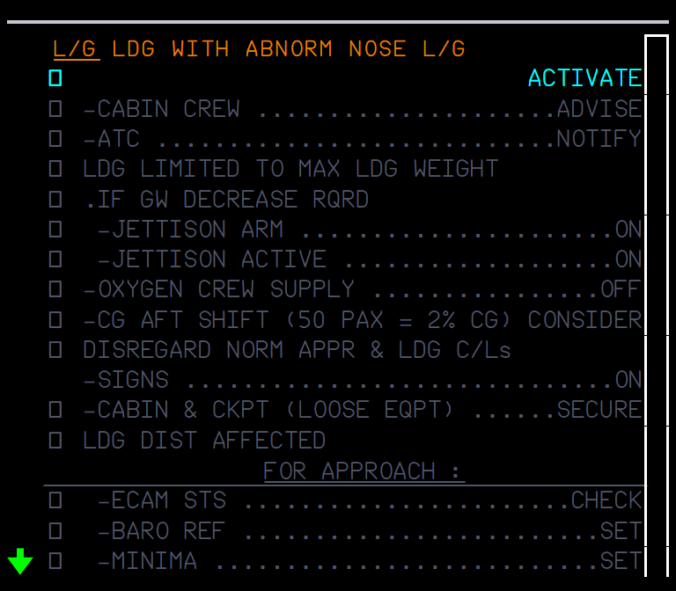  Figure 112. LDG WITH ABNORM NOSE L/G (preview). | 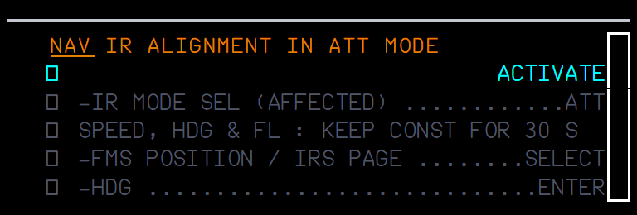  Figure 113. IR ALIGNMENT IN ATT MODE (preview).

4. Sensed alerts with FCOM lines
These appear by themselves when the failure is detected.
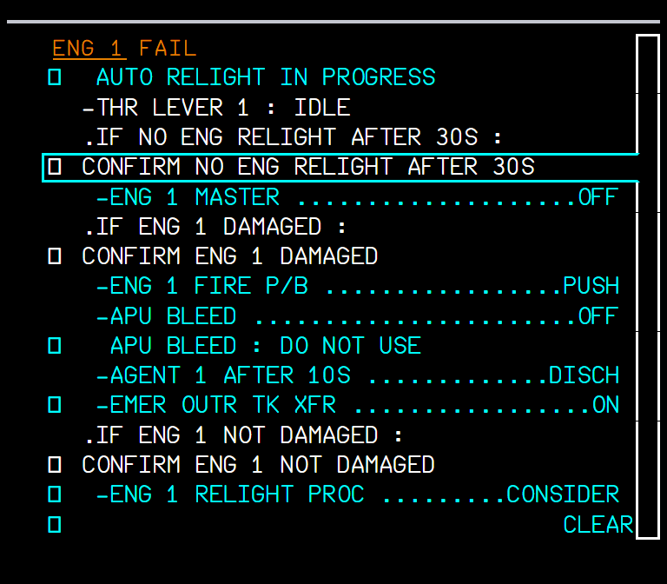  Figure 114. ENG 1 FAIL in flight: AUTO RELIGHT IN PROGRESS, THR LEVER 1 IDLE (ticked, the lever is at idle), then the relight / damaged branches. | 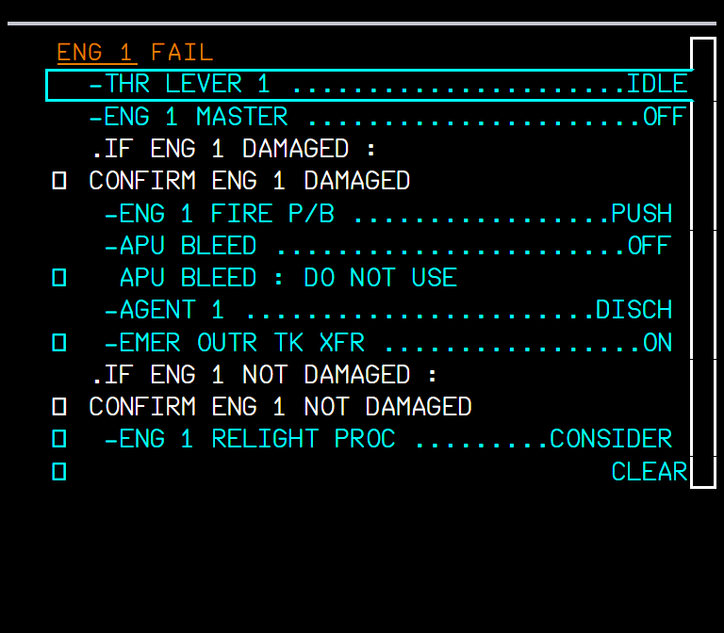  Figure 115. ENG 1 FAIL on the ground: the ground lines only.

Situation | What you should see
ENG x FAIL just after lift-off | The first line is L/G ... UP, until the gear lever is up.
ENG x FAIL in flight | AUTO RELIGHT IN PROGRESS; THR LEVER x IDLE, ENG x MASTER OFF, FIRE P/B, APU BLEED, AGENT: these tick from the cockpit controls.
ENG x FAIL on the ground | Only the ground part of the procedure.
All four engines fail in flight | ALL ENGINES FAILURE (red, LAND ASAP): the FCOM ALL ENG FLAME OUT procedure, fuel remaining / no fuel, relight, then forced landing or ditching; it scrolls with the cursor.
HOT AIR 1 (2) pushbutton OFF | COND HOT AIR 1 (2) FAULT: CARGO TEMP MONITOR, HOT AIR 1 ON.
COND TEMP CTL FAULT | Now with its FCOM lines.

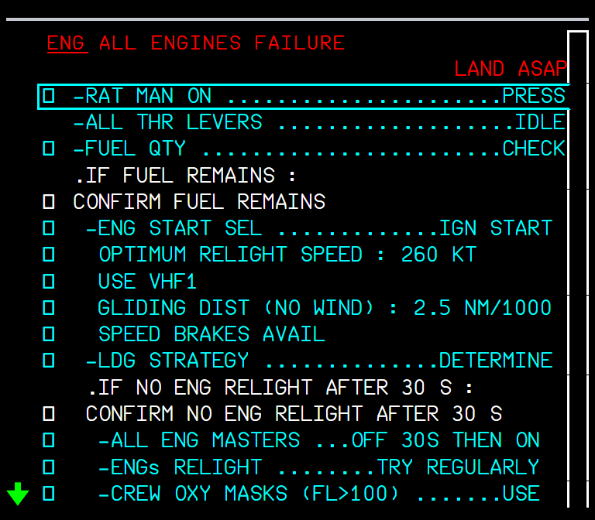  Figure 116. ALL ENGINES FAILURE, first page. | 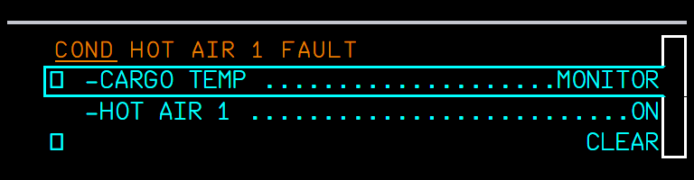  Figure 117. COND HOT AIR 1 FAULT.

5. Reading the lines
- Upper case .IF ... lines are ECAM conditions: the crew confirms them (CONFIRM ...), then the lines below become active.
- Headers such as AT TOP OF DESCENT : are centred sub-headings.
- Sensed lines tick by themselves once the action is done; the others are ticked by the crew with the ECP CHECK key.
- A line fits the 41 characters of the EWD; nesting is capped at three levels.

6. Limitations and why
Limitation | Why | What to do
About 85 sensed alerts show their title only. | The FCOM gives no lines for them ("Crew awareness"). | -
No deferred procedures, limitations or STATUS for the new procedures. | Not in this change. | -
FLUCTUATING VERTICAL SPEED stays WIP; HOT AIR 1(2) OFF / VLV OPEN, T.O V1/VR/V2 DISAGREE, OVERSPEED LOAD ANALYSIS REQUIRED have no lines. | They are not in the 2011 FCOM used as the source. | -
ALL ENGINES FAILURE is long. | It is the full FCOM procedure; the EWD scrolls with the cursor. | -

PR 18 - A32NX RAAS runway awareness callouts
The Honeywell Runway Awareness and Advisory System option of the EGPWS: spoken advisories and cautions about runways, from the sim's own airport data
Aircraft | A32NX
Where to find it | flyPad Settings > Aircraft Options / Pin Programs > RAAS: Off, Feet or Meters
PR branch | pr/18-a32nx-raas (independent)
Status | Tested in the sim (September 2026): the voice and the callouts were heard in flight and on the ground.
Pictures | The flyPad setting from the local browser harness; RAAS is audio only, so the callouts are shown on diagrams drawn from the code (Honeywell product description 060-4564-001, section 4).

1. What it is for
RAAS is an option of the A320's Honeywell EGPWS (A320 FCOM GEN aircraft configuration, used as a line-up aid in PRO-NOR-SOP-11 TAKEOFF RUNWAY CONFIRM). It tells the crew which runway they are approaching or are on, warns of a taxiway takeoff or landing, and calls the distance remaining. It needs no airport map: the runways come from the sim's airport database.

2. Turning it on
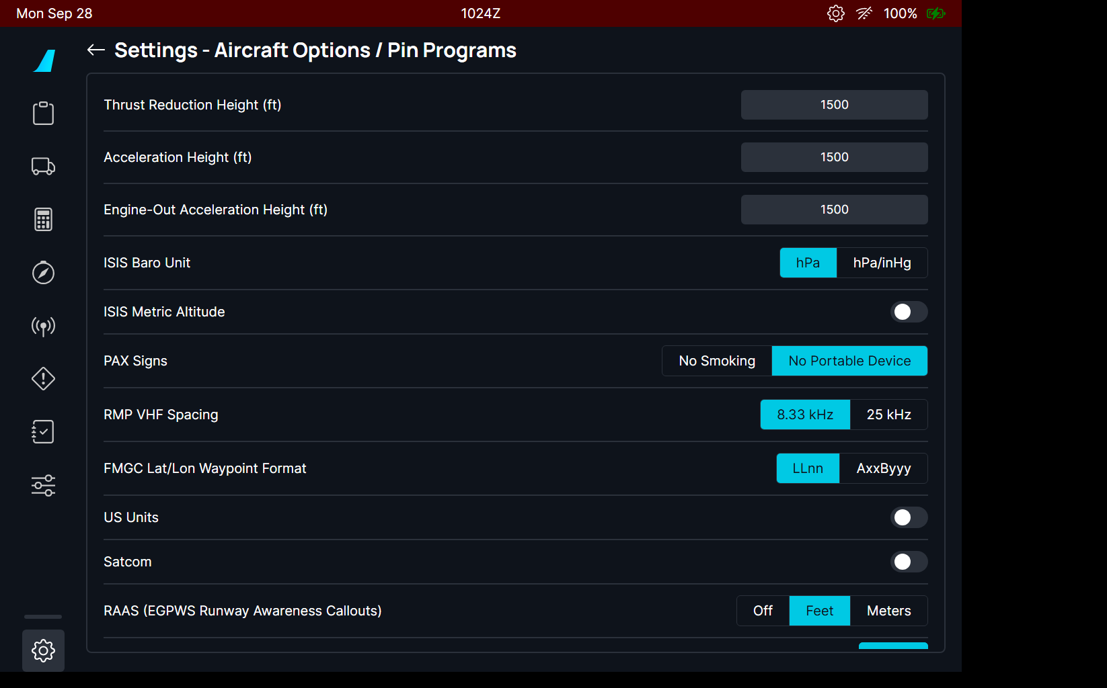
Figure 118. flyPad Settings > Aircraft Options / Pin Programs.
Figure 119. RAAS: Off, Feet (default) or Meters. The unit is the one of the distance callouts.
- The callouts run while the EGPWC is powered (AC BUS 1) and the GPWS SYS pushbutton is not OFF.
- The EGPWS aural alerts (e.g. "TOO LOW TERRAIN", "GLIDE SLOPE") have priority: RAAS waits for them.
- The voice is played word by word.

3. On the ground
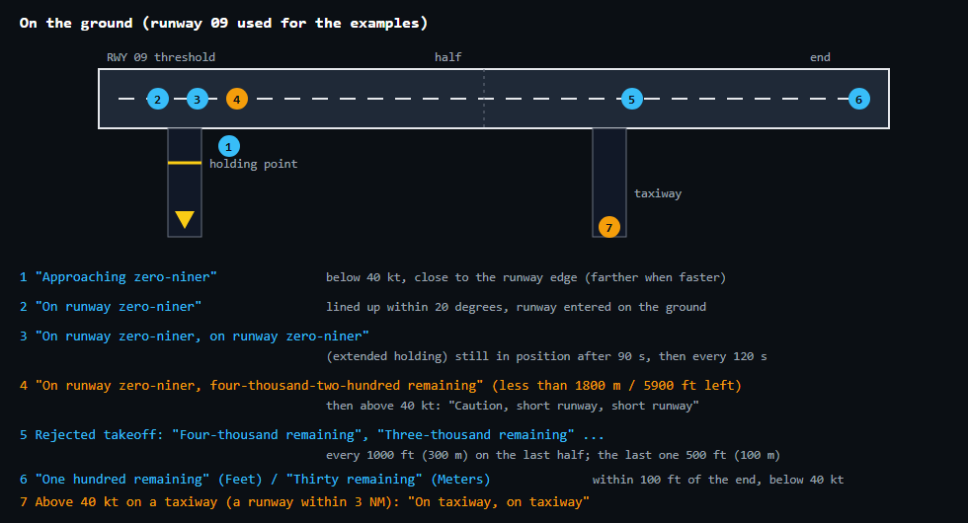
Figure 120. The ground callouts, in blue the advisories, in amber the cautions.
Diagram drawn for this manual: not representative of the in-game UI, reference for the explanation only.
Situation | What you should see
Taxiing towards a runway (below 40 kt) | "Approaching" and the runway end nearest to where you will enter; "Approaching runways" when two at once.
Lining up | "On runway" and the runway, once, when the runway was entered on the ground.
Lining up with less than 1800 m (5900 ft) ahead | The length remaining is added; at the start of the roll (above 40 kt), "Caution, short runway".
Holding on the runway for 90 s | "On runway ..." twice, then every 120 s while you stay.
Starting a takeoff roll on a taxiway (above 40 kt) | "On taxiway, on taxiway".
Rejected takeoff (ground speed down 7 kt from its maximum) | The distance remaining on the last half of the runway.
Slow near the end (within 100 ft, below 40 kt) | "One hundred remaining" (Feet) or "Thirty remaining" (Meters).

4. Approach and landing
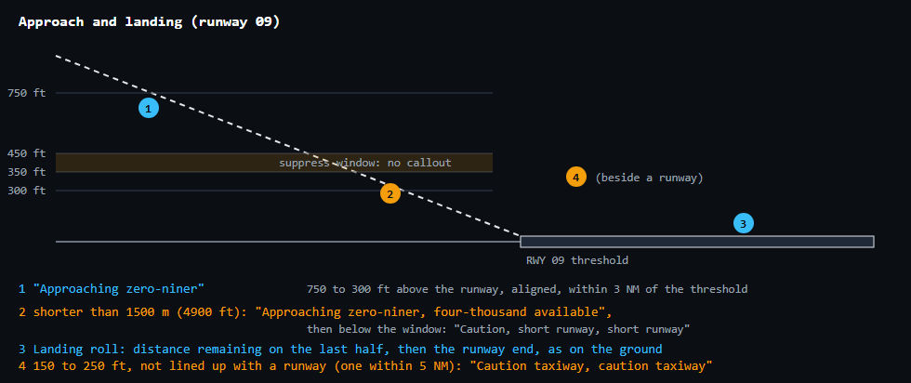
Figure 121. The approach callouts and the suppress window.
Diagram drawn for this manual: not representative of the in-game UI, reference for the explanation only.
Situation | What you should see
Between 750 and 300 ft, lined up, within 3 NM | "Approaching" and the runway, once. Not between 450 and 350 ft (the Airbus suppress window, where the crew is busy with the auto callouts).
The runway is shorter than 1500 m (4900 ft) | The available length is added; below the window: "Caution, short runway".
150 to 250 ft, not lined up with any runway | "Caution taxiway, caution taxiway".
Landing roll | The distance remaining on the last half: every 1000 ft (Feet) or 300 m (Meters), the last one at 500 ft / 100 m; then the runway end.

5. Limitations and why
Limitation | Why | What to do
Only runways known to the sim. | The runways come from the MSFS airport database, not from an airport map: no taxiway geometry, so "on taxiway" is judged as "not aligned with a runway". | -
One synthetic voice. | The clips are generated with the Piper text-to-speech engine (voice trained on the public-domain LJ Speech dataset); its licence allows the clips in the aircraft. | -
No RAAS on the A380X. | The A380X uses the OANS runway alerts instead (see the PR 19 manual). | -

PR 19 - A380X RWY AHEAD without an airport map
The OANS RWY AHEAD advisory now works without the Navigraph airport map, from the runways of the sim's own airport database
Aircraft | A380X
Where to find it | PFD and ND, automatic while taxiing
PR branch | pr/19-a380x-oans-rwy-ahead-without-map (stacked on PR 18: it uses the runway module of the RAAS PR)
Status | Built with 4 unit tests; used in the sim during development (September 2026).
Pictures | Captain ND in the local browser harness, running the build installed in the sim; the advisory is triggered by the harness (the harness has no sim airport database).

1. What it is for
While taxiing, the A380 OANS warns the crew before the aircraft enters a runway: RWY AHEAD with the runway name, on the PFD and the ND. In FBW this advisory came from the Navigraph airport map (AMDB): without a Navigraph subscription, or at an airport without a map, it never came. Now, while no airport map is loaded, the OANS uses the runways of the sim's own airport database with the same rule.

2. The rule
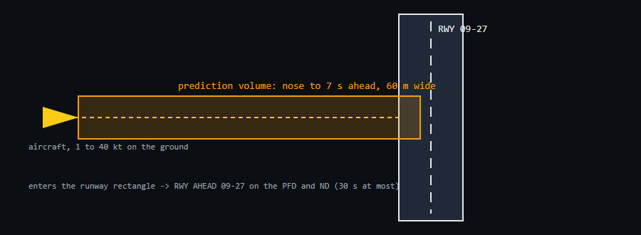
Figure 122. The prediction volume: from the nose to 7 seconds ahead at the current ground speed, 60 m wide. When it reaches a runway, RWY AHEAD appears for that runway.
Diagram drawn for this manual: not representative of the in-game UI, reference for the explanation only.
- On the ground, from 1 to 40 kt.
- The advisory stays at most 30 s, and goes when the aircraft is on the runway.
- With an airport map loaded, nothing changes: the map is used as before.

3. What it looks like
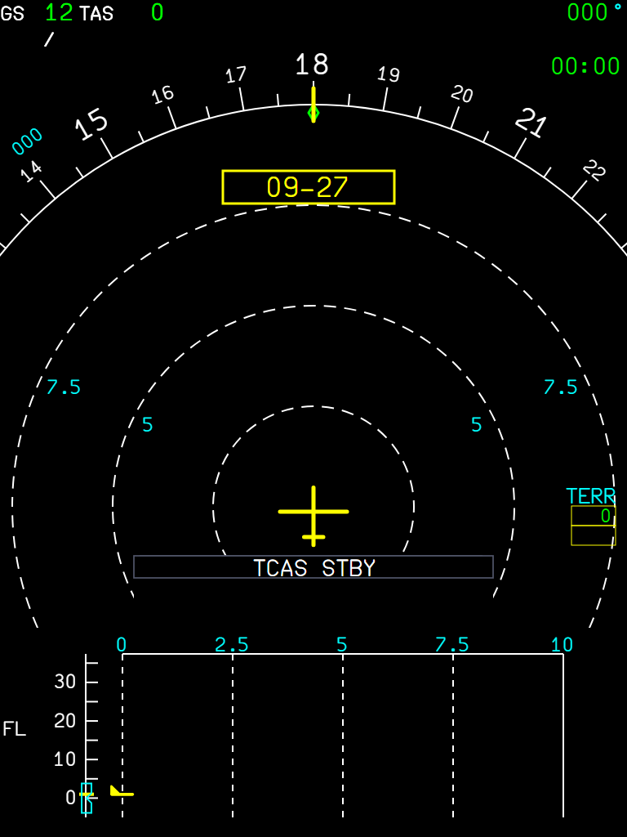
Figure 123. The ND advisory: the runway name in a yellow box at the top (here 09-27, when the aircraft taxis south towards runway 09/27). The PFD shows RWY AHEAD too.

4. What to expect
Situation | What you should see
Taxiing towards a runway, no Navigraph map | RWY AHEAD with the runway name, up to 30 s.
Taxiing towards a runway, with the Navigraph map | RWY AHEAD from the map (as before).
Stopped, or above 40 kt | No advisory.
On the runway | The advisory goes.

5. Limitations and why
Limitation | Why | What to do
Runway rectangles only. | The sim database gives each runway as a rectangle (threshold, length, width); displaced thresholds and runway shapes of the airport map are not known. | -
Waits for PR 18. | It shares the runway module of the RAAS PR. | -

PR 20 - A380X computed alternate fuel, EXTRA time and OFP fuel figures
The ALTN fuel and time of FUEL&LOAD computed as the FCOM defines them, instead of a fixed 6.5 t; the EXTRA time next to the EXTRA fuel
Aircraft | A380X
Where to find it | MFD > ACTIVE > FUEL&LOAD (ALTN line) and ACTIVE > F-PLN > ALTERNATE
PR branch | pr/20-a380x-altn-fuel-computation (stacked on PR 10)
Status | Built with 5 unit tests; ALTN checked in the sim during the fuel formula audit (September 2026); EXTRA time checked in the harness only.
Pictures | Captain MFD in the local browser harness (no flight plan, so the values are dashes). The table in section 3 comes from the predictor of this feature run on its own.

1. What it is for
The block fuel includes the fuel to divert to the alternate. FBW used a fixed 6.5 t, whatever the alternate. The A380 FCOM (DSC-22-FMS-20-30, FUEL&LOAD page) defines the ALTN fuel as the fuel (and time) for the trip from the primary destination to the landing at the alternate, computed with CI 0, at FL220 when the alternate route is shorter than 200 NM and FL310 otherwise. This is what the FMS computes now.

2. Where you see it
Figure 124. FUEL&LOAD: the ALTN line gets its fuel and its time; the arrival at the alternate (destination + ALTN time) is under ALTN in the UTC column. | Figure 125. ALTERNATE page: the fuel to each alternate (EXTRA column) uses the same computation.

- The distance is the alternate flight plan distance, without its missed approach; without an alternate route, the direct distance.
- The weight is the weight at the destination (ZFW + MIN FUEL AT DEST), with the ALTN wind of the WIND page.
- No ZFW: no default ALTN fuel. The value is recomputed only when its inputs change.

3. How much to expect
Results of the predictor for an alternate close to sea level, fuel on board 12.5 t at the destination (fuel in tonnes / time in minutes / cruise level):
Alternate distance | ZFW 300 t | ZFW 344 t | ZFW 344 t, 30 kt headwind | ZFW 344 t, 30 kt tailwind
60 NM | 2.3 t / 13 min / FL140 | 2.3 / 13 / FL120 | 2.5 / 14 | 2.1 / 12
100 NM | 3.7 / 19 / FL220 | 3.7 / 19 / FL200 | 4.0 / 21 | 3.4 / 18
150 NM | 4.9 / 26 / FL220 | 5.1 / 27 / FL220 | 5.5 / 29 | 4.8 / 25
199 NM | 6.1 / 34 / FL220 | 6.3 / 34 / FL220 | 6.8 / 37 | 5.9 / 32
200 NM | 6.3 / 32 / FL310 | 6.5 / 33 / FL310 | 6.9 / 36 | 6.2 / 31
300 NM | 8.5 / 46 / FL310 | 8.8 / 46 / FL310 | 9.4 / 50 | 8.3 / 44
400 NM | 10.8 / 59 / FL310 | 11.1 / 59 / FL310 | 11.8 / 64 | 10.4 / 56
500 NM | 13.0 / 72 / FL310 | 13.3 / 73 / FL310 | 14.2 / 78 | 12.5 / 68

- At 200 NM the level jumps from FL220 to FL310 (the FCOM rule): the time drops a little, the fuel rises a little.
- Short alternates (60-100 NM) fly lower than FL220: the cruise level is lowered until the climb and the descent fit in the distance.
- The old fixed value, 6.5 t, is about right only for an alternate 200 NM away.

4. The computation
- Climb at climb thrust, cruise, idle descent, with the aircraft's VNAV prediction models (the same as the FMS predictions).
- CI 0 speeds of the A380 FMS: 290 kt climb and cruise, 288 kt descent, M0.84, 250 kt below FL100.

5. EXTRA time
The EXTRA time next to the EXTRA fuel (FCOM: the fuel, and time, that remains after landing at the destination, minus the MIN FUEL AT DEST) was never computed and always showed --:--. It is now the time the EXTRA fuel lasts at the holding fuel flow of the FINAL fuel default, 0.2 t/min (30 min = 6 t): 7.4 t of EXTRA shows 00:37, 12.0 t shows 01:00.
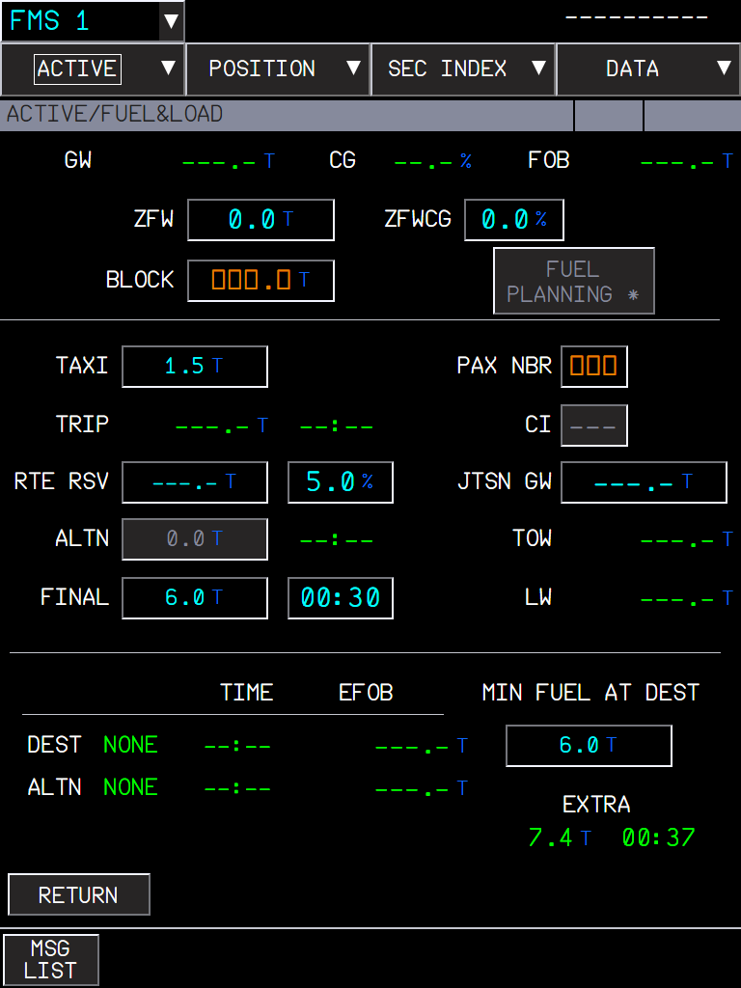
Figure 126. FUEL&LOAD with 7.4 t of EXTRA fuel: EXTRA time 00:37. The harness has no flight plan, so the EXTRA fuel is set by hand for this picture; the other values stay as dashes.
- The FCOM leaves the FINAL default to the airline fuel policy (AMI file) and gives no rule to turn the EXTRA fuel into a time: the same holding flow keeps FINAL and EXTRA consistent on the page.
- No EXTRA fuel (no flight plan predictions, or a SEC flight plan): --:--, as the fuel.

6. Fuel figures of the company flight plan
Before engine start, performance data come with the company flight plan (FCOM COMPANY F-PLN REQUEST). When the flight plan received from SimBrief is inserted (INIT CPNY F-PLN REQUEST, then INSERT), FUEL&LOAD takes from the OFP, as if typed by the crew: TAXI, RTE RSV (the OFP contingency, the % is cleared), ALTN (only with an alternate) and FINAL (the OFP final reserve).
- The BLOCK is not taken: press FUEL PLANNING, which computes it from these figures and the FMS TRIP.
- After engine start the flight plan comes in without its fuel figures.
- The FINAL time is computed from the FINAL fuel at 0.2 t/min (4.8 t shows 00:24).
- Any value can be overwritten as usual.

7. What to expect
Situation | What you should see
No ZFW entered | ALTN fuel shown as dashes (no default).
Alternate route entered | ALTN fuel and time from its distance; the arrival time at the alternate in UTC.
No alternate route, alternate airport set | Computed on the direct distance.
ALTN wind entered | More fuel with a headwind, less with a tailwind.
EXTRA fuel shown | EXTRA time = EXTRA fuel at 0.2 t/min (6 t = 30 min).
Company flight plan inserted before engine start | TAXI, RTE RSV, ALTN and FINAL from the OFP; BLOCK empty until FUEL PLANNING or an entry.

8. Limitations and why
Limitation | Why | What to do
One mean wind for the alternate trip. | The FCOM computation uses the ALTN wind of the WIND page. | -
No holding or approach fuel in ALTN. | The FCOM definition ends at the landing at the alternate; FINAL covers the reserve. | -
EXTRA time at a fixed holding flow. | The FCOM gives no fuel-to-time rule for EXTRA; the flow is the FINAL default one, not a computed holding at the actual weight. | -

PR 21 - A380X company datalink reply time
Company requests (flight plan, winds, takeoff data) answer after a realistic datalink delay, with REQUEST PENDING... and NO COMPANY REPLY as in the FCOM
Aircraft | A380X (the A32NX MCDU uplink stays instant)
Where to find it | flyPad > Settings > Realism > Company Datalink Reply Time; MFD INIT, WIND and PERF company request buttons
PR branch | pr/21-a380x-company-datalink-delay (stacked on PR 12)
Status | Built and checked in the harness; used in the sim during development.
Pictures | flyPad and captain MFD in the local browser harness, running the build installed in the sim. The harness has no SimBrief access (blocked), so requests stay pending.

1. What it is for
On the A380 the flight plan, the winds and the takeoff data come from the airline by datalink (FCOM DSC-22-FMS-10-40-90). A request takes time: the button shows REQUEST PENDING... until the answer, and NO COMPANY REPLY appears when nothing comes within 4 minutes. FBW answered instantly; now the answer arrives after a reply time you choose.

2. The setting
Figure 127. flyPad > Settings > Realism: Company Datalink Reply Time, Real by default.
Setting | Answer to a request | Message sent without a request (e.g. SEND TO FMS)
Instant | immediately | immediately
Fast | 5 to 15 s | 1 to 3 s
Real (default) | 60 to 120 s | 5 to 15 s

Airbus gives no figure: these are typical airline values, below the 4 minute limit of the FCOM.

3. Requesting the flight plan
- INIT > CPNY F-PLN REQUEST opens COMPANY F-PLN REQUEST (flight number, company route, free text).
- Press SEND F-PLN REQUEST. The button becomes REQUEST PENDING..., here and on INIT; one request at a time.
- After the reply time the SimBrief flight plan is delivered to the FMS, as before.
- If SimBrief does not answer (no network, no flight plan), NO COMPANY REPLY appears after 4 minutes.
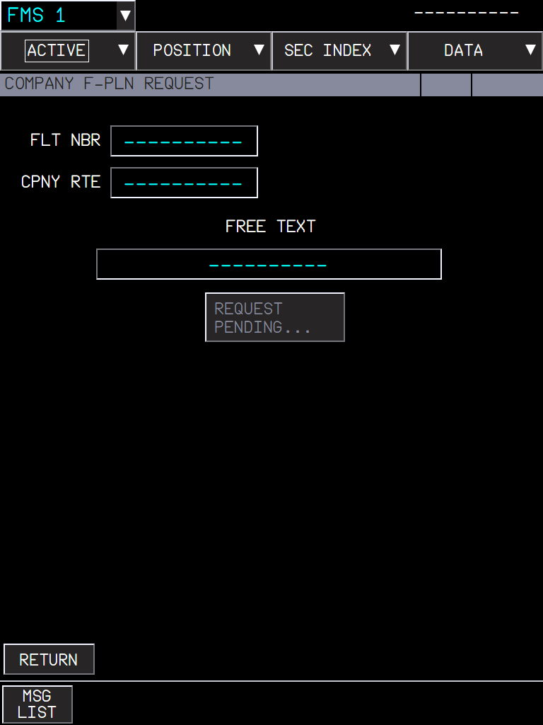  Figure 128. Request sent: REQUEST PENDING... (greyed until the answer). | 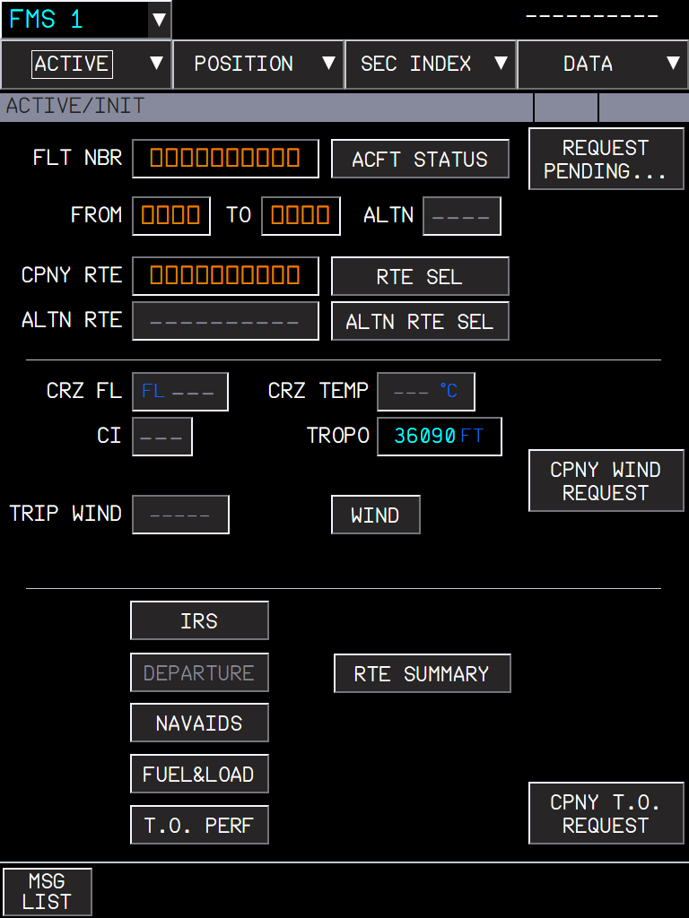  Figure 129. INIT shows the pending request too.

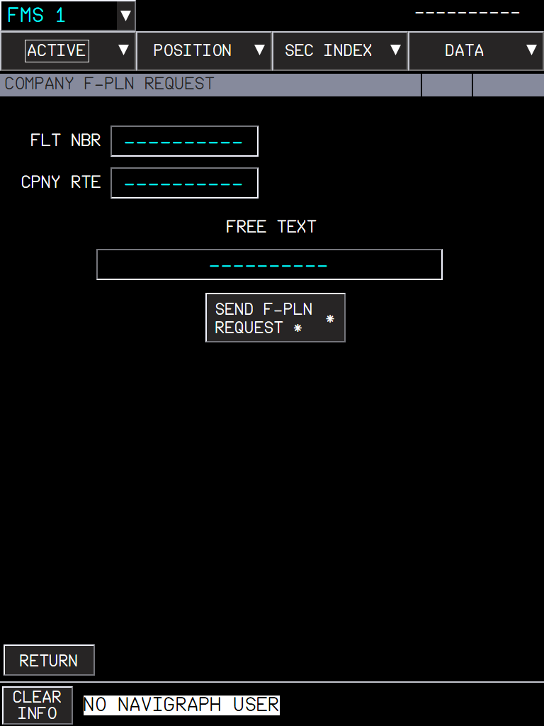
Figure 130. Without a Navigraph account or a SimBrief ID in the flyPad settings: NO NAVIGRAPH USER, no request.

4. Winds and takeoff data
- CPNY WIND REQUEST (INIT or WIND page): the winds are delivered after the reply time.
- Takeoff data (PERF T.O > CPNY T.O REQUEST, see the PR 11 manual): the answer of the flyPad Send to FMS reaches the FMS not before the reply time of the request; without a request, after the transit time only.

5. What to expect
Situation | What you should see
Real, request sent | REQUEST PENDING... for one to two minutes, then the data.
Instant | The data at once, as before this change.
A second request while one is pending | Not possible: the button stays REQUEST PENDING....
No answer | NO COMPANY REPLY after 4 minutes.
No Navigraph user / SimBrief ID | NO NAVIGRAPH USER; nothing is sent.

6. Limitations and why
Limitation | Why | What to do
The reply times are typical values. | Airbus publishes no figure for the airline answer. | Choose Fast or Instant if you prefer.
The A32NX MCDU uplink stays instant. | This change is for the A380 FMS; the A320 uplink has its own messages. | -

PR 22 - A380X ATC COM pages and SD mailbox
Datalink with ATC (CPDLC logon, requests, reports, emergency, ATIS) on the MFD ATC COM pages of the FCOM, and the ATC mailbox on the SD
Aircraft | A380X
Where to find it | MFD system menu ATC COM (or the KCCU ATC COM key); the MAILBOX at the bottom of the SD
PR branch | pr/22-a380x-mfd-atccom (stacked on PR 10)
Status | Tested in the sim on 2026-09-27 (ATIS, REQUEST / REPORT / EMERGENCY frames, fixes of the test included); logon to BeyondATC and a MAYDAY sent tested on 2026-09-29 after the datalink connection fix; full CPDLC dialogues with a live ATC network are still to test.
Pictures | Captain MFD and SD in the local browser harness, running the build installed in the sim; the messages come from the harness (no ATC network).

1. What it is for
The A380 talks to ATC by datalink: the crew logs on to a center, sends requests and reports, receives clearances and answers them, and gets the airport ATIS as text. The FCOM describes the MFD ATC COM pages (DSC-46-10-20-30) and the SD MAILBOX (DSC-46-10-10-70). They are all built on their FCOM figures and connected to the FBW ATSU, the same datalink system as the A32NX DCDU.
NOTE The network is chosen in the flyPad: Settings > ATSU / AOC (Hoppie, BeyondATC or SayIntentions). The datalink needs VHF3 in DATA mode on the RMP.
Page (header) | Use
CONNECT | Logon (NOTIFICATION), CONNECTION STATUS with ADS, MAX UPLINK DELAY.
REQUEST | Build a request from frames (climb, direct, offset, weather deviation, speed, clearances...) and send it to the mailbox.
REPORT & MODIFY | Position report, other reports, modify a prepared answer.
MSG RECORD | The record of the closed dialogues.
ATIS | Request and read the ATIS of three airports.
EMER | MAYDAY / PANPAN and the emergency reports.

2. Logging on: CONNECT
- CONNECT > NOTIFICATION: type the ATC CENTER (4 letters) and press NOTIFY. The page shows NOTIFYING, then the center in NOTIFIED TO CENTERS (with the time), or NOTIFICATION FAILED.
- When ATC accepts, CONNECTION STATUS shows the ACTIVE ATC (and the NEXT ATC after a transfer). DISCONNECT ends the connection.
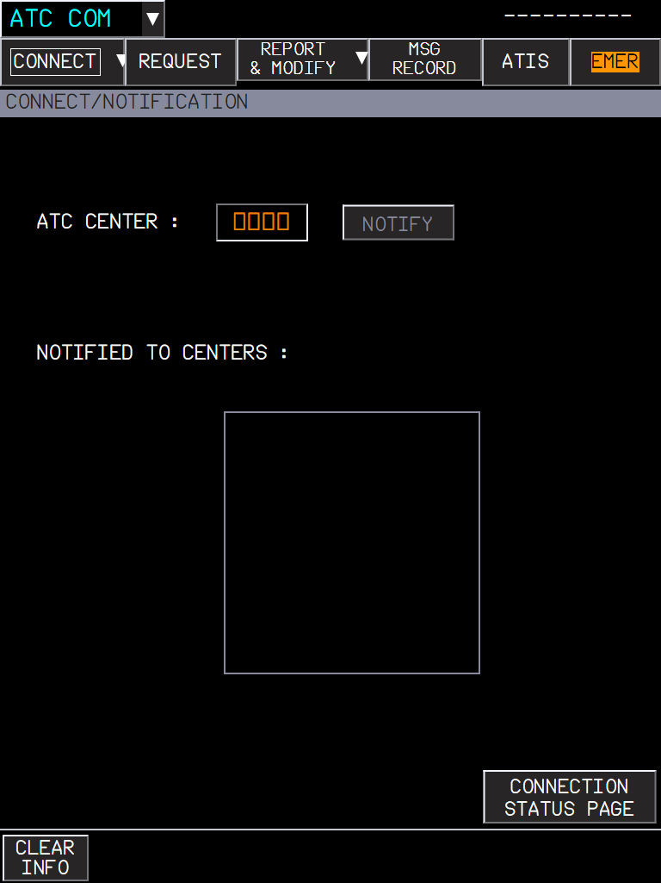  Figure 131. CONNECT / NOTIFICATION. | 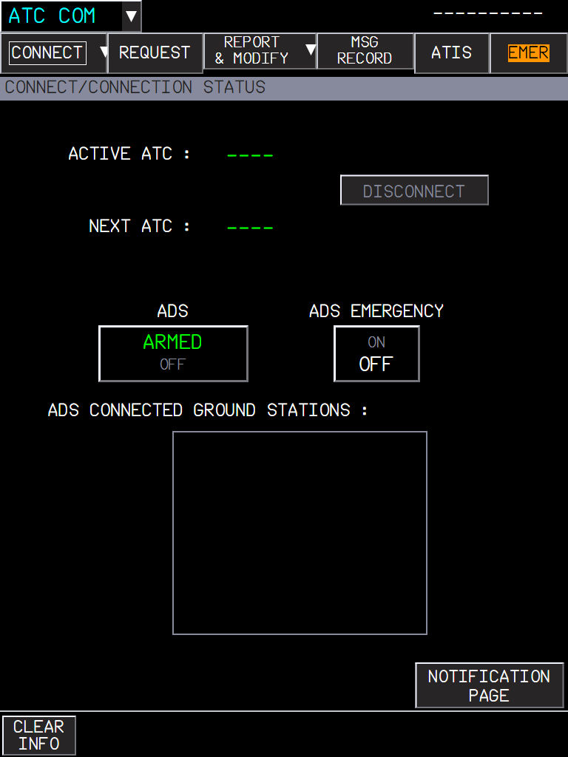  Figure 132. CONNECTION STATUS: active and next ATC, ADS ARMED / OFF, ADS EMERGENCY.

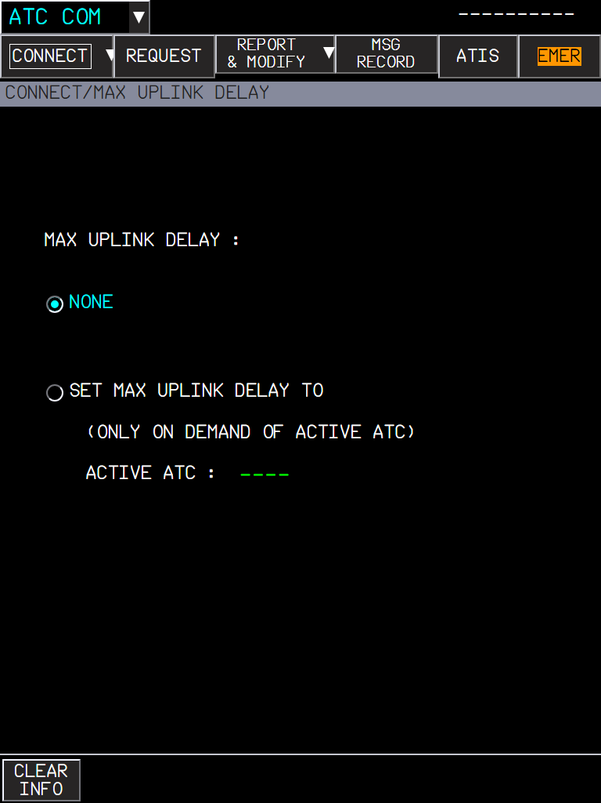
Figure 133. MAX UPLINK DELAY: NONE, or a delay set on the demand of the active ATC.

3. Asking ATC: REQUEST
- Open the menus on the right (VERTICAL, LATERAL, SPEED, CLEARANCE, WHEN CAN WE EXPECT, OTHER) and pick the frames you need; up to 5 frames, each with its fields.
- Fill the fields (FCOM entry formats; amber boxes are mandatory). ADD TEXT adds free text. The bin deletes a frame.
- Press XFR TO MAILBOX: the request goes to the SD mailbox, where you SEND it.
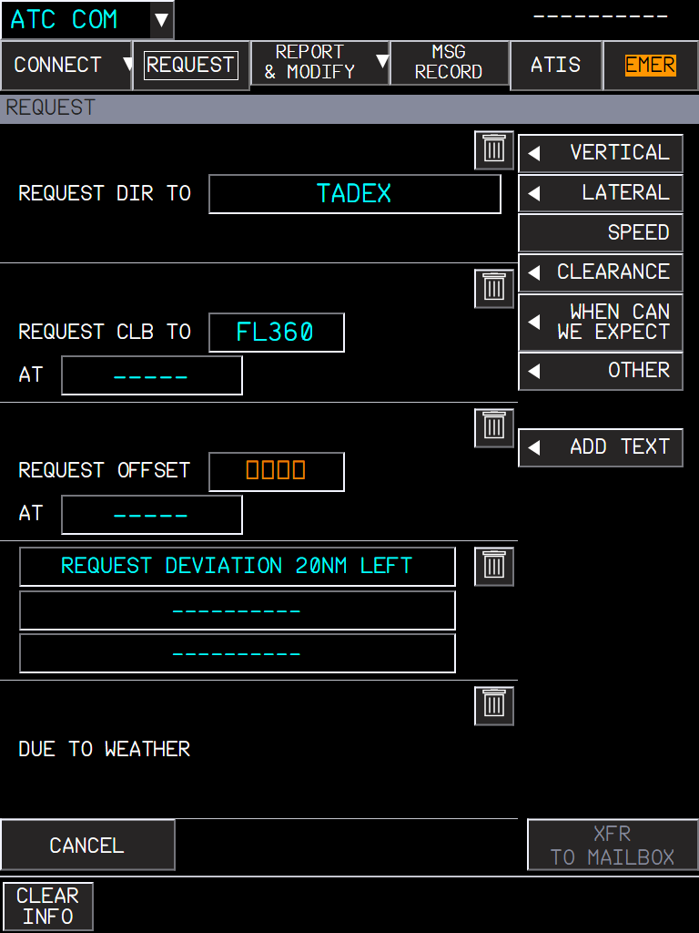  Figure 134. A request of 5 frames: DIR TO TADEX, CLB TO FL360, OFFSET (amber: to fill), free text, DUE TO WEATHER. | 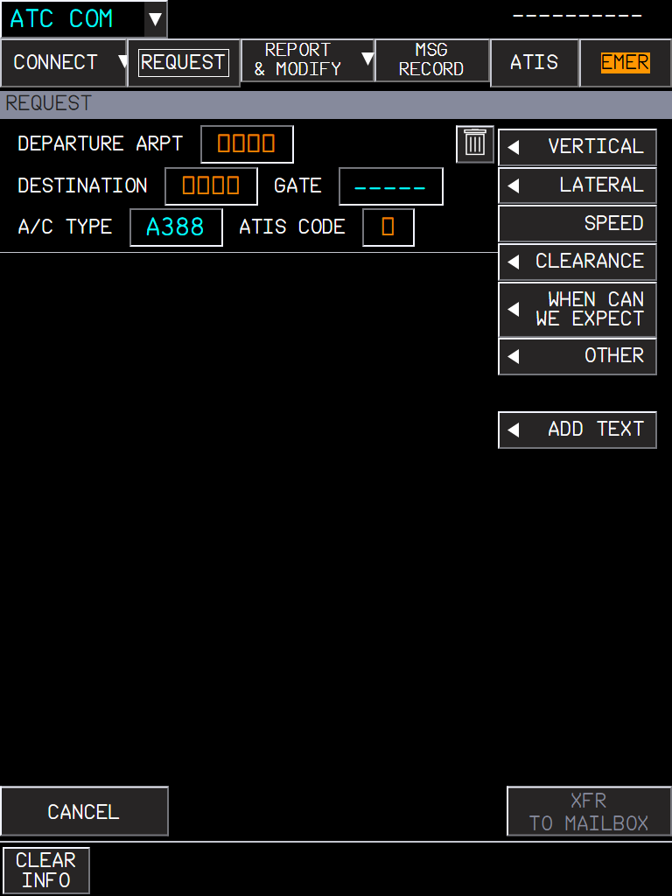  Figure 135. CLEARANCE > DEPARTURE: the departure clearance request (DCL): departure airport, destination, gate, aircraft type, ATIS code.

4. Reports: REPORT & MODIFY
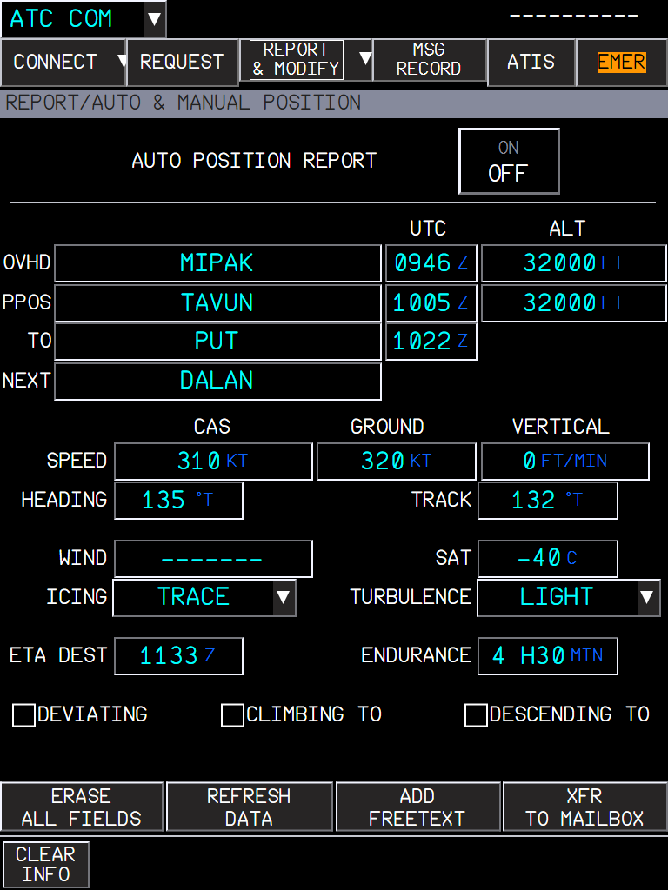  Figure 136. AUTO & MANUAL POSITION: the position report filled by the FMS (overhead, present position, to, next, times, levels, speeds, wind, SAT, ETA, endurance); AUTO POSITION REPORT ON sends it at each reporting point. | 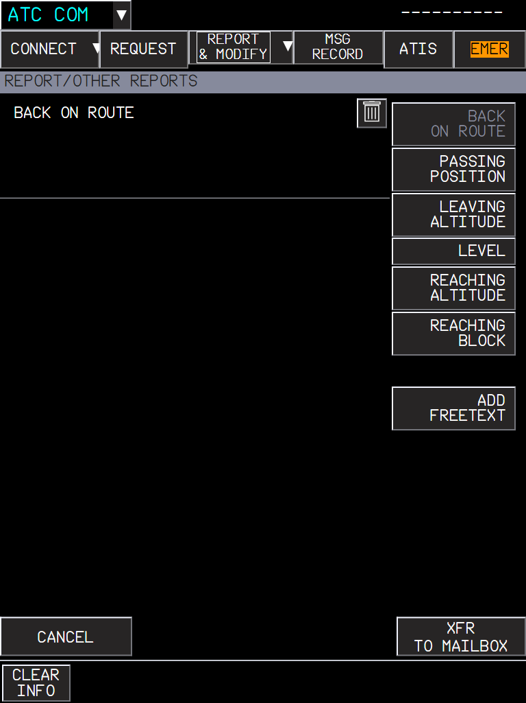  Figure 137. OTHER REPORTS: back on route, passing position, leaving / reaching altitude, level, reaching block, free text.

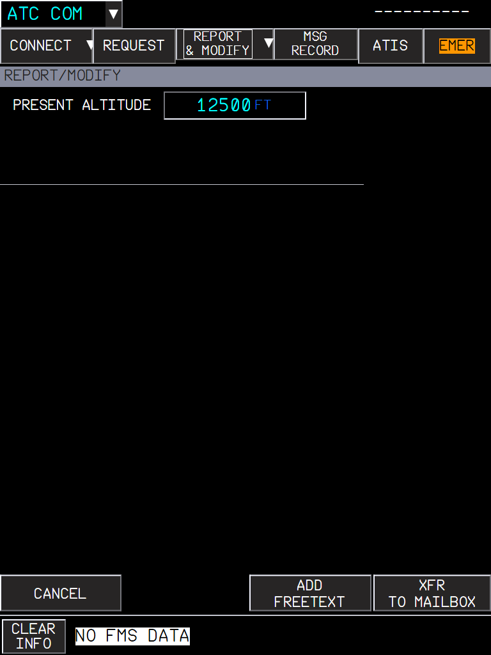
Figure 138. MODIFY: a prepared answer (here PRESENT ALTITUDE 12500 FT) that the crew can change before sending.

5. The SD MAILBOX
Every message to and from ATC goes through the mailbox at the bottom of the SD. It shows the active ATC, the ADS status, the message and the answer buttons the message expects.
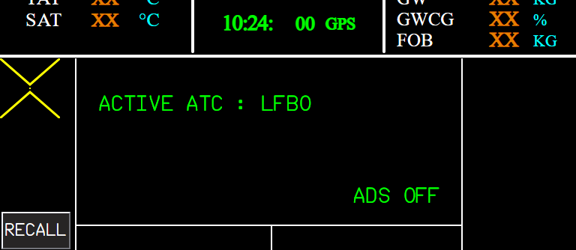
Figure 139. Mailbox without a message: ACTIVE ATC LFBO, ADS OFF.
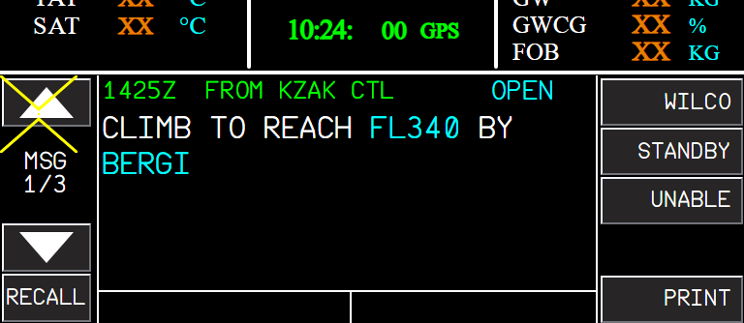
Figure 140. An uplink: CLIMB TO REACH FL340 BY BERGI, OPEN, with WILCO / STANDBY / UNABLE. MSG 1/3: three messages are waiting.
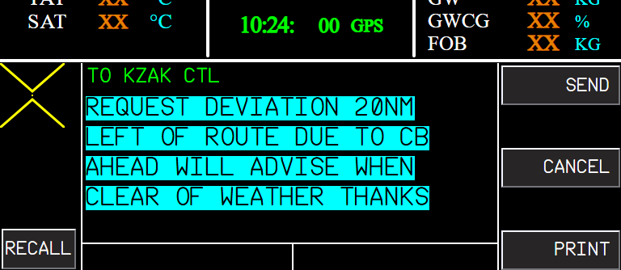
Figure 141. A request ready to go: SEND or CANCEL.
The message expects | Buttons
WILCO / UNABLE (a clearance) | WILCO, STANDBY, UNABLE
AFFIRM / NEGATIVE (a question) | AFFIRM, STANDBY, NEGATIVE
ROGER (information) | ROGER
A departure or oceanic clearance | ACK / REFUSE

UNABLE and NEGATIVE can add a reason (DUE TO WEATHER, A/C PERFORMANCE, TURBULENCE) and free text; MODIFY opens the answer on the MFD. The message colours follow the FCOM status legend.

6. MSG RECORD and ATIS
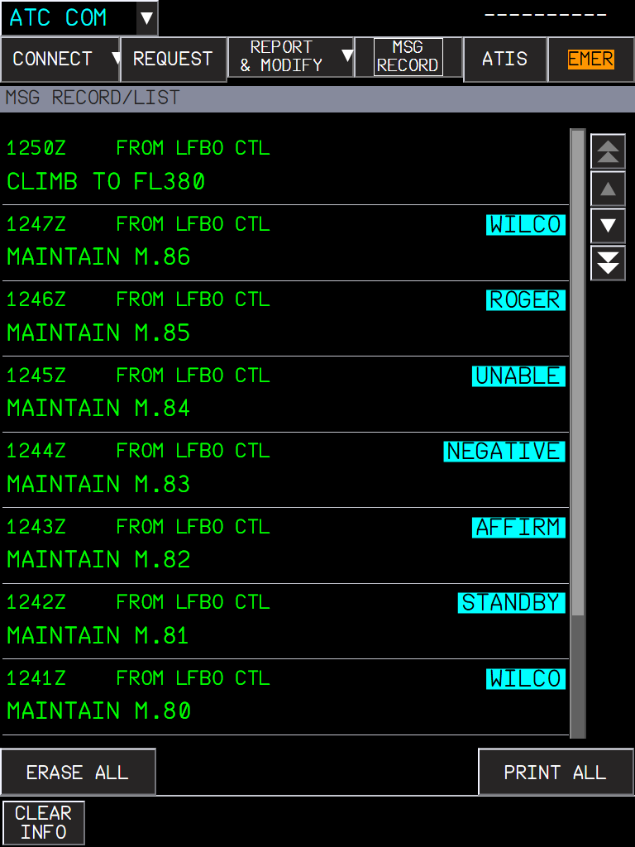  Figure 142. MSG RECORD: the closed dialogues with their time and the answer given; ZOOM shows one in full; ERASE ALL, PRINT ALL. | 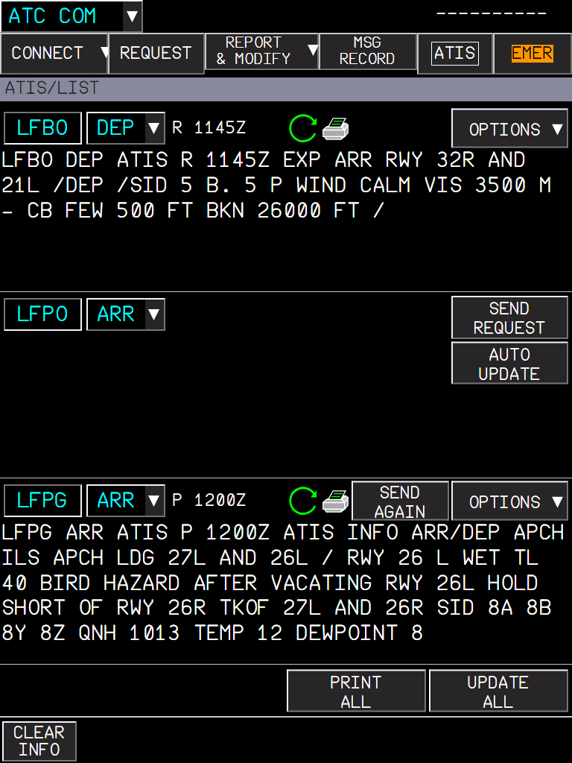  Figure 143. ATIS: three request areas (departure, arrival, alternate, following the FMS airports), each with its ATIS text, AUTO UPDATE, and SEND REQUEST / SEND AGAIN.

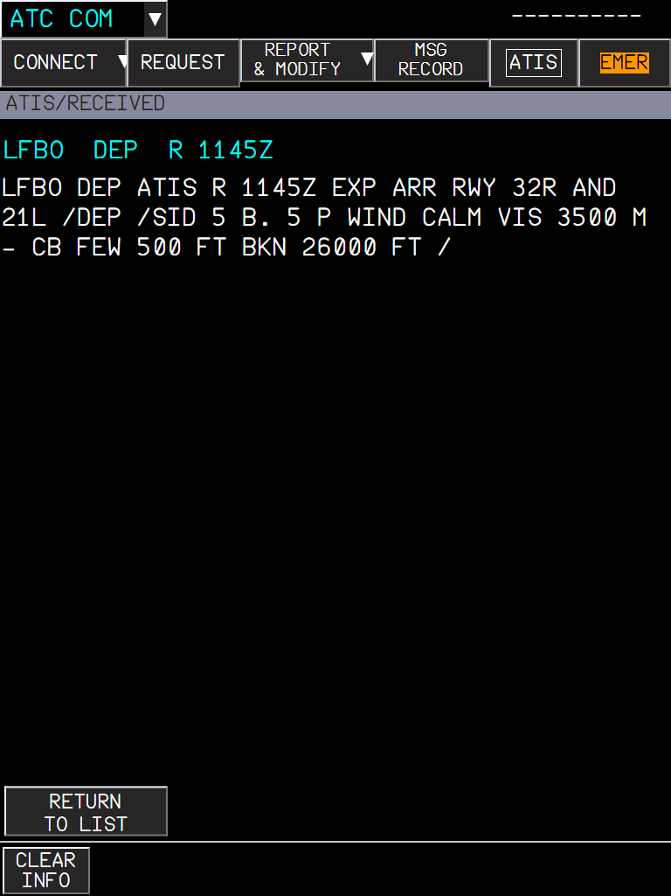
Figure 144. ATIS RECEIVED: the full text of an ATIS, RETURN TO LIST.

7. Emergency: EMER
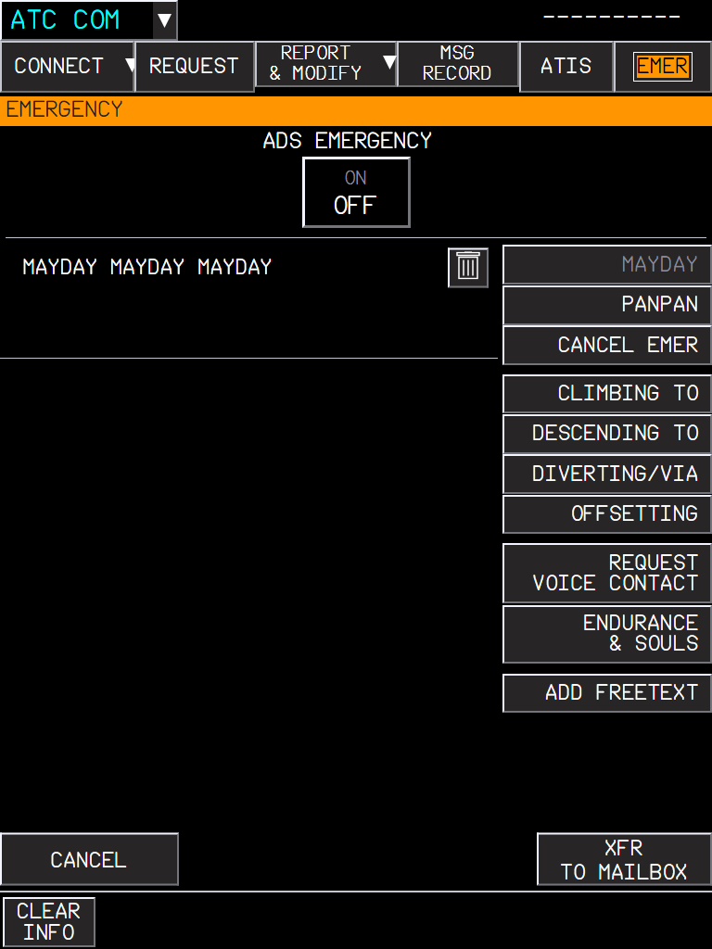
Figure 145. EMERGENCY (orange title): MAYDAY MAYDAY MAYDAY frame, PANPAN, CANCEL EMER and the emergency reports (climbing / descending to, diverting, offsetting, voice contact, endurance and souls). MAYDAY also switches the ADS to EMERGENCY.

8. Getting connected: the flight number, and messages that cannot be sent
The ATC COM pages send and receive through the aircraft datalink, which connects with the flight number of the active flight plan (FMS INIT, FLT NBR). It must be your callsign on the network (Hoppie, BeyondATC or SayIntentions: the one set in the flyPad, Settings > ATSU / AOC).
- The flight number connects the datalink however it gets there: typed on the INIT page, from the company flight plan (SimBrief), from an activated secondary flight plan, or already there when you reload the flight.
- If the connection is refused, or the datalink does not answer, the FMS message area shows FMS DATALINK NOT AVAIL (white). It goes away by itself once connected; typing the flight number again tries again.
- A message sent from the mailbox with no ATC center connected (no logon done, or the center logged you off) shows SEND FAILED instead of nothing.
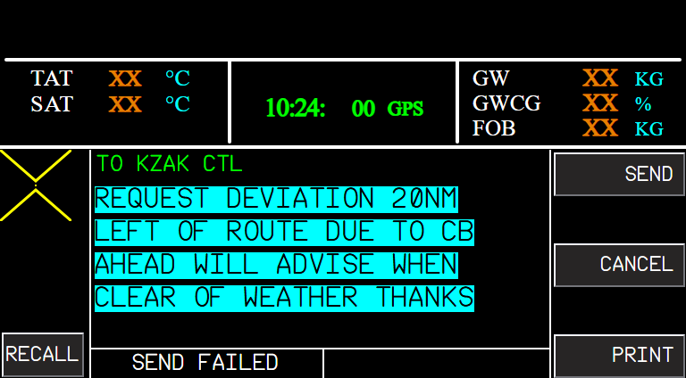
Figure 146. SEND FAILED under a message the mailbox could not send (no active ATC center).
NOTE With BeyondATC: log on to the center shown in its Frequencies tab (e.g. RJJJ), above FL145. BeyondATC does not handle MAYDAY or PAN PAN by datalink: it answers NO MESSAGE HANDLING AVAILABLE FOR THIS REQUEST. Declare an emergency by voice with it.

9. What to expect
Situation | What you should see
NOTIFY with no network set | NOTIFICATION FAILED.
Request with an empty mandatory field | XFR TO MAILBOX stays greyed.
Uplink received | Mailbox message with its answer buttons.
Answer sent | The dialogue closes and goes to MSG RECORD.
ATIS requested | The text appears in its area; a newer version replaces it (AUTO UPDATE).
MAYDAY sent | ADS EMERGENCY ON.

10. Limitations and why
Limitation | Why | What to do
Needs an online datalink network. | ATC messages come from Hoppie, BeyondATC or SayIntentions through the flyPad ATSU settings. | Set the network in the flyPad.
No real ADS contracts. | The ATSU networks do not handle ADS-C; ADS ARMED / EMERGENCY is shown locally. | -
MSG RECORD and mailbox PRINT say PRINTER NOT AVAIL. | Printing needs the pedestal printer, which has no PR yet. | -
CPDLC dialogues with a live network are not tested yet. | Only the harness messages and the ATIS were checked in the sim. | Report any wrong answer element.

PR 23 - flyPad landing calculator
Landing distances, maximum landing weight, approach and go-around speeds for the A380 (new) and the A320 (reworked), on one screen laid out like the A380 OIS LDG PERF application
Aircraft | A380X and A32NX
Where to find it | flyPad > Performance (calculator icon) > Landing tab
PR branch | pr/23-efb-landing-calculator (stacked on PR 12)
Status | Tested in the sim by the user: OK (2026-09-29).
Pictures | flyPad pages in the local browser harness, running the build installed in the sim. The harness has no navigation database, so the runway is entered by hand (in the sim, the runway list fills the RUNWAY section).

1. What it is for
Before the descent, the crew checks that the aircraft can land on the planned runway: the landing distance for the runway condition and braking, the margin left, the approach speed VAPP and the go-around performance. On the real A380 this is the LDG PERF application of the OIS (FCOM PER-LND); on the A320 it is the QRH (in flight) and the FCOM tables (dispatch). This page does both, with the data of each aircraft.
- IN-FLIGHT (default): the actual landing distance for the braking mode you will use, as in the QRH / OIS, with the stop margin.
- DISPATCH: the regulatory (factored) required landing distance, to check a runway before departure.

2. The screen
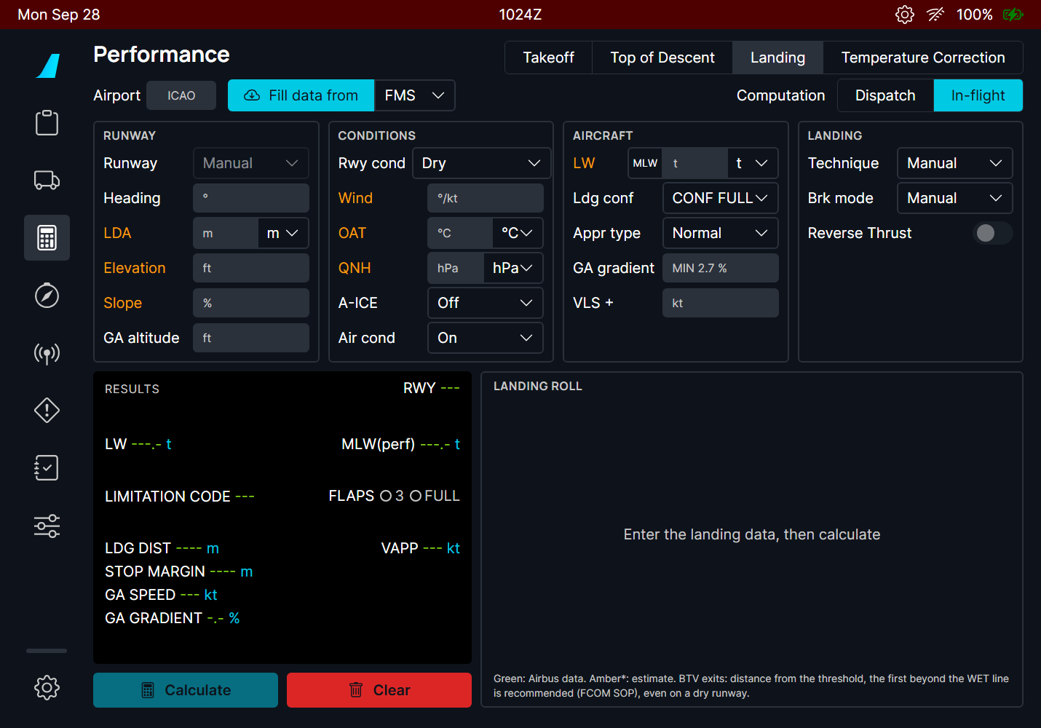
Figure 147. The A380 landing screen before any input. Amber labels are the inputs still missing for a calculation.
Part | Contents
Airport, Fill data from | The ICAO code; Fill data from imports the data from the FMS (A380 FMC / A320 MCDU), the OFP (SimBrief) or the METAR.
Computation | DISPATCH or IN-FLIGHT.
RUNWAY | Runway from the list (or Manual), heading, landing distance available (LDA), elevation, slope, and on the A380 the go-around altitude.
CONDITIONS | Runway condition, wind (direction/speed), OAT, QNH; on the A380 the anti-ice and air conditioning (they change the go-around gradient).
AIRCRAFT | Landing weight (MLW button = the maximum landing weight), landing configuration, and on the A380 the approach type, the required go-around gradient and the VLS increment.
LANDING | Manual landing or autoland, braking mode, reverse thrust, and on the A320 the overweight procedure.
RESULTS | The results in the OIS layout (below).
LANDING ROLL | A picture of the runway with the touchdown, the stop point of each braking mode, the stop margin, and on the A380 the BTV lines and the runway exits.

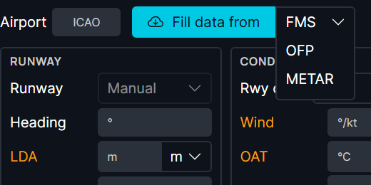
Figure 148. Fill data from: FMS (destination, runway, predicted landing weight and the PERF APPR QNH, temperature, wind and landing configuration), OFP or METAR.

3. A normal in-flight calculation (A380)
- In flight, with the destination and the arrival runway in the flight plan and PERF APPR filled: choose FMS and press Fill data from. Otherwise type the airport, choose the runway and fill the conditions.
- Check the landing weight (the FMS prediction) and the configuration.
- Choose the braking mode you plan to use (manual, autobrake LO / 2 / 3 / HI).
- Press Calculate.
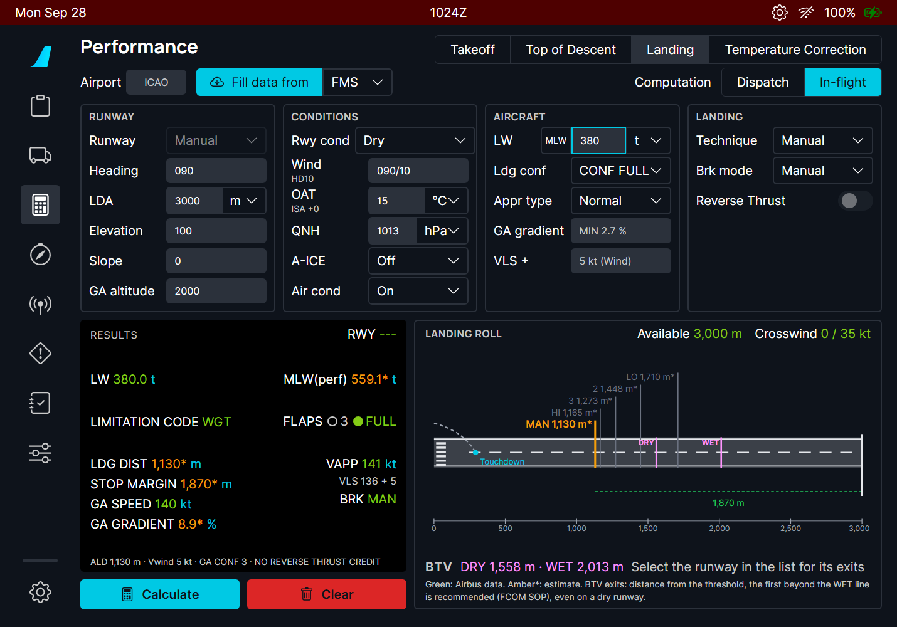
Figure 149. Dry runway, 3000 m, 380 t, CONF FULL, manual braking: landing distance 1130 m, stop margin 1870 m, VAPP 141 kt (VLS 136 + 5). The landing roll shows where each braking mode would stop.

Reading the results
Line | Meaning
LW | The landing weight used.
MLW(perf) | The highest landing weight the runway and the go-around allow: the lower of the weight whose landing distance just fits the LDA and the weight that still gives the required go-around gradient. It is a performance limit, not the structural maximum landing weight (395 t on the A380): it can be above it. Above the structural MLW the page shows OVERWEIGHT LANDING.
LIMITATION CODE | WGT: your weight is below MLW(perf), nothing limits you. LDA (red): the landing distance limits the weight. ACG: the go-around gradient limits it.
FLAPS | The landing configuration used (with AUTO CONF: the one the page chose).
LDG DIST / REG LDG DIST | In flight: the actual landing distance for the braking mode. Dispatch: the required (regulatory) distance.
STOP MARGIN | LDA minus the landing distance. Negative (red): the aircraft does not stop on the runway.
GA SPEED, GA GRADIENT | The go-around speed and the climb gradient of the go-around configuration.
VAPP | VLS of the landing configuration + the VLS increment (the wind increment, or what you enter).
Bottom line | The actual landing distance (ALD), the wind taken into account, the go-around configuration, and whether reverse thrust was credited.

Colours follow the flyPad takeoff calculator: green values come from Airbus data; values in amber with a star (*) are estimates of a model fitted on that data (see Limitations).

4. Braking modes
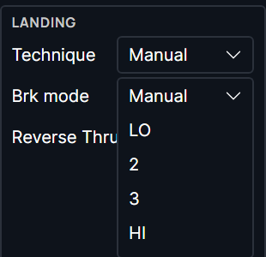  Figure 150. A380 braking modes: Manual, autobrake LO, 2, 3, HI. BTV is not a mode here: the page gives its DRY / WET lines and exit advice. | 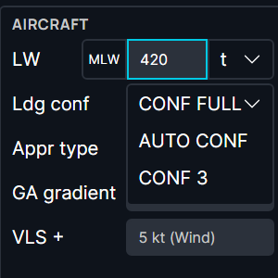  Figure 151. Landing configuration: CONF FULL, CONF 3 or AUTO CONF (the page chooses, as the OIS does).

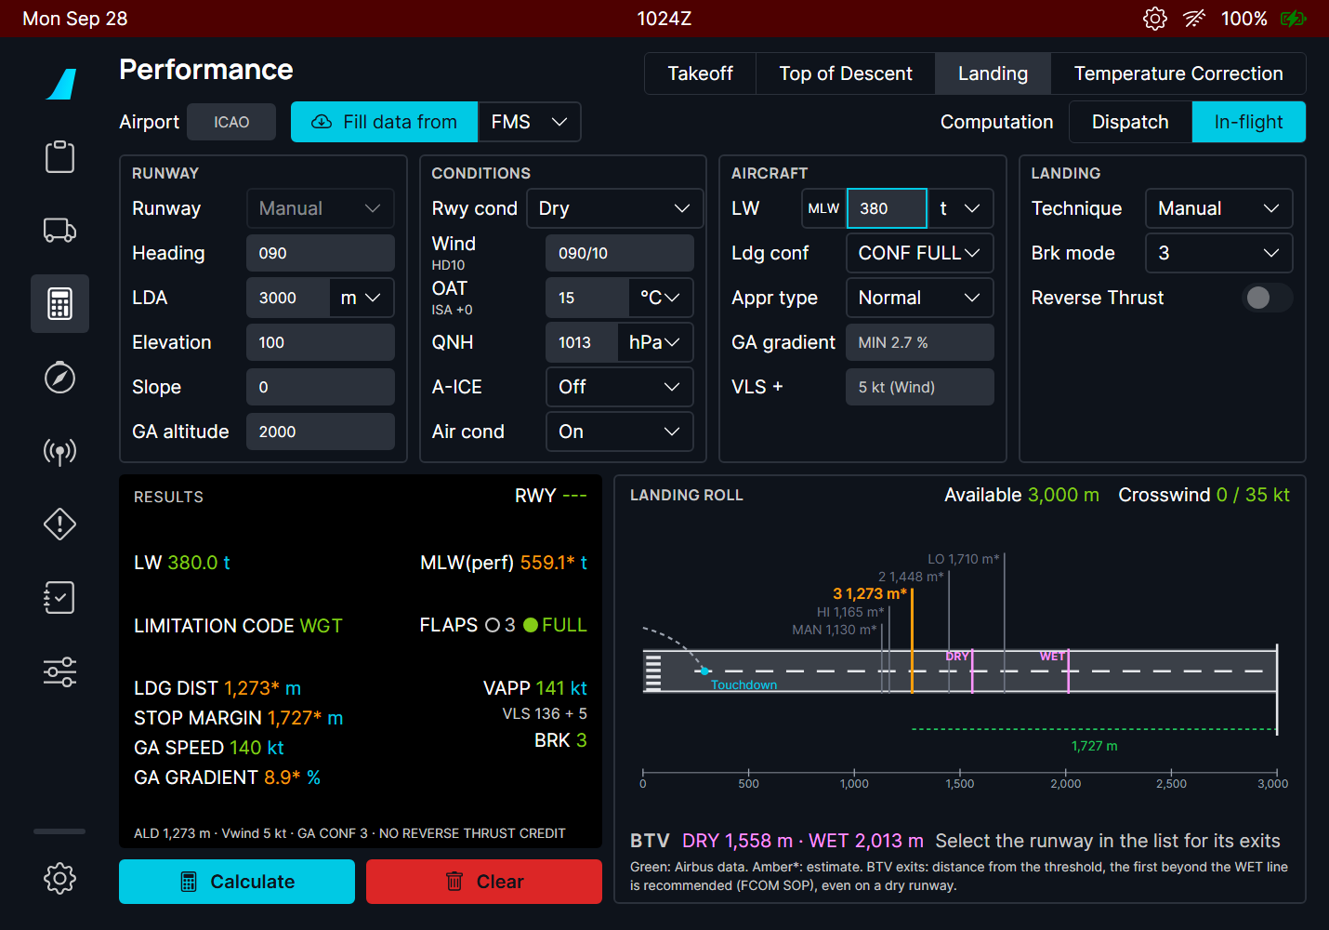
Figure 152. Same landing with autobrake 3: 1507 m. The stop point of the chosen mode is highlighted; the others stay visible for comparison.
AUTO CONF (A380, FCOM PER-LND): CONF FULL when its go-around in CONF 3 gives the required gradient, otherwise CONF 3 with a go-around in CONF 2; for an overweight landing, CONF 3 with a go-around in CONF 1+F.

5. Runway condition and reverse thrust
The runway condition follows the runway condition codes (RWYCC): dry, wet, water and slush 1/4" or 1/2", compacted snow, ice. The crosswind limit of the condition is shown at the top of the landing roll.
- Reverse thrust is credited only on a contaminated runway (FCOM: no credit on dry and wet runways); the result line says REVERSE THRUST CREDIT or NO REVERSE THRUST CREDIT.
- On the A380, BTV is prohibited on a contaminated runway (FCOM LIM-32-30): the BTV line says so and advises autobrake 3.
- With 1/2" of water or slush, a message reminds you that Airbus does not recommend these distances: a deeper contaminant gives a shorter distance in the data.
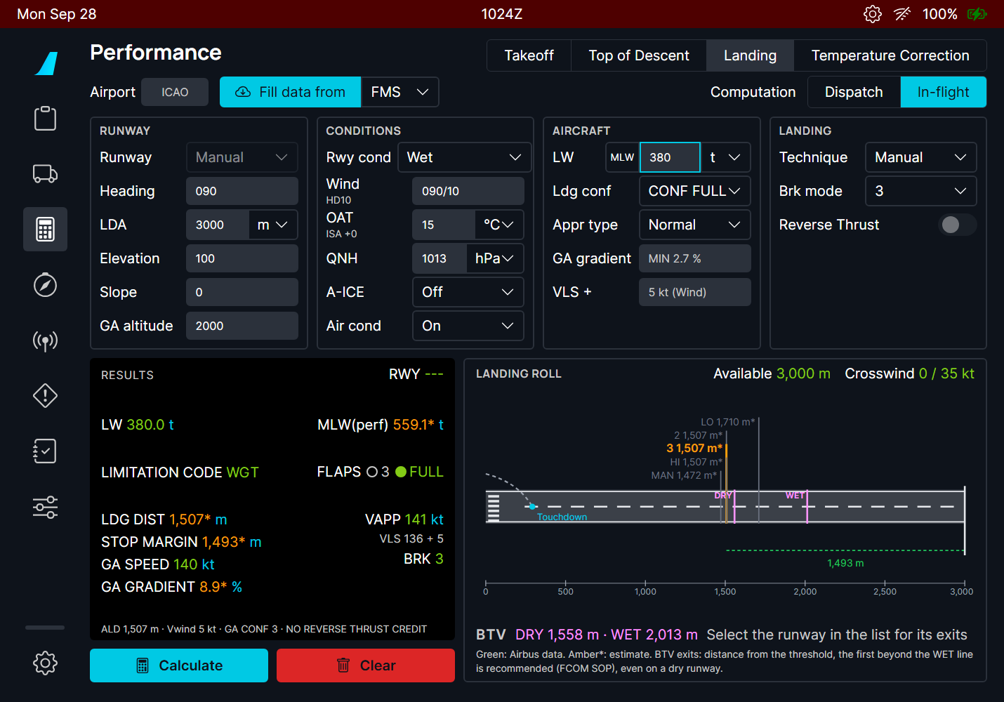  Figure 153. Wet runway, autobrake 3. | 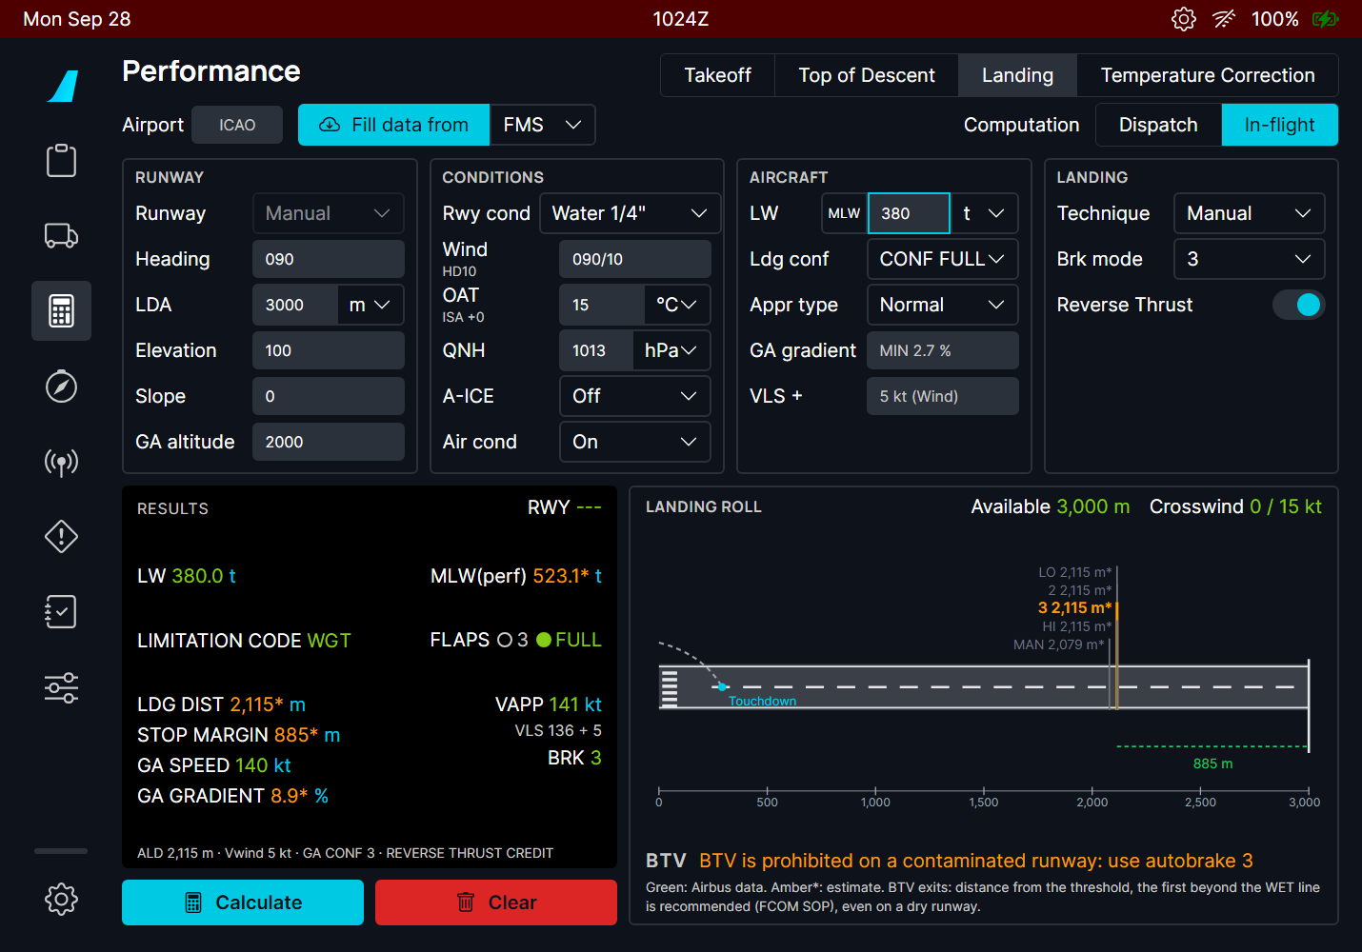  Figure 154. Water 1/4" with reverse thrust: credited, BTV prohibited, crosswind limit 15 kt.

6. BTV exits (A380)
On the A380, the page shows the BTV DRY and WET lines: where the aircraft stops with the BTV decelerations (FCOM DSC-32-10-30-20), from 400 m after the threshold plus 5 s of roll. When the runway comes from the list and a Navigraph account is linked, the runway exits of the airport map are drawn and rated:
Exit | Meaning
Recommended | The first exit beyond the WET line (the FCOM SOP choice, even on a dry runway).
Beyond WET | Achievable wet or dry.
Dry only | Between the DRY and WET lines: only on a dry runway.
Not achievable | Before the DRY line.

Without the runway list or the Navigraph data, the line says "Select the runway in the list for its exits". This is information for your briefing: the BTV selection itself is made on the OANS, as on the real aircraft.

7. Dispatch
DISPATCH gives the required landing distance used to check a runway before departure: the actual distance divided by 0.6 on a dry runway, ×1.15 on a wet one, and on a contaminated runway the higher of the wet value and ALD ×1.15 (A380 FCOM PER-LND). Braking is manual (the braking mode is greyed out). The orange bar is the required distance.
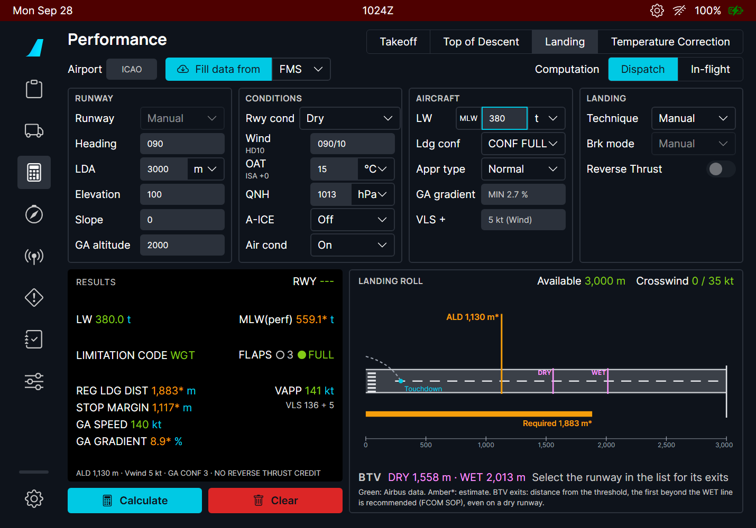
Figure 155. Dispatch on the same runway: required landing distance 1883 m (REG LDG DIST).

8. When the runway is too short or the aircraft too heavy
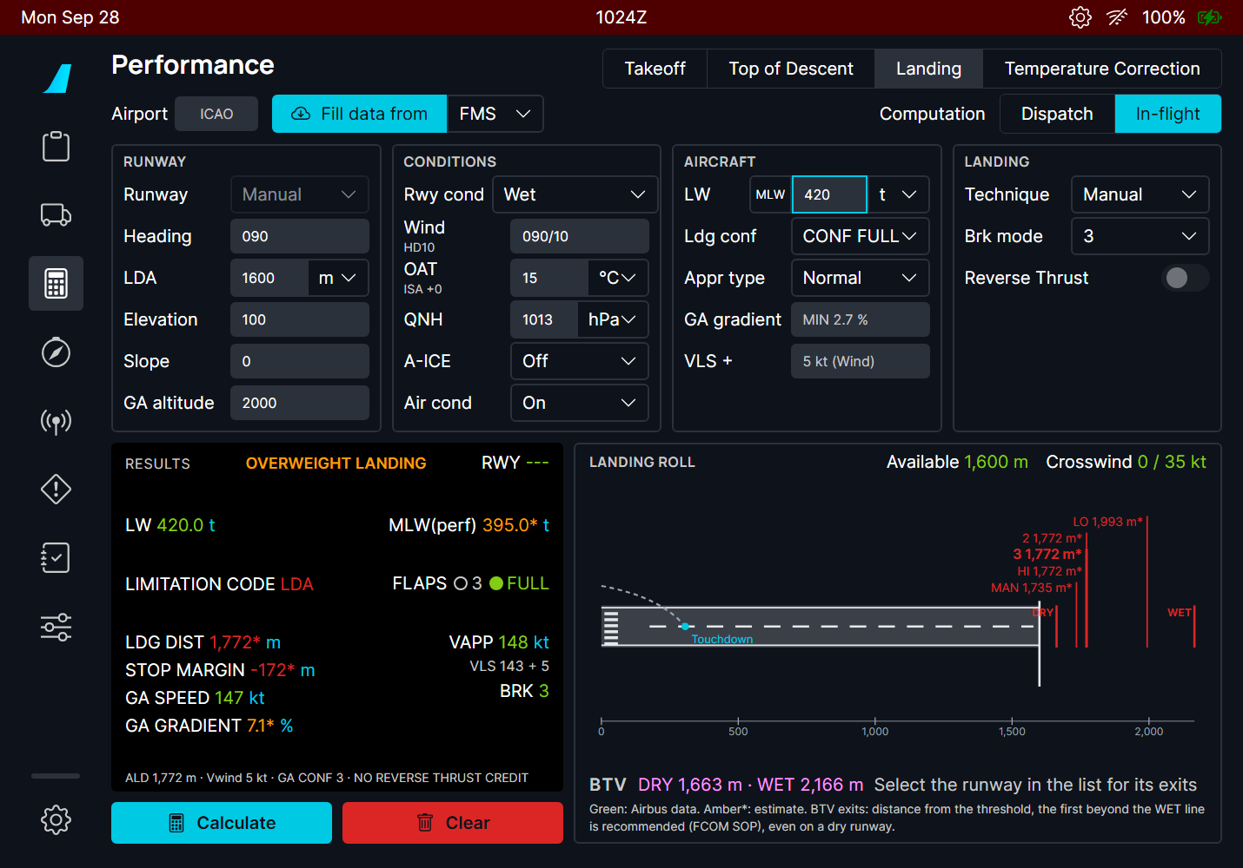
Figure 156. 1600 m wet runway at 420 t: OVERWEIGHT LANDING (above the 395 t MLW), limitation code LDA in red, negative stop margin (-172 m): the aircraft does not stop on this runway with autobrake 3.

9. The A320 version
The A320 uses the same screen with its own data: the QRH in-flight landing distances (shown ×1.15, the QRH margin) and the FCOM dispatch tables (PER-LDG-DIS-RLD) with the autoland correction and the wet minimum. Braking modes are Manual, LO and MED; the Overweight Procedure switch applies the QRH overweight landing corrections. There is no go-around section.
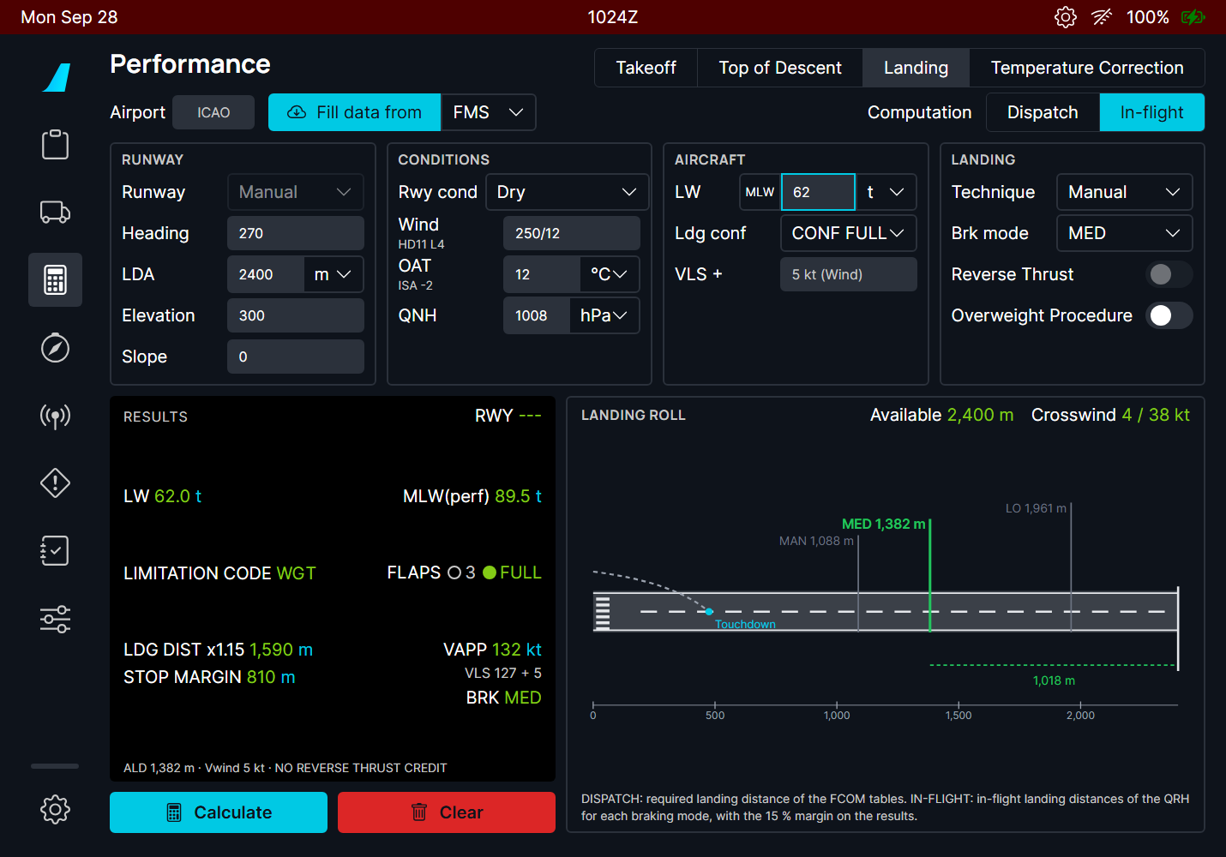  Figure 157. A320 in flight: 62 t, 2400 m dry, autobrake MED: 1382 m (1590 m with the 15 % margin). | 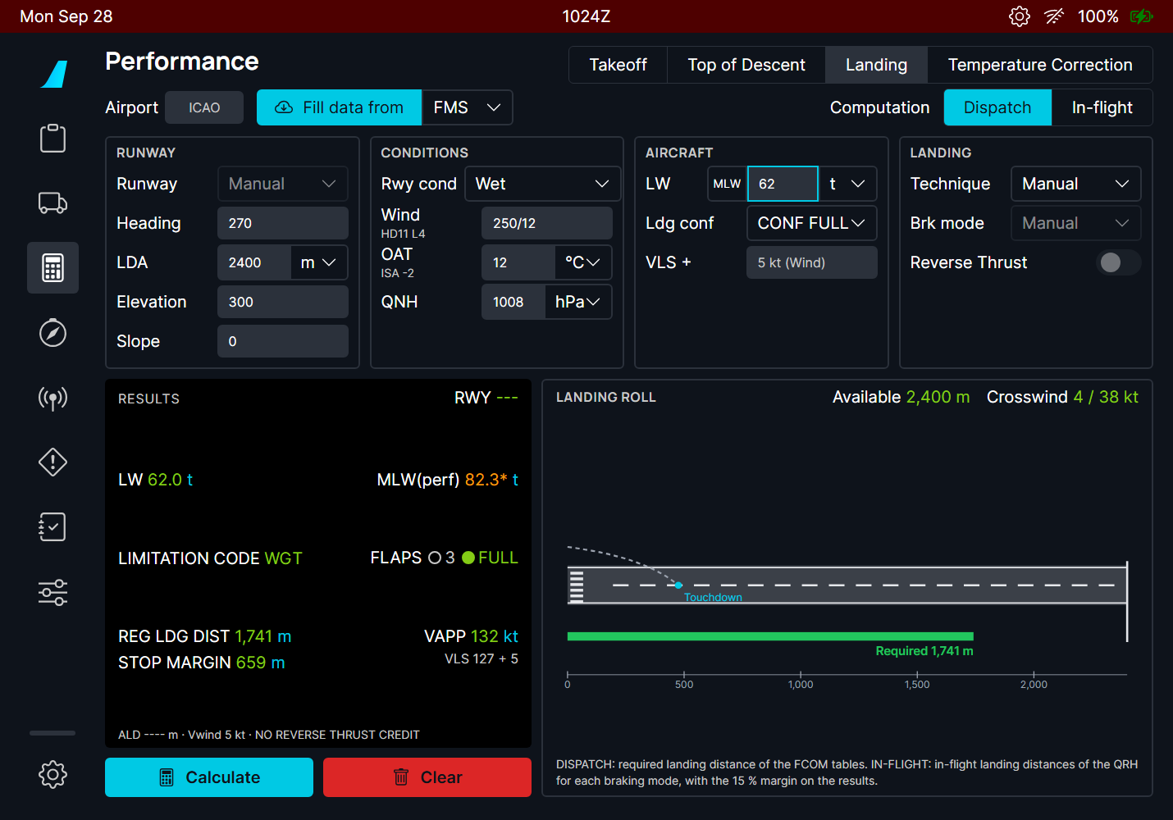  Figure 158. A320 dispatch on a wet runway: required 1741 m from the FCOM tables (green: Airbus data).

10. What to expect
Situation | What you should see
Inputs missing | Amber labels; the Calculate button stays dim until they are filled.
Fill data from FMS without a flight plan | Only what the FMS has is filled; complete the rest by hand.
Dry or wet runway, reverse thrust on | NO REVERSE THRUST CREDIT: the FCOM gives none there.
Contaminated runway | Longer distances, lower crosswind limit; A380: BTV prohibited.
Landing weight above the MLW | OVERWEIGHT LANDING in the RESULTS; A380 AUTO CONF lands in CONF 3.
LW above MLW(perf) | Limitation code LDA or ACG in red; the stop margin may be negative.
Change of an input after Calculate | Press Calculate again.

11. Limitations and why
Limitation | Why | What to do
Most A380 values are estimates (amber *). | The only public A380 landing data is the landing field length chart of the Airbus A380 Aircraft Characteristics (dry, manual, CONF FULL). The other cases use a model fitted on it (0.8 % error on the chart) and the FCOM rules. | Use the results for training and planning, not as certified data.
Autobrake and BTV distances are estimates. | They come from the autobrake decelerations of the FCOM, not from Airbus tables. | -
BTV exits need the runway from the list and a Navigraph account. | The exits come from the Navigraph airport map (the OANS data). | Choose the runway in the list; link Navigraph.
No BTV on the A320. | The A320 has no BTV. | -
The go-around gradient is calibrated on one FCOM example. | No A380 go-around tables are public. | -

PR 24 - flyPad descent calculator
Top of descent, time, distance and fuel of the descent with the FMS performance model, and a live check of where to start down: the IN-FLT PERF DES module of the A380 OIS on both aircraft
Aircraft | A380X and A32NX
Where to find it | flyPad > Performance > Top of Descent tab
PR branch | pr/24-efb-descent-calculator (stacked on PR 23)
Status | Tested in the sim by the user: OK (2026-09-29).
Pictures | flyPad pages in the local browser harness, running the build installed in the sim (A380X). The harness has no FMS, so the inputs are typed; in the sim, Fill data from FMS fills them.

1. What it is for
The FMS computes the top of descent (T/D) for the managed descent. The crew still needs other answers: how long an emergency descent takes, where to start a descent at a given V/S, whether the aircraft is late on the profile after a shortcut, and a cross-check of the FMS T/D. The A380 OIS has an in-flight descent module for this (FCOM PER-IFT-DES); this page does the same on both aircraft, and replaces the old Top of Descent calculator.
It uses the same flight and engine models as the FBW FMS predictions, so its T/D agrees with the one drawn on the ND for the same inputs.

2. The screen
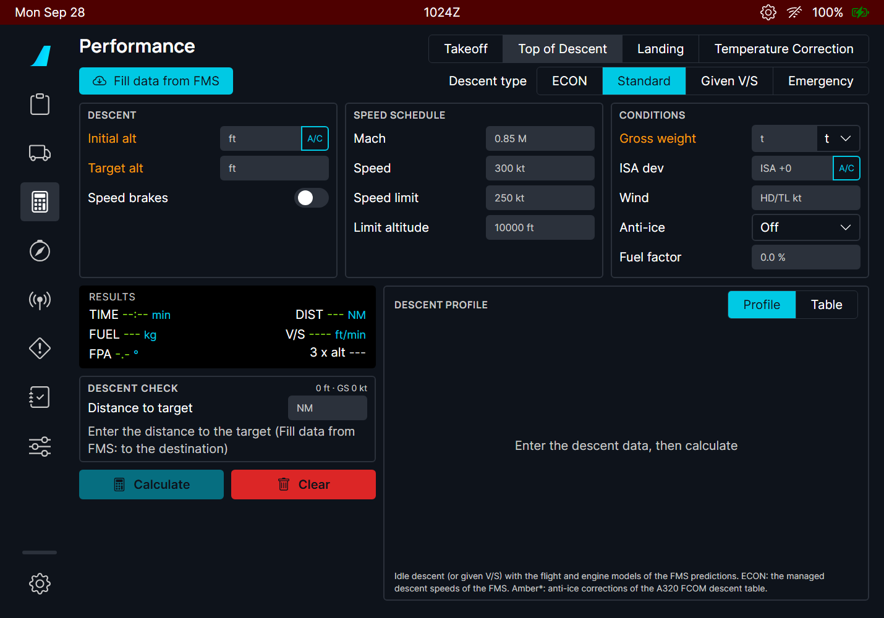
Figure 159. The descent calculator. Amber labels: inputs still needed.
Part | Contents
Fill data from FMS | Cruise level (or the current altitude when lower), destination elevation + 1500 ft, gross weight, the FMS speed limit, the ECON speeds and the distance to the destination.
Descent type | ECON: the managed descent speeds of the FMS. Standard: the FCOM speed schedule (A380 M.85 / 300 kt / 250 kt below FL100; A320 M.78 / 300 / 250). Given V/S: a constant vertical speed. Emergency: MMO / VMO with the speed brakes.
DESCENT | Initial altitude (A/C: the current one) and target altitude; speed brakes.
SPEED SCHEDULE | Mach, speed, speed limit and its altitude. Empty = the standard values shown in grey.
CONDITIONS | Gross weight, ISA deviation (A/C: from the current temperature), wind component (positive = headwind, negative = tailwind), anti-ice (off / engine / total), fuel factor.
RESULTS | Time, distance, fuel, mean V/S and flight path angle, and the "3 × altitude" rule of thumb for comparison; the crossover altitude and where the aircraft slows to the speed limit.
DESCENT CHECK | With the distance to the target: when to start down, or how late you are.
DESCENT PROFILE | Profile chart or table every 5000 ft.

3. Standard descent
- Press Fill data from FMS in cruise with a flight plan, or type the initial altitude, the target altitude and the weight.
- Choose the descent type and, if needed, the wind component and anti-ice.
- Press Calculate.
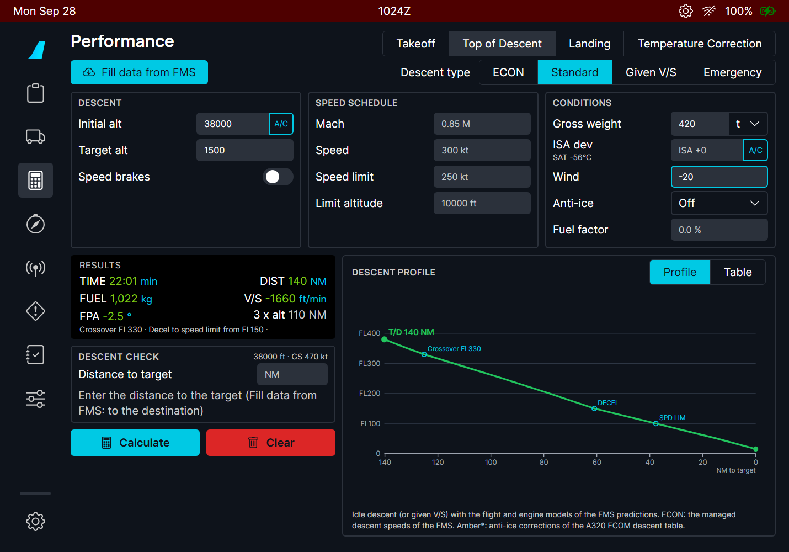
Figure 160. FL380 to 1500 ft, 420 t, 20 kt tailwind, standard speeds: 22 min, 140 NM, 1022 kg, -1660 ft/min on average (-2.5°). The chart shows the T/D, the crossover altitude (Mach to CAS), the deceleration (DECEL) and the speed limit (SPD LIM).
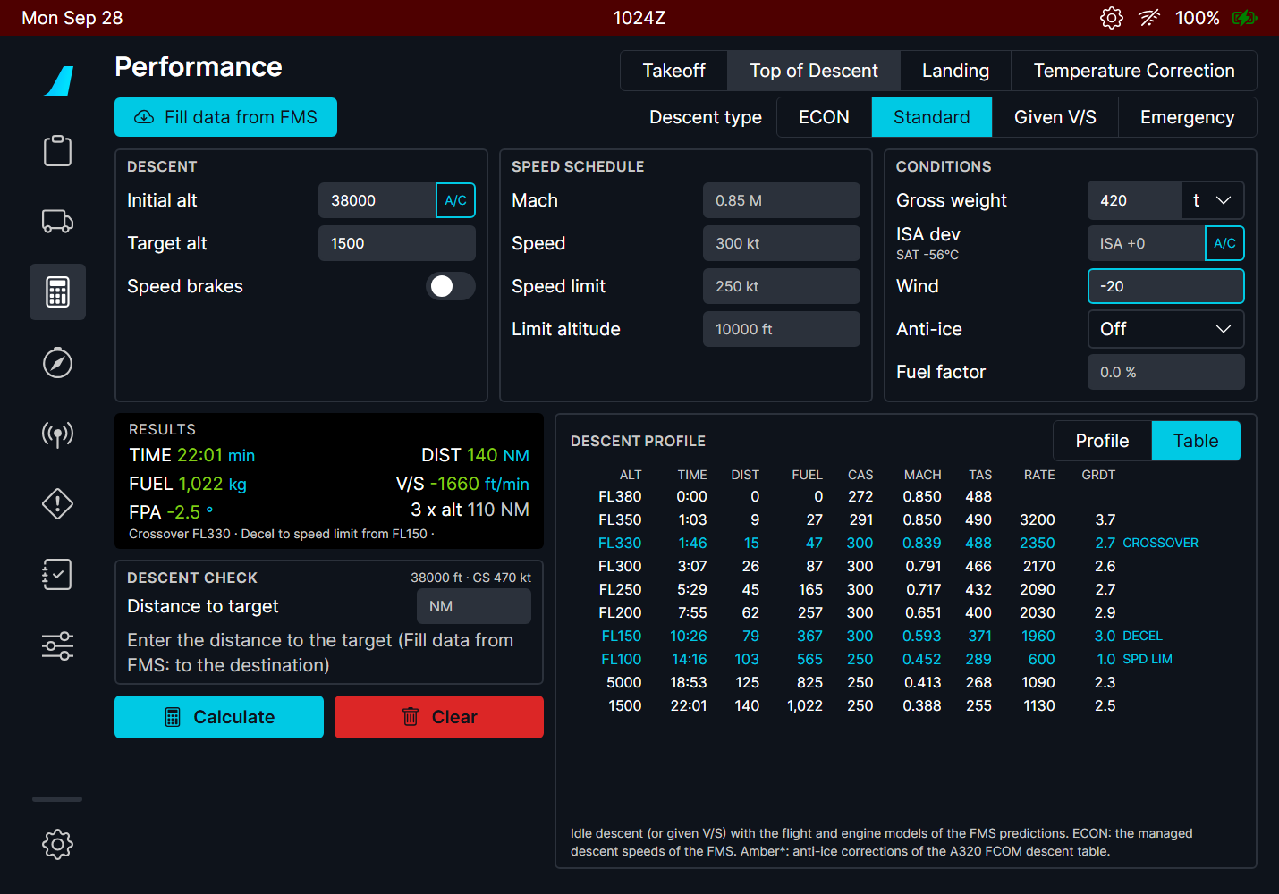
Figure 161. Table view: time, distance, fuel, CAS, Mach, TAS, RATE (rate of descent, ft/min) and GRDT (descent gradient, degrees) every 5000 ft, named and signed like the FCOM table results (PER-IFT-DES-DSR: both positive in descent); the crossover, DECEL and SPD LIM lines in blue. The RESULTS line gives V/S and FPA negative, as set on the FCU.
The deceleration to the speed limit is flown on the -1° idle path of the FMS descent strategy, which is why the profile flattens between DECEL and SPD LIM.

4. Descent check
Enter the distance to the target (Fill data from FMS enters the distance to the destination). The page reads the aircraft altitude and ground speed (shown top right of the box) and compares the aircraft with the profile. The aircraft is the triangle on the chart.
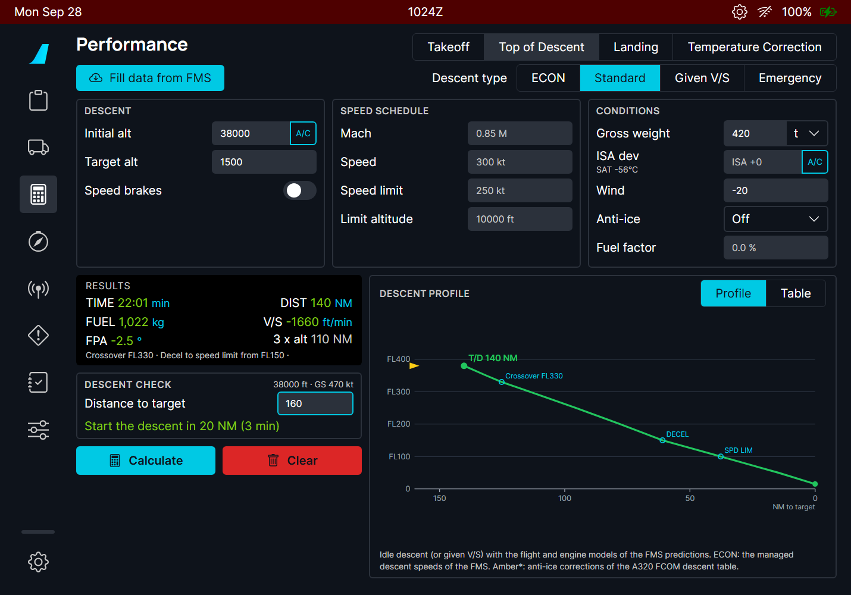  Figure 162. 160 NM to go, T/D at 140 NM: "Start the descent in 20 NM (3 min)". | 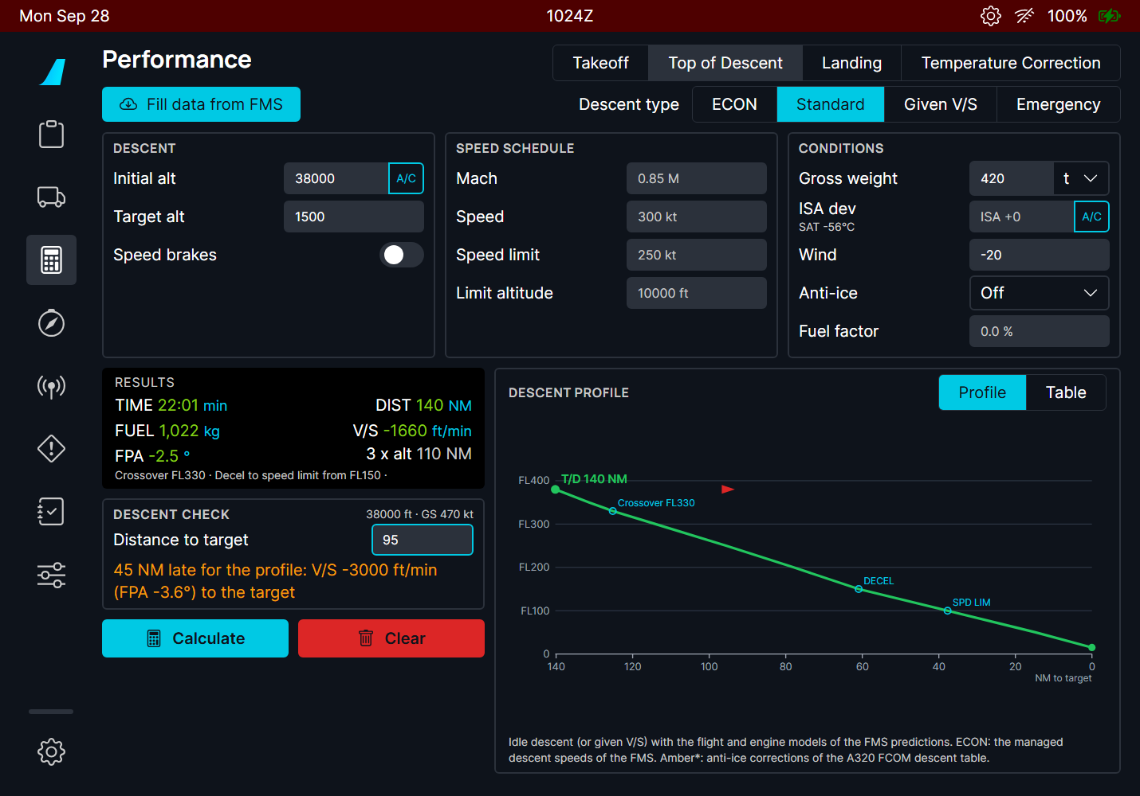  Figure 163. 95 NM to go at FL380: "45 NM late for the profile: V/S -3000 ft/min (FPA -3.6°) to the target".

TIP After a shortcut, the late message gives the V/S (or FPA) that still makes the target, to set in V/S or FPA mode, or tells you to use the speed brakes.

5. Given V/S, emergency and ECON
Given V/S adds a V/S field. The page flies that V/S with the thrust it needs. Where the V/S is steeper than an idle descent can give, the page flies idle there and says so in amber (the aircraft cannot descend faster at idle without speed brakes).
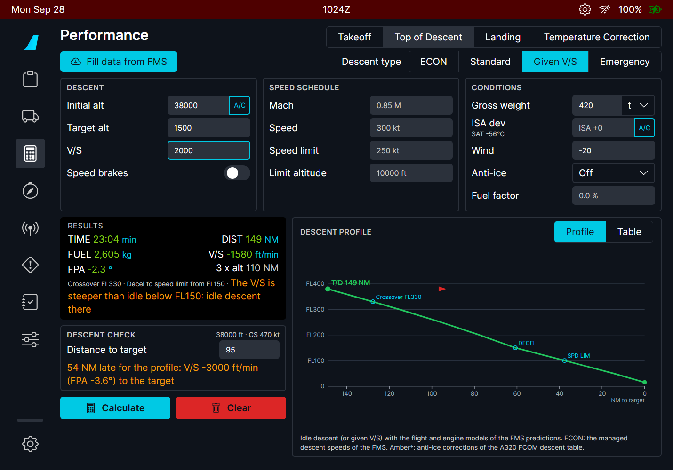
Figure 164. 2000 ft/min: shallower than idle at high level (149 NM, more fuel: 2605 kg), and steeper than idle below FL150, where the page flies idle.
Emergency uses MMO / VMO with the speed brakes extended (the schedule fields turn grey).
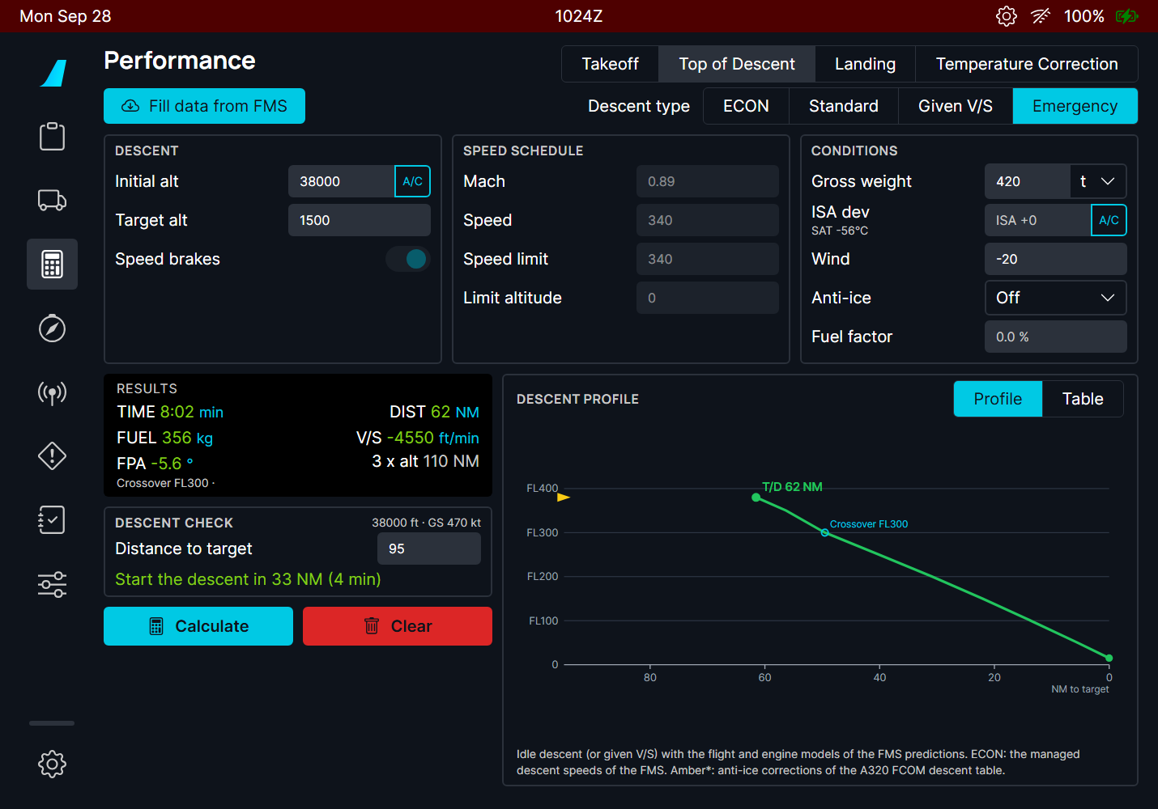
Figure 165. Emergency descent from FL380: 8 min, 62 NM, -4550 ft/min on average.
ECON needs the FMS: it asks the FMS for its managed descent speeds. Without a flight plan in the FMS, a message says so and the page stays on the previous type.
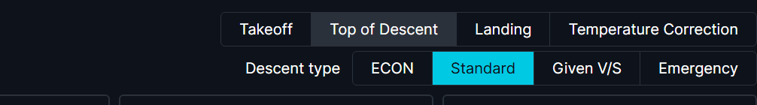
Figure 166. ECON without FMS data.

6. Anti-ice, fuel factor and estimates
Anti-ice (engine or total) raises the idle thrust and flattens the descent. Its effect uses the corrections of the A320 FCOM descent table (no A380 table is public): the values it changes turn amber with a star. The fuel factor (a percentage) scales the fuel burn, like the FMS PERF FACTOR.
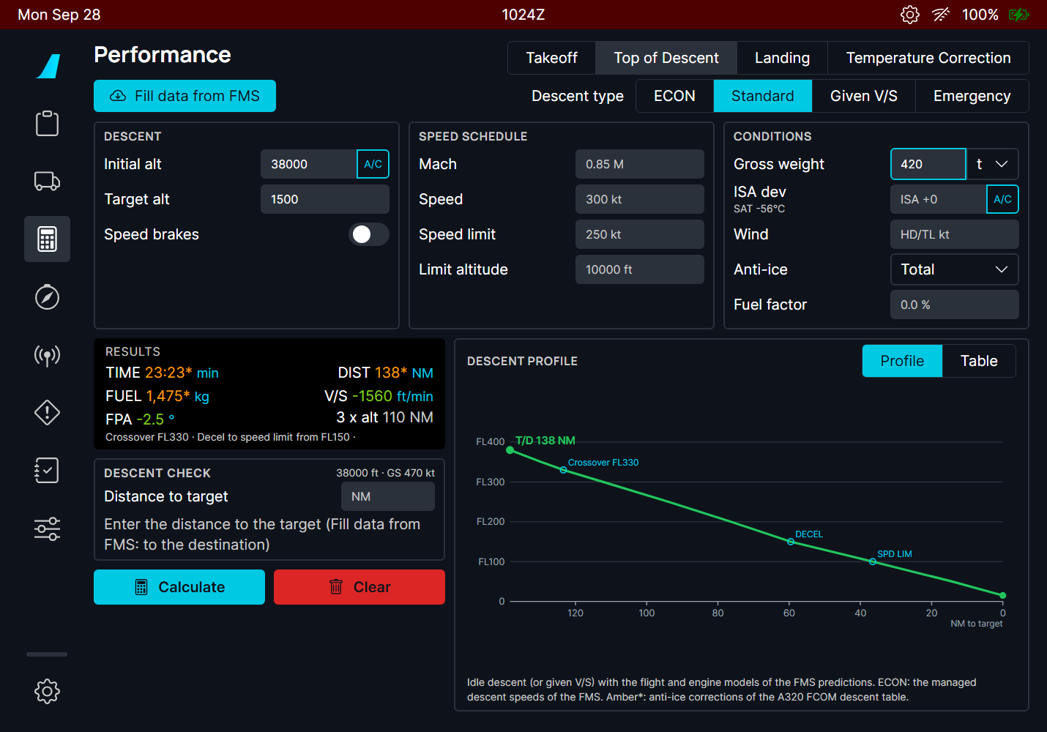
Figure 167. Total anti-ice: 138 NM, 23 min, 1475 kg, in amber (estimate).

7. What if the descent starts earlier or later?
After a calculation, the T/D distance slider under the profile moves the start of the descent: to the left farther from the target (earlier, e.g. vectors), to the right closer (later, e.g. a shortcut), up to 60 NM each way. The chart draws the moved top of descent dashed, straight to the target, and the line under the slider gives the V/S and the path angle it needs, to compare with the calculated ones.
- Later: steeper than the idle descent: the figures turn amber, "speed brakes or a higher speed needed" (red when the calculation already used the speed brakes: start earlier).
- Earlier: shallower than the idle descent: "thrust needed, more fuel".
- The figures keep the mean ground speed of the calculated descent: an estimate for the decision, not a new calculation.
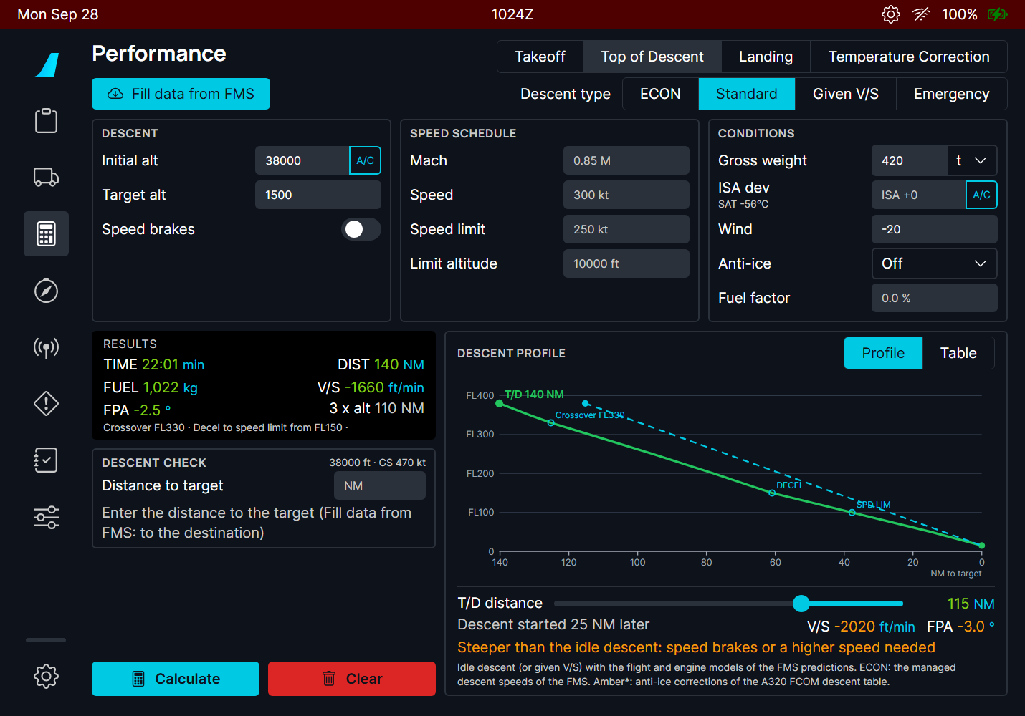  Figure 168. Slider 25 NM later: 115 NM, -2020 ft/min, -3.0°: steeper than idle. | 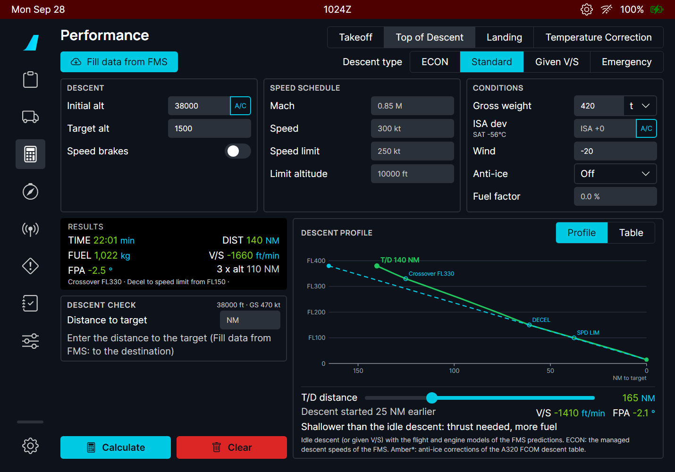  Figure 169. Slider 25 NM earlier: 165 NM, -1410 ft/min, -2.1°: shallower.

The Calculate and Clear buttons are at the bottom of the page, where they are on the takeoff and landing pages.

8. What to expect
Situation | What you should see
Inputs missing | Amber labels; no results.
Any input changed | The results are cleared: press Calculate again.
Target above the initial altitude | Message "The target altitude must be below the initial altitude".
Initial altitude above the aircraft ceiling, or weight out of range | A message gives the limit (maximum altitude, or the weight range from the empty weight to the MTOW).
Given V/S steeper than idle | Amber line: idle descent below the altitude it names.
ECON without FMS flight plan | "No FMS data: enter a flight plan in the FMS".
Distance to target larger than the descent | Green "Start the descent in X NM (Y min)".
Distance shorter than the descent | Amber "N NM late for the profile" with the V/S and FPA needed.

9. Limitations and why
Limitation | Why | What to do
The descent is a still-air profile plus a mean wind. | The wind is one component for the whole descent, as in the FCOM and OIS; the FMS uses the wind of each altitude. | Use the mean wind of the descent.
About 8 % longer than the A320 FCOM table. | The FCOM table is for the CFM56 A320; the FBW A320neo engine model idles differently. | Compare with the FMS T/D, which uses the same model.
Anti-ice values are estimates. | Only the A320 FCOM has anti-ice descent corrections. | -
No descent path constraints or approach. | The page computes a clean descent to one target altitude, not the FMS path with its constraints. | Use it as a cross-check of the FMS.

PR 25 - A380X OANS default airport
The airport map of the ND (OANS) shows the right airport by itself: the current airport on ground, the origin, destination or alternate in flight, as the A380 FCOM describes the moving airport map
Aircraft | A380X
Where to find it | ND in ARC or ROSE-NAV at the ZOOM range (the OANS), or PLAN; the ARPT SEL panel of the OANS
PR branch | pr/25-a380x-oans-default-airport (independent)
Status | Tested in the sim on 2026-09-27 (user-confirmed).
Pictures | Captain ND in the local browser harness, running the build installed in the sim, with a small test airport (XTST, no buildings) standing in for the Navigraph airport map.

1. What it is for
The OANS draws the airport around the aircraft on the ND. The FCOM (DSC-34-10-70-20, MOVING AIRPORT MAP) says no manual selection is needed: the OANS shows a default airport. FBW loaded the nearest airport on ground, but in flight only the destination (within 50 NM, at any height), and a manual selection stopped the automatic choice for 10 minutes. Now the FCOM rules apply.

2. The rules
ND mode | Default airport
ARC, ROSE-NAV (on ground) | The airport where the aircraft is.
ARC, ROSE-NAV (in flight) | The origin, destination or alternate of the FMS while the aircraft is inside its virtual cylinder: 20 NM radius, 5000 ft above the airport. The OANS keeps it while the aircraft stays in the cylinder.
PLAN (in flight) | The origin if it is closer than 50 NM, otherwise the destination; the destination when origin and destination are less than 300 NM apart.
Manual (ARPT SEL) | Only in PLAN: another airport can be displayed. It stays until the ND leaves PLAN, or the aircraft lands or takes off. In ARC / ROSE-NAV the OANS says SET PLAN MODE.

Only one airport is displayed on both NDs; the PLAN rule applies when the other ND is not in ARC or ROSE-NAV, so the two sides never fight.

3. What it looks like
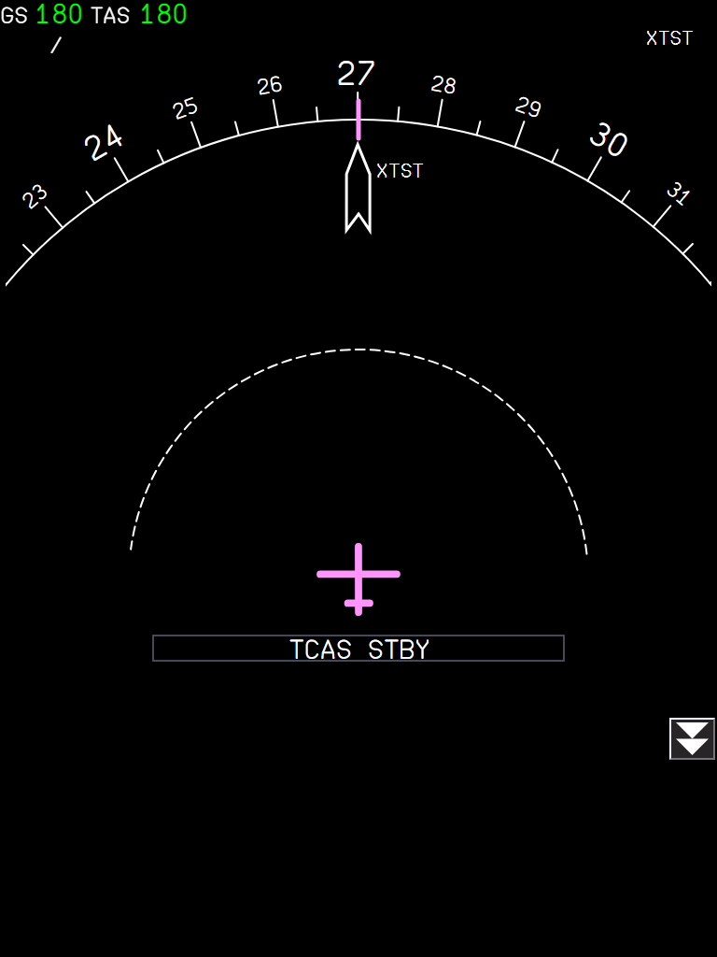  Figure 170. In flight, 12 NM from the destination XTST at 3000 ft: the destination loads by itself (name top right; the arrow points to the airport, still outside the zoom range). | 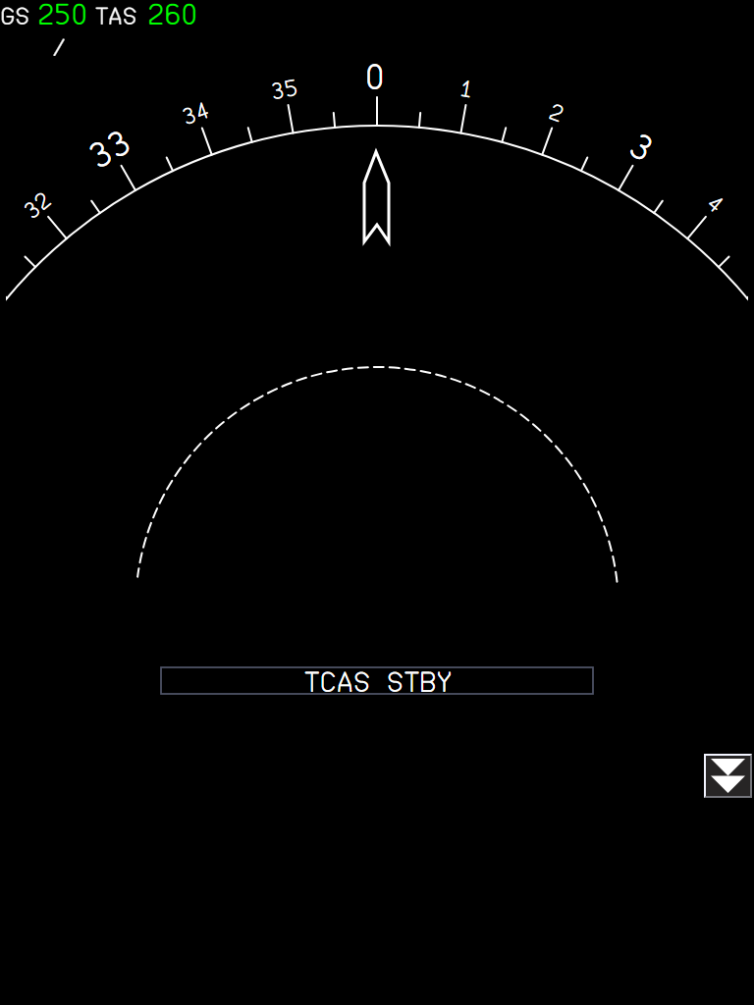  Figure 171. 30 NM away at 9000 ft: outside the cylinder, no airport is loaded.

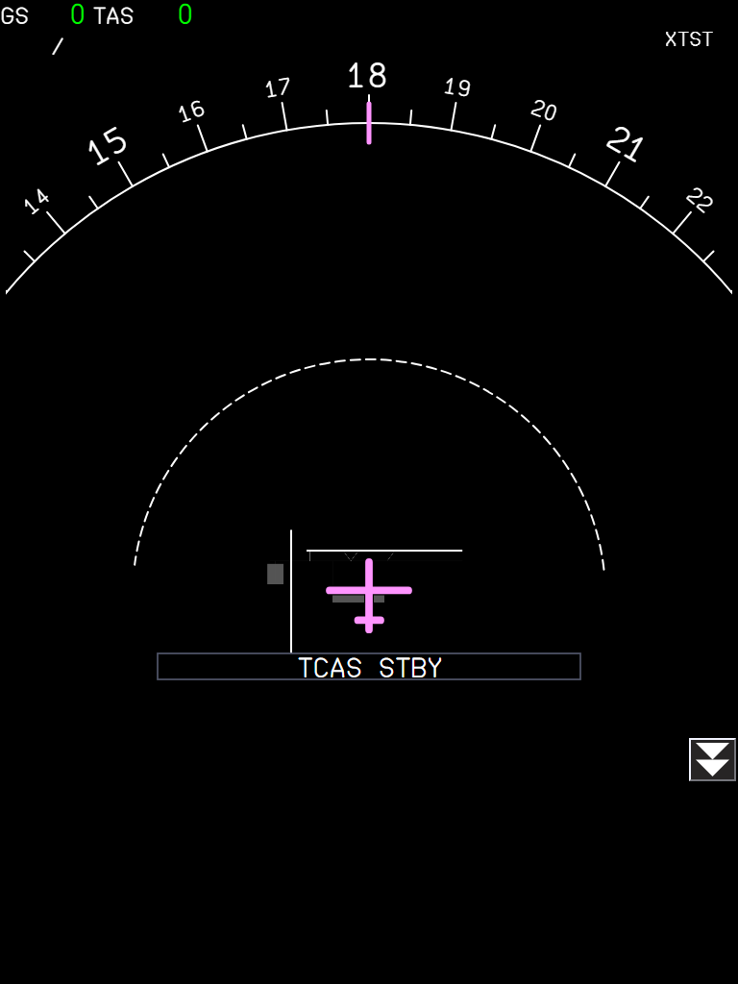
Figure 172. On ground at XTST: the current airport, with the aircraft at its gate.

4. What to expect
Situation | What you should see
On ground | The airport where you are, whatever the flight plan.
Climbing out of the origin | The origin until you leave its 20 NM / 5000 ft cylinder, then nothing (or the alternate / destination when inside theirs).
Approach to the destination | The destination from 20 NM and 5000 ft above it.
Diversion to the alternate | The alternate from 20 NM and 5000 ft above it.
ARPT SEL in PLAN | Your airport until you leave PLAN, land or take off.
No present position | No automatic airport.

5. Limitations and why
Limitation | Why | What to do
Needs the Navigraph airport database. | The OANS map is the Navigraph AMDB. | Link Navigraph in the flyPad.
One displayed airport for both NDs. | The real OANS has one per side; FBW shares one map. | -
The destination arrow (5 NM range, map out of range) is FBW's. | Not part of this change. | -

PR 26 - flyPad taxi route
Ground > Taxi: see the taxi route of your ATC clearance on the airport map, from the gate to the runway holding point and from the runway exit to the gate
Aircraft | A32NX and A380X (the same flyPad page on both)
Where to find it | flyPad > Ground (truck icon) > Taxi tab
PR branch | pr/26-efb-taxi-route
Status | Tested in the sim at RJTT (Tokyo Haneda) on 2026-09-28 and at Montreal CYUL on 2026-09-29 (its fixes: section "Locate the aircraft..."). The OANS flags are not tested in the sim yet.
Pictures | flyPad pages in the local browser harness, running the build installed in the sim, on a small test airport (XTST) made for the pictures. In the sim, the page uses the Navigraph airport map of the real airport.

1. What it is for
Before taxiing, the crew gets a taxi clearance from ATC such as "taxi to holding point runway 09 via M, K, A". On an unknown airport, following it on the chart is where mistakes happen: a wrong turn, a runway crossed without clearance. This page draws the route of the clearance on the airport map, lists the runways it crosses and stops it at the runway holding point.
The real A380 has no taxi routing: its OANS (the airport map on the ND) only lets the crew place green flags and white crosses (FCOM DSC-34-10-70-20), and MSFS has no datalink taxi clearance (D-TAXI). So the route is built on the flyPad, and the cockpit displays stay as the FCOM describes them. On the A380, the accepted route is marked on the OANS with those green flags (section 9).
- Departure (default): from a gate, a ramp or cargo stand, or the aircraft position, to a runway entry.
- Arrival: from the runway exit you plan to take (or the aircraft position) to your gate.
- The page suggests the shortest route; you type the taxiways of the ATC clearance and accept it.

2. Before you start
- Navigraph account linked in the flyPad settings (third party options). The airport map comes from the Navigraph airport database, the same data as the A380 OANS. Without it the page says "No airport database".
- Airport: type the ICAO code, or press ORIG / DEST to take the airports of the SimBrief flight plan loaded in the flyPad. The line below shows how many gates, ramp and cargo stands the map has.
- An airport that is not in the Navigraph airport database shows "Not in the Navigraph airport database".
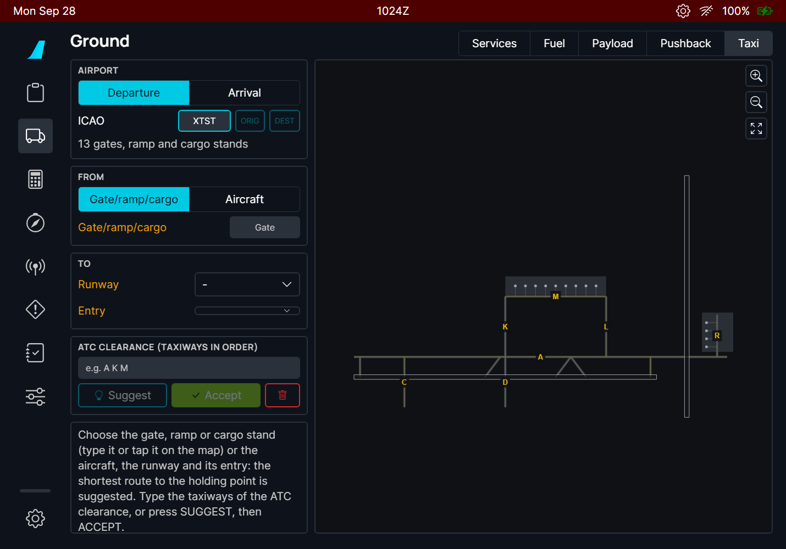
Figure 173. The Taxi page after entering the airport: the airport map on the right, the route inputs on the left. Amber labels show what is still missing.
Part of the page | What it does
AIRPORT | Departure or Arrival, the ICAO code, ORIG / DEST buttons, the number of stands on the map.
FROM | Where the taxi starts: a gate / ramp / cargo stand (departure), a runway exit (arrival), or the aircraft.
TO | Where it ends: the runway and its entry (departure), or the gate (arrival).
ATC CLEARANCE | The taxiways of the clearance, in order. SUGGEST fills it with the shortest route, ACCEPT confirms it, the red bin clears the page.
Route box | The route as a clearance reads, its length, the taxiways and the runway crossings in red.
Map | The airport with the route, the runway entries (cyan), the holding point (amber bar), the aircraft (yellow). Drag to move, buttons to zoom and to fit the route.

3. Departure: from the gate to the runway
- Keep Departure selected and enter the airport.
- In FROM, keep Gate/ramp/cargo and type your gate. While you type, the gates that match appear as buttons under the field: tap one. You can also tap the gate on the map (zoom in to see the names).
- In TO, choose the runway. The entry is set to the full length entry; choose another one for an intersection departure.
- The shortest route appears on the map as a dashed magenta line ending at the HOLD bar of the runway holding point.
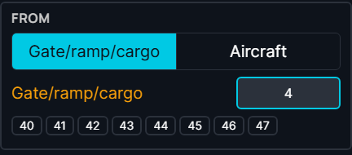  Figure 174. Typing "4" lists the gates 40 to 47: tap one. | 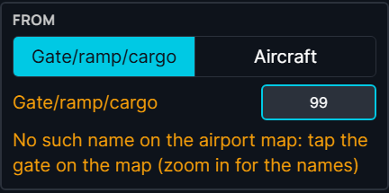  Figure 175. A name that is not on the map: the amber line says so.

Gate names are found even when they are written differently on the map: "16" finds "016", spaces and dashes do not matter. If nothing matches, the airport map uses another name (for example a letter prefix): tap the gate on the map instead.
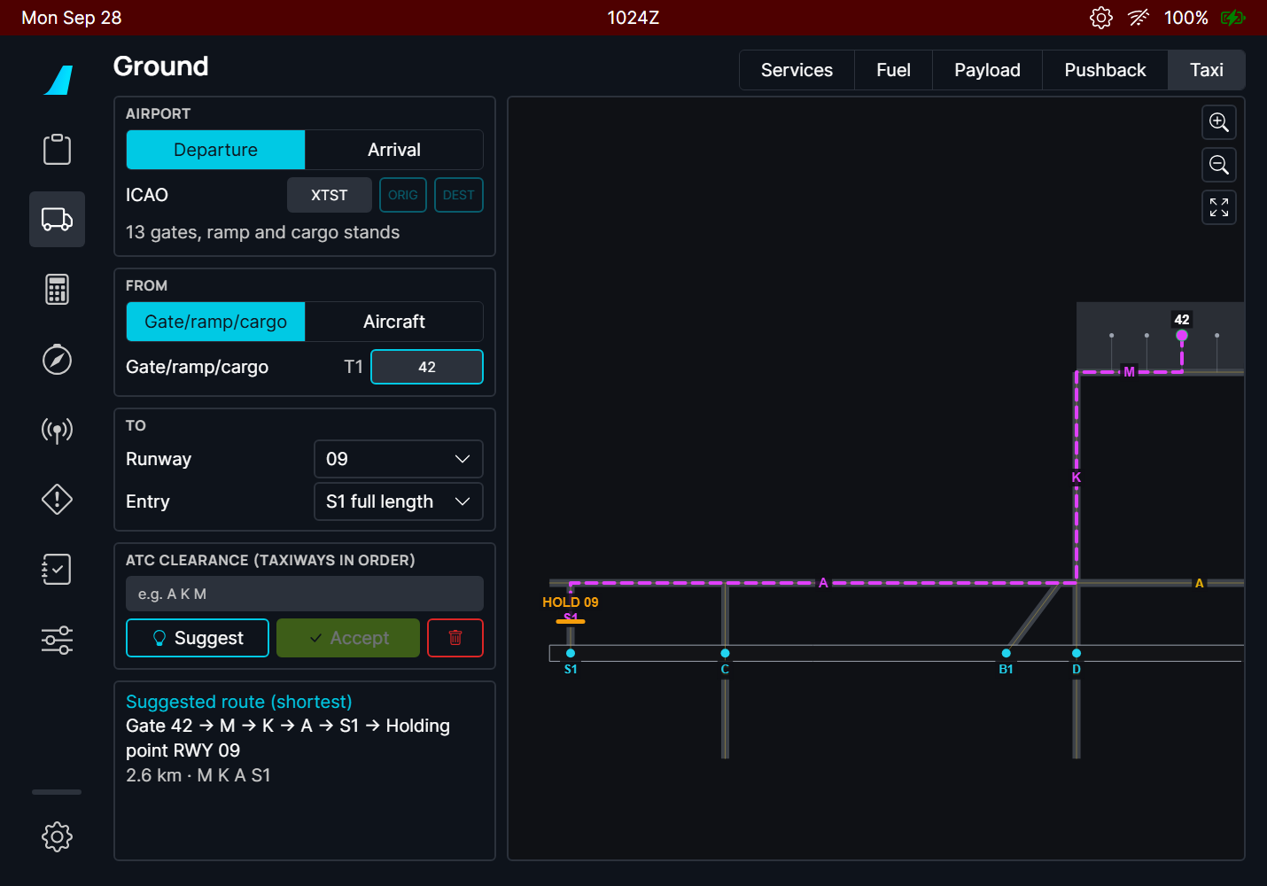
Figure 176. Gate 42 to runway 09, full length: the suggested route (dashed) along M, K and A to entry S1, stopped at the holding point (HOLD 09). The route box reads it as a clearance: Gate 42 → M → K → A → S1 → Holding point RWY 09, 2.6 km.

Runway entries
The Entry list shows every taxiway that enters the runway, in order from the threshold. The first one is the full length entry; the others show the runway length remaining from them, to check an intersection departure against your takeoff performance. On the map, the entries of the selected runway are the cyan dots with their names.
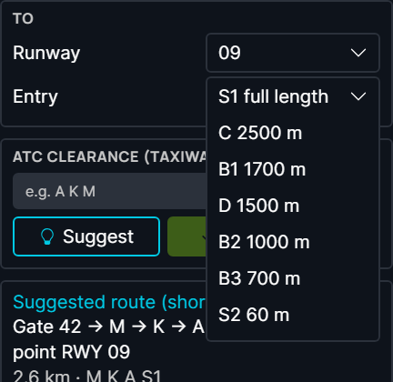
Figure 177. The entries of runway 09: S1 full length, then C (2500 m left), B1 (1700 m), D (1500 m) and so on.
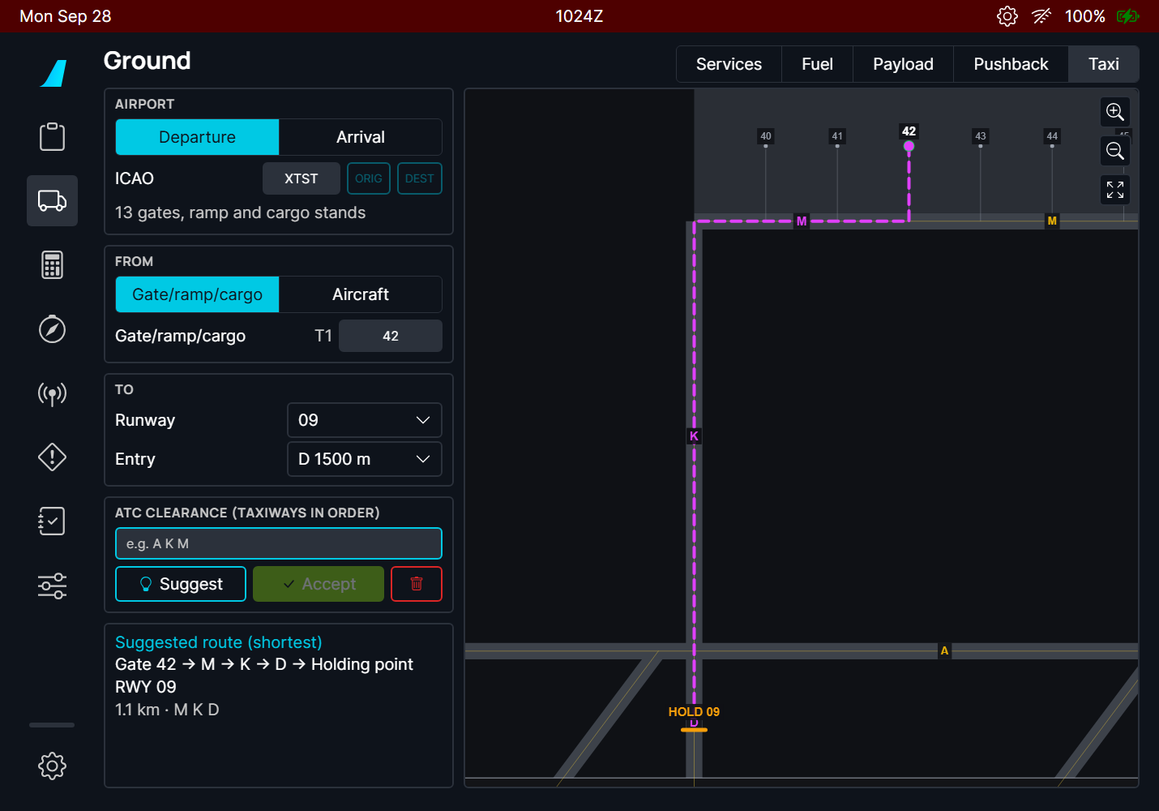
Figure 178. Intersection departure from D: the route stops at the holding point of D, with 1500 m of runway ahead.

4. The ATC clearance
Type the taxiways of your clearance in the order ATC gives them, separated by spaces (commas and dashes work too). The route then follows them strictly, in that order:
- Short unnamed connecting lines between two cleared taxiways are allowed.
- The runway entry can be left out: "via M, K, A" to a holding point still ends on the entry you chose.
- While the typed route is not accepted, the box reads "Route along the clearance (not accepted)" and the line stays dashed.
SUGGEST copies the taxiways of the suggested route into the clearance field: a quick start when ATC clears you along the obvious way. ACCEPT confirms the route: the line turns solid. Any change (gate, runway, entry, clearance) takes the acceptance away.
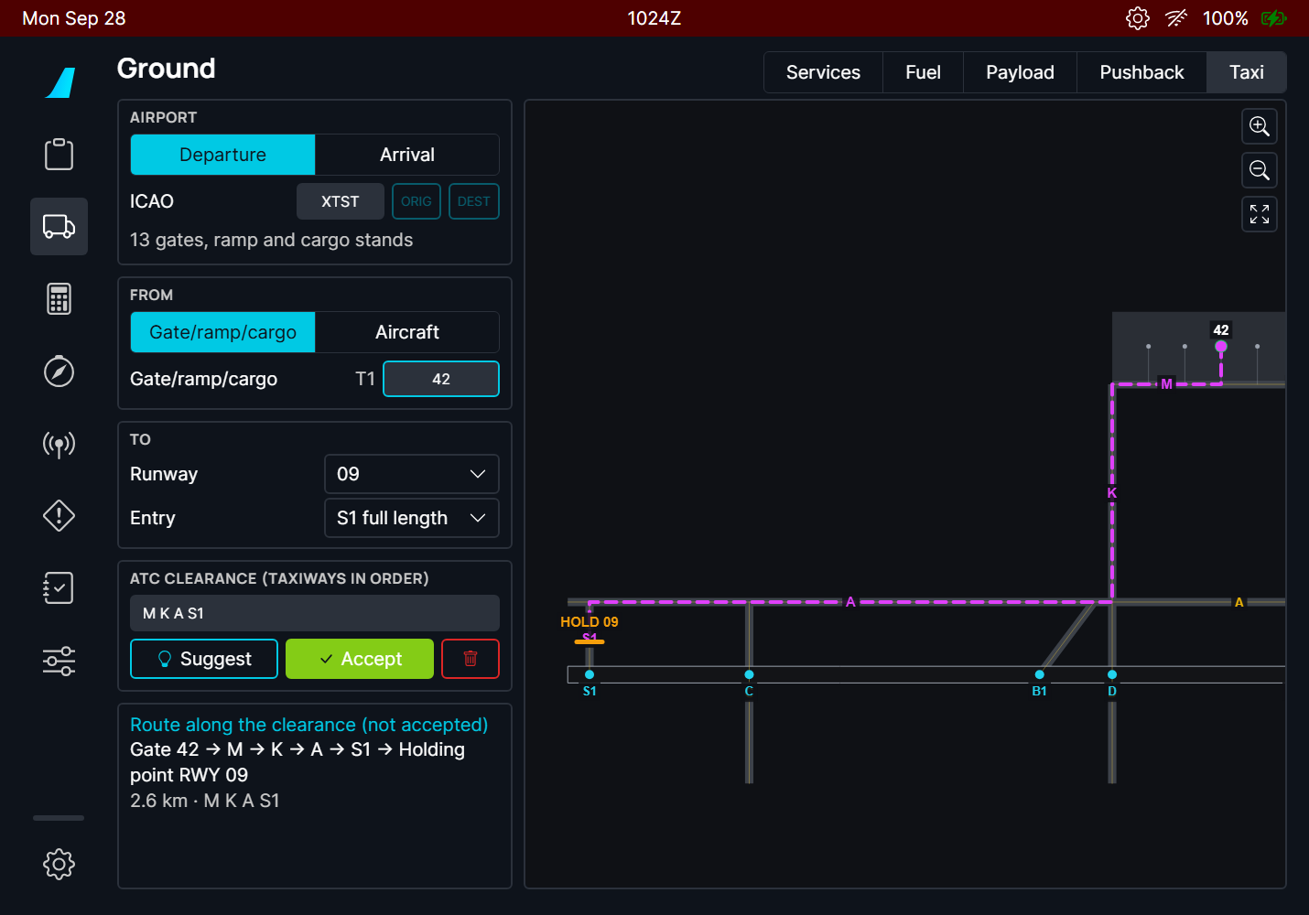  Figure 179. After SUGGEST: the clearance field holds M K A S1, the route is a preview. | 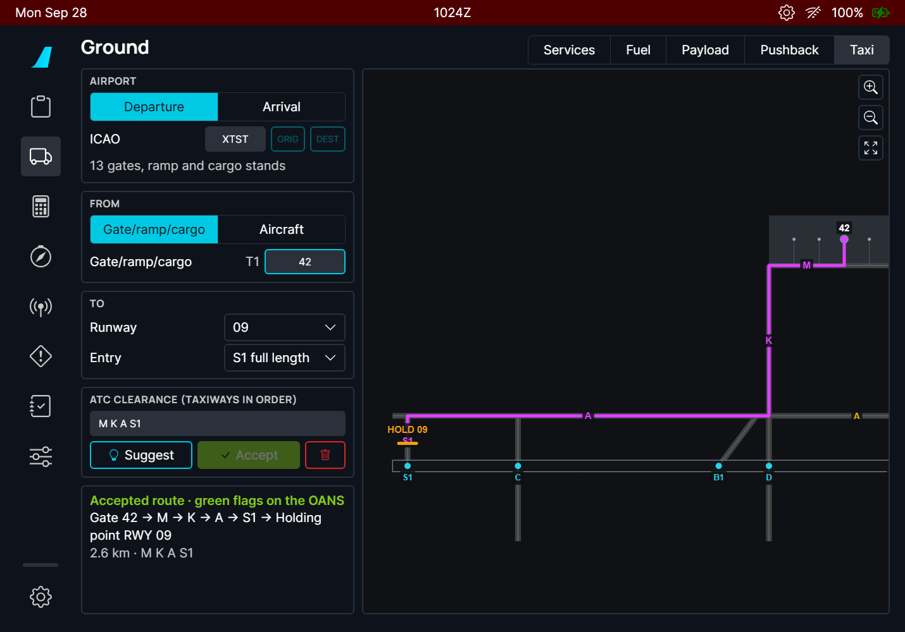  Figure 180. After ACCEPT: solid line, "Accepted route". On the A380 the route is also flagged on the OANS.

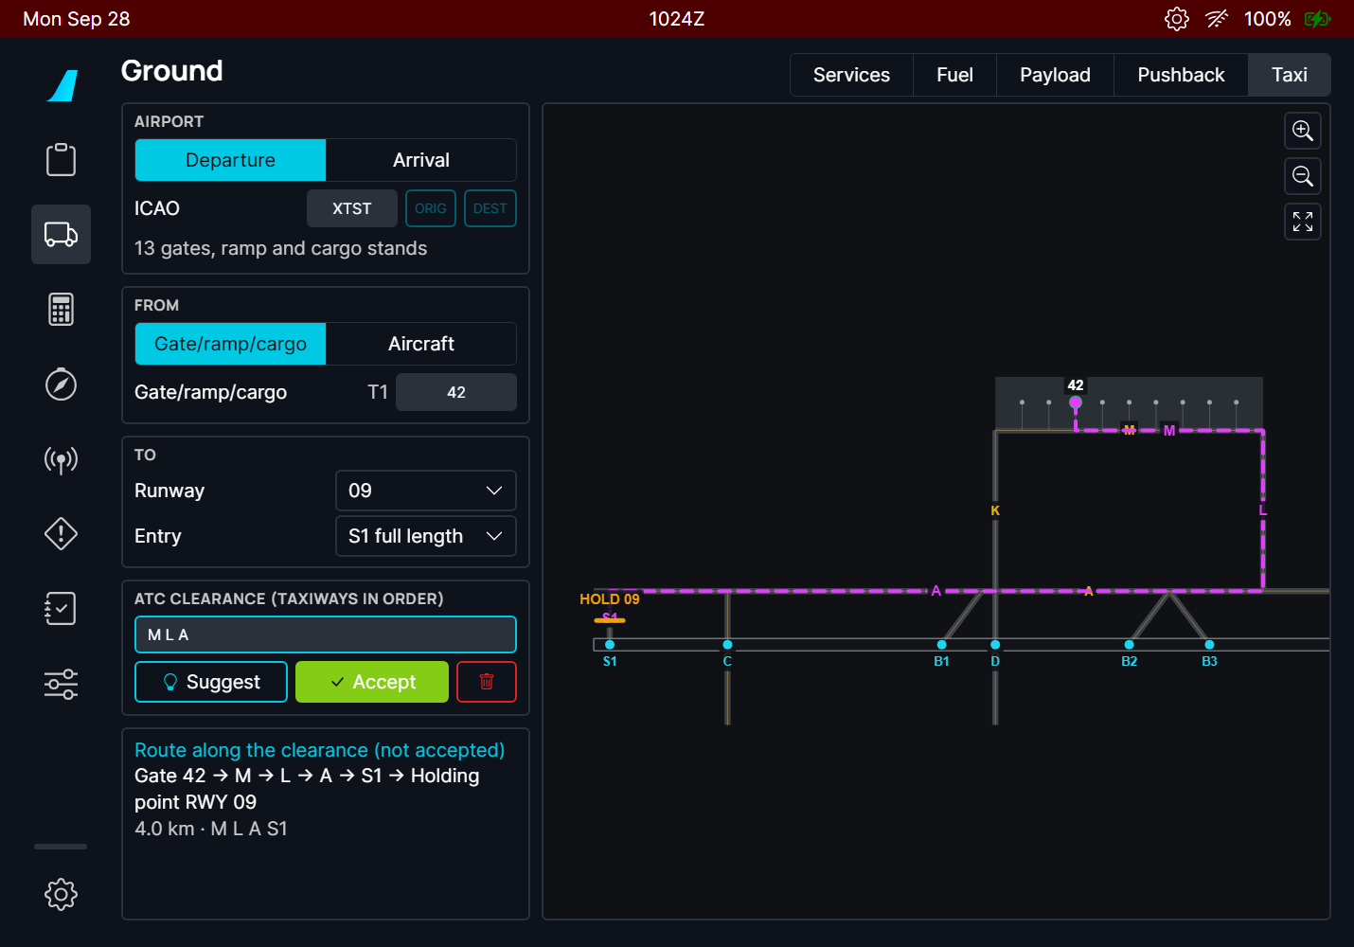
Figure 181. A different clearance, "M L A": the route goes the long way round via L (4.0 km instead of 2.6 km), as ATC asked.
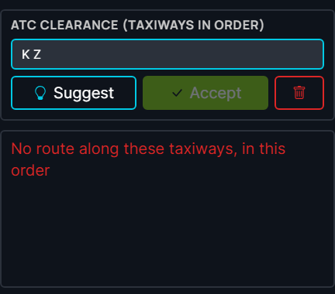
Figure 182. A clearance with a taxiway that does not exist here, or taxiways that do not connect in that order: "No route along these taxiways, in this order". Check the spelling and the order.

5. Runway crossings
Every runway the route crosses is circled in red on the map with its name, and listed in red under the route ("Crossing runway 01/19"). A runway crossing always needs its own ATC clearance: stop at the holding point before it and ask if you do not have it.
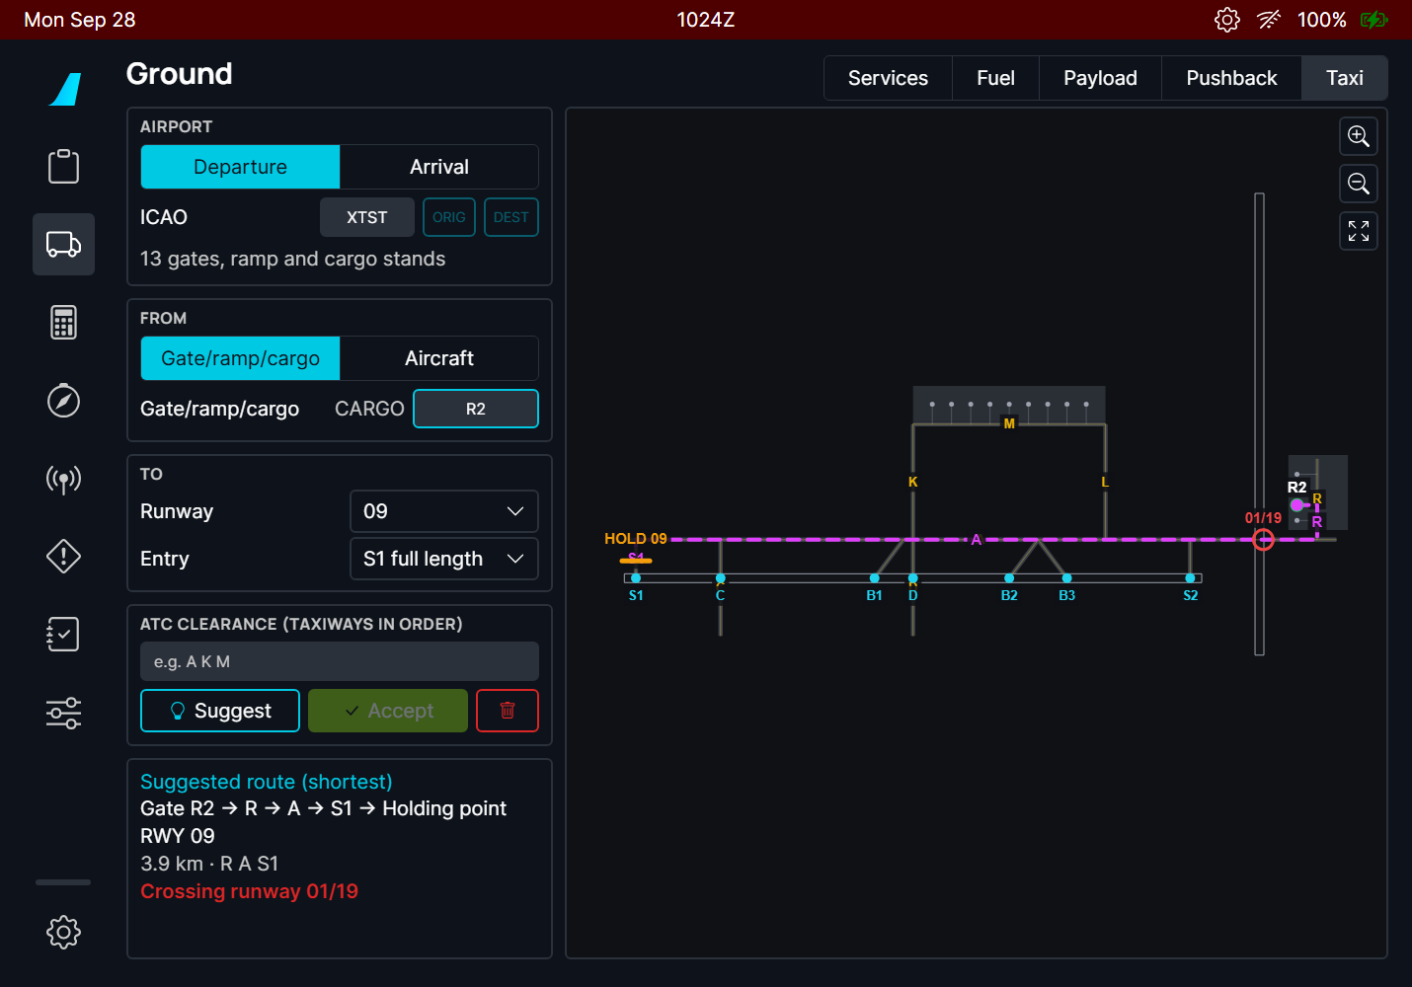
Figure 183. From cargo stand R2 to runway 09: taxiway A crosses runway 01/19 (red circle, red line in the route box).

6. Arrival: from the runway exit to the gate
- Select Arrival and enter the airport (DEST fills it from the flight plan).
- In FROM, keep Runway exit, choose the landing runway and the exit you plan to take. The exits are those of the landing calculator, with their distance from the threshold.
- In TO, type or tap the gate.
- Check the route, type the clearance if ATC gives another one, and ACCEPT.
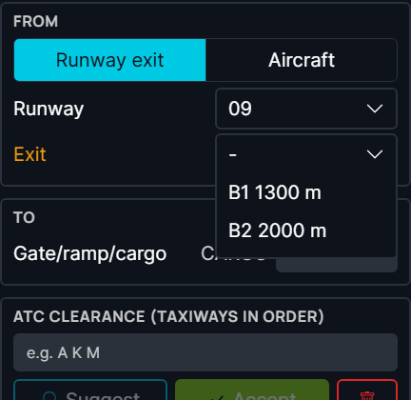  Figure 184. The exits of runway 09 with their distance from the threshold. | 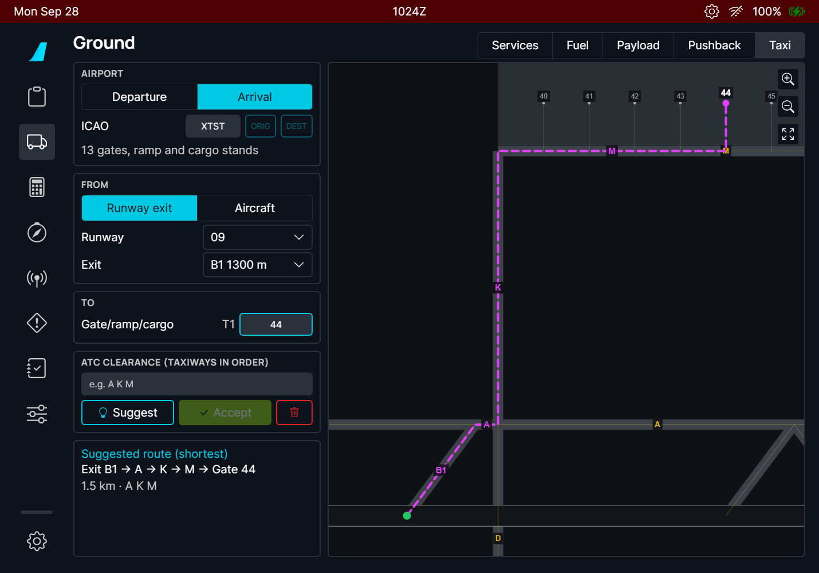  Figure 185. Exit B1 to gate 44: Exit B1 → A → K → M → Gate 44. The green dot is the start.

TIP Prepare the arrival route during the descent briefing with the exit from the landing calculator: after landing, the page is ready. If you vacate by another exit, choose it (or use the aircraft position) and the route updates.

7. From the aircraft position
Choose Aircraft in FROM to start the route where the aircraft is, for example after a pushback, or when ATC changes the route while you taxi. The page takes the position when you select it; press Update to take it again. The route starts on the taxi line nearest to the aircraft and prefers its heading: it does not start by turning back if there is a way ahead.
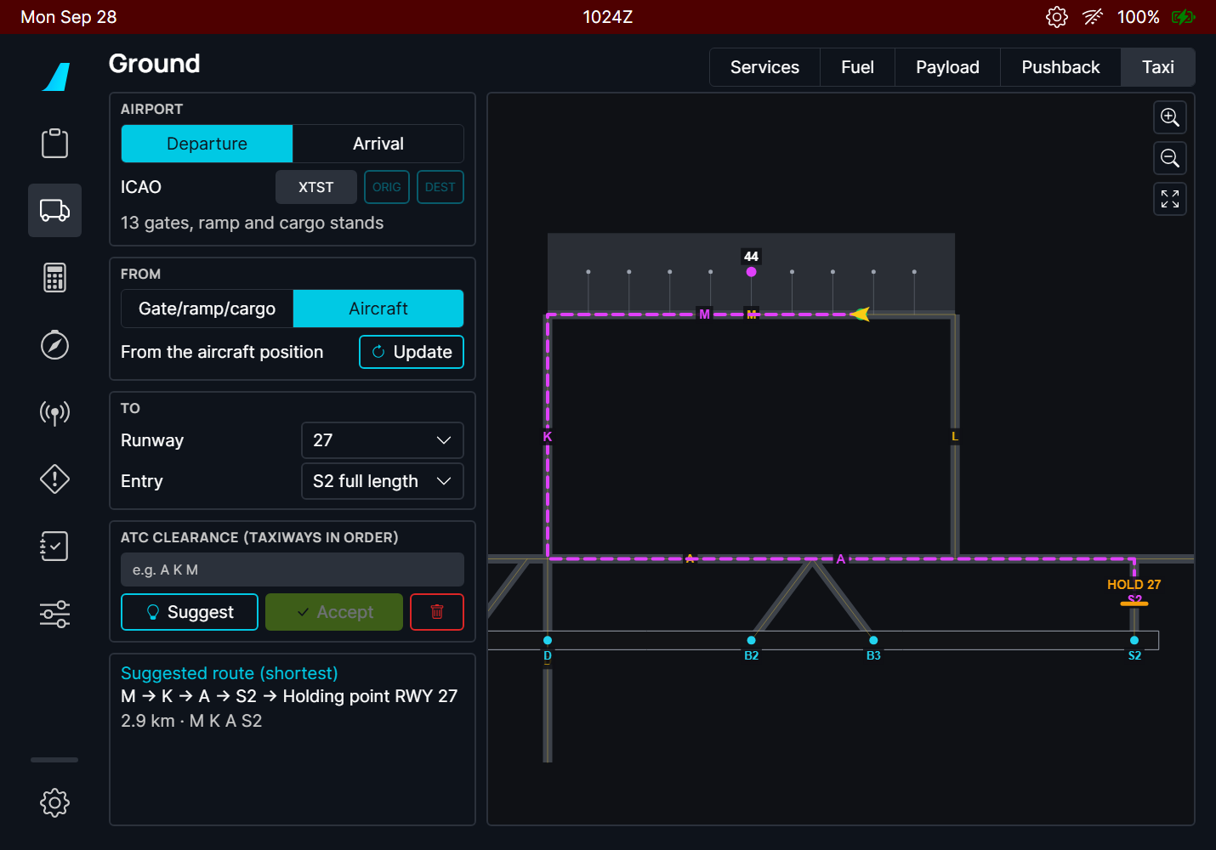
Figure 186. The aircraft (yellow) on M facing west, for runway 27: the route goes ahead via K and A (2.9 km) rather than turning back on M.
"The aircraft is not at this airport" means the aircraft is more than 8 km from the airport of the page.

8. Locate the aircraft, taxiway names of several words, proposed entry
- Locate button (pin, under the zoom buttons): centres the map on the aircraft and zooms in until the stand names show. It is greyed when the aircraft is not at this airport.
- Taxiways named with several words (e.g. SOUTH RAMP, NORTH RAMP at Montreal CYUL) are read as one taxiway in the clearance: type them as the map shows them, or press SUGGEST.
- The runway entry proposed first is the first one from the threshold you can reach without crossing a runway. At CYUL, runway 24L full length (R) is across 06R/24L from the terminal: the entry proposed is the first one on the terminal side; choose R in the Entry list if ATC clears you across.
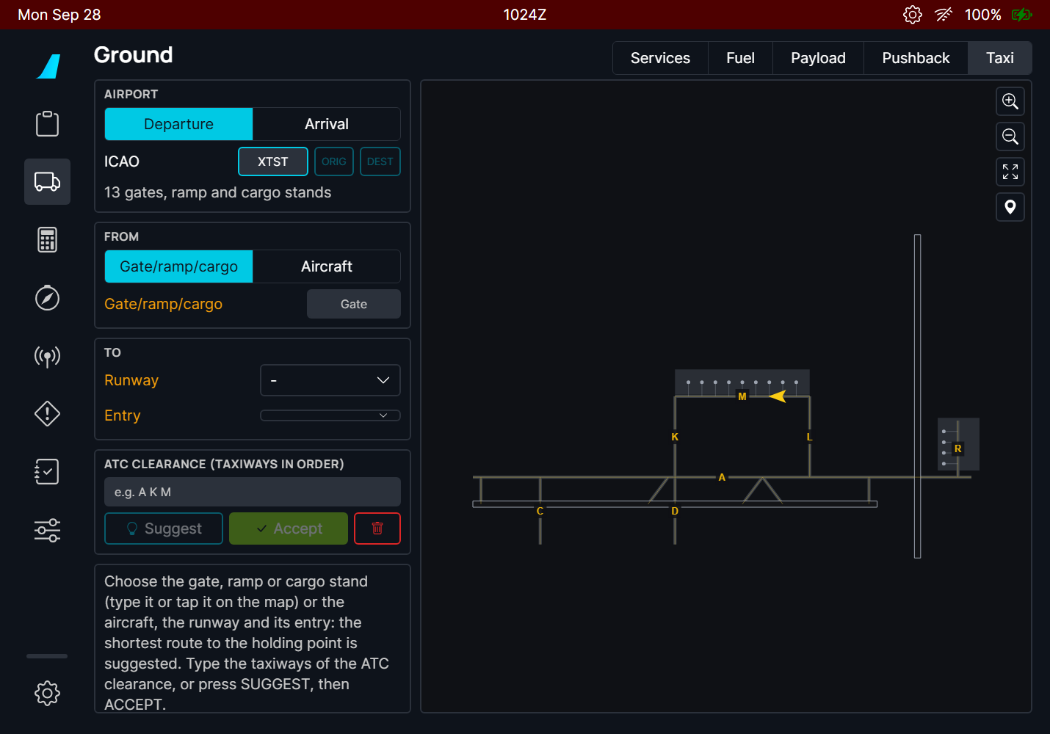  Figure 187. The whole airport, the aircraft on M. | 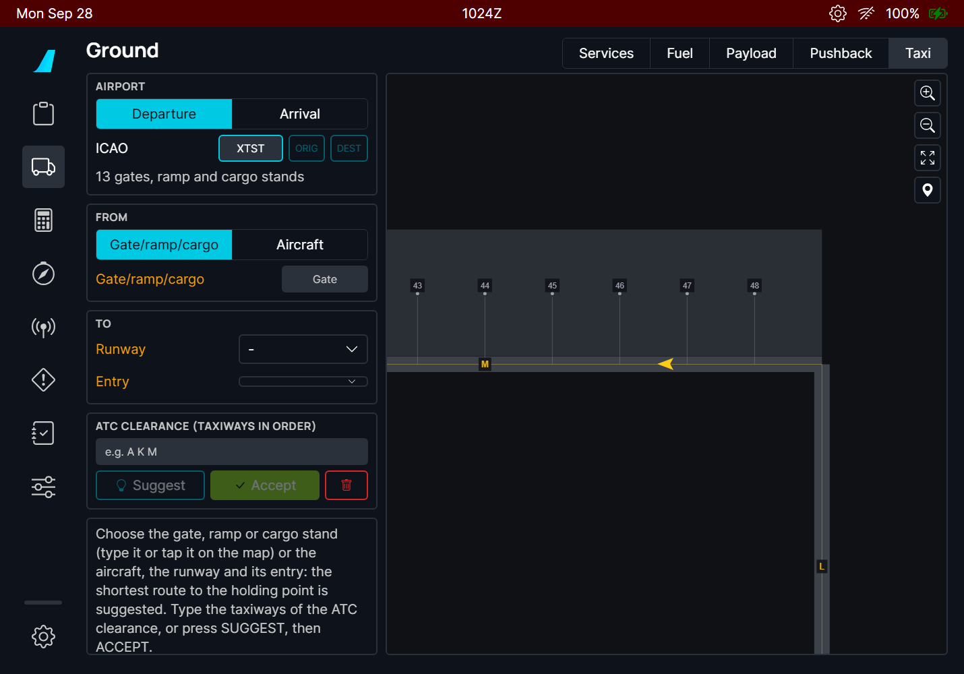  Figure 188. After the locate button: centred on the aircraft, stand names shown.

9. The map
- Drag the map to move it; + / - zoom; the frame button fits the route (or the whole airport).
- The map is north up. Aprons are lighter grey, taxiways dark grey, runways black with a white edge. The thin yellow lines are the taxi guidance lines the route follows.
- Taxiway names are shown in yellow; the taxiways of the route in magenta. Gate names appear when you zoom in.
- Tap a gate on the map to choose it (when the page asks for a gate).
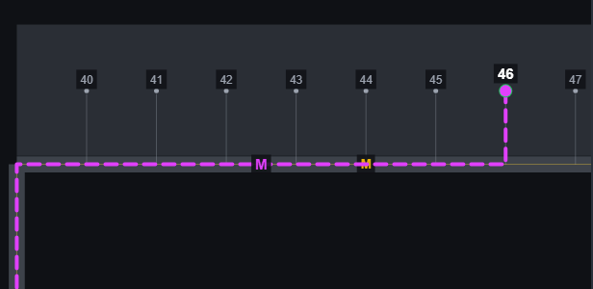
Figure 189. Zoomed on the apron: the gate names, the route to gate 46 along M.

10. On the A380: the route on the OANS
When you accept the route on the A380 flyPad, green flags appear on the OANS (the airport map on the ND) at the start of each taxiway of the route and at the gate or holding point. They are the crew flags of the FCOM ("to locate or mark a given point on the airport"), so you can remove them like any flag: click one and DELETE, or ERASE ALL SYMBOLS in the ND menu. Flags you placed yourself are never touched.
- The flags appear when the OANS displays that airport (they come back if the OANS reloads it).
- A new accepted route replaces the flags of the previous one; a route that is no longer accepted removes them.
- The A320 has no OANS: nothing else changes on it.
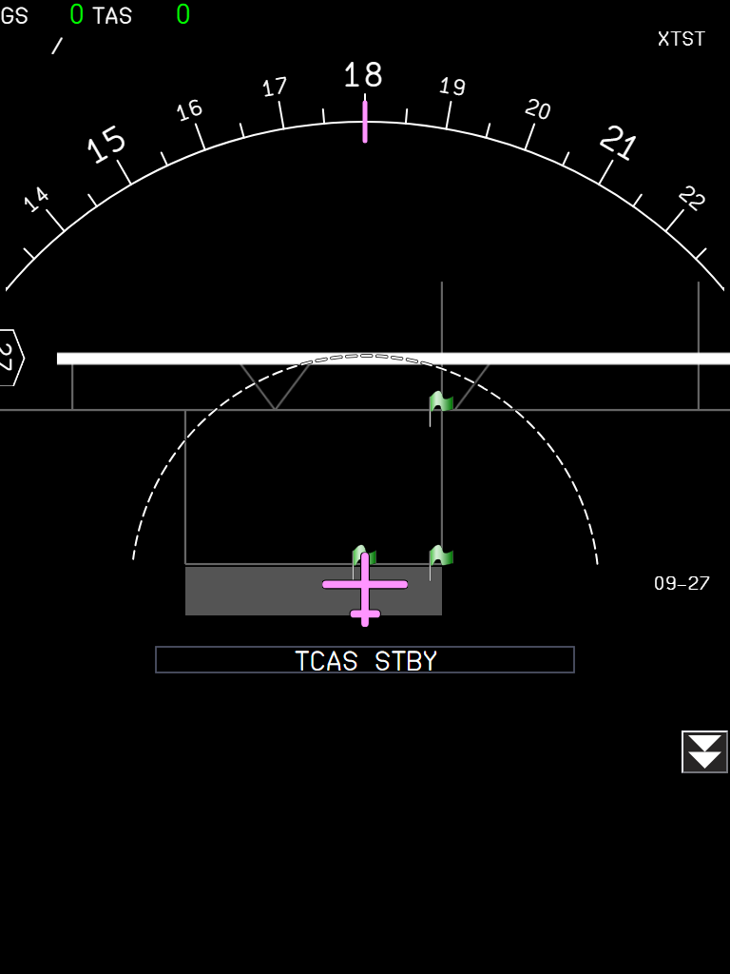
Figure 190. The A380 ND (OANS, ARC, zoom range) at gate 42 facing south, after ACCEPT of the route of figure 6: green flags where M, K and A start (S1 and the holding point are further west, off the picture). Harness picture: the test airport has no buildings.
NOTE This part is built and deployed but not committed yet, and not tested in the sim.

11. What to expect
Situation | What you should see
Airport entered, nothing else | The airport map, amber labels on the inputs still missing, the help text in the route box.
Start and end chosen | The suggested route, dashed, with its clearance text, length and crossings.
SUGGEST | The clearance field holds the taxiways of the suggested route; the route is a preview (dashed).
Clearance typed | The route follows the typed taxiways in order (dashed until accepted), or the red message "No route along these taxiways, in this order".
ACCEPT | Solid line, "Accepted route" in green (A380: green flags on the OANS).
Any input changed after ACCEPT | Back to a preview: accept again.
Departure to a runway with holding position lines | The route stops at the HOLD bar before the runway.
Two entries behind the same HOLD bar (e.g. RJTT 34R C2 and C3) | The same route to the holding point: the entries only differ after it.
Gate whose lead-in is another stand's line (e.g. RJTT gate 5 behind 5R) | The route leaves along that line: "Gate 5 → Gate 5R → W ...".
Runway without holding position lines on the map | The route ends on the runway entry itself and the box says "Runway 09" instead of "Holding point RWY 09".
The route crosses a runway | Red circle with the runway name on the map, red "Crossing runway" line.
Aircraft start, aircraft far from the airport | "The aircraft is not at this airport"; no route.
Leaving the page and coming back | Everything is kept, except an Aircraft start: press Aircraft or Update again.

12. Limitations and why
Limitation | Why | What to do
Needs a Navigraph account. | The airport map (taxi lines, stands, holding points) exists only in the Navigraph airport database; MSFS does not give it to the aircraft. | Link your account in the flyPad settings.
Closed taxiways, one-way taxiways and NOTAMs are unknown. | The airport database has the lines painted on the ground, not their status of the day. | Type the taxiways of the ATC clearance: the route follows them.
The suggestion is the shortest route, not the usual one. | Airports have preferred flows (ATC habits, one-way loops) that are not in the data. | Always check against the clearance and the airport chart.
Some real airports have gaps in their taxi lines. | A lead-in line may stop a few metres short of the taxi line. Gaps up to 15 m between parts that are otherwise not connected are joined; larger ones are not. | If "No taxi line of the airport map connects the start to the end" appears, choose another start (the nearest taxiway, or the aircraft) or end.
Gate names follow the airport database. | The database may use names that differ from the gate signs. | Tap the gate on the map.
No route on the A380 OANS, only flags. | The A380 FCOM has no taxi route display; the flags are the FCOM way to mark points on the airport map. | -
The aircraft position is taken once. | The route is a plan to check, not a moving map that follows you. | Press Update after a change.

13. Troubleshooting
What you see | Why | What to do
SUGGEST and ACCEPT are greyed | There is no route yet: the gate is not found (amber label, no terminal next to the name), or the runway / entry / exit is missing. | Pick the gate from the suggestion buttons or tap it on the map; check the amber labels.
"No such name on the airport map" | No stand of the map has this name. | Tap the gate on the map.
"No taxi line of the airport map connects the start to the end" | The start and the end are on parts of the map that are not connected. | Start from the nearest taxiway (Aircraft), or choose another gate or entry.
"No route along these taxiways, in this order" | A taxiway of the clearance is misspelt, missing, or they do not connect in that order. | Check the clearance; press SUGGEST to see the names the map uses.
"Not in the Navigraph airport database" | Navigraph has no airport map for this airport. | -

PR 27 - A380X pedestal printer
Print the FMS pages and the ATIS from the MFD on the paper of the printer on the pedestal, tear the sheets off and read them
Aircraft | A380X
Where to find it | MFD: FMS > DATA > PRINTER, SEC INDEX PRINT, ATC COM > ATIS (PRINT, PRINT ALL, auto print); the printer on the pedestal, behind the captain's KCCU
PR branch | pr/27-a380x-pedestal-printer
Status | Tested in the sim on 2026-09-27 with the paper added to the installed cockpit model: the paper of the model is not in the FBW package yet (see the end of this manual).
Pictures | MFD pages in the local browser harness (build installed in the sim); the paper sheets rendered by the printer page of the build, with the printouts of the unit tests (test flight plan LFPG - EGLL).

1. What it is for
The A380 has a printer on the pedestal. The FMS prints its data (initialization, takeoff, winds, flight reports) and the ATC COM prints the ATIS, so the crew has them on paper. The printer now works as on the FBW A320: the sheet comes out of the printer, you tear it off and read it.

2. Printing
From | What prints
FMS > DATA > PRINTER | F-PLN INIT, T.O DATA, WIND DATA; the active flight plan PRE-FLIGHT, IN-FLIGHT and POST-FLIGHT reports; the SEC 1 to 3 reports; the AUTO PRINT options (company data on reception, reports at engine start, takeoff and shutdown)
FMS > SEC INDEX | PRINT of a secondary flight plan
ATC COM > ATIS | PRINT of one ATIS, PRINT ALL (all the ATIS on one printout), and the auto print (printer icon) when an ATIS is received

Figure 191. FMS DATA / PRINTER: the PRINT buttons and the AUTO PRINT options. | Figure 192. ATC COM ATIS: the printer icon (auto print) and PRINT ALL.

3. The paper
- Each printout starts with its title, the date and the time (UTC); an ATIS printout shows the time of the ATIS message.
- A sheet holds 45 lines: a longer page (e.g. a flight report) comes out on several sheets, one after the other.
- Click the sheet in the printer to tear it off: it goes on the pedestal (or the captain's pull-out table), where you can page through the torn sheets and discard them, as on the A320.
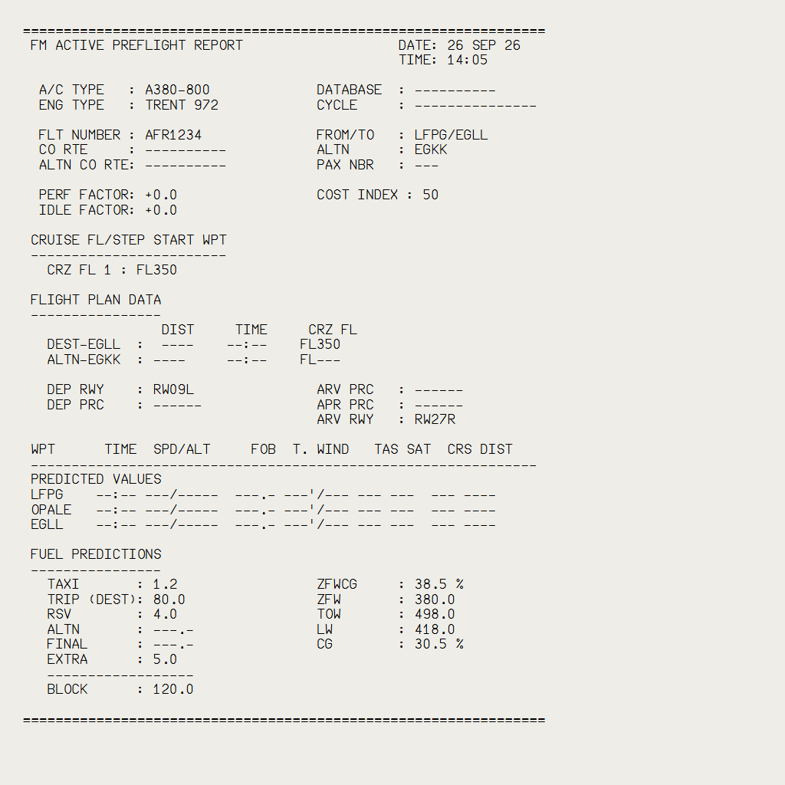  Figure 193. FM ACTIVE PREFLIGHT REPORT. | 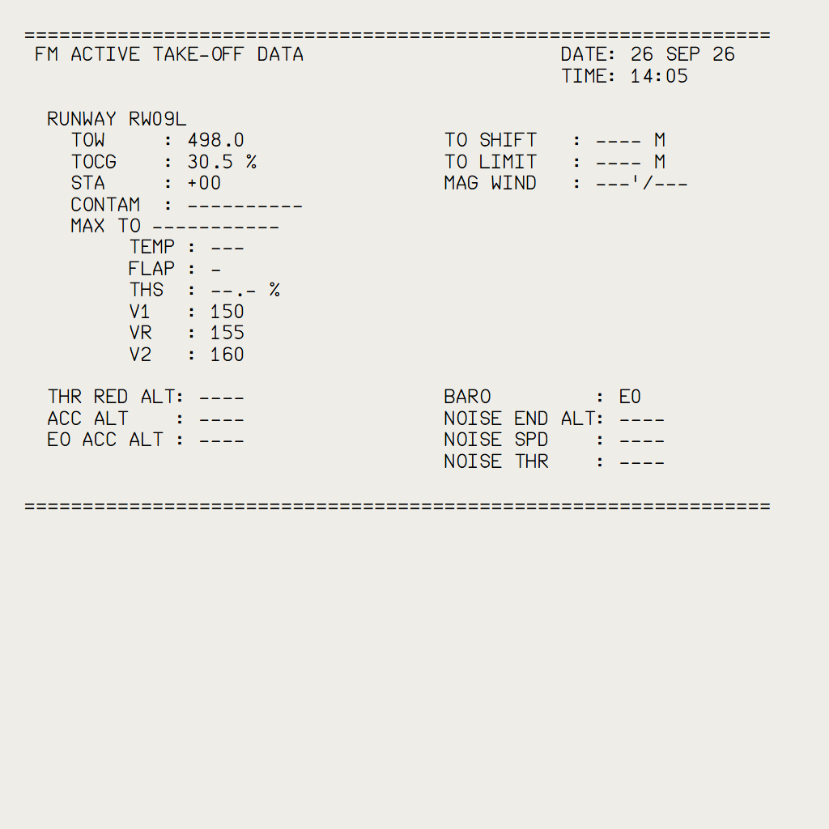  Figure 194. FM ACTIVE TAKE-OFF DATA.

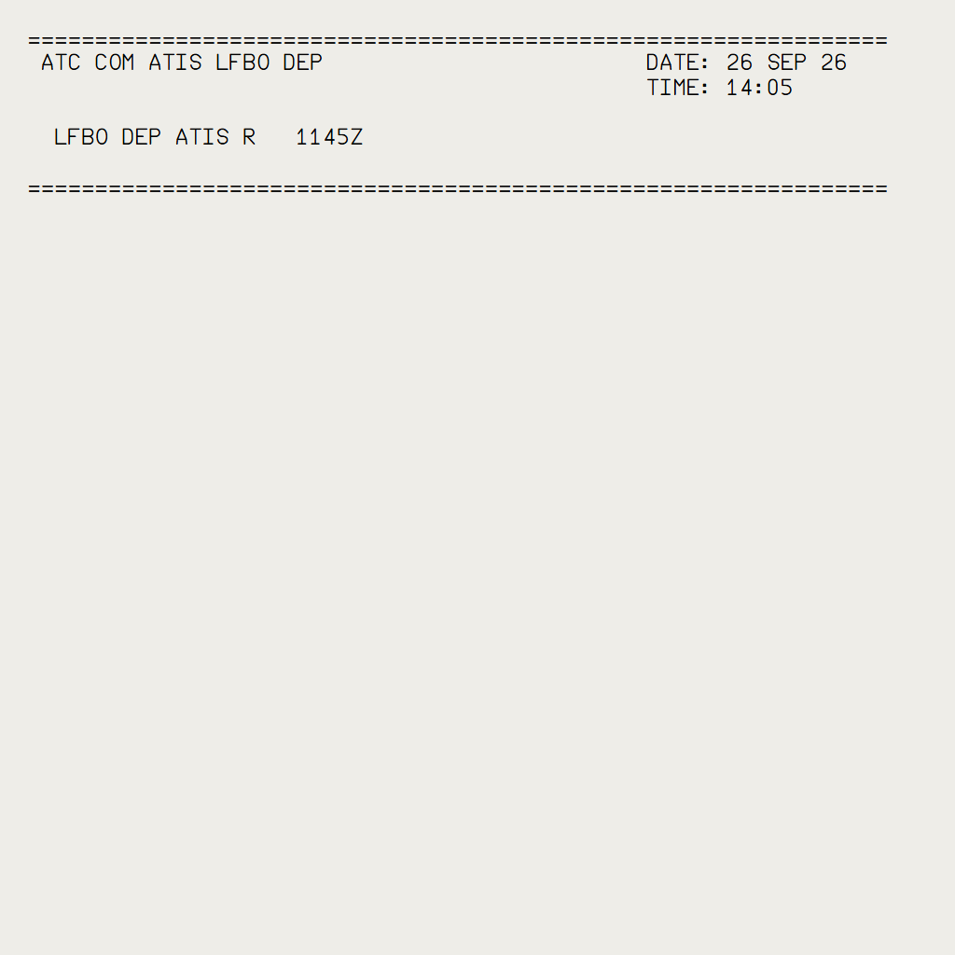
Figure 195. ATC COM ATIS printout.

4. Limitations and why
Limitation | Why
No paper visible in the FBW package yet | the A380 cockpit model has no paper: it was added to the model for the test, and must come with a change of the 3D model
The paper looks like the A320 one | the paper, its animation and its buttons come from the A320 printer

PR 28 - A380X EMER CANC pushbutton
Silence a warning, cancel a caution for the rest of the flight, and get the cancelled cautions back: the EMER CANC pushbutton of the ECP as the A380 FCOM describes it
Aircraft | A380X
Where to find it | ECP (ECAM control panel, pedestal): the guarded EMER CANC pushbutton, right of the RCL pushbutton
PR branch | pr/28-a380x-fws-emer-canc
Status | Tested in the sim by the user: OK (2026-09-29).
Pictures | None: the flight warning system does not run in the local browser harness, and the FCOM describes the pushbutton in text only (DSC-31-40-20 P 5, DSC-31-40-10).

1. What it is for
EMER CANC stops an alert that is wrong or no longer useful: a spurious warning whose aural alert would sound for the rest of the approach, or a caution the crew has dealt with and does not want to see again. Until now the pushbutton did nothing on the FBW A380.

2. What it does
It acts on the alert at the top of the EWD (A380 FCOM DSC-31-40-20):
Top alert | EMER CANC
A warning (red) | Its aural alert and the MASTER WARN light stop. The procedure stays on the EWD. If the warning goes away and comes back, the aural alert and MASTER WARN come back.
A caution (amber) | The caution, its procedure and the MASTER CAUT light go away for the rest of the flight, even if the failure comes back. It is listed in white under CANCELLED CAUTION on the STATUS page (MORE).
In every case | All the aural alerts stop (the one sounding and those waiting), and the procedures you called from ABN PROC are removed.
Nothing to cancel | The memo EMERGENCY CANCEL ON shows for 3 seconds.

3. Getting the cancelled cautions back
- Press and hold RCL for more than 3 seconds.
- The cancelled cautions that are still active come back on the EWD with their procedures.
The cancelled cautions are also forgotten when the warning system loses power, or 50 minutes after the engines are shut down, as the other ECAM memories.

4. What to expect
- A cancelled caution never sounds again in the flight, even if the failure comes back: check the STATUS page.
- A silenced warning comes back only if it goes away and triggers again.
- EMERGENCY CANCEL ON lasts 3 seconds: the FCOM gives no time; 3 s as the RCL "NORMAL" message.

PR 29 - ACARS provider connection
Hoppie, BeyondATC or SayIntentions as the ACARS network of the aircraft: found whenever you start it, followed when you close it, and your settings kept
Aircraft | A32NX and A380X (the shared datalink of both aircraft)
Where to find it | flyPad > Settings > ATSU / AOC: ACARS Provider
PR branch | pr/29-datalink-acars-activation
Status | Tested with BeyondATC in the sim on 2026-09-29 (started late, closed and started again).
Pictures | flyPad page in the local browser harness, running the build installed in the sim.

1. What it is for
The ATC and company datalink of the aircraft (CPDLC logon, requests, messages, ATIS and METAR) goes through an ACARS provider you choose on the flyPad: Hoppie, BeyondATC or SayIntentions. The aircraft must find it, then connect your flight number to it.
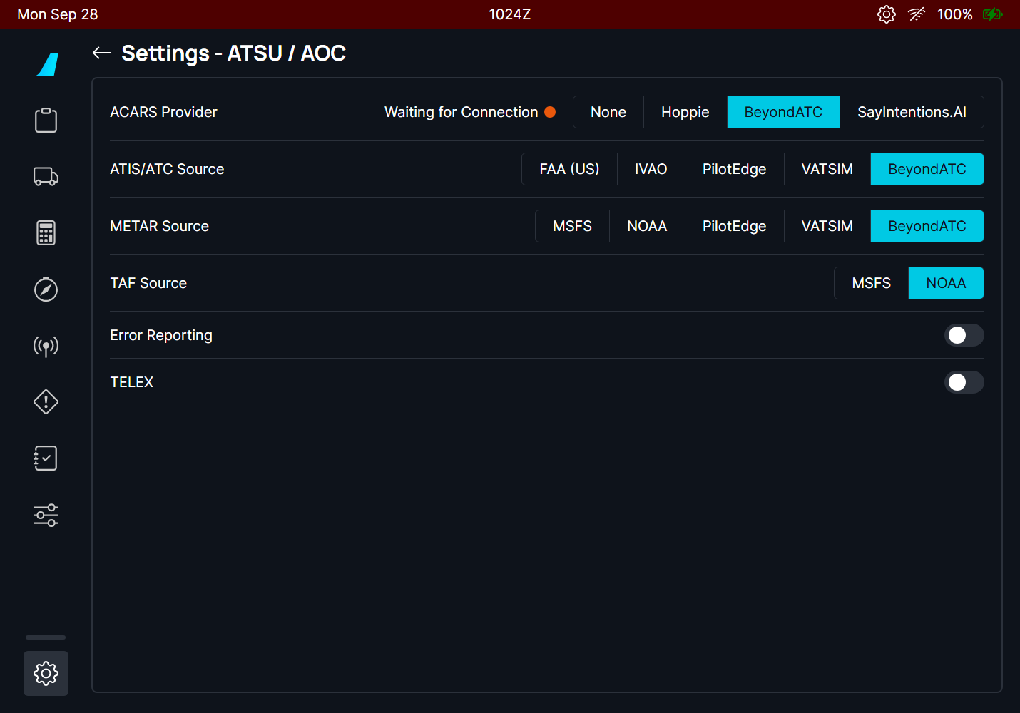
Figure 196. ACARS Provider: BeyondATC, "Waiting for Connection" until BeyondATC answers (then "Connected", green).

2. What happens now
- Start the provider when you like. The aircraft looks for it every 5 s for 5 minutes, then once a minute, without end. Your provider, ATIS and METAR settings are never changed.
- Flight number. Entered before the provider answers, it is connected as soon as it answers.
- Provider closed. Within about a minute the status goes back to "Waiting for Connection"; start it again and the aircraft connects your flight number again by itself. With BeyondATC, log on to the ATC center again (it forgets the logon when it closes).
- TELEX on. If FBW's TELEX service refuses your flight number, the ACARS provider is connected anyway (on the A380X, the FMS shows FMS DATALINK NOT AVAIL for the TELEX failure).

3. What to expect
- No extra traffic with Hoppie: once your flight number is connected, the regular polls (every 45 to 75 s) check the provider.
- Before this change, a provider started more than 5 minutes after the aircraft set the flyPad to NONE: select your provider again once if it shows NONE.

PR 30 - FIRE TEST extended after the button release
A flyPad option on both aircraft: the FIRE TEST goes on for 7 seconds after you release the button, so you can check every warning and light without holding it
Aircraft | A32NX and A380X
Where to find it | flyPad > Settings > Realism: "Extend Fire Test Warnings After Button Release"
PR branch | pr/30-fire-test-extension
Status | A32NX tested in the sim (2026-09-17); A380X tested in the sim by the user: OK (2026-09-29).
Pictures | flyPad page (A380X) in the local browser harness, running the build installed in the sim.

1. What it is for
On the aircraft, the FIRE TEST lasts as long as the button is held. In the simulator, holding the button with the mouse while looking at the ECAM, the master warning and every FIRE and AGENT light is awkward. This option keeps the test running for 7 seconds after you release the button. It is marked unrealistic and is on by default.
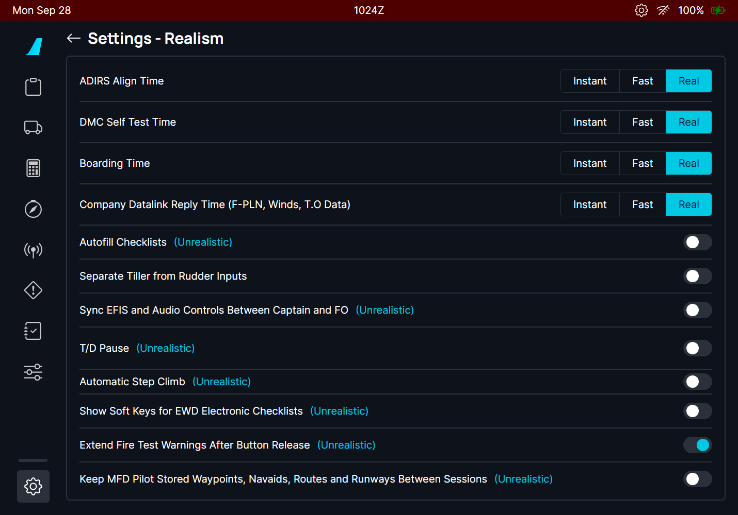
Figure 197. Settings > Realism on the A380X: "Extend Fire Test Warnings After Button Release".

2. What it does
Aircraft | Test | Kept 7 s after the release
A32NX | APU, ENG 1 and ENG 2 FIRE TEST pushbuttons | master warning and CRC, ECAM, FIRE pushbutton lights, AGENT / SQUIB DISCH lights, together
A380X | FIRE TEST pushbutton (overhead) | the fire detection test itself: FIRE lights, squib lights and the FWS warnings, together

Option off: the test stops the instant you release the button, as on the aircraft.

3. What to expect
- The test starts half a second after you press (A380X), as before.
- Pressing again during the 7 seconds starts a new 7 seconds after the next release.
- The A380X systems host and fire protection system changed: a full MSFS restart after an update.

PR 31 - A380X Standby Navigation Display (SND)
The lower ISIS as the A380 standby navigation display: heading, track, ground speed and position, a waypoint list with DIR TO, and a FIX
Aircraft | A380X
Where to find it | Centre instrument panel, the lower ISIS (under the standby flight display)
PR branch | pr/31-a380x-isis-snd
Status | Tested in the sim by the user: OK (2026-09-29).
Pictures | The SND instrument in the local browser harness, running the build of the branch, with ADIRU data typed in (the harness has no aircraft).

1. What it is for
The A380 has two ISIS (integrated standby instrument systems): the upper one is the Standby Flight Display (SFD: attitude, speed, altitude), the lower one the Standby Navigation Display (SND): heading, position and a small navigation of its own, independent of the FMS (A380 FCOM DSC-34-10-20). On the FBW A380 the lower screen was black; it is now the SND.

2. The screen
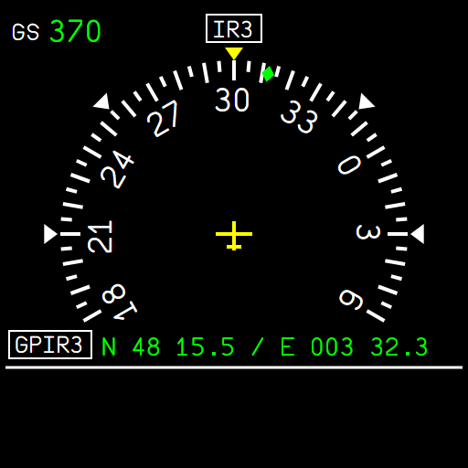
Figure 198. The SND: ground speed, heading source IR3, heading rose with the yellow heading index and the green track diamond, aircraft symbol, position from ADIRU 3.
Item | Meaning
GS 370 | ground speed, kt
IR3 | the heading comes from ADIRU 3 (IR1 when ADIRU 3 has none); TRU in cyan in true reference
Heading rose | 240° shown, a mark every 5°, numbers every 30°; white markers at 45° and 90°
Green diamond | the aircraft track
GPIR3 N 48 15.5 / E 003 32.3 | the aircraft position (degrees and minutes) and its source
HDG, PPOS (amber) | heading or position not available

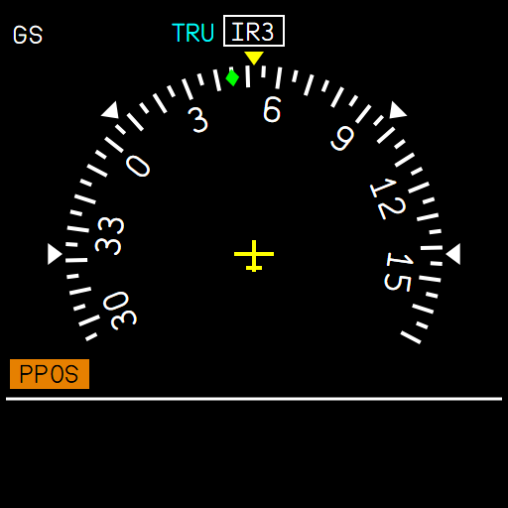  Figure 199. True reference (TRU), no position (PPOS), no ground speed. | 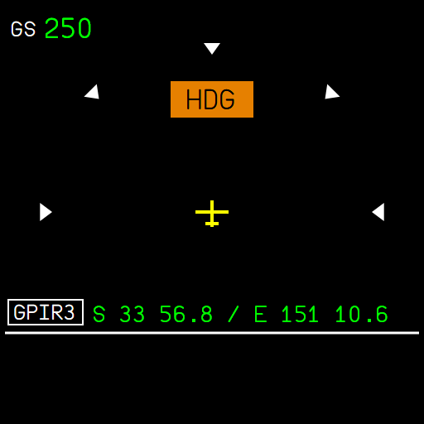  Figure 200. No heading from either ADIRU: HDG replaces the rose.

3. Buttons
Button | Action
MODE | switches the SND off, and on again
+ / - | brightness
MENU | opens the menu under the white line; press again to leave it
SET/SEL knob | turn: next item or value; push: select, or go to the next field
LS/DIR TO | DIR TO (see below); press again to leave it

4. The waypoint list
The SND has its own list of waypoints, entered by coordinates (it has no database). Press MENU: the menu shows INSERT WPT, INSERT FIX, EDIT WPT / FIX and CLEAR WPT / FIX in cyan; turn the knob to choose, push to select.
- MENU, then push on INSERT WPT: the coordinates show, starting from the last waypoint (or your position).
- Turn the knob to change the underlined field, push to go to the next one: N/S, degrees, minutes, tenths, then E/W, degrees, minutes, tenths.
- Push on the last field: the waypoint is added at the end of the list.
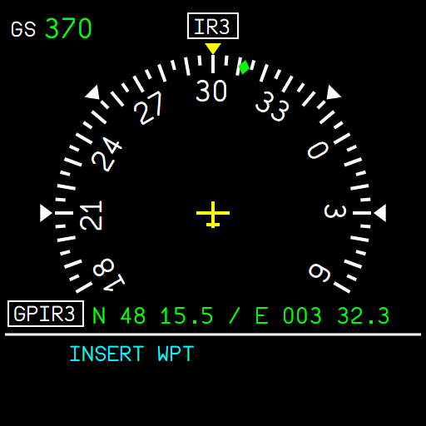  Figure 201. The menu: INSERT WPT. | 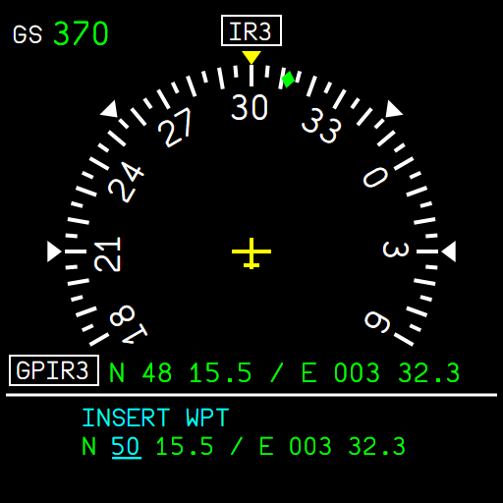  Figure 202. Entering the coordinates: the degrees of latitude being set.

EDIT and CLEAR WPT / FIX: turn to choose the waypoint ("2/3 N5015/E00232", then the FIX last), push to edit or to delete it.

5. DIR TO and the navigation
- Press LS/DIR TO. With a list, turn to choose the waypoint and push. Without a list, enter the coordinates of the point as above.
- The navigation starts from your position: FROM, TO (white) and NEXT under the line, the bearing and distance to the TO waypoint top right, and the course on the rose.
- Passing abeam the TO waypoint, the SND goes on to the next one.
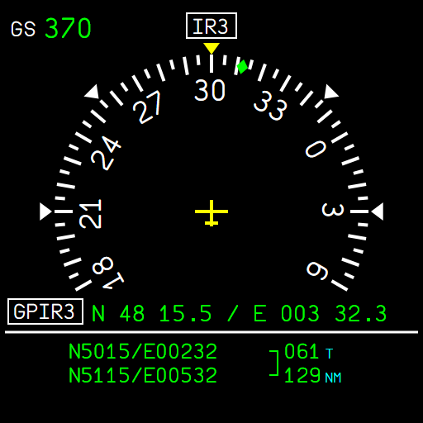  Figure 203. Two waypoints, navigation not active: the true bearing and distance between them. | 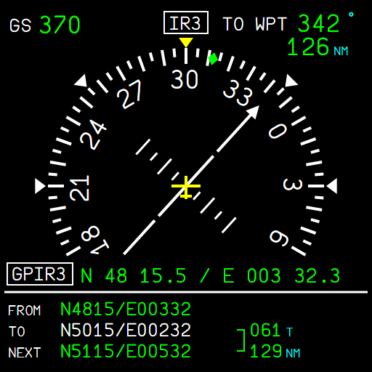  Figure 204. After DIR TO: FROM / TO / NEXT, TO WPT 342° 126 NM, the course arrow.

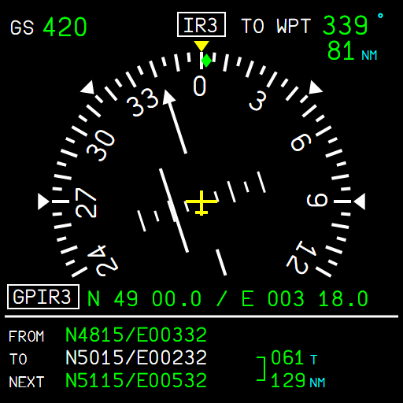
Figure 205. About 5 NM right of the track: the deviation bar one large mark left of the aircraft (large marks every 5 NM, small every 2.5 NM).

6. The FIX
One point you want to watch (a beacon, an airport): MENU, INSERT FIX, enter its coordinates. The SND shows its distance top left, a magenta pointer towards it on the rose, and its coordinates in magenta at the bottom of the list. A new FIX replaces the old one; EDIT / CLEAR WPT / FIX offer it after the waypoints.
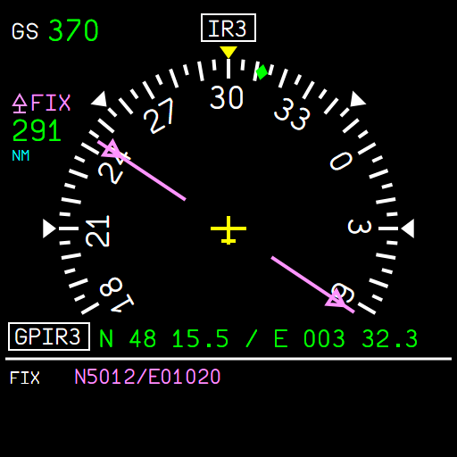  Figure 206. A FIX alone: 291 NM, bearing 060°. | 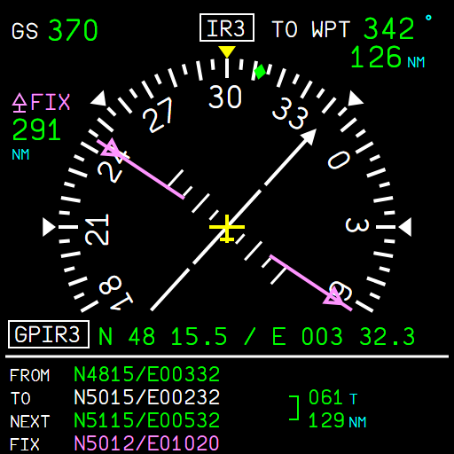  Figure 207. The FIX together with a DIR TO: FROM / TO / NEXT / FIX.

7. Limitations and why
Limitation | Why
MODE only switches the SND off and on | the swap of the SFD and the SND between the two ISIS is not done yet
The list is lost when the flight is reloaded | the ISIS keeps it while it runs
Position source always GPIR | the FBW ADIRS has no separate GPS / IRS positions yet
Coordinate entry, 10 waypoints at most, sequencing abeam | the FCOM figures of these procedures stop at the first frame: this is our reading

