**Table of Contents for Air Compliance Standard Operating Procedure (SOP)**

1. **Introduction**
   * Purpose of the SOP
   * Scope and Applicability
   * Regulatory Framework (EPA, TCEQ, and International Standards)
   * Roles and Responsibilities
2. **Definitions and Acronyms**
   * Key Terminology in Air Compliance
   * Acronyms Used in the Document
3. **Regulatory Overview**
   * Overview of Applicable Air Quality Regulations
   * Federal Requirements (Clean Air Act, Title V, NSPS, NESHAP, etc.)
   * Texas-Specific Requirements (TCEQ Guidelines and Permitting)
   * International Standards (ISO 14001)
4. **Emission Sources**
   * Identification of Emission Sources (Point Sources, Fugitives, Mobile Sources)
   * Types of Pollutants (Criteria Pollutants, HAPs, GHGs)
   * Permitted vs. Non-Permitted Sources
5. **Monitoring and Recordkeeping**
   * Continuous Emissions Monitoring Systems (CEMS)
   * Operational Logs and Maintenance Records
   * Data Management and Reporting Tools
   * Retention Periods and Access Control
6. **Compliance Assurance and Permitting**
   * Air Permitting Process
   * Title V Permit Requirements
   * Nonattainment Area Considerations
   * Renewal and Modification Procedures
7. **Inspections and Audits**
   * Internal Inspection Protocols
   * Third-Party Audit Guidelines
   * Addressing Findings and Corrective Actions
   * TCEQ and EPA Inspections: Preparation and Response
8. **Emissions Calculations**
   * Emission Factor Usage and Sources (AP-42, Vendor Data, Stack Tests)
   * Calculation Methods for Criteria Pollutants, HAPs, and GHGs
   * Reporting Units (Tons/Year, lbs/hr, etc.)
   * Tools and Software (e.g., EPA’s TANKS, AERMOD)
9. **Reporting Requirements**
   * Federal Reporting (e.g., TRI, EIS, GHG Reporting under Subpart C)
   * State Reporting (TCEQ Emissions Inventory, Air Quality Reporting)
   * Deadlines and Submission Processes
   * Communication with Agencies
10. **Control Technologies and Mitigation**
    * Best Available Control Technology (BACT)
    * Control Devices (Scrubbers, Baghouses, Catalytic Converters)
    * Leak Detection and Repair (LDAR) Programs
    * Fugitive Emissions Management
11. **Emergency Response and Incident Management**
    * Emergency Notification Requirements
    * Response Procedures for Excess Emissions and Upset Events
    * Root Cause Analysis and Incident Documentation
    * Mitigation and Follow-Up Actions
12. **Training and Competency**
    * Required Training for Air Compliance Staff
    * Documentation of Training Records
    * Continuous Improvement and Knowledge Updates
13. **Stakeholder Communication**
    * Community Right-to-Know Requirements
    * Managing Public Inquiries
    * Coordination with Neighboring Facilities
14. **Performance Metrics and Continuous Improvement**
    * Key Performance Indicators (KPIs) for Air Compliance
    * Root Cause Analysis for Non-Compliance Events
    * Continuous Improvement Initiatives
15. **Document Control and Updates**
    * Version History and Approval Process
    * SOP Review Schedule
    * Distribution and Accessibility
16. **Appendices**
    * Detailed Emission Calculation Examples
    * Permitting Flowcharts
    * Contact List for Regulatory Agencies
    * Reference Materials (Regulatory Documents, Tools, and Guidelines)

Calculations

1. Emission Calculations

1. Criteria Pollutant Emissions
2. Greenhouse Gas (GHG) Emissions
3. Fugitive Emissions

|  |  |
| --- | --- |
|  |  |
|  |  |
|  | |

**2. Permitted vs. Actual Emissions**

|  |  |
| --- | --- |
|  |  |

**3. Continuous Emissions Monitoring Systems (CEMS)**

1. Emission Rate (lbs/hour):
2. Rolling Average Emissions (24-hour or 12-month):

|  |  |
| --- | --- |
|  |  |
|  | |

4. Fuel Consumption and Heat Input

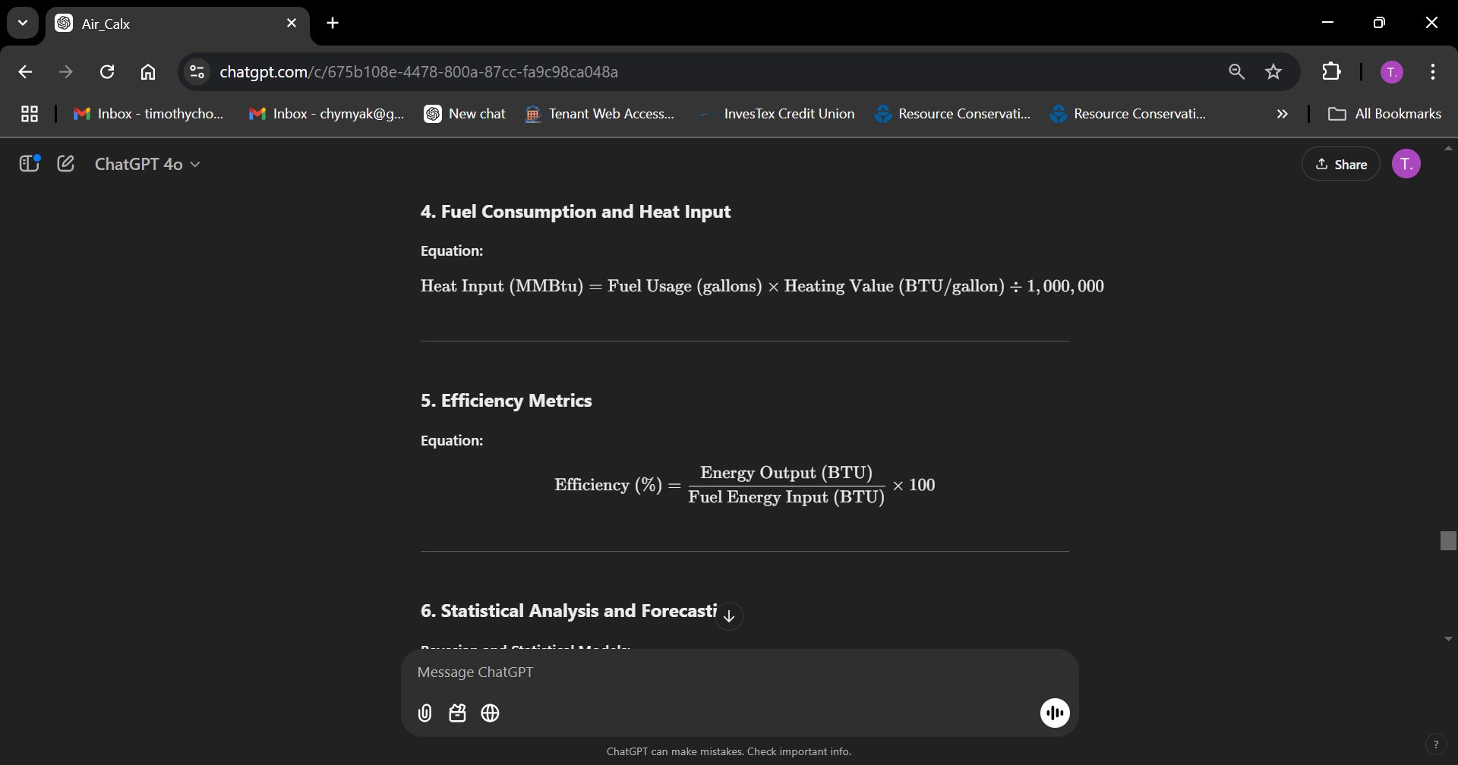

1. Efficiency Metrics



6. Statistical Analysis and Forecasting

Bayesian and Statistical Models:

1. Emission Trends:
   * Use regression models to predict future emissions based on historical data.
2. Anomaly Detection:
   * Leverage Bayesian statistics or outlier detection to identify unexpected spikes in emissions.

7. Air Dispersion Modeling (AERMOD Integration)

|  |  |
| --- | --- |
|  |  |

8. Leak Detection and Repair (LDAR) Metrics

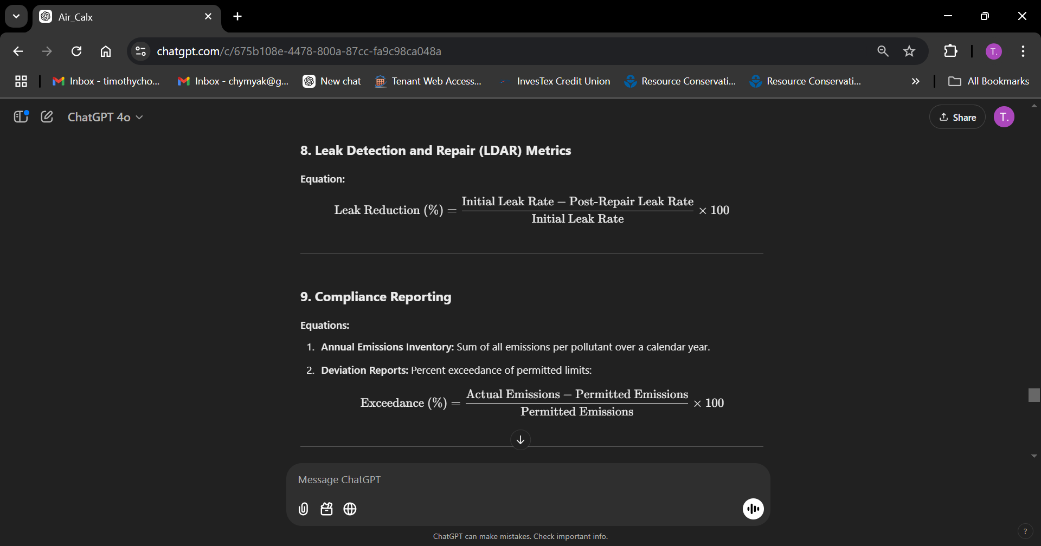

9. Compliance Reporting

1. Annual Emissions Inventory: Sum of all emissions per pollutant over a calendar year.
2. Deviation Reports: Percent exceedance of permitted limits:



10. Key Performance Indicators (KPIs)

1. Compliance Rate (%):
2. Emission Reduction (%):

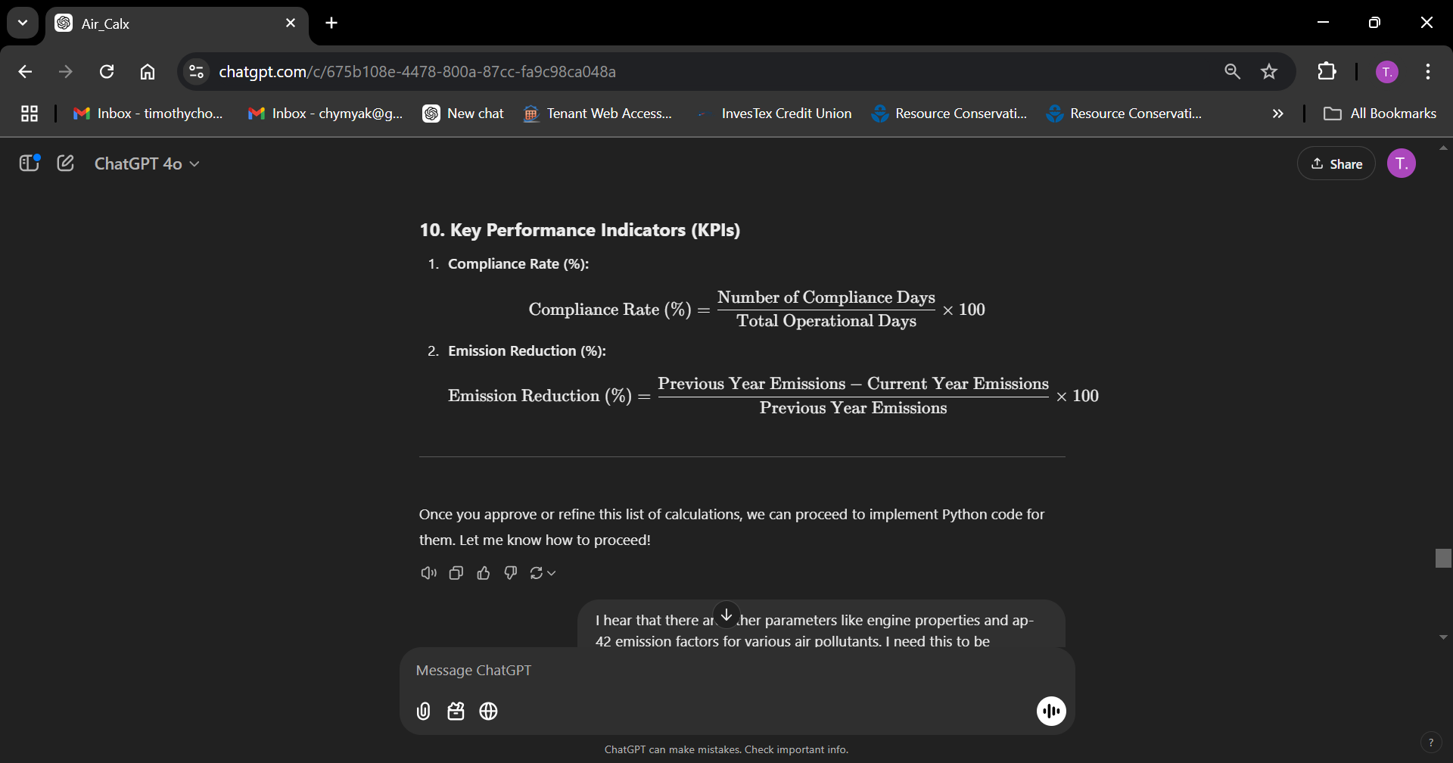

Supplemental Information

**1. General Parameters**

| **Parameter** | **Description** | **Unit** | **Source** |
| --- | --- | --- | --- |
| Fuel Usage | Amount of fuel consumed by the equipment. | Gallons or MMBtu | Operational Logs |
| Heating Value (HHV) | Energy content of the fuel. | BTU/gallon or MMBtu/unit | AP-42, Fuel Supplier SDS |
| Operating Hours | Total hours of operation during a reporting period. | Hours | Operational Logs |
| Flow Rate | Volumetric flow rate from stack or exhaust system. | SCFM | CEMS, Stack Testing |
| Concentration of Pollutants | Measured pollutant concentrations. | ppm | CEMS, Stack Testing |

**2. Fuel-Specific Parameters**

| **Fuel Type** | **Heating Value (HHV)** | **Sulfur Content** | **Common Emission Factors (AP-42)** |
| --- | --- | --- | --- |
| Diesel (#2) | 137,000 BTU/gallon | 0.0015 (ULSD) | NOx, CO, SO₂, PM, VOC |
| Natural Gas | 1,020 BTU/SCF | Negligible | NOx, CO, SO₂, PM, VOC |
| Propane | 91,500 BTU/gallon | Negligible | NOx, CO, SO₂, PM, VOC |
| Isopropyl Alcohol (IPA) | 84,000 BTU/gallon | Negligible | Custom Vendor Data |

**3. Equipment-Specific Properties**

**For Boilers:**

| **Property** | **Description** | **Unit** | **Source** |
| --- | --- | --- | --- |
| Heat Input Capacity | Maximum heat input to the boiler. | MMBtu/hr | Manufacturer Specs |
| Efficiency | Ratio of energy output to input. | Percentage (%) | Performance Reports |

**For Engines (e.g., Stationary Engines):**

| **Property** | **Description** | **Unit** | **Source** |
| --- | --- | --- | --- |
| Horsepower (HP) | Rated engine power. | HP | Manufacturer Specs |
| Load Factor | Percentage of maximum capacity at which the engine operates. | Percentage (%) | Operational Data |
| Fuel Conversion Factor | Energy produced per unit of fuel. | BTU/hp-hr | Manufacturer Specs |

**4. Pollutants and AP-42 Emission Factors**

**Common Air Pollutants:**

| **Pollutant** | **AP-42 Emission Factor (Example for Diesel Combustion)** | **Units** | **Notes** |
| --- | --- | --- | --- |
| NOx (Nitrogen Oxides) | ~0.031 (boilers) / ~0.0315 (engines) | lbs/MMBtu | Based on combustion properties |
| CO (Carbon Monoxide) | ~0.0084 | lbs/MMBtu | Related to incomplete combustion |
| SO₂ (Sulfur Dioxide) | ~0.0000051 | lbs/MMBtu | Depends on sulfur content in fuel |
| PM (Particulate Matter) | ~0.0022 | lbs/MMBtu | Includes filterable and condensable PM |
| VOCs | ~0.000705 | lbs/MMBtu | Volatile Organic Compounds |
| CO₂ | ~163 (diesel) / ~117 (natural gas) | lbs/MMBtu | Greenhouse gas |

**GHG-Specific Data:**

| **Gas** | **Emission Factor (EPA)** | **GWP (AR5)** | **Unit** |
| --- | --- | --- | --- |
| CO₂ | ~163 (diesel) / ~117 (natural gas) | 1.0 | lbs/MMBtu |
| CH₄ (Methane) | ~0.005 / ~0.001 | 28 (100-year) | lbs/MMBtu |
| N₂O (Nitrous Oxide) | ~0.0002 / ~0.0001 | 265 (100-year) | lbs/MMBtu |

**5. CEMS-Specific Parameters**

| **Parameter** | **Description** | **Unit** | **Source** |
| --- | --- | --- | --- |
| Stack Flow Rate | Volumetric flow through the stack. | SCFM | Stack Test, CEMS |
| Pollutant Concentration | Measured concentration of pollutants in exhaust. | ppm | CEMS |
| Moisture Content | Proportion of water vapor in exhaust gas. | Percentage (%) | Stack Test, CEMS |

**6. Operational and Compliance Metrics**

| **Parameter** | **Description** | **Unit** | **Source** |
| --- | --- | --- | --- |
| Permitted Emissions | Regulatory limit for each pollutant. | Tons/year | Title V Permit |
| Actual Emissions | Measured or calculated emissions. | Tons/year | Calculations |
| Utilization Factor | Ratio of actual to permitted emissions. | Percentage (%) | Compliance Reports |

**Quick Reference**

**1. Higher Heating Value (HHV) of Fuels**

* **Diesel Fuel (#2 Distillate):**
  + **HHV:** Approximately 137,000 BTU/gallon.
  + **Source:** EPA's AP-42, Chapter 1, Section 1.3, "Fuel Oil Combustion." [EPA](https://www.epa.gov/air-emissions-factors-and-quantification/ap-42-fifth-edition-volume-i-chapter-1-external-0?utm_source=chatgpt.com)
* **Natural Gas:**
  + **HHV:** Approximately 1,020 BTU/standard cubic foot (scf).
  + **Source:** EPA's AP-42, Chapter 1, Section 1.4, "Natural Gas Combustion." [EPA](https://www.epa.gov/air-emissions-factors-and-quantification/ap-42-fifth-edition-volume-i-chapter-1-external-0?utm_source=chatgpt.com)
* **Propane:**
  + **HHV:** Approximately 91,500 BTU/gallon.
  + **Source:** Engineering ToolBox, "Fuels - Higher and Lower Calorific Values." [Engineering Toolbox](https://www.engineeringtoolbox.com/fuels-higher-calorific-values-d_169.html?utm_source=chatgpt.com)

**2. Sulfur Content in Fuels**

* **Ultra-Low Sulfur Diesel (ULSD):**
  + **Sulfur Content:** 15 parts per million (ppm) or 0.0015% by weight.
  + **Source:** EPA regulations on ULSD standards.

**3. Emission Factors for Combustion Sources**

* **Diesel Engines:**
  + **Nitrogen Oxides (NOₓ):** 0.0315 lbs/MMBtu.
  + **Carbon Monoxide (CO):** 0.00668 lbs/MMBtu.
  + **Particulate Matter (PM):** 0.0022 lbs/MMBtu.
  + **Source:** EPA's AP-42, Chapter 3, Section 3.3, "Gasoline and Diesel Industrial Engines." [EPA](https://www3.epa.gov/ttnchie1/ap42/ch03/final/c03s03.pdf?utm_source=chatgpt.com)
* **Natural Gas Combustion:**
  + **Nitrogen Oxides (NOₓ):** 0.1 lbs/MMscf.
  + **Carbon Monoxide (CO):** 0.084 lbs/MMscf.
  + **Particulate Matter (PM):** 0.0075 lbs/MMscf.
  + **Source:** EPA's AP-42, Chapter 1, Section 1.4, "Natural Gas Combustion." [EPA](https://www.epa.gov/air-emissions-factors-and-quantification/ap-42-fifth-edition-volume-i-chapter-1-external-0?utm_source=chatgpt.com)

**4. Global Warming Potentials (GWPs)**

* **Carbon Dioxide (CO₂):** GWP of 1.
* **Methane (CH₄):** GWP of 25.
* **Nitrous Oxide (N₂O):** GWP of 298.
* **Source:** Intergovernmental Panel on Climate Change (IPCC) Fourth Assessment Report.

**5. Fuel Density**

* **Diesel Fuel:**
  + **Density:** Approximately 7.1 lbs/gallon.
  + **Source:** Engineering ToolBox, "Fuels - Higher and Lower Calorific Values." [Engineering Toolbox](https://www.engineeringtoolbox.com/fuels-higher-calorific-values-d_169.html?utm_source=chatgpt.com)
* **Propane:**
  + **Density:** Approximately 4.24 lbs/gallon.
  + **Source:** Engineering ToolBox, "Fuels - Higher and Lower Calorific Values." [Engineering Toolbox](https://www.engineeringtoolbox.com/fuels-higher-calorific-values-d_169.html?utm_source=chatgpt.com)

**6. Conversion Factors**

* **BTU to MMBtu:** 1 MMBtu = 1,000,000 BTU.
* **Gallons to Pounds (for diesel):** 1 gallon ≈ 7.1 lbs.

These sources provide the foundational data necessary for accurate emissions calculations and compliance reporting. Ensure that all data used in your calculations are current and sourced from reputable references to maintain compliance with regulatory standards.

Air Compliance Reporting

**1. Folder Management System**

Organizing your data and documentation is critical for efficient compliance and auditing.

|  |
| --- |
| Air_Compliance/  ├── Permits/  │ ├── Title_V_Permit.pdf  │ ├── TCEQ_Emissions_Inventory.xlsx  ├── Calculations/  │ ├── Monthly_Reports/  │ │ ├── 2024_01_Emissions.csv  │ │ ├── 2024_02_Emissions.csv  │ ├── Annual_Reports/  │ ├── 2024_Emissions_Summary.xlsx  ├── Monitoring_Data/  │ ├── CEMS/  │ │ ├── 2024_CEMS_January.csv  │ │ ├── 2024_CEMS_February.csv  │ ├── Stack_Tests/  │ ├── Stack_Test_2024.pdf  ├── Python_Scripts/  │ ├── emissions_calculations.py  │ ├── emissions_reporting.py  ├── Logs/  │ ├── Corrective_Actions/  │ │ ├── Action_Log_January2024.xlsx  │ ├── Inspection_Reports/  │ ├── TCEQ_Inspection_February2024.pdf |

**2. Python Framework for Air Compliance**

* Pandas (data manipulation), Numpy (numerical calculations), matplotlib (visualizations), openpyxl (reading/writing Excel files), SQLAlchemy (database integration), scikit-learn or statsmodels (trend analysis and forecasting).

**3. Emissions Calculation Workflow**

**Step 1: Import Data**

* Collect, input, standardize, and clean datasets from multiple sources (i.e., CEMS data, Fuel usage logs, Stack test results)

**Step 2: Perform Emissions Calculations**

* Automate calculations for criteria pollutants and greenhouse gases using AP-42 emission factors.

**Step 3: Generate Reports**

* Summarize emissions by month or year and export to Excel for compliance reporting.

**Step 4: Visualize Trends**

* Use **matplotlib** and **seaborn** to create visualizations for trends and anomalies.

|  |
| --- |
| **# Import and Clean Data**  # Import CEMS data  cems_data = pd.read_csv("Monitoring_Data/CEMS/2024_CEMS_January.csv")  # Import fuel usage logs  fuel_usage = pd.read_excel("Calculations/Monthly_Reports/Fuel_Usage_January2024.xlsx")  # Combine datasets for analysis  df = pd.merge(cems_data, fuel_usage, on="Timestamp", how="inner") |
| **# Perform Emissions Calculations**  # Constants  NOx_FACTOR = 0.0315 # lbs/MMBtu  SO2_FACTOR = 0.0000051 # lbs/MMBtu  HEATING_VALUE_DIESEL = 137000 # BTU/gallon  # Calculate heat input  df["Heat_Input_MMBtu"] = df["Fuel_Usage_Gallons"] * HEATING_VALUE_DIESEL / 1_000_000  # Calculate emissions  df["NOx_Emissions_lbs"] = df["Heat_Input_MMBtu"] * NOx_FACTOR  df["SO2_Emissions_lbs"] = df["Heat_Input_MMBtu"] * SO2_FACTOR |
| **# Generate Reports**  # Monthly summary  monthly_summary = df.groupby("Month")[["NOx_Emissions_lbs", "SO2_Emissions_lbs"]].sum()  # Export to Excel  monthly_summary.to_excel("Calculations/Monthly_Reports/2024_01_Emissions_Summary.xlsx", engine="openpyxl") |
| **# Visualize Trends**  # Plot emissions trends  sns.lineplot(data=df, x="Date", y="NOx_Emissions_lbs", label="NOx Emissions")  plt.title("NOx Emissions Over Time")  plt.xlabel("Date")  plt.ylabel("Emissions (lbs)")  plt.legend()  plt.show() |
| **# Anomaly Detection with Python**  from sklearn.ensemble import IsolationForest  # Train anomaly detection model  model = IsolationForest(contamination=0.05)  df["Anomaly"] = model.fit_predict(df[["NOx_Emissions_lbs", "SO2_Emissions_lbs"]])  # Highlight anomalies  anomalies = df[df["Anomaly"] == -1]  print("Detected Anomalies:")  print(anomalies) |

**4. Compliance Monitoring and Alerts**

**Anomaly Detection with Python:**

* Use statistical models to detect deviations in emissions trends.

**5. Task Automation and Scheduling**

**Automate Periodic Tasks:**

* Use **Task Scheduler** (Windows) or **cron jobs** (Linux) to:
  + Run Python scripts for monthly calculations.
  + Generate and email compliance reports.

**6. Version Control and Collaboration**

**Use Git:**

* Manage Python scripts and calculation templates in a Git repository.
* Collaborate with team members using platforms like GitHub.

**7. Recommended Enhancements**

* **Database Integration:** Use SQL databases (e.g., PostgreSQL) to store and query monitoring data.
* **Dashboard:** Build an interactive dashboard using **Dash** or **Power BI** to track compliance metrics in real-time.
* **Machine Learning:** Apply predictive models to forecast emissions and plan corrective actions.

Datasets

**1. Fuel Usage Dataset**

**Purpose:** Track fuel consumption for calculating heat input and emissions.

| **Column Name** | **Description** | **Example** |
| --- | --- | --- |
| Date | Date of fuel usage | 2024-01-01 |
| Fuel_Type | Type of fuel used | Diesel |
| Usage_Gallons | Quantity of fuel consumed (gallons) | 1500 |
| Heating_Value_BTU | HHV of the fuel (BTU/gallon) | 137000 |
| Sulfur_Content | Fuel sulfur content (wt %) | 0.0015 |

**2. Continuous Emissions Monitoring System (CEMS) Dataset**

**Purpose:** Monitor real-time pollutant concentrations and flow rates.

| **Column Name** | **Description** | **Example** |
| --- | --- | --- |
| Timestamp | Date and time of reading | 2024-01-01 08:00 |
| Pollutant | Pollutant measured | NOx |
| Concentration_ppm | Concentration of pollutant (ppm) | 15 |
| Stack_Flow_Rate | Volumetric flow rate (scfm) | 2500 |
| Temperature_F | Stack gas temperature (°F) | 300 |

**3. Stack Test Results Dataset**

**Purpose:** Validate and calibrate emission factors and permit limits.

| **Column Name** | **Description** | **Example** |
| --- | --- | --- |
| Test_Date | Date of stack test | 2024-01-15 |
| Pollutant | Pollutant tested | SO₂ |
| Measured_Emission_Rate | Emission rate during test (lbs/hr) | 1.5 |
| Permitted_Emission_Rate | Permitted rate (lbs/hr) | 2.0 |
| Test_Method | Testing method used (e.g., EPA Method 5) | EPA Method 5 |

**4. Emission Factors Dataset**

**Purpose:** Provide emission factors for calculations based on fuel type, equipment, and pollutants.

| **Column Name** | **Description** | **Example** |
| --- | --- | --- |
| Fuel_Type | Type of fuel | Diesel |
| Equipment_Type | Type of equipment | Boiler |
| Pollutant | Pollutant emitted | NOx |
| Emission_Factor | Emission factor (lbs/MMBtu) | 0.0315 |
| Source | Source of emission factor | AP-42 Section 1.3 |

**5. Permitting Data Dataset**

**Purpose:** Manage permit limits and operational thresholds.

| **Column Name** | **Description** | **Example** |
| --- | --- | --- |
| Permit_ID | Unique identifier for the permit | TX-123456 |
| Pollutant | Pollutant covered by the permit | CO |
| Permitted_Emission_Rate | Maximum allowable emissions (lbs/hr) | 5.0 |
| Averaging_Period | Averaging period for compliance | 1 hour |

**6. Meteorological Data Dataset**

**Purpose:** Support dispersion modeling and assess weather-related impacts.

| **Column Name** | **Description** | **Example** |
| --- | --- | --- |
| Timestamp | Date and time of reading | 2024-01-01 08:00 |
| Wind_Speed_mph | Wind speed at stack location | 15 |
| Wind_Direction_Degrees | Direction of wind | 270 (west) |
| Ambient_Temperature_F | Ambient temperature | 75 |
| Humidity_Percentage | Relative humidity | 40 |

**7. Compliance Monitoring Dataset**

**Purpose:** Track compliance status and exceedances.

| **Column Name** | **Description** | **Example** |
| --- | --- | --- |
| Date | Date of compliance check | 2024-01-01 |
| Pollutant | Pollutant being monitored | VOC |
| Measured_Emissions | Actual emissions (lbs/hr) | 1.2 |
| Compliance_Status | Compliance with permitted limits | In Compliance |
| Notes | Additional information | N/A |

**8. Corrective Action Dataset**

**Purpose:** Document and manage actions taken for non-compliance or maintenance issues.

| **Column Name** | **Description** | **Example** |
| --- | --- | --- |
| Action_Date | Date of corrective action | 2024-01-10 |
| Issue_Description | Description of the issue | Exceedance of NOx limits |
| Corrective_Action | Action taken to resolve the issue | Adjusted combustion parameters |
| Resolution_Status | Status of resolution | Resolved |

**9. Annual Emissions Inventory Dataset**

Purpose: Summarize annual emissions for regulatory reporting.

| **Column Name** | **Description** | **Example** |
| --- | --- | --- |
| Year | Reporting year | 2024 |
| Pollutant | Pollutant emitted | NOx |
| Annual_Emissions_Tons | Total annual emissions (tons/year) | 15.6 |
| Equipment_ID | Equipment contributing to emissions | Boiler-01 |
| Compliance_Status | Compliance with annual permit limits | In Compliance |

**1. Water Compliance**

**Groundwater Flow and Contaminant Transport**

* **Piezometers or Monitoring Wells**: Measure hydraulic head (hhh) to calculate groundwater gradients.
* **Slug Test Equipment**: Evaluate hydraulic conductivity (kkk).
* **Water Sampling Kits**: Collect samples for pollutant concentration (CCC) analysis.
* **Gas Chromatography-Mass Spectrometry (GC-MS)**: Identify and quantify contaminants (e.g., VOCs, metals).
* **Flow Meters**: Measure groundwater velocity (uuu) in remediation systems.
* **Turbidity Sensors**: Monitor sediment concentration and movement in water bodies.

**Wastewater Treatment and Sedimentation**

* **Particle Size Analyzers**: Determine particle sizes for sedimentation modeling.
* **Viscometers**: Measure fluid viscosity (μ\muμ) for Stokes' Law calculations.
* **Automated Water Quality Monitors**: Provide real-time data on parameters like pHpHpH, dissolved oxygen (DO), and nutrient levels.

**2. Air Compliance**

**Atmospheric Dispersion Modeling**

* **Meteorological Towers**: Measure wind velocity (ux,uy,uzu_x, u_y, u_zux​,uy​,uz​) and atmospheric stability.
  + Instruments: Anemometers, wind vanes, and sonic anemometers.
* **Ambient Air Quality Monitors**: Measure pollutant concentrations (CCC) in real-time.
  + Example: NOx, SOx, and particulate matter monitors.
* **Emission Stack Monitors**: Collect data on emissions velocity, temperature, and composition.
  + Instruments: Continuous Emission Monitoring Systems (CEMS).
* **LIDAR (Light Detection and Ranging)**: Remote sensing for mapping pollutant dispersion.

**Chemical Kinetics for Combustion**

* **Gas Analyzers**: Measure concentrations of combustion byproducts like CO, CO2, and VOCs.
  + Example: Fourier Transform Infrared (FTIR) Spectroscopy.
* **Thermocouples**: Monitor temperature in combustion systems.
* **Mass Flow Meters**: Measure fuel and oxidant flow rates for reaction modeling.

**3. RCRA Compliance**

**Hazardous Waste Decay and Leachate**

* **Leachate Collection Systems**: Gather leachate samples for analysis.
* **Ion Chromatography (IC)**: Detect ionic species in leachate (e.g., nitrate, sulfate).
* **Spectrophotometers**: Measure chemical concentrations through UV/visible light absorption.
* **pH and Conductivity Probes**: Monitor basic leachate properties.

**Contaminant Decay**

* **High-Performance Liquid Chromatography (HPLC)**: Analyze the degradation of complex organic compounds.
* **Isotopic Analyzers**: Evaluate radionuclide decay for radioactive waste.

**4. Waste Management/Shipping**

**Transportation Emissions**

* **GPS-Integrated Emission Trackers**: Monitor vehicle emissions and fuel consumption.
  + Example: Portable Emission Measurement Systems (PEMS).
* **Vehicle Diagnostic Tools**: Provide engine performance data for Newtonian motion modeling.

**Cross-Cutting Instrumentation**

**Multi-Parameter Monitoring**

* **Remote Sensing Devices**: Satellite or drone-mounted sensors for large-scale environmental data collection.
* **Data Loggers**: Collect time-series data for temperature, flow, or chemical concentrations.

**Data for Numerical Models**

* **Geophysical Survey Equipment**: Ground-penetrating radar and electrical resistivity for subsurface modeling.
* **Thermal Cameras**: Detect heat emissions from combustion or leachate systems.
* **Lab-Grade Analytical Instruments**:
  + Inductively Coupled Plasma Mass Spectrometry (ICP-MS): Analyze metals in air, water, or waste.
  + Total Organic Carbon (TOC) Analyzers: Assess organic content in water samples.

**Advanced Needs**

* **Computational Models**: While not instrumentation, these require high-quality data inputs.
  + Example: COMSOL, FLUENT, or Python-based models like OpenFOAM for fluid dynamics.

**Integrating Data**

To optimize the use of this instrumentation:

1. **Centralized Data Management**: Use a data logger or SCADA (Supervisory Control and Data Acquisition) system to consolidate readings.
2. **Python Integration**: Import instrument data directly into Python for analysis using libraries like pandas, numpy, and matplotlib.
3. **Calibration Standards**: Ensure all instruments are calibrated to recognized standards (e.g., NIST) for regulatory compliance.