CHAPTER FOUR
SYSTEM IMPLEMENTATION AND DOCUMENTATION

4.0 Introduction
This chapter describes how NaijaTax Enlighten was built. The application helps Nigerian workers and small business owners understand the Nigeria Tax Act (NTA) 2025 and work out how much tax they owe. The chapter begins with the reasons behind the choice of development environment. It then presents the implementation architecture, the program modules, the input and output formats, the flow of information and data through the system, and screenshots of the working application. The testing procedures follow, and the chapter closes with the system documentation: the data dictionary, the user manual and the source code listing.

4.1 Choice of Development Environment
Choosing the right platform, tools and programming languages makes a project easier to build and maintain, while a poor choice can stall it entirely. Three requirements shaped the choices made for this project. First, the application had to run on Android, iOS and the web, since most of its intended users go online through their phones. Second, it had to produce accurate financial results and keep user data secure. Third, it had to be inexpensive to host without compromising on reliability.

4.1.1 System Platform
The system was developed on a laptop running Windows 10 Pro (64-bit) with 8 GB of RAM. Table 4.1 lists the platforms on which the finished system runs.
Table 4.1: System platform and requirements
Component | Platform / Requirement
Development computer | Windows 10 Pro (64-bit), 8 GB RAM, at least 20 GB of free disk space
Mobile app | Android 7.0 or later; iOS 13 or later
Web app | Any modern browser (Chrome, Safari, Edge or Firefox) on a phone or computer
Application server | Node.js 20 on Render (a cloud hosting service)
Database and sign-in | PostgreSQL database and Supabase Auth on Supabase
Network | An internet connection for signing in, calculations and AI features

4.1.2 Integrated Development Environment and Tools
Visual Studio Code was the main IDE. With its Flutter, Dart and Prisma extensions it provided code completion, debugging and hot reload, which shows code changes in the running app within seconds. The Android SDK, installed through Android Studio, supplied the emulator and the tools for building the Android package (APK), while Xcode is needed for iOS builds. Git and GitHub were used for version control, and GitHub Actions checked the code automatically after every update. The diagrams in this chapter were drawn with draw.io.

4.1.3 Choice of Programming Languages
Dart, with Google's Flutter framework (version 3.44), was used for the user-facing application. Flutter compiles one set of source code into an Android app, an iOS app and a web app, so the same features did not have to be written three times. It also gives precise control over how screens adapt to phones, tablets and desktop browsers.
TypeScript, running on Node.js with the Express framework, was used for the server. TypeScript checks data types before the code runs, which matters in tax calculations where a mistyped value can quietly produce a wrong amount. Node.js handles many requests at once efficiently, which suits a server that also waits on outside services for AI answers and news.
PostgreSQL was chosen as the database and is accessed through the Prisma library. PostgreSQL stores money in an exact decimal format, so naira amounts are never affected by rounding errors. Prisma builds safe database queries from a single schema file and keeps a history of every change to the database structure. Table 4.2 summarises the tools used.
Table 4.2: Languages, frameworks and key libraries
Layer | Technology | Purpose
Client | Dart, Flutter 3.44 | User interface for Android, iOS and the web
Client | Riverpod, go_router, Dio | App state, navigation between screens, server requests
Client | Hive, fl_chart, pdf | Storage on the device, charts and PDF reports
Server | TypeScript, Node.js 20, Express | REST API and business logic
Server | Zod, Helmet, rate limiting | Input checking and protection against abuse
Server | Google Gemini (Groq as backup) | Answers for the AI tax assistant
Database | PostgreSQL, Prisma | Data storage and access
Sign-in | Supabase Auth | Email, phone and Google sign-in
Testing | Vitest, flutter analyze, GitHub Actions | Automated tests and code checks

4.2 Implementation Architecture

4.2.1 System Architecture
The system uses a three-tier architecture made up of a presentation tier, a middle tier and a data tier, as shown in Figure 4.1. Because the tiers are separate, each one can be changed or moved to a different host without rewriting the others.
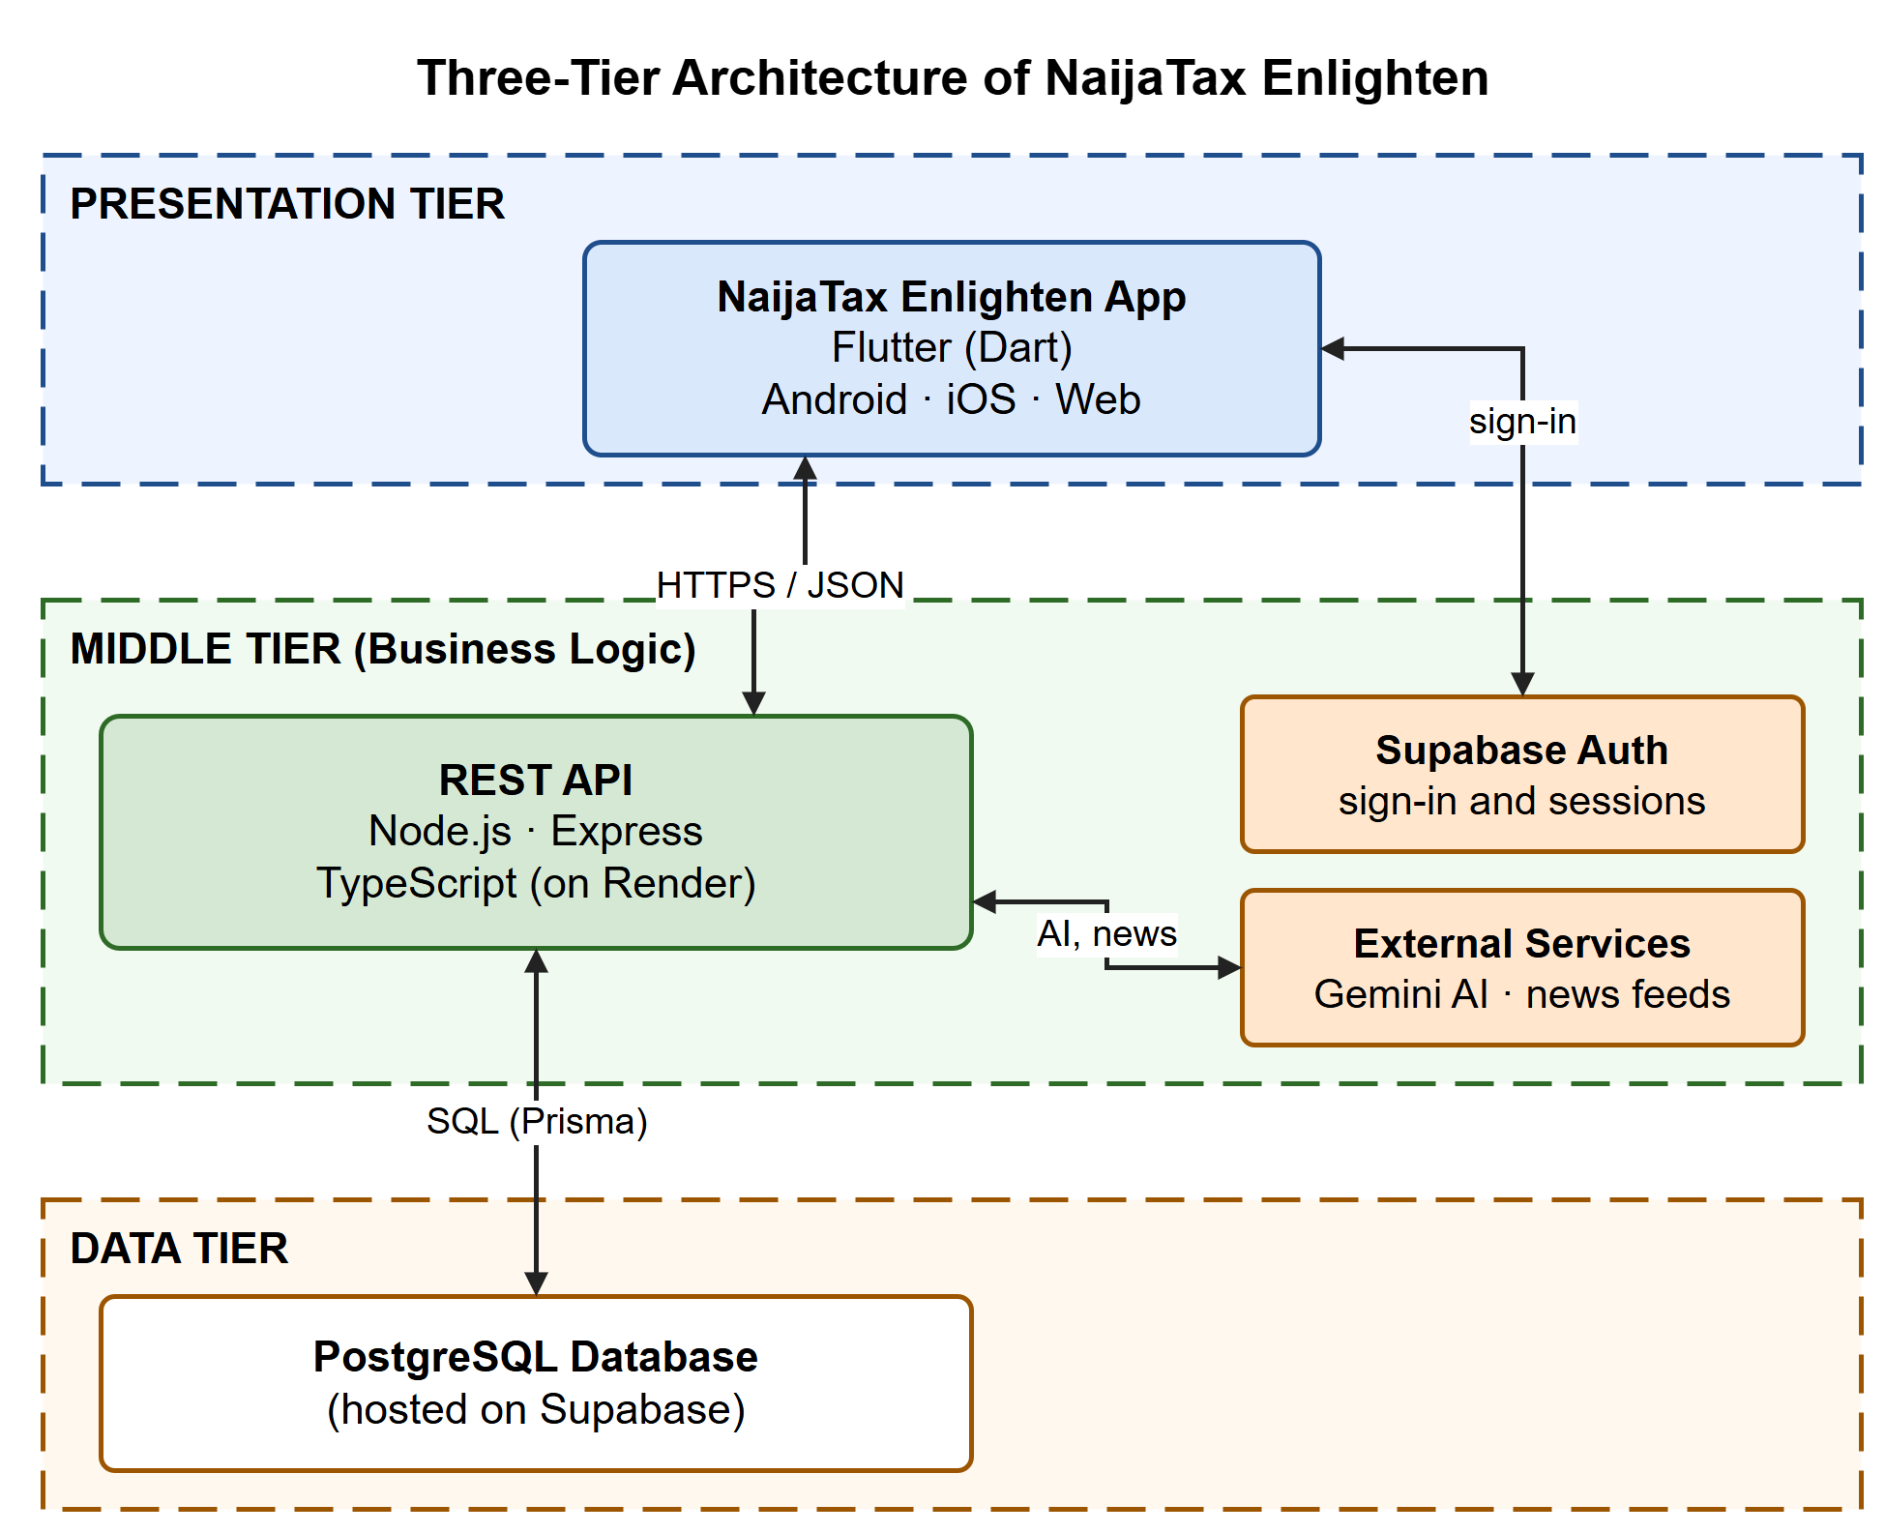
Figure 4.1: Three-tier architecture of NaijaTax Enlighten
- Presentation tier: the Flutter application that users see and use. The same code is built as an Android app, an iOS app and a web app. It talks to the middle tier over a secure (HTTPS) connection, exchanging data in JSON format.
- Middle tier: a REST API written in TypeScript and hosted on Render. It contains the business logic: it confirms who the user is, checks every input, calculates tax under NTA 2025, and runs the AI assistant, forum, quiz, VAT and news features. Sign-in itself is handled by Supabase Auth, and the API calls Google Gemini for AI answers and reads tax news from online feeds.
- Data tier: a PostgreSQL database hosted on Supabase. Only the middle tier can read from or write to it.

4.2.2 Deployment Platform
The system runs entirely on cloud services, listed in Table 4.3. When new code is pushed to the main branch on GitHub, the checks run automatically and the web app and server are redeployed, so the live system always matches the latest source code.
Table 4.3: Deployment platforms
Component | Platform | Notes
Web app | Vercel | Served securely over HTTPS
Android app | Signed APK file | Installed directly on Android phones
REST API | Render | Node.js web service
Database and sign-in | Supabase | PostgreSQL database with email, phone and Google sign-in
Automated checks | GitHub Actions | Runs the type check, unit tests and Flutter analysis after each update

4.2.3 Program Modules
Figure 4.2 shows the program modules and how they are linked. The control centre drives the software. It is the app shell that holds navigation and the user's sign-in state, and it decides which screens a user may open; a guest, for example, can use the calculator but cannot post in the forum. Each module exchanges data with its matching route on the server. Table 4.4 describes what each module does.
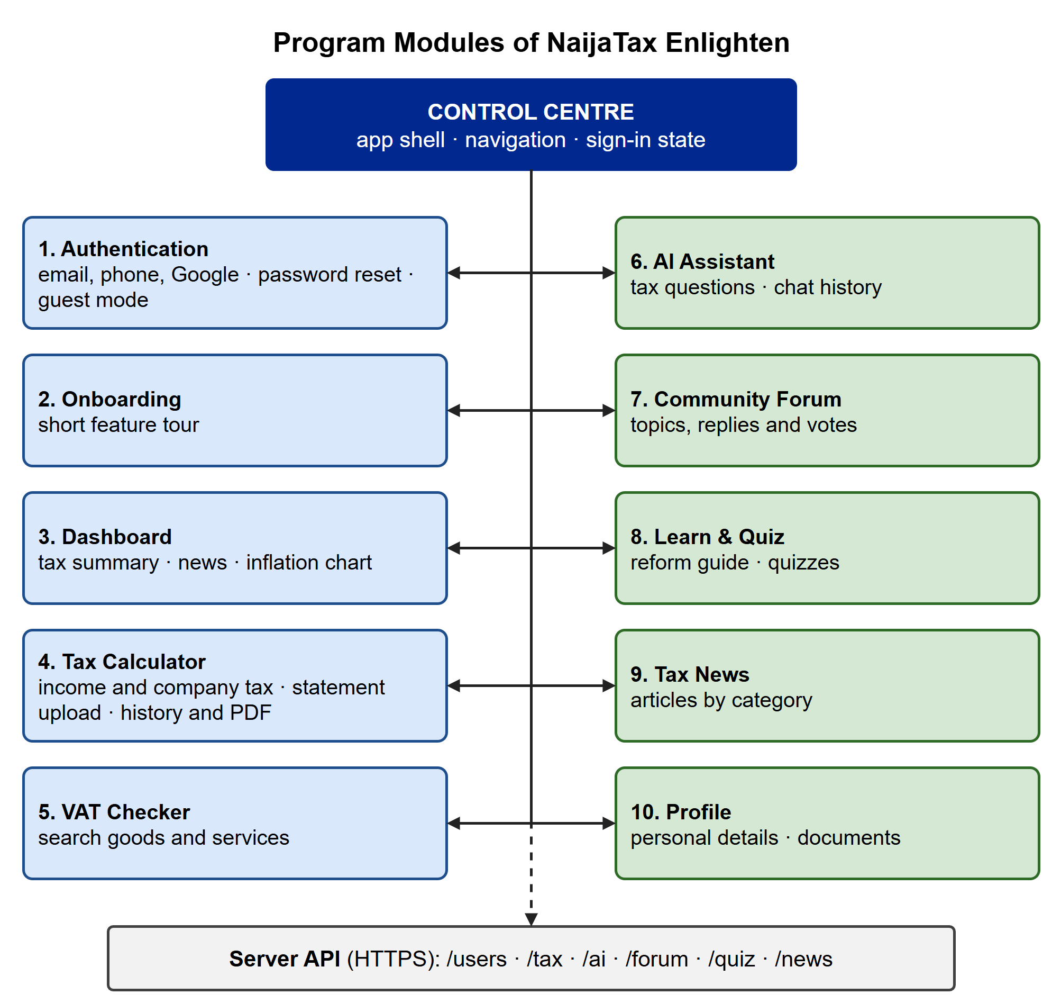
Figure 4.2: Program modules of NaijaTax Enlighten and their linkages
Table 4.4: Description of program modules
Module | Function
Authentication | Signs users up and in by email, phone or Google; resets passwords; allows guest access
Onboarding | Introduces the main features the first time a user signs in
Dashboard | Shows the user's latest tax summary, an inflation chart and recent tax news
Tax Calculator | Calculates personal income tax under NTA 2025, checks company income tax status, reads bank statements, keeps a history and creates PDF reports
VAT Checker | Shows whether a product or service is standard-rated, zero-rated or exempt from VAT
AI Assistant | Answers tax questions in plain language and keeps past conversations
Community Forum | Lets users ask questions, reply, vote and mark the best answer
Learn & Quiz | Explains the tax reform and tests the user's knowledge with quizzes
Tax News | Gathers tax news from Nigerian sources and sorts it by category
Profile | Manages personal details, the profile photo and stored documents

4.2.4 Input and Output Formats
Figure 4.3 shows, in symbolic form, what goes into the tax calculator and what comes out of it. The user types amounts into a form or uploads a bank statement so the form is filled automatically. The system checks the figures, subtracts the allowed deductions, applies the NTA 2025 tax bands and returns the result as figures, a breakdown table, charts and a PDF report.
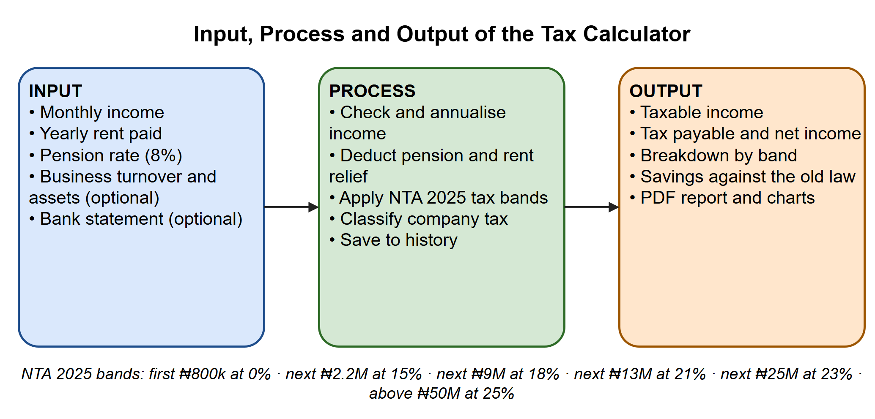
Figure 4.3: Input, process and output of the tax calculator

4.2.5 Product and Information Flow
NaijaTax Enlighten does not sell physical goods. Its products are information: tax calculations and reports, AI answers, VAT status checks, learning material and community answers. These are provided free to individuals and small businesses through the Android app and the web app. Table 4.5 shows which information passes between each party in the system. It is adapted from a manager-by-manager matrix, with each row showing what that party sends to the party named in each column.
Table 4.5: Information flow matrix (from row to column)
From \ To | System | Registered user | Guest user | External services
Registered user | Income details, questions, forum posts, quiz answers | Forum replies and votes | Forum answers (read only) | Sign-in details to Supabase Auth
Guest user | Income details, VAT searches | — | — | —
System | — | Tax results, PDF reports, AI answers, quiz scores, news | Tax estimates, VAT status, news | Questions to Gemini, requests for news feeds
External services | Sign-in tokens, AI answers, news articles | Google account chooser | — | —
Each calculation is saved once as a tax profile and can be downloaded as a PDF report as many times as the user wants, with no limit on copies. Guests' results are not saved to the server. Conversations, forum posts and quiz scores are saved once and loaded whenever they are needed.

4.2.6 Data Flow Diagrams
The overall data flow of the system is shown using the four standard symbols of a data flow diagram (DFD): the data source or destination (external entity), the process, the data store and the information flow. Figure 4.4, the context diagram, shows the whole system as a single process and its links with the outside world. Figure 4.5 breaks that process into the eight main processes and the seven data stores they use. News is collected automatically from the feeds every 30 minutes.
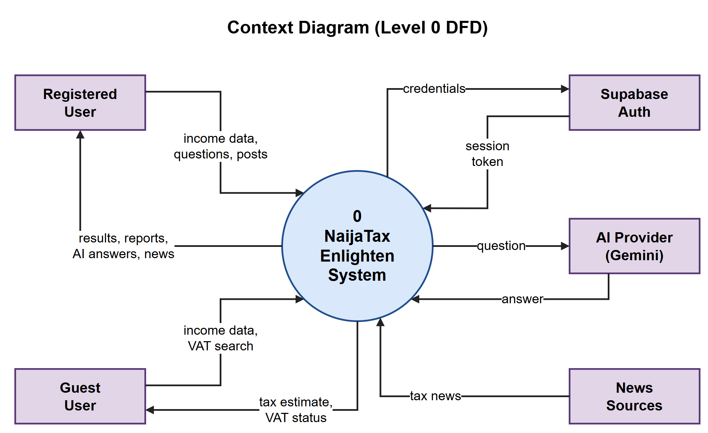
Figure 4.4: Context diagram (Level 0 DFD)
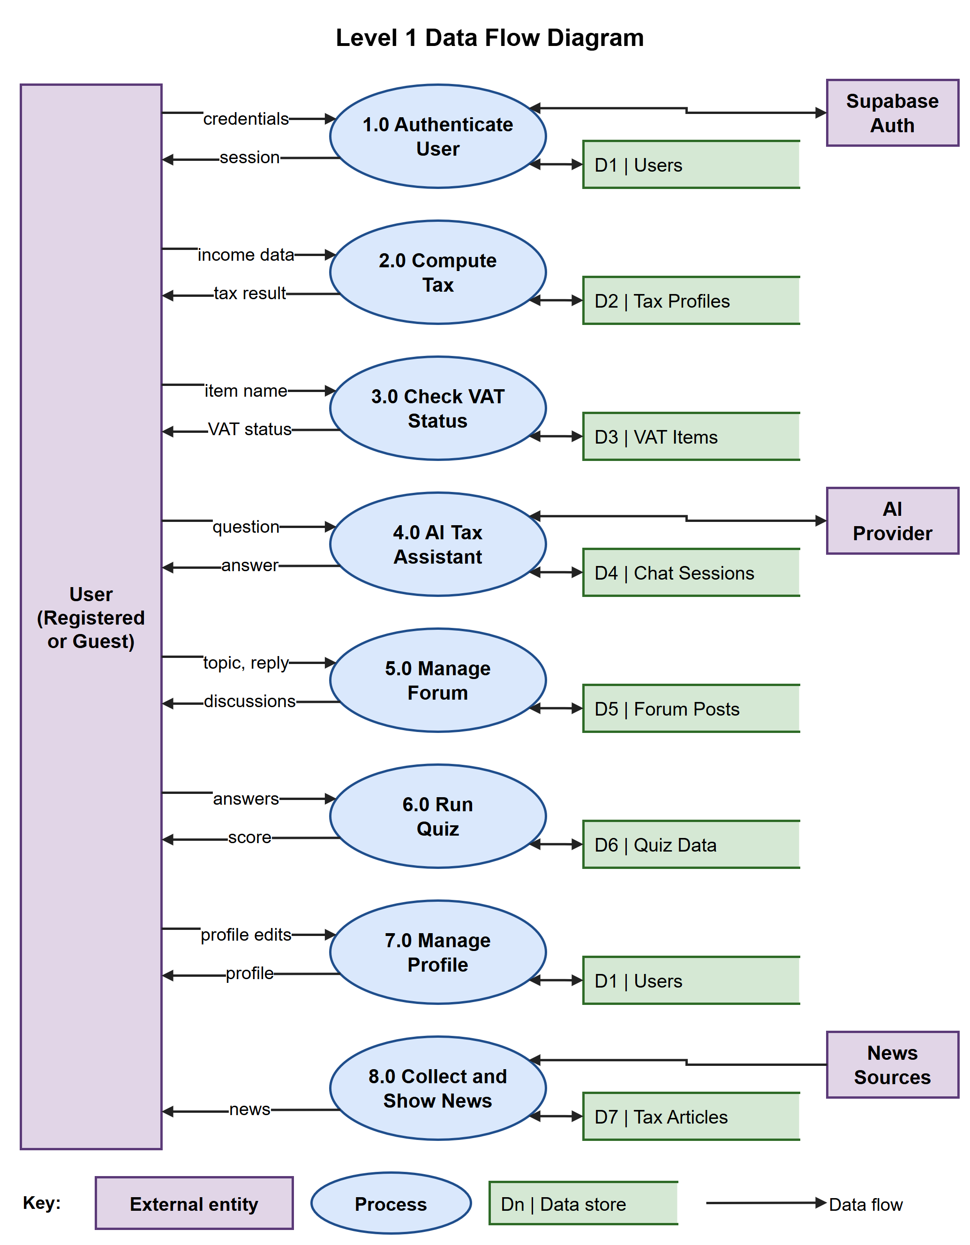
Figure 4.5: Level 1 data flow diagram

4.2.7 System Demonstration
Figures 4.6 to 4.8 show the deployed system. The web landing page (Figure 4.6) introduces the app and invites visitors to sign up, log in or continue as a guest. The login screen (Figure 4.7) offers email, phone and Google sign-in, and on iOS and the web Google always asks the user to choose an account. New users see the onboarding screens once and then reach the dashboard (Figure 4.8), which summarises their latest tax position, inflation trends and recent tax news.
[ INSERT SCREENSHOT HERE ]
Capture: Web landing page on a desktop browser (full width), showing the main banner and the Sign In / Get Started buttons.
Figure 4.6: Web landing page of NaijaTax Enlighten

[ INSERT SCREENSHOT HERE ]  Capture: Login screen on a phone, showing the email and password fields and the 'Continue with Google' button. |  | [ INSERT SCREENSHOT HERE ]  Capture: Dashboard on a phone after signing in, showing the tax summary card and the news section.
Figure 4.7: Login screen |  | Figure 4.8: User dashboard

4.3 Software Testing
The system was tested at every stage of development so that errors could be found and fixed straight away. Testing took place in two phases.
Phase one: testing during development. Each feature was tested as it was written, and bugs were removed before work moved on. The TypeScript compiler and the Flutter analyser checked every change for type errors and unsafe code. The tax engine, where a mistake would be most costly, was covered by automated unit tests that compare its results with hand-worked figures. GitHub Actions repeats these checks after every update, so a change that breaks existing behaviour is caught at once.
Phase two: running the complete system. The server was run on the developer's computer (localhost) and the app was used from end to end with sample data to confirm that it met its requirements. The same tests were then repeated on the deployed system, using the Android app and the web app.

4.3.1 Unit Test Results
Table 4.6 summarises the automated tests on the tax engine. All 21 tests passed, as shown in Figure 4.9.
Table 4.6: Unit tests of the tax engine
Test group | What is checked | Tests | Result
Tax bands | No tax on the first ₦800k; the correct tax at each band limit (₦3M, ₦12M, ₦25M, ₦50M); 25% only above ₦50M | 9 | Pass
Deductions | Pension and rent relief are taken off before tax is worked out; rent relief stops at ₦500k; monthly and yearly entries give the same result | 3 | Pass
Flat-rate mode | A chosen flat rate is applied correctly; choosing 0% does not count as the legal exemption | 2 | Pass
Savings | Savings compared with the old law are correct and never negative | 2 | Pass
Company income tax | The small-business exemption limits, and the 20% and 30% rates for medium and large businesses | 5 | Pass
Total |  | 21 | Pass

[ INSERT SCREENSHOT HERE ]
Capture: A terminal running 'npm test' in the server folder, showing 'Test Files 1 passed' and 'Tests 21 passed'.
Figure 4.9: Automated unit tests passing

4.3.2 System Testing with Sample Data
The main system test used a person who earns ₦450,000 a month, pays ₦1,200,000 in rent each year and contributes 8% of their pay to a pension. Figure 4.10 shows these figures entered into the tax calculator, and Figure 4.11 shows the result the system produced. Table 4.7 confirms that the result matches a manual calculation.
Table 4.7: Sample calculation: manual working compared with the system's result
Item | Working | Amount
Annual gross income | ₦450,000 × 12 | ₦5,400,000
Pension deduction | 8% of ₦5,400,000 | ₦432,000
Rent relief | 20% of ₦1,200,000 (under the ₦500,000 limit) | ₦240,000
Taxable income | ₦5,400,000 − ₦432,000 − ₦240,000 | ₦4,728,000
Tax on the first ₦800,000 | 0% | ₦0
Tax on the next ₦2,200,000 | 15% of ₦2,200,000 | ₦330,000
Tax on the remaining ₦1,728,000 | 18% of ₦1,728,000 | ₦311,040
Total tax payable | Sum of the three bands | ₦641,040
Net income | ₦5,400,000 − ₦432,000 − ₦641,040 | ₦4,326,960
Saving compared with the old law | Worked out by the system | ₦36,080

[ INSERT SCREENSHOT HERE ]  Capture: The tax calculator form filled with the sample data, before tapping Calculate.  Sample data: Monthly income ₦450,000; rent ₦1,200,000; pension 8% |  | [ INSERT SCREENSHOT HERE ]  Capture: The result screen showing tax payable, net income and the band-by-band breakdown.  Sample data: Tax ₦641,040; net income ₦4,326,960
Figure 4.10: Tax calculator with sample input |  | Figure 4.11: Result produced by the system

Table 4.8 lists the other system tests. Each one was carried out on both the Android app and the web app.
Table 4.8: System test cases
ID | Test | Input | Expected result | Result
T1 | Email sign-up | A new email address and password | Account is created; onboarding appears once, then the dashboard | Pass
T2 | Google sign-in | Tap 'Continue with Google' | Google asks which account to use; the user is signed in | Pass
T3 | Returning user | Sign in with an existing account | Dashboard opens directly, without showing onboarding | Pass
T4 | Guest limits | A guest tries to post in the forum | Guest is asked to sign up and taken to the landing page | Pass
T5 | Invalid input | Letters typed into the income field | An error message appears and nothing is sent | Pass
T6 | VAT check | Search for "rice" | The item is listed with its VAT status | Pass
T7 | AI assistant | "Is my pension taxable?" | A relevant answer appears and is saved to the chat | Pass
T8 | PDF report | Tap 'Download report' on a result | A PDF with the full breakdown is created | Pass
T9 | Forum | Post a topic, then reply and vote | The topic, reply and vote count appear | Pass
T10 | Quiz | Answer a seven-question quiz | The score is shown and saved to history | Pass

[ INSERT SCREENSHOT HERE ]  Capture: The PDF tax report opened on the phone or in a PDF viewer. |  | [ INSERT SCREENSHOT HERE ]  Capture: The AI assistant answering the question 'Is my pension taxable?'.
Figure 4.12: PDF tax report |  | Figure 4.13: AI tax assistant answering a question

4.4 Documentation

Data Dictionary
The data dictionary explains what each data item used in the system is made up of. For example, wherever USER appears it means User ID + Email + Phone + Display Name + Avatar URL + Address + Onboarded + Role + Date Created. Figure 4.14 shows how the stored items relate to one another, and Table 4.9 gives the make-up of each one (PK means primary key and FK means foreign key).
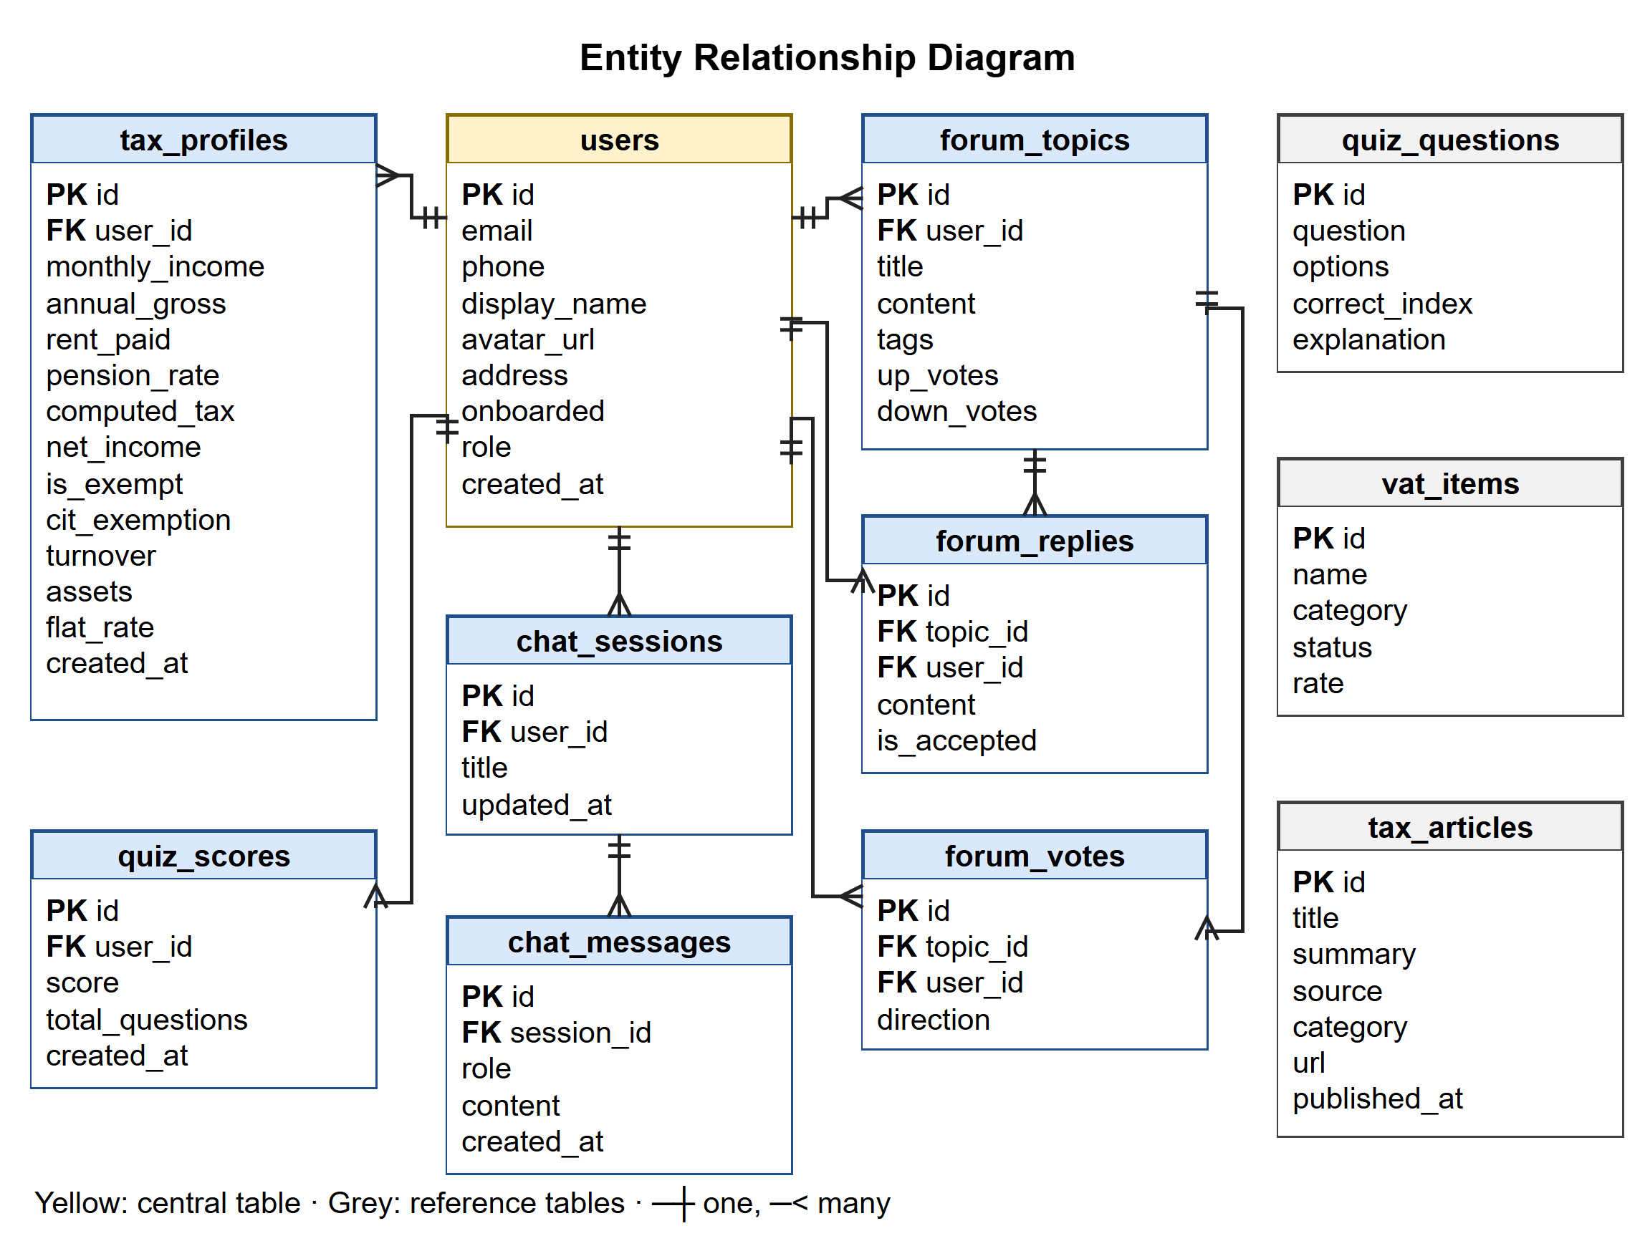
Figure 4.14: Entity relationship diagram of the database
Table 4.9: Data dictionary
Data item | Composition | Description
USER | User ID (PK) + Email + Phone + Display Name + Avatar URL + Address + Onboarded + Role + Date Created | A registered person. The User ID is the same as their sign-in account ID
TAX PROFILE | Profile ID (PK) + User ID (FK) + Monthly Income + Annual Gross + Rent Paid + Pension Rate + Computed Tax + Net Income + Is Exempt + CIT Status + Turnover + Assets + Flat Rate + Rent Relief Rate + Date | One saved tax calculation. Amounts are stored to two decimal places
VAT ITEM | Item ID (PK) + Name + Category + Status + Rate | Status is standard, zero-rated or exempt
CHAT SESSION | Session ID (PK) + User ID (FK) + Title + Dates | One conversation with the AI assistant
CHAT MESSAGE | Message ID (PK) + Session ID (FK) + Role + Content + Date | One message; Role shows whether the user or the assistant sent it
FORUM TOPIC | Topic ID (PK) + User ID (FK) + Title + Content + Tags + Up Votes + Down Votes + Dates | A question or discussion in the forum
FORUM REPLY | Reply ID (PK) + Topic ID (FK) + User ID (FK) + Content + Is Accepted + Date | An answer to a topic
FORUM VOTE | Vote ID (PK) + Topic ID (FK) + User ID (FK) + Direction | An up or down vote; one per user per topic
QUIZ QUESTION | Question ID (PK) + Question + Options + Correct Index + Explanation | One quiz question and its choices
QUIZ SCORE | Score ID (PK) + User ID (FK) + Score + Total Questions + Date | The result of one completed quiz
TAX ARTICLE | Article ID (PK) + Title + Summary + Content + Source + Category + URL + Is Featured + Published Date | A tax news story collected from a news feed

4.4.1 User Manual
A. Installation
On an Android phone:
- Copy the file NaijaTax.apk to the phone, or download it from the link provided.
- Open the file. If the phone asks, allow apps to be installed from this source.
- Tap Install, then Open. The NaijaTax Enlighten icon will appear on the home screen.
In a web browser: open the NaijaTax Enlighten web address on any phone or computer. On an iPhone, tap Share, then Add to Home Screen, to open it like an app.
From the source code (for developers):
- Install Flutter 3.44, Node.js 20 and Git, then download (clone) the project.
- In the server folder, copy .env.example to .env and fill in the database address, the Supabase address and a Gemini API key. Then run npm install, npx prisma migrate deploy and npm run db:seed.
- Start the server with npm run dev. It runs on port 3000.
- In the client folder, copy config.example.json to config.dev.json, run flutter pub get, and then run flutter run --dart-define-from-file=config.dev.json.
B. Using the application
- Sign up or log in with an email address, a phone number or a Google account. To try the app first, tap Continue as Guest; guests can use the calculator and the VAT checker.
- Read the short onboarding screens, which appear only once, to reach the dashboard.
- Open Calculator and enter your monthly income, yearly rent and pension rate. Business owners can also enter their turnover and assets. Tap Calculate. You can instead upload a bank statement to fill in the form automatically.
- Check your tax, net income and the breakdown by band. Tap Download report to save a PDF, or open History to see earlier calculations.
- Open VAT Items to find out whether a product or service attracts VAT.
- Open AI Assistant to ask a tax question in your own words. Earlier conversations are listed in the side menu.
- Use Community to ask or answer questions, and Learn to read about the tax reform and take quizzes.
- Open Profile to update your details or photo, store documents or sign out.

4.4.2 Source Code Listing
The project has two main folders. The client folder contains the Flutter application (screens, state providers, services and shared widgets). The server folder contains the Express API (routes, controllers, services, the sign-in check and the database schema).
For source code listing and sample outputs see appendices A and B, respectively.

