DESIGN AND DEVELOPMENT OF A MOBILE TAX AWARENESS AND
CALCULATION SYSTEM IN NIGERIA

BY

AMADI TOBIAS EBUBE – (2022/246095)
AMASIKE CHUKWUWEBUKA FRANKLYN – (2022/246739)
APPOLOS ESTHER EZINNE – (2022/241749)

A BSC PROJECT SUBMITTED IN PARTIAL FULFILLMENT OF THE
REQUIREMENTS FOR THE AWARD OF BACHELOR OF SCIENCE (BSC) DEGREE IN COMPUTER SCIENCE

DEPARTMENT OF COMPUTER SCIENCE
UNIVERSITY OF NIGERIA, NSUKKA

PROJECT SUPERVISOR:
PROF. AGOZIE ENEH

JUNE, 2026

ABSTRACT
Nigeria’s fragmented tax system has contributed to one of the lowest tax-to-GDP ratios in the world at approximately 6%, far below the sub-Saharan African average of 16% (World Bank, 2024). In June 2025, the Nigerian government enacted four comprehensive Tax Reform Acts led by the Nigeria Tax Act (NTA) which took effect on January 1, 2026, introducing major changes including a ₦800,000 annual income tax exemption threshold, revised Pay As You Earn (PAYE) bands, a full Companies Income Tax exemption for small businesses earning up to ₦100 million annually, and an expanded list of zero-rated Value Added Tax (VAT) items; yet surveys found that over 78% of Nigerian citizens remained unaware of these changes and no free interactive tool existed to help them calculate their obligations under the new law (Adeleke & Okafor, 2024). This study therefore aims to design, develop, and evaluate NaijaTax Enlighten, a cross-platform application that educates Nigerian citizens on the 2025 Tax Reform Acts and provides interactive tools for personal income tax calculation, business tax eligibility checking, VAT classification lookup, an AI-powered tax assistant, peer community discussion, and knowledge assessment. The Agile methodology was adopted, organised into six sprints covering requirements gathering, system design, frontend and backend development, testing, and deployment, supported by OOADM design artefacts including use case diagrams, entity-relationship diagrams, and Figma wireframes. The application is built using Flutter 3.44 with Riverpod and GoRouter for the cross-platform frontend, Express.js 4.21 with TypeScript 5.6 for the backend REST API, PostgreSQL (hosted on Supabase) managed through the Prisma 7 ORM as the primary database, Supabase Auth for user sign-in and session management, and Google Gemini AI for the conversational tax assistant, and it is deployed on Android, iOS and the web. The completed system is expected to improve users’ understanding of their tax obligations under the 2025 NTA, enable workers below the exemption threshold to identify incorrect PAYE deductions, help small business owners confirm their CIT exemption status, and serve as a freely accessible civic resource for tax education across Nigeria, with outcomes validated through pre- and post-use knowledge assessments during the user testing phase.

CHAPTER ONE

Introduction

1.1 Background to the Study
Taxation is one of the most important ways any government raises money to provide public services such as roads, hospitals, schools, and security. In Nigeria, the tax system has existed in various forms for many decades, but it has always been regarded as complicated, fragmented, and difficult for ordinary people to understand. For a very long time, Nigeria operated multiple separate tax laws at the same time, each one written by a different government at a different period in history. There was the Personal Income Tax Act (PITA), which governed how employed individuals are taxed; the Companies Income Tax Act (CITA), which covered businesses; the Value Added Tax Act (VATA), which regulated VAT on goods and services; and several others including the Capital Gains Tax Act and the Stamp Duties Act. Managing all of these at once was difficult even for trained professionals, let alone ordinary citizens.
The process through which Nigerian employees are taxed on their income is called Pay As You Earn, commonly known as PAYE. Under this system, an employer deducts a portion of an employee’s salary before payment and remits it to the relevant tax authority. The amount to be deducted is calculated based on progressive tax bands, that is, the more a person earns, the higher the percentage of their income that goes to tax. In addition to PAYE, Nigerian businesses are expected to pay Companies Income Tax (CIT) on their annual profits, and consumers pay Value Added Tax (VAT) on the goods and services they purchase. The administration of all these different taxes was the responsibility of the Federal Inland Revenue Service (FIRS) at the federal level and state-level Internal Revenue Services for certain categories of tax.
Despite this long-standing structure, the Nigerian tax system has been plagued by several serious problems. The first is widespread confusion among taxpayers. Because the laws were written in dense legal and accounting language, the average Nigerian worker had no practical way to understand what they owed, what deductions they were entitled to, or even whether they should be paying tax at all. Studies have shown that many employees pay whatever amount their employer deducts without ever questioning whether the calculation is correct. Many small business owners, particularly those in the informal sector, simply opt out of the tax system entirely because they do not know how to engage with it.
The second major problem is the absence of accessible and reliable tools for personal tax calculation. Unlike countries such as the United Kingdom and Australia, where the government provides online calculators and mobile apps to help citizens estimate their tax liability, Nigeria has no equivalent citizen-facing tool. The Nigeria Revenue Service (NRS) operates a compliance portal called TaxProMax, but this platform is designed for filing returns, not for helping citizens understand or calculate their obligations. It assumes a level of tax knowledge that most Nigerians simply do not have.
The third problem is that the existing laws were outdated and no longer reflected the economic realities facing Nigerians. The income thresholds, relief allowances, and exemption criteria had not been meaningfully updated for years, meaning that millions of low-income earners who should not have been paying income tax at all were still being taxed.
These problems have serious implications for the country as a whole. Nigeria’s tax-to-GDP ratio has remained at approximately 6% which is one of the lowest in the world and far below the African average of over 16%. This means the government lacks the revenue needed to fund basic public services and has had to depend excessively on oil income, which is unpredictable. For individual citizens, the lack of tax knowledge means that many are unknowingly overpaying their taxes, losing money that should remain in their pockets. For small businesses, confusion around tax rules creates compliance anxiety and sometimes leads to fines and penalties for unintentional errors.
Recognising these deep structural problems, the Nigerian government under President Bola Ahmed Tinubu initiated a comprehensive tax reform process. In June 2025, four new tax laws were signed: the Nigeria Tax Act (NTA), the Nigeria Tax Administration Act (NTAA), the Nigeria Revenue Service (Establishment) Act (NRSA), and the Joint Revenue Board (Establishment) Act (JRBA). These laws came into effect on January 1, 2026, and represent the most significant overhaul of Nigeria’s tax system in modern history. Among the key changes, the annual income exemption threshold was raised to ₦800,000 (meaning anyone earning this amount or less per year pays zero income tax), small businesses with turnover up to ₦100 million are now fully exempt from Companies Income Tax, and a wider range of essential goods including food, medicine, and school materials are now zero-rated for VAT.
While the reform is a welcome development, it has created a new and urgent problem: the vast majority of Nigerians do not know about these changes, do not understand what they mean, and have no way to calculate how the new rules affect their personal finances. The existing tools and resources government gazettes, consultant analyses, and news articles are either too technical, too expensive to access, or simply not interactive enough to give a citizen a personalized answer to the question: “How does this tax reform affect me?”
It is against this background that NaijaTax Enlighten is proposed. NaijaTax Enlighten is a full-featured, cross-platform mobile and web application built with Flutter, supported by an Express.js and TypeScript backend, and powered by a PostgreSQL database managed through Prisma ORM. The application provides Nigerian citizens with a personal income tax calculator, a business tax eligibility checker, a searchable VAT guide, an AI-powered tax assistant built on Gemini AI, a community forum for peer questions and answers, a tax news section, and a
personalised tax impact quiz. It is available on Android, iOS and the web, reaching the widest possible range of Nigerian users at no cost.

1.2 Statement of the Problem
A Nigeria where the tax system is no longer a source of confusion and fear, but a system that citizens understand, trust, and voluntarily comply with because they can see that it is fair and transparent.
The 2025 Nigeria Tax Reform Acts, which took effect on January 1, 2026, introduced major changes to how individual income tax, business income tax, and VAT are calculated and applied. These changes directly affect the financial lives of millions of Nigerians. Yet the vast majority of citizens have no practical way to understand what these changes mean for them personally. No freely available mobile application exists that allows a Nigerian to calculate their personal income tax under the new law, check whether their business is now tax-exempt, or look up whether a particular product should attract VAT. If this problem is left unaddressed, millions of workers will continue to accept incorrect PAYE deductions, small business owners will continue to pay taxes they no longer owe, and voluntary tax compliance will remain low, costing the government revenue and costing citizens money they should legally keep.
This project solves the stated problem by designing and developing NaijaTax Enlighten a full-featured, cross-platform application built with Flutter for the frontend, Express.js and TypeScript for the backend REST API, PostgreSQL and Prisma ORM for the database layer and Gemini for the AI tax assistant feature. Development follows the Agile methodology in iterative sprints. The completed application will be evaluated through structured user testing to confirm that it improves tax knowledge and practical capability among Nigerian users.

1.3 Aim and Objectives of the Study
The general aim of this study is to design, develop, and deploy NaijaTax Enlighten a cross-platform application that makes Nigeria’s 2025 Tax Reform Acts accessible, understandable, and practically useful to ordinary Nigerian citizens and small business owners, regardless of their financial or educational background, and regardless of which device they use to access it.
The following specific objectives guide the study:
- To gather and document the functional and non-functional requirements of NaijaTax Enlighten through a structured user survey and a systematic review of the 2025 Nigeria Tax Act, producing a System Requirements Specification (SRS) that will serve as the foundation for all subsequent development sprints.
- To produce a complete system design comprising a PostgreSQL database schema, a
REST API specification for the Express.js backend, and Figma UI wireframes for all application screens, reviewed and approved by the project supervisor before any development commences
- To develop the Flutter frontend using Riverpod 2.5 for state management and GoRouter 17 for navigation, implementing the PAYE Calculator, Business Tax Checker, VAT Guide, Tax Reform Explainer, and Tax Quiz as fully working and independently testable UI screens.
- To build the Express.js and TypeScript backend REST API with Prisma ORM and PostgreSQL integration, implementing all tax calculation logic, VAT guide data, quiz content, and tax news endpoints, and validating every calculation result against the official 2025 NTA documentation before the sprint closes.
- To integrate Supabase Auth for secure sign-in (email and password, phone OTP and Google), with JSON Web Tokens checked by the backend on every protected request, covering registration, login, automatic token refresh, password reset, session management and saved calculation history.
- To implement the AI Tax Assistant by integrating Gemini AI on the Express.js backend with a domain-anchored system prompt embedding the complete 2025 NTA knowledge base, per-user conversation memory stored in PostgreSQL, and rate-limited API endpoints to prevent misuse.
- To develop the Community Forum with authenticated topic creation, reply posting, accepted answer marking, and tag-based filtering, completing the full feature set of the application.
- To conduct structured testing across three levels, unit testing of all backend calculation functions, integration testing of all REST API endpoints, and usability testing with a sample of Nigerian participants on multiple device types and to document all findings, defects, and resolutions in a formal Test Report.
- To deploy the complete application on Android, iOS and the web using Flutter’s cross-platform build system, hosting the Express.js backend on Render and the PostgreSQL database on Supabase, producing a publicly accessible live application.
- To evaluate the application’s educational impact by measuring and comparing participants’ tax knowledge scores before and after using the app, and to present all findings, limitations, and recommendations for future development in the final project report.

1.4 Significance of the Study
This study is significant because it addresses a real and pressing problem that affects millions of Nigerians at a particularly important moment in the country’s fiscal history. The 2025 Tax Reform Acts represent the most comprehensive overhaul of Nigeria’s tax system in decades, and the absence of accessible tools to explain these changes to ordinary people is a genuine gap that, if left unfilled, will slow the pace of voluntary compliance and undermine the goals of the reform itself. The findings and outputs of this study will be of benefit to several groups.
Salaried employees across Nigeria stand to benefit most directly from this research. Under the 2025 NTA, anyone earning ₦800,000 or less per year is fully exempt from personal income tax. Many workers who fall within this threshold are still having PAYE deducted from their salaries simply because neither they nor their employers are aware of the change. The NaijaTax Enlighten app will give these workers a clear, instant calculation that tells them what they should be paying, empowering them to query incorrect deductions and recover money they are legally entitled to keep.
Small and medium business owners are another major group of beneficiaries. The new law exempts businesses with annual turnover of ₦100 million or less from Companies Income Tax entirely. Many owners of such businesses currently spend money on tax consultants or accountants simply to understand and file a tax they no longer legally owe. This application will allow them to check their exemption status in seconds, free of charge, and redirect those resources into growing their businesses.
The Nigeria Revenue Service (NRS) and the federal government will also benefit indirectly from this study. One of the stated goals of the 2025 tax reform is to broaden the tax base and improve voluntary compliance. Research consistently shows that compliance increases when citizens understand the tax system and trust that it is being applied fairly. By improving tax literacy among millions of Nigerians, NaijaTax Enlighten supports the government’s compliance goals without requiring any direct government investment.
Students, researchers, and educators in the field of taxation, public finance, and civic technology will also find value in this work. The study demonstrates a practical, technology-based approach to addressing tax literacy challenges in a developing economy context, and the methodology and findings can serve as a reference for future research in this area. The system architecture, a Flutter frontend communicating with an Express.js (TypeScript) API and a PostgreSQL database, also serves as a replicable model for building similar citizen-information mobile applications in other regulatory domains.
Finally, civil society organisations, journalists, community leaders, and non-governmental organisations working on financial inclusion and economic literacy in Nigeria will benefit from having a credible, accurate, and freely available reference tool to share with the people and communities they serve. The app will give them something concrete to point to when explaining the 2025 tax reform to audiences who may not have ready access to professional tax advice.

1.5 Scope of the Study
This study covers the design and development of NaijaTax Enlighten, a cross-platform mobile application for tax education and calculation. The scope of the work is defined by the key components of the project title and the objectives stated above.
In terms of content scope, the study covers three main areas of the Nigeria Tax Act 2025: personal income tax (PAYE) as it applies to employed individuals, corporate income tax as it applies to small and medium-sized businesses with annual turnover of up to ₦500 million, and Value Added Tax as it applies to the everyday goods and services purchased by Nigerian consumers. The study does not extend to petroleum profits tax, mining sector provisions, international tax treaties, estate duty, or the specialist provisions applicable to multinational corporations, as these areas require professional expertise beyond the scope of this undergraduate research.
In terms of technical scope, the study covers the full software development lifecycle of the application: requirements gathering, system design, frontend development in Flutter and Dart with Riverpod state management and GoRouter navigation, backend development in Express.js and TypeScript with Prisma ORM and PostgreSQL, Supabase Auth for user authentication, Google Gemini integration for the AI assistant (with Groq as a backup provider), community forum implementation, and multi-platform deployment to Android, iOS and the web. The study includes structured user testing and evaluation but does not extend to long-term post-deployment monitoring or content maintenance beyond the academic submission period.
In terms of target users, the study focuses on three groups: salaried employees in both the public and private sectors, small and medium business owners, and members of the general public who wish to understand the VAT implications of their everyday purchases.

1.6 Limitations of the Study
The following limitations define the boundaries of this study. They do not affect the usability of the application, which is designed for all Nigerian citizens regardless of the complexity of their tax situation.
- Scope of Tax Law Covered: This study addresses only the provisions of the 2025 NTA most relevant to individual citizens and businesses, specifically personal income tax (PAYE), corporate income tax, and VAT on goods and services. Specialist areas including petroleum profits tax, mining sector taxation, estate duties, international tax treaties, and rules governing multinational corporations are not covered in this version of the application. These represent planned areas for future development.
- Not a Tax Filing Tool: NaijaTax Enlighten does not currently allow users to file tax returns or submit payments directly to the Nigeria Revenue Service. The application provides full calculation, education, and AI-assisted guidance, but formal return submission remains on the NRS TaxProMax portal. Integration with the NRS filing system is identified as an important future enhancement.
- Post-Submission Maintenance: Tax rates, thresholds, and VAT classifications are subject to change as the NRS publishes amendments to the 2025 NTA. While the database-driven architecture of the application makes updates straightforward, ongoing content maintenance after the academic submission date is not guaranteed as part of this study.

1.7 Definition of Technical Terms
The following technical terms appear throughout this project work and are defined here for clarity:
- PAYE (Pay As You Earn): The system through which personal income tax is deducted from an employee’s salary at source in Nigeria. The employer computes the tax due each month, deducts it before payment, and remits it to the Nigeria Revenue Service on the employee’s behalf.
- VAT (Value Added Tax): A consumption tax charged on the supply of taxable goods and services in Nigeria, currently at a rate of 7.5%. Under the 2025 NTA, certain essential goods including food, medicines, and educational materials are zero-rated, meaning VAT is charged at 0% and effectively not collected on those items.
- CIT (Companies Income Tax): A tax levied on the annual taxable profits of companies in Nigeria. The standard rate is 30% for large companies. Under the 2025 NTA, small companies with annual turnover of ₦100 million or less and fixed assets not exceeding ₦250 million are fully exempt from CIT.
- Nigeria Tax Act (NTA) 2025: A comprehensive law signed in June 2025 that consolidates multiple previously separate Nigerian tax laws into a unified framework. It took effect on January 1, 2026, and governs personal income tax, corporate income tax, VAT, capital gains tax, and other taxes.
- Nigeria Revenue Service (NRS): The federal tax administration body created by the NRS Establishment Act 2025, replacing the former Federal Inland Revenue Service (FIRS). It is responsible for assessing, collecting, and accounting for all federal taxes under the 2025 reform framework.
- Flutter: An open-source cross-platform mobile and desktop application development framework created by Google. Flutter uses the Dart programming language and produces fully native applications for Android, iOS, Web, Windows, and macOS from a single shared codebase.
- Dart: The strictly typed, object-oriented programming language developed by Google and used exclusively with Flutter for writing cross-platform mobile and desktop applications.
- Express.js: A lightweight and widely used Node.js web application framework for building RESTful APIs. In this project, Express.js is used as the backend server that handles all incoming requests from the Flutter frontend, processes business logic, and communicates with the PostgreSQL database.
- TypeScript: A strictly typed programming language developed by Microsoft that builds on JavaScript. TypeScript adds static type checking to JavaScript, reducing runtime errors and improving code maintainability. It is used throughout the backend of this project.
- PostgreSQL: An open-source relational database management system known for its reliability, feature richness, and support for complex queries. It serves as the primary data store for all application data including user accounts, tax configurations, VAT items, forum posts, and AI chat sessions.
- Prisma ORM: An open-source Object Relational Mapper (ORM) for Node.js and TypeScript that provides type-safe database access. Prisma generates database clients from a schema definition file and handles all SQL queries automatically. It is used in this project to interact with the PostgreSQL database from the Express.js backend.
- JWT (JSON Web Token): A compact, URL-safe token format used for securely transmitting authentication information between parties. In this project, Supabase Auth issues a short-lived JWT access token when a user signs in, together with a refresh token that renews it automatically. The Express.js backend checks the token’s signature on every protected request.
- Bcrypt: A password hashing algorithm designed to be computationally expensive in order to resist brute-force attacks. In this project, passwords are handled by Supabase Auth, which stores them as bcrypt hashes; the application’s own server and database never see or store plain-text passwords.
- Riverpod: A state management library for Flutter. In this project, Riverpod 2.5+ manages all application state including authentication status, theme preferences, and routing configuration.
- GoRouter: A declarative, URL-based navigation package for Flutter. In this project, GoRouter 17 handles all in-app navigation with support for deep linking, path parameters, and authentication-based route guards.
- REST API (Representational State Transfer Application Programming Interface):
A standard architectural style for building web services that communicate over HTTP. The Flutter frontend and the Express.js backend communicate exclusively through a REST API, with the Dio HTTP client used on the Flutter side.
- Zod: A TypeScript-first schema validation library used in the Express.js backend to validate all incoming request data before processing. Zod ensures that malformed or malicious inputs are rejected before they reach the business logic or database layers.
- Google Gemini AI: A large language model developed by Google, used in this project to power the AI Tax Assistant feature. Gemini is called from the Express.js backend with a
system prompt embedding the 2025 NTA knowledge base, enabling it to answer tax questions accurately within the defined scope of Nigerian tax law.
- Agile Methodology: A software development approach that organises work into short, iterative cycles called sprints, typically lasting two to three weeks each. Agile allows for continuous delivery of working software and accommodates changing requirements during development, which is particularly relevant for a project where the underlying tax data may be updated by the NRS during the build period.
- Progressive Tax: A tax system in which the rate of tax increases as the taxable income increases. Nigeria’s 2025 PAYE system is progressive, with rates ranging from 0% for income at or below ₦800,000 per year up to 25% for income above ₦50 million per year.
- Cross-Platform Application: A software application that is designed to run on multiple different operating systems or devices from a single codebase. NaijaTax Enlighten is cross-platform, running on Android, iOS and the web from one Flutter codebase.
- TaxProMax: The Nigeria Revenue Service’s official online portal for electronic tax filing, TIN registration, and payment of federal taxes. It is a compliance submission platform and does not provide tax education, calculation tools, or plain-language guidance for ordinary citizens.

CHAPTER TWO

Literature Review

2.0 Introduction
This chapter presents the theoretical background and a review of related literature relevant to the development of NaijaTax Enlighten, a cross-platform application for Nigeria tax reform education and calculation. The chapter is organised into three main sections. The first section presents the theoretical background, which is divided into concepts and technology. The concepts subsection examines the key ideas underpinning the study: taxation and the Nigerian tax system, Pay As You Earn, Value Added Tax, tax literacy, and mobile civic technology. The technology subsection examines the core technologies used to build the application: Flutter, Express.js and TypeScript, PostgreSQL and Prisma ORM, JWT authentication, and Gemini AI large language model. The second section reviews related published works, tracing contributions from the oldest to the most recent, and comparing each to the present study. The chapter concludes with an identification of the research and knowledge gap that this project fills.

2.1 Theoretical Background
The theoretical background of this study draws from two distinct but interrelated areas: the conceptual framework surrounding taxation, tax literacy, and digital civic tools, and the underlying technologies used in the design and implementation of the proposed mobile application. Both areas are examined in the subsections that follow.
2.1.1 Concepts

1. Taxation and the Nigerian Tax System
Taxation is the compulsory financial contribution made by individuals and organisations to the government, in accordance with the law, to fund public services and infrastructure (Nightingale,
2002). In the Nigerian context, taxation serves as the primary alternative to oil revenue for funding government operations at the federal, state, and local government levels. The Nigerian tax system is classified as a multi-tier system: some taxes are collected by the federal government through the Nigeria Revenue Service (NRS), while others are administered by state-level Internal Revenue Services.
The main categories of tax in Nigeria under the 2025 Nigeria Tax Act include Personal Income Tax, which is collected through the Pay As You Earn (PAYE) system from employed workers;
Companies Income Tax (CIT), which is levied on the annual profits of incorporated businesses; Value Added Tax (VAT), which is charged on the supply of goods and services; Capital Gains Tax (CGT), levied on profits from the disposal of assets; and the Development Levy, a new unified levy that replaced several older levies including the Tertiary Education Tax. The NTA 2025 introduced major structural changes to all of these categories, with particular significance for low-income earners and small businesses.

2. Pay As You Earn (PAYE)
PAYE is the mechanism through which personal income tax is deducted at source from the salaries of employed workers in Nigeria. Under this system, the employer acts as an agent of the tax authority, computing the tax due on the employee’s gross income each month, deducting it before payment, and remitting it to the relevant authority. The employee’s taxable income is calculated by subtracting all applicable deductions such as pension contributions and the new Rent Relief from the gross income, and then applying the progressive tax bands to the resulting figure.
The 2025 NTA introduced two significant changes to the PAYE system. First, the old Consolidated Relief Allowance (CRA), which had provided a combined flat and percentage deduction since 2011, was abolished. In its place, workers who pay rent are now entitled to a Rent Relief equivalent to 20% of their actual annual rent, capped at ₦500,000. Second, and most importantly for low-income workers, the annual income exemption threshold was raised to ₦800,000. This means that any Nigerian employee earning ₦800,000 or less per year approximately ₦66,667 per month pays zero income tax. Above that threshold the new progressive bands are 15% up to ₦3 million, 18% up to ₦12 million, 21% up to ₦25 million, 23% up to ₦50 million, and 25% on income above ₦50 million per year.

3. Tax Literacy and Its Importance
Tax literacy refers to the level of knowledge and understanding that a taxpayer has regarding the tax system, their obligations within it, and the rights and reliefs available to them (Organisation for Economic Co-operation and Development, 2021). It is distinct from tax compliance: a person can be willing to comply but unable to do so correctly because they lack the knowledge to compute their liability accurately. Research in Nigeria and across sub-Saharan Africa has consistently found that low tax literacy is one of the most significant barriers to voluntary compliance (Ola and Adeniran, 2012; Nwosu and Mba, 2020).
The concept of tax literacy gains particular urgency following a major legislative change such as the 2025 NTA. When the rules of a system change significantly, the existing (already limited) knowledge of taxpayers becomes outdated overnight. This creates what can be described as a tax literacy gap, the difference between what citizens need to know to comply correctly and what they actually know. Closing this gap in a timely and accessible way is the core purpose of the NaijaTax Enlighten application.

4. Mobile Civic Technology
Mobile civic technology refers to the use of smartphone applications and digital tools to help citizens engage more effectively with government services, public information, and their civic rights and responsibilities (Sandoval-Almazan and Gil-Garcia, 2012). In recent years, civic apps have been deployed across a wide range of domains, from voter registration and election monitoring to health information, public transport navigation, and financial literacy. The common thread across successful civic apps is that they take information that exists in a complex or inaccessible form of legislation, official statistics, government processes and translate it into something a non-expert citizen can understand and act on from their mobile device.
In the Nigerian context, mobile civic technology has enormous potential because mobile penetration is high while access to professional advisory services (lawyers, accountants, financial advisors) is low and expensive. The Nigerian Communications Commission reported over 220 million active mobile subscribers in Nigeria as of 2024, with smartphones accounting for a growing majority of these. This infrastructure makes a well-designed mobile civic app one of the most cost-effective tools available for bridging the information gap between government policy and citizen understanding.

5. Value Added Tax (VAT) in Nigeria
Value Added Tax (VAT) was introduced in Nigeria in 1993 under the Value Added Tax Act, replacing the earlier Sales Tax regime. It is an indirect tax levied on the supply of taxable goods and services, currently at a rate of 7.5% (raised from 5% in 2020). VAT is collected at each stage of the supply chain but is ultimately borne by the final consumer. In practice, most Nigerian consumers have very limited knowledge of how VAT operates, which goods are exempt, and when it is appropriate to challenge a VAT charge (Somorin, 2020).
The 2025 NTA significantly expanded the list of zero-rated goods to include basic food items, medicines and medical devices, educational materials, and electricity. This is a pro-poor measure designed to reduce the tax burden on lower-income households. However, without a reliable and accessible guide to these new classifications, consumers cannot easily challenge retailers who continue to charge VAT on zero-rated items, and the practical benefit of the reform is weakened.
2.1.2 Technology

1. Flutter and Cross-Platform Mobile Development
Flutter is an open-source mobile application development framework created by Google and released for stable production use in December 2018. It uses the Dart programming language and a widget-based architecture to produce native applications for Android, iOS, web, and desktop from a single codebase (Google, 2024). Unlike hybrid frameworks such as Cordova or Ionic, which use a web view to render content, Flutter compiles directly to native machine code, producing applications that perform at full native speed on both Android and iOS devices.
Flutter has seen rapid adoption globally. As of 2023, it was the most widely used cross-platform framework among mobile developers surveyed by Stack Overflow, ahead of React Native and Xamarin (Stack Overflow, 2023). Notable applications built with Flutter include BMW’s My BMW app, eBay Motors, Google Pay, and Alibaba’s Xianyu platform. For NaijaTax Enlighten, Flutter enables a single development effort to produce a fully native app for all target devices.

2. Riverpod and GoRouter
State management in Flutter applications refers to how the application stores, updates, and shares data across different widgets and screens. Riverpod 2.5+ is the state management solution adopted for this project. Riverpod is a compile-safe, reactive state management library that provides a clean, testable approach to managing application state without the limitations of Flutter’s built-in InheritedWidget system. In NaijaTax Enlighten, Riverpod manages authentication state, theme mode (light/dark), calculator input and result state, forum data, and AI chat session state. Its provider-based architecture ensures that UI components automatically rebuild when the data they depend on changes, without unnecessary rebuilds of unrelated parts of the screen.
GoRouter 17 is used for declarative, URL-based in-app navigation. Unlike Flutter’s built-in Navigator API, GoRouter defines all routes centrally and supports deep linking, path parameters for dynamic routes and authentication-based route guards that redirect unauthenticated users away from protected screens. This makes the app’s navigation predictable, testable, and consistent on Android, iOS and the web.

3. PostgreSQL as a Relational Database System
PostgreSQL is an open-source object-relational database management system with over 35 years of active development. It is widely regarded as one of the most powerful and reliable open-source databases available, with strong support for complex queries, ACID-compliant transactions, and advanced data types (PostgreSQL Global Development Group, 2024). PostgreSQL is used in production by major organisations including Apple, Instagram, Skype, and the U.S. Department of Labor.
For NaijaTax Enlighten, PostgreSQL was chosen because it handles structured relational data well, which is exactly what this project requires. Tax bands, income thresholds, VAT category tables, and relief configurations all have clear relational structure and benefit from the referential integrity and query capabilities that PostgreSQL provides.

4. Agile Software Development Methodology
Agile software development is an iterative approach to building software that emphasises flexibility, collaboration, and continuous delivery of working software. Rather than planning and building an entire system at once (as in the traditional waterfall model), Agile breaks development into short cycles called sprints, typically lasting two to four weeks each. At the end of each sprint, a working portion of the software is delivered and reviewed, and the findings inform the next sprint (Beck et al., 2001).
Agile was adopted for this project for specific practical reasons. The Nigeria Revenue Service continued publishing clarifications on the interpretation of certain 2025 NTA provisions throughout the development period, meaning the underlying tax data could change. Agile accommodates this kind of in-flight change without disrupting the overall project. The modular feature set of the application calculator, business checker, VAT guide, AI assistant, forum, news, and quiz also maps naturally onto separate sprints, allowing each feature to be built, tested, and reviewed independently before integration.

2.2 Review of Related Literature
This section reviews published works closely related to the present study. The review proceeds from the oldest available work to the most recent and examines each in terms of its contribution, its relevance to the present research, and the differences between it and the proposed study.
Ola and Adeniran (2012) conducted a study titled “Tax Knowledge and Tax Compliance Determinants in the Self-Assessment System in Nigeria.” The study surveyed small and medium enterprise (SME) owners and salaried employees in Lagos State, using a structured questionnaire administered to a sample of 200 respondents drawn through a stratified random sampling technique. The researchers analysed their data using descriptive statistics and found that the majority of respondents had very limited knowledge of their tax obligations. Specifically, over 70% of surveyed SME owners could not correctly identify the applicable tax rate for their business category, and fewer than 30% of salaried employees could explain how their PAYE deduction was computed. The study concluded that tax knowledge is a significant determinant of voluntary compliance and recommended that the government invest in public tax education campaigns, particularly those targeted at small business owners and informal sector workers.
This study is directly related to the present research because it identifies the same core problem: low tax literacy among Nigerian citizens leads to both non-compliance and unintentional over-payment. The findings of Ola and Adeniran (2012) provide empirical justification for the development of a tax education tool such as NaijaTax Enlighten. However, the study differs from the present work in two important ways. First, it is a social science study focused on measuring and analysing the problem rather than proposing or building a technological solution to it. Second, it was conducted before the 2025 Tax Reform Acts, and its findings reflect the old tax system, not the new one that this project addresses.

Adeyemi and Olowookere (2013) published a paper titled “The Effect of Tax
Administration on Revenue Generation in Nigeria.” The researchers used a descriptive survey design with a population of 250 tax officials and corporate taxpayers in Ogun State. Data were collected using questionnaires and analysed using simple percentage tables and chi-square statistical tests. The study found that weaknesses in the tax administration process including poor record-keeping, inadequate use of technology, and lack of taxpayer education were among the primary reasons for low tax revenue collection in Nigeria. The authors specifically recommended the introduction of electronic tax administration tools to simplify the compliance process for ordinary taxpayers and reduce the cost of tax administration for the government.
This work is related to the present study because it identifies the inadequacy of existing tax administration tools as a problem and calls for technology-based solutions, which is precisely what this project delivers. The difference is that Adeyemi and Olowookere (2013) focused on the administration side of the tax system, whereas the present study focuses on the citizen education side. Their recommendation for technology tools aligns with and provides a historical basis for the work being done here.
Somorin (2020) conducted a study titled “VAT Compliance Challenges Among Small Businesses in Nigeria: An Empirical Assessment.” Using a mixed-methods approach combining survey data from 160 small business owners across four states with qualitative interviews with tax practitioners, the study found that the majority of small businesses were either unregistered for VAT, charging the wrong rate, or exempting transactions that should attract VAT. The main finding was that these errors were not driven primarily by bad faith but by genuine lack of knowledge about which transactions are VATable and which are not. The study found this knowledge gap to be especially pronounced regarding exempt and zero-rated goods, which many business owners conflated or ignored entirely.
This study has strong relevance to the VAT Guide component of NaijaTax Enlighten. Somorin’s (2020) findings confirm that confusion around VAT classification standard-rated, zero-rated, and exempt is a widespread and persistent problem. The present study responds directly to this gap by building a searchable, categorised VAT guide as one of the core features of the application. The difference is that Somorin’s work focused on business-side compliance, while the present study also addresses the consumer side, empowering everyday Nigerians to identify incorrectly charged VAT on their purchases.
Nwosu and Mba (2020) published a study titled “Tax Non-Compliance in Nigeria’s Informal Sector: Causes, Consequences and Remedies.” The study used a qualitative design, conducting in-depth interviews with 45 traders, artisans, and self-employed workers across three states. The researchers found that the dominant reason for non-compliance in the informal sector was not unwillingness to pay but rather a genuine lack of understanding of how to engage with the tax system. Respondents cited difficulty in calculating what they owed, fear of making mistakes, and the inaccessibility of tax offices and officials as the key barriers. The study recommended the development of simple, user-friendly digital tools specifically designed for informal sector workers who may have low formal education levels.
This study is closely related to the present research because it directly supports the argument that low tax literacy, rather than outright evasion, is the main driver of non-compliance among a significant proportion of the Nigerian population. The recommendation for user-friendly digital tools aligns precisely with what NaijaTax Enlighten is designed to provide. The difference is that Nwosu and Mba (2020) focused on the informal sector and did not propose or build any specific tool, while this study focuses on all categories of taxpayers and delivers a working mobile application.
Ogundele and Adesanya (2023) conducted a comparative review titled “Digital Tax Administration and Voluntary Compliance in West Africa: Evidence from Ghana and Nigeria.” The study examined three government-launched digital tax tools in Ghana and Nigeria and assessed their impact on self-reported compliance behaviour among a sample of 300 taxpayers across both countries. The authors found that while government-led compliance portals (such as GRA’s Ghana Tax Platform and Nigeria’s TaxProMax) had improved filing rates, they had little effect on tax literacy or the confidence of ordinary citizens in computing their own liability. The study recommended a complementary category of citizen-facing educational apps distinct from compliance submission portals built with plain language, interactive calculators, and mobile-first design.
This work is the most directly aligned with the present study of all the reviewed literature. It not only identifies the same gap that NaijaTax Enlighten fills but provides a clear articulation of what an effective citizen-facing tax app should look like. The difference between this work and the present study is that Ogundele and Adesanya (2023) stopped at the recommendation stage and did not develop or evaluate a working application, while this project takes the next step and actually builds and tests such an application for the Nigerian context using the 2025 Tax Reform as its specific focus.
Nwamaka and Chidinma (2023) published a paper titled “Mobile Application Development for Financial Literacy Among Nigerian Youth: A Case Study of BudgetRight.” The study presented the design and evaluation of a personal budgeting mobile app built for Nigerian university students using React Native. The application allowed users to track income and expenses and receive simple financial advice based on their spending patterns. A sample of 60 students at two Nigerian universities tested the app over a four-week period. The study found that users who interacted with the app showed a significant improvement in budgeting knowledge and confidence compared to a control group. It also found that offline functionality and a simple, clean interface were the two most important design factors for adoption among students with limited data access.
This study is relevant to the present research in that it demonstrates the effectiveness of mobile applications as a tool for financial literacy in the Nigerian context. The finding that offline functionality is critical for Nigerian users reinforces the design decision in this project to implement local caching via Hive so that recently fetched tax data remains accessible when internet connectivity is poor. The primary difference between the two studies is subject matter: BudgetRight focuses on personal budgeting and financial planning, while NaijaTax Enlighten focuses specifically on tax education and calculation.

Adeleke and Okafor (2024) conducted a study titled “Citizen Awareness of the 2025 Nigeria
Tax Reform Acts: A Survey of Urban and Semi-Urban Residents.” Published in the Nigerian Journal of Public Finance and Administration, the study surveyed 450 respondents across Lagos, Enugu, and Kaduna states between February and April 2026. Using a structured questionnaire and simple random sampling, the researchers found that over 78% of respondents were unaware of the ₦800,000 annual income exemption threshold introduced by the 2025 NTA. Of those earning below this threshold, only 12% were aware that they should not be paying income tax at all. The study concluded that the communication gap surrounding the 2025 tax reform was severe and called urgently for digital information tools that could reach citizens where they spend their time, that is, on their mobile phones.
This study is the most contemporary reviewed work and provides the strongest empirical evidence of the precise problem that NaijaTax Enlighten is designed to solve. The 78% unawareness rate regarding the income exemption threshold confirms that the information gap identified in the problem statement of this project is real and significant, not assumed. The difference between this work and the present study is again that it diagnoses the problem without building or proposing a specific technological solution. This project is a direct technological response to the gap that Adeleke and Okafor (2024) identified.

2.3 Research/Literature/Knowledge Gap
From the review of related literature conducted in the preceding section, it is clear that a substantial body of research has been devoted to understanding tax compliance challenges in Nigeria, documenting the low levels of tax literacy among citizens, and calling for the development of accessible digital tools to address this problem. However, despite the consistency of these recommendations across a decade of published work, no study reviewed has actually built and evaluated a mobile application specifically designed to help ordinary Nigerian citizens understand and calculate their personal tax obligations. This is the central knowledge gap that the present study addresses.
More specifically, the review reveals the following gaps in the existing literature and practice:
- No working digital tool has been built for Nigerian tax education: Every reviewed study on tax literacy in Nigeria (Ola and Adeniran, 2012; Nwosu and Mba, 2020; Adeyemi and Olowookere, 2013; Adeleke and Okafor, 2024) diagnoses the problem and recommends digital solutions but stops there. No study in the reviewed literature actually designed or built a working application as its primary output. The present study fills this gap by delivering a fully functional, deployed, multi-platform application.
- No study specifically addresses the 2025 NTA: All reviewed literature addresses the pre-2025 tax system. The major provisions of the Nigeria Tax Act 2025, the ₦800,000 exemption threshold, the new Rent Relief, the expanded CIT exemption for small businesses, and the widened VAT zero-rating have not been addressed by any reviewed study from a technology or application development perspective. This is the most time-sensitive gap identified.
- No AI-assisted tax education tool exists for Nigeria: No reviewed study integrates an AI-powered conversational assistant within a Nigerian civic tax application. Zhao et al. (2023) proposed techniques for safe LLM deployment in civic contexts, but this was not applied to tax law or to a Nigerian use case. The present study implements Gemini AI with domain-anchored prompting for 2025 NTA-specific Q&A, contributing a novel application of this technique to the Nigerian civic technology domain.
- Community and authenticated user features are absent from reviewed works: The reviewed fintech and civic app literature (Nwamaka and Chidinma, 2023; Ogundele and Adesanya, 2023) does not address authenticated multi-user applications with saved calculation history, community forum features, or cross-platform deployment beyond mobile. The present study introduces all of these within a single, unified tax education platform.
- Technical implementation gap: No reviewed study uses the specific technical combination of Flutter, Express.js with TypeScript, PostgreSQL managed by Prisma ORM and Gemini AI for a civic information application in Africa. This architecture represents a novel implementation contribution that extends beyond the domain-specific findings of the study.
NaijaTax Enlighten is designed to fill all of these gaps simultaneously: it is a mobile application (not just a study), it is built specifically for the 2025 NTA, it targets citizen education not just compliance filing, and it demonstrates a practical Flutter, Express.js and PostgreSQL implementation for a civic tax information use case. This represents the project’s contribution to knowledge.
CHAPTER THREE

SYSTEMS ANALYSIS AND DESIGN METHODOLOGY

3.0 Introduction
This chapter presents the methodology adopted for the development of NaijaTax Enlighten, an analysis of the existing system, and an analysis and design of the proposed system. The chapter begins by examining several software development methodologies and justifying the selection of the one adopted for this project. It then describes the existing system through which Nigerians currently attempt to understand and engage with the tax system, identifying the weaknesses that make it inadequate. Finally, it presents the analysis and design of the proposed mobile application, covering the system requirements, process flows, and data design.

3.1 Methodology
A software development methodology is a structured process that guides how a software system is planned, developed, tested, and delivered. Several methodologies exist, each with its own strengths and limitations depending on the nature and context of the project. Three well-known methodologies are examined below before the selection is made for this project.

a. Structured Systems Analysis and Design Method (SSADM)
SSADM is a waterfall-based methodology developed in the United Kingdom in the 1980s and widely used in government and public sector systems development (Weaver, 1993). It proceeds through a fixed sequence of stages: feasibility study, requirements analysis, requirements specification, logical system specification, physical design, and implementation. Each stage produces detailed documentation before the next begins. SSADM is thorough and well-structured, making it suitable for large-scale, long-term projects where requirements are well understood and unlikely to change. However, it is rigid: once a stage is complete, going back to revise it is costly and disruptive. For a project like NaijaTax Enlighten, where the tax data may be updated as the NRS publishes new guidance, SSADM’s inflexibility is a significant disadvantage.

b. Object-Oriented Analysis and Design Methodology (OOADM)
OOADM models a system as a collection of interacting objects, each of which encapsulates data and behaviour (Booch, 1994). It uses tools such as class diagrams, use case diagrams, and sequence diagrams (typically represented using the Unified Modelling Language, UML) to plan and communicate the structure of a system before and during development. OOADM maps naturally onto object-oriented programming languages and frameworks such as TypeScript (used in this project for the Express.js backend) and Dart (used for the Flutter frontend) making the design artefacts directly translatable into code structure. Its emphasis on modular, reusable objects is particularly well-suited to a project like NaijaTax Enlighten, which has multiple distinct, independently testable features. OOADM is most commonly used for the design phase rather than as a complete development lifecycle methodology on its own.

c. Agile Software Development Methodology
Agile is an iterative, incremental methodology formalised in the Agile Manifesto (Beck et al., 2001). Rather than planning the entire system upfront, Agile develops software in short cycles called sprints, each delivering a working increment of the product. Requirements and designs evolve through collaboration between the developer and stakeholders. Agile values working software over comprehensive documentation, and responding to change over following a fixed plan. It is the most widely adopted methodology in modern software development, particularly for mobile and web application projects.

1. Adopted Methodology: Agile with SSADM/OOADM Design Artefacts
This project adopts the Agile Software Development Methodology as its primary development framework, supplemented by OOADM and SSADM design artefacts (use case diagrams and class diagrams, ERD) during the design phase. This combination was chosen for the following specific reasons as they apply to this project:
- Changing tax data requirements: The Nigeria Revenue Service published implementation guidance on certain provisions of the 2025 NTA throughout early 2026, meaning specific tax band values and VAT classifications in the application’s PostgreSQL database could need to be updated during the development period. Agile accommodates in-flight data changes naturally within its sprint review process, whereas SSADM would require formal stage revisiting.
- Modular feature architecture: NaijaTax Enlighten comprises nine distinct features: PAYE calculator, business tax checker, VAT guide, AI assistant, community forum, tax news, user authentication, quiz, and the tax reform learning hub. Each of these maps cleanly onto one or two sprints, allowing the team to build, test, and validate each feature independently before integration.
- Object-oriented alignment with the tech stack: Both TypeScript (backend) and Dart (frontend) are strongly object-oriented languages. The class diagrams and entity-relationship diagrams produced using OOADM principles during the design sprint translate directly into Prisma schema models, TypeScript interfaces, and Flutter widget classes.

3.2 System Analysis
Systems analysis involves the careful examination of an existing process or system to understand how it currently works, what its limitations are, and what a new or improved system must do to address those limitations. This section presents a description of the existing system through which Nigerian citizens currently access tax information, followed by an analysis of the proposed system.

3.2.1 Description of the Existing System
The existing system for tax information and calculation in Nigeria is not a single, unified system. Rather, it is a fragmented collection of manual and semi-digital processes that citizens must navigate, often without guidance, to understand their tax obligations. This existing system operates through several distinct channels:

1. Government Publications and Official Channels
The primary official source of tax information in Nigeria is the Nigeria Revenue Service, which publishes tax legislation, guidance notes, and circulars on its website and through official gazettes. The NRS also operates the TaxProMax portal, which provides facilities for TIN registration, e-filing, and payment of taxes online. While TaxProMax represents a significant improvement over the fully manual process that preceded it, it is a compliance submission platform. It does not explain how taxes are calculated, what deductions a worker is entitled to, or whether a particular business or individual qualifies for any exemption. A citizen who visits TaxProMax with no prior tax knowledge will find little that helps them understand their situation.

2. Professional Tax Advisors and Accountants
For those who can afford it, the most reliable way to understand personal or business tax obligations in Nigeria has traditionally been to engage a professional tax consultant or chartered accountant. These professionals are trained to interpret tax legislation, compute liabilities, and advise on available reliefs. However, professional advisory services are expensive and largely inaccessible to low-income workers, informal sector operators, and small businesses in rural or semi-urban areas. The cost of consulting a tax professional places this option out of reach for the majority of Nigerians.

3. News Articles, Social Media, and Online Searches
A growing number of Nigerians attempt to understand tax obligations through informal channels such as news websites, social media platforms, and general internet searches. While this approach is free and accessible, the information available is of highly variable quality. News articles on tax reform are frequently written without specialist knowledge, contain inaccuracies, or present information at a level of generality that is not useful for someone trying to calculate their own tax. Social media discussions are similarly unreliable. There is no single trustworthy, interactive, and comprehensive source of tax information for the average Nigerian available online.

4. Employer Payroll Departments
For salaried employees, the most direct interface with the tax system is often their employer’s payroll or HR department, which is responsible for computing and deducting PAYE. However, many employers, particularly smaller businesses lack the in-house expertise to ensure that PAYE calculations are performed correctly under the current law. This means that some employees are having the wrong amount deducted, and without an accessible way to verify the correct calculation, neither the employee nor the employer may be aware of the error.

3.2.1.1 Weaknesses of the Existing System
From the description above, the following weaknesses of the existing system can be identified:
- Inaccessibility: The existing channels government publications, consultant fees, and news articles all require either technical knowledge, financial resources, or both. The majority of Nigerian citizens, particularly those in rural areas, the informal sector, and lower income brackets, cannot effectively access tax information through any of these channels.
- Absence of calculation tools: Neither the NRS website, TaxProMax, nor any other official platform provides a calculator or tool that allows a citizen to compute their PAYE, check their business tax status, or verify the VAT status of a product. Citizens must interpret the raw legal text themselves or hire someone to do it for them.
- Unreliable informal information: Tax information obtained through news media and social media is frequently inaccurate, outdated, or misrepresented. There is no official plain-language guide to the 2025 NTA that a non-expert can rely on.
- No personalisation: The information available to taxpayers does not adjust to their personal situation. A salaried worker earning ₦80,000 per month, a teacher earning ₦200,000 per month, and a business owner with ₦50 million in annual turnover all need different information. The existing system treats all of them the same way: it provides general information that requires each person to figure out their own application.
- Not updated for the 2025 reform: The 2025 NTA has only been in effect since January 2026. Existing tools, calculators, and guides to the limited extent they exist were built for the old system and have not been updated to reflect the new law, new tax bands, new exemption thresholds, or new VAT classifications.

3.2.2 Analysis of the Proposed System
NaijaTax Enlighten is proposed as a direct solution to the weaknesses identified in the existing system. It is a cross-platform mobile application that any Nigerian with a smartphone can download for free, use without any prior tax knowledge, and rely on for accurate and up-to-date information about their obligations under the 2025 NTA.
The proposed system will operate as follows:
- User Entry: When a user opens the app, they can sign up, log in or continue as a guest. They then reach the dashboard, which summarises their latest tax result and recent tax news. The main features (Calculator, AI Assistant, Community, Learn, VAT Items and Profile) are each one tap away on the navigation bar.
- PAYE Tax Calculator: The user navigates to the PAYE Calculator screen and enters three values: their monthly income, their pension contribution rate (8% by default) and their annual rent paid. The Flutter frontend sends these inputs via a POST request to the /tax/calculate endpoint on the Express.js backend. The backend validates the inputs using Zod, applies the 2025 tax bands defined in its tax engine, runs the progressive bracket algorithm, and returns a structured JSON response containing the full tax breakdown. The Flutter app displays this as an itemised result: gross income, pension deduction, rent relief, taxable income, each tax band applied with its amount, total annual tax, and monthly take-home pay. For signed-in users, each calculation is saved to their history automatically and can be downloaded as a PDF report.
- Business Tax Checker: The business owner enters their annual turnover and total fixed asset value. The backend checks these against the CIT exemption limits in its tax engine (turnover up to ₦100 million and fixed assets up to ₦250 million) and returns a determination: either exempt under the small-business rule, or taxable at 20% (medium business) or 30% (large business).
- VAT Guide: The VAT Guide screen presents a searchable, filterable database of over 50 Nigerian goods and services. Each item is stored in the vat_items table in PostgreSQL with its name, category, VAT status (standard-rated, zero-rated or exempt) and rate. Users can search by name and filter by VAT status (all, standard-rated, zero-rated or exempt); each item shows its category, status and rate.
- AI Tax Assistant: Authenticated users can open the AI Tax Assistant screen, which presents a chat interface. The user types or selects a suggested starter question. The Flutter app sends the message to the /ai/message endpoint on the Express.js backend. The backend retrieves the last 10 messages from the current chat session and the user’s most recent tax results from PostgreSQL, adds the 2025 NTA system prompt, and sends everything to the Gemini AI API (switching to Groq as a backup if Gemini is busy). The model’s response is stored in the chat_messages table and returned to the Flutter app, where it is displayed in the chat interface. The Gemini AI API key is never transmitted to the client device. Users can maintain multiple named chat sessions and review previous conversations.
- Community Forum: The Community Forum allows authenticated users to post tax questions, browse and respond to questions from others. Topics are tagged with categories such as PAYE, VAT etc, making it easy to filter discussions by subject. Users can search topics, filter them by tag and vote them up or down, and the author of a topic can mark the best reply as accepted. A floating action button opens the new topic form. All forum data is stored in the forum_topics, forum_replies and forum_votes tables in PostgreSQL and served through the /forum endpoints on the Express.js backend.
- Tax News and Quiz: The Tax News section aggregates articles and updates related to the 2025 NTA, collected automatically from Nigerian news feeds every 30 minutes, stored in the tax_articles table and displayed in a card list with a featured article at the top. The Tax Quiz presents seven questions at a time, drawn from the quiz_questions table, with immediate feedback after each answer and a final score summary.

I. The Use Case Diagram of the new system
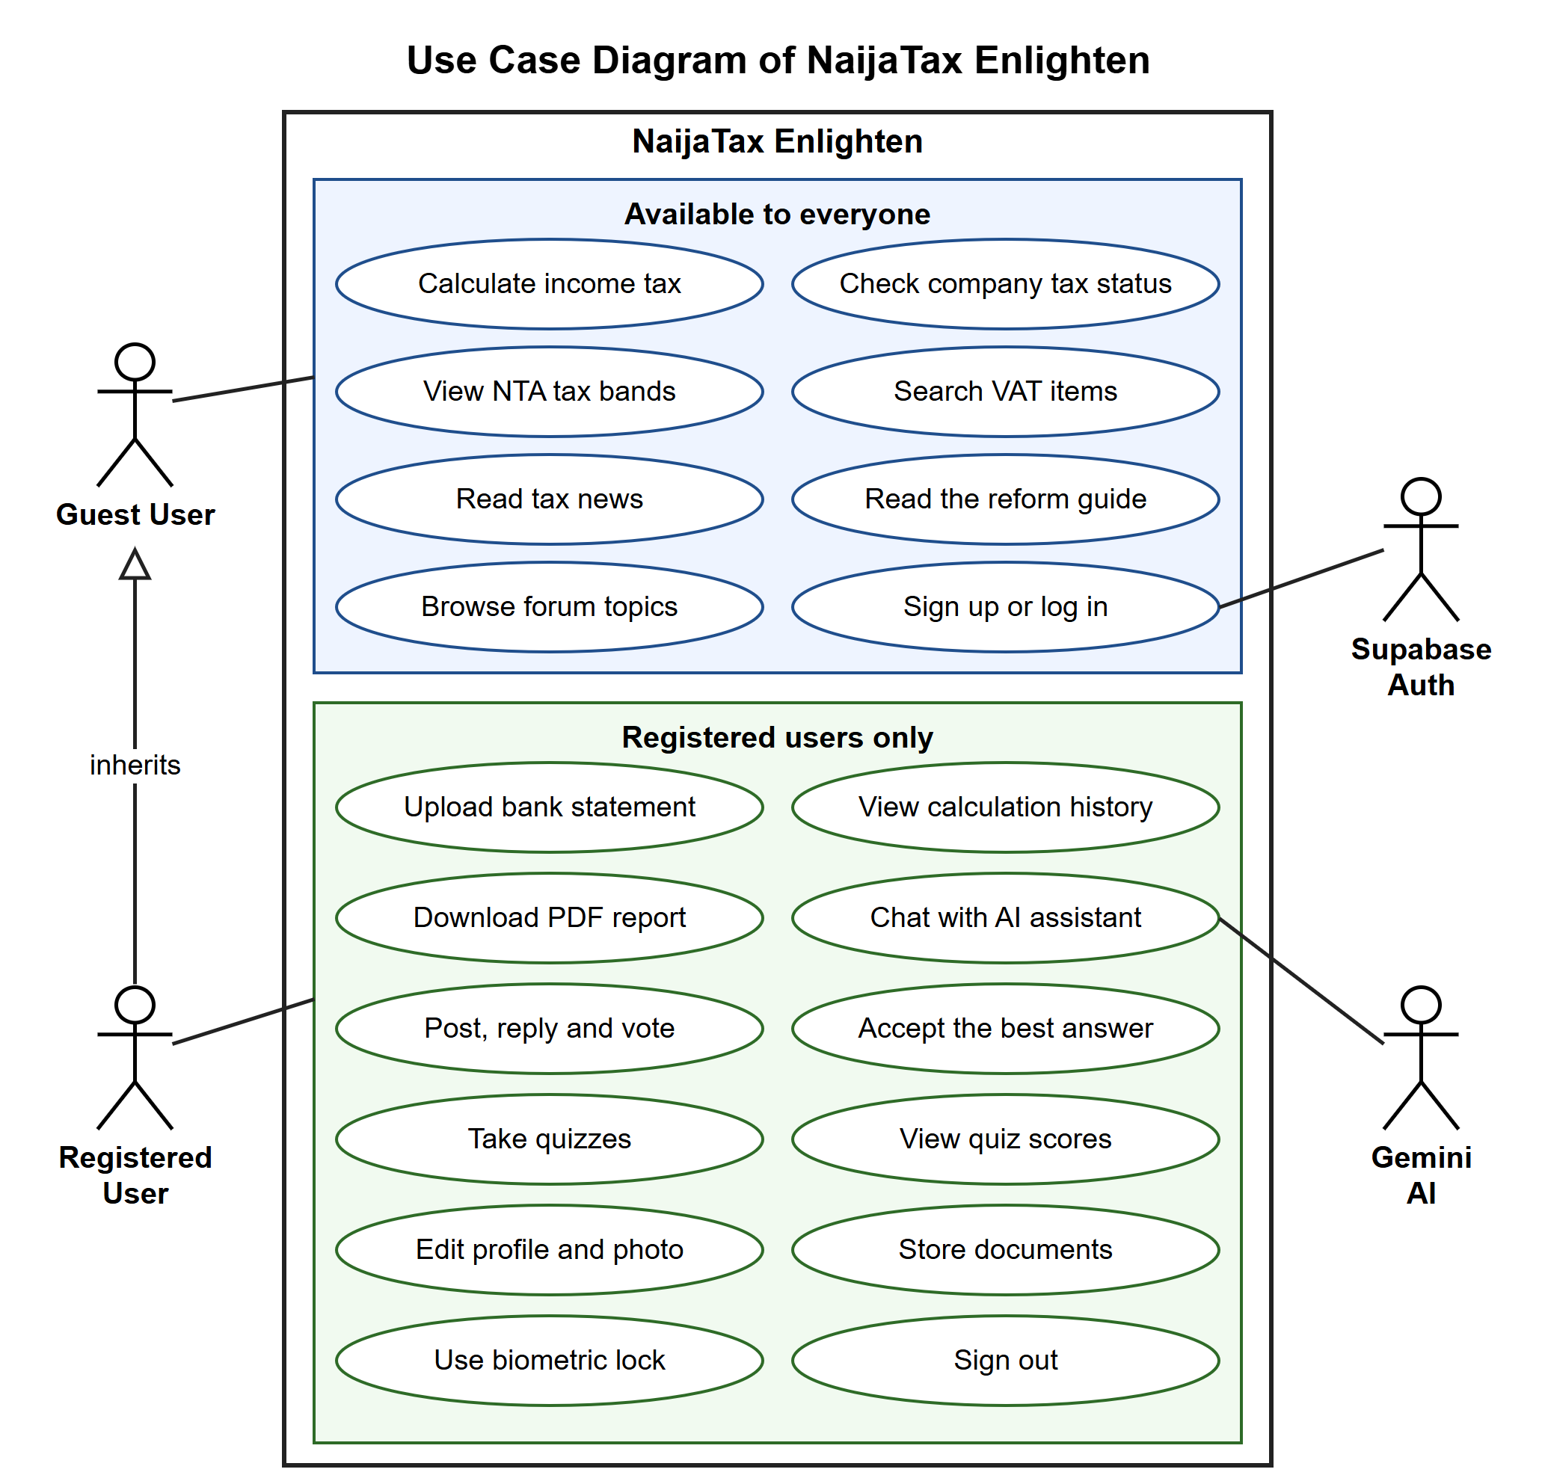
Figure 3.1: Use case diagram of NaijaTax Enlighten

II. The Activity Diagram
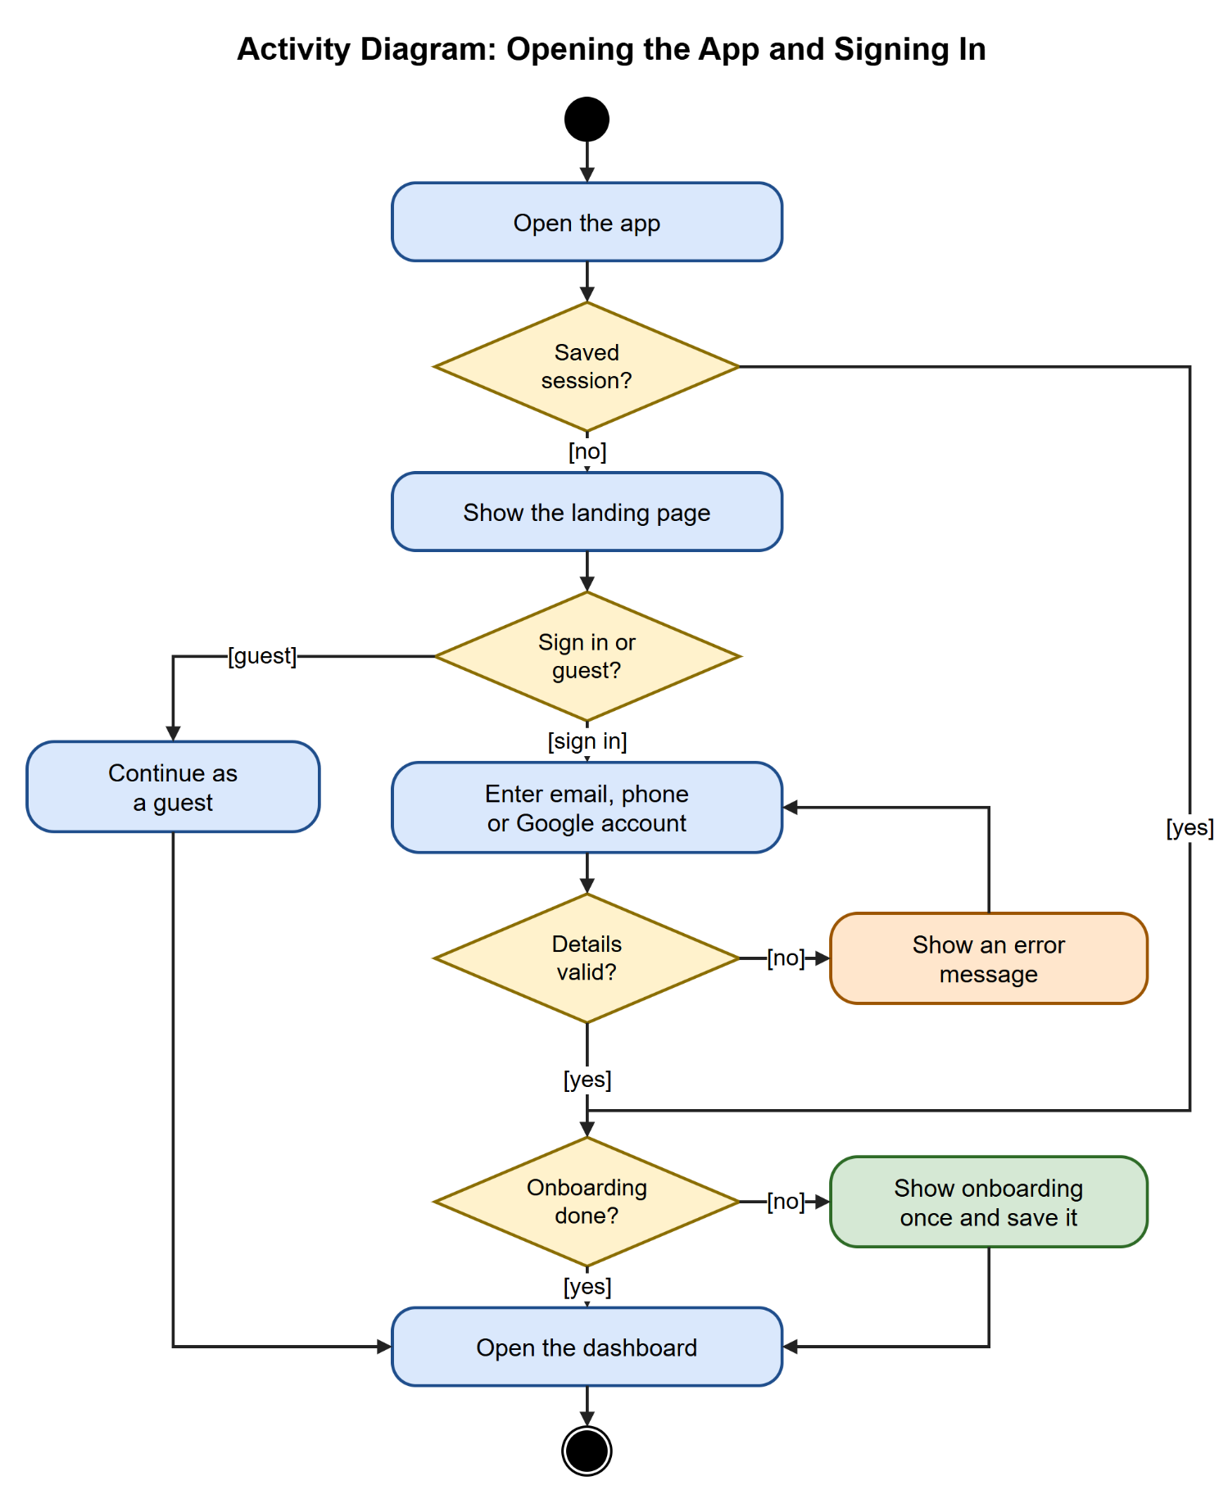
Figure 3.2: Activity diagram for opening the app and signing in
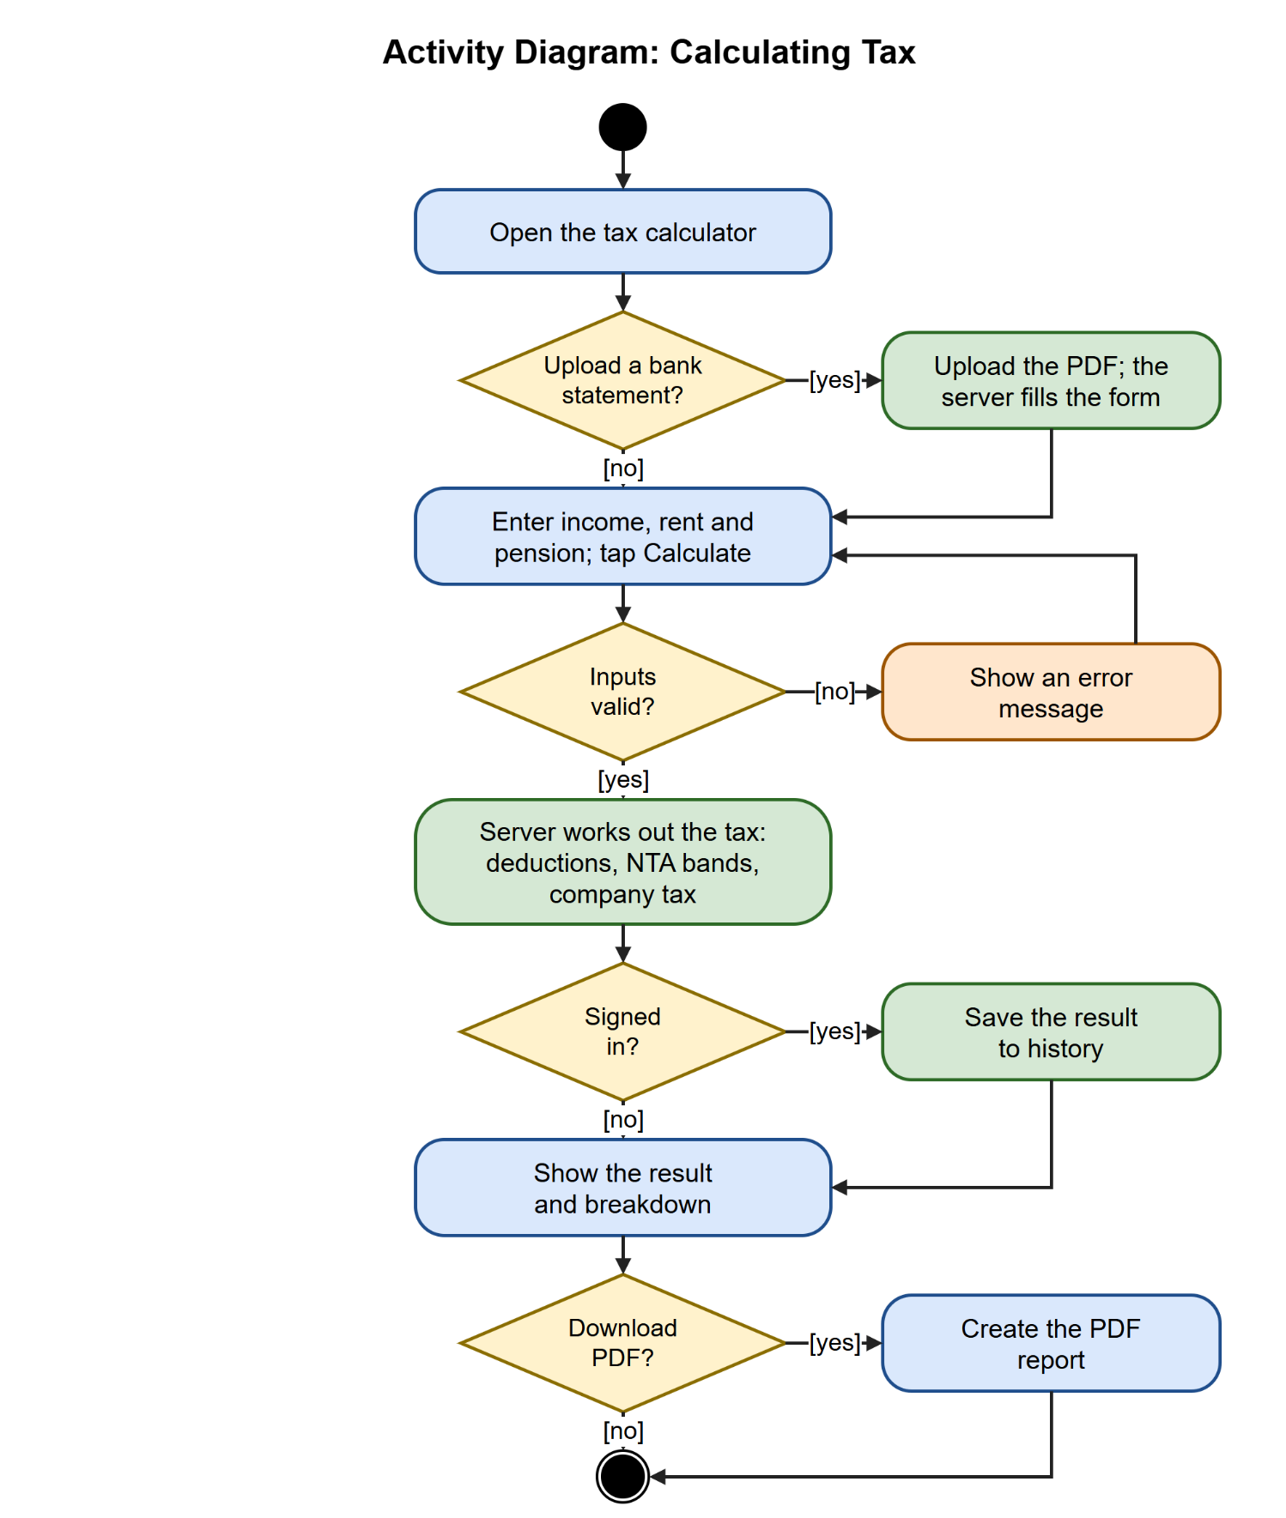
Figure 3.3: Activity diagram for calculating tax
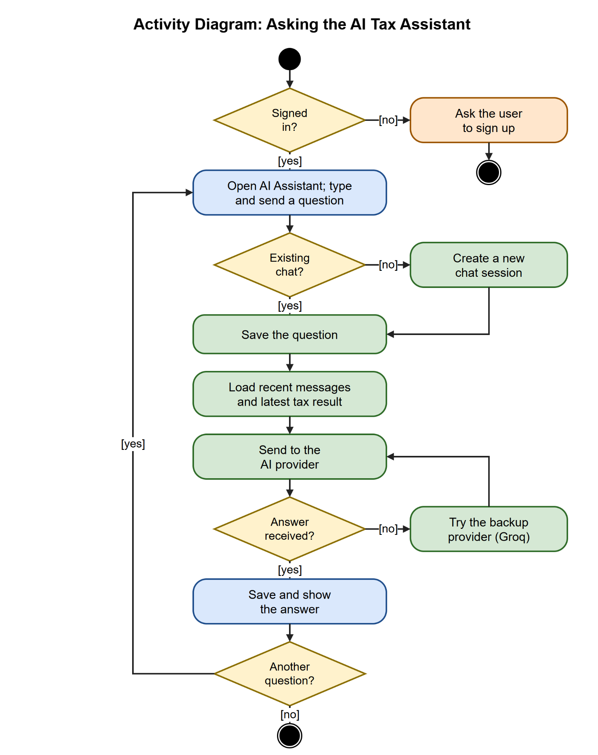
Figure 3.4: Activity diagram for asking the AI tax assistant
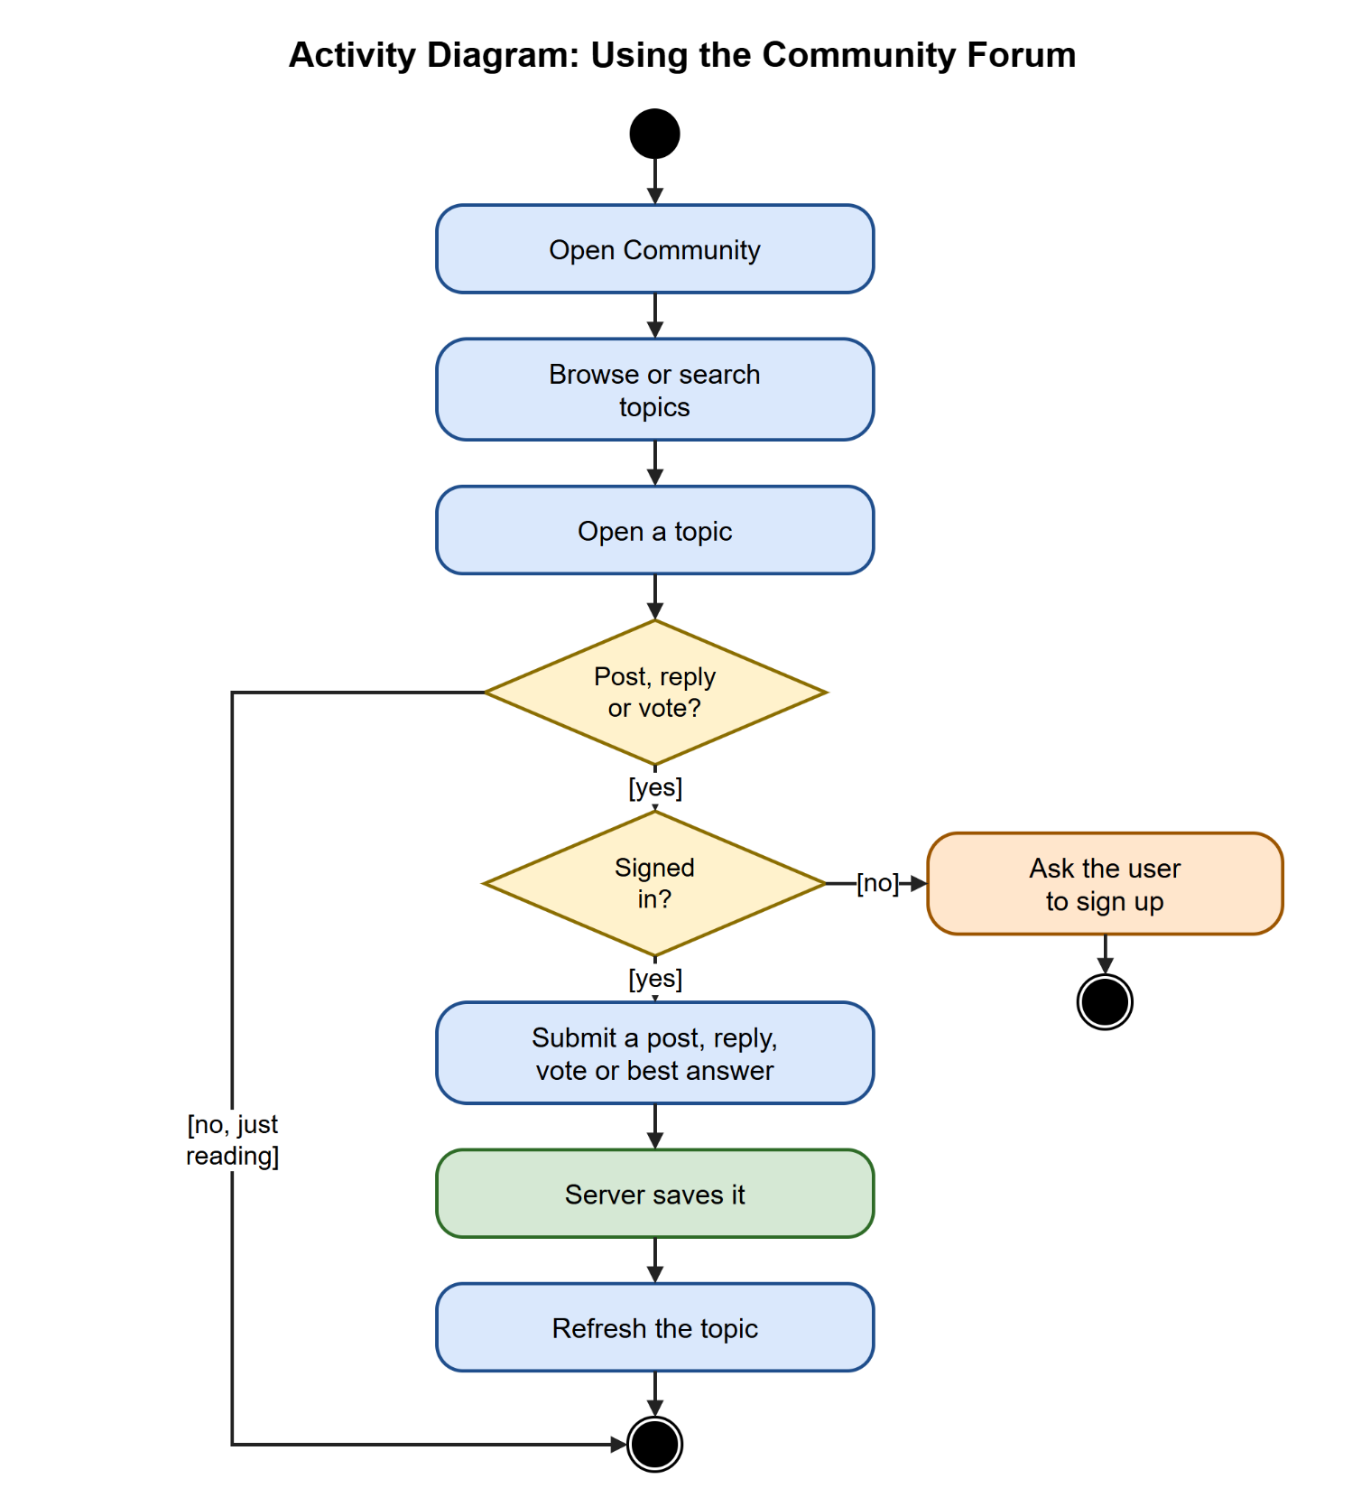
Figure 3.5: Activity diagram for using the community forum
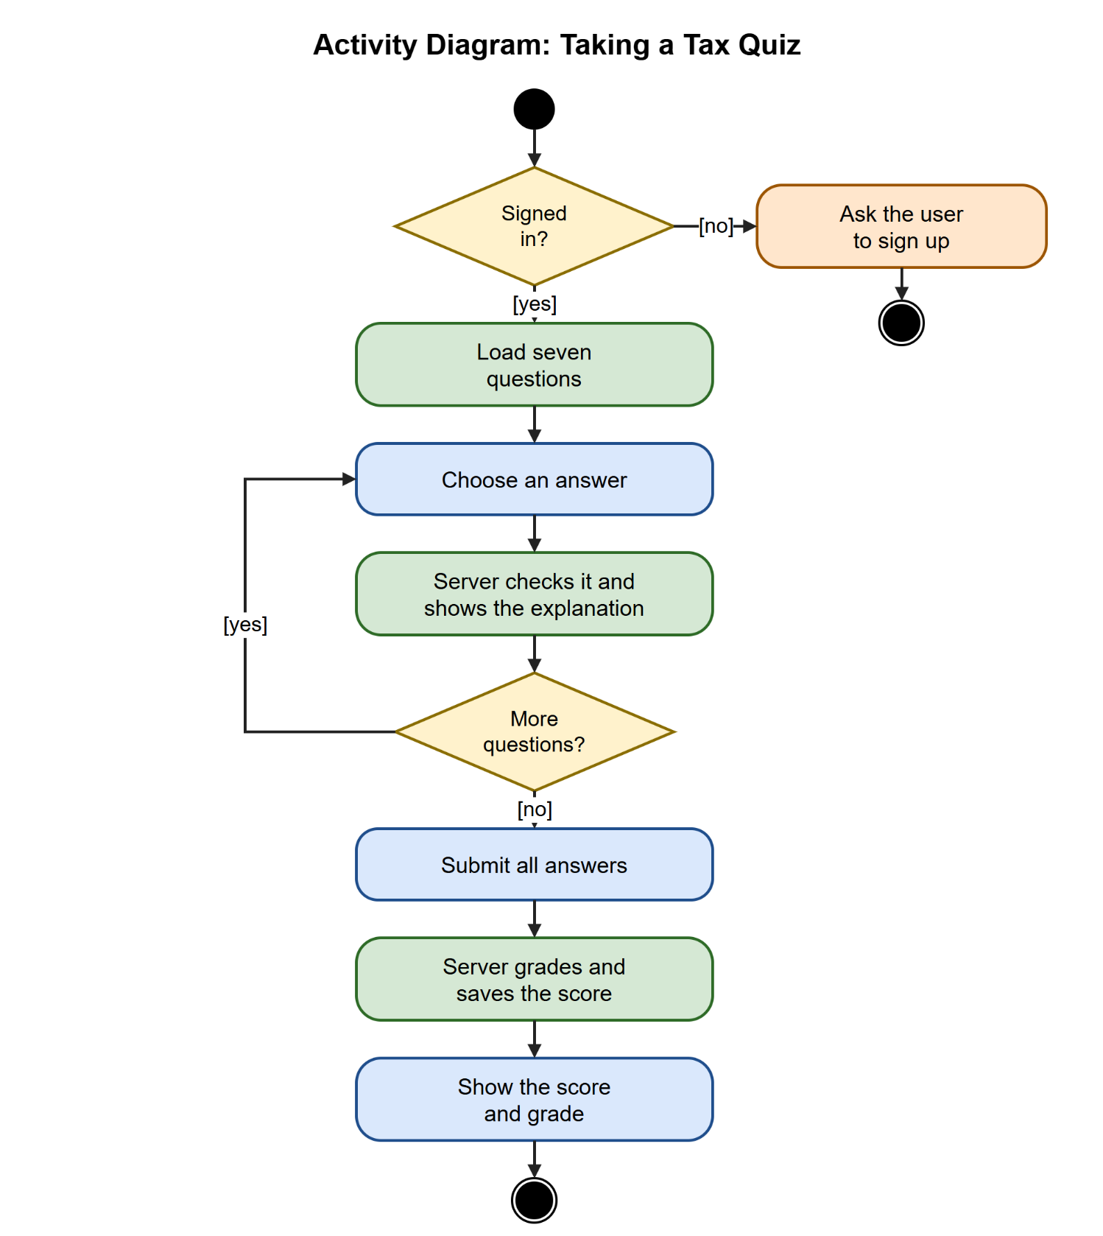
Figure 3.6: Activity diagram for taking a tax quiz

3.3 System Design
The system design phase translates the requirements identified in the analysis into a concrete technical blueprint. This section presents the architecture, the use case description,and the database design for NaijaTax Enlighten.

System Architecture
The application follows a three-tier client-server architecture:
- Presentation Tier — Flutter Application: The Flutter application is the only component that users interact with directly. It handles all UI rendering, user input, animations, and state management using Riverpod 2.5+. Navigation between screens is managed by GoRouter 17 with authentication-based route guards. The app communicates with the backend exclusively through HTTP requests made using the Dio HTTP client. On first load, the app authenticates the user (or continues as a guest), fetches the initial data it needs from the API, and stores it in memory via Riverpod providers. Data such as the user’s latest tax result, settings and recent news articles is cached locally using the Hive package to reduce API calls and improve performance on slow connections. The app runs on Android, iOS and the web from the same Dart codebase.
- Application Tier — Express.js + TypeScript Backend: The Express.js backend is the brain of the application. It receives all incoming HTTP requests from the Flutter app, validates them using Zod schemas, applies the appropriate business logic, communicates with the database via Prisma and calls the Gemini AI API for AI assistant requests. Security is enforced at this tier through middleware that verifies the Supabase-issued JWT on protected routes, Zod input validation, rate limiting, and Helmet for HTTP security headers. Passwords are handled entirely by Supabase Auth.
- Data Tier — PostgreSQL + Prisma: The data tier consists of two components. The PostgreSQL relational database (hosted on Supabase) is the primary persistent data store. It holds all application data: user accounts, calculation history, VAT item classifications, forum content, AI chat sessions and messages, tax news articles, quiz questions and quiz scores. Prisma 7 serves as the ORM, providing a type-safe client generated from the Prisma schema and handling all database queries, migrations, and relationships. The database is hosted on Supabase, while the Express.js server runs on Render.

3.3.1 The Class Diagram
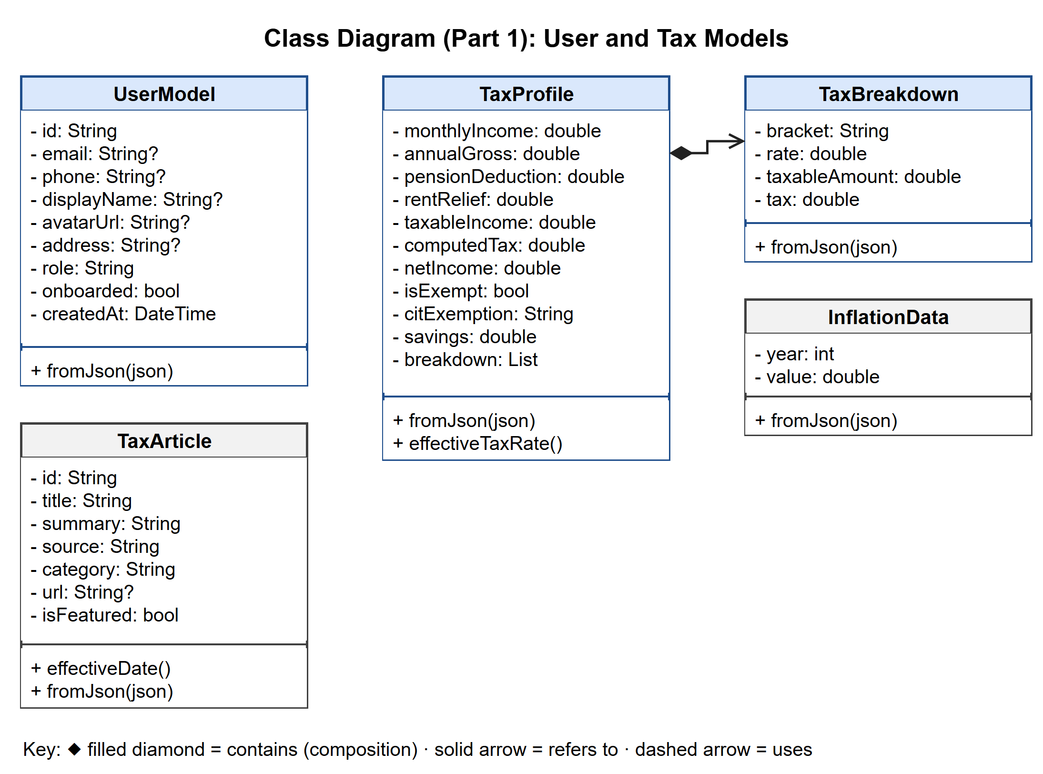
Figure 3.7: Class diagram (part 1): user and tax models
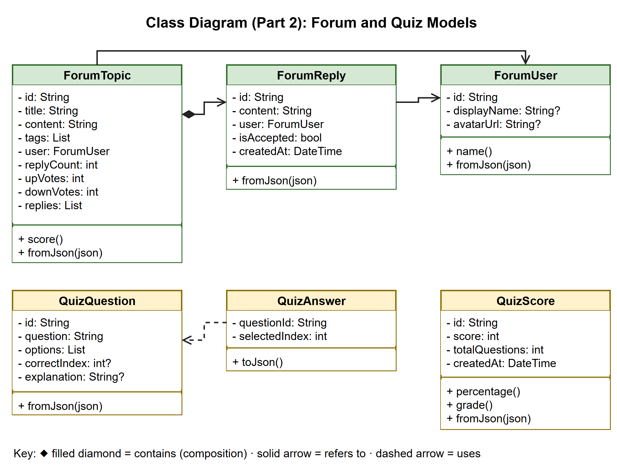
Figure 3.8: Class diagram (part 2): forum and quiz models
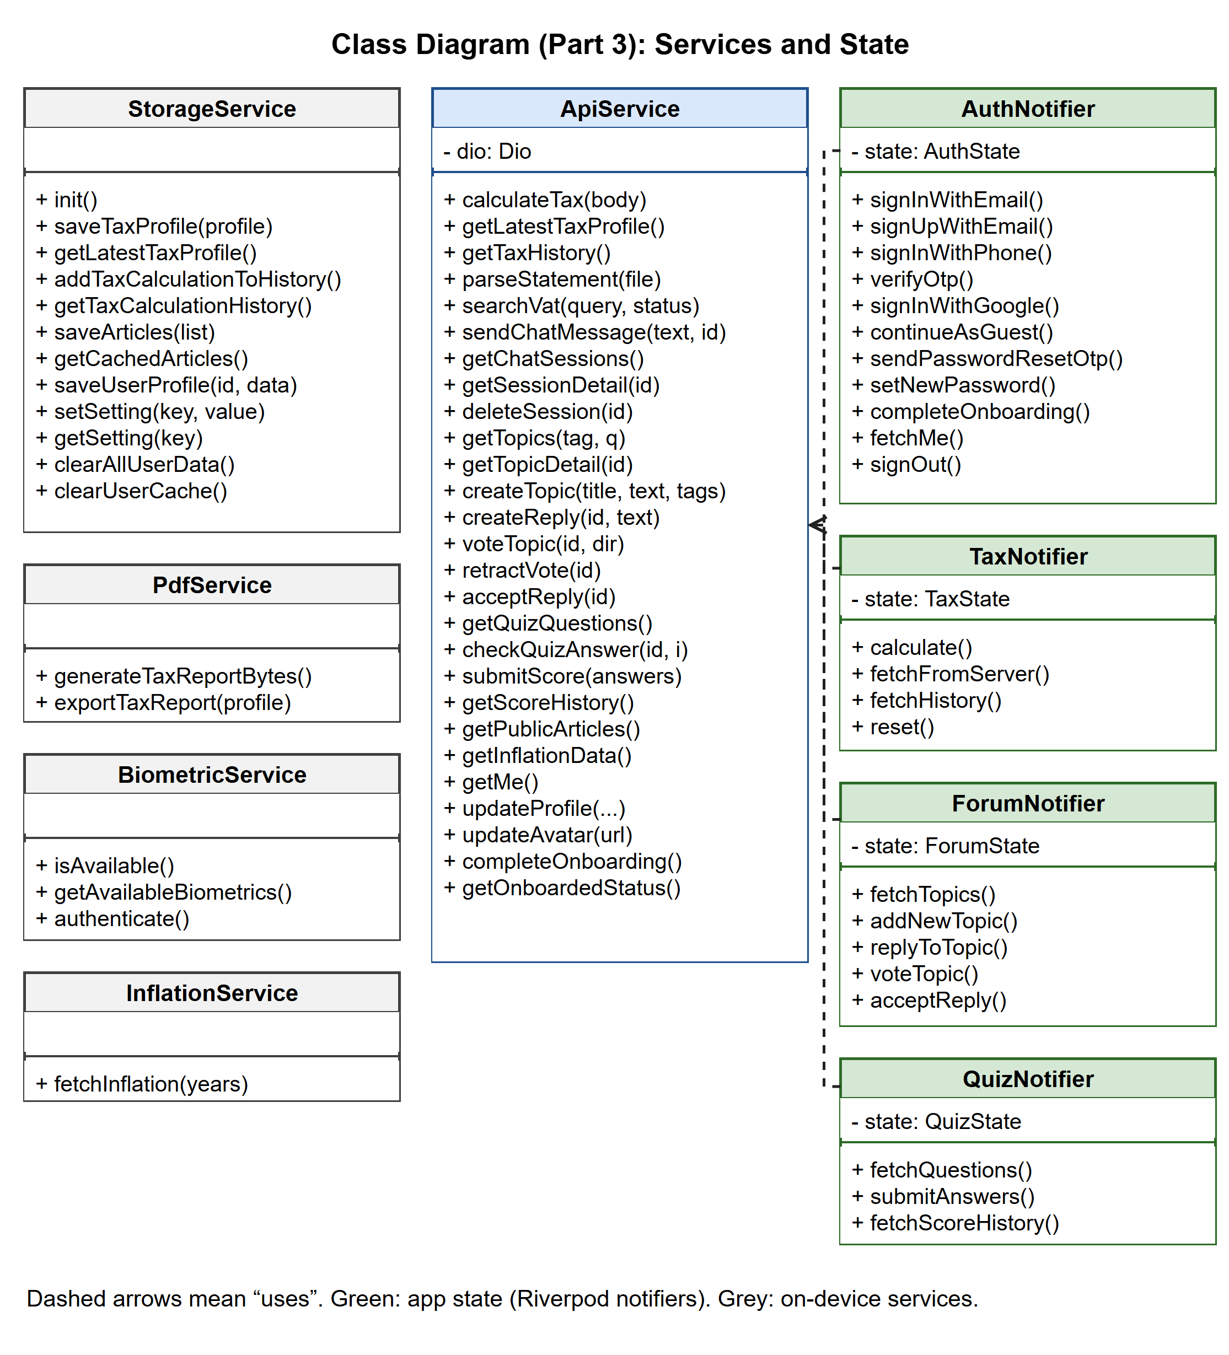
Figure 3.9: Class diagram (part 3): services and state

3.3.2 The Sequence Diagram
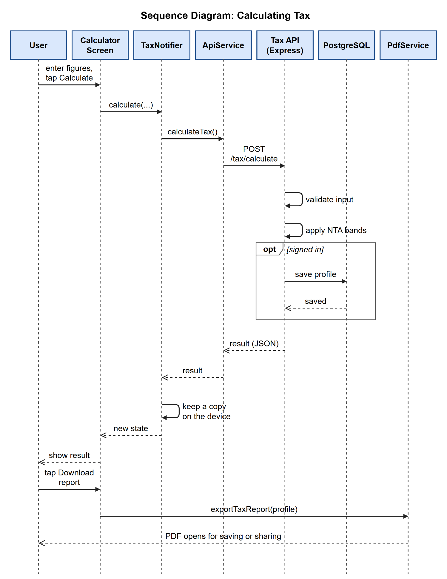
Figure 3.10: Sequence diagram for calculating tax
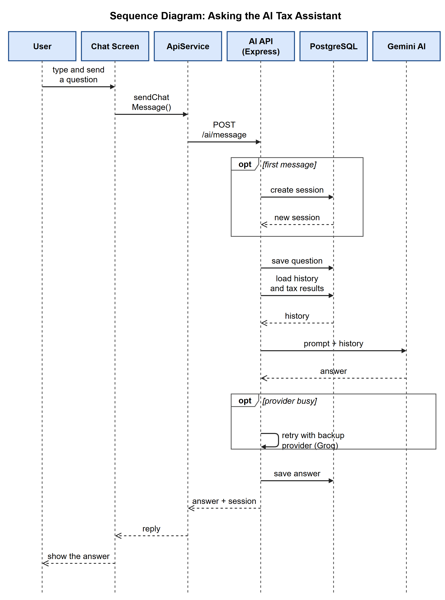
Figure 3.11: Sequence diagram for asking the AI tax assistant

3.3.3 The Database Design
The database used for this project is PostgreSQL. All its tables are shown in the entity relationship diagram in Figure 3.12. The two main tables are users and tax_profiles: the users table holds each registered user’s details, while the tax_profiles table holds every tax calculation a user saves.
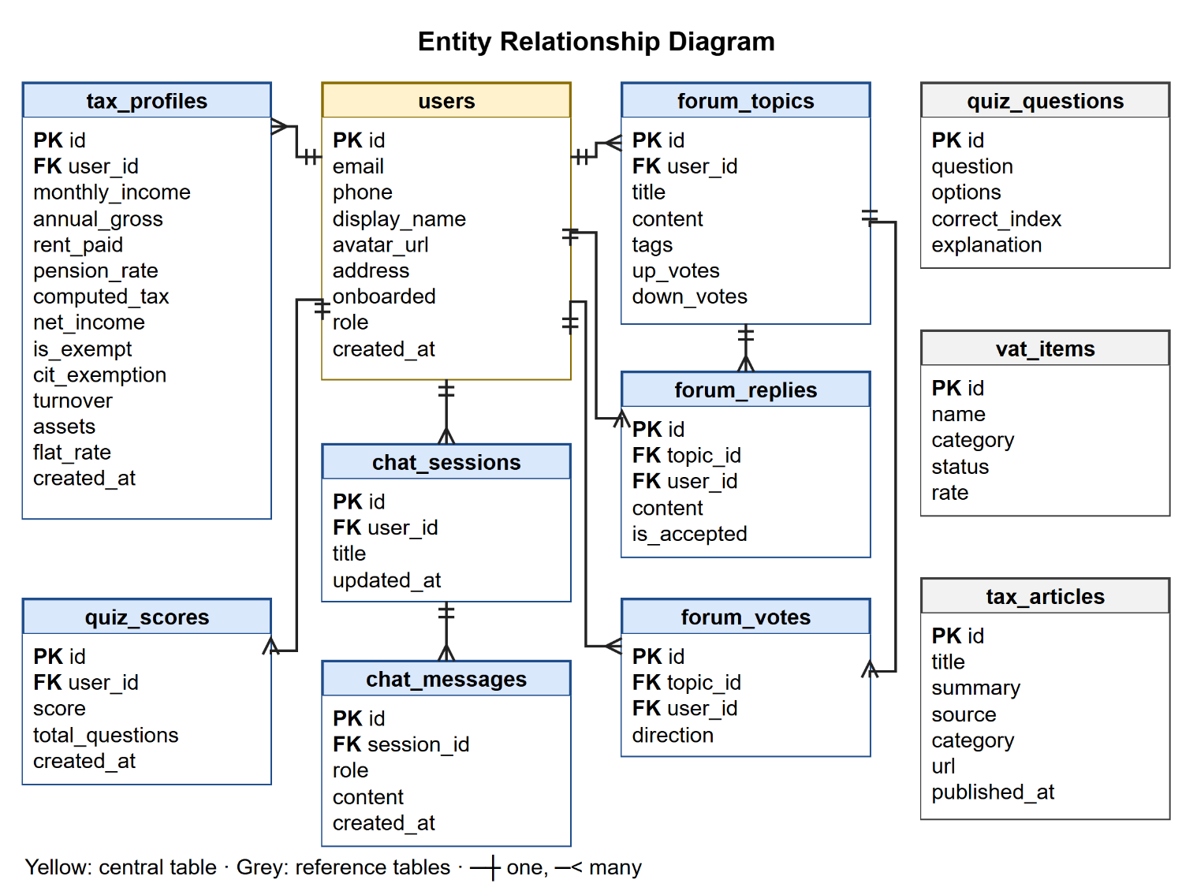
Figure 3.12: Entity relationship diagram of the database

