**Mental Health**  **Support Group**

*Helping Us Bounce Back* in Havering, Barking & Dagenham

Contact: Secretary on 07985-983673 or at djwbset@ntlworld.com

*HUBB Newsletter APRIL 2020.*

Hello, fellow HUBB members & Friends!

It is strange to have to meet this way, but it’s good to keep in touch however we can until whenever we can hold our next HUBB Meeting.

I hope you had a healthy & peaceful Easter, & are able to enjoy the sunshine out of doors occasionally, & that you are getting the food & meds, etc. that you need.

If not, here are contact details for free help or support during this corona-virus crisis:

**Barking & Dagenham**  
Call 0208- 215-3000 & ask for BD CAN, the local Citizens’ Alliance Network. They have come together in 9 centres across the borough run by local community group & volunteers.

**Havering**

Call the Council Helpline on

0800-368-5201

or Havering Volunteer Centre

on 01708-922-2154

or Mobile 07757-426-481

Havering Volunteer Centre’s emergency or out of office hours number is

01708-433-999

It must be Spring!

Deer in bluebell wood, **Romford**



from The Times on 16-4-20 , Jeff Moore

On 18-4-20, the Secretary of State for Communities, Robert Jenrik MP said *“Parks must stay open for the health of the nation. People need parks”*

So, although 150 people have ignored rules on using play areas in **Barking &** **Dagenham,** public parks remain open.

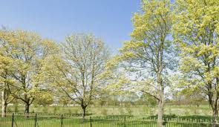

From Time1075.net 7-4-20

One cheering message we received was from Zurich, our Insurance company They have provided an extra 3 months cover, free, for HUBB from August until November 2020.

Thanks, Zurich!

**THE IDEA of the BRAIN, a History**, *by Matthew Cobb, was recently published & reviewed in The Guardian on 12-3-20, where Alan Rutherford wrote:*

**“This is the story of our quest to understand the most mysterious object in the universe: the human brain.**

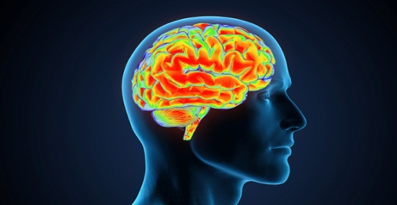Today we tend

to picture it as a computer.

Earlier scientists thought about it in their own technological terms: as a telephone switchboard, or a clock, or all manner of fantastic mechanical or hydraulic devices. Could the right metaphor unlock its deepest secrets once and for all?

Galloping through centuries of wild speculation and ingenious, sometimes macabre anatomical investigations, scientist and historian Matthew Cobb reveals how we came to our present (still limited) state of knowledge.”

*In The Times on 8-3-20, reviewing the same book, James McConnachie wrote***, it “shows just how little we know about the working of our minds. “**

*For instance, he quoted that in the case of Mental Illness*, “researchers have no real idea yet of how or why (or in some cases, if) the SSRIs, such as Prozac, taken to treat depression, actually work.”

*And in the case of a lobster: It* “has only **30 brain cells** in a most basic nervous system which has been comprehensively studied by the world’s leading neuroscientists. And yet we have very little idea of how even parts of it work.”

[ *So we have a long way to go to understand the workings of the human’s* ***90 billion*** *brain cells.!DJB]*

**“**Life is what happens when you’re busy making other plans”

From John Lennon’s song ‘Darling Boy’, 1980, quoting a Reader’s Digest article in 1957.

COMMENTS on COPING:

Sarah C, who had been Detained under Section in mental health hospital for years said about Self-Isolating: *“It doesn’t feel dissimilar to my time in hospital, but now it’s the government controlling my movements rather than my doctors”*

The Guardian newspaper on 16-4-20

Andrew Soloman wrote*“When I lived with the Greenlandic Inuit, I found their high level of depression was tied, not to their sunless winter, but to the intimacy it forced”*

The Guardian on 13-4-20

Prince William pointed out in an interview with the BBC on 17-4-20 after his father had been in hospital with Corvid-19 *“ that NHS workers had to absorb the pain, fear & loneliness of their Corvid-19 patients, whilst protecting their own lives & families.”*

Prince William & the Duchess of Cambridge with Prince Charles who has recovered from Corvid-19

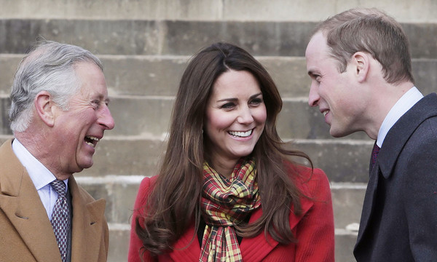

Hello Magazine on 17-4-20

**“A very healthy coping strategy”**

Since the lockdown, many people have been spending more time on their own. Should they be worried if they end up chatting to the only person in the room? Sue Elliott-Nicholls thinks not.

**Before the coronavirus lockdown Georgia Maskery didn't talk to herself, but now she's becoming her own motivational speaker, giving herself pep talks.**

"I always start with*'Georgia'*, because then it's like someone else is talking to me," she says.

"I have to motivate myself to do everything, I have to motivate myself to put pants on in the morning! Although this morning, I was going to go for a run, but I actually talked myself out of it. *'Right, Georgia, are you gonna go?'* I began. Then I'm like,*'Yeah yeah, I'm gonna go,'* though by this time I was already buttering my bagel."

Then it went like this, she told me:

“Look Georgia... are you going to go?

*Yes.*

Are you sure?

*No, no, I'm not sure, because actually what I think I'm gonna do is have breakfast first, because it's meant to be sunnier at lunch time.”*

This doesn't sound like a "sign of madness" to me, this sounds like a very healthy coping strategy, says Sue.

BBC stories on 18-4-20

LONELY HEARTS Advert:

Single man with Toilet Rolls would like to meet single woman with Hand Sanitizer for good clean fun.

**HUBB’s Official Status: Proposed Action:**

As you know, HUBB sadly lost Christine, our Treasurer on 31-12-19, but as soon as we can run HUBB’s AGM & election again, Yulia Shibaeva, who attended our last meeting on 6th Feb. is suitably qualified & interested in standing for this position

Our Chair, Henry, is out of action at present, but John Newman is capable & interested in standing for the post of Deputy Chair.

Until we fill these posts, HUBB is not eligible to make decisions or bid for charitable funds in order to develop our organisation as we would like.

**I therefore propose, as HUBB’S remaining Trustee & Secretary, to invite Yulia & John to become co-opted Trustees to fill these 2 posts, for the duration of the ‘lockdown’**.

If they accept, we will communicate online & review our options for HUBB’s future, as discussed at recent HUBB meetings.

*Any HUBB member who has concerns about this proposal should contact me on 07985-983673 or at djwbset@ntworld.com*

**What should I do if I can’t find Hand SANITIZER?**

Don’t worry: the NHS advises using Hand Sanitizer gel ONLY if soap & water are not available.

Hand Sanitizer is not a magic solution to getting your hands as clean as possible

**Firstly**, to be effective, it must be at least 60% alcohol – to be safe, look for 60-90% alcohol concentration. Avoid alcohol-free options.

**Secondly**, the UK Centre for Disease Control (CDC) says if your hands are very dirty or greasy, this can prevent Hand Sanitizer from working properly. You also need to ensure you are using enough of the gel, & that you are not wiping it off before it is properly dry.

**Thirdly**, Hand Sanitizers don’t eliminate all types of virus. The CDC says that soap & water is more effective. And washing your hands with soap is easier! [& cheaper..DJB]

**Home Thoughts from Abroad**

Oh, to be in England  
Now that April’s there,  
And whoever wakes in England  
Sees, some morning, unaware,  
That the lowest boughs and the brushwood sheaf  
Round the elm-tree bole are in tiny leaf,  
While the chaffinch sings on the orchard bough  
In England—now!

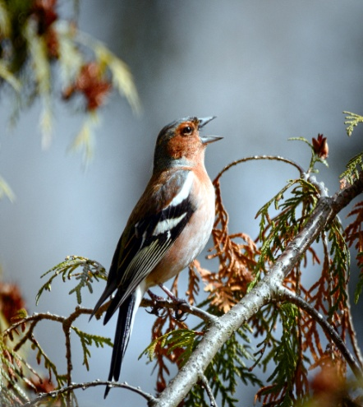And after April, when May follows,  
And the whitethroat builds, and all the swallows!  
Hark, where my blossomed pear-tree in the hedge  
Leans to the field and scatters on the clover  
Blossoms and dewdrops—at the bent spray’s edge—  
That’s the wise thrush; he sings each song twice over,  
Lest you should think he never could recapture  
The first fine careless rapture!  
And though the fields look rough with hoary dew,  
All will be gay when noontide wakes anew  
The buttercups, the little children’s dower  
—Far brighter than this gaudy melon-flower!

Robert Browning, probably written in Italy in 1845.

**MENTAL HEALTH AWARENESS WEEK**

Mark Rowland, CEO Mental Health Foundation emailed this on 9th April:

“I am writing to you all with an update about this year’s Mental Health Awareness Week, which we have been hosting since 2001.

Owing to the current coronavirus pandemic we have decided to change the theme for this year’s Mental Health Awareness Week which will run from **18th to 24th May 2020**

The new theme will be “KINDNESS”, as we feel that now more than ever we need to re-discover our connection to kindness and each other in our daily lives. It therefore feels right to use Mental Health Awareness Week this year to celebrate the many thousands of acts of kindness that are so central to the quality of our mental health.

We also want to start a discussion about the kind of society we want to shape as we emerge from this pandemic.

We will return to the original topic of “SLEEP” at a later date, because it remains such an important topic.”

Dear HUBBsters: Have you experienced or know of any acts of Kindness which HUBB could share in next month’s Newsletter?

If so, please email [djwbset@ntlworld.com](mailto:djwbset@ntlworld.com) or text or phone Dinah on 07985-983673 before 12th May

Last thought:

“Panic, too, is contagious. Avoid it!”