**

*Helping Us Bounce Back* in Havering, Barking & Dagenham

Contact: Secretary on 07985-983673 or djwbset@ntlworld.com

***HUBB Newsletter SEPTEMBER 2020.***

Who or What is HUBB? See back page!

We did it!

HUBB members (16 of us) managed to hold a HUBB meeting of sorts at last, on August 6th, under the Bandstand in Raphael’s Park, Romford.

We kept a register as usual - but also to enable track & trace if necessary -& we enjoyed meeting eachother again, & being able to chat face-to-face (but keeping our distance).

For our buffet we had fruit & ready-wrapped snacks like crisps & chocolates & mini-fruit juices.

And we were the ones who stayed dry under the Bandstand when the rain eventually swept through the park!

HUBB’s PUBLIC FACE is BEING UPDATED!

Andy Walpole, who helped Christine Maloney when she created our previous **Website**, is now updating it for us. Soon it will display our news, our values & purpose, updated policies, membership forms & photos.

Paul Bergin, who joined us in Raphael’s Park, is a graphic designer who has offered to create a livelier public image for HUBB, & has already produced a new streamlined **logo** for us: see above.

HUBB’s NEXT MEETING

***(latest Covid-19 rules permitting*** *\*)*

will be on Thursday 1st October

from 4.30 to 6.30pm

(note later times)

at The Hub Community Centre,

12 Gubbins Lane, Harold Wood

Romford RM3 0QA

This is a modern ground floor building with all facilities including a cafe & a kitchen, & a large Main Room with enough tables to hold about 20 of us whilst we are **socially distancing**.

The Hub is at the junction of Squirrels Heath Rd & Gubbins Lane. Buses 256, 294, 646 & 656 stop outside.& the 496 347 stops at Harold Wood Station which is about a 5 minute walk away.

As HUBB is a community support group, the Hub is RENT FREE (but donations towards the Buffet gratefully received.)

We will have a Buffet- served at your table- & a Raffle, & may have a Speaker.

You must wear your **Mask** when you are not seated, & stay 6 ‘ apart from eachother _ no hugging!

*Please let Dinah the Secretary know if you expect to join us, for catering numbers, &*

***\*if new rules mean this Meeting must be cancelled at short notice(still OK at 24th,) we will phone to tell you so on Thursday morning1/10/20.***

*Hospital: where those who are*

*run down wind up*

. HUBB is grateful to KallKwik, Romford, for ‘helping to keep Romford open for business” & printing our Newsletters during the ‘lockdown’

**ASK, LISTEN & HELP**

In HUBB’s December 2019 we reported that a Barber in North Somerset provides Men in Mind sessions in his barber shop to encourage his clients to share their anxieties in an informal environment.

This was part of a project run by the Lion’s Barber Collective, a mental health & suicide prevention charity, which offers barbers 4 short videos to demonstrate how to ‘Recognise, Ask, Listen & Help’ their customers who show signs of mental stress.

Now this has been incorporated in a £8 million package during 2020-2021 “in which local NHS, public health teams & voluntary organisations are helping to bolster suicide prevention plans (which includes the Lions Barber online training) & an additional £2 million to give practical & emotional support to grieving friends & family.”

Clair Murdoch, the NHS national mental Health director [ who knew?] said “Every death by suicide is a tragedy.. which is why we continue to expand access to mental health care, including offering help from different & convenient community locations....”

(From The Times on 14-9-20)

MASKS: Why? Which one?

(Extracts from which.co.uk & The Times 15/7/20)

Have you noticed how masks are now fashion items? Designers like Fendi, Louis Vuitton & Gucci are producing stylish masks to match your dress or shirt!

*But the job of any face covering is vital: to capture large droplets & smaller aerosol particles when we speak, sneeze or cough, & prevent them - & the virus - from spreading*

*particles when we speak, sneeze or cough, & prevent them - & the virus - from spreading.*

**You can choose from** adjustable loops or fixed straps, curved masks that are shaped to your face, or masks with built-in metal nose-wires that help to keep the mask in place & are particularly useful if you wear glasses & find they get steamed up in some masks.

**Compare the choices Maximum score is 5.**

**Cotton or silk & cotton masks: *Research found that wearing these masks protects the wearer as well as those around him* The more layers of fabric a mask has, the better. Some have a pocket for a filter (you can use kitchen roll) .Remove this after each use & wash the mask as often as you would a handkerchief. SCORE: 5**

**Replaceable filter masks are made of silicone, are washable, lightweight & & fit to your face. They cost £19.99, plus £19.99 for 20 replacement filters (each one lasts a week.) SCORE: 5**

**Synthetic fibre masks: the best ones are made from polypropylene, but also polyester or spandex. They are not always easy to breathe through, but fit well & provide good protection. SCORE: 4**

**Scarves are the least effective (even if fashionable)– often loose fitting so needing frequent adjustment, & made from loosely woven fabric, allowing gaps where the tiny particles can escape. SCORE: 1**

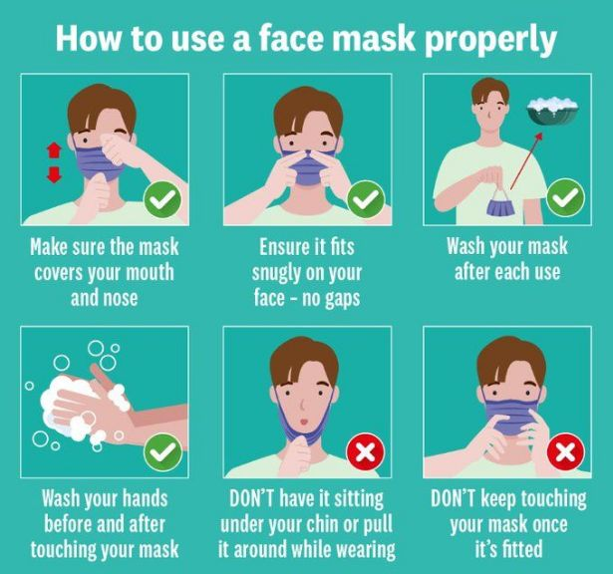

Continued on p 3.

MASKS cont.

**Cycling Masks: Usually made from Neoprene, thick & bulky with a filter against pollution, easy to breath in but made to help the wearer exhale nasty stuff, including any tiny virus particles, so do not protect others. SCORE 1**

**Single-use Disposable Masks: Cheap, only give basic protection against large droplets, not small particles, not washable or biodegradable, risk that people may use them repeatedly, thus spreading the virus. SCORE 1**

**From which.co.uk & The Times of 15-7-20**

Did you hear about the illegally parked frog ?



He had to be toad away! *Boom Boom* !

**The Birth of HUBB**

*HUBB came into being around the beginning of the 90s.*

*There were plans being made to develop services in the community to enable the closure of Warley Hospital.There was a national push to develop User*

*Involvement and we (Havering, Barking& Dagenham and BHB Health Trust) decided to create a system.*

*Polly Bagnall, John Helbin and I travelled to Bristol to learn how this could happen.*

*HUBB began with a coordinator and a secretary.*

*Our early attempts to involve users in the*

*planning meetings were not very successful.Users were keen to be involved but we didn’t know how to use them. One person sitting in a meeting was intimidated at worst and non- productive at best- they could only give their own personal views. The pressure on some was so much that they suffered a relapse and ended up back in Warley.*

*Fortunately, we learnt from this and when*

*Caroline Lovejoy joined as Project manager, HUBB invited service users from both Boroughs (and Brentwood)*

*to meet, and plans were presented for discussion.*

*The use of post-it notes was invaluable to enable people to share their thoughts privately and anonymously.*

*The outcome was a very well- developed user acceptable plan which was worked on over the next few years.*

*CMHTs, welfare advice, employment schemes, drop-in centres, befriending and our HUBB were developed.*

*The Statutory Advocacy role which HUBB eventually provided together with the ongoing user support groups and our* *Newsletter maintained HUBB’s position as the key user organisation in the Boroughs.*

*Time has moved on and resources available in the 90’s have been squeezed so that many of the above services are no more - but HUBB still remains ,all be it in a smaller version of its former self.*

*On a personal note I have been privileged*

*to live through all these changes, from a Principal officer in B&D Social Services to Operations Director at NELMHT (now NELFT) to Treasurer of HUBB (after my retirement) until its merger with VoiceAbilty.*

*I am so pleased to see HUBB continuing to provide a crucial support to individuals and their families.*

***Onward and Upwards!***

***Steve Marsh***

*A psychiatrist fellow from Rye*

*Went to visit another close by,*

*Who said with a grin*

*As he welcomed him in*

*“Hello Joe- you’re all right! How am I?*

**WHO or WHAT is HUBB?**

**HUBB Support Group** is an independent, self-managing, unregistered charity for adults who support eachother to move on from Mental Illness.

**We meet** once a month for

Friendship, Refreshments, Visiting Speakers, a Raffle, & Encouragement, in a ‘Safe Place’ to share Experiences.

IF RULES ALLOW US TO MEET AGAIN: - Join us on the **1st Thursday** of every month, from 4.0 to 6.0pm –address to be confirmed, but probably in the Lecture Room at YMCA Thames Gateway, 29 Rush Green Rd. RN7 0PH (near Roneo Corner). Entry is £2. **Next meeting to be announced in advance in the Monthly HUBB Newsletter**, sent to all members **& on our Website: www.HUBBsupportgroup.org.uk**

We also join in relevant public **Events** & invite our members to respond to selected **local & national** **Consultations** such as the plans for the future of Romford & the Review of the Mental Health Act .

**TERRY STREET**

On a sqeaking cart they push the usual stuff,

A mattress, bed ends, cups, carpets,chairs,

Four paperback westerns.Two whistling youths

In surplus US army battle-jackets

Remove their sister’s goods. Her husband

Follows, carrying on his shoulders the son

(Whose mischief we are glad to see removed)

And pushing, of all things, a lawnmower.

There is no grass in Terry Street. The worms

Come up in concrete yards in moonlight.

That man, I wish him well. I wish him grass.

By Douglas Dunn

**BLOOD TESTS in Havering, Barking, Dagenham & Redbridge are by appointment only.**

**From 5-8-20 we MUST book in advance & be registered with a GP in one these boroughs**

**. Contact any of the clinics below on**

* [03003001704 / 03005551045](tel:03003001704%20/%2003005551045)
* [nelft.nhs.uk](https://www.nelft.nhs.uk/phlebotomy-blood-test-appointments/)
* Barking Community Hospital
* Barley Court Clinic
* Chadwell Heath Health Centre
* Church Elm Lane Health Centre
* Elm Park Clinic
* Harold Hill Health Centre
* Loxford Polyclinic
* Porters Avenue Health Centre
* Victoria Centre

*UNIVERSAL CREDIT SUCCESSES*

Although this system has been heavily criticised for its delays & regulations, it appears to have become surprisingly efficient under the immense pressure of claims during lockdown. In a normal week there would be 12,000 new claims, but on March 26th there were 136,000.

Figures show that 90% of these claims were paid on time & in full.

To achieve this Neil Couling, the Director, abandoned some security checks & notably the requirement for claimants to look for work. He also re-allocated 10,000 staff from Passport Office to the DWP. 20,000 laptops were provided for staff to work from home. And payments were raised by £20 a week.

Now, optimistically, the DWP plans to double the number of their Job Coaches, but in some areas they will struggle to find jobs to fill this year.

'Sam F is taking part in a #HADheroes fundraiser for the Havering Association for People with Disabilities.' 'To find out about her challenge or to make a donation, go to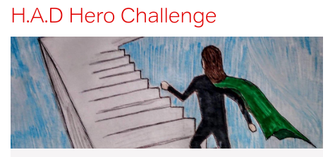 [www.virginmoneygiving.com/SamFinlay](http://www.virginmoneygiving.com/SamFinlay)  '