**Southern University of Science and Technology**

**Computer Networking Lab Report**

**唐润哲 11710418**

* ***Introduction：***

In this lab, we were taught some important commands to detect and diagnose network.

* ***Procedure and Result：***

**Fig.1**

* **Q1:**

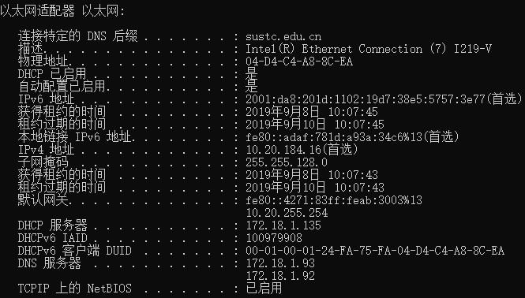

**Steps:** ipconfig /all (The result is shown in Fig.1)

**Results:** ① IP address: IPv4: 10.20.184.16

IPv6: 2001:da8:201d:1102:19d7:38e5:5757:3e77

② Mac Address: 04-D4-C4-A8-8C-EA

③ gateway IP address: IPv6：fe80::4271:83ff:feab:3003%13

IPv4:10.20.255.254

④ DHCP server IP address: 172.18.1.135

⑤ subnet mask: 255.255.128.0

The IP address of the host is allocated dynamically through DHCP. The lease time of the current IP is from “2019.9.8 10:07:43” to “2019.9.10 10:07:43” ,exactly 48 hours.

* 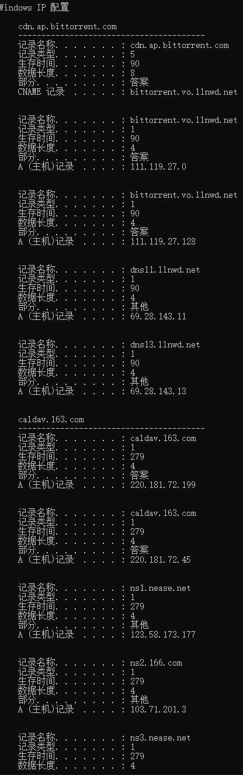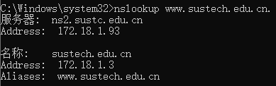**Q2:**

**Fig.2**

**Fig.3**

**Steps:**

① ipconfig /all (The result is shown in Fig.1)

② ipconfig /displaydns

③ nslookup www.sustech.edu.cn.

**Results:**

① As shown in Fig.1,the IP address of host’s DNS server is 172.18.1.93 and 172.18.1.92

② DNS information is shown in Fig.2

③ IP address of [www.sustech.edu.cn](http://www.sustech.edu.cn). is 172.18.1.3(Fig.3)

* 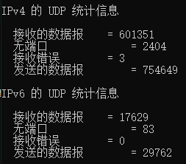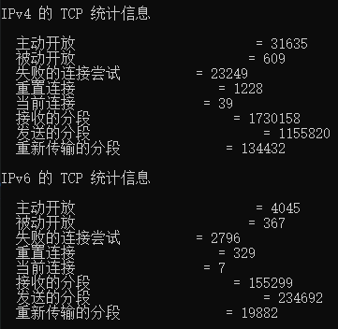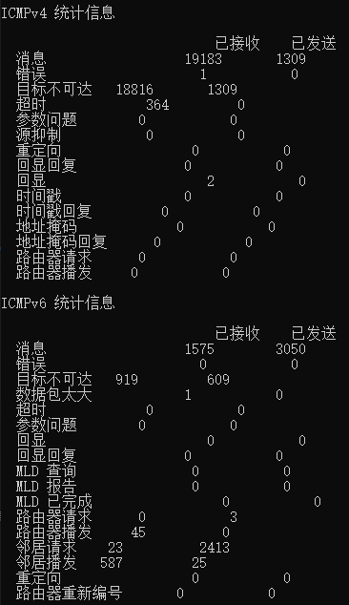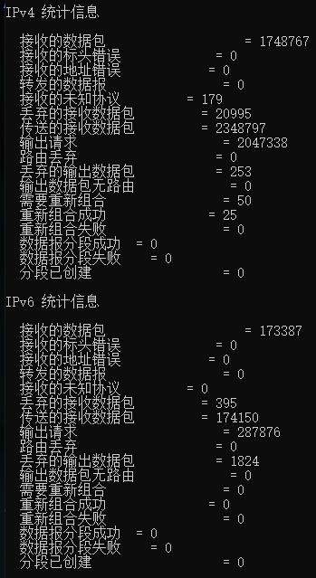**Q3:**

**Fig.7**

**Fig.6**

**Fig.5**

**Fig.4**

**Steps:** netstat -s (The result is shown in Fig.4~Fig.7)

**Results:** ① IP,ICMP,TCP and UDP are counted by the command based on IPv4 and IPv6.

* 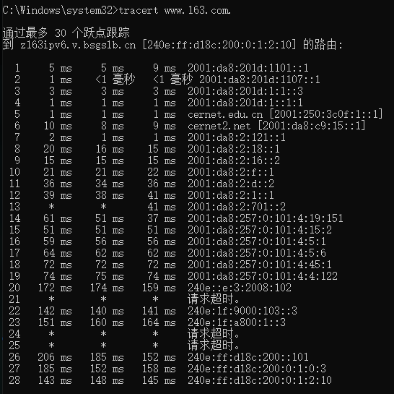**Q4:**

**Fig.8**

**Fig.9**

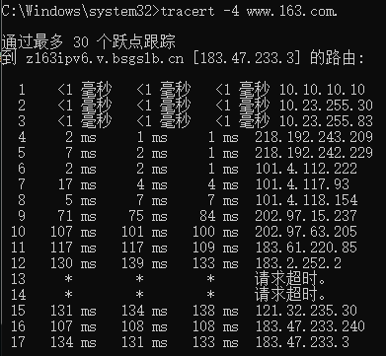

**Steps:**

1. tracert www.163.com.
2. tracert -4 www.163.com.

**Results:**

The default IP address of ‘www.163.com’ is ‘240e:ff:d18c:200:0:1:2:10’ and the total number of hops is 28. However when -4 is used , there are only 17 hops, and the IP address is ‘183.47.233.240’.Both of them have ICMP messages lost during the process.

* ***Conclusion and Experience：***

**Fig.10**

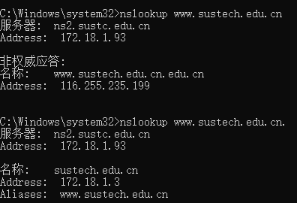

In Fig.10,we can see different results when we use the command ‘nslookup <domain>’, the reason is that when we forget to add a dot ’.’ at the end of the domain, the system may redirect to another domain with the prefixed name. As shown in the picture, when ‘nslookup www.sustech.edu.cn’, actually the domain name searched is ‘www.sustech.edu.cn.edu.cn’. This name stored in the DNS server may not actually exist, as we I can’t visit it, but it does cause some problems.