**Southern University of Science and Technology**

**Computer Networking Lab Report**

**唐润哲 11710418**

* + ***Procedure and Result：Homework#3***
* **Q1:**

Consider a datagram network using 8-bit host addresses. Suppose a router uses longest prefix matching and has the following forwarding table:

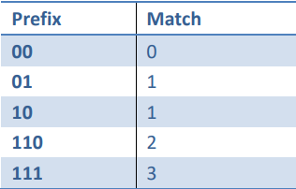

For each of the four interfaces, give the associated range of destination host addresses and the number of addresses in the range

**A1:**

|  |  |  |
| --- | --- | --- |
| Interface | Range | Number |
| 0 | 0000 0000~0011 1111 | 26=64 |
| 1 | 0100 0000~1011 1111  （0100 0000~0111 1111）  （1000 0000~1011 1111） | 2*26=128 |
| 2 | 1100 0000~1101 1111 | 25=32 |
| 3 | 1110 0000~1111 1111 | 25=32 |

* **Q2:**

Consider a router that interconnects three subnets: Subnet 1, Subnet 2, and Subnet 3. Suppose all interfaces in these three subnets are required to have the prefix 222.1.16/24. Also suppose that Subnet 1 is required to support at least 60 interfaces, Subnet 2 is to support at least 90 interfaces, and Subnet 3 is to support at least 12 interfaces. Provide three network addresses(of the form a.b.c.d/x) that satisfy these constraints, please show the calculation procedure.

**A2:**

All subnets have the prefix 222.1.16/24,and subnet1 interfaces ≥ 60，subnet1 interfaces ≥ 90，subnet1 interfaces ≥ 12

Prefix: 222.1.16/24, 24=32-8, then 28=256>(60+90+12=162), so the number of address is enough for three subnets

1、subnet1：60 interfaces → 25<60<26, 32-6=26

→ network address：222.1.16.64/26

2、subnet2：90 interfaces → 26<90<27, 32-7=25

→ network address：222.1.16.128/25

3、subnet3：12 interfaces → 23<12<24, 32-4 = 28

→ network address：222.1.16.16/28

* **Q3:**

Consider the network setup in the figure below. Suppose that the ISP instead assigns the router the address 24.34.112.232 and that the network address of the home network is 192.168.2.0/25.

1. Assign addresses to all interfaces in the home network.
2. Suppose each host has two ongoing TCP connections, all to port 80 at host 128.119.40.87.Provide the six corresponding entries in the NAT translation table.

**A3:**

network address : 192.168.2.0/25,25=32-7,27=128=number of address.

All interfaces in the home network is from 192.168.2.0 to 192.168.2.127

* + 1. Here we assign home addresses: 192.168.2.1, 192.168.2.2,192.168.2.3 with the router interface 192.168.2.4

|  |  |
| --- | --- |
| NAT translation table | |
| WAN | LAN |
| 24.34.112.232, 4000 | 192.168.2.1, 3000 |
| 24.34.112.232, 4001 | 192.168.2.1, 3001 |
| 24.34.112.232, 4002 | 192.168.2.2, 3000 |
| 24.34.112.232, 4003 | 192.168.2.2, 3001 |
| 24.34.112.232, 4004 | 192.168.2.3, 3000 |
| 24.34.112.232, 4005 | 192.168.2.3, 3001 |

* **Q4:**

What is the difference between a forwarding table that we encountered in destination based forwarding in Section 4.1 and OpenFlow's flow table that we encountered in Section 4.4?

**A4:**

* + 1. Forwarding table: destination-based forwarding is based on the IP address and show which packet in the input should be moved to which output.
    2. Flow table, OpenFlow's flow table is based on any set of header field values, defining many actions including drop, forward, modify.
* **Q5:**

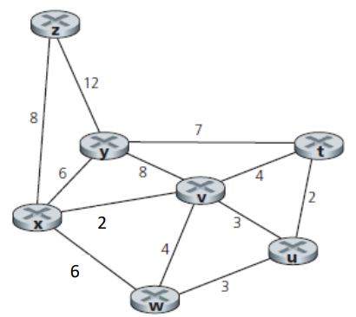Consider the following network. With the indicated link costs, use Dijkstra’s shortest-path algorithm to compute the shortest path from x to all network nodes. Show how the algorithm works and show the final forwarding table in x.

**A5:**

* 1. Find the shortest-hop from the start point x and the find another shortest-hop to the destination.

|  |  |  |  |  |  |  |
| --- | --- | --- | --- | --- | --- | --- |
| N | D(t) | D(u) | D(v) | D(w) | D(y) | D(z) |
| x | ∞ | ∞ | 2,x | 6,x | 6,x | 8,x |
| xv | 6,v | 5,v | 2,x | 6,x | 6,x | 8,x |
| xvu | 6,v | 5,v | 2,x | 6,x | 6,x | 8,x |
| xvut | 6,v | 5,v | 2,x | 6,x | 6,x | 8,x |
| xvutw | 6,v | 5,v | 2,x | 6,x | 6,x | 8,x |
| xvutwy | 6,v | 5,v | 2,x | 6,x | 6,x | 8,x |

* **Q6:**

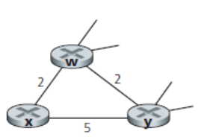Consider the network fragment shown below. x has only two attached neighbors, w and y. w has a minimum-cost path to destination u (not shown) of 5, and y has a minimum-cost path to u of 6. The complete paths from w and y to u (and between w and y) are not shown. All link costs in the network have strictly positive integer values.

* 1. Give x’s distance vector for destinations w, y, and u.
  2. Give a link-cost change for either c(x,w) or c(x,y) such that x will inform its neighbors of a new minimum-cost path to u as a result of executing the distance-vector algorithm.
  3. Give a link-cost change for either c(x,w) or c(x,y) such that x will not inform its neighbors of a new minimum-cost path to u as a result of executing the distance-vector algorithm.

**A6:**

1. Dx(w)=2 Dx(y)=4 Dx(u)=7
2. c(x,w) = 2 c(x,y) = 5

So if c(x,w)>6 ,it will cause updating the neighbors

1. c(x,w) = 2 c(x,y) = 5

So when 6>c(x,w)>1 and whatever c(x,y) changes, it will not cause updating the neighbors