MCP Inspector with Conformance Checks: User Guide
A practical guide for developers and testers who check MCP servers
This guide shows you how to use a fork of the MCP Inspector that adds a Conformance tab. You can point it at any MCP server. It covers starting the Inspector, adding a server, sending an API key or other headers, using the Tools tab, and using the Conformance tab to find schema problems before your users do.
Who this is for: developers who build MCP servers, and testers who check them.
A few terms first:
- MCP (Model Context Protocol): the protocol AI clients use to talk to tool servers. A server publishes tools, and a client calls them.
- JSON Schema: a standard way to describe what a JSON value must look like, for example "an object with a required name that is a string". MCP uses JSON Schema 2020-12.
- inputSchema: the JSON Schema for a tool's arguments.
- outputSchema: an optional JSON Schema that describes what a tool returns.
- structuredContent: the machine-readable JSON object a tool returns. If a tool declares an outputSchema, its structuredContent must match it.
- Strict client: a client that checks every structuredContent against the outputSchema and rejects the whole response if anything is off. The official Python MCP SDK works this way.

Contents
Right-click and choose Update Field to build the table of contents.

1. Why the Conformance tab exists
The stock Inspector can show a tool result as fine even though a strict client would reject it. There are two reasons:
- It honors OpenAPI nullable. The stock Inspector checks results with Ajv, a JavaScript validator that understands nullable: true. That keyword comes from OpenAPI, and JSON Schema 2020-12 ignores it. So a field declared {"type": "string", "nullable": true} that comes back as null passes in the stock Inspector, but the Python SDK rejects it.
- It mislabels response problems. When a result does not match its output schema, the stock Tools tab shows Tool Call Failed / Invalid Parameters and says "The server rejected this call with -32602 (Invalid params). Check the argument values against the tool's schema." The server did not reject anything, and your arguments were fine. The problem is in the server's response.
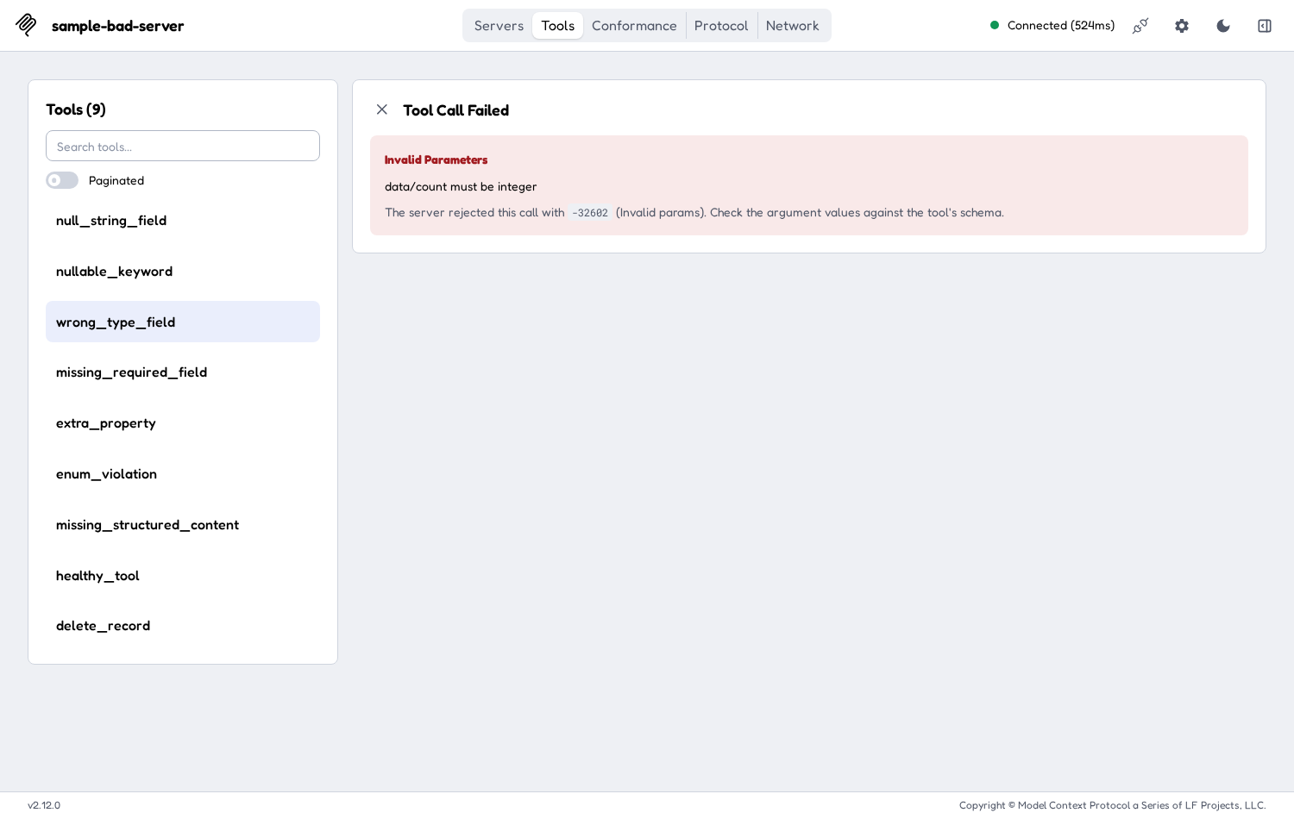
The stock Tools tab reports an output problem as -32602 Invalid params
The Conformance tab checks every result the way a strict client does (JSON Schema 2020-12, nullable ignored). It explains each problem in plain words: what was expected, what came back, where (the JSON path), and how to fix it.
Important: the Conformance tab checks the shape of responses only: types, required fields, allowed values and so on. It does not check whether the data is correct. A tool that returns the wrong customer with the right shape will pass.

2. Install and start
These steps assume you unzipped the package and opened a terminal in its top folder, the one that contains mcp-inspector-fork/, mcp-check/ and guide/.

2.1 What you need
- Node.js 22.19 or newer (with npm). The Inspector's package.json requires >=22.19.0. Check with node --version.
- Python 3.10 or newer, for mcp-check and the sample server. Check with python3 --version.
- Chrome or another current browser.

2.2 First-time install
- Install the Inspector's dependencies. This can take a few minutes:
cd mcp-inspector-fork
npm install
cd ..

Run npm install in mcp-inspector-fork, not in clients/web. It installs the shared code and then every client, including the web client.
- Set up mcp-check, which also contains the sample server:
cd mcp-check
python3 -m venv .venv
.venv/bin/pip install -r requirements.txt
.venv/bin/pip install -e .
cd ..

On Windows, use .venv\Scripts\pip instead of .venv/bin/pip.
You only need to do this once.

2.3 Start the Inspector
- Go to the web client folder:
cd mcp-inspector-fork/clients/web

- Start the dev server with a local token of your choice:
MCP_INSPECTOR_API_TOKEN=<your-token> npm run dev

That syntax is for macOS and Linux shells. In Windows PowerShell, use $env:MCP_INSPECTOR_API_TOKEN="<your-token>"; npm run dev.
Replace <your-token> with any password you make up, for example my-local-token. It protects the Inspector's local backend so that other web pages on your machine can't use it. It is not an MCP server key and it is not sent to any MCP server. If you leave it out, the Inspector makes up a random one on each start and prints it.
- Wait for the line MCP Inspector Web is up and running at:. Then open this address in Chrome, using the same token:
http://127.0.0.1:6274/?MCP_INSPECTOR_API_TOKEN=<your-token>

- You will see the Servers screen, with some example servers already listed.
To stop the Inspector, press Ctrl+C in the terminal.

3. Add a server
- On the Servers screen, click Add Servers, then choose + Add manually. (The same menu has Import from client config and Import from registry config if you already have a server config file.)
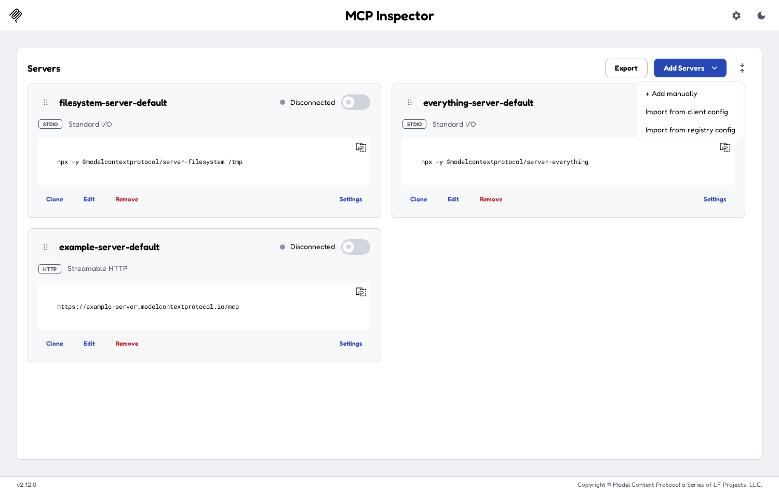
The Add Servers menu
- In the Add server dialog, fill in:
- Server ID: a short name, for example my-server. Use only letters, numbers, hyphens and underscores. It becomes the key in mcp.json.
- Transport: how the Inspector talks to the server:
- streamable-http: the current standard for remote servers. Use this for most HTTP servers.
- sse (Server-Sent Events): the older HTTP transport. Use it only if the server still requires it.
- stdio (local process): the Inspector starts the server as a program on your machine. You then fill in Command, Arguments, Environment and Working directory instead of a URL.
- URL (HTTP transports only): the server's full MCP endpoint, including the path, for example https://example.com/mcp.
- Click Add. The server appears as a card on the Servers screen.
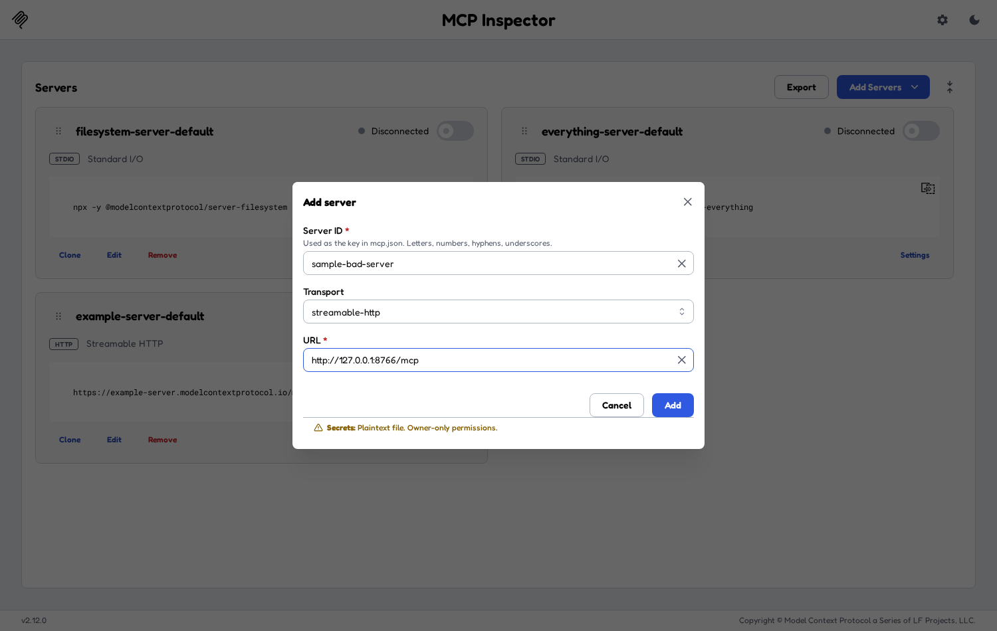
The Add server dialog
To change a server later, click Edit on its card. Clone makes a copy and Remove deletes it.

4. Add an API key or other headers
Many servers want an API key in a header such as x-api-key or Authorization.
- On the server's card, click Settings. The Server Settings dialog opens.
- Open the Custom Headers section.
- Click + Add Header.
- In Key, type the header name, for example x-api-key. In Value, paste the key.
- Close the dialog with the X in the top-right corner. There is no Save button: settings are saved as you type.
- If you are already connected, disconnect and connect again. Header changes take effect on the next connect.
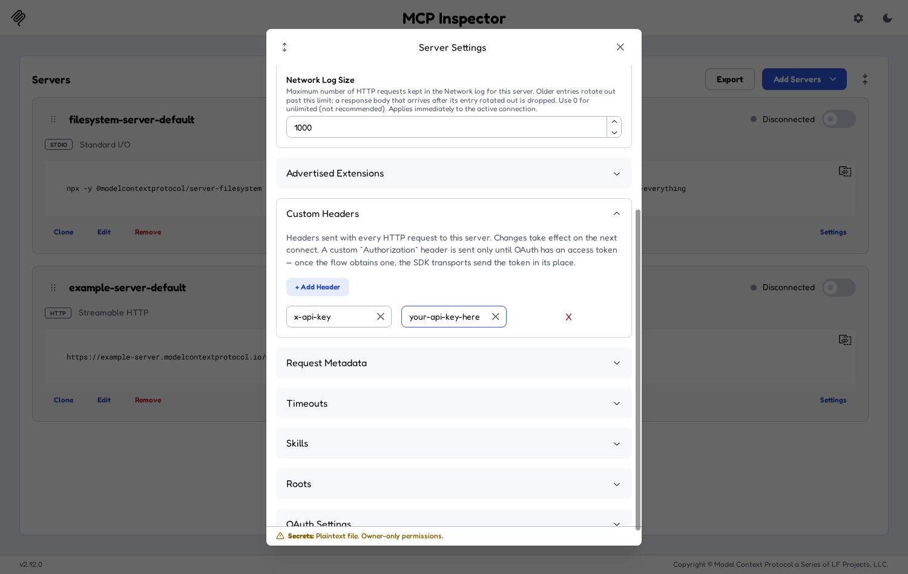
Custom Headers in Server Settings
Notes:
- The headers are sent with every HTTP request to this server.
- A custom Authorization header is sent only until OAuth gets an access token. After that the OAuth token replaces it.
- For servers that use OAuth sign-in, use the OAuth Settings section in the same dialog instead.
- The footer of the dialog tells you where secrets are stored. On a machine without a system keychain it says Secrets: Plaintext file. Owner-only permissions. Don't put production keys on a shared machine.

5. Connect
- Turn on the switch at the top-right of the server's card. The label changes from Disconnected to Connected, and the header shows the connection time.
- Tabs for the server appear in the top bar. Only the tabs the server supports are shown.
- A monitoring sidebar opens on the right with the Protocol log (every JSON-RPC message) and, for HTTP servers, the Network log (every HTTP request). Use the Close monitoring sidebar button at the top-right to hide it. Protocol and Network then become ordinary tabs.
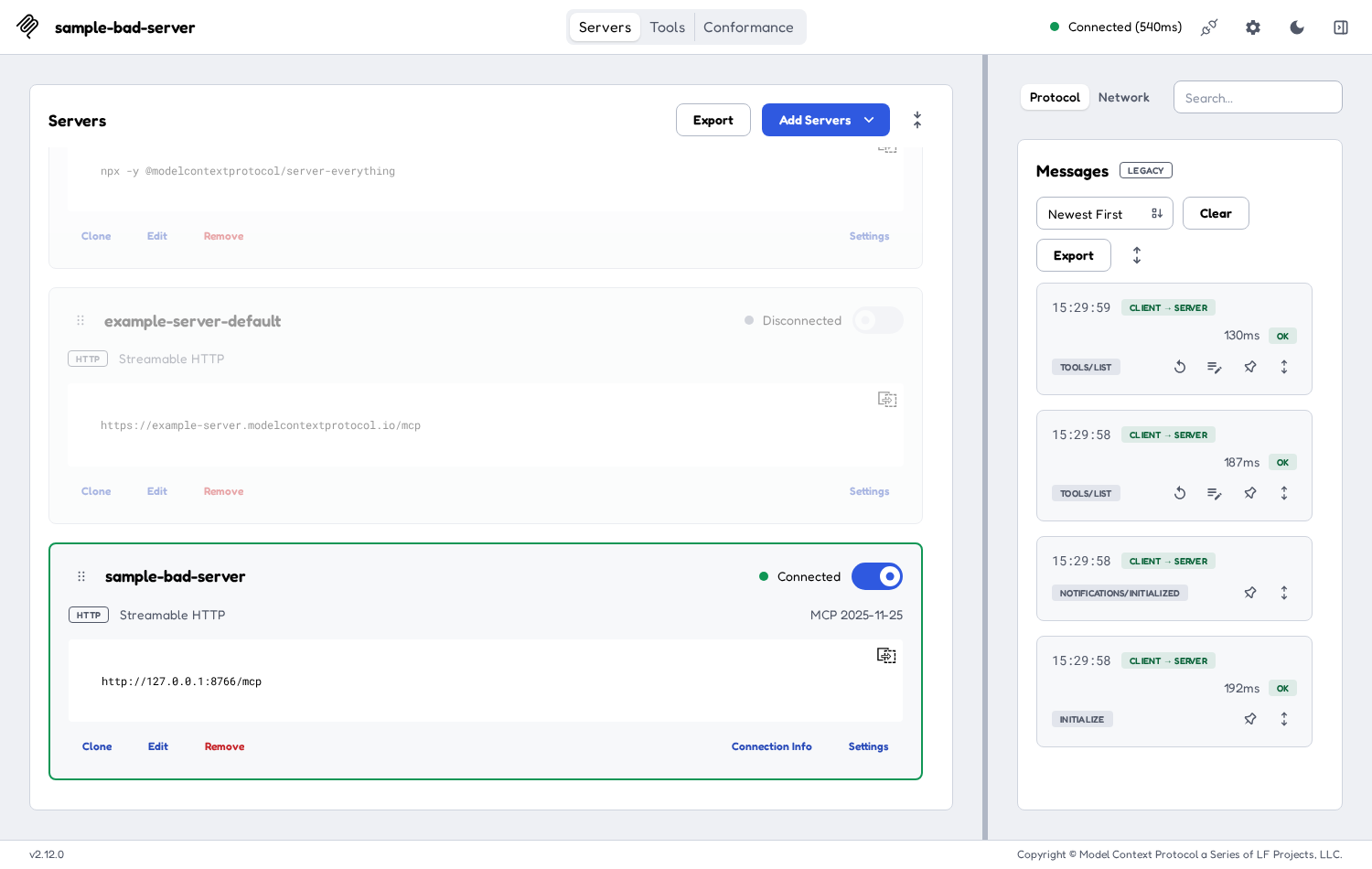
Connected to a server, with the monitoring sidebar open
If the label shows Failed instead, see Troubleshooting.

6. The Tools tab
Use the Tools tab to call one tool by hand and look at what comes back.
- Click Tools in the top bar. The left panel lists the tools, for example Tools (9). Type in Search tools… to filter the list. Turn on Paginated to load the list one page at a time.
- Click a tool. The right panel shows its name, badges such as READ-ONLY, and its description.
- Fill in the inputs. Required inputs are marked with *. Turn on Edit as JSON if you'd rather type the arguments as one JSON object.
- Click Execute Tool.
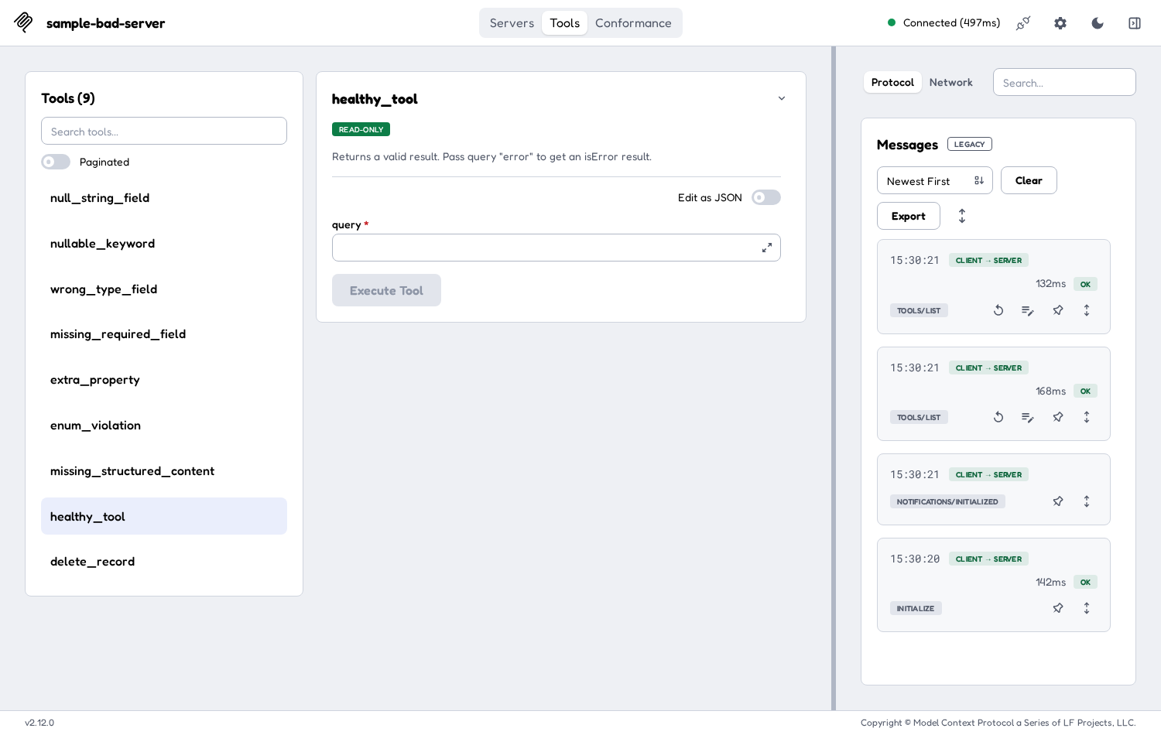
A tool selected, with its input form
The result replaces the form:
- Results: the tool's content, which is the text (or images and so on) a person or model would read.
- Structured Output: the tool's structuredContent, which is the JSON object that programs read. It appears only when the tool returned one. If the tool declares an outputSchema, this object must match it.
Click the X next to Results to go back to the form.
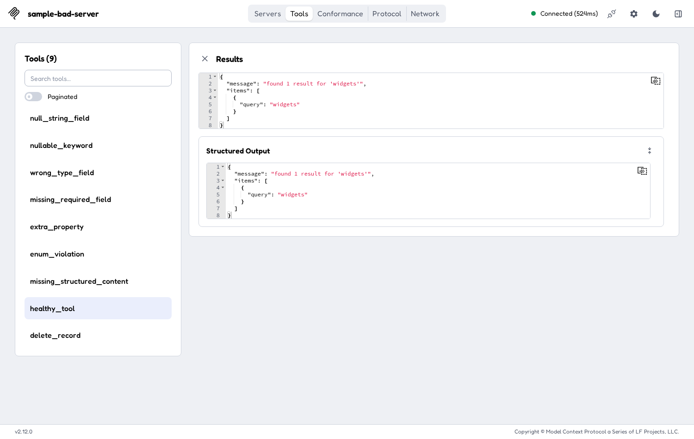
A successful result: Results and Structured Output
The Tools tab does not show the outputSchema itself. To see the schema next to the response, with the problem fields highlighted, use the Details dialog in the Conformance tab (section 8.6).
If the result shows Tool Call Failed / Invalid Parameters (-32602), the cause may be the response, not your arguments (see section 1). Run the same tool in the Conformance tab to see the real reason.

7. Other tabs
Tabs appear only when the connected server supports them:
Tab | What it is for
Servers | Add, edit, clone, remove, connect and configure servers.
Apps | Open tools that come with an interactive UI (MCP Apps).
Tools | List and call tools (section 6).
Prompts | List the server's prompt templates, fill in their arguments and see the messages they produce.
Resources | Browse and read the files and data the server publishes.
Skills | Browse skills, if the server offers the skills extension.
Conformance | Schema and response checks (section 8). Shown when the server has tools.
Tasks | Follow long-running tasks, if the server supports them.
Logs | Log messages the server sends, if it supports logging.
Protocol | Every JSON-RPC message, in both directions.
Network | Every HTTP request and response (HTTP servers only).
Console | The server process's error output (stdio servers only).

8. The Conformance tab
Click Conformance in the top bar.
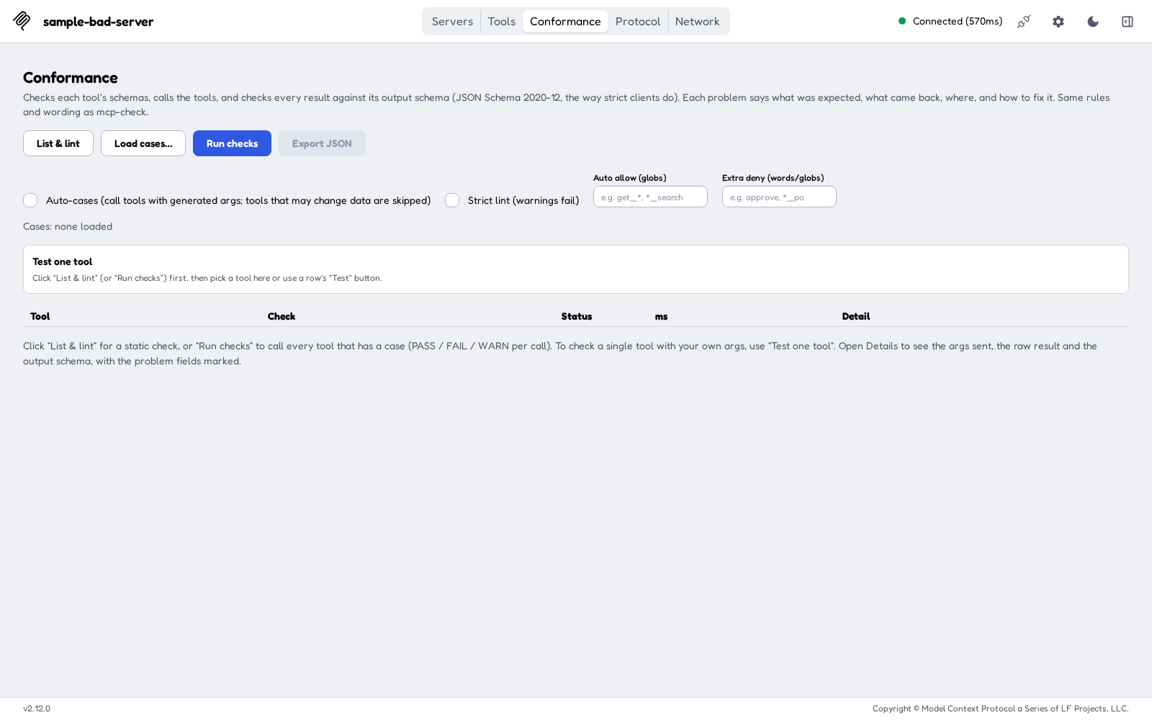
The Conformance tab before any run

8.1 Controls at a glance
Control | What it does | Calls tools?
List & lint | Runs tools/list (all pages) and checks every tool's schemas locally. | No
Load cases… | Loads a cases file (.yaml, .yml or .json) with the arguments to use for chosen tools. | No
Run checks | Lints every tool, then calls each tool that has a case. If Auto-cases is ticked, it also calls tools that have no case, using generated arguments. | Yes, if there are cases or Auto-cases is ticked
Export JSON | Downloads the current results as conformance-report.json. | No
Auto-cases (call tools with generated args; tools that may change data are skipped) | Lets Run checks call tools that have no case. Off by default. | (setting)
Strict lint (warnings fail) | Treats lint warnings as failures. | (setting)
Auto allow (globs) | Only auto-call tools whose names match, for example get_*, *_search. | (setting)
Extra deny (words/globs) | More names to treat as "may change data", for example approve, *_po. | (setting)
Test one tool | Pick one tool, edit its arguments, and click Run this tool. | Yes, that one tool

The line under the checkboxes shows Cases: with the loaded file (or none loaded), plus what is running right now.

8.2 List & lint: the safe first step
List & lint only calls tools/list and checks the schemas on your machine. It never calls a tool, so it is safe to run against production.
- Click List & lint.
- Each tool gets one lint row. The summary line reads like tools: 9 | lint: 8 pass, 1 warn, 0 fail | ....
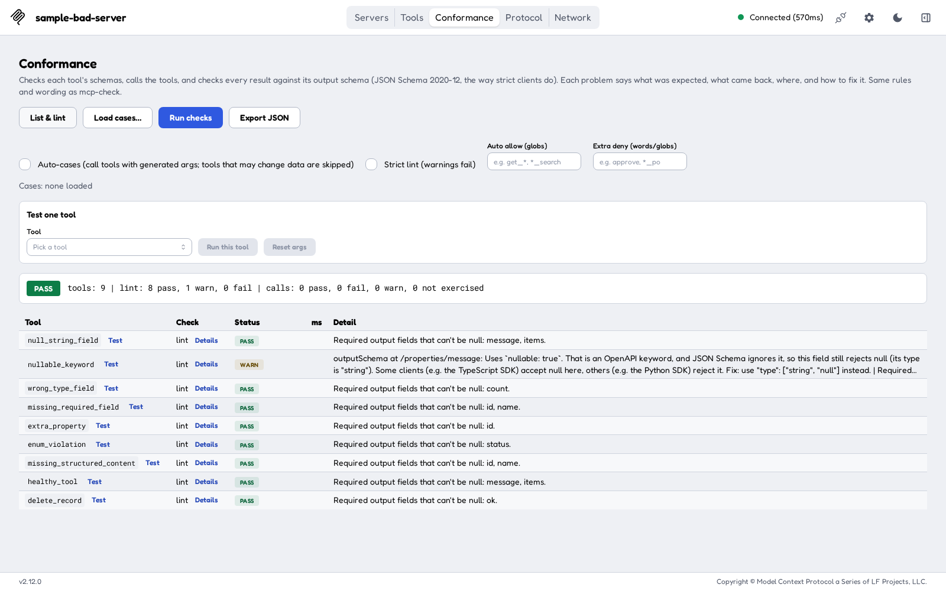
List & lint results
Lint checks:
- Each inputSchema and outputSchema is valid JSON Schema.
- The root of each schema is "type": "object" (MCP requires this).
- No OpenAPI-only keywords are used: nullable, discriminator, xml, externalDocs or example. These give a WARN.
- Tool names are 1–128 characters long and use only A-Z a-z 0-9 _ - ..
- Every tool has an input schema.
- For information, it lists the required output fields that can't be null. These are the fields that break when a backend returns null.

8.3 Run checks with Auto-cases
Run checks lints every tool and then calls tools:
- A tool with a case in a loaded cases file is called with those arguments.
- A tool with no case is called only if Auto-cases is ticked. Otherwise its row says Not exercised: "Not called: there is no case for it. Turn on auto-cases, or run this tool on its own."
With Auto-cases on, the Inspector builds the smallest valid arguments from each tool's inputSchema:
- It fills in required fields only. Optional fields are left out.
- For each field it uses the first of these that exists: const, default, the first enum value, the first examples value.
- Otherwise it goes by type:
- string: "test", repeated and cut to reach minLength if one is set (and never longer than maxLength). Known formats get a sample value, for example 2026-01-01 for date and test@example.com for email.
- number / integer: minimum if set, otherwise 1 (kept at or below maximum).
- boolean: false.
- array: minItems items (none if minItems isn't set).
- object: its required properties, built the same way.
- For anyOf/oneOf it uses the first option that isn't null. Local $refs are followed.
- If the generated arguments would not pass the tool's own inputSchema, the tool is not called. The row says why.
Tools that may change data are never auto-called. A tool is skipped if:
- its name contains submit, create, update, delete, place, order, send, cancel, write or post. The match ignores case and also matches parts of words, so order_search is skipped too, on purpose;
- its name matches something you typed in Extra deny (words/globs), for example approve;
- the server marks it destructiveHint: true or readOnlyHint: false; or
- Auto allow (globs) is set and the tool doesn't match it.
These rules always beat Auto allow. A skipped tool shows Not exercised with the reason, for example "... auto-cases skips it because its name suggests side effects (contains 'delete')."
After the run you will see:
- one or more rows per tool: lint, then call[auto] (generated arguments), call[0], call[1]… (cases from a file), or call[args] (your own arguments from Test one tool), and a null-sweep row if any disallowed null was found;
- the ms column, which is how long each call took;
- a big PASS or FAIL badge and the summary line;
- a coverage line, for example coverage: 9 tools, 8 exercised, 1 not exercised (delete_record), so a tool that was never called is easy to spot.
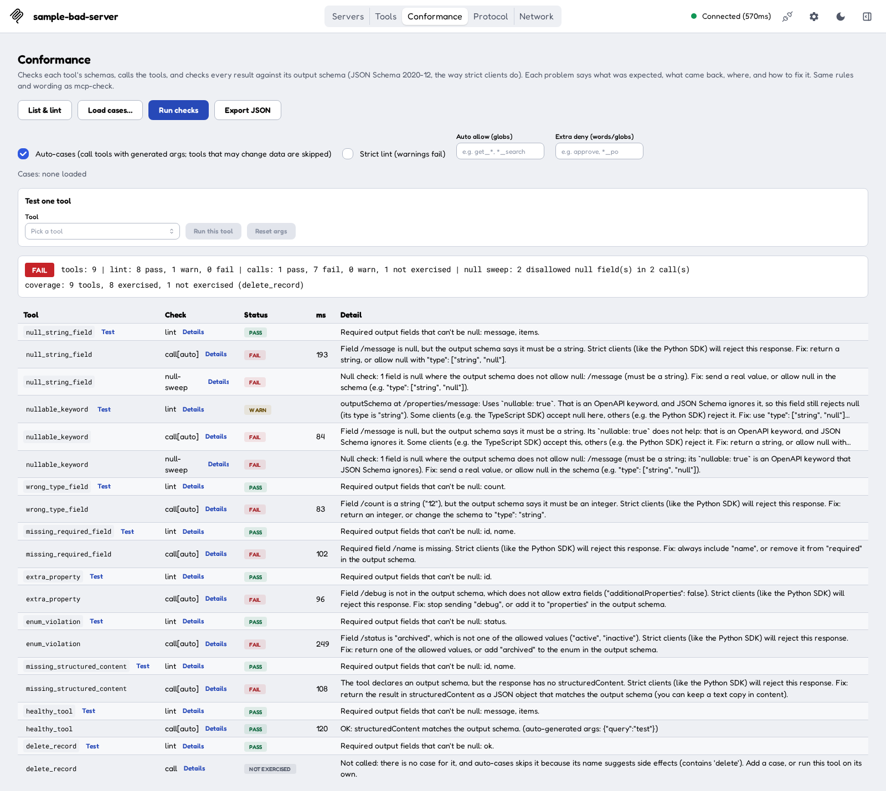
Run checks with Auto-cases against the sample server
How call results are graded:
Status | Meaning
PASS | The call worked and structuredContent matches the output schema, or the tool has no output schema.
FAIL | The response breaks the output schema, structuredContent is missing, or a disallowed null was found. With your own arguments or a case, an error result also fails unless the case says expect: error.
WARN | With generated arguments, the tool returned an error. Made-up arguments can simply be unrealistic. Add a real case or test it on its own.
Not exercised | Not called: there was no case, it was skipped as possibly changing data, or you declined to confirm.

On production servers: keep Auto-cases unticked. It is off by default. With Auto-cases off and no cases file loaded, Run checks makes no tool calls. A cases file is different: tools listed in it are called even if their names look risky, so list only read-only tools in a cases file. Test one tool always calls the tool you pick. Prefer List & lint on production, and run calls against a test environment.

8.4 Test one tool
Use this to check one tool, with generated or your own arguments.
- Run List & lint (or Run checks) first, so the tool list is loaded.
- Under Test one tool, pick a tool in Tool, or click the small Test button next to the tool's name in any lint row.
- The Args box is filled in with the smallest valid arguments. Edit them as you like. They must be a JSON object, for example {"query": "widgets"}. Reset args puts the generated arguments back.
- Click Run this tool.
The table now shows only that tool, with an Only <tool name> badge. If you edited the arguments, the call row is call[args] and the call is expected to succeed. If you didn't, the tool's cases from a loaded file are used, or else the generated arguments (call[auto]). To go back to the full list, click List & lint or Run checks again.
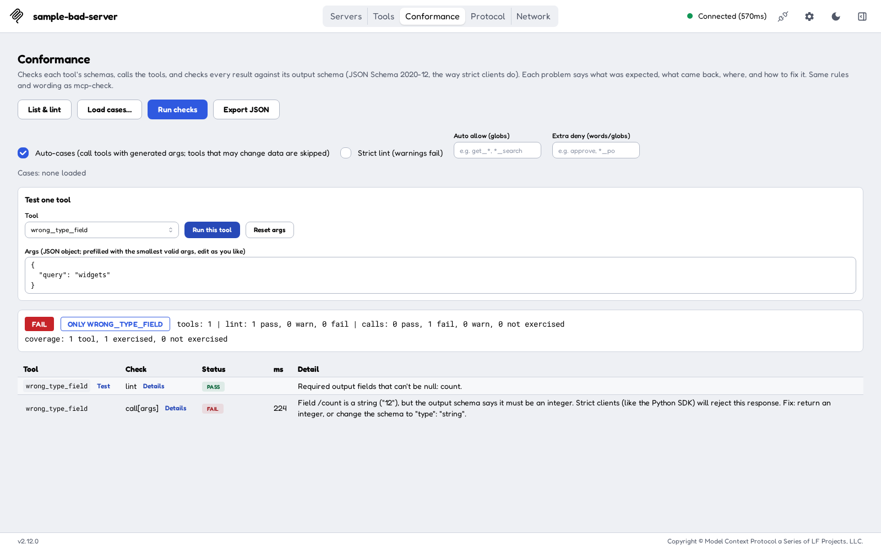
Test one tool with your own arguments
If the tool may change data, an orange note appears: "Careful: its name suggests side effects (contains 'delete'), so it may change data. You will be asked to confirm before it is called." When you click Run this tool, the browser asks "Call it anyway with these args?" If you click Cancel, the tool is not called and the row says "Not called: ... and you did not confirm the call."
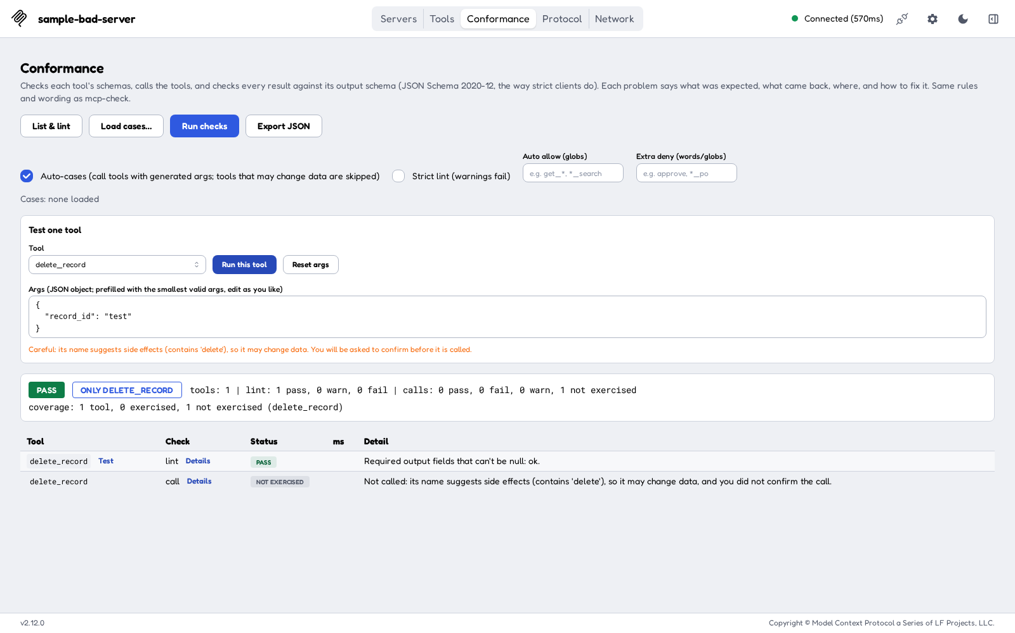
A risky tool, declined at the confirmation prompt

8.5 Load a cases file (optional)
A cases file lists realistic arguments for chosen tools, so that Run checks can call them with real data. It uses the same format as the mcp-check command-line tool:
healthy_tool:
- args: {query: laptop}
- name: error result
args: {query: error}
expect: error
wrong_type_field:
- args: {query: laptop}

- Each key is a tool name, with a list of cases under it.
- args holds the tool arguments. expect is success (the default) or error. name is an optional label.
- Click Load cases… and pick the file. The Cases: line shows how many cases and tools were loaded.
- If the file has a case for a tool the server doesn't list, you get a WARN row.

8.6 The Details dialog
Every row has a Details button next to its check name. It opens a large dialog. Close it with Escape or the X.
For a lint row, the dialog shows:
- Schema findings: one card per problem, with an Error or Warning badge, the schema (inputSchema or outputSchema), the field path and an explanation.
- Required output fields: the fields that must be present and can't be null.
- No output schema, if the tool has none. Clients then can't validate its results.
- Schemas: Input schema and Structured schema (outputSchema) side by side, with the problem lines highlighted.
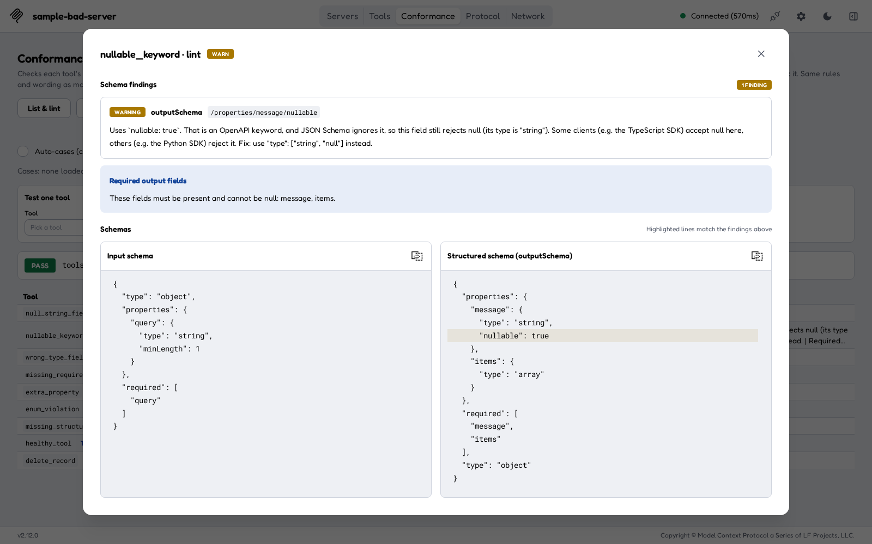
Details for a lint warning: an OpenAPI nullable keyword
For a call row, the dialog shows:
- Check result: the full explanation and fix.
- Args sent: exactly what was sent to the tool.
- Response and schema: the raw Result (content, structuredContent, isError) next to the Structured schema (outputSchema). The problem fields are highlighted in both. If the call returned nothing, it says No result: and the error.
Each block has a copy button, so you can paste the JSON into a bug report.
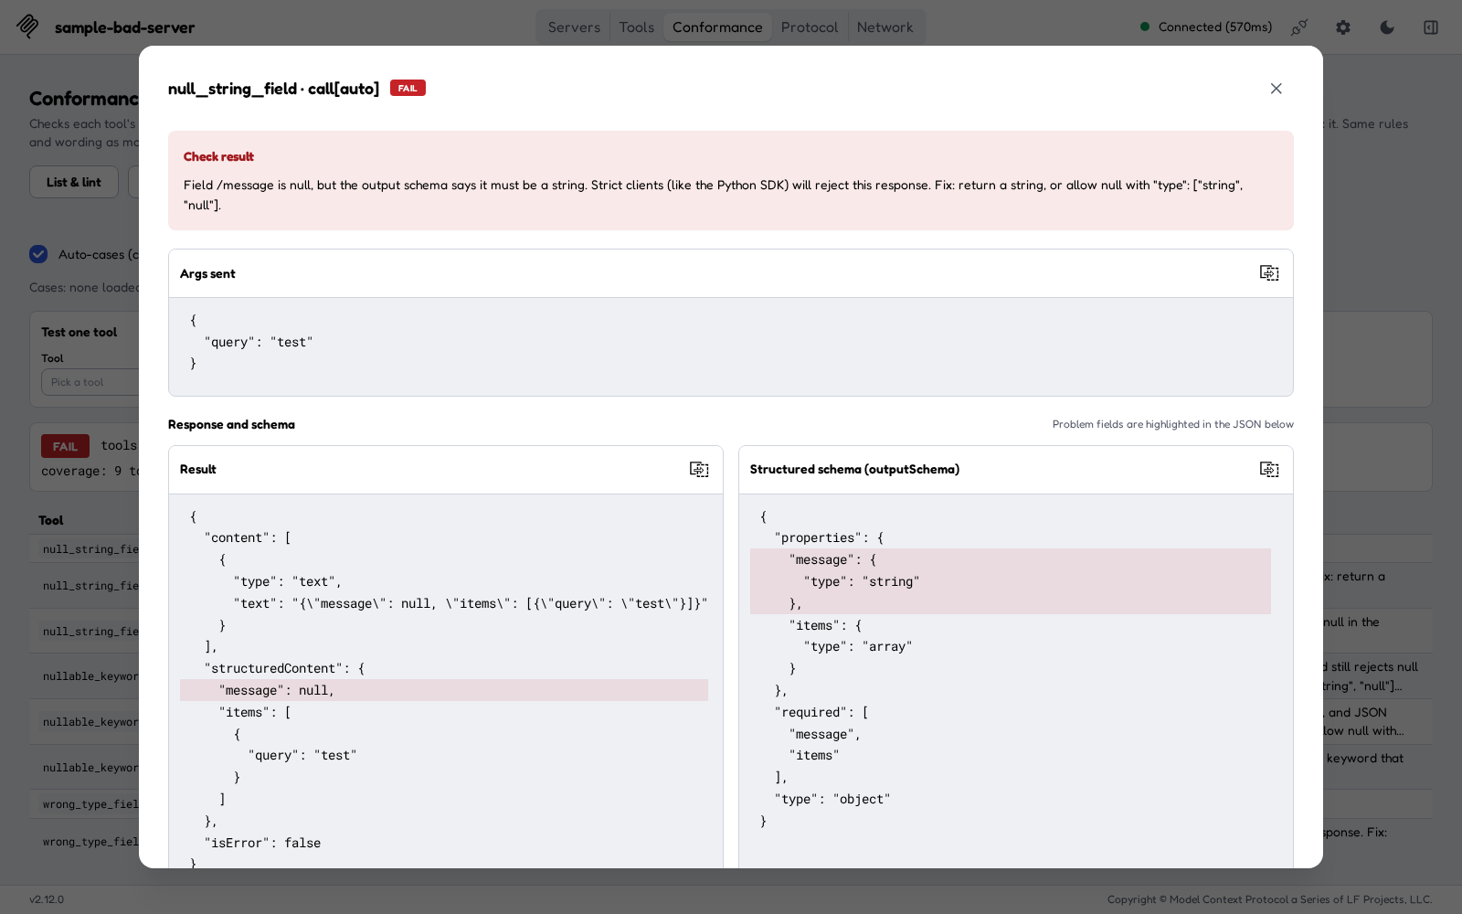
Details for a failing call: message is null where the schema says string

8.7 Export the results
Click Export JSON to download conformance-report.json. It contains the server name and version, the time, whether Auto-cases was on, the cases file name, the overall result (PASS/FAIL), the coverage, every row (including the arguments, the raw result and the schema for call rows), and the full tool list. Attach it to a ticket, or compare it between server versions.

8.8 Results stay while you switch tabs
The Conformance tab keeps your loaded cases, settings, chosen tool, edited arguments and results when you switch to another tab and back, as long as you stay on the same connection. A run keeps going while you look at another tab. Connecting again starts a fresh workspace, and so does refreshing the browser page.

8.9 What each check catches
Problem | Example | Where it shows | Result
null where the schema doesn't allow it | "message": null, schema says string | call row and a null-sweep row (lists every disallowed null, at any depth) | FAIL
Wrong type | "count": "12", schema says integer | call row | FAIL
Missing required field | name is required but missing | call row | FAIL
Extra property when additionalProperties: false | "debug" is sent but not in the schema | call row | FAIL
Value not in the enum | "status": "archived", allowed values are active and inactive | call row | FAIL
Wrong const value | a value other than the exact one required | call row | FAIL
Missing structuredContent | an outputSchema is declared but only text comes back | call row | FAIL
OpenAPI nullable in a schema | {"type": "string", "nullable": true}. JSON Schema 2020-12 ignores nullable, so null is still rejected | lint row (WARN). A call that returns null there also FAILs, noting that some clients accept it and others reject it | WARN / FAIL
Other OpenAPI-only keywords | discriminator, xml, externalDocs, example | lint row | WARN
Invalid schema | a schema that isn't valid JSON Schema, a root that isn't "type": "object", or no input schema at all | lint row | FAIL
Bad tool name | spaces or other characters outside A-Z a-z 0-9 _ - ., or longer than 128 characters | lint row | WARN
Error result with no text | isError: true with nothing in content | call row detail | FAIL or WARN

All of these are about the shape of the data. Whether the values are right is still up to you.

9. Try it with the sample server
The companion mcp-check project has a small sample server with one tool for each common mistake. It's a quick way to see every check fire.
- In a second terminal, go to the package's top folder and start the sample server. It needs the mcp-check setup from section 2.2:
cd mcp-check
.venv/bin/python tests/sample_bad_server.py --port 8766

It serves Streamable HTTP at http://127.0.0.1:8766/mcp. It prints nothing while it waits. Leave it running.
- In the Inspector, add a server (section 3) with Server ID sample-bad-server, Transport streamable-http and URL http://127.0.0.1:8766/mcp. The sample server needs no key.
- Connect, open Conformance, tick Auto-cases and click Run checks.
What you should see:
Tool | What it does wrong | Expected result
null_string_field | returns "message": null, but the schema says string | FAIL (call + null-sweep)
nullable_keyword | the same, but the schema adds OpenAPI nullable: true | lint WARN, call FAIL + null-sweep FAIL
wrong_type_field | returns "count": "12" (a string), but the schema says integer | FAIL
missing_required_field | leaves out the required name | FAIL
extra_property | sends debug, but the schema has additionalProperties: false | FAIL
enum_violation | returns "status": "archived", which isn't active or inactive | FAIL
missing_structured_content | declares an output schema but returns only text | FAIL
healthy_tool | nothing: it returns a valid result (query error makes it return an error result) | PASS
delete_record | marked destructive, and its name contains delete | Not exercised (never auto-called)

The summary should read tools: 9 | lint: 8 pass, 1 warn, 0 fail | calls: 1 pass, 7 fail, 0 warn, 1 not exercised | null sweep: 2 disallowed null field(s) in 2 call(s), followed by coverage: 9 tools, 8 exercised, 1 not exercised (delete_record).
Also try:
- Test one tool with delete_record, and click Cancel at the prompt. It is not called.
- nullable_keyword in the Tools tab. The stock view accepts the null, while the Conformance tab fails it.
- wrong_type_field in the Tools tab, to see the misleading -32602 (Invalid params) message.
The sample server sends tools/list in two pages, so pagination gets tested too.

10. Troubleshooting

The Inspector won't start: "Port 6274 is already in use"
Another Inspector (or another program) is using the port.
- Find it: lsof -nP -iTCP:6274 -sTCP:LISTEN.
- Stop it with Ctrl+C in its terminal, or kill <PID>.
- Or run this one on another port: CLIENT_PORT=6280 MCP_INSPECTOR_API_TOKEN=<your-token> npm run dev, then open http://127.0.0.1:6280/?MCP_INSPECTOR_API_TOKEN=<your-token>. The MCP Apps sandbox uses its own port, 6275. If that one is busy, set MCP_SANDBOX_PORT to a free port as well.

The sample server won't start: "address already in use"
A copy is already running on port 8766. Use it, stop it, or start a new one with --port 8767 and use http://127.0.0.1:8767/mcp.

The server card shows "Failed"
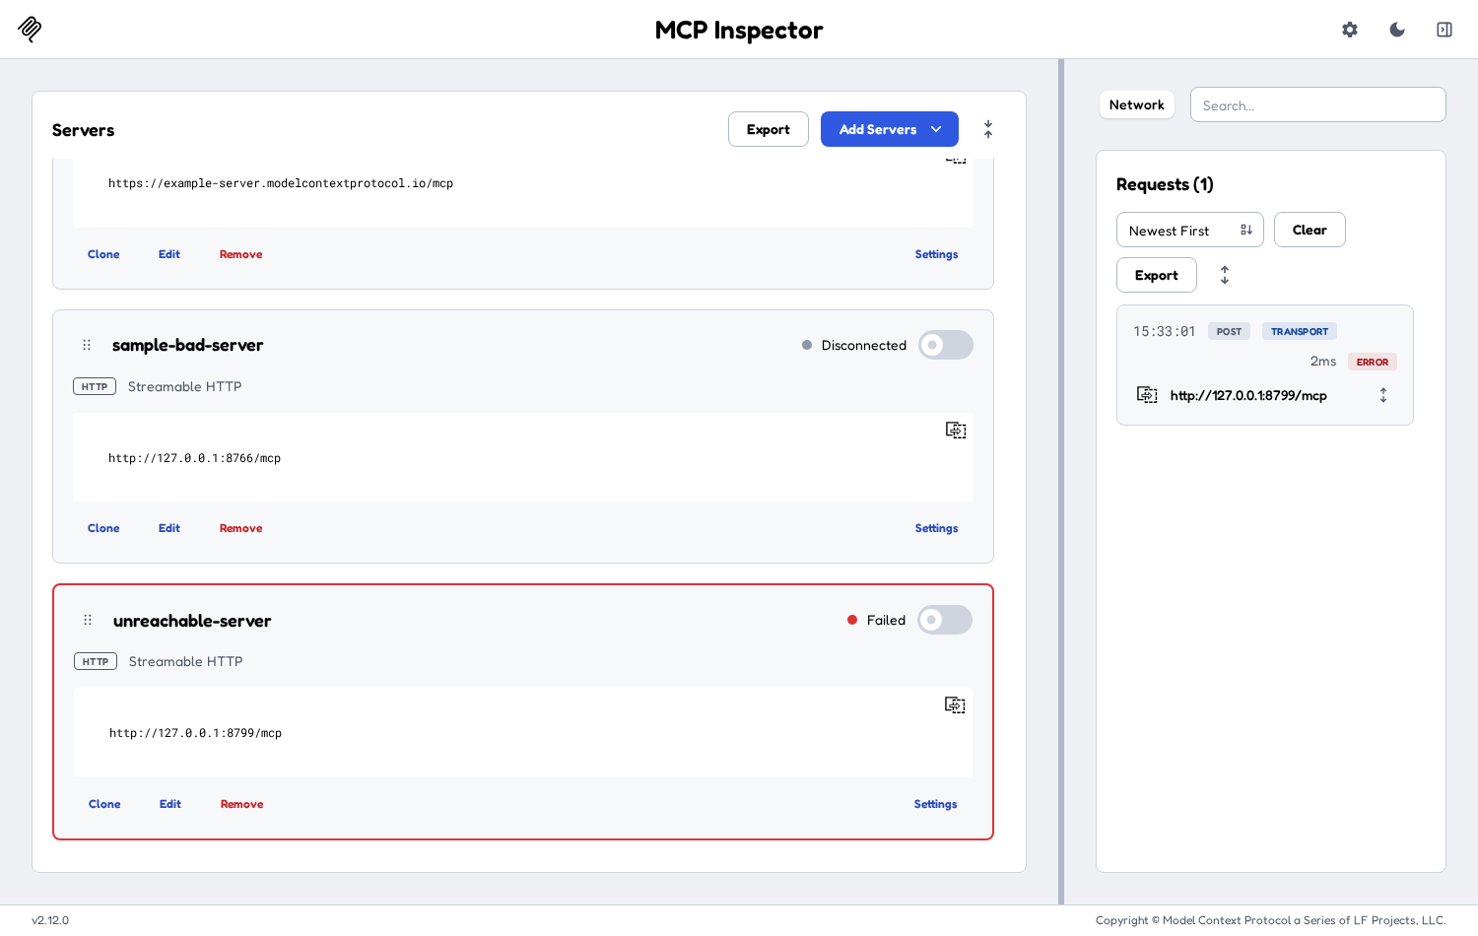
A server that can't be reached
- Open the Network panel and click the failed request to see the error.
- Check that the server is running and that the URL is exactly right, including the path (/mcp, /sse, …) and http versus https.
- Check that the Transport matches the server: streamable-http for most servers, sse for older ones.
- Fix it with Edit on the card, then connect again.

401 Unauthorized or 403 Forbidden from the MCP server
The server wants credentials.
- Add the key under Settings → Custom Headers (section 4). Use the exact header name the server expects, for example x-api-key, or Authorization with the value Bearer <key>.
- Disconnect and connect again. Header changes take effect on the next connect.
- If the server uses OAuth, set it up under Settings → OAuth Settings.
- In the Network panel, open the request and check that the header was sent.

401 from the Inspector itself (its local `/api`)
This is about the Inspector's local token, not your server's key. It happens when the page and the backend disagree on the token, for example if you restarted the Inspector with a different token and kept an old tab open. Open the address with the new token, or reload the page. The backend puts the current token into the page each time it loads.

CORS errors
CORS (Cross-Origin Resource Sharing) is a browser rule that blocks a web page from calling a server on another origin unless that server allows it. This Inspector sends MCP traffic through its own local backend, so your MCP server normally doesn't need CORS settings. If you do see a CORS or "origin not allowed" error:
- Open the Inspector at the address it printed (http://127.0.0.1:6274/...), not through a different host name or a proxy.
- If the error comes from the MCP server's own origin or host checks (some servers have DNS-rebinding protection), allow 127.0.0.1 and localhost on the server.

"Tool Call Failed / Invalid Parameters (-32602)" in the Tools tab
Often this is a response problem, not an argument problem (section 1). If the Protocol log shows the tools/call as OK, run the tool in Conformance → Test one tool to see what is wrong with the response.

Reading Conformance messages
Every message follows the same pattern: what was found, who will reject it, how to fix it. For example:
Field /count is a string ("12"), but the output schema says it must be an integer. Strict clients (like the Python SDK) will reject this response. Fix: return an integer, or change the schema to "type": "string".
- /count is a JSON path inside structuredContent. /items/0/name means the name of the first item.
- "Strict clients (like the Python SDK) will reject this response" means the problem will break real clients.
- "Some clients (e.g. the TypeScript SDK) accept this, others (e.g. the Python SDK) reject it" means it works in some clients and not in others. This is usually the nullable case. Fix it anyway.
Other common messages:
Message | What it means and what to do
tools/list failed: ... (red Error box) | The connection dropped or the server failed to list its tools. Reconnect and check the Network panel.
Not called: there is no case for it. Turn on auto-cases, or run this tool on its own. | Expected when Auto-cases is off.
... auto-cases skips it because it could not build valid args (...) | The input schema is too complex for generated arguments (or has a remote $ref). Use Test one tool with your own arguments, or add a case.
The call failed for the auto-generated args ... (WARN) | The server didn't like the made-up arguments. It's not a schema failure. Try real arguments.
The tool reported an error (isError: true). ... | With your own arguments, the tool returned an error. Check the arguments, or use expect: error in a case if the error is intended.
Args are not valid JSON / Args must be a JSON object | Fix the text in the Args box.
... The TypeScript SDK rejected it: ... | The strict check passed but the TypeScript SDK's own check failed. Read the message after the colon.

Appendix A: The mcp-check command-line tool
mcp-check is a Python command-line tool with the same rules and the same wording as the Conformance tab. It connects through the official Python MCP SDK, so it sees exactly what a strict Python client sees. Use it in scripts and CI.
Setup (Python 3.10 or newer). This is the same as section 2.2, and requirements.txt includes pytest for the test suite:
cd mcp-check
python3 -m venv .venv && . .venv/bin/activate
pip install -r requirements.txt && pip install -e .
python -m pytest -q # optional: run the test suite

Common commands:
export MCP_URL=https://example.com/mcp # or --url
export MCP_API_KEY=... # secret: set it only in the environment
export MCP_AUTH_HEADER=x-api-key # default: Authorization (sent as "Bearer <key>")
mcp-check --no-calls # list + lint only, no tool calls (safe on production)
mcp-check --cases cases.yaml --json out/report.json --junit out/report.junit.xml
mcp-check --auto-cases # call read-only tools with generated args
mcp-check --tool healthy_tool --args '{"query": "laptop"}' # test one tool
mcp-check --auto-cases --show-response # also print args, raw result and schema for failures

Useful options: --only and --skip (tool names or globs), --auto-allow and --auto-deny (the same as the two text boxes in the tab), --confirm-side-effects (lets --tool call a risky tool), --strict-lint, --header 'Name: value' (non-secret headers), --sse (legacy transport) and --oauth (browser sign-in instead of a key). The API key is masked as <SECRET> in all output.
Exit codes: 0 means pass, 1 means at least one FAIL or a connection failure, and 2 means a usage error.
Against the sample server:
.venv/bin/mcp-check --url http://127.0.0.1:8766/mcp --auto-cases

The output ends with the same summary and coverage lines as the Conformance tab, then RESULT: FAIL.

Appendix B: Quick reference
I want to… | Do this
Check schemas without calling anything | Conformance → List & lint
Check responses on a test server | Tick Auto-cases, then Run checks
Check responses with real data | Load cases…, then Run checks
Check one tool | Test one tool → pick a tool → edit Args → Run this tool
See why a row failed | Details on the row
Share results | Export JSON
Send an API key | Server card → Settings → Custom Headers → + Add Header

