1. A Boolean value is either True or False.

Eg: 4!=5

5>=3

6<=9

2. Flowchart is a diagram of the sequence of actions that Python would take.

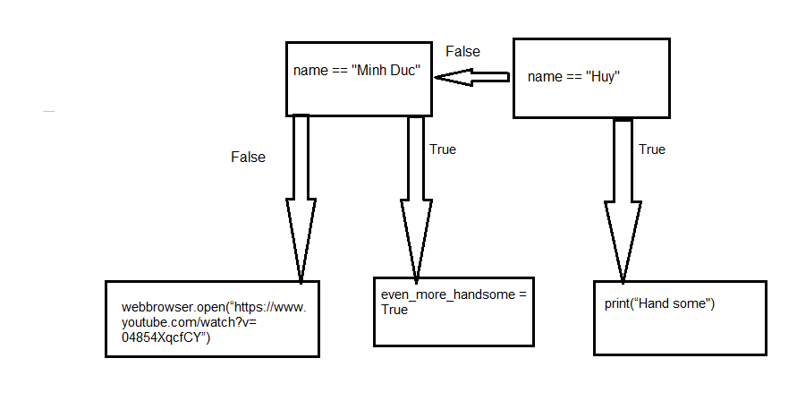

3. the conditionals contained by a conditional is called nested conditionals

Eg:

b =5

If a == 5:

If b==a:

print(‘a=b=5”)