Website Design Specification
In The Booth Website UI Prototype
McCall Southern Photography • In The Booth • IT299 Final Product
—
1. Product Overview
In The Booth is a multi-page website UI prototype created for McCall Southern Photography. The website presents a modern digital experience for new and existing customers and demonstrates how the company could centralize booking, portfolio browsing, print ordering, online payment, touch-up requests, customer service chats, and confirmations into one front-facing website.
2. Business Need
McCall Southern is a small photography company with a main office and a studio location. Increased demand for graduation sessions, marching band photography, and other miscellaneous photo requests created the need for one organized digital location where the customer journey can be shown clearly and professionally.
3. Target Users
- New customers browsing photography services for the first time
- Returning customers checking galleries, placing orders, or requesting edits
- School, graduation, and marching band customers with higher seasonal demand
- Internal stakeholders reviewing the future customer-facing digital experience
4. Required Features Reflected in the Prototype
- Customer service chat interface
- Shopping cart and online payment pages
- Confirmation page for transactions and requests
- Touch-up request page with sample input fields
- Image library / portfolio gallery with sample customer photos
- Photo crop tool mock page
- Standard pages such as Home, About, Support, and Contact
5. Site Structure
Page | Primary Purpose
Home | Introduces the company, website purpose, and featured capabilities
About | Explains company background and digital transformation goals
Portfolio | Displays sample image categories and gallery sections
Services | Summarizes photography and support services
Packages | Shows sample pricing packages and plan options
Booking | Displays mock scheduling form for customers
Cart | Displays sample order items and total
Payment | Displays online payment interface fields
Confirmation | Displays successful transaction confirmation state
Touch-Up Requests | Captures retouching instructions and order details
Crop Tool | Demonstrates future crop picture functionality
Support | Displays customer service chat and FAQ content
Contact | Provides contact form and office details
6. Common Elements
- Consistent top navigation used across all pages
- Shared footer with quick links, contact details, and prototype note
- Breadcrumb trail below the header
- Single color system using warm neutral backgrounds with a burgundy accent
- Reusable card, button, form, and pricing styles
- Image library with branded sample visuals
7. Visual Design Choices
The interface uses a warm, modern aesthetic to support the company’s trend-forward brand goal. Rounded cards, soft shadows, consistent spacing, and a burgundy accent color were chosen to create a professional but approachable customer experience. Forms were intentionally styled to look complete and usable even though the prototype does not perform live processing.
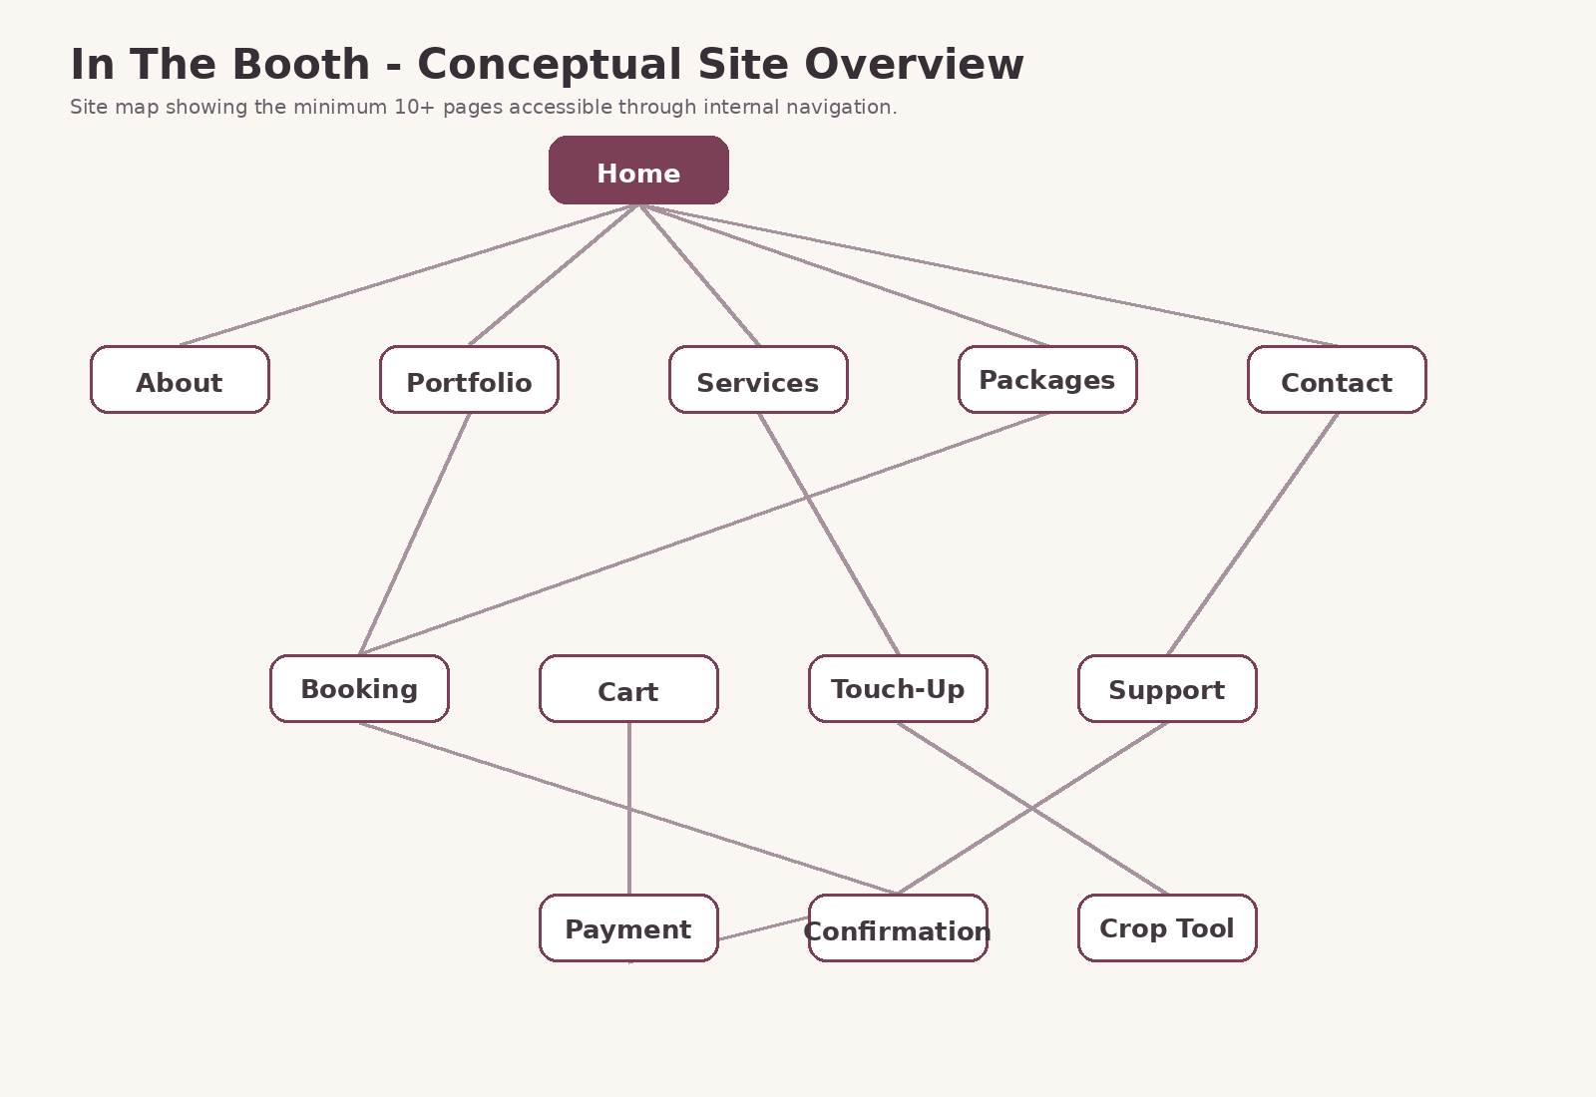
Figure 1. Conceptual site overview used in the design package.
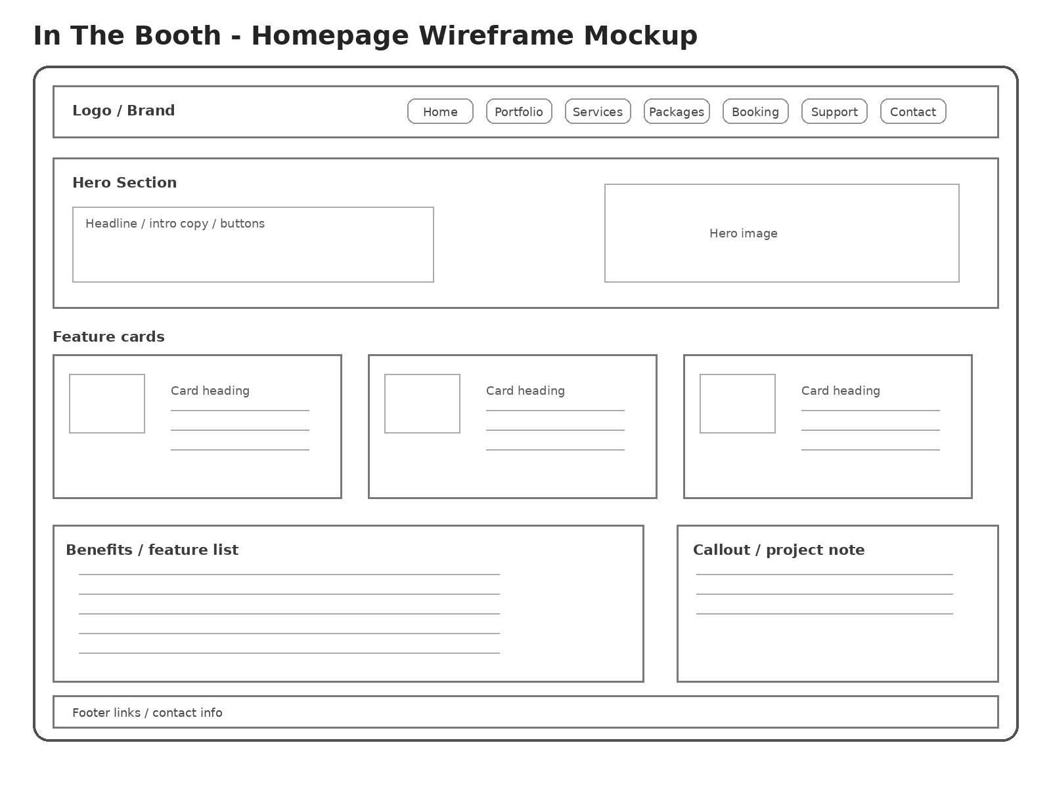
Figure 2. Homepage wireframe mockup showing navigation, hero, feature cards, and footer.

