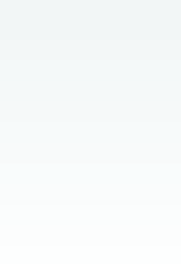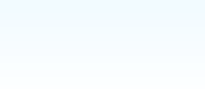

**Django Reference Sheet**

**Project Setup**   
Create A Project's Directory Structure   
django-admin.py startproject *projectname*   
(this command needs to be issued in the directory you w ant the project to be in)

Customize the DB and other setting in the *projectname*/settings/main.py file

Initialize the DB   
django-admin.py init   
(this command should be issued in your *projectname* directory)

Set your DJANGO_SETTING_MODULE environment variable Unix:

**Django Admin SQL Commands**   
All the following commands output sql specific to the *appname* specified in the command and should be run from with the *projectname* directory.

django-admin.py sqlinitialdata *appname* Outputs the initial-data inserts required for Django's admin framework.

django-admin.py sql *appname* Outputs the table creation statements

django-admin.py sqlall *appname* Outputs both the sqlinitialdata and sql data

export DJANGO_SETTINGS_MODULE=*projectname*.settings.main

Windows:   
set DJANGO_SETTINGS_MODULE=myproject.settings.main (you'll probably w ant to set these permanently in your ~/.bashrc file in Unix or your my computer properties in Window s)

More Details: <http://www.djangoproject.com/documentation/tutorial1/>

**App Setup**   
Create an App's Directory Structure   
django-admin.py startapp *appname*   
(this command should be issued in your *projectname/apps* directory)

Setup App's models in the *projectname*/apps/*appname*/models/*appname*.py file

Add the App to the INSTALLED_APPS in *projectname*/settings/main.py

Install the App in the DB   
django-admin.py install *appname*   
(this command should be issued in your *projectname* directory)

More Details:   
<http://www.djangoproject.com/documentation/tutorial1/#creating-models>

django-admin.py sqlindexes *appname* Outputs the the create index statements

django-admin.py sqlclear *appname* Outputs the the drop table statements and the delete statements for deleting the “initialdata”.

django-admin.py startapp *appname*   
(this should be issued in your *projectname/apps* directory)

More Details:   
[http://www.djangoproject.com/documentation/ tutorial1/#activating-models](http://www.djangoproject.com/documentation/tutorial1/#activating-models)

**Template Syntax**   
There are two types of syntax:   
{% something %} - For tags which include blocks and functional items like loops, if statements, and includes.

{{ variable }} - For variable insertion where “variable” is replaced with it's value.

**URL Dispatcher Sample Config Files**   
Sample *projectname*/settings/urls/main.py file   
from django.conf.urls.defaults import *   
urlpatterns = patterns('',  
 (r'^weblog/', include('django_website.apps.blog.urls.blog')), (r'^documentation/', include('django_website.apps.docs.urls.docs')), (r'^comments/', include('django.contrib.comments.urls.comments')), (r'', include('django.conf.urls.flatfiles')),   
)

Sample *projectname*/apps/blog/urls/main.py file   
from django.conf.urls.defaults import *   
info_dict = {  
 'app_label': 'blog',  
 'module_name': 'entries',   
}   
urlpatterns = patterns('django.views.generic.date_based.',  
 (r'^(?P<year>\d{4})/(?P<month>[a-z]{3})/(?P<day>\w{1,2})/$', 'archive_day', info_dict), (r'^(?P<year>\d{4})/(?P<month>[a-z]{3})/$', 'archive_month', info_dict),  
 (r'^(?P<year>\d{4})/$', 'archive_year', info_dict),  
 (r'^/?$', 'archive_index', info_dict),   
)

*Italicized Text* – Placeholder names for your object(s) • Courier Text – Commands you type in

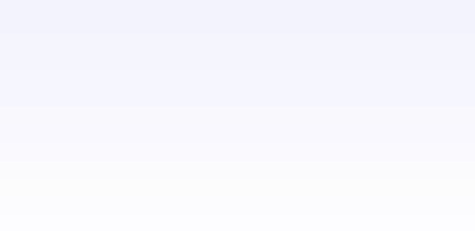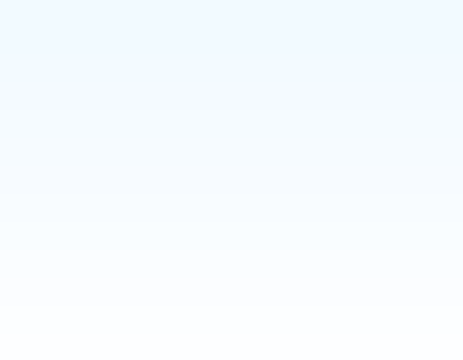

**Template Filters**

**add -**  Adds the arg to the value   
**addslashes** - Adds slashes, for passing strings to JavaScript.

**Capfirst -** Capitalizes the first character of the value   
**center** - Centers the value in a field of a given width   
**cut** - Removes all values of arg from the given string   
**date** - Formats a dateto the given format using “now” format **default** - If value is unavailable, use given default   
**dictsort** - Takes a list of dicts, returns that list sorted by the property given in the argument.

**dictsortreversed** - Takes a list of dicts, returns that list sorted in reverse order by the property given in the argument.

**divisibleby** - Returns true if the value is divisible by the argument **escape** - Escapes a string's HTML   
**filesizeformat** - Format the value like a 'human-readable' file.

**First** - Returns the first item in a list   
**fix_ampersands** - Replaces ampersands with &amp; entities **floatformat** - Displays a floating point number as 34.2 (with one decimal places) - but only if there is a decimal point.

**get_digit** - Given a whole number, returns the requested digit of it, where 1 is the right-most digit, 2 is the second-right-most digit, etc.

Returns the original value for invalid input,   
**join -** Joins a list with a string, like Python's str.join(list)   
**length** - Returns the length of the value - useful for lists   
**length_is** - Returns a boolean of whether the value's length is the argument   
**linebreaks -** Converts newlines into <p> and <br />s   
**linebreaksbr -** Converts newlines into <br />s   
**linenumbers -** Displays text with line numbers   
**ljust -**  Left-aligns the value in a field of a given width, Argument: field size   
**lower** - Converts a string into all lowercase   
**make_list** - Returns the value turned into a list.

**phone2numeric** - Takes a phone number and converts it in to its numerical equivalent   
**pluralize -** Returns 's' if the value is not 1.

**pprint** - A wrapper around pprint.pprint -- for debugging.

**random -** Returns a random item from the list   
**removetags** - Removes a space separated list of [X]HTML tags from the output   
**rjust** - Right-aligns the value in a field of a given width, Argument: field size   
**slice -** Returns a slice of the list.

**slugify** - Converts to lowercase, removes non-alpha chars and converts spaces to hyphens   
**stringformat -** Formats the variable according to the   
argument, a string formatting specifier. This specifier uses Python string formating syntax, with the exception that the leading "%" is dropped.

**striptags -** Strips all [X]HTML tags   
**time -** Formats a time according to the given format (same as the now tag).

**timesince -** Formats a date as the time since that date (i.e. "4 days, 6 hours")   
**title** - Converts a string into titlecase   
**truncatewords** - Truncates a string after a certain number of words. Argument: Number of words to truncate after.

**unordered_list** - Recursively takes a self-nested list and returns an HTML unordered list -- WITHOUT opening and closing <ul> tags.

**upper -** Converts a string into all uppercase   
**urlencode -** Escapes a value for use in a URL   
**urlize** - Converts URLs in plain text into clickable links **urlizetrunc -** Converts URLs into clickable links, truncating URLs to the given character limit. Argument: Length to truncate URLs to.

**wordcount -** Returns the number of words   
**wordwrap** - Wraps words at specified line length.

Argument: number of words to wrap the text at.

**yesno** - Given a string mapping values for true, false and (optionally) None, returns one of those strings according to the value. Sample argument "yeah,no,maybe" returns yeah for true, no for false, and maybe for none.

**Template Tag Reference**

**block** – Defines an area that the content can be inserted into. **if** – Evaluates for true or false

{% block content %}Default Content{% endblock %} {% if athlete %}{{ athlete }}{% endif %}

**comment** - {% comment %}{% endcomment %} (if statements can have “not” and “or”, but are not allow ed to have “and”)

**cycle** – Rotates through items **ifchanged** – Outputs it's content if different from last loop.

<tr class="{% cycle red,blue as colors %}">..</tr> {% ifchanged %}{{ name }}{% endifchanged %}

<tr class="{% cycle colors %}">...</tr> (code w ould be w ithin for loop)

**debug** – Outputs a bunch of debug info {% debug %}   
**extends** – Inherits from another template   
{% extends "base" %}   
(leave off the .html for the template name)   
**filter** – Applies the specified filter(s) to the content in between {% filter lower %}Lowercase this{% endfilter %} **firstOf** – Outputs the first true variable, or nothing if all are false.

{% firstof var1 var2 var3 %}   
**for** – Loop through list item   
{% for athlete in athlete_list %} {{ athlete.name }}   
{% endfor %}   
forloop.counter = current loop iteration starting at 1 forloop.counter0 = current loop iteration starting at 0 forloop.first = True if first time through loop   
forloop.last = True if this is the list time through the loop forloop.parentloop = Parentloop counter (???)

**ifnotequal** – Checks for equality   
{% ifnotequal v1 v2 %}hi{% endifnotequal %} **load** – loads a custom tag set {% load comments %} **now** – Outputs current date {% now "jS F Y H:i" %} (formatting matches php's date function for the most part)   
**regroup** –Regroup a list of like objects by an attribute {% regroup people by gender as grouped %} **ssi** – Includes a file   
{% ssi /home/html/side.html parsed %}   
(if the option passed “parsed it w ill be treated as a template)   
**templatetag** – Used to escape template tags   
{% templatetag openblock %}   
(arguments open/closeblock and open/closevariable)   
**widthratio** – Calculates the ratio of a given value to a maximum value, and then applies that ratio to a constant.

{% widthratio this_value max_value 100 %}

*Italicized Text* – Placeholder names for your object(s) • Courier Text – Commands you type in

**Sample Template**   
**{% extends "base" %}**   
**{% block title %}{{ title|title }}{% endblock %}**   
**{% block intro %}**   
 **Default Intro Copy that can be replaced by templates extending this one {% endblock %}**   
**{% block content %}**  
  **{% for entry in blog_entries %}**   
 {% ifchanged %}<h1>{{ entry.pub_date|date”F, y” }}</h1>{% endifchanged %}  **<h2>{{ entry.title }}</h2> <p>**  
  **{{ entry.body|escape|urlizetrunc:"40"|linebreaks}}</p>**

|  |
| --- |
| **{% endfor %}** |

|  |
| --- |
| **{% endblock %}** |

**Additional Template Resources:**   
http://www.djangoproject.com/documentation/templates/   
http://www.djangoproject.com/documentation/tutorial3/

**General Django Resources:**   
Django Website - http://www.djangoproject.com/   
Django User Group/Mailing List - http://groups-beta.google.com/group/django-users   
Django Developers Group/Mailing List - http://groups-beta.google.com/group/django-developers Django IRC - irc://irc.freenode.net/django   
IRC Logs - <http://loglibrary.com/show_page/latest/179>

**Most of the Content in this reference sheet was gathered from the <http://www.djangoproject.com/> website.**

**Document Version: .1.1**   
The current document will always be available at: <http://www.dobbes.com/>

**License:**   
Creative Commons Attribution-NonCommercial-ShareAlike 2.5 License <http://creativecommons.org/licenses/by-nc-sa/2.5/>

*Italicized Text* – Placeholder names for your object(s) • Courier Text – Commands you type in