1. Systerm Architecture Model:

The Model-View-Controller Framework

This diagram illustrates how we will apply the MVC framework to our project:



1. Entity Relationship Diagram:



1. Class Diagram:



1. Use case Diagram:



1. Sequence Diagram:

Register movie

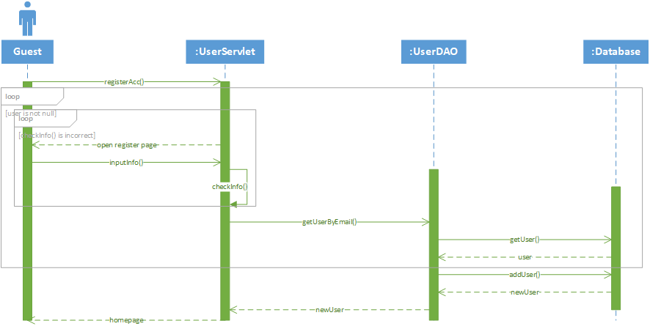

View movie and watch movie

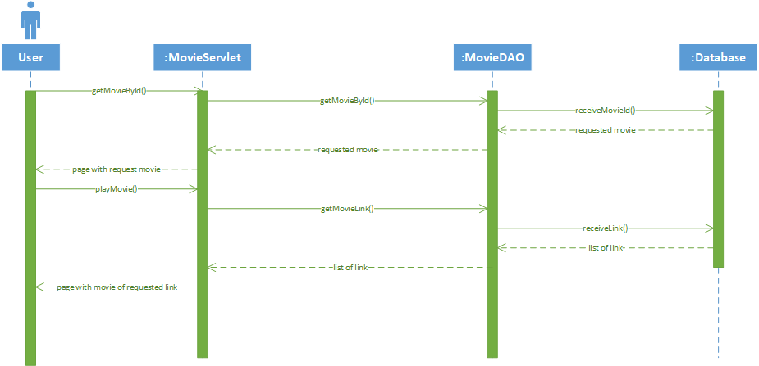

Search movie

