Tjok Dalem Arsa Artha

Pace University – CS639

Git and GitHub

**What is GitHub? When was it created? Why? By who? What similar platforms exist? Why would you use such a platform?**

GitHub is an online repository for hosting computer code projects using version control through the Git software. Its development began in October 2007 and launched in the following April by its creators Tom Preston-Werner, Chris Wanstrath, and PJ Hyett as a means for programmers to collaborate and keep track of who contributes and makes changes to projects hosted on the website. Other platforms include GitLab, Bitbucket, and Kiln. Using a version control platform, especially one like GitHub, is beneficial because of the features and capabilities that it provides, for example streamlining contributions and updates to a project’s source code, and for essentially being a networking platform for programmers to interact. In June 2018, Microsoft has announced its intentions to acquire GitHub for $7.5 billion.

**Part 4 – Git Tutorial**

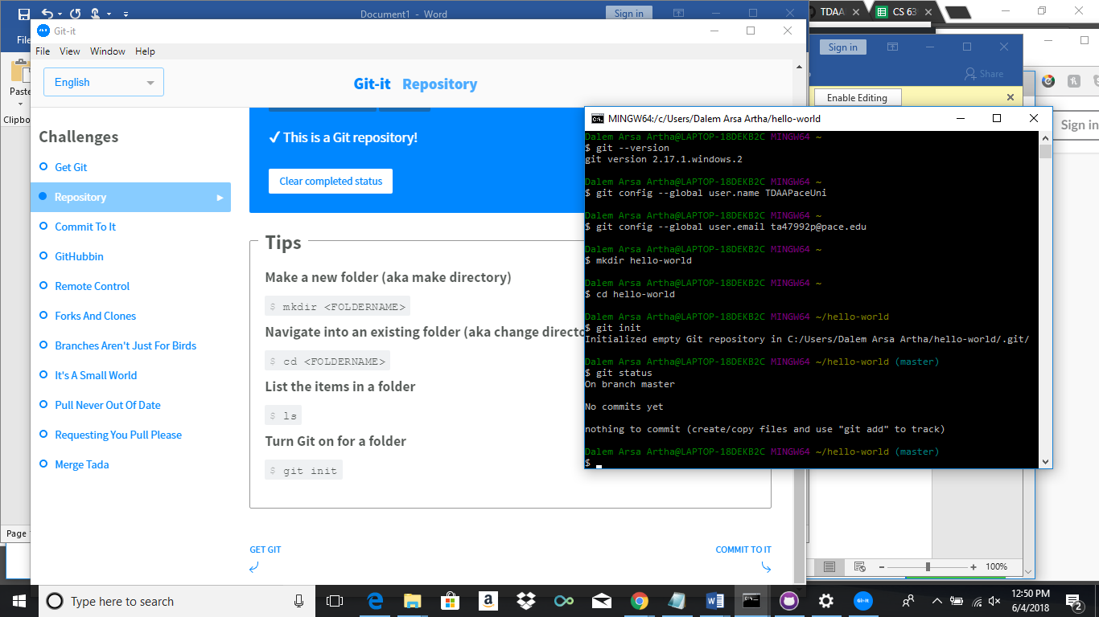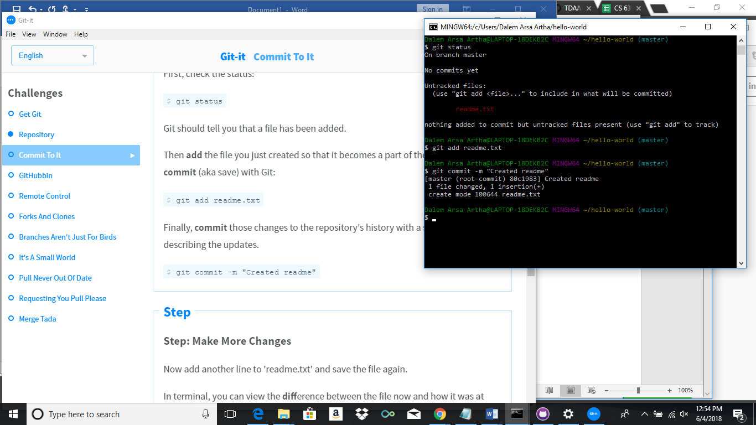

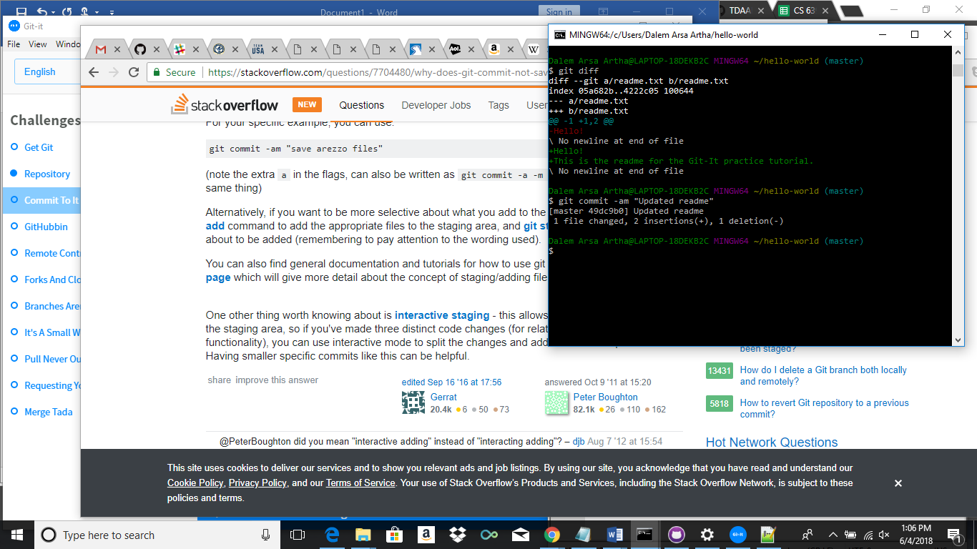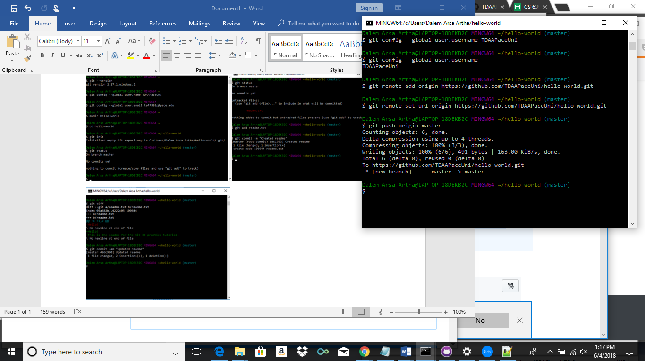

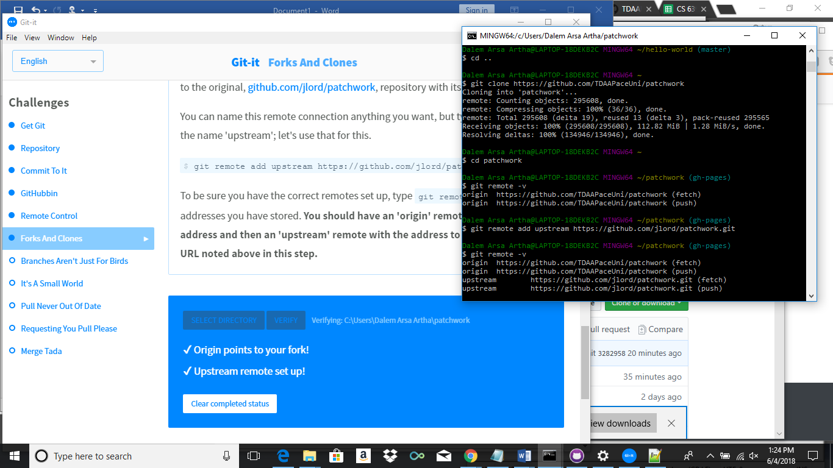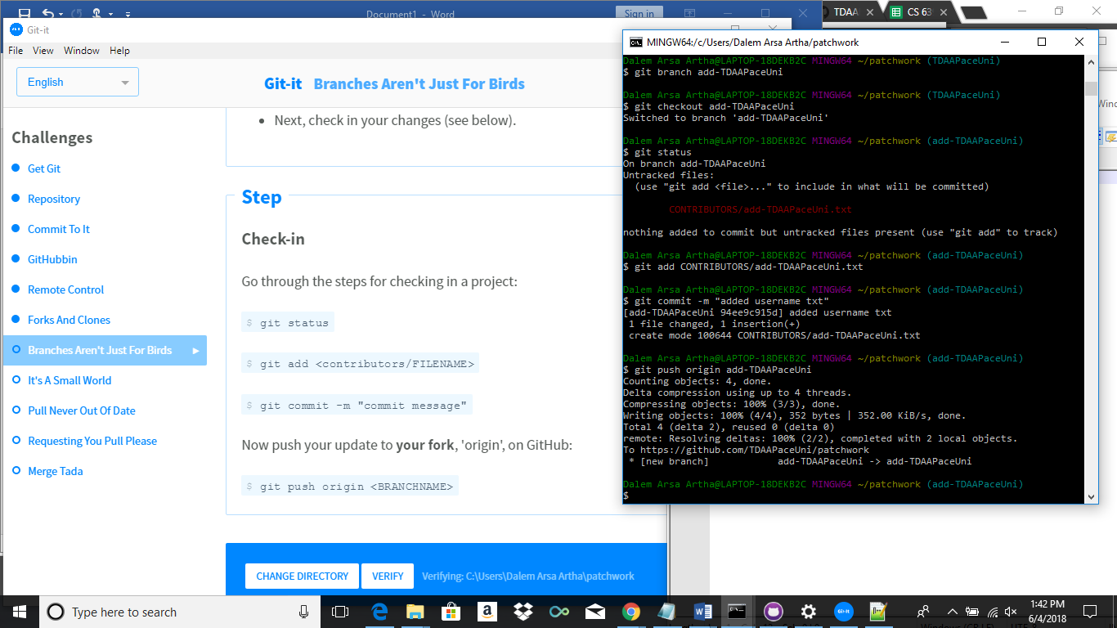

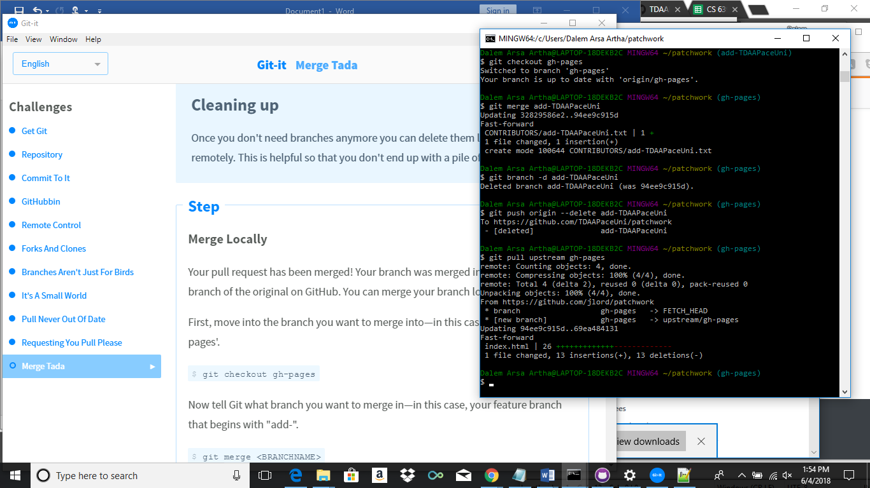

**Part 5 – Word Definitions**

Repository: The cornerstone of using Git, containing all of the project files and tracks the revision history on every file.

Commit: A revision to a file or set of files with an ID that tracks who and when made such changes.

Push: An action that sends committed changes to a remote repository.

Branch: A version of a repository alongside the master branch within the repository that can be worked on without affecting the master until the changes are merged.

Fork: A user’s personal copy of a repository that allows the user to edit without changing the original.

Merge: An action that applies chages made from one branch into another branch.

Clone: A copy or the action of making a copy of a repository that lives on the client computer.

Pull: An action that fetches changes made to a file and merges the changes to the user’s local copy.

Pull Request: An action to propose changes to a repository subject to the decision of its collaborators.