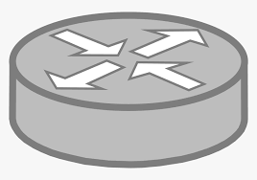IoT end-device Access network Internet (core network + cloud)

Cellular connection

Backhaul connection

 

     RSU Pedestrian Vehicle Sensor Cellular BS Fog server Router