Tylor Lehman
BatPi
Final Essay

BatPi
My senior project is called the BatPi. The intent of the project was to design and create a computer-controlled vehicle. The parameters were that the vehicle was to be able to be operated both manually by a user and automatically by the computer itself through a programmed AI. This project offered a variety of important learning opportunities, as well as a good chance to showcase some of the skills I have picked up during my time as a computer science student at SUNY Potsdam.
There were a number of reasons that I chose this project. One such reason was the resources I had at my disposal when trying to decide on a subject. From my previous classes at Potsdam, including Assembly Languages and Computer Architecture and Operating Systems I had a Raspberry Pi model B+ that I no longer had a purpose for. This was a chance for me to use a platform that I wanted to spend more time on. In addition to this, I also had a vehicle chassis from an Electrical Fabrication class I took from Alfred State University. These resources greatly reduced the total expected cost of the project, which was an issue based on my finances as a student. Another reason I chose this project was how it nicely lined up with many of my personal interests in computing. While I had some experience on the Raspberry Pi, I had not had an opportunity to utilize the General Purpose Input Output (hereby referred to as GPIO) pins. Professionally, I would like to be in a career involving hardware and software systems integration. While not the equivalent of professional experience, this was a good project to develop a fundamental understanding outside of what had been offered in my curriculum. Another reason was the available learning opportunities offered by this task. Beyond hardware integration, Additional requirements of this project include circuit design through a prototyping board with the use of voltage dividers and other basic electrical components, Gradle as a build automation platform, Git as a version control system, Python and Java as programming languages, and Agile development in the sense of breaking larger tasks into smaller subtasks and focusing on them in a general order of importance and writing progress reports on a regular basis. In addition to these hard skills, experience was gained in a number of software packages and libraries, such as RPi.GPIO, ServoBlaster, Weaved, Raspbian and GitHub.
After choosing a project, the first major decision I was faced with was which programming language to use. This ultimately came down to knowledge versus convenience. I am very familiar with Java, as it is the primary language used in the bulk of classes in the curicullum. Because of this, I started the project in Java. After writing a graphical display in java titled radarmap, a task that took a considerable amount of time, I started trying to write the general programming in Java. This turned out to be a near insurmountable feat, as it is a very complicated process to control the GPIO pins of the Raspberry pi using Java. I attempted to circumvent the issue by using a python interpreter inside of Java called Jython. This ended up creating more problems than it solved. I eventually declared it a lost cause, and switched my entire project to python, which was significantly easier to get interacting with the GPIO pins through a library called RPI.GPIO. While difficult at first due to my unfamiliarity, this was ultimately a good decision.
As for the actual completion of my project, there were a number of major tasks that I divided up into sub-tasks in order to have a more precise measurement of progress. In chronological order, and not necessarily in order of importance, the tasks and their methodology of completion are outlined in the upcoming paragraphs.
The first major step was figuring out how to make the vehicle able to sense its surroundings. There were a number of different options available on the market. Some such options were through laser sensors, infrared sensors, sonic sensors or physical buttons. While all of these were feasible options, there were a couple of deciding factors. The first was the price of the method. While laser sensors were by far the most accurate, the price was such that it rendered it unfeasible. This was also the case, but to a lesser degree with the IR sensor. The sonar distance sensor and buttons were the most cost effective method. Between the two of these, only the sonar distance sensor fit the necessary requirements. While a button system could detect collisions with objects, it is useless until that point, and therefore would not be able to complete the task appropriately. The model that I decided on using was the HC-SR04. This functions by reading a 5 volt pulse for a very short time. After receiving the pulse, it would send out a low-frequency sound wave and set a pin to 5 volts. Once an echo is received, that pin is then set to low voltage. The raspberry Pi can only accept a max input voltage of 3.3 volts, so I had to wire a voltage divider to drop the 5 volts to 3.3 volts. This was accomplished by using a 2 kiloohm resistor and a kiloohm resistor. This ratio of 1:2 is precisely what is required, because the formula for voltage dividers is Voltage out is equal to voltage in multiplied by the quotient of Resistor 2 divided by the sum of Resistor 1 plus Resistor 2 [Vo=Vi*R2/(R1+R2)]. To make the computer read the distance, I took the total time the pin stayed high, and divided that number by 17000 to get distance in centimeters. This number specifically is used because the speed of sound is 34000 cm/sec, and that number is divided by 2 to account for the round trip time it takes for the sound wave to get to the nearest obstacle and then return to the device. This will result in the distance to the target in centimeters. There are two major shortcomings to using this method of distance detection. The first is as a sound wave, there is significant spread. Each pulse of sound covers about a 15 degree angle from the source, reducing accuracy over longer distances. The second are ghost readings. When taking many readings consecutively, sound waves from previous readings may bounce off farther obstacles and be recorded for subsequent readings, skewing results. The effects of these two problems can be mitigated by taking multiple measurements, or by removing outliers before calculating average distances. A second, less ideal option is adding a longer wait between measurements. This has a significant impact on performance, as if you are taking many measurements, the total time required is compounded by a much larger factor. This results in a monumental wait time between pauses.
The second problem was to get all of the necessary hardware to communicate with the Raspberry Pi through the GPIO pins. This was not a very difficult task, as there is a standard library on the Pi called Rpi.gpio that had nearly all of the required functions. Pins could be set to high or low voltages, and voltages from pins could be read. The one instance that this functionality wasn't quite sufficient was in the operation of the servomotor. Servomotors operate by having a high voltage from a capable power supply (at least 300 milliamps). In addition, there is a signal pin that expects to receive a pulse every second. Based on the length of the pulse, a small controller inside the motor determines where it should be facing, and calls on the high voltage pin to position it in that location. In python, I wrote a short loop that Was told which position the motor was expected to be in, and then sent a pulse with a length corresponding to that position. This created an issue because of the unimpressive speed of the Raspberry pi. As this thread has to be ran separately from the main program, it adds a small extra cost in context switches. Because of this, and because timing is based on the software clock, there was some slight differences between the intended and the actual lengths of the pulses, resulting in jitter in the servomotor. While it wasn't extreme, I decided to try to remedy this problem. This was accomplished through a program available on GitHub called ServoBlaster. This program locks pins for this precise purpose, and sets voltages based on the hardware clock instead of the software clock. This completely fixed all problems of servomotor jitter.
The next step of this project was controlling the DC motors that were intended to drive the vehicle. After experimenting with a circuit comprised of basic components, such as resistors, diodes, transistors and voltage regulators, it was deemed impractical to design a motor controller capable of driving two motors independently and bi-directionally. I found an inexpensive controller that satisfied all of these requirements in the L293D. A 16 pin microprocessor that requires 3 signal rails per motor, a small 5v source to drive the internal processor, and a larger 5v source to drive the motors. This was much easier to wire than the prototype circuit I had previously designed, and worked wonderfully. A shortcoming of this particular motorcontroller is that it requires three pins to operate. The minimum number of pins that could be required per motor are two, and the circuits that I designed would have successfully operated two motors using only two pins and the ground pin. This would be accomplished by designating two pins as General Purpose Input Output pin 1 and General Purpose Input Output pin 2. If pin 1 is high and pin 2 is low, spin clockwise. If pin 2 is high and pin 1 is low, spin counterclockwise. If the two pins are the same voltage, stop. Because I did not run out of available GPIO pins through the course of this project, this problem was not large enough to justify wiring a custom circuit rather than using a motorcontroller.
The next step was setting up remote access to the Raspberry pi. This was necessary to keep the platform mobile. There were a couple of options for this point in the project. Bluetooth was a very promising option, because the only requirement would be suitable adapters and relative proximity. The shortcoming of this is that I wanted it to be operable almost entirely remotely. I intended to be able to control the robot at my home while I am at school. Based on this, I decided to use WiFi instead. While this made it so it was necessary to have a reliable internet connection, it enabled me to operate it from a different location. After this choice, I was still left with a number of options. I could use python's integrated Transmission Control Protocol, and code the networking interface directly into my program. This had the benefit of being executable at the boot of the Raspberry Pi. The second option was through a Secure SHell connection. The decision between these two protocols came down to accessibility. It was nearly impossible to get the networking protocol working on unfamiliar networks in a simple way. While I could get each working at my home, where I had complete control of the network security, it was much more complicated to gain access from on Suny Potsdam's campus, where I do not have administrator rights to modify permissions. To get around this issue, I used a program called Weaved, a software–only firewall and Virtual Private Network solution that operates by providing a direct secure tunnel connection to a device. After installing the program on my Raspberry Pi, I only had to log on using my account credentials and was given a unique Internet Protocol address with a generated password to connect to through a proxy provided by Weaved. The limitation of this software is that in the free version, a connection is only provided in 30 minute intervals, but this is plenty of time to update software and test the artificial intelligence, before shutting down to make changes from a different platform with more processing power to compile and run code.
After purchasing all of the hardware and deciding on what software to use, the next step was to wire all of the hardware to the Pi. This was performed by using a half sized prototyping board. This didn't leave much leftover room, but the form factor fit the project perfectly. A total of 11 GPIO pins were used. These pins were 1 power pin (physical pin 2), 1 ground pin (6), two pins for the Echolocator, a trigger pin (16) and an echo pin (18), one pin used for the servomotor (7), and six pins for the motorcontroller, three for each DC motor (pins 11, 13, 15, 29, 31, 33). I cordoned off various sections of the prototyping board for each smaller circuit, with the servo circuit on the left side of the board, the motorcontroller in the middle, and the echolocator's circuit on the right hand side, when looking at the machine from behind. When trying to wire the circuits, I made a few mistakes. When hooking up the motor controller, I was trying to connect the external battery to the Voltage in, when I accidently touched one of the signal pins. This sent 300 milliamps along a rail designed for 3 milliamps. There was an audible frying sound, followed by the scent of burning plastic. The microprocessor was ruined. Lucky for me I had ordered 5 of them because it was only nominally more expensive than purchasing one. I swapped the fried chip out and connected a new one, and everything worked perfectly. The second issue I had was the external battery had a habit of turning off when only a little current was being drawn from it. This had the effect of when I was testing my hardware with the Raspberry pi being plugged into a wall outlet, the servo and DC motors would continuously shut off, and not turn back on until I hit the power button on the battery. I installed a light emitting diode directly into the power circuit so I could tell when the battery had shut off. There was no need to remedy this problem further, because once I plugged the Pi into the external battery it drew enough current to keep the battery operating.
The next part of my project was the three dimensional modeling. This was required because while I had a leftover chassis from a project from Alfred State, I no longer had the original wheels that came with the kit. I was completely unfamiliar with 3d modeling and printing, so things started out very rough. After a lot of research, I discovered TinkerCAD, a free browser-based design tool offered by AutoDesk. As a member of the physics department, I have free access to the 3d printer, a MakerBot Replicator 2X. The first model I created was called PiWheel, a wheel that fit the very uniquely shaped axel of the motors I had available. It took two prints to get correct, which was fortunate. The wheel had to attach to a very small outcropping, and fit around two screws holding the motor in place. This was a very specific design and no pre-made solutions were available. The second contraption printed was a mount to connect the sonic distance sensor to the servomotor. For this purpose, I found a model that was custom made for the distance sensor, and also a model of the servomotor. Using these two designs as resources, it was a simple task to add a mounting bracket to the distance sensors design. While printing this, I ran into an issue. Due to the nature of the print, with a large hollow circle in the middle of it, there was a high risk of sagging. It wasn't until after the print that I discovered the function of what is referred to as support pylons, thin structures automatically created by the printer to support the main portions of the model to prevent sagging. These pylons can then be broken off by hand to be left with the correctly shaped model. About 2/3rds of the way through my print, I noticed very significant sagging. If the print was allowed to continue, it would have been so incorrectly shaped that the scanner wouldn't have fit into the frame. I canceled the print, and discovered that as it was, the frame would work perfectly well for my intended use, and I went with the mostly finished model. Through using these programs and hardware, I was introduced to a number of different things. I was introduced to many different 3d model types, and ended up using the STL format. I was introduced to a number of different modeling terms. Infill is the percentage of the model that will actually be filled with plastic. This is completed by using a hollow honeycomb shaped fill, and the smaller the infill the larger each honeycomb. The second is a printing stage, which prints a very thin sheet of plastic under the model in order to facilitate easy removal to protect the model from breaking. The number of shells in a print is how many times the printer goes over the outer layers of the model, in order to increase strength. Pylons are, as previously mentioned, disposable supports to prevent sagging. All of my prints worked successfully and I am much more comfortable with 3d design and printing as a result.
I wrote three python classes to operate the hardware. The first class was named Echolocate.py This class had the responsibility of running the sonic distance sensor. It could both take one sample or take three samples and average them out, discarding any outliers. The second class was PiDrive.py, and was tasked with operating the motors used to move the device. It is capable of driving forward, backward, turning left, and turning right. A separate method is called to make the device stop. This method is called when the program is terminated with nonzero exit code, because otherwise the wheels would keep spinning until the Raspberry Pi was shut down manually. This caused a number of problems until I developed the solution of executing stopping code when a nonzero exit code was received from terminating a program prematurely. The third program I wrote was Fullsweep.py. This worked alongside ServoBlaster to operate the motor that controlled the direction the distance sensor was facing. It did this by writing a time corresponding with a particular direction to a file called /dev/ServoBlaster. The servo program then read this file and sent the corresponding pulse on the servo rail using hardware timing. The format of the command sent was 0=x, where 0 was the pin being used for servo timing and x is the length of the pulse that should be sent to the servomotor.
To control the completed robot I wrote two classes. The first was User.py, which allowed commands to be written into the terminal using a very simple interface to both control the robot and return information about its surroundings. The commands available are drive forward, drive backward, turn left, turn right, scan surroundings, scan forward and quit. The second class for operating the robot is called Vlad.py. It is named because it uses echolocation to see, and Vlad was a famous mythological vampire. It had a very simple directive. It always attempted to go forward until it discovered that its path was obstructed. It would then check its surroundings to see if it could turn left or right, and then try to continue forward. If it discovered it could not, it would try to reverse out of the trap it had found itself in and navigate around the obstacle. This artificial intelligence worked pretty well, but there were some issues with over-correction that lead it to run into the side of obstacles rather than cleanly around them.
There were a couple additional problems with the completion of the project. The first was that the machine wasn't heavy enough for it to travel over surfaces other than carpet. The plastic wheels didn't create enough friction with the floor, and would spin without moving the robot. To get around this issue I applied a layer of electrical tape around the circumference of the wheel, and put two small rubber bands around each. The combination of the rubber and the tape created enough friction for the robot to travel over any surface. The second additional issue was with the ServoBlaster program used to control the servomotor. After I set the program up, I noticed only one of my DC motors would spin. After reading further into the documentation on ServoBlaster, I discovered the program defaulted to controlling a large number of GPIO pins, preventing them from being used by other programs. I then had to modify the ServoBlaster program so it would only take control of the one pin I needed to use for servo timing. This actually fixed another problem that I had, with the trigger pin of the sonic distance sensor pin never firing, that seemed to be caused by the same issue. Another small issue was that the DC motors would operate at slightly different speeds due to different internal resistance, both electrically and physically. To solve this issue, I wrote PiDrive.py in such a way that a function was called in one second intervals, and for each interval, the motors ran for slightly different lengths of time to compensate. The necessary difference was determined by marking the tires in the same place. The program was then ran for 5 seconds and how far the marks were from each other was then measured. This distance was divided by 5 to find out the difference per second, and the difference was added to one motors execution time. After a few trials of this process, the motors were close enough to equal that the difference was negligible in operation.
This project was a success on all accounts. I achieved the goal that I had set forth to accomplish in constructing a robot that was capable of driving itself and being operated by a user remotely. I gained a large number of valuable skills as laid out in the previous paragraphs, including python programming, circuit design, software and hardware system integration, the AGILE development model, Git version control and 3D modeling. The full process of my work is presented in the projects git repository at https://github.com/TylorLehman/BatPi.git, along with substantial documentation on the process. Included in the following pages are images of the hardware and design processes used.

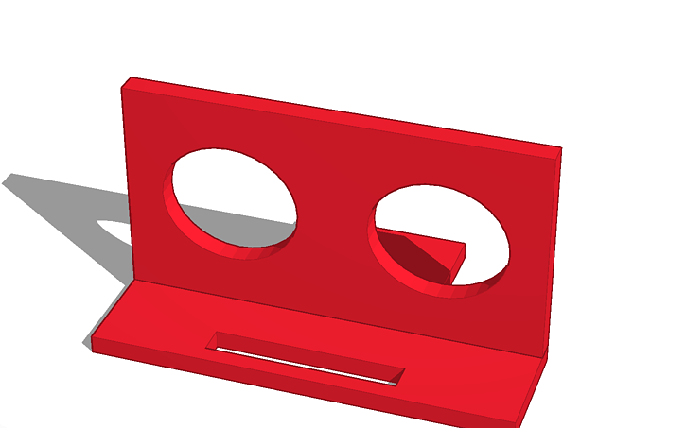
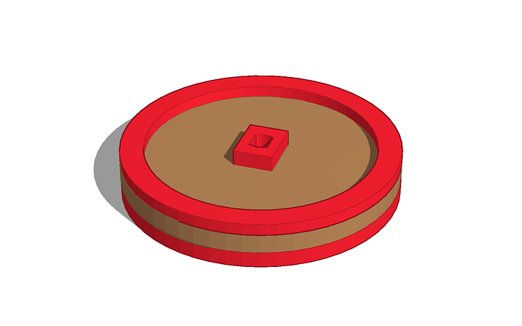
Model For Distance Sensor – Servo Mount Model for Pi Wheels.

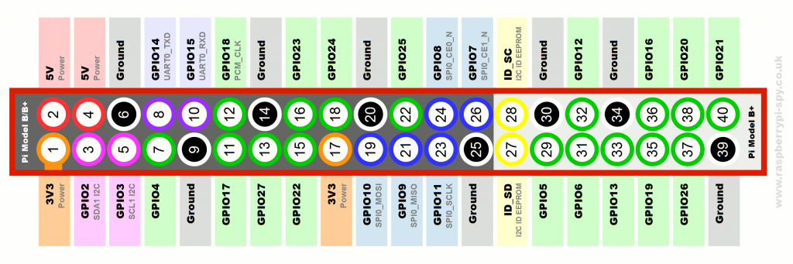
GPIO Pin layout

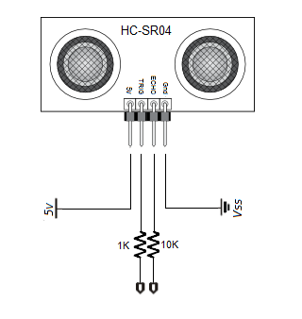
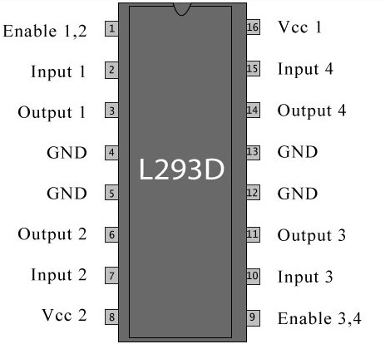
Distance Sensor Layout Motor Controller Pin layout

