

*Summary of Data*

**Player Count**

* There are 576 active players, some players making multiple purchases.

**Purchasing Analysis (Total)**

* There are 179 unique items.
* The average purchase price is at $3.05.
* The is a total of 780 purchases.
* The total revenue came in at $2,379.77

**Gender Demographics**

* 484 players are Male which is 84.03% of the total number of players.
* 81 players are Female which is 14.06% of the total number of players.
* 11 players are Other /NON-Disclosed which is 1.91% of the total number of players.

**Purchasing Analysis (Gender)**

* Males made 652 purchases with and average purchase prices of $3.02 totaling $1,967.64 in revenue. Male players spent an average of $4.07 in total.
* Females made 113 purchases with and average purchase prices of $3.20 totaling $361.94 in revenue. Female players spent an average of $4.47 in total.
* Other /NON-Disclosed players made 15 purchases with and average purchase prices of $3.35 totaling $50.19 in revenue. These players spent an average of $4.56 in total.

**Age Demographics**

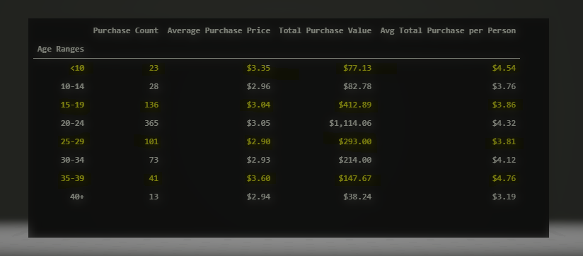

**Top Spenders**

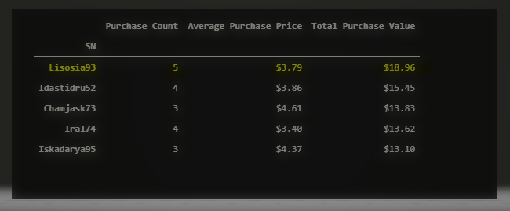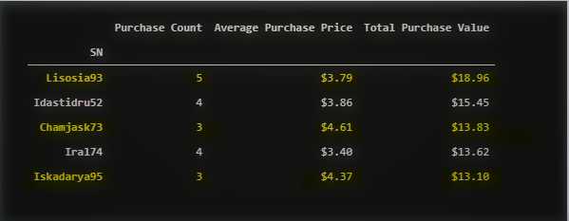

**Most Popular Items**

