|  |
| --- |
| Software design |
| Yarn Towel  Management system |
| Version 1.0 |
| Prepared by class PRN211.M1, Group 7  Truong Quang Son  Ha Tri Dung  Dao Huy Hung  Ta Duc Nghia |

**Table of Contents**

**Introduction** **1**

Purpose 1

Definitions, Acronyms and Abbreviations 1

Document Conventions 1

Intended Audience and Reading Suggestions 2

Project Scope 2

References 2

Software requirement specification form 2

**Overall Description** **2**

Product/System Perspective 2

System/Product Features 3

User requirements 3

User Classes and Characteristics 3

Operating Environment 3

Design and Implementation Constraints 4

User Documentation 4

Assumptions and Dependencies 4

**Specific Requirements** **4**

Functional Requirements Specification 5

Login 5

Screen Design 5

Use Case Specification 6

Logout 7

Screen Design 7

Use Case Specification 8

Manage Customer 8

Screen Design 8

Use Case Specification 9

Customer/Supplier Detail 10

Screen Design 10

Use Case Specification 11

Customer/Supplier Detail 11

Customer/Supplier Edit 12

Screen Design 12

Use Case Specification 13

Customer/Supplier Edit 13

Customer/Supplier Add 14

Screen Design 14

Use Case Specification 15

Customer/Supplier Add 15

Edit Employee 16

Screen Design 16

Use Case Specification 17

Table of all Employee 18

Screen Design 18

Use Case Specification 19

Edit Customer 20

Screen Design 20

Use Case Specification 21

Table of Customer 23

Screen Design 23

Use Case Specification 23

Edit Product 25

Screen Design 25

Use Case Specification 25

Table of all Product 27

Screen Design 27

Use Case Specification 27

Non-Functional Requirements Specification 29

External Interface Requirements 29

User Interfaces 29

Hardware Interfaces 29

Software Interfaces 29

Communications Interfaces 29

Other Nonfunctional Requirements 30

Performance Requirements 30

Design constraints 30

Safety Requirements 30

Security Requirements 30

Software Quality Attributes 30

**Other Requirements** **31**

Appendix A: Glossary 31

Appendix B: Analysis Models 31

Appendix C: Issues List 31

**Revision History**

|  |  |  |  |
| --- | --- | --- | --- |
| **Name** | **Date** | **Reason For Changes** | **Version** |
|  |  |  |  |
|  |  |  |  |

# Introduction

## Purpose

This document gives information about Management system application named “**winform quản lý vật tư xây dựng** ”. All functions, information of its, how it be coded, how it works, and all software component will be shown. This document also has a lot of useful for next team developer if another version be developed in the future, support for tester if need fix bug.

## Definitions, Acronyms and Abbreviations

|  |  |
| --- | --- |
| **Acronyms** | **Definitions** |
| **DBMS** | Database Management System |
| **IDE** | Integrated Development Environment |
| **N/A** | Not Available |
| **OS** | Operating System |
| **GUI** | Graphical User Interface |
| **UC** | Use Case |
|  |  |

## Document Conventions

* Font family: Times New Roman
* Font weight: Regular.
* Font size: 14.
* Font weight heading 1: bold.
* Font size heading 1: 24.
* Font weight heading 2: bold.
* Font size heading 2: 18.

## Intended Audience and Reading Suggestions

Developer, tester should read document before update coding or fix bugs of previous version.

## Project Scope

*“*Yarn Towel Management*”*  is an application that allows users to manage products, users, revenue and transactions.

## References

## Software requirement specification form

* SRS of Cafeteria Ordering System (by Karl Wiegers)

# Overall Description

## Product/System Perspective

* Yarn Towel Management focus on users who:
  + Want to buy product from Yarn Towel Management
* On store side, they can:
  + Manage their users:login,logout
  + Manage product in shop: import, sell, …
  + See report: users, product, revenue
  + Manage Employee

## System/Product Features

* Manage Account
  + Edit Employee
  + Table of all Employee
  + Create new account
  + Login
  + Logout
* Manage Customer
  + Edit Customer
  + Table of all Customer
* Manage Product
  + Edit Product
  + Table of all Product
* Transaction
  + Export Product
  + Bill

## User requirements

User need a device in Windows operating system. Then user must login to use the application.

The owner/manager will have admin/manager account to use another feature.

## User Classes and Characteristics

*Identify the various user classes that you anticipate will use this product. User classes may be differentiated based on frequency of use, subset of product functions used, technical expertise, security or privilege levels, educational level, or experience. Describe the pertinent characteristics of each user class. Certain requirements may pertain only to certain user classes. Distinguish the favored user classes from those who are less important to satisfy.*

## Operating Environment

* Main Programming language:
  + C# with Windows Form
* IDE:
  + Microsoft Visual Studio 2019
  + .NET framework 5.0
* Database:
  + SQL Server Management Studio 2019
* Project workspace, source code:
  + Gitlab

## Design and Implementation Constraints

* Variables used camel case (words are joined without spaces and are lowercase with first letter)
* Methods, functions must be commented on to support maintenance programmers (comment before functions, before loop, before long code) to understand code easily.

## User Documentation

The user documentation will be made as an application of a website, it will use screen captures of the application to describe all features.

## Assumptions and Dependencies

Assume the user has a computer and the user also has knowledge about using it at minimum level (access, fill in field).

One assumption is that developers team use for develop like database we use have issue, bug, down or update, it’s will affect the website’s performance or even make website down

# 3. Data model

## Entity Relationship Diagram

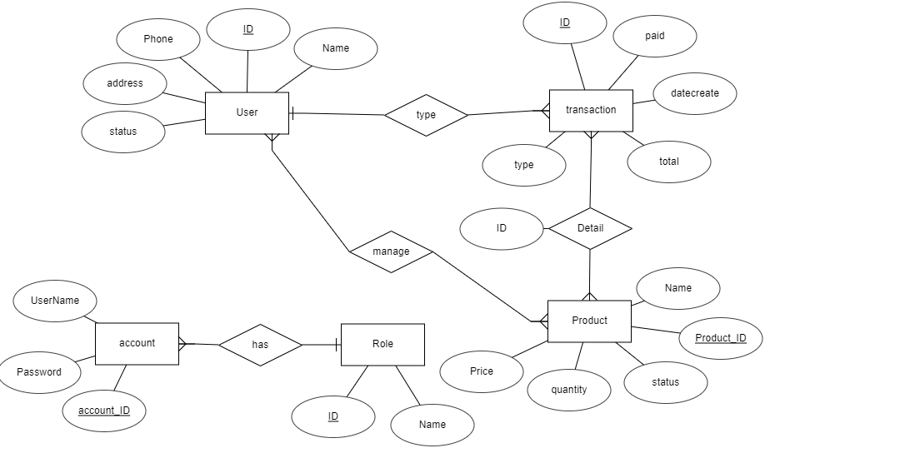

* 1. Database

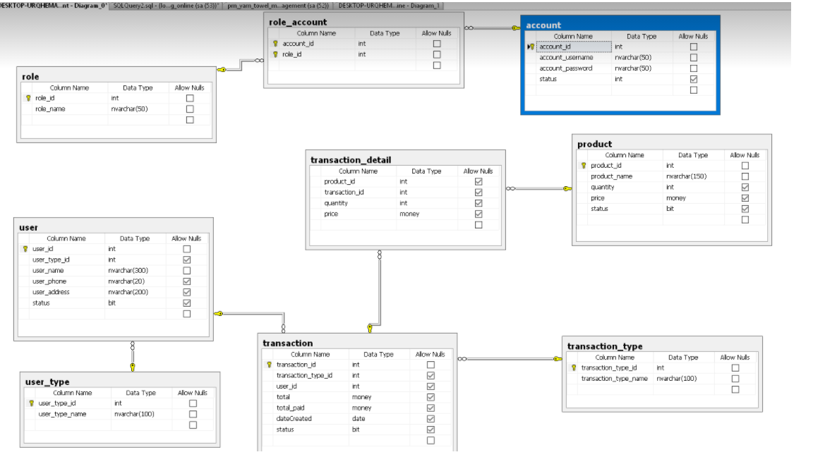

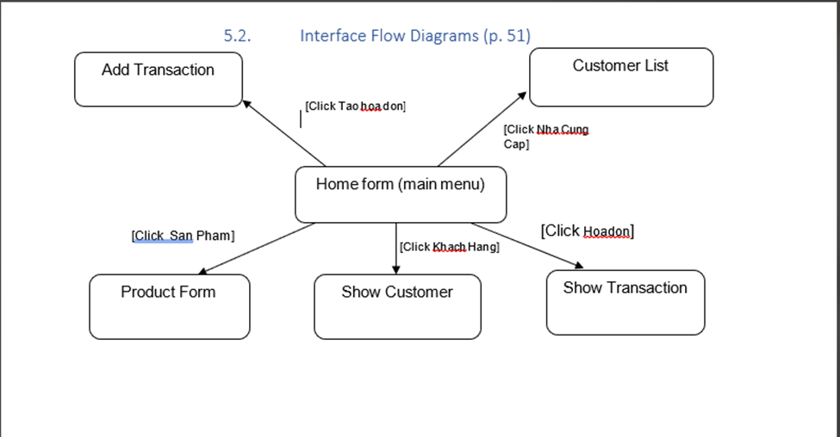3.3 Interface Flow Diagrams (p. 51)

# 

# 4.Class diagram (p.61 – p70)

## 4.1.List of classes in the Layers

Layer DT

Layer GUI

Layer DA

Library Database

Note: Allow to use

BL: Business logic DT: Data transfer

DA: Data access

TransactionType

AddTransaction

Product

Transaction

ShowCus

TransactionDetail

User

UserType

Product

Transaction

## Modeling the Class Behaviors - sequence diagrams ( p. 66, 77)

prn_yarn_towel_managementContext

## 5.User interface model design

### 51.1. Screen “Tao hoa don”

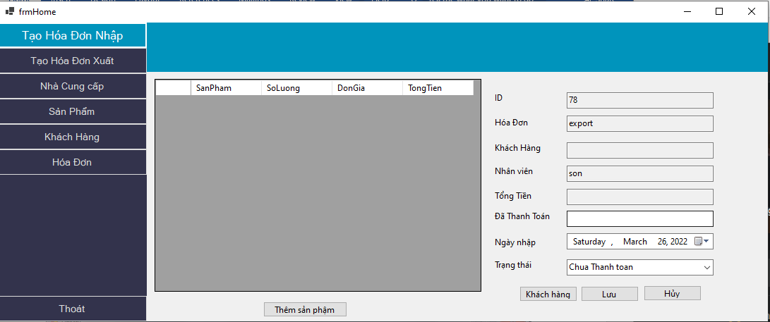

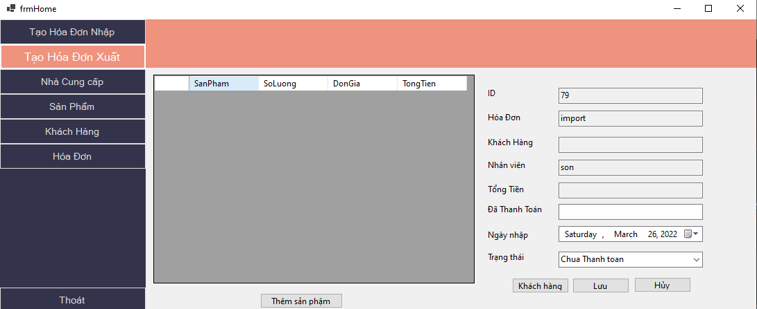

### 51.2. Screen “Nha Cung Cap”

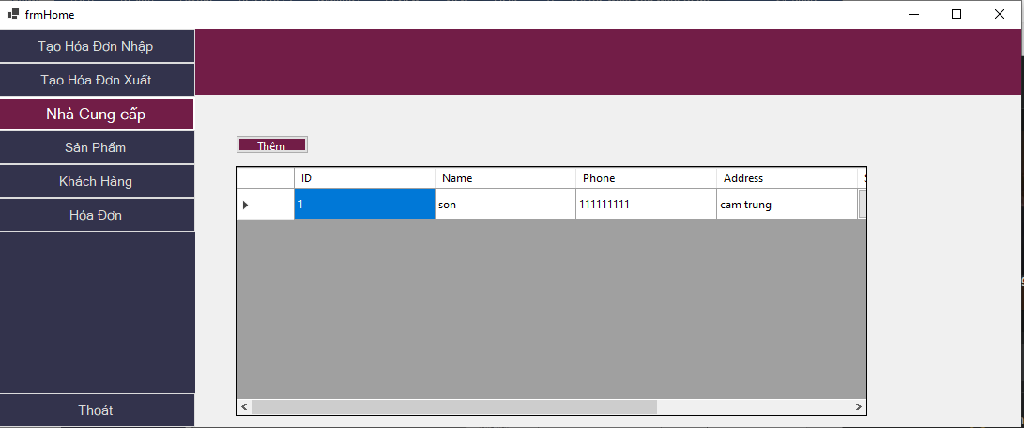

### 51.3. Screen “San Pham”

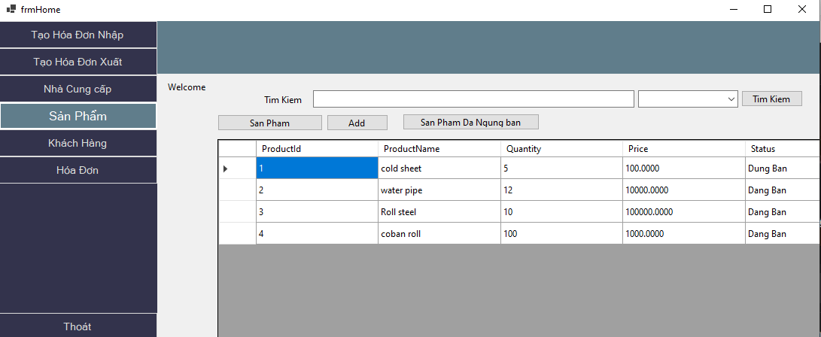

### 51.4. Screen “Khach hang”

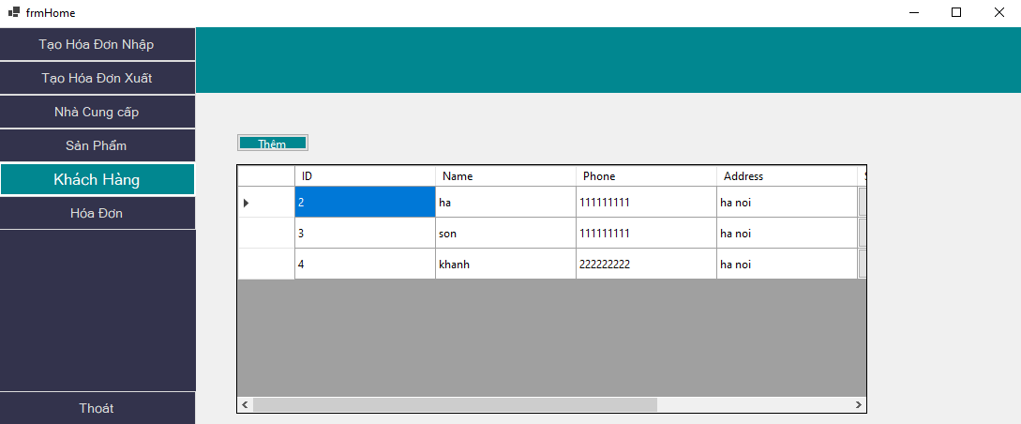

### 51.5. Screen “Hoa Don”

