Finding the dominant recurrence structures by singular value
decomposition
Zitian Wang,1 Norbert Marwan,2, 3 and Yong Zou1, a)
1)School of Physics and Electronic Science, East China Normal University, Shanghai 200062,
China
2)Potsdam Institute for Climate Impact Research (PIK), Member of the Leibniz Association, Telegrafenberg A31, 14473 Potsdam,
Germany
3)Institute of Geosciences, University of Potsdam, Karl-Liebknecht-Str. 24–25, 14476 Potsdam,
Germany
(Dated: 23 June 2025)

I. INTRODUCTION

What are the dominant recurrence structures? Recurrence plots (RPs) often have fascinating structures, especially when the embedding dimension is 1. We identify four basic patterns of a RP, namely, patterns along the main (45) diagonal, patterns along the 135 diagonal, block-like structures, and square-like textures.
However, these main structures are significantly influenced by noise effects.
Introducing Singular Value Decomposition (SVD) to the distance matrix from recurrence plot analysis is a fascinating and potentially very powerful idea. While the standard recurrence plot (RP) directly thresholds this matrix, SVD offers a way to extract underlying structures and reduce dimensionality before or in conjunction with the recurrence plot.

II. METHOD
In essence, the distance matrix provides the raw “similarity” information between all points in the phase space, and the recurrence plot then binarizes this information based on a chosen threshold to highlight when the system returns to ap- proximately the same state. This resulting recurrence plot then reveals characteristic patterns (diagonal lines, vertical lines, clusters) that are used in Recurrence Quantification Analysis (RQA) to extract meaningful insights about the system’s dynamics.

A. SVD

Distance matrix for all recurrence analyses
$$\begin{aligned}D=\left|\left|\vec{x}-\vec{x}\right|\right| \#\left(1\right)\end{aligned}$$
The element of this matrix is Di,j and D becomes blurred by different levels of noise. It also includes redundant information, since we compute the pairwise distance. The leading modes store the dominant recurrence structures that are embedded in the distance matrix D.
To this end, we first perform singular value decomposition (SVD) for D,
$$\begin{aligned}D=UΣV^{T} \#\left(2\right)\end{aligned}$$
where U is an $m×m$ unitary matrix, Σ is an m × n rectangular diagonal matrix with non-negative real numbers on the diagonal, V is an n × n unitary matrix, and${ V}^{T}$ is the conjugate transpose of V. Note that the columns of U and V are orthonormal and the matrix Σ is diagonal with positive real entries.
The diagonal entries of Σ are uniquely determined by D and are known as the singular values. The number of non- zero singular values is equal to the rank of D.
We reconstruct D by the associated eigenvectors, that correspond to the leading r modes. We argue that the possible noise effects are minimized or removed in Di,j because noise appears in the non-leading modes only.
We then choose a threshold εp such that the resulting recurrence matrix has a fixed recurrence rate 1%. Therefore, the original recurrence plots are denoted as RP, while the ap- proximate version is RPapprox
$$\begin{aligned}R=Θ\left(e_{p}-D\right),R^{α}=Θ\left(e_{p}-\hat{D}\right) \#\left(3\right)\end{aligned}$$
In the next, we show some examples of periodic, quasi- periodic and chaotic signals that are contaminated by noise. Meanwhile, we include stochastic signals for comparison.

III. RESULT
Fig 1. This figure shows the singular value distribution information and reconstruction status for periodic signals, quasi-periodic signals, and chaotic signals. The k-th rebuild ratio equals $\frac{{(Σ}_{i=1}^{k}σ_{i})}{Σ_{i=1}^{\min\left(m,n\right)}σ_{i}}$

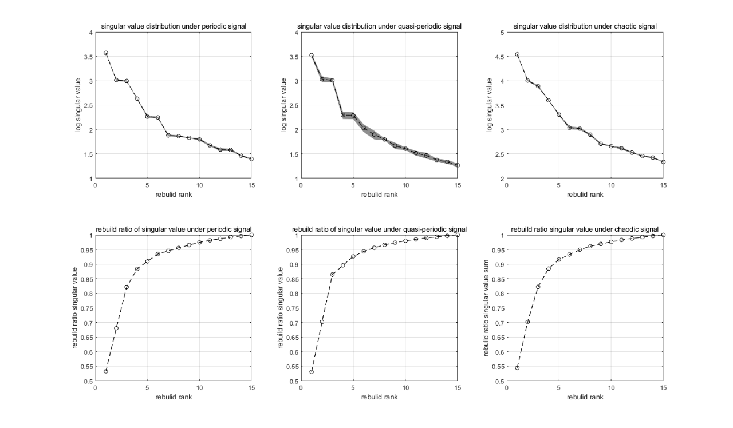

In the following, we show that the dominant recurrence structures in the signal are successfully captured by the approximated RP.

- SINGULAR VALUE ANALYSES

Firstly, we analyze the singular value distribution of different recursive matrices. In this paper, signals without noise influence are constructed, including periodic signals, quasi-periodic signals, and chaotic signals. The periodic signals are constructed using sine waves with a rational frequency ratio, the quasi-periodic signals are constructed using sine waves with an irrational frequency ratio, and the chaotic signals are generated from the trajectory of the Lorenz attractor. Additionally, the frequencies of the periodic and quasi-periodic signals, as well as the initial conditions of the chaotic signals, are randomly selected. This allows us to obtain the singular value distribution images under diverse random conditions, as shown in Figure 1.

