**Part A: Describe the dataset in your own words.**

This dataset is call speed dating data which include all the data that are related to speed dating experiment. Speed dating is a method of meeting potential partners in which each participant has only a few minutes to talk to each other before being moved on to the next one. At the end of the event, participants will decide whether they would dates again. This dataset was collected and done by Columbia Business School professors Ray Fisman and Sheena Iyengar in years 2002-2004. All the data was gathered from participants that involved in this experiment.

In this dataset, there are total number of 195 variables or columns are created and it had total number of 8378 observations or rows are recorded based on the experiment. Types of attributes in this dataset which are category attribute and continuous attribute. For the continuous attribute, it have binary type data example like 0/1, discrete type data and continuous type data. Because this dataset had involved binary type data, for this reason it can’t figure out whether it is normal distributed.

Some important variables in this dataset which are likes gender, age, race, goal, match and so on. The key variable or class attribute in this dataset which is Match. Table below shows the descriptions for each important variables in this dataset.

|  |  |  |
| --- | --- | --- |
| Variable | Description | Note |
| Gender | Gender of the participant | Female= 0, Male= 1 |
| Age  Age_o | Age of the participant  Age of partner |  |
| Race  Race_o | Race of the participant  Race of the partner | Black/African American= 1  European/Caucasian-American= 2  Latino/Hispanic American= 3  Asian/Pacific Islander/Asian-American= 4  Native American= 5  Other= 6 |
| Goal | Primary goal for participating in this event | Seemed like a fun night out= 1  To meet new people= 2  To get a date= 3  Looking for a serious relationship= 4  To say I did it= 5  Other= 6 |
| Match | Determine whether the participant is successfully match with the partner | Yes= 1, No= 0 |

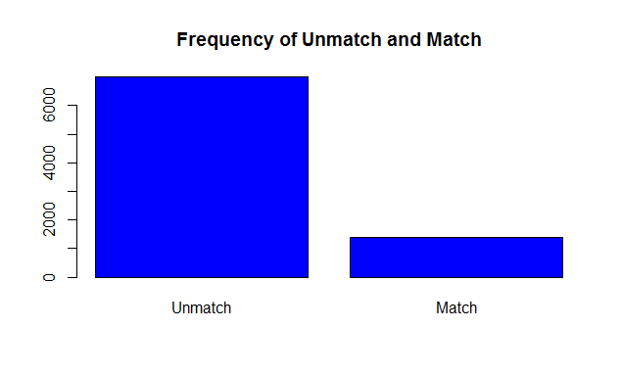

Bar chart above shows that the frequency of un-matched or matched result in this speed dating experiment. Based on the result, there are total number of 6998 participants which are un-matched with theirs partner throughout this experiment while only total number of 1380 participants are matched with theirs partner. From the result, we can say that majority of participants are unsuccessfully matched with others, because the frequency of un-matched result is more than five times the frequency of matched result.

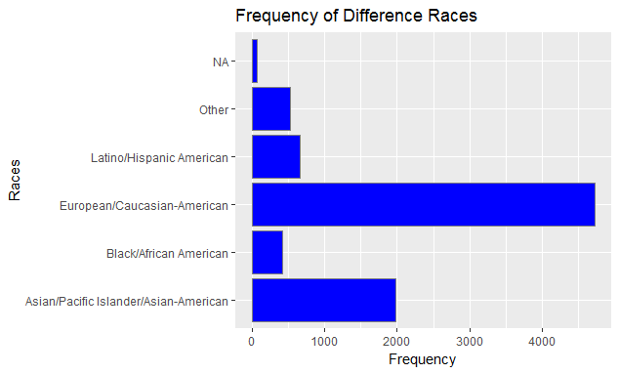

Bar chart above shows that the frequency of difference races of the participants that participate in this experiment. Based on the bar chart, we can see that the most high frequency of races is European/Caucasian-American which have 4727 of participants than follow by Asian/Pacific Islander/Asian-American, Latino/Hispanic American, Other and last is Black/African American which only have 420 participants. Unfortunately, they are total of 63 participants are not showing theirs races in this dataset. Based on the result, we can say that the race of European/Caucasian-American have more courage to try this experiment compare to others race.

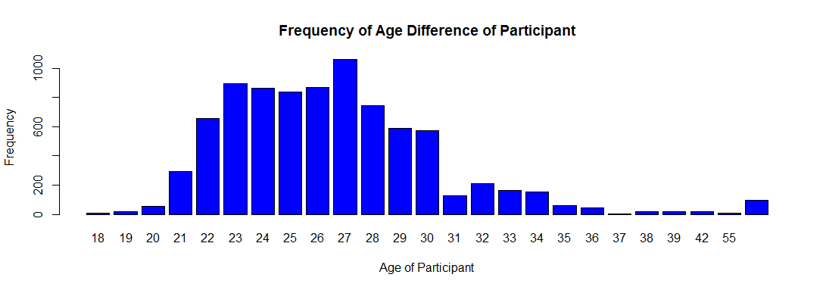

Bar chart above shows that the frequency of age difference of participant that participate in this experiment. The age group that participate in this experiment are from the smallest age which is 18 to the largest age which is 55. Based on the dataset, the most high frequency of age that participate in this experiment which is falls on age 27 while the most low frequency which is falls on age 37. After calculation, the mean of age that participate in this experiment which is 26.35893. Based on the result, we can say that most of the participant that participate in this experiment which are adult and it is falls on age group of 21 to 30.

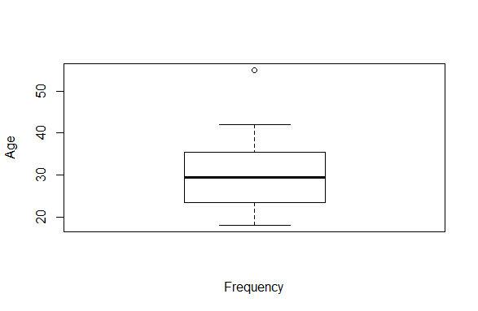

Above is the box-and-whisker plots which shows that the outliers for the age differences of the speed dating participant. In the plots, it shows the age 55 is the outlier of the age for the participant, this is because in this data set the average age for all the participants are 26.35893, therefore this makes that age 55 have some serious age gap compare to the average age.

**Section B: Possible Insight on the Speed Dating Dataset**

There are many different exploratory ideas one can get within this speed dating dataset. The idea here is to focus more on the chances of getting a match with a speed date partner and go on a second date.

**Insight:**

Do people who go on dates frequently have higher chance to get second date than those who does not?

For the attribute go on dates frequently in the dataset have a fairly vague meaning, it can mean how frequent that a person went on dates with different person, or it can also mean that how frequent a person went on dates with the same person.

People who goes on date frequently would have slightly more advantage and experience in terms of what to expect in dating, they may even come up with interesting topic or pickup lines that may interest their speed dating partners to leave a good impression that is nice enough to land them a chance for second date.

For this insight, we only consider the case where by the people went on dates with the same person each time which is an advantage for this speed dating case. Besides that, in order to further describe the participant that are successful in matching we also take in consideration of the participant’s activity of interest.

**Section D: Describe data quality issues, and be specific.**

Attribute Career is having misspelling issue. For example, one of the column in the dataset is career. There are several choices for this column but it is inconsistent because there are different terms that are referring to the same thing. For instances, law, Law, lawyer and Lawyer. It is sometimes caused by the computer program. Another common reason for misspelling is where words are spelt differently from their pronunciation. Sometimes, data entry clerk may be tired or lose some focus, so they are unaware of their spelling mistake. In order to solve this problem, we can use “adist” function in R to look for the minimum character substitution required to convert these terms into a consistent and correct spelling.

Attribute career_c is having missing data issue. Attribute career and career_c is correlated, there are many career options in the list and each of them is labelled. In addition, when the user fill in their career, the attribute career_c will fill in with the number list of the options. For example, lawyer in the career option is “1”, so in the attribute career_c, it should fill in with “1”. In the data set, there are some value missing when the user did fill in career but in the attribute career_c didn’t show up anything. Missing data occurs for many reason in survey. Sometimes, daters may refuse to answer a question due to privacy issues. Perhaps, the respondent just lost of interest or do not have enough time to complete the questionnaire. Every survey question without an answer is a missing data point. Beside that, missed observations may occur when data entry. There is a way to solve the problem which is using imputation.

Attribute data_3 is having outlier issue. In this attribute, there is two option for the user to select which 1=yes and 2=no. In the data set, there is invalid number show on the column which is ‘0’, the range of the options is from 1 to 2, so 0 is invalid in this case. This will occur due to the reason of entering the wrong value at the beginning. In order to identify these outliers, we could use whisker box plot.