class05.R

TuanTran

Fri Jan 25 13:20:33 2019

# Class 05 Graphics and Plots with R  
  
# Section 2A: Line plot  
  
weight <- read.table("bimm143_05_rstats/weight_chart.txt", header = TRUE)  
  
plot(weight$Age, weight$Weight, type = "o", pch = 15, cex = 1.5, lwd = 2, ylim = c(2,10), xlab = "Age (month)", ylab = "Weight (kg)", main = "Some title")

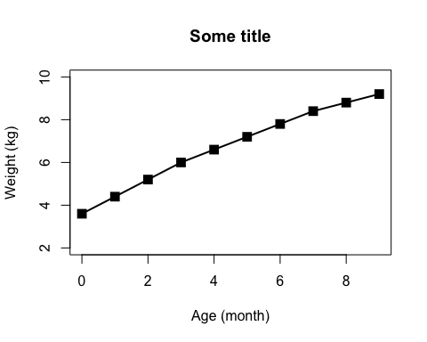

# Section 2B: Bar plot  
  
feature <- read.table("bimm143_05_rstats/feature_counts.txt", header = TRUE, sep = "\t")   
# sep: delimiter, google for the standard symbol of different deimiters  
  
barplot(feature$Count, names.arg = feature$Feature, las = 1, horiz = TRUE, xlab = "A little", main = "Some title")

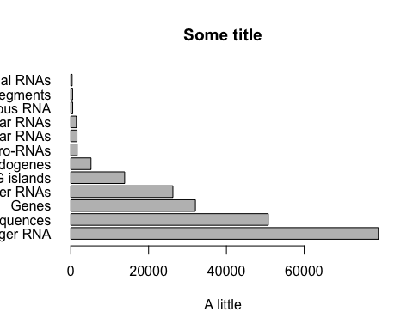

# names.arg: to assign observations for each bar, and las to rotate the observations' strings for visualization  
  
# to look up possible parameters, use ?par. To change parameters, in this example, use par()$mar. Then set the margin to accommodate the graph with the following:  
par(mar= c(3, 11, 4, 2))  
  
barplot(feature$Count, names.arg = feature$Feature, las = 1, horiz = TRUE, main = "Number of features in the mouse GRCm38 genome", xlim = c(0,80000))

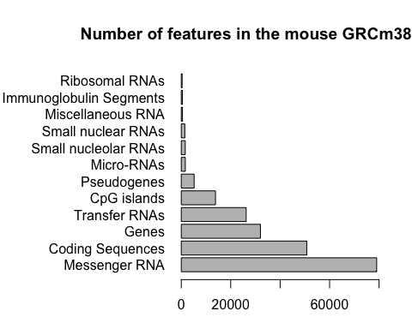

# Section 3A  
  
mf <- read.table("bimm143_05_rstats/male_female_counts.txt", header = TRUE, sep = "\t")  
  
par(mar = c(5, 7, 4, 2))  
  
barplot(mf$Count, names.arg = mf$Sample, las = 2, col = topo.colors(nrow(mf)))

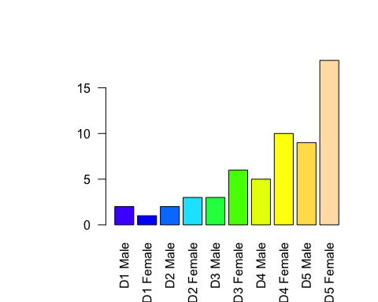

# Section 3B  
  
genes <- read.delim("bimm143_05_rstats/up_down_expression.txt")  
  
nrow(genes)

## [1] 5196

table(genes$State)

##   
## down unchanging up   
## 72 4997 127

plot(genes$Condition1, genes$Condition2, type = "p", xlab = "Expression condition 1", ylab = "Expression condition 2", col=genes$State)

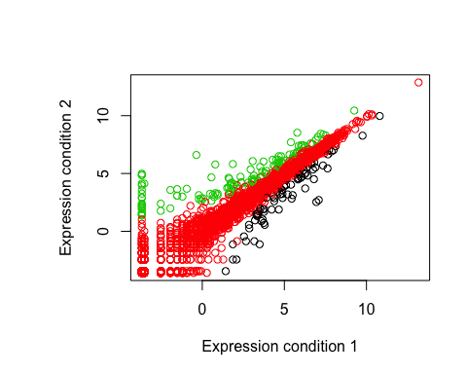

levels(genes$State)

## [1] "down" "unchanging" "up"

palette(c("blue", "gray", "red"))  
  
plot(genes$Condition1, genes$Condition2, type = "p", xlab = "Expression condition 1", ylab = "Expression condition 2", col=genes$State)

