

SENG 3210– Applied Software Engineering

Online Voting System

Trevor Dayton (TRU ID)

Brendan Mierau (T00670407)

Date submitted

Table of Contents

1 Introduction 5

2 Design Problem 6

2.1 Problem Definition 6

2.2 Design Requirements 6

2.2.1 Functions 6

2.2.2 Non-functional requirements and constraints 6

3 Solution 7

3.1 Solution 1 7

3.2 Solution 2 7

3.3 Final Solution 7

3.3.1 Features and the software architecture 7

3.3.2 The system interfaces 7

3.3.3 The user interface design 7

3.3.4 The requirements tractability matrix 8

3.3.5 Environmental, Societal, Safety, and Economic Considerations 8

3.3.6 Limitations 8

4 Teamwork 8

4.1 Meeting 1 8

4.2 Meeting 2 8

4.3 Meeting 3 9

4.4 Meeting 4 9

5 Conclusion and Future Work 9

6 References 10

Appendix 11

* The table of contents should be automatically generated by selecting “References/ Table of Contents”. Remember that the table of contents should not have an entry of the “Table of Contents” itself.
* Proofread the text for typing and grammar mistakes.
* Follow the IEEE Bibliography style for the references by selecting "References/ Citations & Bibliography/ Style".

List of Figures

List of Tables

# Introduction

* Give a brief description of the design and summarize the relevant background information related to the topic. Give a rationale about what is needed and why.
* Give the reader an overview of what is in the next sections.
* Do not put any detailed results of your work here.

An Online Voting System is a system for managers to create topics to be stored in a database for users to vote on. When the users open the app they will have a different user experience where they can see a list of available topics to vote on. Once they select a topic they can pick an option to vote on and their feedback is sent back to the database and stored. The managers can then look at this data to get feedback from users on their topics to make more informed decisions with their users.

THIS PART NEEDS TO BE AN OVERVIEW

# Design Problem

## Problem Definition

There can be an exceedingly large amount of misunderstanding between management and users the same as between a government and its people. To gather feedback for what the users want, voting is one of the strongest strategies but the cost and time of the activity can make this strategy can be prohibitive.

Our project aims to make the process far more accessible and cost effective for business’s to implement using an android application. This allows everyone easy access to the system and eliminates the cost of posing new topics to the users. This allows a greater level of understanding about how users feel on certain topics and allows management to make more informed decisions.

## Design Requirements

### Functions

* An android application available to all desired users
* Users can cast votes on any topic that is created
* Managers can see the real-time statistics of every topics current polling
* Managers can create topics for users to vote on

### Objectives

* Allow for more understanding between users and managment
* Allow users to have a voice on topics within an organization
* Remove the high cost of in person voting systems
* Implement using firebase integration
* Have one app that operates different depending on who is using it (Voter or Manager)
* Provide objectives of the design project. Remember that the objectives are specified as adjectives.

### Non-functional requirements and constraints

* Users cannot vote multiple times on the same topic
* The app must operate differently depending on if a user logs in or a manager
* It must be a cheaper solution than in person voting
* This solution must be created in a very limited timeframe of only several weeks
* Data must be reliably stored in a firebase cloud database
* Environmentally friendly
* Provide non-functional requirements and constraints here.

# Solution

This section will provide an account of some solutions your team brainstormed to implement the project. Some solutions might not have all the desired features; some might not satisfy the constraints or both. These solutions come up in your mind while you brainstorm ways of implementing all the features while meeting the constraints. Towards this end, you select a solution that you think has all the features and satisfies all the constraints. Please remember that an engineering design is iterative!

## Solution 1

The first solution that was considered was integrating the OVS with a MYSQL database created in-house. The MVC was designed as shown in figure 1 where the database would be a MYSQL database. This solution would allow more power on how to structure the database. This solution is more costly in the upfront capital into getting servers setup. There is also additional cost in implementing a more complex server solution in the form of the time it takes to implement. This solution is more environmentally friendly than in person voting as a small amount of servers are needed for data collection.

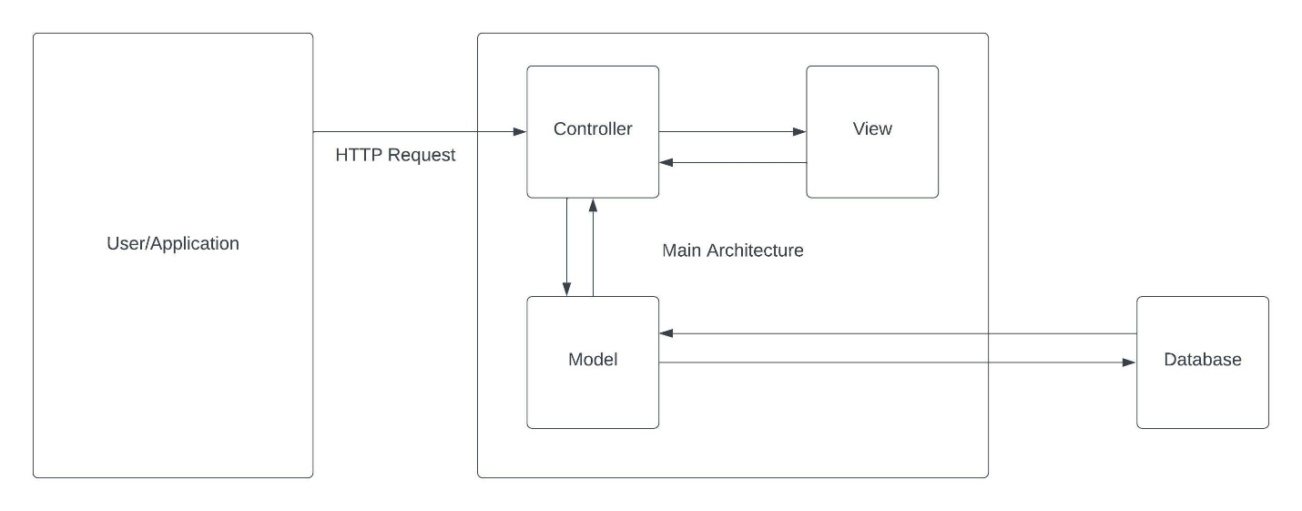

MYSQL SOLUTION

Write a brief description of your first solution and provide the reasons for not selecting this one.

You can use the component diagram, sequence diagram, and class diagram.

## Solution 2

This solution is an improved solution but might not be the final solution that you select. Give a brief description of this solution here.

You can use the component diagram, sequence diagram, and class diagram.

## Final Solution

This solution is the final solution. Explain why it is better than other solutions. You may use a table for comparison purposes. After providing the reason for selecting this solution, detail it below.

### Features and the software architecture

Discuss all the features of your final solution. Describe the functionalities of the top-level components and how they will be used for enabling those features. The product features may be tabulated (with a title) for improved comprehension. Use component diagrams to model the internal structures (i.e., sub-components or second-level components) of two major components. Describe the functionalities of the sub-components and the interactions (e.g., the interfaces) between the sub-components. Explain the interfaces between the top-level architecture and the internal structures (i.e., explaining how the internal structures interact with other top-level components).

### The system interfaces

Describe the temporal events (i.e., the time-triggered events) and the signal events (i.e., events received from external components) of the Online Voting System. Describe the expected response of the system to each event.

### The user interface design

Design the user interface components. Describe the user interface components, the possible business events, and the responses to the triggered events.

### The requirements traceability matrix

List the system’s requirements and map the requirements to the corresponding design component, code component (e.g., java class file or XML configuration file), and the required testing scenario.

### Environmental, Societal, Safety, and Economic Considerations

Explain how your design project considered environmental, societal, and economic considerations. It may include how your implementation has positive contributions to the environment and society. What type of financial decisions did you make? How did you make sure that the implementation is safe to use?

#### Environmental considerations

Explain how your design project considered environmental considerations.

#### Societal considerations

Explain how your design project considered societal considerations.

#### Safety considerations

Explain how your design project considered safety considerations.

#### Economic considerations

Explain how your design project considered economic considerations.

### Limitations

Every product has some limitations, so is the case with your design solution to the Online Voting System (OVS). Highlight some of the limitations of your implementation here.

# Teamwork

Since this is a group project, you must have a fair distribution of tasks among yourselves. To this end, you must hold meetings to discuss the distribution of tasks and keep track of the project progress.

## Meeting 1

Time: January 21, 2021, 10:00 am to 11:00 am

Agenda: Distribution of Project Tasks

|  |  |  |  |
| --- | --- | --- | --- |
| Team Member | Previous Task | Completion State | Next Task |
| Team member 1 | N/A | N/A | Task 1 |
| Team member 2 | N/A | N/A | Task 2 |
| Team member 3 | N/A | N/A | Task 3 |
| Team member 4 | N/A | N/A | Task 4 |

## Meeting 2

Time: February 4, 2021, 10:00 am to 11:00 am

Agenda: Review of Individual Progress

|  |  |  |  |
| --- | --- | --- | --- |
| Team Member | Previous Task | Completion State | Next Task |
| Team member 1 | Task 1 | 80% | Task 1, Task 5 |
| Team member 2 | Task 2 | 50% | Task 2 |
| Team member 3 | Task 3 | 100% | Task 6 |
| Team member 4 | Task 4 | 75% | Task 4, Task 7 |

## Meeting 3

Provide a similar description here.

## Meeting 4

Provide a similar description here.

# Conclusion and Future Work

* Describe a summary of what you achieved. Mention all the design functions and objectives that you achieved while satisfying the constraints?
* While keeping the limitations of the Online Voting System’s design, provide recommendations for future design improvements.

# References

* Use the IEEE reference style.
* Do not put any reference if it is not cited in the text.

# Appendix

If you want to provide additional information, use this appendix.