**EXERCISES FOR LAB 8.**

1. Write a python program to draw the following graphs

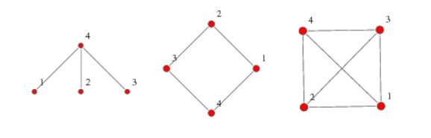

[Grab your reader’s attention with a great quote from the document or use this space to emphasize a key point. To place this text box anywhere on the page, just drag it.]

1. Given the graph

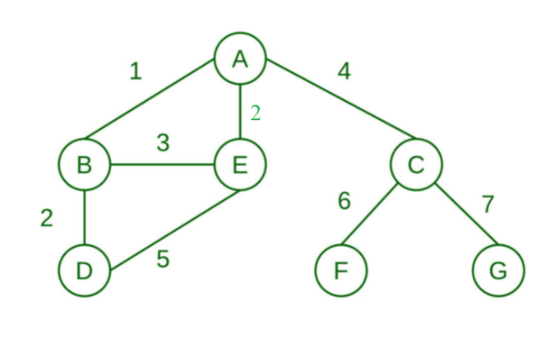

a. Draw the graph

b. Find shortest path from A to D; from G to D; from D to C.

import networkx as nx  
import matplotlib.pyplot as plt  
G = nx.Graph()  
G.add_edge('A', 'B', weight=1)  
G.add_edge('B', 'D', weight=2)  
G.add_edge('B', 'E', weight=3)  
G.add_edge('D', 'E', weight=5)  
G.add_edge('A', 'E', weight=2)  
G.add_edge('A', 'C', weight=4)  
G.add_edge('C', 'F', weight=6)  
G.add_edge('C', 'G', weight=7)  
print(nx.shortest_path(G, 'A', 'D', weight='weight'))

1. Given the graph

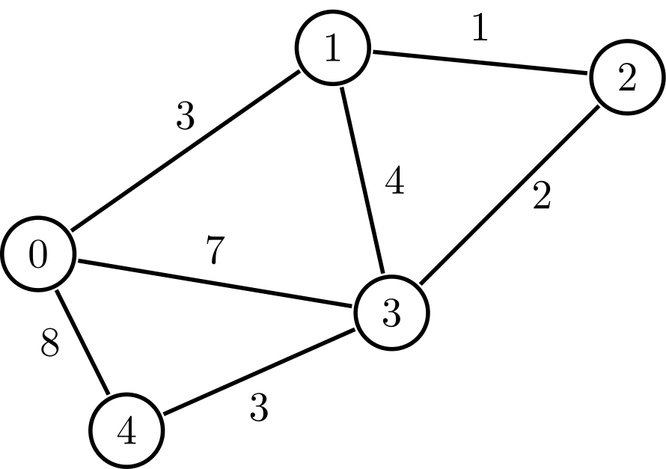

a. Draw the graph.

b. Calculate the Weighted Matrix.

b. Find shortest path from 2 to 4.

1. Given the graph

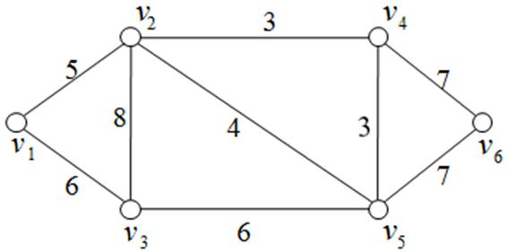

a. Draw the graph.

b. Calculate the Weighted Matrix.

c. Find shortest path from v1 to v6.

d. Calculate the Adjacency matrix.

e. How many paths are there of length 3 from v1 to v6?