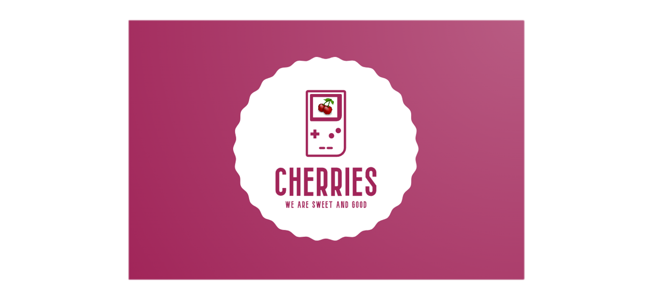

Table of Contents

1.About us 3

2.Game Description 3

3.Stages of Realization 3

4.Used Technologies 3

5.Functions 3

# **1.About us**

|  |  |  |
| --- | --- | --- |
| Name | Role | Grade |
| Miroslav Ganev | Scrum-trainer | 10A |
| Lazar Apostolov | Front-end developer | 10B |
| Georgi Ivanov | Back-end developer | 10V |
| Teodor Tanev | Back-end developer | 10G |

# **2.Game Description**

There were times when people decided to get better, to change themselves to a better reality and a different lifestyle, so that's why they all gathered all the trash on the planet together and put them on a big recycling ship. But the big ship crashed on an iceberg and all the garbage went floating in the ocean. Your task is to gather all the leftovers of the trash by completing chemistry and biology problems and questions. Good luck saving the whole planet ECO pirate.

# **3.Stages of Realization**

1st Week – Creating logo and discussing ideas about the game.

2nd Week – Making basic game’s design and creating our main character.

3rd Week – Implementing our game idea through code.

4th Week – Finishing the game and making documentation.

# **4.Used Technologies**

* GitHub – for the project synchronization.
* Git – to commit our changes.
* C++ - for creating the game.
* Raylib – for game visualization.
* Adobe – for creating the logo.
* Power Point – for creating the presentation.
* Word – for creating the documentation.
* Excel – for creating the QA documentation.

# **5.Functions**

# 6.Block Scheme

