**Views:**

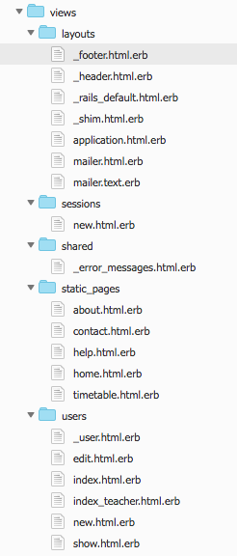

The file tree view of the views in the website (Figure 1) show all pages created for release 1. The layout pages are used for all pages in the website and ensure continuity throughout the entire site. Sessions has one page for signing in. Static-Pages contains views for all pages that can be used even when the user is not signed in. It was discussed that these files be moved to the public folder to increase the speed of the website however, for release 1 they are planned to remain in static-pages and connected to the static-page controller. Finally, users has pages for all the required CRUD with an additional file for displaying teachers. **Figure 1. Views files used for release 1.**

**Routes:**

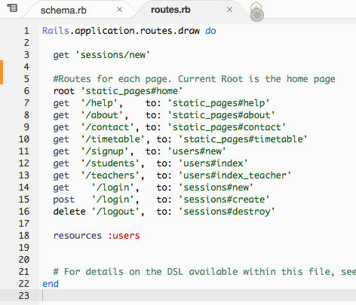

**Figure 2. Routes file of the website at the end of Release 1**

The routes file went through many different iterations during the first release. Towards the end of release 1, all need static pages where routed vie the router file. They were all linked to a single words and thus could be added in the html header simply. This was a design consideration so that other members with little html or ruby knowledge, could easily identify where each link was going to. As can be seen, the root page was decided to be the home page of the website. This was discussed with the other members before being implemented.

**Sign up:**

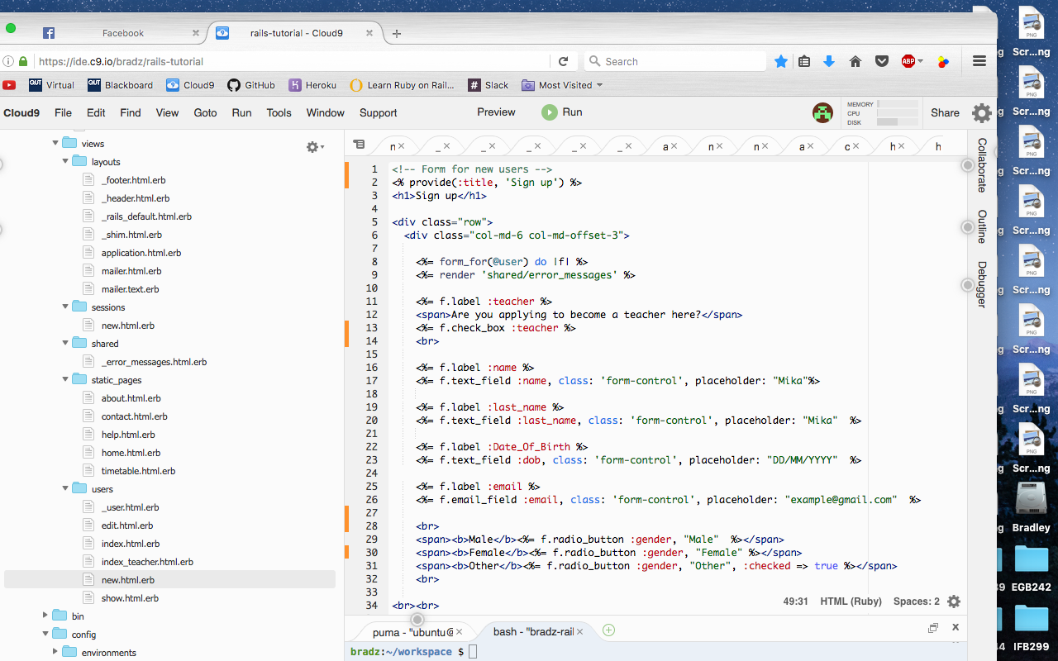

**Figure 3. Sign up form of the website at the end of Release 1**

Above (Figure 3) is a screen shot of the sign up form. The form uses standard rails conventions and returns all params to the controller. Additionally, this form has multiple form element types. It is planned for release 2 to have different input types for different elements in order to make sign up easier.

**Display User Profile:**

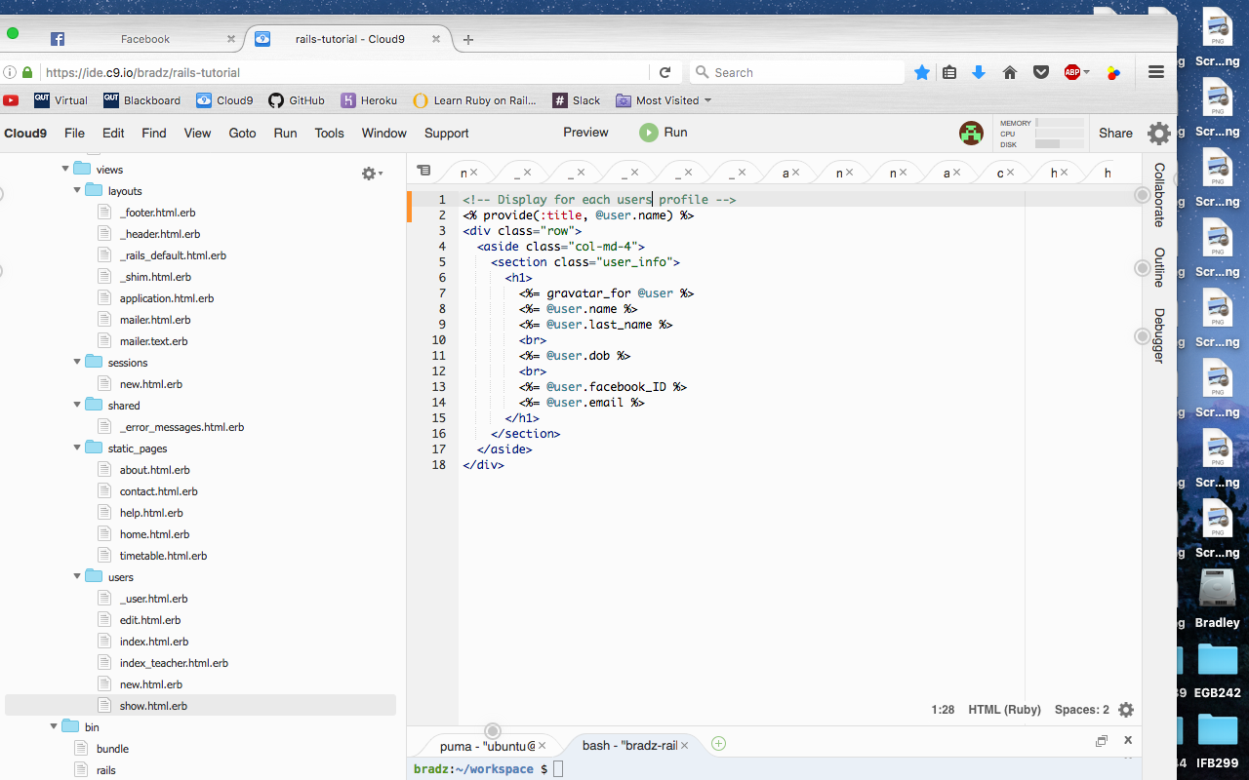

**Figure 4. Page for displaying User Profile**

After discussions on what should be displayed on the user profile it was agreed upon to display the users name, last name, date of birth, facebook ID (If any) and user email. This can be seen above in Figure 4. There were plans of displaying certain information depending on the user viewing the profile. For example, if the admin were to view the profile, the page would display more information such as users gender, if they are a teach, there address etc. However, this was postponed for a later release as it was not planned anywhere in the release 1 sprint plan.

**Map:**

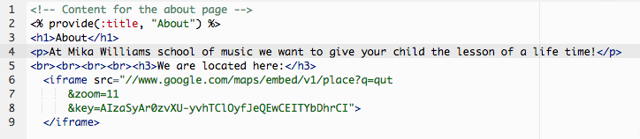

**Figure 5. HTML code for map being displayed on the about page.**

Above shows the code used to display the map on the about page (Figure 5). This is a very simply and insecure way of displaying a map using the google maps API. As this was all that was need for the acceptance criteria, the code for the map will remain unchanged. However, for future releases the size, security and features of the map should be changed.