**Initial Database Design (Tables) Planned for Release 2:**

|  |  |
| --- | --- |
| **User** | |
| First\_Name: | STRING |
| Last\_Name: | STRING |
| DOB: | VARCHAR |
| Gender: | STRING |
| Address: | STRING |
| Facebook ID: | STRING |
| Mobile Number: | VARCHAR |
| Email: | STRING |
| Created\_at: | DATETIME |
| Updated\_at: | DATETIME |
| Password\_digest: | STRING |
| Parent\_Name: | STRING |
| Parent Mobile: | VARCHAR |
| Parent\_Email: | STRING (PRIMARY) |
| Teacher\_qualifications: | STRING |
| Teacher: | Bool |
| Admin: | Bool |

|  |  |
| --- | --- |
| **Teacher Skills** | |
| User.Email(Teacher): | STRING (FOREIGN KEY) |
| Instrument\_1: | STRING |
| Instrument\_1\_Skill\_Level: | STRING |
| Instrument\_2: | STRING |
| Instrument\_2\_Skill\_Level: | STRING |
| Language\_1: | STRING |
| Language\_1\_Skill: | STRING |
| Language\_2: | STRING |
| Language\_2\_Skill: | STRING |
| Created\_at: | DATETIME |
| Updated\_at: | DATETIME |

|  |  |
| --- | --- |
| **Teacher Availabilities** | |
| User.Email(Teacher): | STRING (FOREIGN KEY) |
| Day: | STRING |
| Time: | TIME |
| Duration: | TIME |
| Created\_at: | DATETIME |
| Updated\_at: | DATETIME |

|  |  |
| --- | --- |
| **Student Preferences** | |
| User.Email (Student): | STRING (FOREIGN KEY) |
| Preferred\_Day: | STRING |
| Preferred\_Time: | TIME |
| Instrument: | STRING |
| Preferred\_Teacher\_Language: | STRING |
| Preferred\_Teacher\_Gender: | STRING |
| Created\_at: | DATETIME |
| Updated\_at: | DATETIME |

|  |  |
| --- | --- |
| **Admin Interview** | |
| User.Email (Admin): | STRING (FOREIGN KEY) |
| User.Email (Teacher): | STRING |
| Date: | DATE |
| Time: | TIME |
| Duration: | TIME |
| Created\_at: | DATETIME |
| Updated\_at | DATETIME |

|  |  |
| --- | --- |
| **Lesson** | |
| User.Email (Teacher): | STRING (FOREIGN KEY) |
| User.Email (Student): | STRING |
| Start\_Date: | DATE |
| End\_Date: | DATE |
| Day: | STRING |
| Lesson\_Time: | STRING |
| Lesson\_Type: | STRING |
| Lesson\_Duration: | STRING |
| Lesson\_Cost: | VARCHAR |
| Created\_at: | DATETIME |
| Updated\_at: | DATETIME |

|  |  |
| --- | --- |
| **Student Free Play Room** | |
| User.Email (Student): | STRING (FOREIGN KEY) |
| Date: | DATE |
| Time: | TIME |
| Duration: | TIME |
| Created\_at: | DATETIME |
| Updated\_at: | DATETIME |

**Initial Database Design (UML Diagram) Planned for Release 2:**

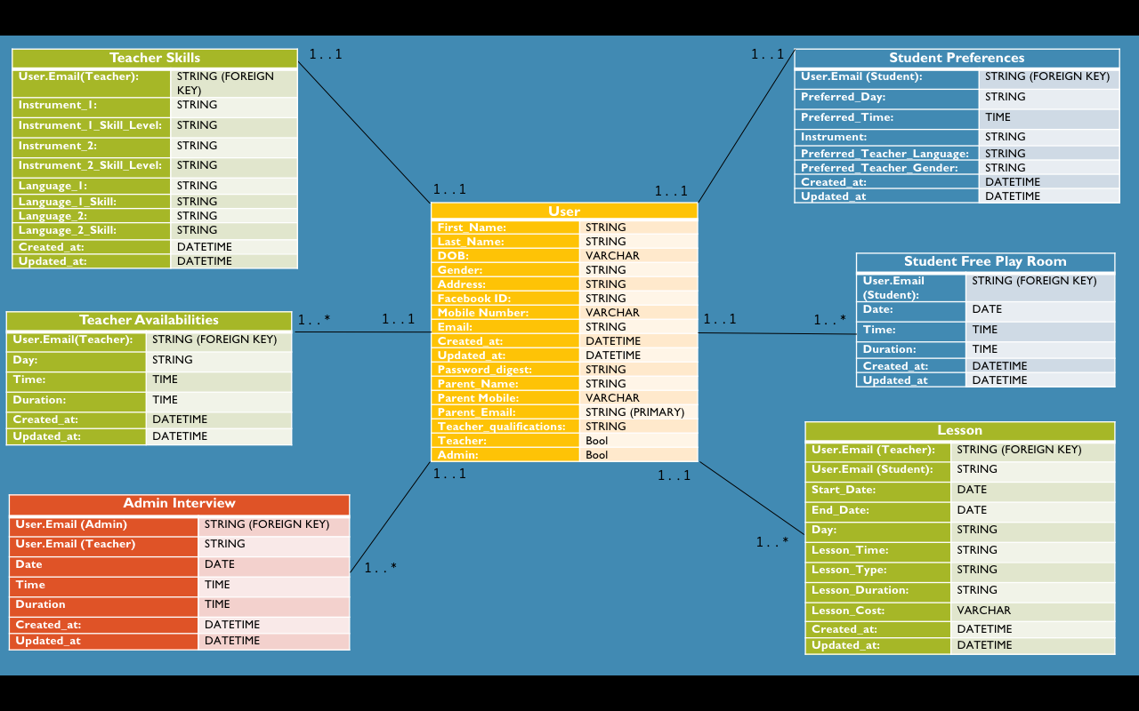

**Figure 1: UML diagram planned for release 2**

The above UML diagram is the initial database design plan for the website. The colour of each table depicts who can create, edit and delete entries into the table. Green tables entries can only be created by teachers; Red tables entries can only be created by admins while blue can only be altered by students. This plan is to be shown to the client team towards the beginning of sprint 3. Once the design has been agreed upon. The updates design will be implemented into the website.

**Revised Database Design (UML Diagram) Planned for Release 2:**

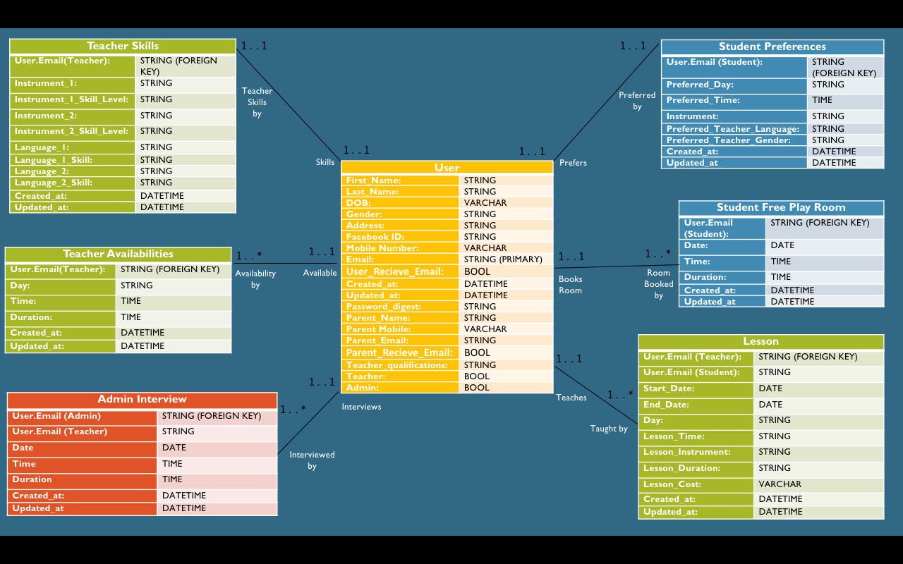

**Figure 2: Revised UML diagram planned for release 2**

On the 6/10/16 the Initial UML Diagram for the Database design was displayed to the client team and the tutor. Minor mistakes were found and changed as reflected above. Added Bool for student and parent receive email. This database design will now be implemented into ruby with both model and table created.

**Database Design Release 1 vs Database Design Release 2:**

|  |  |
| --- | --- |
| **Supporting_Files/Screen%20Shot%202016-10-09%20at%201.40.26%20PM.png**  **Figure 3: Database Design for Release 1** | **Supporting_Files/Screen%20Shot%202016-10-09%20at%201.40.38%20PM.png**  **Figure 4: Revised Database Design for Release 2** |

As can be seen above (Figure 3 and 4), the database design has been revised considerably. The design now has relationships between tables. Additionally, the user table has more columns as required as part of release 2. This adds much more functionality to the project and is required in order to complete issues in release 2.