REPORT: SORTING

# Information

|  |  |
| --- | --- |
| Full Name | Student ID |
| Trần Nguyễn Minh Hoàng | 22127131 |
| Đỗ Đình Hải | 22127095 |
| Phạm Thành Đạt | 22127064 |
| Đỗ Phan Tuấn Đạt | 22127057 |

# Introduction

## Specifications of device used for sorting

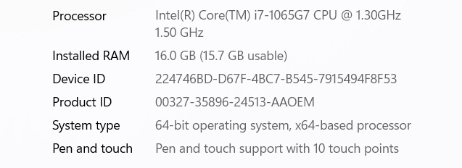

# Algorithm presentation