Rare Book store library.

Needs

Has transferable inventory information

Inventory system

Multiple Locations

Basic book information

Book price

Book Condition

| Manager/super | Employee |
| --- | --- |
| Can access inventory database  Can add entries  Can delete entries | Can access inventory database  Can add entries |

What needs to be solved?

* The logins has to have a differentiation between managers and employees to control the dele function
* Everyone must be able to access and add entries
* Are we using photos to show book condition?
  + If so how many
  + What would be the upload process
  + How does this affect new entries

Initial thoughts

* Some information such as Location, Genre can be drop down options
* Entry page can be a form
* Drop down in the initial sign-up for manager/employee that is linked to the delete entry function.
  + Can this be structured in the html?

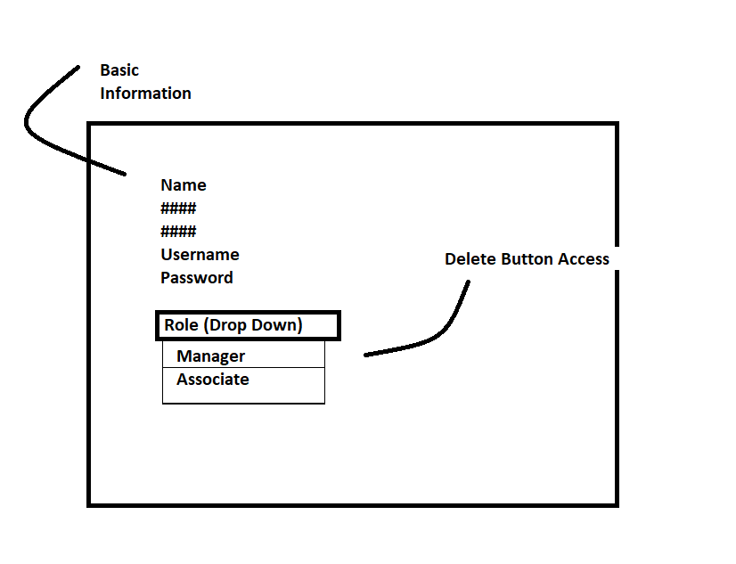

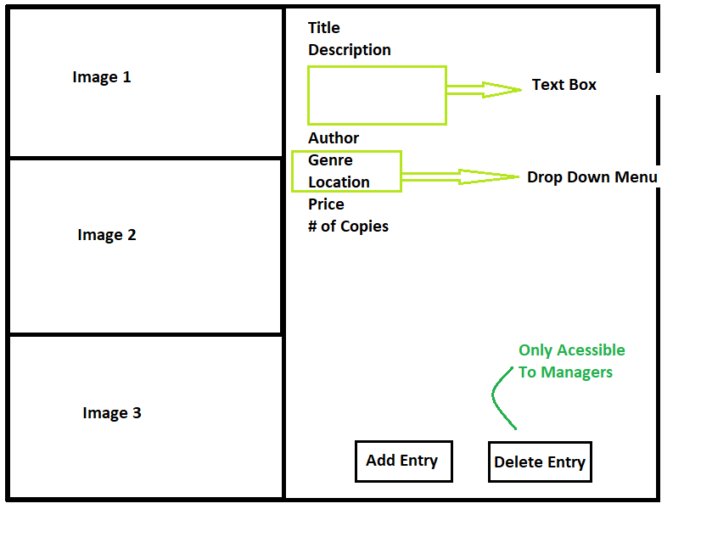

**To Dos**

* Create Repository GitHub
* Review Class video to Create Project
* Initial coding through Sandbox