**Python Online Editor**   
  
We will be using the online IDE [trinket.io](http://trinket.io/) to write python code this semester. Below are instructions for how to sign up, name a file, create a new file, and run a program. Refer to this sheet if you are having difficulties.

**Signing Up Instructions**

1. Open your email and find an email from [hello@trinket.io](mailto:hello@trinket.io). Click "Join Course":

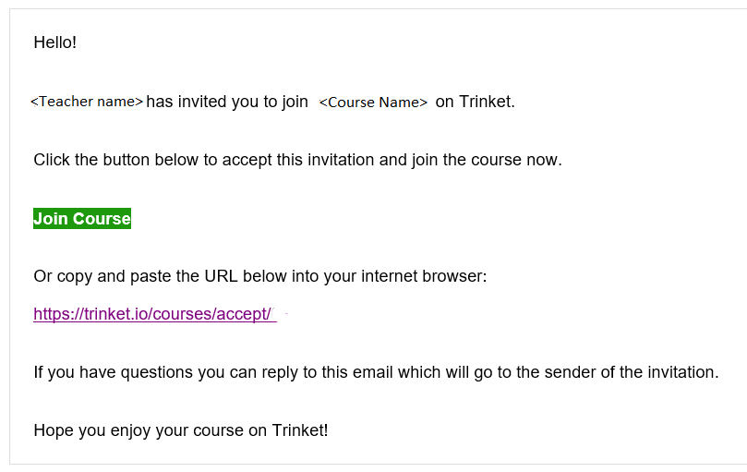

1. Close "Login to Trinket" window by clicking "X" in upper right corner:

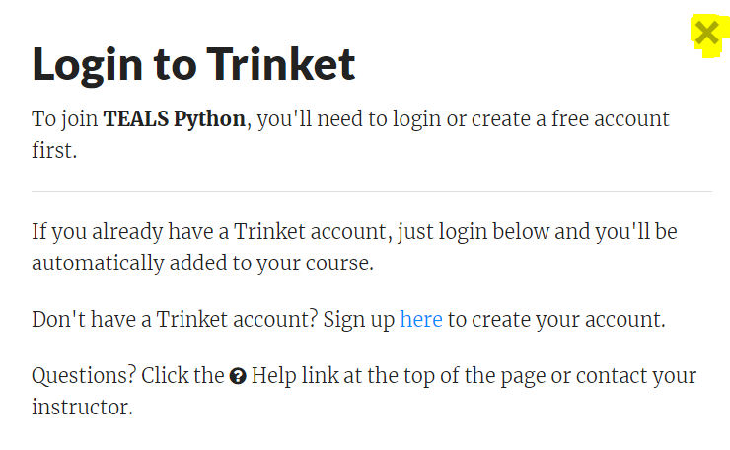

1. Sign up for an account by clicking the "Sign Up" in the lower right corner:

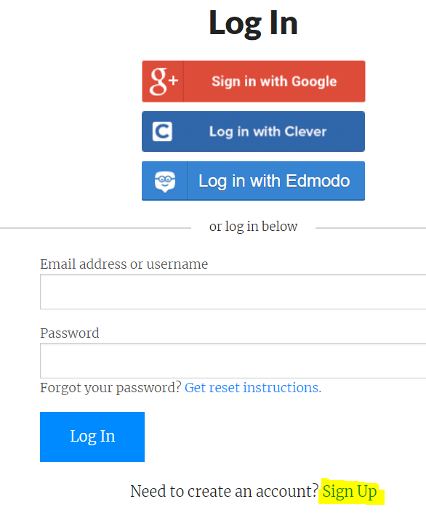

1. Fill out the "Full Name", "Username", "Email Address", and "Password" as instructed by your teacher and click "Sign Up":

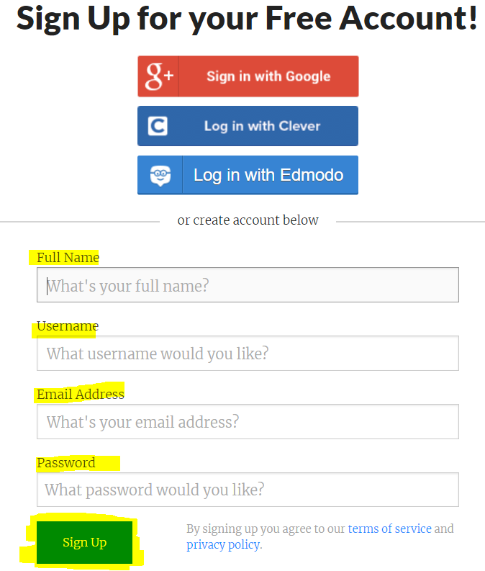

1. You will be brought to your "Home" page. The course will be listed under "My Courses", click the course to open:

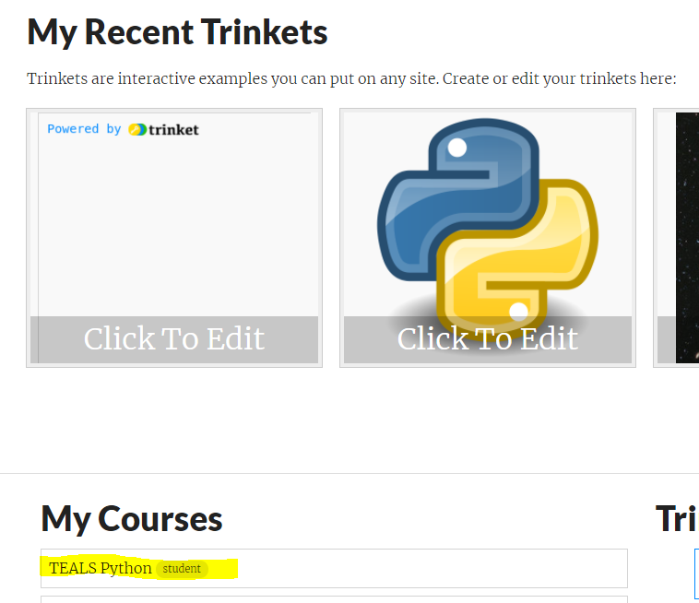

1. You can now view the content of your course.

**Creating a new Python 3 Program and Submitting Link**

1. Navigate to your home page by clicking "Home" on the top menu, click the "New Trinket" dropdown, and select "Python3"  
     
   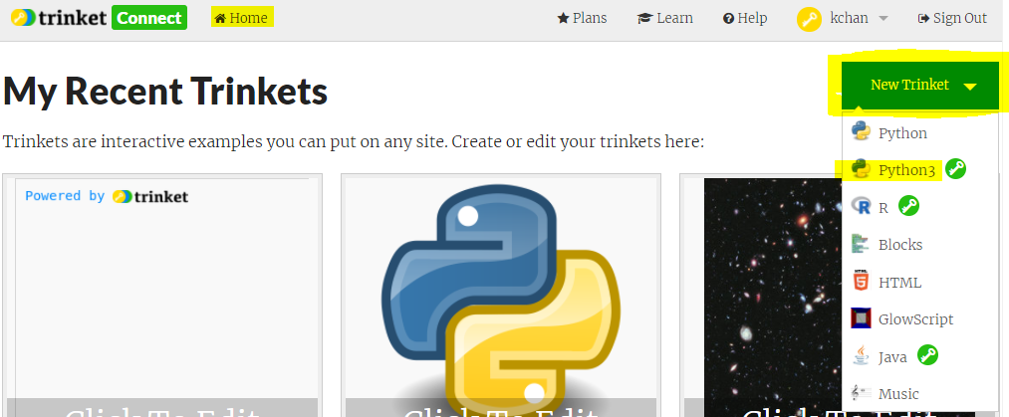
2. Name your project by clicking the "Untitled" text box, open the Python Console by clicking the drop arrow next to ">_ Run", click ">_ Console". You will see the console window open on the right panel. Click "Save" to save the project.  
   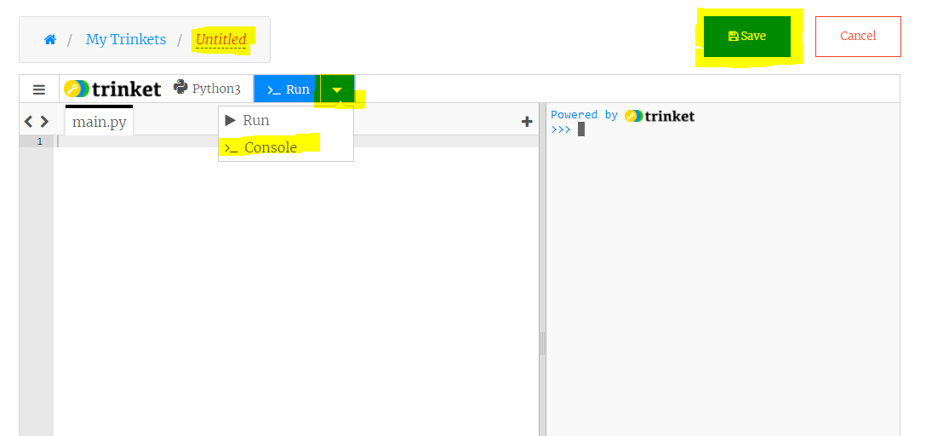
3. To share your project with your teacher, click "Share", then "Link":  
   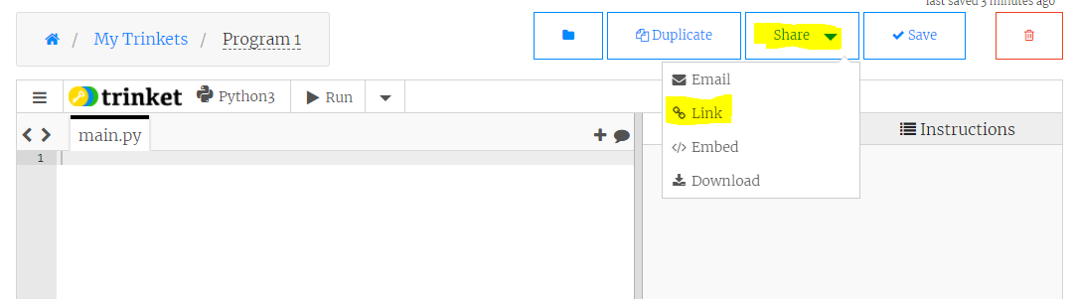
4. Copy the link and follow instructions from your teacher on how to submit your assignment.  
   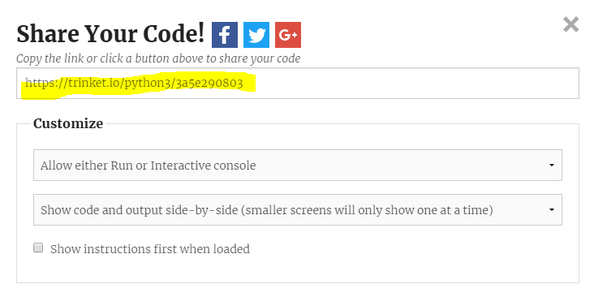

**Execute in Console mode and Running a Python 3 Program**

1. To execute code in interactive mode, type any Python into the right panel Console window and hit "Enter" (make sure your Console is active):  
   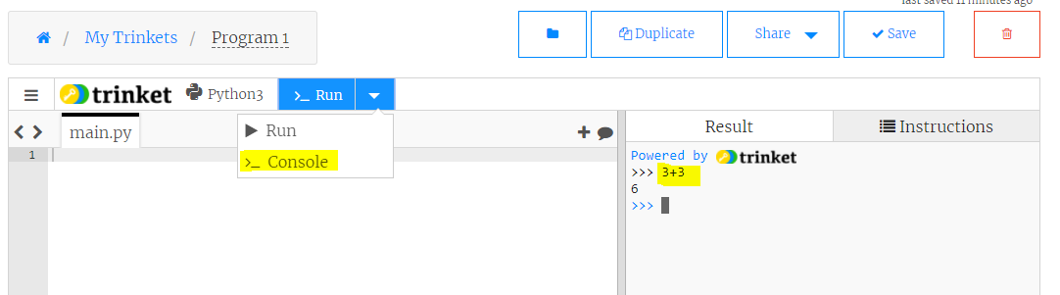
2. To enter a program, type Python code into the left panel. To run your program, click the ">_ Run" button. The output will be displayed in the right panel. Save your program by clicking "Save"  
   