**Create a Trinket teacher account**

1. Navigate to Trinket sign up age: <https://trinket.io/sign-up> and sign up for an account.

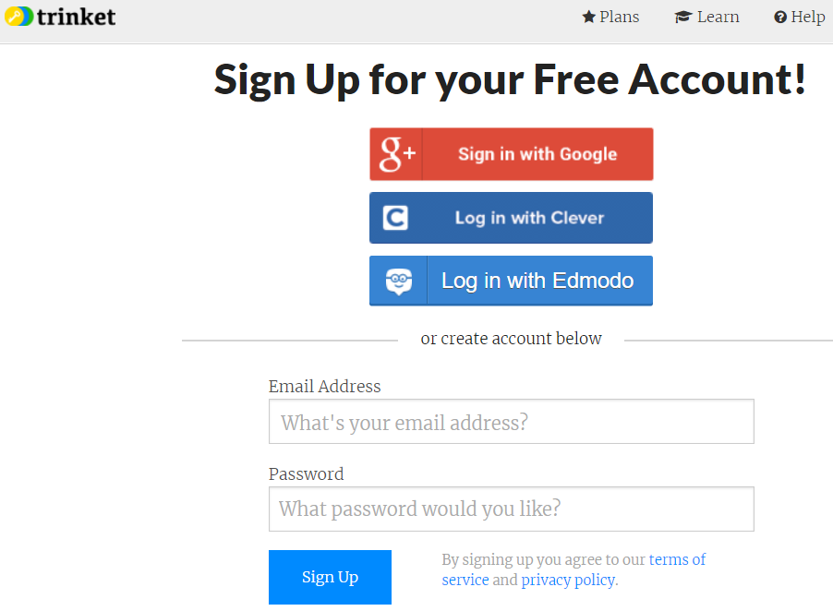

1. To create a course, navigate to your home screen: <https://trinket.io/home>

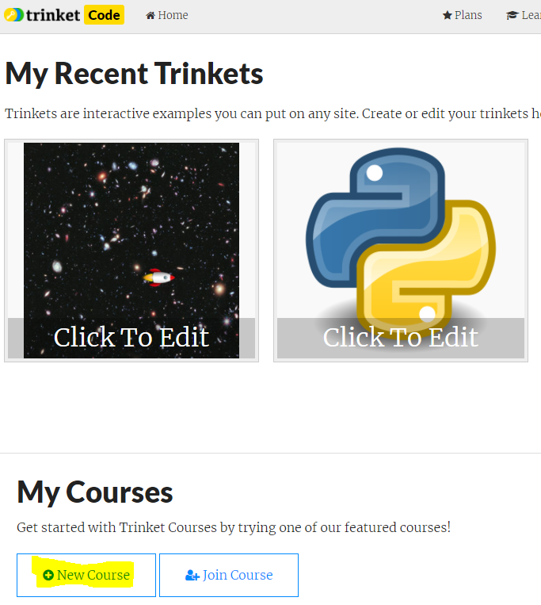

1. Enter "What's the Course Name?" and click "Save"

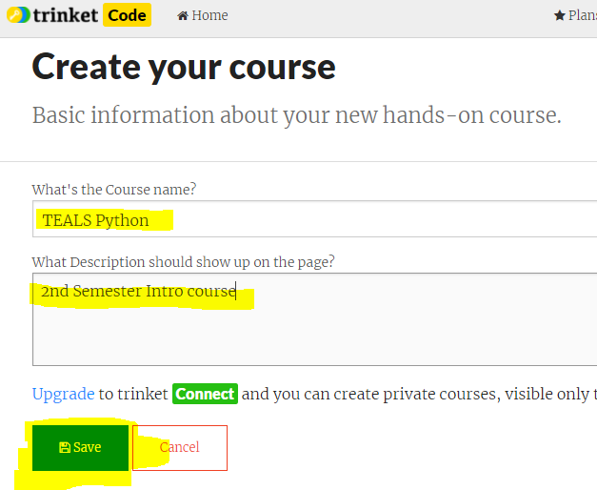

1. Enter “Your Name” and click “Next >”

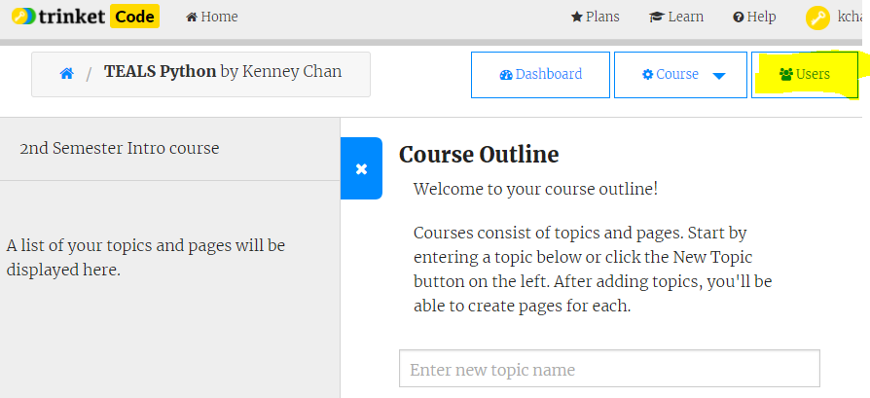

1. In the pop up window click "Add Users". Select "Email Invitation" and past a list of student emails in the list box and click "Send Invitations".

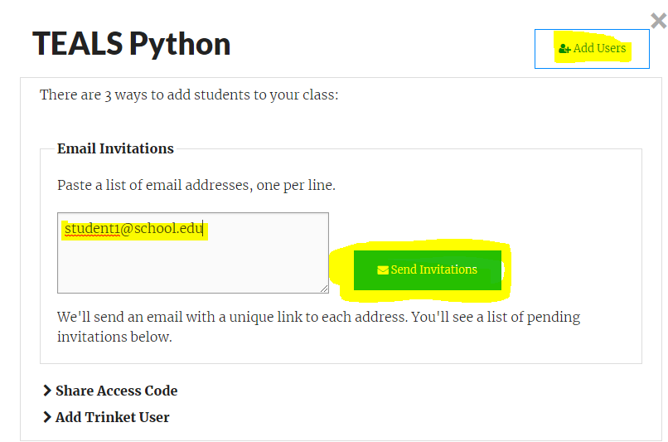

1. Students will receive an email invitation to the course. They will be required to create an account. See Trinket_Student.docx for student instructions.