**Team Members:**

1. Akimov Sarvar (ID: 12214739) - Team Leader

2. Nishonov Uktam (ID: 12214729)

3. Bobokulova Diyora (ID: 12214731)

**Project Overview:**

Our team collaborated on a machine learning model capable of distinguishing between positive and negative data. Using a cascade trainer GUI, we aimed to optimize the model’s accuracy through careful data processing and parameter tuning. Responsibilities were distributed among the team members to maximize efficiency and ensure quality results.

**Tasks and Responsibilities:**

1. Data Search - Nishonov Uktam

- Conducted searches for both positive and negative datasets, ensuring a diverse and representative set of images to enhance model accuracy.

2. Data Correction - Bobokulova Diyora

- Enhanced data quality by:

- Converting RGB images to grayscale for uniformity.

- Removing images from the negative dataset that displayed features similar to positive images, minimizing potential misclassification.

3. Training - Akimov Sarvar

- Led the training process, focusing on the cascade trainer GUI with adjusted parameters. Also solved key issues related to model performance by:

- Finding the minimum and maximum detectable sizes for the model.

- Testing and adjusting image processing speed for optimal performance.

4. Report Writing - Nishonov Uktam

- Documented the project steps, including data search, preprocessing, model training, and demo preparation. This report details each team member’s contributions and the final project outcomes.

5. Demo Creation - Bobokulova Diyora

- Developed a video demonstration to showcase the model’s setup, functionality, and output, illustrating how the system processes and classifies images based on its training.

**Average Detection Time:**

**6 challenges – result:**

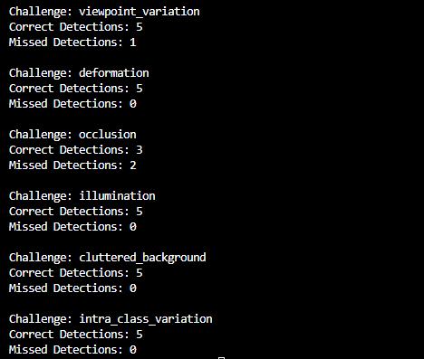

1. **Viewpoint Variation** – precision 5/6 (83%)

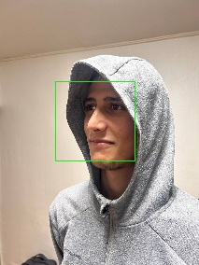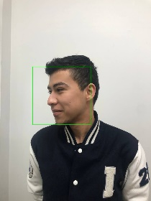

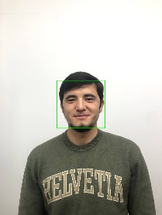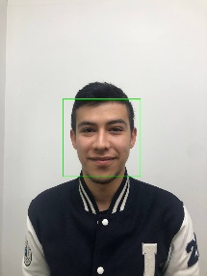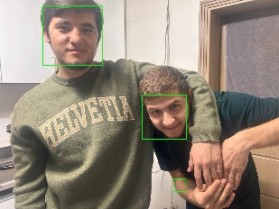

1. **Deformation** – precision 5/5 (100%)

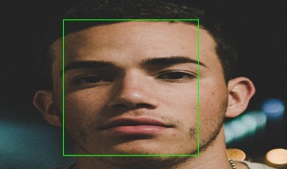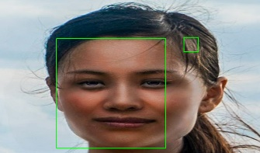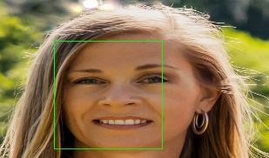

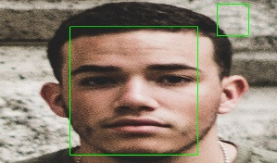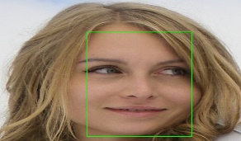

1. 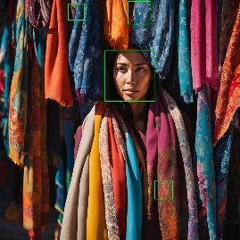**Occlusion** – precision 3/5 (60%)

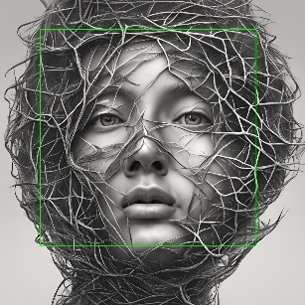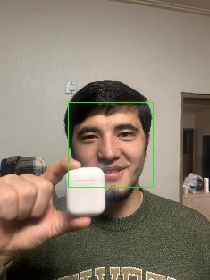

1. **Illumination conditions** – precision 5/5 (100%)

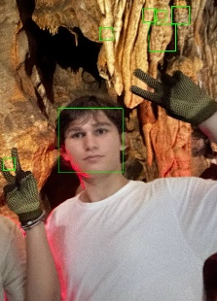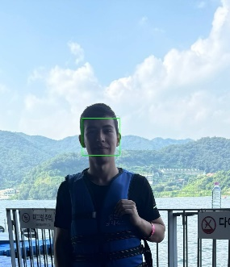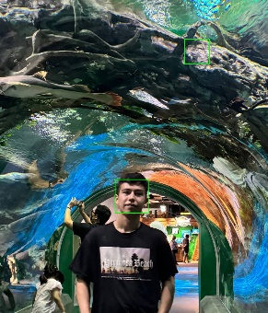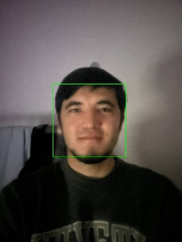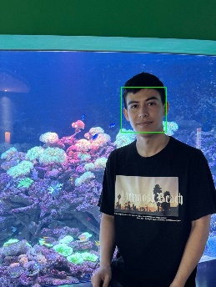

1. **Cluttered Background** – precision 5/5 (100%)

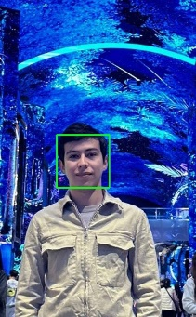

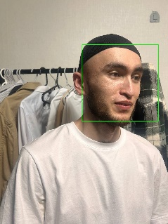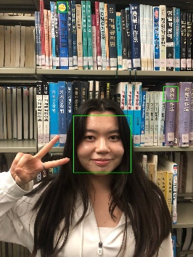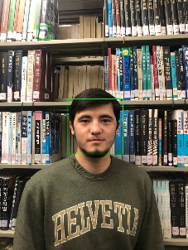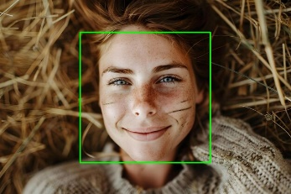

1. **Intra-Class Variation** – precision 5/5 (100%)

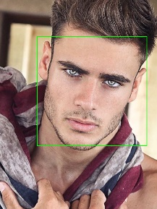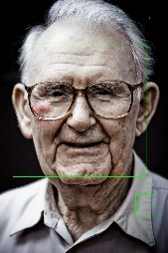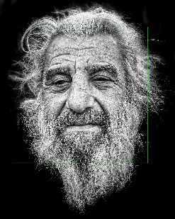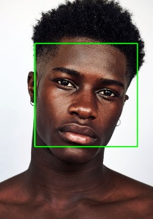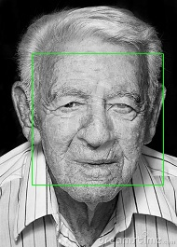

**Conclusion:**

The project was successfully completed through effective collaboration and a clear division of responsibilities. Each member's contributions—from data gathering and correction to training, problem-solving, documentation, and demo creation—were crucial to building a high-performing model capable of accurate classification. Everyone’s work on detecting minimum and maximum sizes and optimizing image processing speed was instrumental in refining the model’s functionality and ensuring its practical application. This report reflects our combined efforts and the successful results of the project.