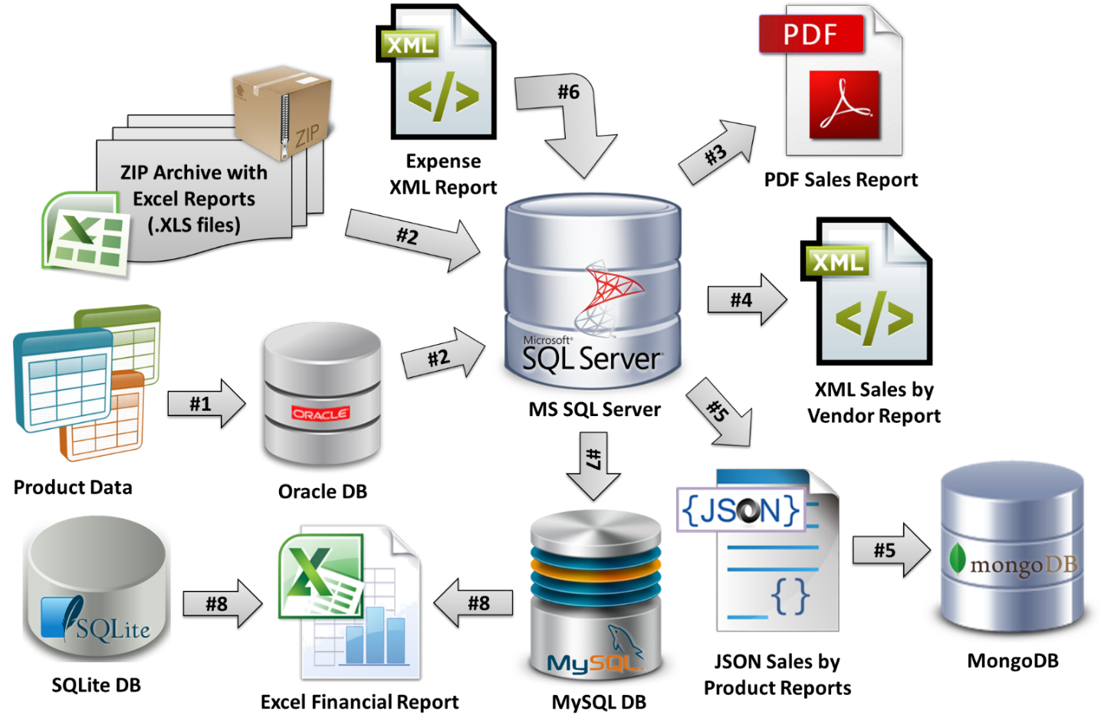

|  |  |  |  |  |
| --- | --- | --- | --- | --- |
| # | From DB | To DB | information | Teammate |
| # 1 | Product Data | Oracle | [OracleSite](http://www.oracle.com/technetwork/articles/dotnet/vs2010-oracle-dev-410461.html); [StackOverflow](http://stackoverflow.com/questions/12568100/connecting-to-oracle-database-through-c); | ZKalev |
| # 2 | Oracle | SQL server | [ASP.NET-Forums](http://forums.asp.net/t/1690135.aspx?Import+Data+From+Oracle+To+SQL+Server); [SQLines](http://www.sqlines.com/oracle-to-sql-server-cs-conversion); |  |
| # 2 | Excel Reports Zip | SQL server | [Blog article](https://tgrignon.wordpress.com/2007/03/07/using-excel-to-generate-inserts-for-sql-server/); [Codeproject.com(Indian)](http://www.codeproject.com/Tips/636719/Import-MS-Excel-data-to-SQL-Server-table-using-Csh) |  |
| # 3 | SQL server | PDF Sales reports | [Asp.NET Snippets](http://www.aspsnippets.com/Articles/Save-and-Retrieve-Files-from-SQL-Server-Database-using-ASPNet.aspx); [C#Corner](http://www.c-sharpcorner.com/UploadFile/013102/save-and-read-pdf-file-using-sql-server-and-C-Sharp/) |  |
| # 4 | SQL server | XML Sales by Vendor | [Indian code](http://blog.sqlauthority.com/2009/02/12/sql-server-simple-example-of-creating-xml-file-using-t-sql/); [Codeproject.com](http://www.codeproject.com/Tips/239156/Export-data-from-SQL-Server-as-XML); |  |
| # 5 | SQL server | JSON by Products | [StackOverflow](http://stackoverflow.com/questions/9416380/creating-a-json-result-from-sql-server-database); [Codeproject.com](http://www.codeproject.com/Questions/808048/SQL-server-table-data-into-JSON) |  |
| # 5 | JSON by Products | MongoDB | [Blog article](http://zaiste.net/2012/08/importing_json_into_mongodb/); [StackOverflow](http://stackoverflow.com/questions/25536306/mongodb-c-sharp-how-to-save-arbitrary-json-document-as-dynamic-type); [StackOverflow](http://stackoverflow.com/questions/25536306/mongodb-c-sharp-how-to-save-arbitrary-json-document-as-dynamic-type) | Пресиян |
| # 6 | Expense XML report | SQL server | [Indian code](http://www.mssqltips.com/sqlservertip/2899/importing-and-processing-data-from-xml-files-into-sql-server-tables/); [StackOverflow](http://stackoverflow.com/questions/16838627/import-xml-into-sql-server); [StackOvetflow](http://stackoverflow.com/questions/18630242/import-data-from-xml-to-sql-server-tables) | Milen |
| # 7 | SQL server | MySQL | [Indian code](https://social.msdn.microsoft.com/Forums/sqlserver/en-US/826cd1e8-cce3-4c08-839d-f6931ac75ef5/step-by-step-guide-to-convert-mssql-db-to-mysql-db); [GuidForDummies](https://www.packtpub.com/books/content/mysql-data-transfer-using-sql-server-integration-services-ssis) | Evgeni |
| # 8 | MySQL | Excel financial report | [Indian video](https://www.youtube.com/watch?v=WcIkjudRORw); [Codeproject.com](http://www.codeproject.com/Questions/537491/bC-dplusEXPORTplusDATABASEplusMYSQLplusTOplus); [StacOverflow;](http://stackoverflow.com/questions/9564753/export-mysql-database-to-excel-in-c-net) |  |
| # 8 | SQLite | Excel financial report | [Blog article](http://csharp.net-informations.com/excel/csharp-excel-export.htm); |  |