Software Architecture and Design Specification
Railway Reservation System (Booking & Cancellation)
- Project: Railway Reservation System (Booking & Cancellation)
- Version: 1.0
- Authors: Team 15 (Pranav B N, Samaresh, Amruta Karoshi, Manapriya Kudurebyalya)
- Date: 08-10-2026
- Status: Draft
- Reference documents: SRS v1.0 (13-09-2026), STP v1.0 (16-09-2026)

Revision History
Version | Date | Author | Change Summary
0.1 | 08-10-2026 | Team 15 | Initial architecture draft from SAD template
1.0 | 08-10-2026 | Team 15 | Sprint 1 architecture and design aligned with implemented code

Approvals
Role | Name | Signature/Date
Dev Lead | Amruta Karoshi
QA Lead | Manapriya Kudurebyalya
Test Lead | Pranav B N
Product Owner | Samaresh
Instructor | Prof. M. Sheela Devi

1. Introduction

1.1 Purpose
This document specifies the architecture and design of the Railway Reservation System (RRS), a C++17 console application for booking and cancelling train tickets. It explains how the system is structured, why the main design choices were made, and how the design maps to the requirements in the SRS.

1.2 Scope
Covers passenger services: registration, login, train search with seat availability, ticket booking with PNR generation and RAC/waiting-list handling, simulated payment, cancellation with refund calculation and waiting-list promotion, PNR status lookup, and file-based data persistence. The admin console (train, fare and quota management, reporting, backup/restore, admin action log) is designed at interface level here and will be implemented in Sprint 2.
Out of scope (as in the SRS): real payment gateway, multi-user concurrency, networked operation, mobile apps, integration with real IRCTC systems.

1.3 Audience
Developers, QA engineers, the course instructor and evaluators, and anyone maintaining or extending the system.

1.4 Definitions
PNR (Passenger Name Record), RAC (Reservation Against Cancellation), WL (Waitlist), CLI (Command Line Interface), SRS, STP, RTM, FR/NFR/SR (functional, non-functional, security requirement), ADR (Architecture Decision Record), SHA-256 (cryptographic hash), Luhn (card-number checksum).

2. Document Overview

2.1 How to use this document
Section 3 describes the architecture (components, pattern, technology, risks, security). Section 4 describes the detailed design (sequence diagrams, interface definitions, error handling, UX). Section 5 contains the glossary, references and tools. Architecture decisions are recorded as ADRs in Section 3.5.

2.2 Related Documents
Software Requirements Specification (SRS v1.0), Software Test Plan (STP v1.0), Requirements Traceability Matrix (SRS Section 8), docs/SPRINT1_PLAN.md and docs/TEST_TRACEABILITY.md in the project repository.

3. Architecture

3.1 Goals & Constraints
Goals: correctness of bookings (no double-allocation of seats, unique PNRs), data safety across crashes and restarts, security of credentials, testability of every business rule, and a simple, modular codebase (RRS-NF-005).
Constraints: C/C++17 console application; single user, single process; no external database or network (SRS); runs on Windows and Linux with GCC/G++; local files only; search response time of 1 second or less for up to 5,000 trains (RRS-NF-001); no crash on invalid input (RRS-NF-002).

3.2 Stakeholders & Concerns
Stakeholder | Concerns
Passengers | Easy menus, clear error messages, correct fares and refunds, secure login
Admin / railway clerk | Maintainable train, fare and quota data; reports (Sprint 2)
Course evaluators / instructor | Traceability to SRS, test evidence, working CI, individual contributions
Developers | Modularity, low coupling, easy unit testing
QA team | Deterministic behaviour, injectable time source, seeded test data

3.3 Component (UML) Diagram
Figure 1 shows the main components and the allowed dependency directions. The Console UI calls services; services use the domain layer; only the Storage component touches the files.
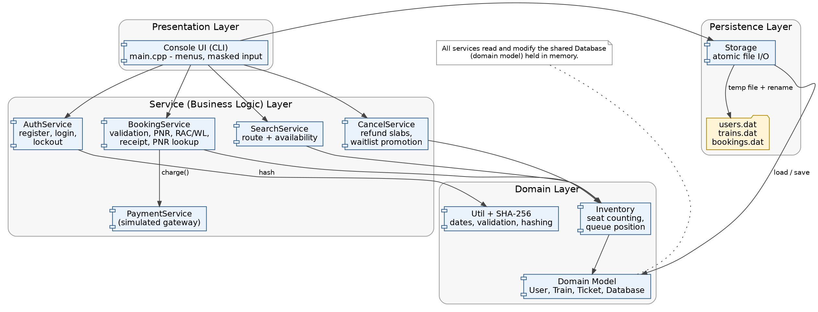
Figure 1: Component diagram of the Railway Reservation System

3.4 Component Descriptions
Component | Responsibility
Console UI (main.cpp) | Menus, prompts, masked entry of passwords and card numbers, display of tables and e-tickets. Contains no business rules.
AuthService | Registration rules, login, admin check, SHA-256 + salt hashing, lockout after 5 failed attempts for 15 minutes.
SearchService | Validates the query and journey date; lists trains and classes for a route with AVAILABLE / RAC / WL / REGRET hint.
BookingService | Validates user, train, class, date and passengers; decides CONFIRMED / RAC / WL; calls payment; creates the ticket and unique PNR; produces the e-ticket receipt; PNR status lookup.
PaymentService | Simulated gateway: 16-digit and Luhn validation, deterministic decline card, transaction id. No real bank integration.
CancelService | Cancellation by PNR with ownership check, refund slab calculation, FIFO promotion RAC to CONFIRMED and WL to RAC/CONFIRMED.
Inventory | Derives seat usage and queue positions from the ticket list, so counters can never drift out of sync with stored bookings.
Domain model (types) | User, Train, ClassInfo, Passenger, Ticket, Database and lookup helpers.
Util and SHA-256 | Strict date/time parsing, journey-date window, string helpers, SHA-256 implementation.
Storage | Loads and saves users.dat, trains.dat, bookings.dat; atomic writes (temp file then rename); skips corrupt records instead of crashing.
AdminService (Sprint 2) | Train, fare and quota management, reports, backup/restore, admin action log (RRS-F-040..043, F-051, SR-004).

3.5 Chosen Architecture Pattern and Rationale
A layered architecture (Presentation, Service, Domain, Persistence) was chosen. It separates concerns, lets each service be unit-tested without the UI or the disk, and keeps dependencies pointing downwards only. Client-server and microservice styles were rejected because the SRS defines a single-user, single-process console program; they would add network and deployment complexity with no benefit.
Architecture Decision Records
ADR | Decision | Rationale | Alternative rejected
ADR-1 | Layered, modular C++17 library plus thin CLI | Testability and the SRS modularity requirement (RRS-NF-005) | Single large main.cpp
ADR-2 | Seat counts derived from tickets (not stored counters) | No inconsistency after reload, crash or cancellation | Stored per-train seat counters
ADR-3 | Pipe-delimited text files with atomic save (temp file + rename) | No external DB allowed; a crash cannot leave a half-written file (RRS-NF-003) | Binary structs; in-place overwrite
ADR-4 | Injected clock (std::function) in all time-dependent services | Makes refund slabs, lockout and departure checks deterministic in tests | Calling the system time directly
ADR-5 | SHA-256 with per-user random salt for passwords | Satisfies RRS-SR-001 without third-party libraries | Plaintext; unsalted hash
ADR-6 | PNR derived from an ever-increasing booking sequence; cancelled tickets retained | PNRs never collide or get reused, even after reload (STP risk) | Random PNR with collision checks
ADR-7 | One status per PNR (all-or-nothing) and strict FIFO promotion | Simple, predictable and fair behaviour that is easy to test | Splitting a booking across statuses

3.6 Technology Stack & Data Stores
- Language and standard: C++17 (GCC/G++, also builds with MSVC).
- Build: CMake (and a plain Makefile). Tests: dependency-free in-house framework, run through CTest.
- CI/CD: GitHub Actions - build and test on Ubuntu and Windows, AddressSanitizer/UBSan job, Valgrind job.
- Data stores: local text files - users.dat (accounts and lockout counters), trains.dat (trains, classes, fares, quotas), bookings.dat (tickets including cancelled ones); admin_log.txt in Sprint 2.
- Debug and quality tools: GDB, Valgrind, sanitizers, Git/GitHub Issues.

3.7 Risks & Mitigations
Risk | Mitigation
File corruption on abrupt termination (RRS-NF-003) | Atomic save via temp file and rename; corrupt lines skipped on load; tests TC_Store_03/04 and IT_10/IT_12
PNR collision after reload | PNR derived from max(seq)+1 of all stored tickets including cancelled; tests IT_05/IT_06
Waiting-list promotion bugs (unfair ordering) | Single promote() routine with FIFO rule; dedicated tests TC_Cancel_06..10
Refund-policy misunderstanding | Slabs isolated in calculateRefund() with boundary tests; assumption A-3 confirmed with the product owner
Lockout bypassed by restarting the program | Failure counters and lock time are persisted; test IT_03
Search too slow for 5,000 trains | Linear scan is acceptable (well under 1 s); verified in the Sprint 2 performance test (TC-Perf-01)

3.8 Traceability to Requirements
Requirement | Description | Component / tests
RRS-F-001..003 | Registration, login, admin login | AuthService; TC_Reg_*, TC_Auth_*
RRS-F-010..012 | Search, availability, RAC/WL hint | SearchService, Inventory; TC_Search_*
RRS-F-020..025 | Booking, PNR, seats, RAC/WL, payment, receipt | BookingService, PaymentService; TC_Book_*
RRS-F-030..034 | Cancel, refund, promotion, retention, PNR status | CancelService, BookingService; TC_Cancel_*, IT_07
RRS-F-040..043 | Admin train/fare/quota, reports | AdminService (Sprint 2)
RRS-F-050/051 | Persistence, backup/restore | Storage (050 in Sprint 1; 051 in Sprint 2)
RRS-NF-002/003 | No crash on bad input; consistency after termination | Validation in every service; Storage; IT_10, IT_12
RRS-SR-001..005 | Hashing, masking, admin access, admin log, lockout | AuthService, Console UI; TC_Sec_*; SR-004 in Sprint 2

3.9 Security Architecture
Threat modelling (STRIDE) adapted to a local console application:
Threat | Scenario | Mitigation
Spoofing | Guessing another user's password | Salted SHA-256 hashes; generic error message (no user enumeration); lockout after 5 failures
Tampering | Editing bookings.dat or users.dat by hand | Records validated on load, corrupt lines skipped; atomic writes. (Integrity signing noted as future work)
Repudiation | Admin denies changing a fare | Admin action log with timestamps (RRS-SR-004, Sprint 2)
Information disclosure | Reading passwords or card numbers from files or screen | Only hashes stored; card number never stored; password and card input masked; card shown masked
Denial of service | Repeated bad input or logins | Strict input validation; lockout cool-down; corrupt data cannot crash startup
Elevation of privilege | Passenger reaching admin functions or cancelling someone else's ticket | Admin flag checked at login; ownership check in cancel(); admin menu unreachable without admin login

4. Design

4.1 Design Overview
The system is a library of small services over one in-memory Database object, plus a thin console front-end. The program loads the files at start-up, performs operations through services, and saves after every state-changing action. Every business rule lives in a service; the UI only collects input and prints results. Services return result structures (ok, message, data) instead of throwing exceptions, which keeps error handling uniform and testable.

4.2 UML Sequence Diagrams
Three flows are shown: booking a ticket (Figure 2), cancelling a ticket with refund and waiting-list promotion (Figure 3) and login with lockout (Figure 4).
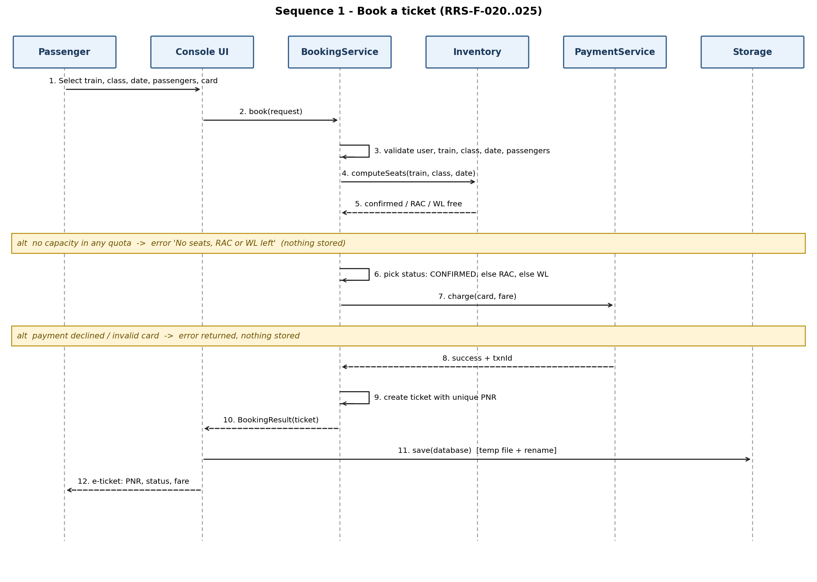
Figure 2: Sequence diagram - book a ticket
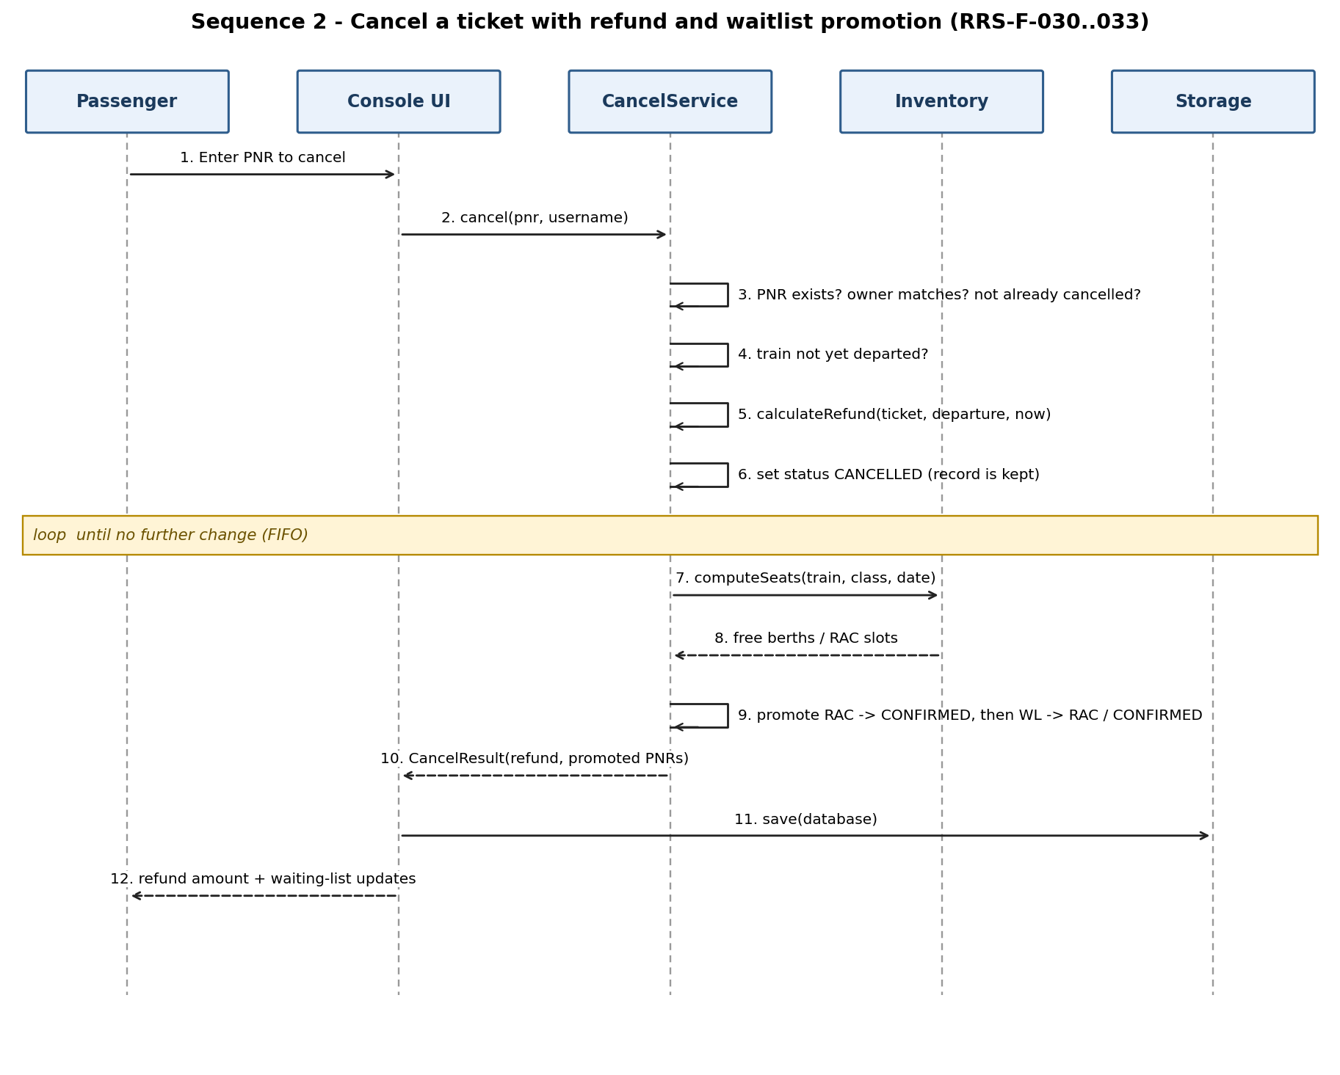
Figure 3: Sequence diagram - cancel a ticket and promote the waiting list
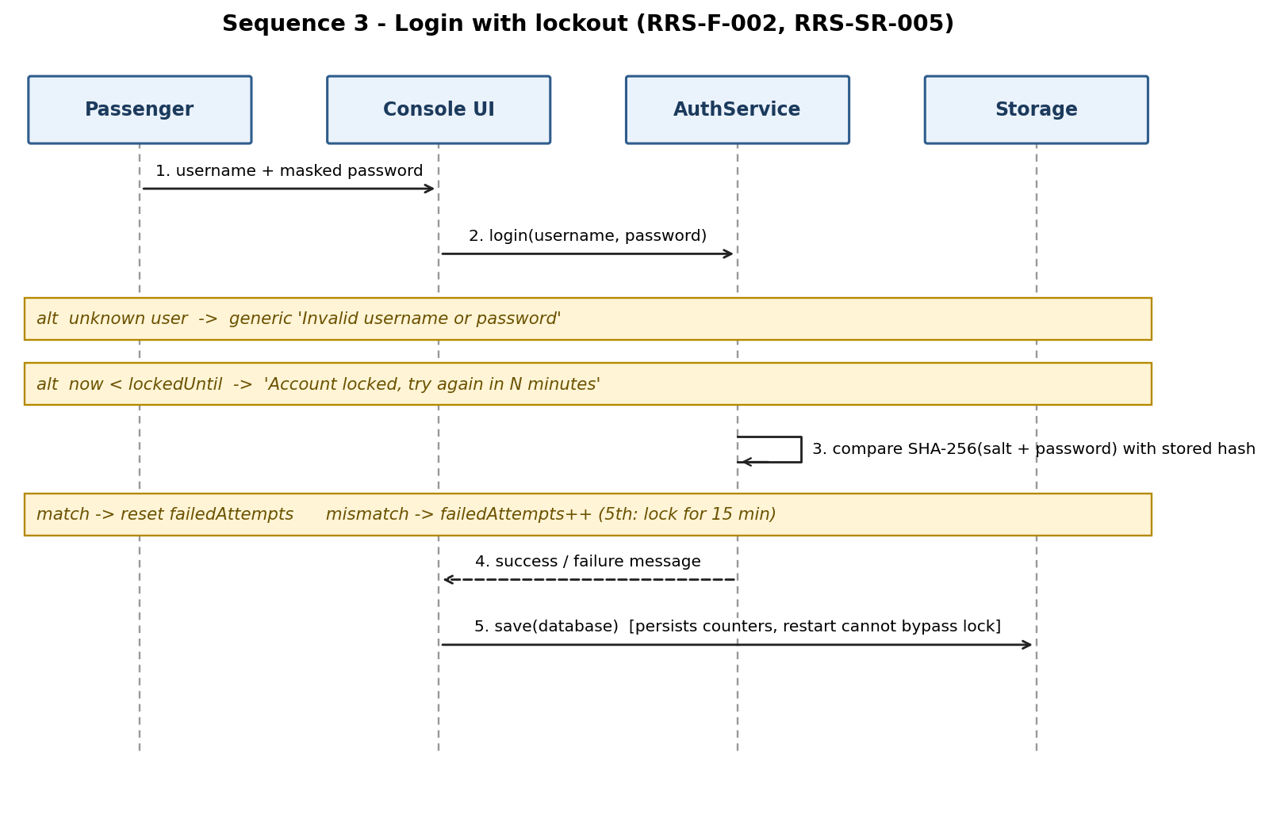
Figure 4: Sequence diagram - login with lockout

4.3 API Design
The components expose C++ interfaces rather than network endpoints. The three main ones are defined below.
Interface 1 - BookingService::book(BookingRequest) -> BookingResult
- Request: { username, trainNumber, classCode, journeyDate (YYYY-MM-DD), passengers[1..6] {name, age 1..120, gender M/F/O}, cardNumber }
- Response: { ok, message, ticket {pnr, status CONFIRMED/RAC/WL, totalFare, ...}, txnId }
- Errors (ok = false, nothing stored): unknown user; train not found or inactive; class not on train; invalid or past journey date; train already departed; invalid passenger count or details; no seat/RAC/WL capacity; payment declined or invalid card.
Interface 2 - CancelService::cancel(pnr, requester) -> CancelResult
- Request: { pnr, requester username }
- Response: { ok, message, refund (rupees), promotedPnrs[] }
- Errors: PNR not found; requester is not the owner; already cancelled; train already departed.
- Refund slabs: WL 100%; 48 h or more: 100% minus Rs.60 per passenger; 12-48 h: 75%; 4-12 h: 50%; under 4 h: 0%.
Interface 3 - AuthService::login(username, password, adminLogin) -> AuthResult
- Response: { ok, message }. Errors: invalid username or password (same text for both cases), account locked (with minutes remaining), administrator account required.
Other interfaces: SearchService::search(SearchQuery) -> SearchResult {rows[]}; lookupPnr(db, pnr) -> Ticket*; PaymentService::charge(card, amount) -> PaymentResult; Storage::load(Database&, LoadReport*) and Storage::save(const Database&, error*).

4.4 Error Handling, Logging & Monitoring
- All user input is validated before use; invalid input produces a plain-language message and never a crash (RRS-NF-002).
- Services return result structures with a user-safe message; no stack traces or internal paths are shown to the user.
- Messages never reveal sensitive data: passwords and full card numbers are never printed or stored.
- Corrupt data records are counted and skipped at load; the CLI reports how many were skipped.
- Admin actions will be appended with a timestamp to admin_log.txt (RRS-SR-004, Sprint 2).
- Monitoring for this project is done through the test suite and CI results (pass rate per module), as defined in the STP metrics.

4.5 UX Design
Plain-language numbered menus (RRS-NF-004). Passwords and card numbers are not echoed while typing. Search results are shown as an aligned table with an availability hint (AVAILABLE n / RAC n / WL n / REGRET). The e-ticket shows PNR, train, route, date, class, status with queue position for RAC/WL, passengers and fare. Invalid menu choices show a short instruction and re-display the menu. Accessibility is limited to a console UI (no GUI in this version).

4.6 Open Issues & Next Steps
- Sprint 2: admin console (train, fare, quota), reports, backup/restore, admin action log, performance test with 5,000 trains, fuzz and system tests.
- Confirm the refund slabs and quota sizes against the final SRS wording.
- Future: integrity protection for data files, multi-user access with file locking or a database, real payment gateway, GUI/web front-end.

5. Appendices

5.1 Glossary
PNR, RAC, WL, CLI, SRS, STP, RTM, FR/NFR/SR, ADR, SHA-256, Luhn - see Section 1.4.

5.2 References
IEEE 42010 (architecture description), OWASP guidance on password storage and input validation, NIST SP 800-160, FIPS 180-4 (SHA-256), SRS v1.0, STP v1.0.

5.3 Tools
Graphviz (component diagram), matplotlib/PlantUML/draw.io (sequence diagrams), CMake, GitHub Actions, Valgrind, GDB.

