## **THE TECHNICAL UNIVERSITY OF KENYA**

SCHOOL OF CO

3MPUTING AND INFORMATION TECHNOLOGIES

DEPARTMENT OF INFORMATION SYSTEMS

COURSE INFORMATION TECHNOLOGY

UNIT IBL3300

## **GROUP 5**

1. MOKUA M STEVE-- PROGRAMMER
2. JAPHETH A ONGERE--DATABASE
3. PURITY MUSYIMI—TEAM LEADER
4. DAVID MAIKO-SYSTEM ANALYST..

## **TASK 1 PLANNING**

## Overall strategy for the System

* Requirements modeling

## **TASK 2 ANALYSIS**

* Feasibility assessment
* Information and process analysis
* System research

**TASK 3 DESIGNS**

* Program development
* Procedure development
* Scheduled group presentations

**TASK 4 IMPLEMENTATIONS**

* Conversion
* Testing

**TASK 5 OPERATIONS**

* Operation & maintenance
* Audit and review
* Final project status demo

|  |  |  |  |  |  |
| --- | --- | --- | --- | --- | --- |
| Task 1 |  |  |  |  |  |
| Task 2 |  |  |  |  |  |
| Task 3 |  |  |  |  |  |
| Task 4 |  |  |  |  |  |
| Task 5 |  |  |  |  |  |
|  | (22/1 – 27/1) | (29/1 – 3/2) | (5/2 – 10/2) | (5/2 – 10/2, 12/2 – 17/2, 19/2 – 24/2) | (19/2 – 24/2) |

**ATTENDANCE SYSTEM NARRATIVE**

This is a simple yet intuitive attendance management system for university lecturers. Lecturers can create an account, add their students, courses and the units they teach and enter students attendance record. The system admin can view all the attendance records for all units ,but lectures only view their own records. The main aim of Student attendance system project is to maintain attendance records of student for any organization school or college

The student attendance management system project is used to maintain school students attendance records. The attendance project has three user module for run the system Admin, Staff and Student. Initially the system will be blank, The **Administrator** has a rights to create standard and classroom for school and same time he has to add staff detail. Administrator generates unique username and password for all staff while adding staff detail**. All staff** maintain attendance of student, generate reports month wise, date wise

### **Student Attendance System Modules:**

The attendance system asp.net project has main three modules.

* Admin Module
* Staff Module
* Student Module

**Admin :**The Admin is a person who run and manage the system, in this project the owner or director of the school has rights of admin. The Admin creates the structure of a system to creating standard and classroom.

### **Admin Functionalities:**

* Add Standerd
* Add Division / Classroom
* Add Staff
* Manage Complain
* Manage Reports

**Staff :** The main aim of the attendance system fulfill by staff. Staff can add student detail and fill the attendance daily for his division. The staff can only fill attendance for his division students and he can manage leaves and complains made by only his division student.

### **Staff Functionalities :**

* Add Student
* Fill Attendance
* Manage Leave
* Manage Complain
* Manage Reports
* Change Password

**Student :**All student have unique username and password to access the system. After login into system student can view his attendance reports and manage his account. If any student has any problem regarding education he can directly make complain to his class teacher using this system. Student can apply for leave through the system and he can get reply from his class teacher about his leave status.

### Student Functionality :

* Manage Account
* Make Complain
* Apply for Leave
* Attendance Reports
* Change Password

**Data Flow Diagram**

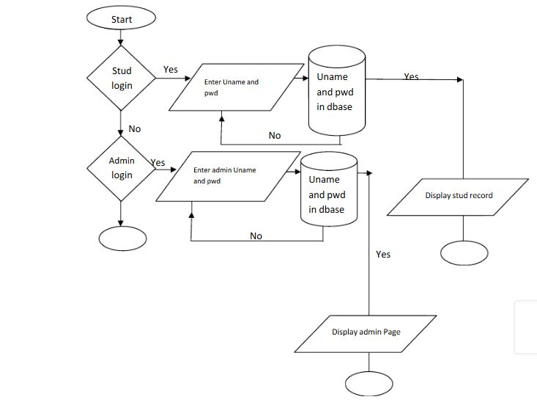

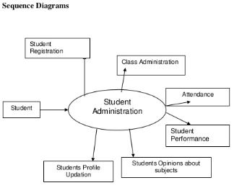

**SWIMLANE DIAGRAM**

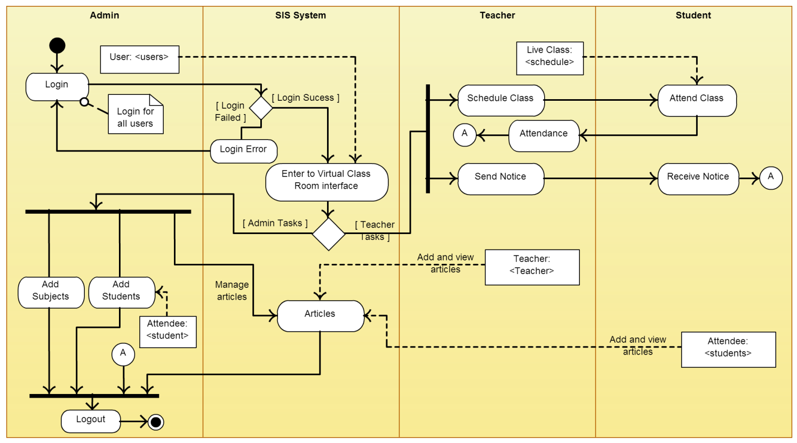

**Use Case Diagram – Student Attendance System Project**

The use case diagram are usually referred to as behavior diagram used to describe the actions of all user in a system. All user describe in use case are actors and the functionality as action of system.  
The Use case diagram is a collection of diagram and text together that make action on goal of a process

**Use case diagram elements:**

The use case diagram consist of six graphics elements that represent whole system :

* Systems
* Actors
* Use cases
* Association
* Dependencies
* Generalization

Below are three actors of a system Admin, Staff and Student.

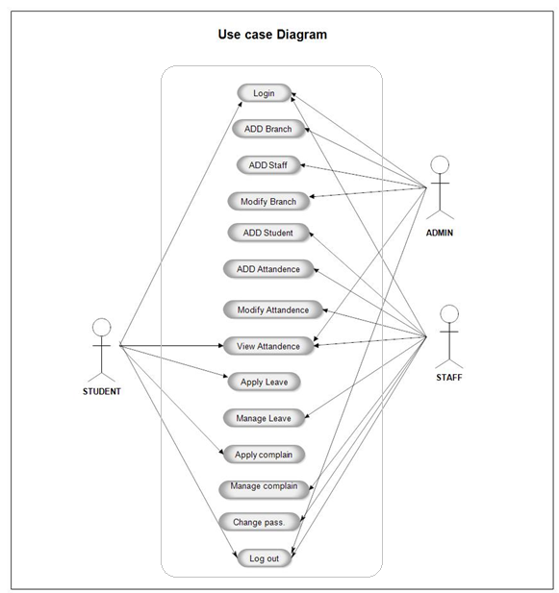

Use case diagram for student attendance management system

|  |  |  |  |  |  |  |
| --- | --- | --- | --- | --- | --- | --- |
| **Sn** | **Use case name** | **Purpose** | **Input** | **Source of input** | **Output** | **Output recipient(s)** |
| 01 | Admin | The Admin is a person who run and manage the system, in this project the owner or director of the school has rights of admin | * Add unit * Add course * Add Staff * Manage * Complain * Manage Reports | Student | Signing attendance | Lecturer(Admin) |
| 02 | Student Module | All student have unique username and password to access the system. After login into system student can view his attendance reports and manage his account. If any student has any problem regarding education he can directly make complain to his class teacher using this system. Student can apply for leave through the system and he can get reply from his class teacher about his leave status. | * Manage Account * Make Complain * Attendance Reports * Change Password | Student | Attended or Dint Attend | * Staff |
| 03 | Staff | **:** The main aim of the attendance system fulfill by staff. Staff can add student detail and fill the attendance daily for his division. The staff can only fill attendance for his division students and he can manage leaves and complains made by only his division student. | * Add Student * Fill Attendance * Manage Complain * Manage Reports * Change Password | Student | Edit Student Details | Admin |